Deep Learning - Assignment 2 Report
Fashion-MNIST: CNN (Exercise 1) and Residual CNN (Exercise 2). PyTorch, CPU. Code: Assignment2.ipynb / assignment2.py.

Exercise 1: Training a CNN

i. Architecture
Input 1x28x28 (pixels scaled to [0,1]; integer labels with CrossEntropyLoss, equivalent to one-hot). Three conv stages, each: Conv3x3-BN-ReLU -> Conv3x3-BN -> ReLU -> MaxPool2x2, with 32, 64 and 128 channels (spatial size 28->14->7->3). Then Flatten (1152) -> FC 256 -> ReLU -> Dropout 0.4 -> FC 10. Total 584,618 parameters. The design follows the LeNet/VGG pattern (small 3x3 kernels, channels doubling as resolution halves), with batch normalisation and dropout for regularisation.
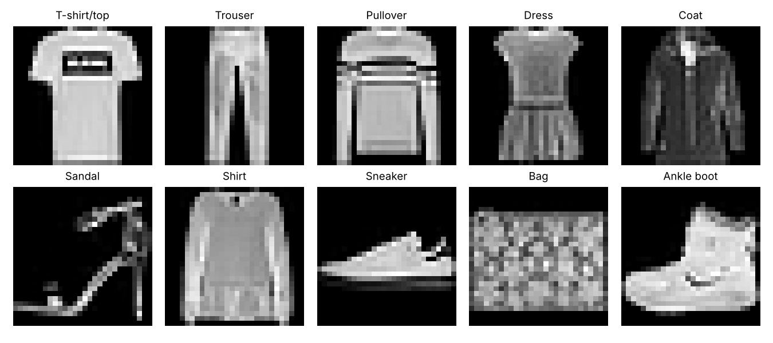

ii. Training and results
Adam (lr 1e-3, cosine decay), batch size 128, 10 epochs, cross-entropy loss, no data augmentation. The test set is used only for monitoring/reporting (no hyper-parameter tuning was done on it). Two random seeds were run.
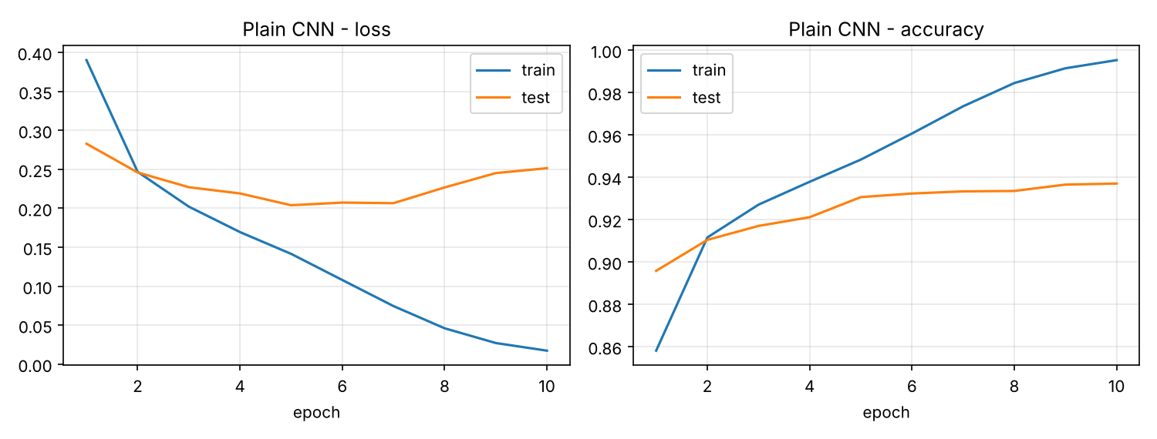
Result (mean of 2 seeds): test accuracy 93.61% (seeds: 93.70, 93.51), test loss 0.257, final train accuracy 99.55%.
Discussion: Accuracy rises quickly (about 89.6% after one epoch) and saturates around 93.5-93.7%. Training accuracy reaches ~99.5% while test loss stops improving after a few epochs, so the model overfits somewhat; dropout and BN limit it but do not remove it. The confusion matrix shows where errors lie: Shirt is by far the hardest class (79.6% recall), confused with T-shirt/top, Pullover and Coat; Pullover/Coat/T-shirt are next. Trousers, bags, sandals and sneakers are above 98%. These are visually similar upper-body garments distinguished by fine detail at only 28x28 resolution.
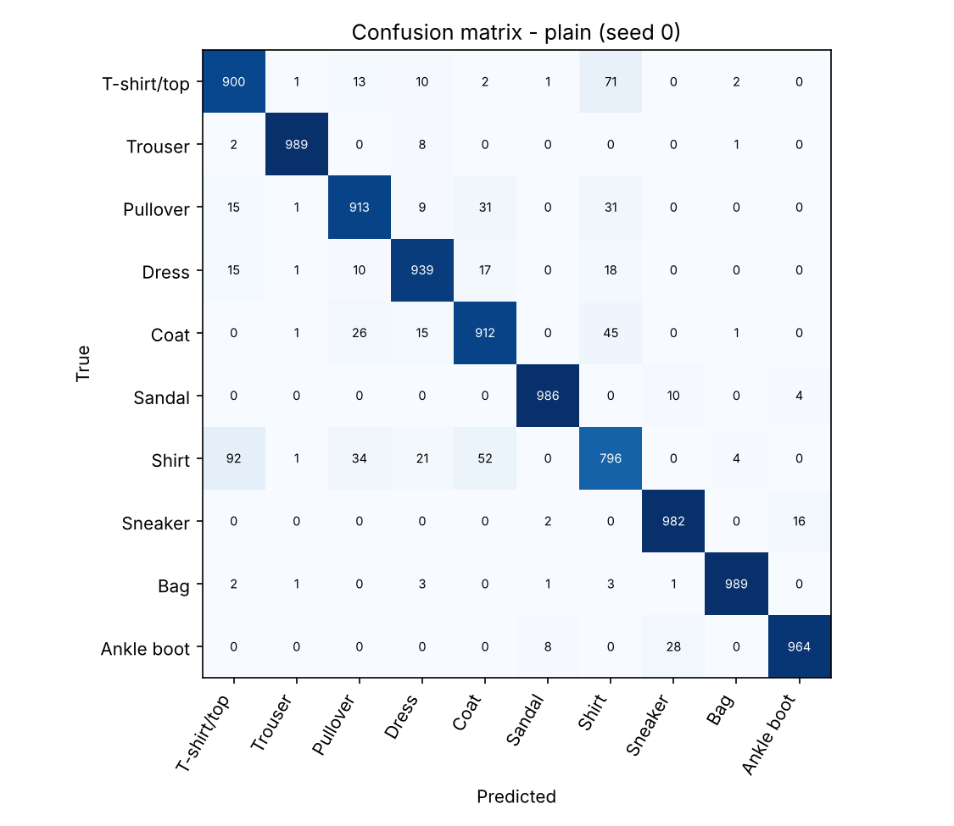

Exercise 2: Residual Networks

i. Residual connections and vanishing gradients
A residual block computes y = F(x) + x instead of y = F(x): the layers learn a residual correction and the input is passed forward through an identity shortcut. In backpropagation, dy/dx = dF/dx + I. The identity term gives the gradient a direct path to earlier layers that does not get multiplied by many weight matrices and activation derivatives. In a plain deep network the gradient is a product of many factors that may be <1, so it shrinks exponentially with depth (vanishing gradient) and early layers learn very slowly; with skip connections the "+I" keeps the signal from collapsing. This also makes it easy for a block to approximate the identity, so adding depth should not hurt optimisation.

ii. Modified forward function
Only the forward pass of each conv stage was changed (same layers, same 584,618 parameters). The stage output before the final ReLU/pool becomes out = BN(conv2(ReLU(BN(conv1(x))))) + shortcut(x). The 3x3 convs use padding=1 so the spatial size is unchanged inside a stage; the channel count grows (1->32, 32->64, 64->128), so the shortcut x is zero-padded along the channel dimension (F.pad(x, (0,0,0,0,0,c_out-c_in))) to match, as suggested in the assignment. This shortcut is parameter-free. The max-pool is applied after the addition, so the "pyramid" dimension reduction affects both paths identically.

iii. Training and comparison
Same data, optimiser, schedule, epochs and seeds as Exercise 1.
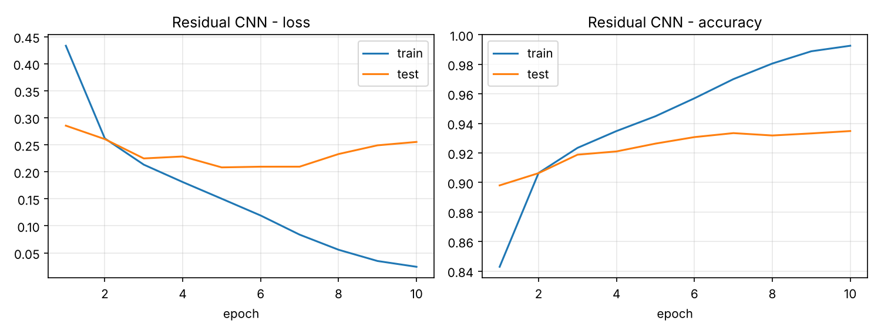
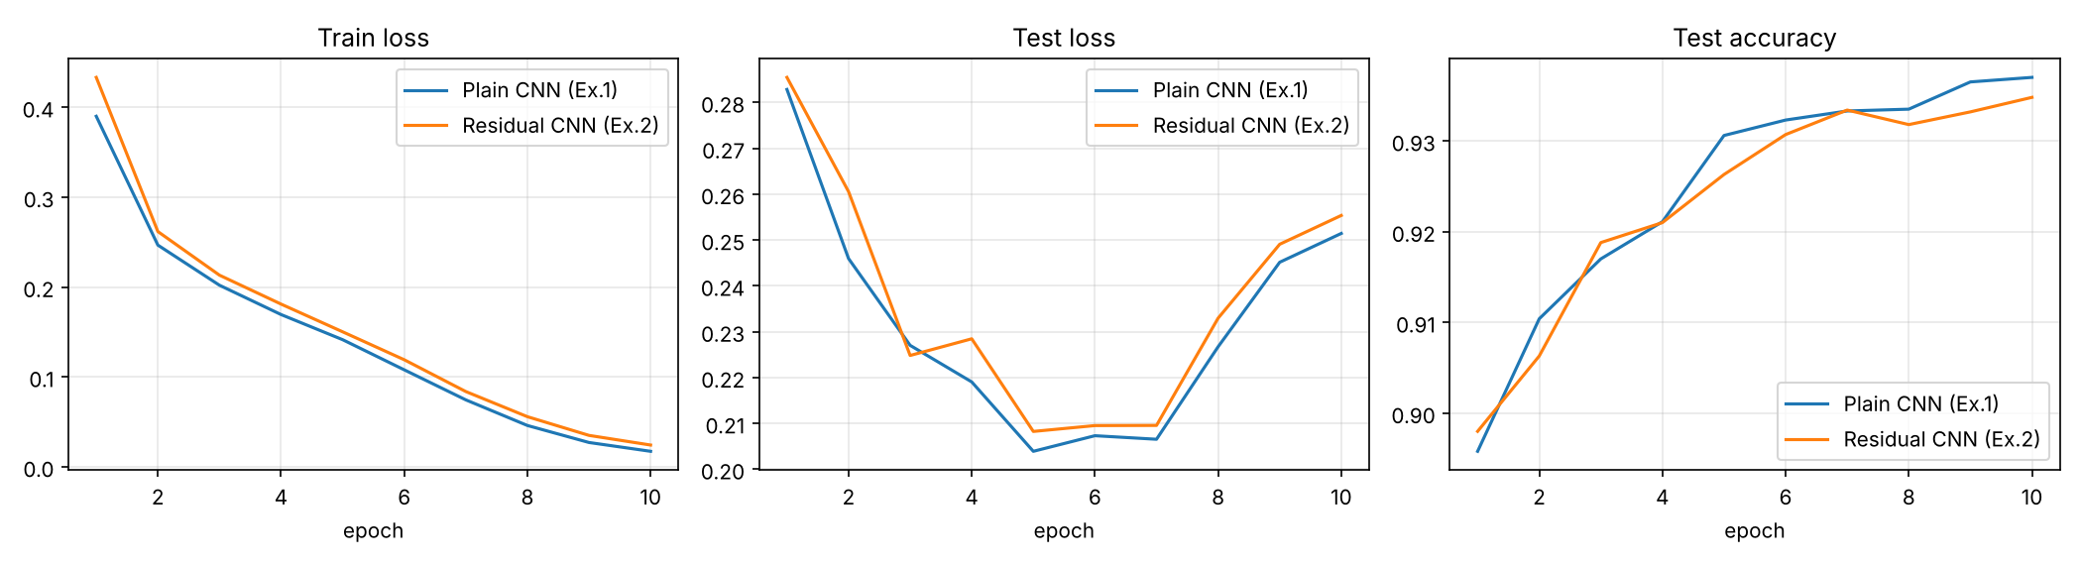
Metric (mean of 2 seeds) | Plain CNN (Ex.1) | Residual CNN (Ex.2)
Test accuracy (%) | 93.61 | 93.64
Per-seed test acc (%) | 93.70, 93.51 | 93.48, 93.81
Test loss | 0.257 | 0.246
Final train acc (%) | 99.55 | 99.25
Parameters | 584,618 | 584,618
Seconds / epoch (CPU) | 83 | 84

Gradient diagnostic: we logged the mean absolute gradient of the first conv of each stage (figure below).
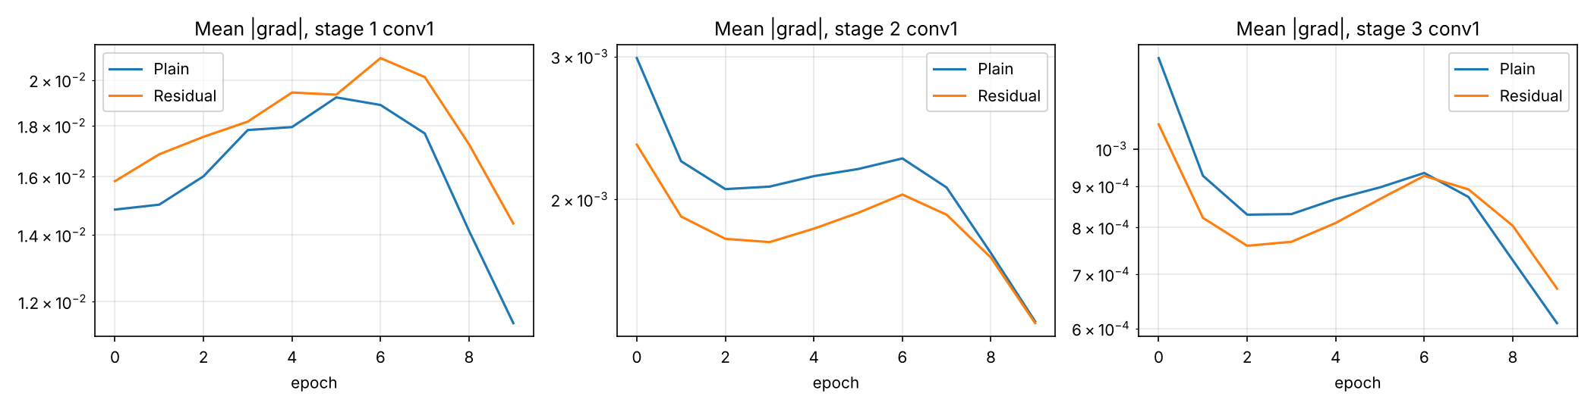
Discussion: The two models perform essentially the same: 93.61% vs 93.65% test accuracy, a difference (0.04 points, 4 test images) far smaller than the seed-to-seed spread (about 0.1-0.3 points), so we cannot claim either is better from 2 seeds. The residual model has slightly lower test loss (0.246 vs 0.257) and slightly lower training accuracy (99.25% vs 99.55%), i.e. a marginally smaller generalisation gap, and it started slightly slower in epoch 1. The gradient plot shows no vanishing gradient in either model: gradients of the earliest stage are even the largest. This is expected: the network has only 6 conv layers, and batch normalisation already keeps gradients well scaled, so there is little for skip connections to fix. Residual connections pay off in much deeper networks (tens to hundreds of layers); a clear benefit would be expected if the depth of this model were increased substantially (e.g. 20+ conv layers), which we did not test. The zero-padded shortcut also adds no parameters or noticeable time.

Conclusion
A small BN-CNN reaches ~93.6% on Fashion-MNIST. Adding parameter-free residual connections leaves accuracy unchanged within noise at this depth, with a slightly smaller loss; the theoretical advantage for gradient flow matters mainly for deeper models. Main weakness for both: the Shirt class.

Limitations
10 epochs, 2 seeds, CPU only, no augmentation, no hyper-parameter search; differences below ~0.3 points should not be over-interpreted.

