

Ανδρέας Λεβής (ΑΜ: 03119160)  
Μαρία-Λαμπρινή Μπαρτσιώκα (ΑΜ: 03119100)  
Χρυσούλα Πανηγυράκη (ΑΜ: 03119010)

Databases pRoject

**ΕΘΝΙΚΟ ΜΕΤΣΟΒΙΟ ΠΟΛΥΤΕΧΝΕΙΟ**

ΣΧΟΛΗ ΗΛΕΚΤΡΟΛΟΓΩΝ ΜΗΧΑΝΙΚΩΝ % ΜΗΧΑΝΙΚΩΝ ΥΠΟΛΟΓΙΣΤΩΝ

*ΤΟΜΕΑΣ ΠΛΗΡΟΦΟΡΙΚΗΣ*

Contents

I. Relational Diagram 2

II. Database in SQL 3

Tables 3

Other 7

III. Prerequisites for Database and App Development 8

IV. Steps for Installation (Windows) 8

# Relational Diagram

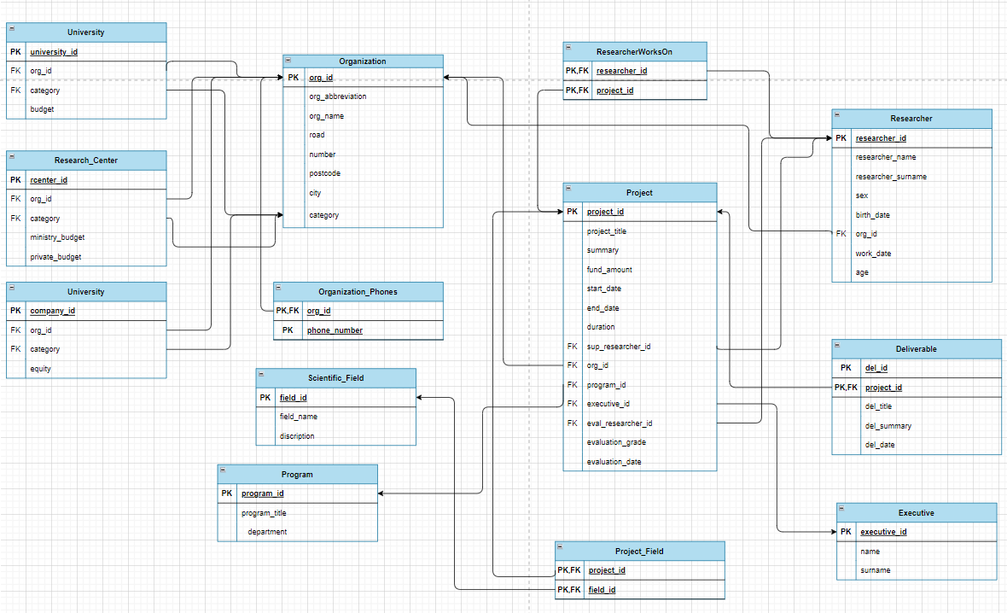

ER Diagram and Relational Diagram illustrate the logic within a database and how individual components relate to one another. Such diagrams lay out the wireframe of internal database structures to aid in understanding, improving efficiency, and debugging logical errors. The key pieces are the entities, attributes, and the relationships between them.

The above relational diagram describes the design of the database of a system which stores, manages and analyzes information for the Hellenic Foundation for Research and Innovation (ELIDEK). This database stores *organizations* (universities, research centers or companies) that manage *projects* and employ *researchers* to carry out these projects. The projects belong to a scientific *field*, while they are financed by ELIDEK *programs*, they have employees, *supervisors*, *evaluators* and *managers* and they may have individual *deliverables*. The necessary data for what was mentioned is stored in the database and the relationships between them are indicated in the diagram with arrows. The separation between entities of the same category is done mainly with the primary keys - IDs.

# Database in SQL

## Tables

The following is the design of the database in SQL language. The tables that are depicted in the relational diagram are created and their primary and foreign keys are defined, based on their importance and the relationships that connect the tables. As for the characteristics of the tables, they are set to NOT NULL when they are deemed necessary for the existence of each element of the respective table and are needed during its initialization. For this reason, the primary keys are always NOT NULL. As primary keys in each table are considered the IDs that are unique for each entity. Foreign keys are also set to NOT NULL, in order to be consistent with the primary keys of the relationships to which they belong.

* Organization

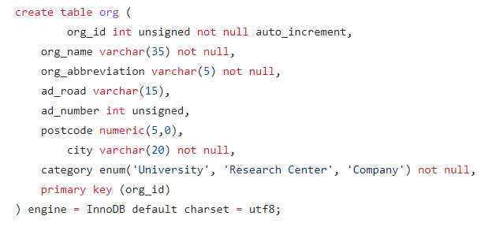

* Researcher

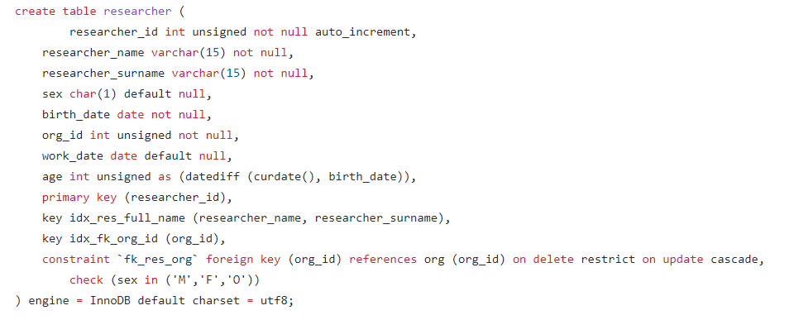

Attribute org_id is foreign key that matches in a relationship one organization to many researchers. An index res_full_name is also made to contain the name and suername of a researcher in one attribute.

* Executive

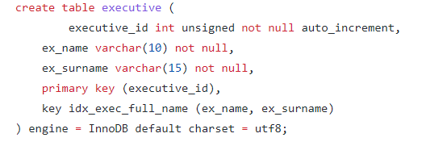

* Organization Phones

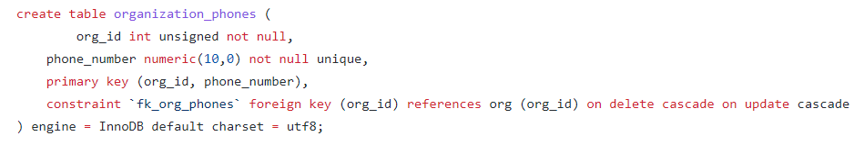

Attribute org_id is foreign key that matches in a relationship one organization to many phones.

* Scientific Field

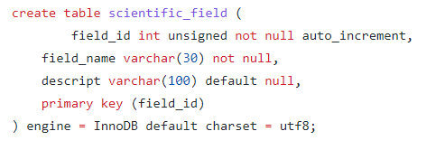

* Program

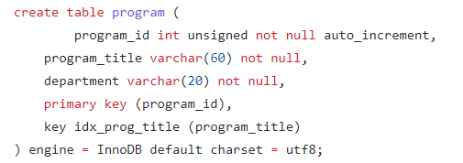

* Project

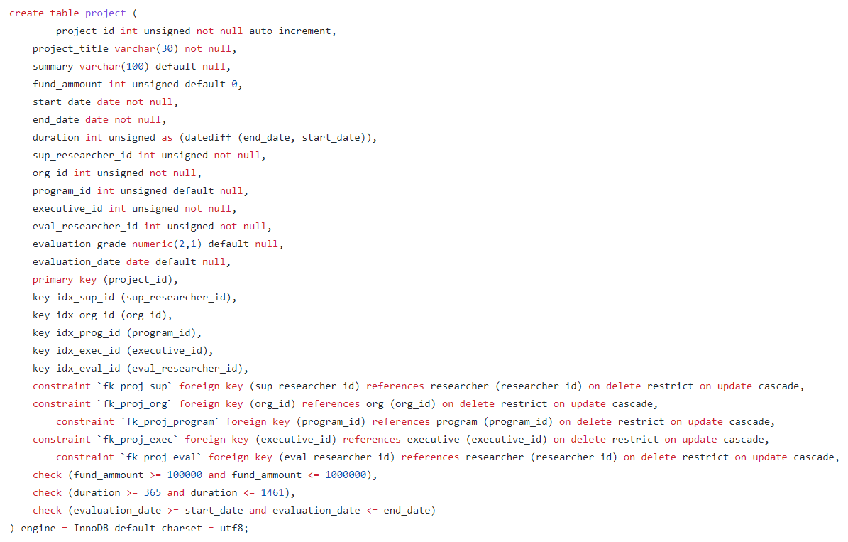

Attribute sup_researcher_id is foreign key that matches in a relationship one supervisor to one project. Attribute org_id is foreign key that matches in a relationship one organization to many projects. Attribute program_id is foreign key that matches in a relationship many projects to one program. Attribute executive_id is foreign key that matches in a relationship one executive to one project. Attribute eval_researcher_id is foreign key that matches in a relationship one evaluator to one project. In addition, the values of the fund amounts, the duration and the evaluation date of the projects are checked to be within the acceptable limits.

* Deliverable

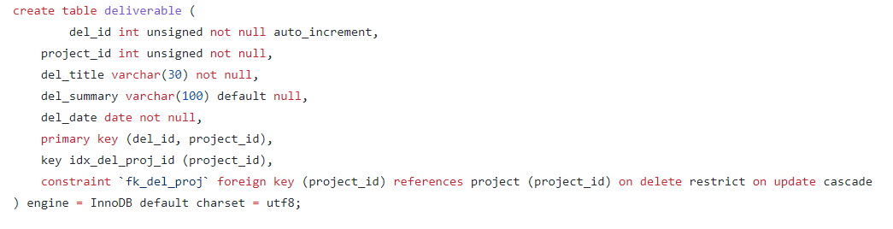

Attribute project_id is foreign key that matches in a relationship one project to many deliverables.

* Researcher Works On

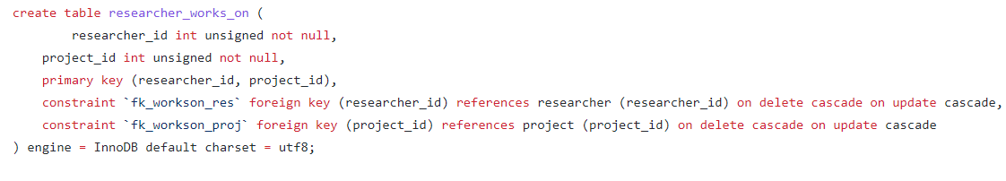

The above table demonstrates the relationship “works on” between researcher who works at a project and is has no specific role. Attributes researcher_id and project_id are foreign keys that matches in a relationship many researchers to one project.

* University

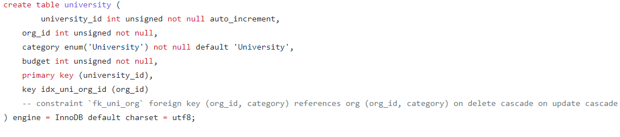

An organization can be either a University or a Research Center or a Company. So an index is created for foreign keys org_id and category in order to match in a relationship many universities to one organization. The tables for research center and company are created below in a same way.

* Research Center

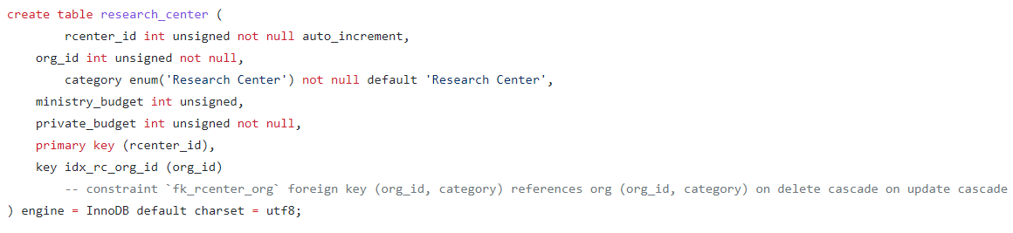

* Company

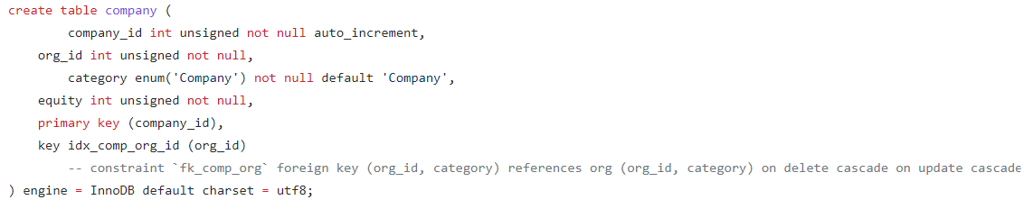

* Project Field

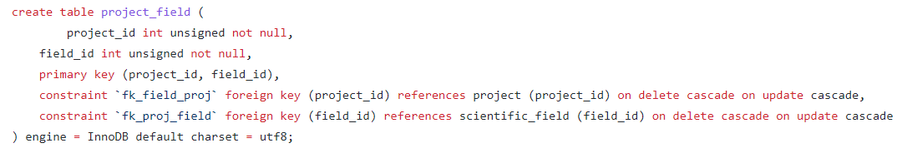

The above table demonstrates the relationship “belongs” between project which belongs to a scientific field. Attributes project_id and researcher_id are foreign keys that match in this relationship many projects to one field.

## Other

**Indexes** are defined for the attributes that are used the most so as to help queries run faster. All of them are obtained in the tables and have already been analyzed.

**Triggers** are stored procedures which automatically invokes whenever a special event occurs in the database and especially when a row is inserted or a column is being updated on a table. One of them is given as an example.

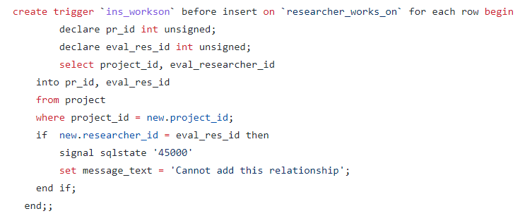

This trigger gives an error message if a new researcher who is entered in the table “researcher_works_on” has already been an evaluator for another project.

**Insert into** is a mandatory statement for every database in order to have values in its tables and to be able to run its queries. At first all the data are being deleted and then new data are inserted in the database. User can also add an insert into command to add individual entities.

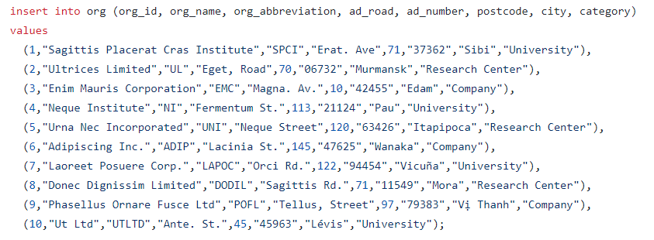

Data are inserted by rows accordingly to the attributes of each table, as it is shown above. In our implementation the database runs fake data generated from online app.

**Queries** request for data or information from a database table or combination of tables. Here queries implement the questions of the project. Queries are often combined with **Views**, that is virtual tables based on the result-set of an SQL query. A view contains rows and columns, just like a real table. The fields in a view are fields from one or more real tables in the database. For instance:

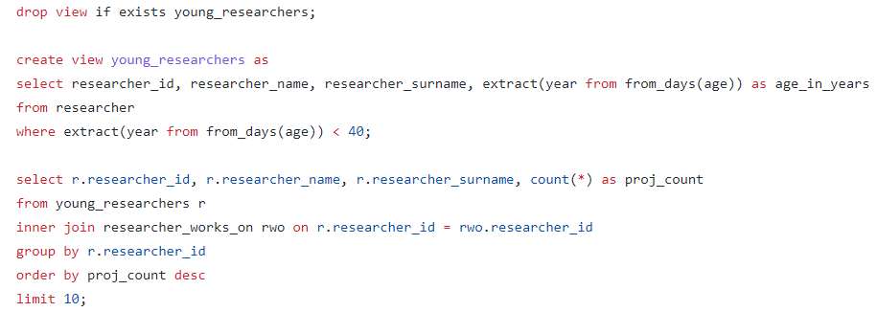

For answering question 3.6 we created a view table which contains all the researchers (independently of their role) that are under 40 years old. Then, we created a query which selects from this view, joined with the relationship table “researcher_works_on”, the number of active projects that every researcher works on.

# Prerequisites for Database and App Development

# Steps for Installation (Windows)