Springboard Data Science Capstone Project - Predicting Machine Failures

Ramaa Vissa

Feb 10, 2020

Contents

Introduction

Problem: “what is the prediction that a particular machine will fail in a given timeframe, say next week/month/quarter.?”

Data

Telemetry

Errors

Maintenance

Failures

Machine

Data Cleaning

Experiment with different attribute combinations

Data Transformation

Exploratory Data Analysis

Introduction to the cleaned data

Plots

Feature Selection

Split the data into train and test data

Model

Evaluation and Optimization

Best Practices

# Introduction

Most manufacturing factories have a quality control unit that oversees the predictive maintenance. On the floor, machine failures can occur due to wear and tear of the machine over prolonged use. The problem is to capture the failed unit before it can cause more failures downstream.

The data presented here is obtained from simulation methods and this is a use case for machine predictive maintenance.

We would like to implement a machine learning algorithm to detect a bad device during a particular time frame and prevent problems before they occur.

This is a Multi-class classification problem. A machine learning algorithm is used to create the predictive model that is trained from historical data.

## Problem: “what is the prediction that a particular machine will fail in a given timeframe, say next week/month/quarter.?”

* label/predictions is the ‘failure’.
* predictors/independent variables:

The Numerical features are Voltage, pressure, rotation, vibration and age of the machine.

The Categorical features are component and error.

Volt, pressure, rotation, vibration are very interesting features that are suitable for feature transformation. The mean and std sampling are calculated over a rolling window of 24 and 3 hours and new features for volt, pressure,rotation and vibration are created. Total of 16 new features are created. The total features before feeding into the model is 30.

See slide

# Data

The acquired data sets were created by data simulation methods outside of this project. There are 5 data sets that are available for data analysis.

## Telemetry

The first data source is the telemetry time-series data which consists of voltage, rotation, pressure, and vibration measurements collected from 100 machines in real time averaged over every hour collected during the year 2015.

## Errors

The second data source is the error logs. These are non-critical errors that surface, while the machine is still operational and thus do not constitute as machine failure. The error date and times are rounded to the closest hour since the telemetry data is collected at an hourly rate.

## Maintenance

These are the scheduled and unscheduled maintenance records which correspond to both regular inspection of components as well as failures. A record is generated if a component is replaced during the scheduled inspection or replaced due to a breakdown. The records that are created due to breakdowns are called failures. The Maintenance data has both 2014 and 2015 records.

## Failures

These are the records of component replacements due to failures. Each record has a date and time, machine ID, and failed component.

## Machine

This data set includes some information about the machines like model type and age, the age here is the years in service.

First step would be to save all four data sets into the proper directories on the local machine.

# Data Cleaning

There were no missing values when I inspected the data.

# Experiment with different attribute combinations

First all the 5 datasets are inspected and joined to form one data set. The failures data set is joined and merged with the machine ID and timestamp of the telemetry data. (preserve the failures and match with the telemetry data).

Build out the error data set by making the categorical attributes into numeric by using get_dummies.

Build out the maint data set using the same transformer.

Build out failure data set.

The final feature set will look like this -

print(features.head())

features.describe()

machineID datetime volt_mean_3h rotate_mean_3h \

0 1 2015-01-02 06:00:00 180.133784 440.608320

1 1 2015-01-02 09:00:00 176.364293 439.349655

2 1 2015-01-02 12:00:00 160.384568 424.385316

3 1 2015-01-02 15:00:00 170.472461 442.933997

4 1 2015-01-02 18:00:00 163.263806 468.937558

pressure_mean_3h vibration_mean_3h volt_sd_3h rotate_sd_3h \

0 94.137969 41.551544 21.322735 48.770512

1 101.553209 36.105580 18.952210 51.329636

2 99.598722 36.094637 13.047080 13.702496

3 102.380586 40.483002 16.642354 56.290447

4 102.726648 40.921802 17.424688 38.680380

pressure_sd_3h vibration_sd_3h volt_mean_24h rotate_mean_24h \

0 2.135684 10.037208 169.733809 445.179865

1 13.789279 6.737739 170.614862 446.364859

2 9.988609 1.639962 169.893965 447.009407

3 3.305739 8.854145 171.243444 444.233563

4 9.105775 3.060781 170.792486 448.440437

pressure_mean_24h vibration_mean_24h volt_sd_24h rotate_sd_24h \

0 96.797113 40.385160 11.233120 48.717395

1 96.849785 39.736826 12.519402 48.385076

2 97.715600 39.498374 13.370357 42.432317

3 96.666060 40.229370 13.299281 41.346121

4 95.766838 40.055214 13.954518 43.490234

pressure_sd_24h vibration_sd_24h error1count error2count error3count \

0 10.079880 5.853209 0.0 0.0 0.0

1 10.171540 6.163231 0.0 0.0 0.0

2 9.471669 6.195076 0.0 0.0 0.0

3 8.731229 5.687944 0.0 0.0 0.0

4 8.061653 5.898069 0.0 0.0 0.0

error4count error5count comp1 comp2 comp3 comp4 model age

0 0.0 0.0 20.000 215.000 155.000 170.000 model3 18

1 0.0 0.0 20.125 215.125 155.125 170.125 model3 18

2 0.0 0.0 20.250 215.250 155.250 170.250 model3 18

3 0.0 0.0 20.375 215.375 155.375 170.375 model3 18

4 0.0 0.0 20.500 215.500 155.500 170.500 model3 18

To find a good attribute combination, it is advisable to try different combinations, for example, should we consider another feature that could be a mean or std of the original feature.

# Data Transformation

The numerical columns were filled with zeros using pandas fillna. Missing values were also replaced with zeros for numeric columns. New variables were created before feeding to the model. These were created for each volt, rotate, pressure, vibration.

Transformation steps need to be executed in the right order. We can use scikit-learn’s Pipeline class to automate the pipelines once the transformers are finalised.

# Exploratory Data Analysis

## Introduction to the cleaned data

The purpose of the EDA is to find out the relationship between the predictors and labels/dependent variables. We can plot scatter plots between Voltage and rotate, voltage and pressure, or vibration to find the relationship between those variables. A bar graph can be plotted for the categorical attributes. These plots are important so that we know the distribution of the predictors and labels.

There are several predictor columns of interest, some needed transformations. All the object data types were converted to either string or numeric. The Columns are either numeric or categorical, the categorical columns were transformed to represent the respective classes. The target column is the failure prediction. The data is divided into training set by the ‘maintenance time’, so if the data is trained on this month’s information, the prediction is validated in the next month's data. The target column of interest is the failure column which contains ‘none’ or the ‘failed component’.

After the data exploration we should have clearly defined target columns and feature columns.

The correlation matrix gives us an intuition on correlation of the features and shows the features that are highly correlated. There should be no correlation to reduce noise and mitigate overfitting. The following are some corr_matrix results.

rotate 1.000000

machineID 0.000171

pressure -0.000688

volt -0.001511

vibration -0.003056

Name: rotate, dtype: float64

vibration 1.000000

volt 0.002390

pressure 0.001395

machineID -0.000922

rotate -0.003056

Name: vibration, dtype: float64

## Plots

The telemetry data is a time series data. The following is a plot of the telemetry data - voltage for 1 machine with machine id 100 and between time periods for 1 month from 12/01 to 12/31.

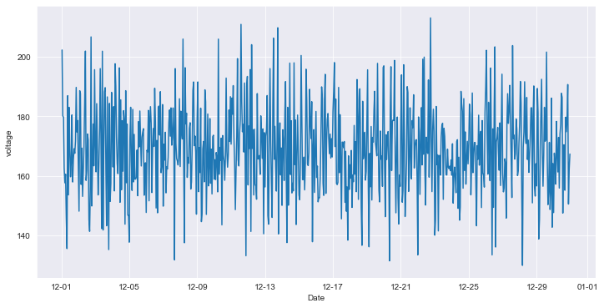

The following is a plot of the telemetry data - rotate for 1 machine with machine id 100 and between time periods for 1 month from 12/01 to 12/31.

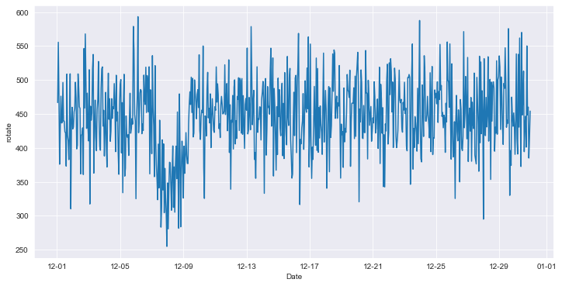

The following is a plot of the telemetry data - pressure for 1 machine with machine id 100 and between time periods for 1 month from 12/01 to 12/31.

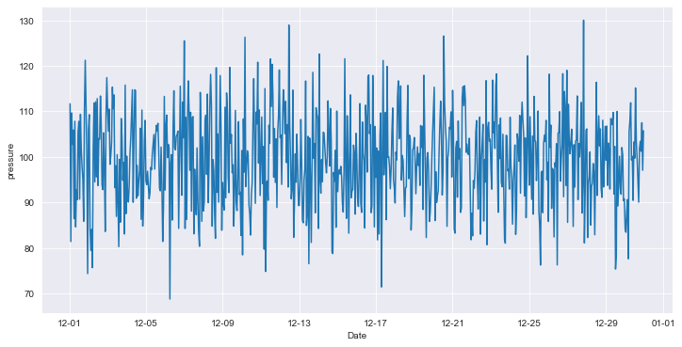

The following is a plot of the telemetry data - vibration for 1 machine with machine id 100 and between time periods for 1 month from 12/01 to 12/31.

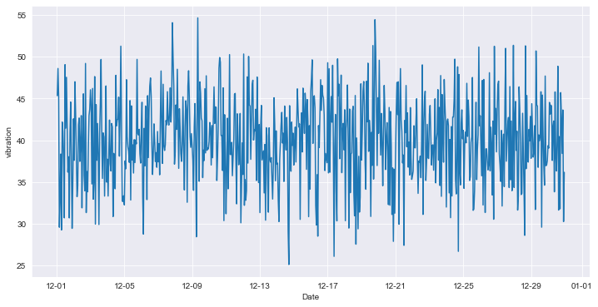

The following is the bar graph showing counts of each type of components failure.

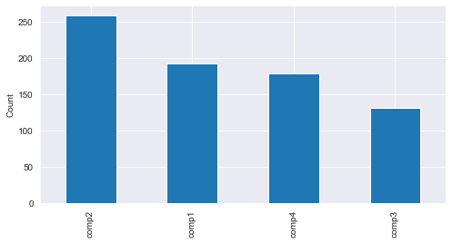

The following is the bar graph showing counts of each type of component maintenance.

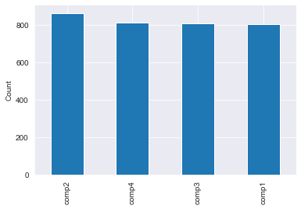

By intuition the failures occurring on component 2 are causing more maintenance leading to either repair or replacement.

The following is the bar graph showing counts of each type of error, errors are not critical like failures.

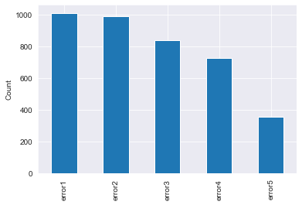

The following is the bar graph showing counts of each type of machine grouped by age.

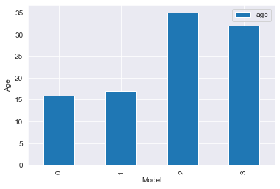

# Feature Selection

It is evident that the volt, pressure and rotation are the most important characteristics of the machine performance, so the rolling mean and standard deviation was calculated.

The feature importance matrix, confirms our choice and transformation of attributes.

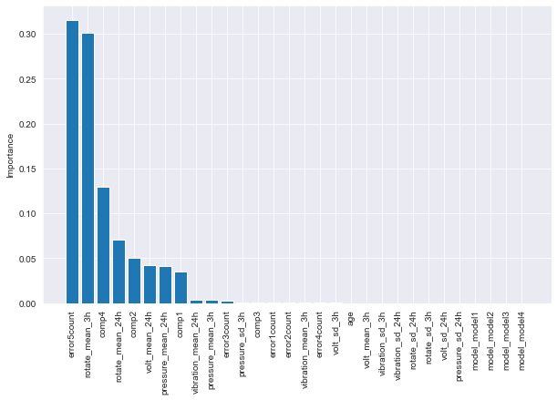

# Split the data into train and test data

In this Use case the training data is a month behind the predictions month. So if the model is trained on a month’s worth of data, the predictions are obtained for the following month. The ‘month’ has been chosen as our per use case. If the use case warrants for a weekly window, this will change.

Usually the train-test split can be used. More efficient is scikit-learn’s K-fold cross validation.

# Model

Knowing the labels for the machine failures, 0 for component 1 failure, 1 for component 2 failure, 2 for component 3 failure and finally 3 for component 4 failure, we use the supervised machine learning algorithms to build a predictive model. Since there are only 4 classes in the data, we use the multi class classification algorithms. The first step involves splitting the data, for the test model, the data is split depending on the month of the date and time of failure.

Several models were evaluated and the best classifier was evaluated. After evaluation, gradient Boosting was chosen as the dominant classifier.

We can use randomised search or grid search to further fine tune the model and look for hyper parameters that could present a model that can enhance in accuracy, recall or precision scores.

# Evaluation and Optimization

Confusion matrix was used to evaluate the Precision and Recall, this use case requires a high Recall. In Predictive maintenance it's important to know how many of the actual failures were predicted by the model..aka Recall. Here the recall rates for all components as well as none -aka no failures are all above 90%, meaning the model was able to capture above 90% of the failures correctly. (Recall becomes more important as the consequences of false negatives, aka true failures that the model did not predict, exceed the consequences of false positives, aka false predictions of future failure.)

# Best Practices

It's good to save the models while tuning as pickle files. The training data can be saved in temporary files.

Further Improvements.

Productionize the model: The model needs to be trained and make sure the evaluation metrics are still valid on new test data. There could be a possibility of overfitting on production /testing if the model is not refreshed and saved with a different version. A scheduling job like crontab can be employed to make sure the model is refreshed. The ‘hotswitch’ could be used to ensure seamless operation in production without any disruption to any services. Make sure you employ a version control to ensure that you can compare the metrics from an earlier model to later model.