JUNJIE CHU  Information Technology Student | Class of 2027  Available full time from late December 2026 | Based in Singapore  +86 18752158616 | WeChat: cjj0908ya | English and Mandarin  chujunjie0908@gmail.com | 2903442978@qq.com | GitHub | Portfolio | 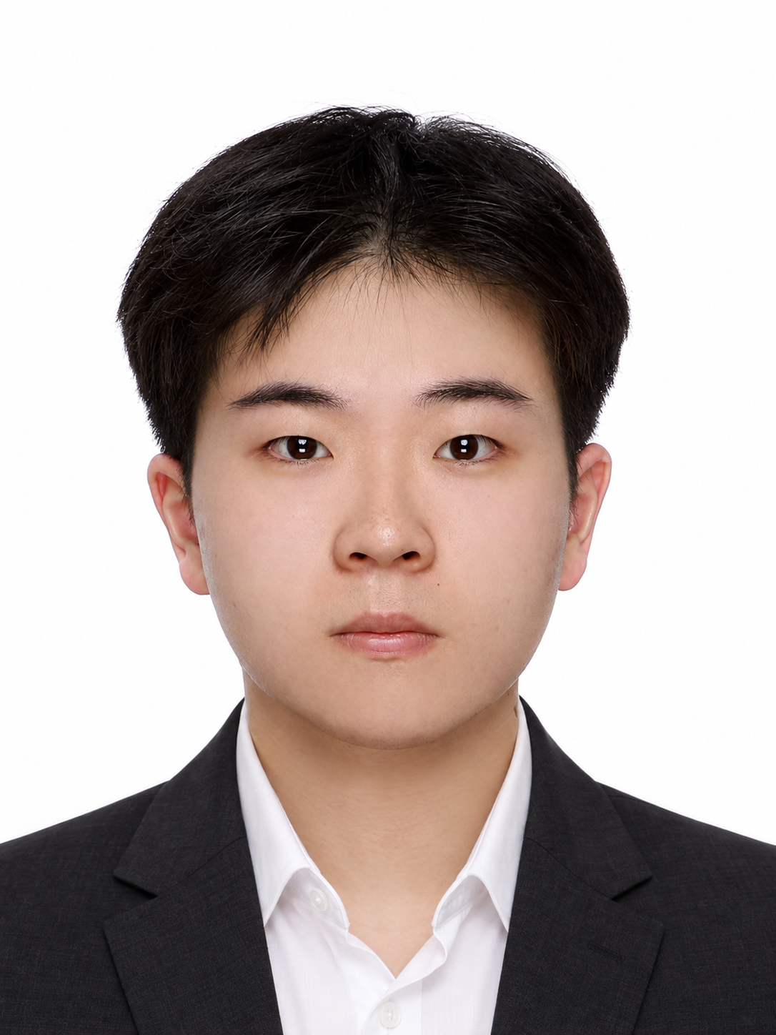

Education
James Cook University Singapore | Bachelor of IT | GPA 5.85/7 Jan 2025 - Mar 2027 expected
Coursework: Advanced Software Engineering, Database Modelling, Machine Learning and Data Science.
EMAS Peer Tutor, May - Aug 2026: supported over 50 students in programming and IT courses.
BCA Academy Singapore | Diploma in Construction Engineering Oct 2021 - Nov 2024

Experience
Basilos Pte. Ltd. Singapore | AI Engineer Intern Jul - Oct 2026
- Compared five face-recognition approaches to assess identity drift in AI-generated model images; built and internally deployed a face-consistency connector with similarity scores and manual-review states.
- Compiled 54 internal test records: 23 identity comparisons were classified correctly, and 30 repeat runs of one input succeeded. Ran 99 PNG-to-SVG experiments and documented suitability and quality limits.
- Evaluated nine Feishu CLI modules, investigated permission and identity issues, and wrote an operating guide. Joined a client visit and prioritised information extraction and deadline-reminder requirements.
STAS Singapore | Operations and Administration Intern Apr - Sep 2024
- Reviewed MEP supplier certification documents; maintained supplier and payment records for three exhibitions, researched construction-material exhibitions in China, and assisted with basic MEP configuration-tool tests.

Selected Projects
Smart Digital Product Recommendation Platform May - Aug 2026
Product Owner / Frontend Contributor | Team of 4 | Scrum, Flask, PostgreSQL | Demo | Code
- Defined 10 user stories and acceptance criteria across three Scrum iterations; coordinated scope, requirement-to-test mapping and release checks. The team delivered recommendations across five product categories.
- Contributed frontend fixes and Flask API integration; coordinated about 11,000 catalogue records, including about 2,000 eligible for recommendations. Checked 12 team CI acceptance tests before the release freeze.
ScamWise Campus Android App May - Aug 2026
Independent Developer | Kotlin, Jetpack Compose, Room | Demo | Code
- Built a five-screen campus scam-awareness app with 18 training cases, URL threat checks and learning statistics, using a layered MVVM architecture and local Room storage.
- Wrote 102 automated tests: 79 unit and 23 UI tests covering validation, scoring, data persistence and network errors. Published source code and a runnable demo.
AI and data: contributed to a five-person wildlife-classification project ranked 48/810 on a DrivenData practice public leaderboard; an individual DL4J MLP dropout study achieved weighted F1 0.893 in cross-validation.

Skills
Python, SQL, Kotlin, Git, Excel, Scrum, GitHub Issues, Figma; professional communication in English and Mandarin.

