**参数定义的影响：**

**Gf和Gm以及viscous的影响（仅0°板）：**

|  |  |  |  |  |  |  |  |  |  |  |
| --- | --- | --- | --- | --- | --- | --- | --- | --- | --- | --- |
| 强度参数 | *TX* | *CX* | *TY* | *CY* | *SXY* | 密度 | Gm | Gf | v |  |
| Pro3 | 1500 | 764 | 36 | 160 | 65 | 1 | 5 | 30 | 0.0005 |  |
| G10_60-V0 | 1500 | 764 | 36 | 160 | 65 | 1 | 10 | 60 | 0 |  |
| G10_60-V5e-3 | 1500 | 764 | 36 | 160 | 65 | 1 | 10 | 60 | 0.0005 |  |
| G5_60-V5e-3 | 1500 | 764 | 36 | 160 | 65 | 1 | 5 | 60 | 0.0005 |  |
| G0.5_600-V5e-3 | 1500 | 764 | 36 | 160 | 65 | 1 | 0.5 | 600 | 0.0005 |  |
| G0.5_600-V5e-3 | 1500 | 764 | 36 | 160 | 65 | 1 | 0.5 | 600 | 0.0005 | exp |
| G0.5_60-V5e-3 | 1500 | 764 | 36 | 160 | 65 | 1 | 0.5 | 60 | 0.0005 |  |
| G0.5_60-V5e-3_exp | 1500 | 764 | 36 | 160 | 65 | 1 | 0.5 | 60 | 0.0005 | exp |

**viscous的影响:**

|  |  |  |  |  |  |  |  |  |  |  |
| --- | --- | --- | --- | --- | --- | --- | --- | --- | --- | --- |
| G10_60-V0 | 1500 | 764 | 36 | 160 | 65 | 1 | 10 | 60 | 0 |  |
| G10_60-V5e-3 | 1500 | 764 | 36 | 160 | 65 | 1 | 10 | 60 | 0.0005 |  |

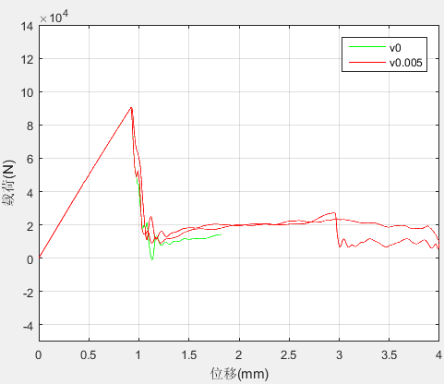

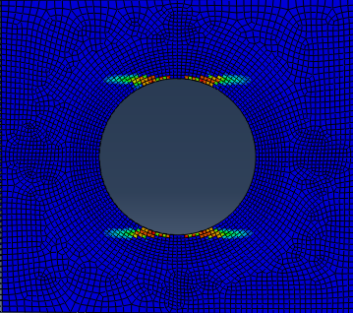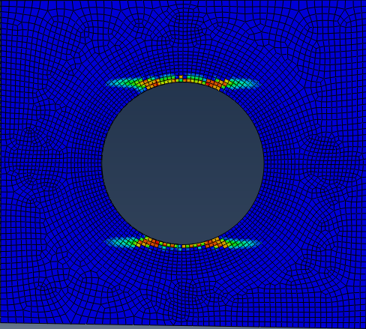

粘性系数太大会造成损伤的延迟，太小会造成计算不收敛。但是在这里取0时都可以收敛，所以不需要考虑。

**Gf和Gm的区别：**

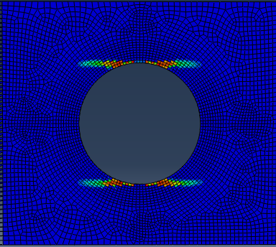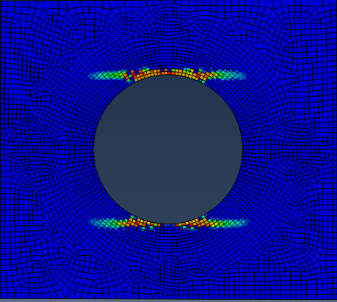

|  |  |
| --- | --- |
| 5 | 600 |

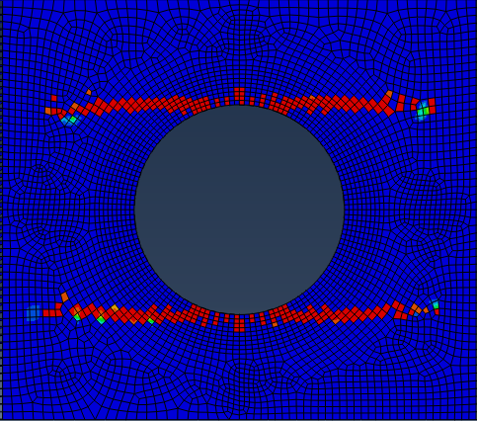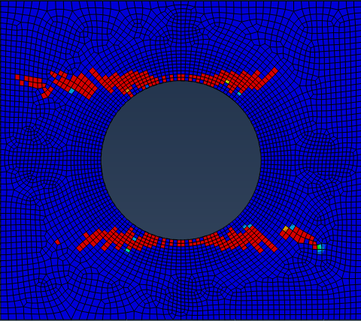

|  |  |
| --- | --- |
| 0.5 | 600 |

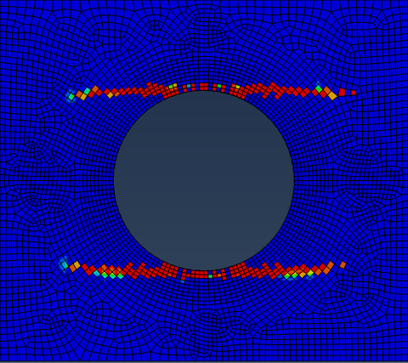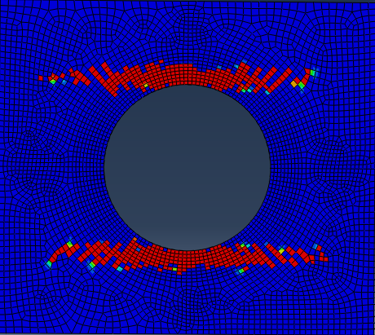

|  |  |
| --- | --- |
| 0.5 | 60 |

结合计算结果（针对0°板而言）以及其他论文，Gm取0.5-1之间，Gf取50-100之间比较合适。

**其他论文中的参数：**

**A continuum damage model for composite laminates: Part II – Computational implementation and validation**

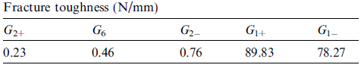

**Laminate damage model for composite structures**

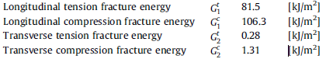

**Prediction of size effects in notched laminates using continuum damage mechanics**

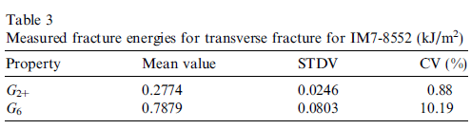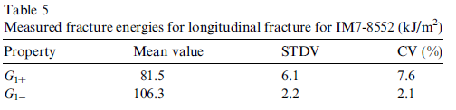

**Progressive damage modeling in fiber-reinforced materials**

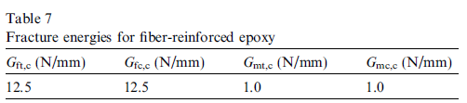

**材料密度（mass density）的影响：**

|  |  |  |  |  |  |  |  |  |  |
| --- | --- | --- | --- | --- | --- | --- | --- | --- | --- |
| 强度参数 | *TX* | *CX* | *TY* | *CY* | *SXY* | 密度 | Gf | Gm | v |
| Pro3 | 1500 | 764 | 36 | 160 | 65 | 1 | 10 | 60 | 0 |
| Density100 | 1500 | 764 | 36 | 160 | 65 | 100 | 10 | 60 | 0 |
| Density0.001 | 1500 | 764 | 36 | 160 | 65 | 0.001 | 10 | 60 | 0 |

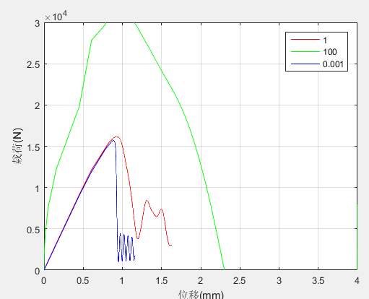

45

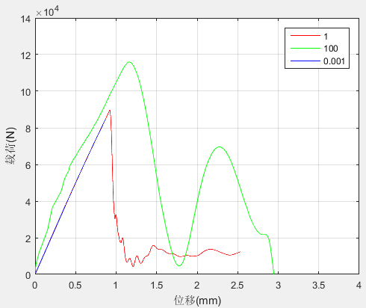

0

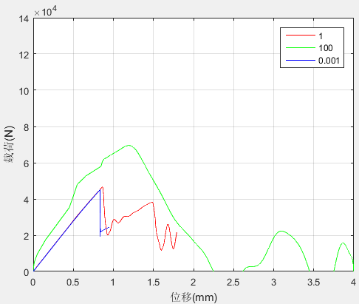

0-90

不同的密度对位移载荷曲线影响较大，对失效图几乎没有影响。当密度取1和取0.001时，极限载荷已经没有区别，所以当密度取1时已经可以得到正确的结果，但是密度0.001可以使得增量步更小。

**指数退化和线性退化：**

|  |  |  |  |  |  |  |  |  |  |  |
| --- | --- | --- | --- | --- | --- | --- | --- | --- | --- | --- |
| Pro3 | 1500 | 764 | 36 | 160 | 65 | 1 | 5 | 30 | 0.0005 |  |
| Pro3-exp | 1500 | 764 | 36 | 160 | 65 | 1 | 5 | 30 | 0.0005 | exp |
| G0.5_600-V5e-3 | 1500 | 764 | 36 | 160 | 65 | 1 | 0.5 | 600 | 0.0005 |  |
| G0.5_600-V5e-3 | 1500 | 764 | 36 | 160 | 65 | 1 | 0.5 | 600 | 0.0005 | exp |
| G0.5_60-V5e-3 | 1500 | 764 | 36 | 160 | 65 | 1 | 0.5 | 60 | 0.0005 |  |
| G0.5_60-V5e-3_exp | 1500 | 764 | 36 | 160 | 65 | 1 | 0.5 | 60 | 0.0005 | exp |

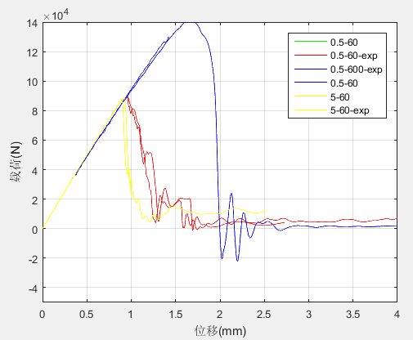

在同样的材料参数下，指数和线性退化的位移载荷曲线的区别不大。0.5和600的结果和试验相差太大。



|  |  |
| --- | --- |
| 5 | 600 |



|  |  |
| --- | --- |
| 0.5 | 600 |



|  |  |
| --- | --- |
| 0.5 | 60 |

在同样的材料参数下，指数和线性退化的失效图的差别不是太大（针对0°铺层而言）

**剪切强度参数的影响：**

|  |  |  |  |  |  |  |
| --- | --- | --- | --- | --- | --- | --- |
| 131 | 1451.55 | 725.78 | 35.99 | 160.28 | 131 | 1 |
| Pro2 | 1528.7 | 764.3 | 36.0 | 160.3 | 90.25 | 1 |
| Pro3 | 1500 | 764 | 36 | 160 | 65 | 1 |

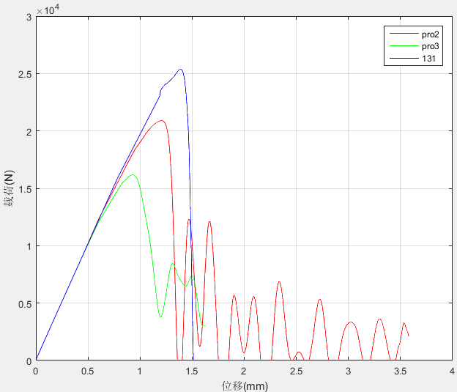

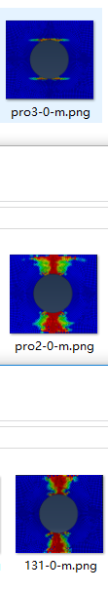

从失效图来看，三种剪切强度情况下的裂纹扩展差别不大，从位移载荷曲线的45°板来看，并结合试验测试结果，Sxy为90更加符合实验。

**修正后的材料参数：**

|  |  |  |  |  |  |  |  |  |  |  |
| --- | --- | --- | --- | --- | --- | --- | --- | --- | --- | --- |
| G0.5_60-V5e-3 | 1500 | 764 | 36 | 160 | 90 | 1 | 0.5 | 60 | 0.0005 |  |
| G0.5_90-V5e-3(修正2) | 1500 | 764 | 36 | 160 | 90 | 1 | 0.5 | 90 | 0.0005 |  |
| 修正3 |  |  |  |  | 90 |  | 1.5 | 60 |  |  |
| 修正4 |  |  |  |  | 90 |  | 0.5 | 6 |  |  |
| 修正5 |  |  |  |  | 90 |  | 5 | 60 |  |  |
|  |  |  |  |  | 90 |  | 2.5 | 60 |  |  |

Sxy提高从60到90后0°的失效图不符合（无论Gf是60还是90）。故只能将Sxy回复到60。

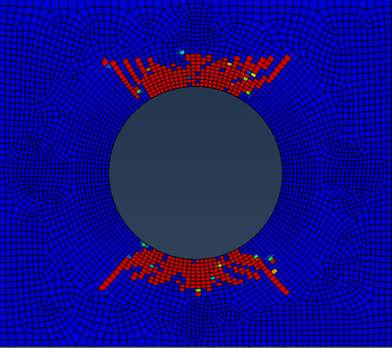

**最后使用的材料参数：**

|  |  |  |  |  |  |  |  |  |  |  |
| --- | --- | --- | --- | --- | --- | --- | --- | --- | --- | --- |
| G0.5_90-V5e-3 | 1500 | 764.3 | 36 | 160 | 60 | 1 | 0.5 | 60 | 0.0005 |  |

此时的0和45比较符合，但是0/90出现问题（由于是Gm为0.5太小）。

|  |  |  |  |  |  |  |  |  |  |  |
| --- | --- | --- | --- | --- | --- | --- | --- | --- | --- | --- |
| G0.5_90-V5e-3 | 1500 | 764.3 | 36 | 160 | 60 | 1 | 1 | 60 | 0.0005 |  |

dm太大（=5）时，0°的裂纹不对，dm太小的时候（=0.5），0/90的裂纹不对

使用的参数：

|  |  |  |  |  |  |  |  |  |  |  |
| --- | --- | --- | --- | --- | --- | --- | --- | --- | --- | --- |
| G0.5_90-V5e-3 | 1500 | 764.3 | 36 | 160 | 60 | 1 | 0.5 | 60 | 0.0005 |  |
|  |  |  |  |  |  |  | 2.5 |  |  |  |
|  |  |  |  |  |  |  | 5 |  |  |  |

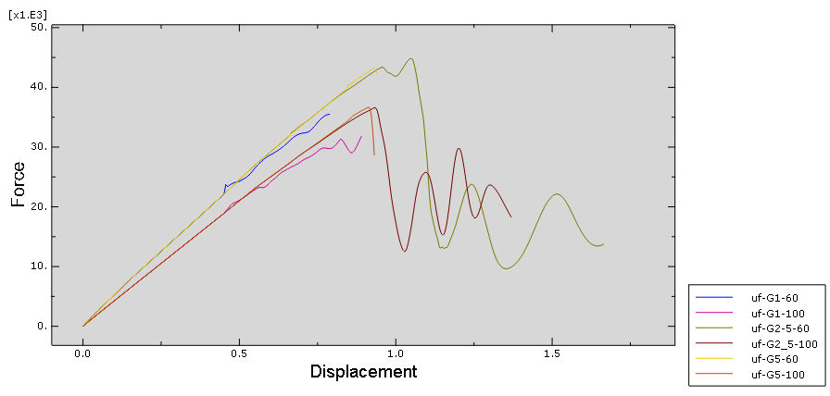

可以看出对三种不同的dm而言，dm=2.5和dm=5的极限失效载荷数值差别并不大，而从失效图来看dm=2.5差不多可以兼顾0以及0/90.所以最后综合考虑的话：

|  |  |  |  |  |  |  |  |  |  |
| --- | --- | --- | --- | --- | --- | --- | --- | --- | --- |
| G0.5_90-V5e-3 | 1500 | 764.3 | 36 | 160 | 60 | 1 | 2.5 | 60 | 0.0005 |

**不同的铺层以及不同的孔径：**

|  |  |  |  |  |  |  |  |  |  |
| --- | --- | --- | --- | --- | --- | --- | --- | --- | --- |
| **Comparing**  **of  Ultimate**  **loads**  **Layer** | **Size of cutout (Ф)** | | | | | | | | |
| 60mm | | | 80mm | | | 100mm | | |
| Simul. | Exp. | Relative error | Simul. | Exp. | Relative error | Simul. | Exp. | Relative error |
| **[0]10** | 97.69 | 78.23 | -19.9% | 76.11 | 69.73 | -8.4% | 52.82 | 35.00 | -34% |
| **[0/90]5** | 56.91 | 59.32 | 4.0% | 45.89 | 47.20 | 2.8% | 32.99 | 37.54 | 12.1% |
| **[±45]5** | 22.46 | 28.72 | 21.8% | 17.89 | 23.79 | 24.8% | 13.42 | 17.60 | 23.8% |

|  |  |  |  |  |  |  |  |  |  |
| --- | --- | --- | --- | --- | --- | --- | --- | --- | --- |
| **Comparing**  **of  Ultimate**  **loads**  **Layer** | **Size of cutout (Ф)** | | | | | | | | |
| 60mm | | | 80mm | | | 100mm | | |
| Simul. | Exp. | Relative error | Simul. | Exp. | Relative error | Simul. | Exp. | Relative error |
| **[0]10** |  | 78.23 |  |  | 69.73 |  |  | 35.00 |  |
| **[0/90]5** |  | 59.32 |  |  | 47.20 |  |  | 37.54 |  |
| **[±45]5** |  | 28.72 |  |  | 23.79 |  |  | 17.60 |  |

一下的计算结果中，没有标注的材料参数均为：**Sxy=60,Gm=0.5, Gf = 60,Density=1**

0°：

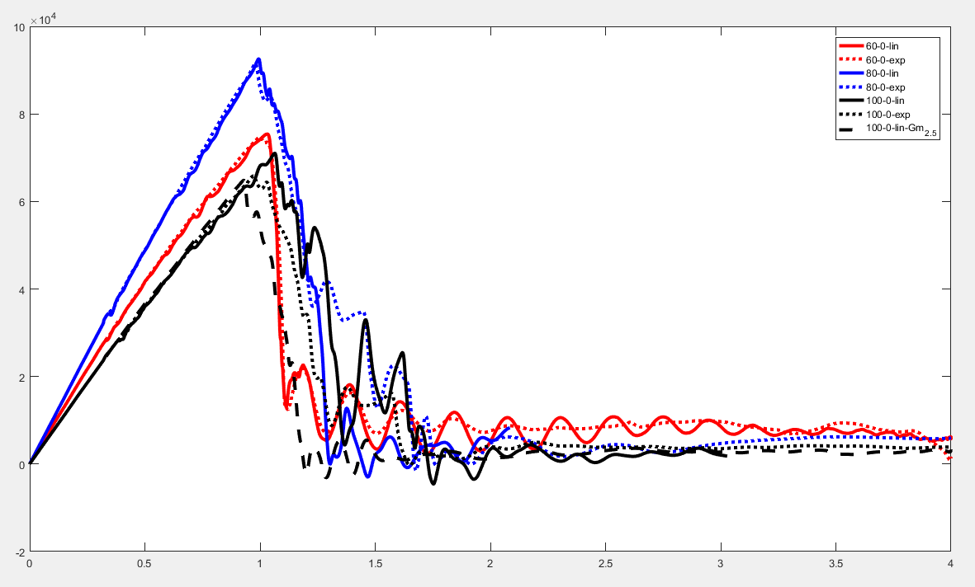

60_0的准确性比较好，而80的居然比60的还高，重新复制60的计算模型，此时80和60的差不多75左右。然后增加80的密度到10，希望能减少他的极限载荷,可是反而增加了（好像之前也是这样），又将80的密度较小至0.001，可是在4000步内算不完，所以将密度调整至0.01，4000步内仍然算不完，所以将step中的最小增量步数由1e-5调整至1e-4，进一步看monitor发现，这样改确实有道理：(略)，调整至1e-4还不够，所以调整至1e-3，可是仍然不够

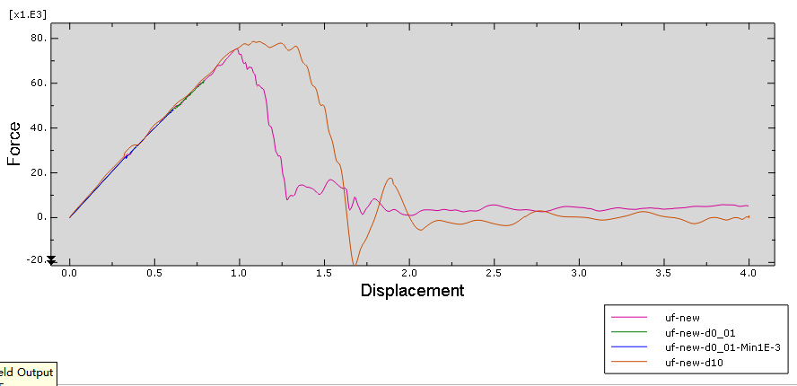

45°：

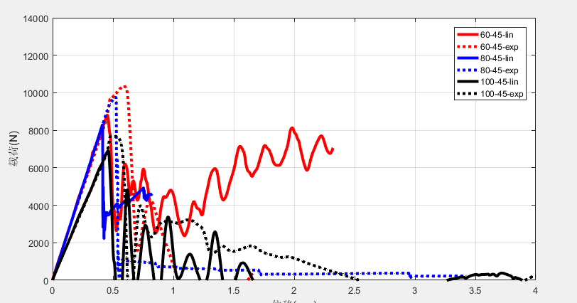

1、采用exp软化模型可以提高极限载荷；

2、尝试提高剪切强度系数、提高Gm来提高模拟的极限载荷,

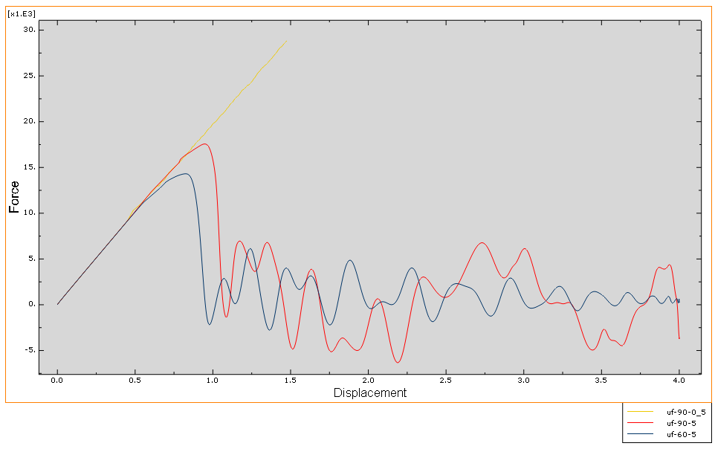

还是用Sxy=90，Gm=5比较好

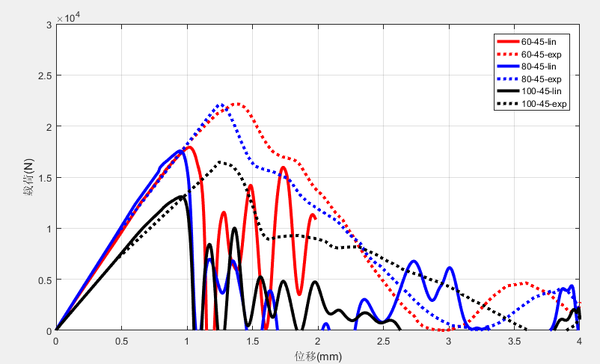

|  |  |  |  |  |  |  |  |  |  |
| --- | --- | --- | --- | --- | --- | --- | --- | --- | --- |
| **孔径** | 60 | | | 80 | | | 100 | | |
| **[±45]5** | Simul. | Exp. | Relative error | Simul. | Exp. | Relative error | Simul. | Exp. | Relative error |
| **Lin** | 17.92 | 28.72 |  | 17.56 | 23.79 |  | 13.08 | 17.60 |  |
| **Exp** | 22.17 |  | 22.12 |  | 16.46 |  |

可以看出exp的退化模型比lin的退化模型更加接近于实验值，但是还没有施加剪切非线性。

0/90:

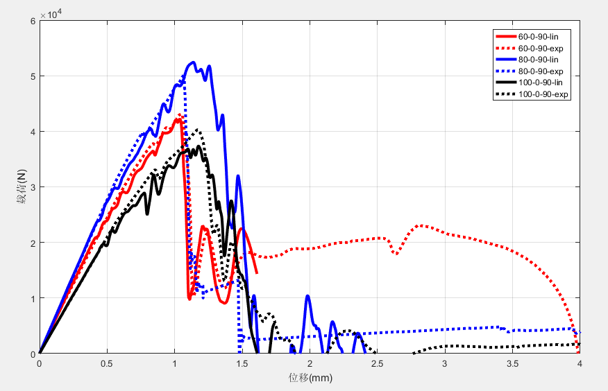

|  |  |  |  |  |  |  |  |  |  |
| --- | --- | --- | --- | --- | --- | --- | --- | --- | --- |
| **孔径** | 60 | | | 80 | | | 100 | | |
| **[0/90]5** | Simul. | Exp. | Relative error | Simul. | Exp. | Relative error | Simul. | Exp. | Relative error |
| **[0/90]5** |  | 59.32 |  |  | 47.20 |  |  | 37.54 |  |

Gm由0.5换成5

问题：

1、在0°板中，剪切强度60更准确(从失效图来看) ，不论是ABAQUS内置模型还是UMAT子程序模型

在45°板中，剪切强度90更准确(从极限载荷来看)，是否和就地强度准测有关系

1. **为什么复制完的model算出来和之前的不一致？**

**修改了****part-node-load，看是不是此原因**

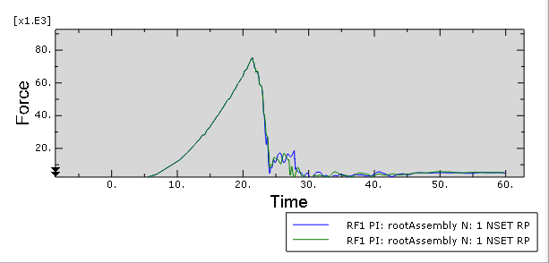

不是**part-node-load的原因；**

**网格的原因？**

1. 在0/90和0板中，开孔为60比开孔80的极限载荷计算结果还要小，初始增量步和最小增量步到底对结果有什么影响？可能并不是增量步的影响

4、到底Gm对结果有什么影响

**屈曲和失效：**

**屈曲极限载荷：**

|  |  |  |  |  |  |  |  |  |  |
| --- | --- | --- | --- | --- | --- | --- | --- | --- | --- |
| Ф/mm | 40 | 50 | 60 | 70 | 80 | 90 | 100 | 110 | 120 |
|  | 106.25 | 62.88 | 41.93 | 30.80 | 24.40 | 20.18 | 17.12 | 15.43 | 13.33 |
|  | 238.21 | 132.99 | 80.73 | 52.53 | 36.72 | 27.67 | 22.54 | 19.55 | 17.61 |
|  | 131.79 | 81.79 | 55.01 | 39.36 | 29.79 | 23.80 | 20.27 | 18.43 | 17.79 |

|  |  |  |  |  |
| --- | --- | --- | --- | --- |
| Ф/mm |  | 60 | 80 | 100 |
|  | lin | 27.09 | 33.56 | 26.78 |
| exp | 27.60 | 33.53 | 26.86 |
|  | lin | 11.06（90层首先出现基体破坏）13.41（90层首先出现基体破坏；） | 23669.4()  13754.2() | 9.07（90层率先出线基体破坏） |
| exp | 8.01(0和90层同时出现了基体破坏) | 13754.2 | 9.07（90层率先出线基体破坏） |
|  | lin | 8.29 | 8.15 | 6.48 |
| exp | 8.67 |  | 6.48 |

通过固定增量步，来看初始损伤时的载荷

**剪切非线性：**

60_0.5_60和60_2.5_60相比，从位移载荷曲线上来看，60_0.5_60更加符合试验，60_2.5_60失效太早，而且比较乱。

试验90_0.5_60,90_2.5_60,

由于计算的太慢（增量步间隔太小），4000步都算不完，所以把密度从0.001增至1.。

计算0°铺层的层合板，发现位移载荷曲线符合试验，而失效图被剪切非线性破坏了，怀疑是N取小了，当N取到6时，0°铺层失效图变正常，但是45°。。。。。。。。。，而且N最好从试验数据获得。。。。。。。。。

**应力集中因子：**

**cohensive单元：**

**铺层和开孔大小**

**材料参数，密度，lin vs exp, 剪切非线性考虑N**