**Overall study objective:**

Prioritize three spatial scales of watersheds in Canada for: 1) area-based conservation; 2) restoration; 3) species at risk management; and 4) invasive species management using a freshwater lens.

The spatial scales:

Hydrobasin 6

Hydrobasin 6 within Freshwater Ecoregions (FEOW) for Canada

Hydrobasin 12 within the Lake Erie Basin (subset of the watersheds where there are sufficient

fish sampling data)

Overview of methods:

Prioritization to be based on 6 input variables:

1. **Fish species richness index** – calculated from number of species for H6 and H12 as min-max normalization
2. **Fish species rarity index** – calculated from fish species p/a matrix and Q index developed by Ken Minns, index value considers how widespread or rare species are within a study area
3. **Fish SAR index** – calculated from number of listed SAR for H6 and H12 (using fish and mussel SAR) as min-max
4. **Fish biodiversity change index** – Jaccard dissimilarity calculated from native vs. native+non-native species richness
5. **Climate velocities** – min-max normalization of forward velocities for SSP2, RCP 4.5 2050s
6. **Watershed stress index** – min-max normalization of Venter’s cumulative threat index for Canada

Once indices calculated, weight for each H6 and H12 using co-author weightings for the four watershed prioritizations (H6 values rescaled for FEOWs)

Calculate the proportion of H6s with protected areas

----------Deliverables ‘level 1’---

Annotated code to produce results for H6, H6 within FEOWs, and H12s in Lake Erie Basin

----------Deliverables ‘level 2----

Annotated code to produce results for H6, H6 within FEOWs, and H12 in Lake Erie Basin

Annotated code for figures and maps (see end of doc for figures that were generated from code in the past)

----------Deliverables ‘level 3’

Annotated code to produce results for H6, H6 within FEOWs, and H12 in Lake Erie Basin

Annotated code for figures

Update the Shiny app with the new H6 (national and within FEOW) results

**Files**

**Much of the R code includes files and analyses for Hydrobasin 5, which has since been dropped from the project so those analyses can be ignored.** Files and code files for H6:

|  |  |  |
| --- | --- | --- |
| **Prioritization variable** | **Folder and calculation** | **Input files/R Code/GIS files** |
| Fish species richness index | Calculating indices folder:  Input: Fish spp PA matrix with 0 = absent, 1 = present, 2 =SAR  Index: min-max normalization based on species counts | Data: Spp_dist_HYBAS6_20230125.csv  Code for index: data_carpentry_lvl6.R |
| Fish species rarity index | Input: Fish spp PA matrix relabel SAR from 2 to 1 then run calculation  Species rarity: calculation based on Q index in Minns 1987  Index: normalization of Q values | Data: Spp_dist_HYBAS6_20230125.csv  Code: calculate I and Q  Output: H6_importance_priority.csv  Only interested in Q values for prioritizations  Code for index: data_carpentry_lvl6.R *may be incorrectly pulling in I rather than Q values* in some tables Q is referred to as “Priority” |
| Fish SAR index | Input: Fish spp PA matrix  SAR index normalization based on count of fish SAR | Data: Spp_dist_HYBAS6_20230125.xls  Code for index: data_carpentry_lvl6.R |
| Fish biodiversity change index | Fish biodiversity change index:  Calculate Jaccard dissimilarity for native spp pool vs. current native + non-native spp pool  Index: normalization of Jaccard D | Jaccard D data and code for calculation:  Results here: FBCI_level6_270123.csv – there are extra significance tests that aren’t needed  FBCI_calculationcode.doc  Code for normalization/index: data_carpentry_lvl6.R |
| Watershed stress index | Original summaries were based on Theobald et al. 2020 but using new Venter cumulative threat index for Canada instead | *new data*  Variable_data_20241018.xlsx  I’ve put all the raw data for the H6 analyses in the Variable_data file  Have to calculate watershed stress index with these new values  Code for index: data_carpentry_lvl6.R |
| Climate change index | Climate change velocities based on CMIP6 SSP2-4.5 forward velocities for 2040-2070 period | *new data* Variable_data_20241018.xlsx  Have to calculate new index values (normalization)  Code for index: data_carpentry_lvl6.R |
| Expert weightings | Median values for 6 variables used to generate weighted-scores for:  Area-based protection  Restoration  SAR management  Invasive species management | Co_author_weightings.csv  Code: Analysis_v5.R  Results: watershed_prioritization_level6.csv  *ranks_feow columns values are wrong |
| Rescaling of prioritizations by Freshwater Ecoregions of the World (FEOW) | FEOWscaling folder | I *think* FEOW_Scaling code has the corrected equation for rescaling the H6 results within the FEOWs |
| Protected area | Calculate proportion of area protected in each H6 | No existing code for it |
|  | H6_Rcode folder:  Code for figures | Results_and_plots.R |
|  | H6_Rcode folder:  Interested in comparison of H6s spatial overlap of high priority watersheds for habitat area-based protection vs. restoration, and separately, species at risk management vs. invasive species management | Percentiles.R |
| LAKE ERIE ANALYSIS | The Lake Erie analysis is new for the project; code for national H6 could be duplicated to run at H12 scale with Erie data. The SAR data are in a different format for Lake Erie than national dataset because mussel SAR are being included. | All Lake Erie H12 data for analyses are in this excel book:  LEH12_wpdata.xlsx |
| Shapefiles:  H6 boundaries (national)  FEOW (national)  H12 in Lake Erie Basin  Protected areas (national) | Shapefiles folder:  Some of the code pulls from map6.gkpg but not sure how up to date the .gkpg is. Included ‘raw’ shapefiles |  |
| Shiny (only for national results) | Code and link |  |

Figures coded

Four prioritizations scores, scaled within FEOWs

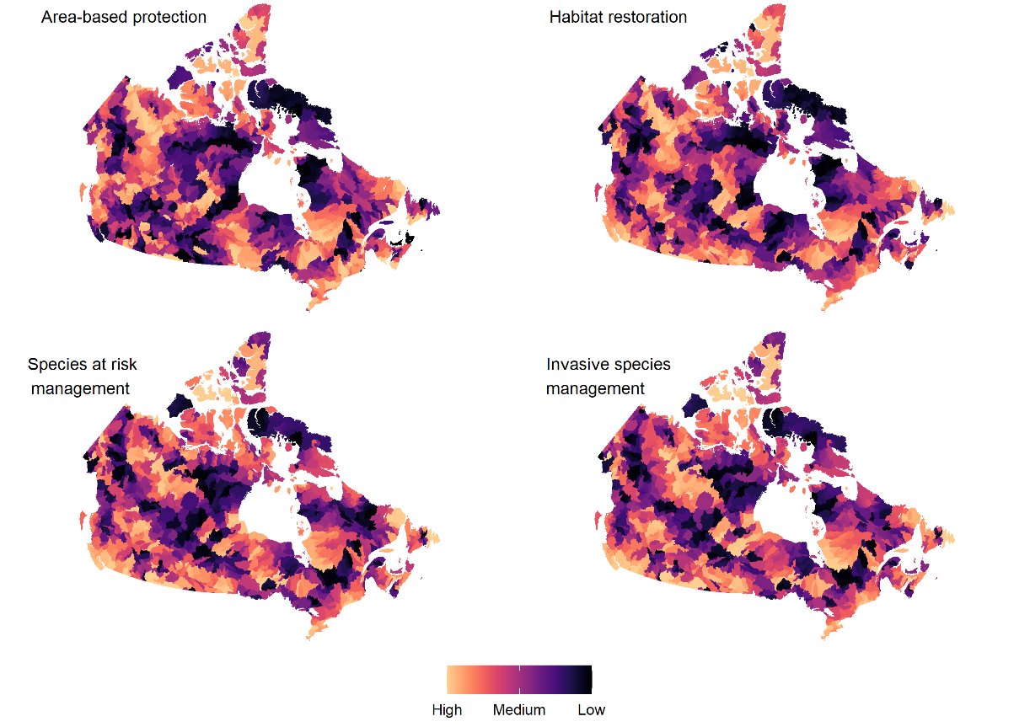

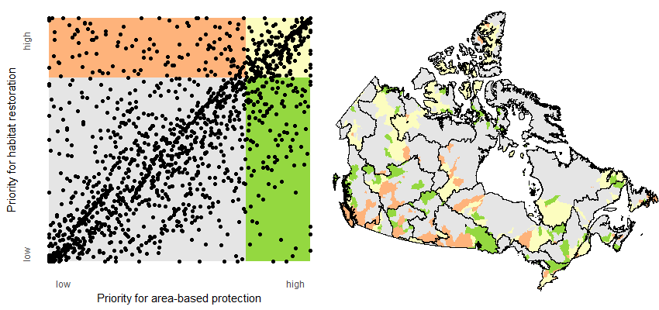

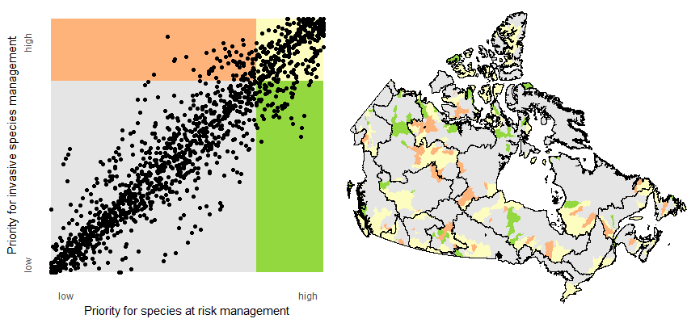

Figure comparing area-based protection vs restoration scores (upper panels) and SAR vs AIS management scores (lower panels)

Comparison of H5 and H6 results below – no longer needed for paper

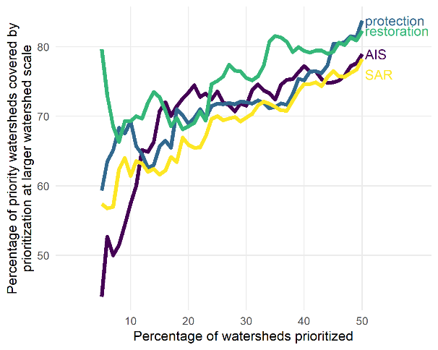

Supplemental information figures

Maps of the input variables

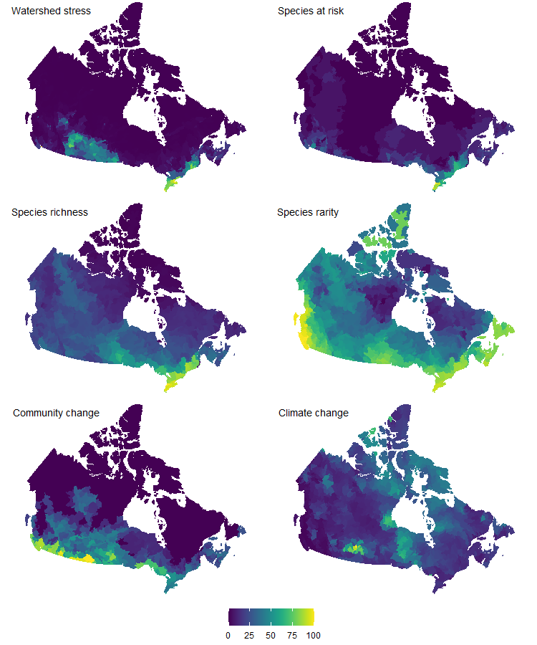

Co-author weightings

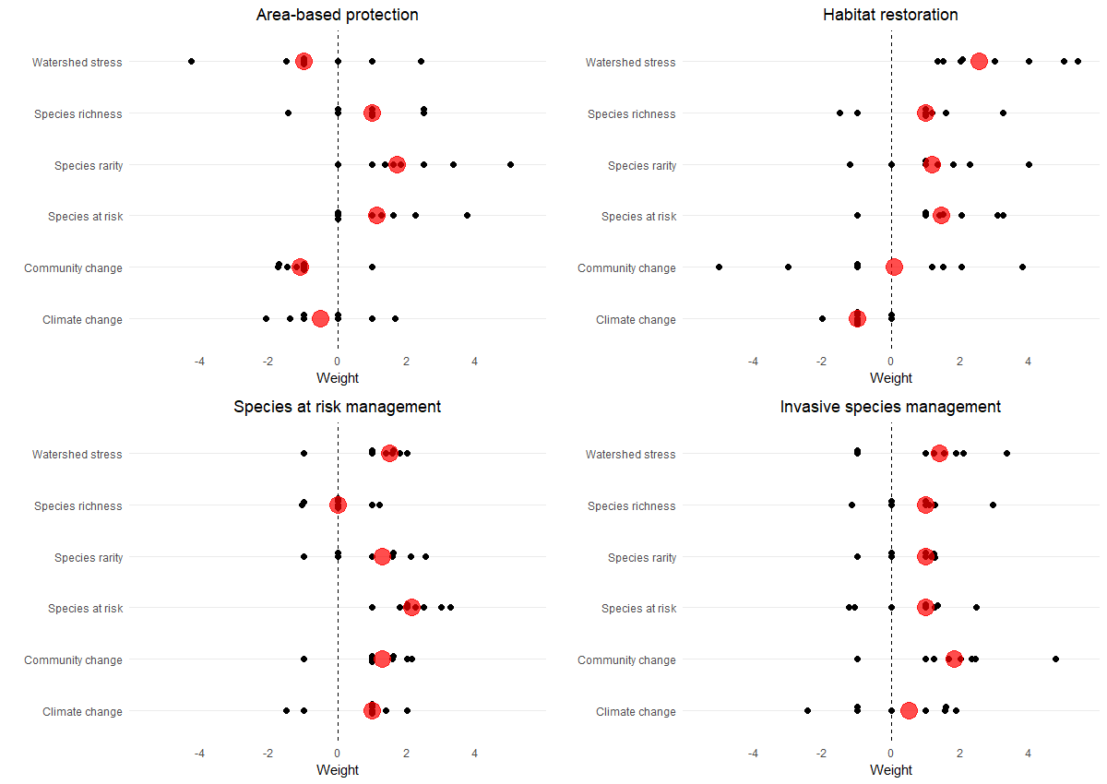

Prioritizations nationally

