**Prioritizing Canadian watersheds for conservation of freshwater fish and fish habitat**

Cody J. Dey1*, Daniel P. Gillis2, M.U. Mohamed Anas2, Nicholas E. Mandrak2, Charles K. Minns2, Donald A. Jackson2, Marie-Josée Fortin2 and Cindy Chu1

1*Great Lakes Laboratory for Fisheries and Aquatic Sciences, Fisheries and Oceans*

*Canada, 867 Lakeshore Road, Burlington, ON L7S 1A1*

2*Other affiliations*

*Author for correspondence: cody.dey@dfo-mpo.gc.ca

Running head: Priority watersheds for conservation

**Summary**

A variety of government and non-governmental programs aim to conserve freshwater fish and fish habitat in Canada. However, limited funding means that all freshwater systems cannot receive high levels of attention, and the identification of priority areas is required to make efficient use of available resources. Here, we identify priority watersheds within Canada for each of four freshwater fish conservation objectives including: i) area-based protection, ii) habitat restoration, iii) species at risk management, and iv) invasive species management. Priority watersheds were identified by compiling national spatial data relating to the richness, rarity, and at-risk status of fishes, the amount of climate change and other watershed stressors, and the degree of fish community change over time. Criteria for identifying priority areas under each of the four objectives, identified through a blind solicitation process, were then applied to map priority areas. Additionally, we provide an online tool for readers to produce maps based on custom criteria. The resultant information should help practitioners select sites for conservation investment and highlight spatial gaps in existing aquatic conservation programs.

**Keywords:** rank, lake, river, park, basin, distribution

***1. Introduction***

Canada contains 26% of global surface freshwater (FAO 2016; Coristine et al. 2019) including over 2.4 million lakes (Downing et al. 2006; Cooke and Murchie 2015) and over 9 million kilometers of river (Natural Resources Canada 2016), which provide habitat for a large national population of freshwater fishes. These animals represent ~10% of vertebrate diversity in Canada (CESCC 2022), support national and regional economies (Welcomme 2011; Castañeda et al. 2020), and contribute to food security, cultural practices and recreational opportunities (Brownscombe et al. 2014; McIntyre et al. 2016; Noble et al. 2016). For example, in 2015, recreational anglers fished over 43.8 million person days in Canadian freshwater systems (in comparison to 3.6 million person days in marine systems), accounting for billions of dollars in direct and indirect spending (DFO 2019). Furthermore, fish represent a large proportion of all animal biomass (Bar-On et al. 2018) and have important roles in the structure and function of both aquatic and terrestrial ecosystems (Willson and Halupka 1995; Eby et al. 2006; Gozlan et al. 2010; Jackson et al. 2016) a pattern that is likely exaggerated in temperate and subpolar regions where productivity is relatively greater in aquatic systems (Rypel and David 2017).

Managing freshwater fish and their habitat is therefore an important component of biodiversity conservation in Canada. However, freshwater fishes are increasingly impacted by the effects of human activities (Dudgeon et al. 2006; Reid et al. 2019), and many species are in decline (Post et al. 2002; Desforges et al. 2022). Freshwater ecosystems are not only affected by activities that occur in water (e.g. habitat disruption and degradation, water abstraction, barrier construction), but also integrate changes to land use and climate occurring across watersheds, as these processes impact the quantity and quality of water, nutrients and pollutants provided to aquatic systems (e.g., Wenger et al. 2008; Lynch et al. 2016; Poesch et al. 2016; Burbank et al. 2021; Lo et al. 2021). The distribution and diversity of aquatic biota, including pathways of non-native species invasions can also be affected directly by human activities in both the terrestrial and aquatic realms (Lee et al. 2017; Anas and Mandrak 2022). As a result, many freshwater fish are currently exposed to the cumulative effects of multiple stressors, and effective conservation efforts require a framework that considers the various direct and indirect stressors acting on freshwater habitats and populations at a watershed scale (Reid et al. 2019; Tickner et al. 2020).

Fortunately, Crown and Indigenous governments administer a variety of legislation, policy and programs aimed at conserving freshwater fishes in Canada. For example, the federal *Fisheries Act (2019)* provides authority for the Minister of Fisheries and Oceans to identify sites for area-based protection (i.e. under the ecologically significant area provisions) while the *Species at Risk Act (2002)* provides a mandate for the department to develop and implement recovery plans for endangered and threatened species. Similarly, non-governmental organizations lead a variety of freshwater conservation activities in Canada including habitat restoration and threat mitigation projects, land protection, and population enhancement programs (e.g. captive breeding, stocking, translocation). Many Canadian freshwater fish and fish habitat conservation programs have seen recent expansion in response to investments associated with changes to the *Fisheries Act* (Imhof et al. 2021)*,* international agreements on biodiversity conservation (e.g. United Nations Kunming-Montreal Global Biodiversity Framework; UN-CBD 2022), and other federal initiatives for freshwater conservation and management (e.g. establishment of the Canada Water Agency and the Freshwater Action Plan; Government of Canada 2023). Yet, funding availability is still insufficient to meet all of Canada’s freshwater fish conservation needs. As a result, the identification of priority areas is required to make efficient use of freshwater fish conservation resources (Wilson et al. 2009a).

In this study, we aim to identify priority watersheds in Canada for each of four common freshwater conservation objectives including, (i) area-based protection including the designation of protected areas, (ii) the restoration of freshwater and riparian habitat, (iii) management of species and habitat for the conservation and recovery of at risk freshwater fishes, and (iv) management of watersheds to avoid and mitigate the impact of invasive freshwater fishes. While such prioritization has been conducted for terrestrial biodiversity (e.g. Coristine et al. 2018), and on a regional scale for freshwater fish (Southee et al. 2021), we are not aware of any study identifying priority areas for freshwater fish conservation across Canada since Chu et al. (2015). To conduct this prioritization, we compiled national spatial data relating to the richness, rarity, and at-risk status of freshwater fishes, the amount of climate change and other watershed stressors, and the degree of fish community change over time, at a watershed scale. We used these data in combination with newly developed criteria for identifying priority watersheds, and explore the consequences of watershed scale and connectivity.

***2. Methods***

*Watershed boundaries*

The spatial units for our analysis were HydroBASIN level six watersheds. HydroBASINs delineate hierarchically nested watershed boundaries, and they were extracted from the high-resolution hydrographic data based on the Pfafstetter coding system (Verdin and Verdin 1999; Lehner and Grill 2013). Each of the 12 HydroBASIN levels displays comparably sized watershed polygons, ranging in size from millions (level 1) to tens (level 12) of km2. We selected level 6 (median size = 4910 km2, n = 1378) to be consistent with the spatial scale of many provincial and territorial watershed planning processes. However, we also explore scale dependency by comparing our results with those generated at a HydroBASIN level 5 scale (median size = 16266 km2, n = 438). We choose to use HydroBASINs as opposed to Water Survey of Canada (Natural Resources Canada 2016) or Hydrological Units HUC (U.S. Geological Survey 2013) watersheds in our study because each HydroBASIN level has seamless coverage across Canada. Therefore, different HydroBASIN levels can be used as the backbone for analyses at larger or smaller watershed scales. For transborder watersheds, we only consider the portion of the watershed within Canada for our analysis.

*Watershed variables*

Six watershed variables relating to the richness, rarity, and at-risk status of fishes, the amount of climate change and other watershed stressors, and the degree of fish community change form the basis of our prioritization work. We recognize that many other factors, including other biological (e.g. distribution of fish predators and prey), and non-biological (e.g. social, historical, economic and cultural factors) variables should be considered when prioritizing watersheds for conservation (Ban et al. 2013). However, such variables were considered either out of scope, or robust national data layers were not available. Watershed variables included in our analysis were:

*(i) Watershed stress index -* was a composite index based on the intensity of human land use within each watershed. This value was based on a 300m x 300m global raster developed by Theobald et al. (2020), which considered the global footprint of urban and built areas, agriculture, energy production and mining, transportation and service corridors, forestry and pollution in 2017, and standardized values on a scale of 0 (no stress) to 1 (maximum stress intensity). For each watershed, we used the mean values among all raster cells within the watershed, excluding those raster cells were covered by waterbodies (lakes, rivers, reservoirs) included in the Global Surface Water dataset (REF?).

*(ii) Climate change index –* was the velocity of climate change across the watershed based on the Representative Concentration Pathways (RCP) 4.5 scenario for the 2050s (Hamann et al. 2015). Gridded climate change velocity layers for North America (at 1 km2 resolution) were accessed from AdaptWest (Adaptwest Project 2015). The AdaptWest dataset is based on climate data from the Parameter Regression of Independent Slopes Model (PRISM) (1981-2010 normal period) and climate change projections from the Coupled Model Intercomparison Project phase 5 (CMIP5) database based on the 5th IPCC Assessment Report (IPCC 2014). The velocities (km/y) are calculated by dividing projected climate change (°C/y) by the rate of spatial climate variability (i.e., the temperature differential of adjacent grid cells, °C/km) (Loarie et al. 2009; Hamann et al. 2015). Mean values across all raster cells within the watershed were then taken as the watershed value.

*(iii) Species richness -* was the number of fish species present within the watershed, based on data compiled from multiple sources (see Supplemental Information). This dataset contained current distribution data for 192 native species, of which 19 were considered translocated species (additional populations outside their native range), and 11 were identified as foreign species with established populations (i.e., populations that show evidence of successful reproduction and overwinter survival). It also contains distribution information of extinct/extirpated populations of native species. Several foreign species with highly localized distributions in Canada (e.g., Mosquitofish, *Gambusia affinis* in Banff Hot Springs) were not included in the analysis. Two species presence/absence matrices were developed for the HydroBASIN level 5 and 6 watersheds: one based on the original native species pool (native species currently found in the watershed plus extinct/extirpated species) and another based on current species composition (including native, translocated and foreign species).

*(iv) Species at risk –* was the number of fish species assessed as Special Concern, Threatened or Endangered by the Committee on the Status of Endangered Wildlife in Canada (COSEWIC). For species with multiple designated units (DUs), a species was counted as at risk within a watershed if the spatial extent of at least one designated unit overlapped the watershed and was assessed one of the three statuses listed above.

*(v) Species rarity –* was a measure of the average rarity of fish species within each watershed, based on the *Q* index described in Minns (1987). At a species level, *Q*is zero for species which occur in all watersheds sites, and approaches 1 when species occur in few watersheds. The watershed *Q* value is then the average Q of the species which are present in the watershed.

*(vi) Community change -* was the Jaccard dissimilarity index between the original native species composition and current species composition within each watershed, which provides a measure of dissimilarity between two datasets by comparing the number of species that are shared or distinct. The index is equal to zero when the current species composition in a sub-basin does not differ from the original species composition, whereas it is greater than zero when current species composition is different from original one due to new species introductions and/or species loss (extinction or extirpation).

*Weighting schemes*

Identifying priority watersheds for conservation requires value-based judgements on what characteristics are most important to prioritize for management action. For each of the four conservation objectives considered, we developed a scheme to weight each of the 6 watershed variables based on their importance to the objective. Weight values were continuous scores that could be either positive (priority watersheds have high values of the watershed variable) or negative (priority values have low values of the watershed variable). Weight values for each conservation objective were submitted by each of the 8 co-authors, blind to the submissions of other co-authors (Figure S1). The median value for each variable within each objective was then used for downstream analyses (see below). We recognize these weighting schemes are only one possible way to select priority watersheds for each of our four conservation objectives. As a result, we have also provided an online tool ([cjdey.shinyapps.io/WatershedPrioritization/](https://cjdey.shinyapps.io/WatershedPrioritization/)) in which users can input custom weighting schemes to identify priority watersheds based on alternative combinations of characteristics.

*Watershed prioritization and analysis*

To prioritize watersheds for each of 4 conservation objectives, we first normalized each watershed variable to a scale of 0-100, based on min-max normalization (Figure S2). Next, we computed a weighted sum for each watershed using the weighting schemes described above, and the individual normalized watershed values for each of the 6 watershed variables. To ensure representativity (Kukkala and Moilanen 2013) of different types of freshwater systems among the set of watersheds with high priority, watersheds scores (i.e. weighted sums) were ranked within freshwater ecoregions, a global set of biogeographic regions describing broad scale variation in the distribution and composition of freshwater fish species, and ecological and evolutionary processes (Abell et al. 2008). However, because each of the 21 freshwater ecoregions in Canada contained a different number of watershed units (range of 3 to 176 watershed units per ecoregion), we further min-max scaled the within ecoregion watershed ranks, such that each ecoregion had a similar range of values (i.e. high and low ranking watersheds would have equivalent values regardless of the number of watershed units within the freshwater ecoregion). We call this value the ‘priority score’ below, and it ranges between 1 (high priority within the ecoregion for the objective) and 100 (low priority within the ecoregion for the objective). Additionally, we also determined priority scores based on simple ranking (of weighted sums) on a national basis (i.e. not blocked and normalized within freshwater ecoregion, see Figure S3), which identifies national priority areas but ignores ecological representativity.

To examine the spatial overlap between high priority watersheds for different conservation objectives, we conducted two pairwise analyses comparing (i) watersheds selected for area-based protection and restoration, and (ii) watersheds selected for species at risk management and invasive species management. These comparisons were selected to contrast areas selected for alternative conservation paradigms, as area-based protection typically aims to preserve ecosystems with high current naturalness while restoration typically aims to repair damages in degraded systems (Wiens and Hobbs 2015). Similarly, species at risk management aims to protect and recover target (native) species, while invasive species management aims to remove and mitigate the impacts of target (non-native) species. Using the watershed ranking methods described above, we identified the top 25th percentile of priority watersheds for each conservation objective. Then, we calculated the Jaccard similarity score of the set of watersheds identified in each pairwise comparison. In addition, we calculated rank correlation coefficients across the full set of watersheds, for each pairwise comparison.

We further examined the effect of watershed scale on prioritization. To do so, we examined the spatial distribution of high priority watersheds identified using the same methodology, but at different watershed scales. Specifically, we compared the highest priority watersheds identified for each conservation objective at the HydroBASIN level 6 (smaller area), and HydroBASIN level 5 (larger area) levels by quantifying what percentage of high priority level 6 watersheds fell within (i.e. were covered by) high priority level 5 watersheds. If a large percentage of high priority level 6 watersheds falls within high priority level 5 watersheds, it would suggest that watershed scale is relatively unimportant as similar areas are being selected at each level. We examined watersheds with the top nth percentile priority scores, and varied n between 10 and 50 by values of 2.5 to further examine the impact of priority thresholds (e.g. what percentage of watersheds would be selected for conservation investment) on scale dependency.

*Data availability*

[What data and how best to make available?]

*Analysis software*

Data management, mapping, and statistical analyses were conducted using *R* version 4.2.2 (R Core Team 2022) and *ArcMap* version 10.7.1 (ESRI 2019), and depended on the *sf* (Pebesma 2018)*, shiny* (Chang et al. 2022) *, leaflet* (Cheng et al. 2022)*, tidyverse* (Wickham et al. 2019) and *Spatial Analyst* (ESRI 2019) libraries.

***3. Results***

*3.1 Priority watersheds for the conservation of fish and fish habitat in Canada*

Priority watersheds for each of four conservation objectives are shown in Figure 1. While several watershed variables showed strong latitudinal patterns (watershed stress, species at risk, species richness, community change; Figure S2), watersheds identified as high priority for each of the 4 objectives occurred in both southern and northern parts of freshwater ecoregions (Figure 1). Watersheds with high human population density in southern Ontario and Quebec were identified as high priority for all objectives, while watersheds in southwestern British Columbia had high priority for habitat restoration, species at risk management, and invasive species management but not area-based protection. Instead, regions containing concentrations of watersheds with high priority scores for area-based protection were those in north-eastern British Columbia and along the Mackenzie River, in the Wollaston and Reindeer Lake area of Saskatchewan, along the Manitoba – Ontario border, and near James Bay (Figure 1).

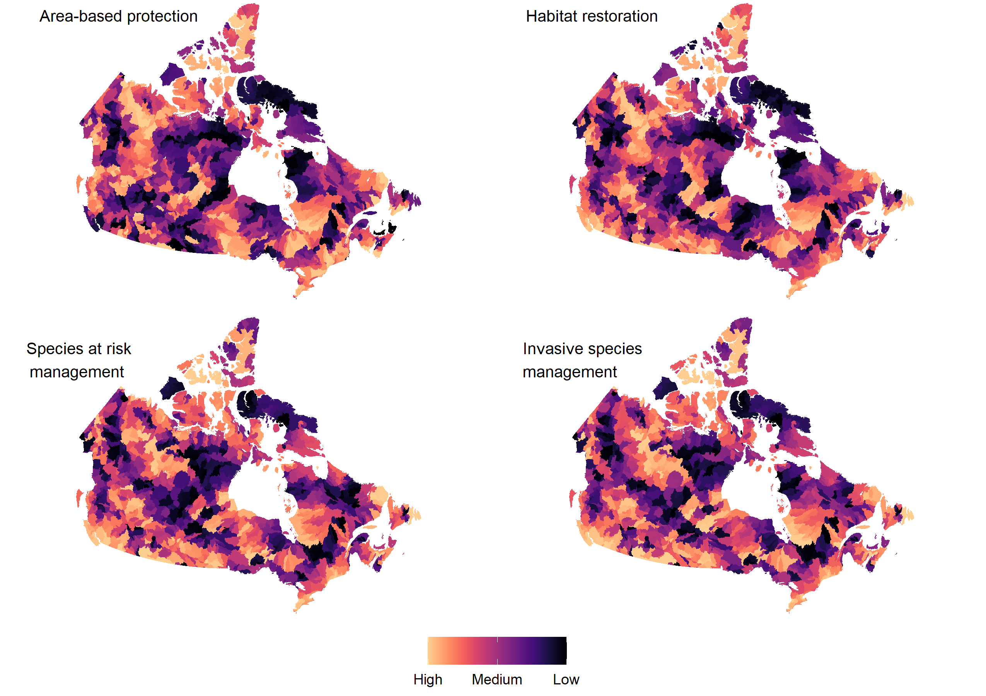

**Figure 1.** The priority score of watersheds for each of 4 conservation objectives in Canada. Watershed color indicates the priority score of each HydroBASIN level 6 watershed within each of 21 freshwater ecoregions, such that yellow coloration indicates a higher priority within the ecoregion. See also [cjdey.shinyapps.io/WatershedPrioritization/](https://cjdey.shinyapps.io/WatershedPrioritization/) for options to customize maps.

Similar analyses ignoring ecological representativity identified different spatial patterns of priority watersheds (Figure S3). Indeed, national priority scores for species at risk management, invasive species management and habitat restoration were dominated by latitudinal patterns, with high values in southern areas (Figure S3). National priority scores for area-based protection high values in watersheds along the Pacific coast and Mackenzie river basin, as well as southern Manitoba, Ontario and the Maritime provinces. Across all four conservation objectives, watersheds in western and eastern Hudson Bay, as well as on Baffin Island, had low priority scores (Figure S3).

*3.2 Spatial overlap of priority watersheds among different conservation objectives*

Some watersheds had high priority scores for multiple conservation objectives. Across all 1378 watersheds, priority scores for area-based protection and restoration were moderately correlated (Figure 2, rho = 0.62). Watersheds in the top 25th percentile for priority score for area-based protection and habitat restoration had some overlap, with a Jaccard similarity coefficient of 0.47. Conversely, priority scores for species at risk management and invasive species management were highly correlated (Figure 2, rho = 0.94). Watersheds in the top 25th percentile for priority score for species at risk management and invasive species management showed high levels of overlap, with a Jaccard similarly coefficient of 0.68.

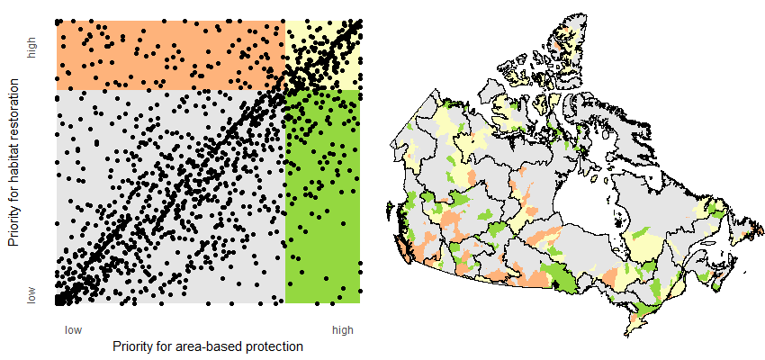

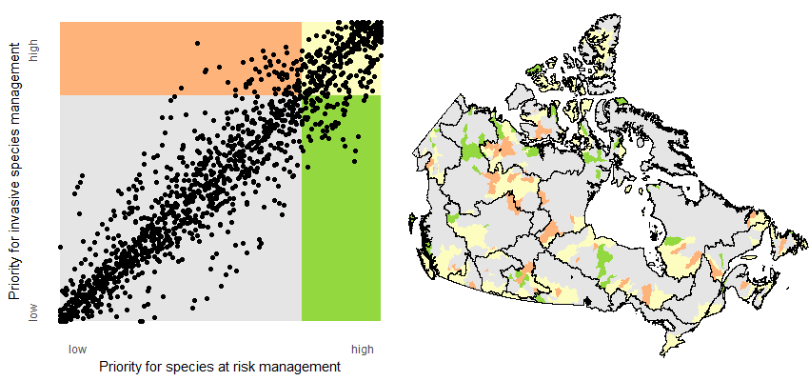

**Figure 2.** Spatial overlap of high priority watersheds for habitat restoration and area-based protection (top panels), and species at risk management and invasive species management (bottom panels). In the scatterplots, each dot indicates a HydroBASIN level 6 watershed. On the maps, watersheds colored in yellow indicate watersheds that were a top 25th percentile priority both of the relevant objectives (i.e. for habitat restoration and area-based protection in the top map, and species at risk and invasive species management in the bottom map). Watersheds colored in orange and green indicate those within the top 25th percentile for only one of the two conservation objectives.

*3.3 Effect of scale on the location of priority watersheds for conservation*

The impact of watershed scale on the selection of priority watersheds depended on the specific conservation objective considered, as well as the percentage of watersheds considered high priority. When a large percentage of watersheds are considered to be high priority, similar areas are selected regardless of scale (Figure 3). However, when only a small percentage of watersheds are selected, as would be typical for most conservation programs in a large country such as Canada, the impact of scale is more profound (Figure 3). For example, in a scenario where the top 10th percentile of watersheds are selected for conservation action, 42.5% of watersheds selected for invasive species management at the HydroBASIN level 6 scale would not be included within the watersheds selected at the HydroBASIN level 5 scale (Figure 3). For other conservation objectives the effect of scale is less severe – only 30.7% of HydroBASIN level 6 watersheds selected for area-based protection would not be included within the HydroBASIN level 5 watersheds at the same threshold level (10th percentile).

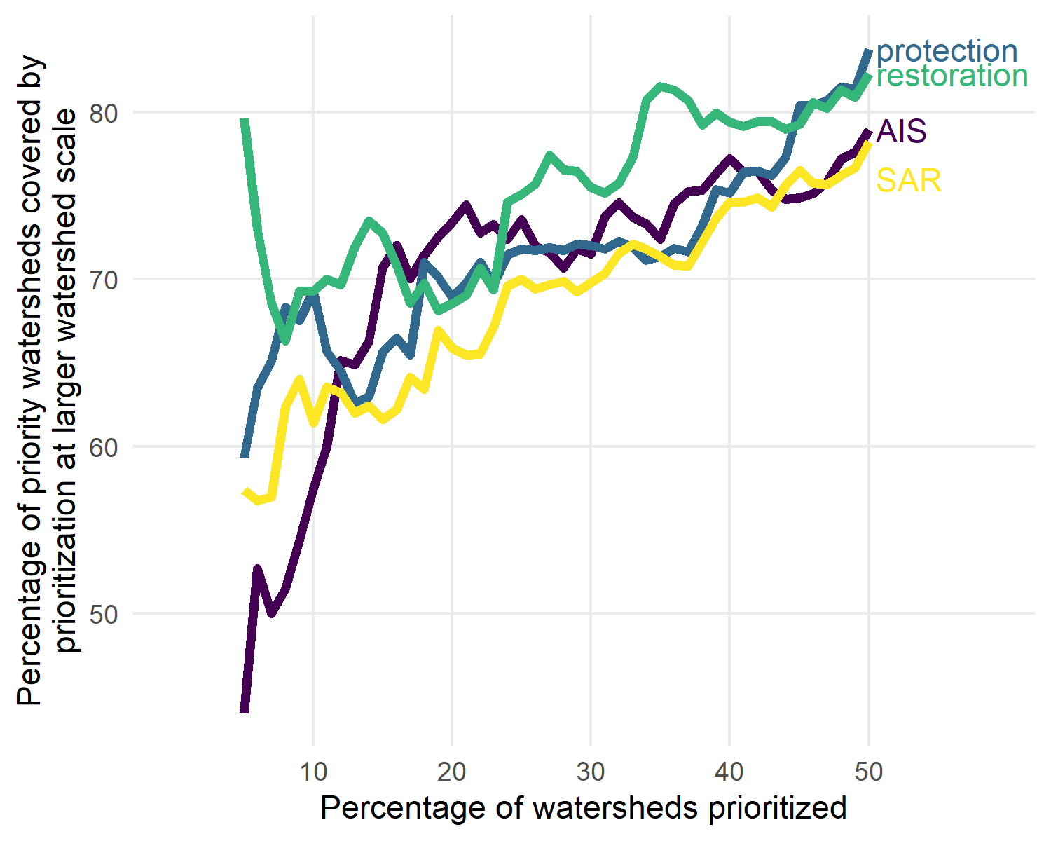

**Figure 3.** Scale dependency of watershed prioritization for the conservation of freshwater fish in Canada. For each of four conservation objectives, we investigated the percentage of priority HydroBASIN level 6 watersheds that would be covered by priority HydroBASIN level 5 watersheds (larger area), were the same prioritization approach and thresholds to be applied at both scales. When this value (y-axis) is high, similar areas are being identified as priorities across the two scales. Line colors indicate whether the focal conservation objective was area-based protection (‘protection’), habitat restoration (‘restoration’), species at risk management (‘SAR’) or invasive species management (‘AIS’).

*3.4 Examination of protected area networks and connectivity withing and among watersheds [Cindy leading]*

***4. Discussion***

Identifying priority areas for investment is an important step in many conservation programs (Wilson et al. 2009b). National conservation programs in Canada may show a particular need for such prioritization given the country’s large area, high spatial variance in environmental stressors (Adaptwest Project 2015; Theobald et al. 2020), and important role in global ecosystem values (Coristine et al. 2019). Here, we identify priority watersheds for the conservation of freshwater fishes. Our analysis builds upon and extends similar efforts described in Chu et al. 2003 and Chu et al. 2015 by conducting our work at a smaller spatial scale that may be more relevant to the scale of conservation action in Canada and including more detailed spatial indices of freshwater fish community status and environmental stressors, including information on predicted climate trajectories. Additionally, while our prioritization approach is based on scientific information, we also explicitly describe our process for selecting how variables were weighted and allow readers to apply custom weightings to identify novel sets of priority watersheds.

Rather than focusing on a single conservation program, our analysis was intended to identify priorities for freshwater fish conservation under four common conservation objectives which individually, or in combination, support a variety of current conservation initiatives operating at international, national and regional scales. For example, under the Kunming-Montreal Global Biodiversity Framework (UN-CBD 2022), Canada has committed to “Minimize the impact of climate change … on biodiversity and increase its resilience” (Target 8). Protecting or restoring habitat for freshwater fishes could contribute to such a target, as high quality habitat is known to mitigate climate impacts by providing refugia (Travis 2003; Priadka et al. 2022). Similarly, protection of freshwater fishes at risk will require action to mitigate novel or intensifying threats associated with climate change (Chu et al. 2005; Poesch et al. 2016; Woo-Durand et al. 2020) and therefore species at risk management actions would also contribute to realizing this target. Other targets under the Global Biodiversity Framework have even more direct relationships with the priorities identified in our study. For example, Target 2 relates to enhancing habitat restoration activities, Target 3 relates to increasing the coverage of protected areas, Target 4 relates to halting extinction of threatened (i.e. ‘at risk’) species, and Target 6 relates to the elimination and mitigation of invasive species. Beyond the Global Biodiversity Framework, many government and non-governmental programs are pursuing the conservation of aquatic ecosystems in Canada and could be informed by our analyses.

Despite significant and intensifying conservation concerns (Reid et al. 2019; Tickner et al. 2020; Desforges et al. 2022), area-based protection of freshwater in Canada has lagged behind terrestrial systems. This gap is due to a combination of few areas being designated specifically for freshwater protection, and inadequate protection of freshwater ecosystems within protected areas designed primarily to protect terrestrial biodiversity (Abell et al. 2007). For example, freshwater fish populations within protected areas are often still exposed to fishing, water abstraction, low levels of connectivity, and invasive species (Acreman et al. 2020). As a result, studies examining whether freshwater fish are more abundant, diverse and healthy within protected areas have found mixed results (e.g. Abraham and Kelkar 2012; Chu et al. 2018; Lamothe et al. 2019). In pursuing the Framework’s Target 3 (‘Ensure and enable that by 2030 at least 30 per cent of terrestrial, inland water, and of coastal and marine areas, … are effectively conserved and managed through … protected areas’), including specific considerations related to the protection of freshwater fishes and other aquatic species could help to prevent biodiversity loss and maintain ecosystem services.

Additionally, when identifying priorities for area-based protection and other freshwater conservation objectives, practitioners may wish to consider the extent to which individual investments may provide indirect benefits for other components of the ecosystem. For example, investment in species at risk management initiatives may also benefit common species and enhance opportunities for harvest (REF). While we identified watersheds that were priorities for multiple conservation objectives (Figure 3), we did not directly consider the extent to which investment in a particular objective could benefit (or trade off against; REF) other objectives. Beyond ecological conservation synergies,

**Acknowledgments**

This study was funded by XXXX. Christopher Rudolph provided assistance with spatial analyses.

***References***

Abell, R., Allan, J.D., and Lehner, B. 2007. Unlocking the potential of protected areas for freshwaters. Biol. Conserv. **134**(1): 48–63. doi:10.1016/j.biocon.2006.08.017.

Abell, R., Thieme, M.L., Revenga, C., Bryer, M., Kottelat, M., Bogutskaya, N., Coad, B., Mandrak, N., Balderas, S.C., Bussing, W., Stiassny, M.L.J., Skelton, P., Allen, G.R., Unmack, P., Naseka, A., Ng, R., Sindorf, N., Robertson, J., Armijo, E., Higgins, J. V., Heibel, T.J., Wikramanayake, E., Olson, D., López, H.L., Reis, R.E., Lundberg, J.G., Sabaj Pérez, M.H., and Petry, P. 2008. Freshwater ecoregions of the world: A new map of biogeographic units for freshwater biodiversity conservation. Bioscience **58**(5): 403–414. doi:10.1641/B580507.

Abraham, R.K., and Kelkar, N. 2012. Do terrestrial protected areas conserve freshwater fish diversity? Results from the Western Ghats of India. Oryx **46**(4): 544–553. doi:10.1017/S0030605311000937.

Acreman, M., Hughes, K.A., Arthington, A.H., Tickner, D., and Dueñas, M.A. 2020. Protected areas and freshwater biodiversity: a novel systematic review distils eight lessons for effective conservation. Conserv. Lett. **13**(1): 1–14. doi:10.1111/conl.12684.

Adaptwest Project. 2015. Gridded climatic velocity data for North America at 1km resolution. Available Adapt.

Anas, M.U.M., and Mandrak, N.E. 2022. Patterns and drivers of native, non-native, and at-risk freshwater fish richness in Canada. Can. J. Fish. Aquat. Sci. **79**(5): 724–737. doi:10.1139/cjfas-2020-0396.

Ban, N.C., Mills, M., Tam, J., Hicks, C.C., Klain, S., Stoeckl, N., Bottrill, M.C., Levine, J., Pressey, R.L., Satterfield, T., and Chan, K.M.A. 2013. A social-ecological approach to conservation planning: Embedding social considerations. Front. Ecol. Environ. **11**(4): 194–202. doi:10.1890/110205.

Bar-On, Y.M., Phillips, R., and Milo, R. 2018. The biomass distribution on Earth. Proc. Natl. Acad. Sci. U. S. A. **115**(25): 6506–6511. doi:10.1073/pnas.1711842115.

Brownscombe, J.W., Bower, S.D., Bowden, W., Nowell, L., Midwood, J.D., Johnson, N., and Cooke, S.J. 2014. Canadian Recreational Fisheries: 35 Years of Social, Biological, and Economic Dynamics from a National Survey. Fisheries **39**(6): 251–260. doi:10.1080/03632415.2014.915811.

Burbank, J., Drake, D.A.R., and Power, M. 2021. Urbanization correlates with altered growth and reduced survival of a small-bodied, imperilled freshwater fish. Ecol. Freshw. Fish **30**(4): 478–489. doi:10.1111/eff.12598.

Castañeda, R.A., Burliuk, C.M.M., Casselman, J.M., Cooke, S.J., Dunmall, K.M., Forbes, L.S., Hasler, C.T., Howland, K.L., Hutchings, J.A., Klein, G.M., Nguyen, V.M., Price, M.H.H., Reid, A.J., Reist, J.D., Reynolds, J.D., Van Nynatten, A., and Mandrak, N.E. 2020. A Brief History of Fisheries in Canada. Fisheries **45**(6): 303–318. doi:10.1002/fsh.10449.

CESCC. 2022. Wild Species 2020: The general status of species in Canada.

Chang, W., Cheng, J., Allaire, J.J., Sievert, C., Schloerke, B., Xie, Y., Allen, J., McPherson, J., Dipert, A., and Borges, B. 2022. shiny: Web Application Framework for R.

Cheng, J., Bhaskar, K., and Yihui, X. 2022. Leaflet: Create Interactive Web Maps with the JavaScript “Leaflet” Library.

Chu, C., Ellis, L., and de Kerckhove, D.T. 2018. Effectiveness of terrestrial protected areas for conservation of lake fish communities. Conserv. Biol. doi:10.1111/cobi.13034.

Chu, C., Mandrak, N.E., and Minns, C.K. 2005. Potential impacts of climate change on the distributions of several common and rare freshwater fishes in Canada. Divers. Distrib. **11**(4): 299–310. doi:10.1111/j.1366-9516.2005.00153.x.

Chu, C., Minns, C.K., Lester, N.P., and Mandrak, N.E. 2015. An updated assessment of human activities, The environment, And freshwater fish biodiversity in Canada. Can. J. Fish. Aquat. Sci. **72**(1): 135–148. doi:10.1139/cjfas-2013-0609.

Chu, C., Minns, C.K., and Mandrak, N.E. 2003. Comparative regional assessment of factors impacting freshwater fish biodiversity in Canada. doi:10.1139/F03-048.

Cooke, S.J., and Murchie, K.J. 2015. Status of aboriginal, commercial and recreational inland fisheries in North America: Past, present and future. Fish. Manag. Ecol. **22**(1): 1–13. doi:10.1111/fme.12005.

Coristine, L.E., Colla, S., Bennett, N., Carlsson, A.M., Davy, C., Davies, K.T.A., Favaro, B., Flockhart, D.T.T., Fraser, K., Orihel, D., Otto, S.P., Palen, W., Polfus, J.L., Venter, O., and Ford, A.T. 2019. National contributions to global ecosystem values. Conserv. Biol. **33**(5): 1219–1223. doi:10.1111/cobi.13284.

Coristine, L.E., Jacob, A.L., Schuster, R., Otto, S.P., Baron, N.E., Bennett, N.J., Bittick, S.J., Dey, C., Favaro, B., Ford, A., Nowlan, L., Orihel, D., Palen, W.J., Polfus, J.L., Shiffman, D.S., Venter, O., and Woodley, S. 2018. Informing Canada’s commitment to biodiversity conservation: A science-based framework to help guide protected areas designation through Target 1 and beyond. Facets **3**(1): 531–562. doi:10.1139/facets-2017-0102.

Desforges, J.E., Clarke, J., Harmsen, E.J., Jardine, A.M., Robichaud, J.A., Serré, S., Chakrabarty, P., Bennett, J.R., Hanna, D.E.L., Smol, J.P., Rytwinski, T., Taylor, J.J., Martel, A.L., Winegardner, A.K., Marty, J., Taylor, M.K., O’connor, C.M., Robinson, S.A., Reid, A.J., Creed, I.F., Gregory-Eaves, I., Lapointe, N.W.R., and Cooke, S.J. 2022. The alarming state of freshwater biodiversity in Canada. Can. J. Fish. Aquat. Sci. **79**(2): 352–365. doi:10.1139/cjfas-2021-0073.

DFO. 2019. Survey of recreational fishing in Canada, 2015.

Downing, J.A., Prairie, Y.T., Cole, J.J., Duarte, C.M., Tranvik, L.J., Striegl, R.G., McDowell, W.H., Kortelainen, P., Caraco, N.F., Melack, J.M., and Middelburg, J.J. 2006. The global abundance and size distribution of lakes, ponds, and impoundments. Limnol. Oceanogr. doi:10.4319/lo.2006.51.5.2388.

Dudgeon, D., Arthington, A.H., Gessner, M.O., Kawabata, Z.I., Knowler, D.J., Lévêque, C., Naiman, R.J., Prieur-Richard, A.H., Soto, D., Stiassny, M.L.J., and Sullivan, C.A. 2006. Freshwater biodiversity: Importance, threats, status and conservation challenges. Biol. Rev. Camb. Philos. Soc. **81**(2): 163–182. doi:10.1017/S1464793105006950.

Eby, L.A., Roach, W.J., Crowder, L.B., and Stanford, J.A. 2006. Effects of stocking-up freshwater food webs. Trends Ecol. Evol. **21**(10): 576–584. doi:10.1016/j.tree.2006.06.016.

FAO. 2016. AQUASTAT - Food and Agriculture Organization of the United Nation’s Information System on Water and Agriculture.

Government of Canada. 2023. Budget 2023 A Made-in-Canada Plan: Strong Middle Class, Affordable Economy, Healthy Future.

Gozlan, R.E., Britton, J.R., Cowx, I., and Copp, G.H. 2010. Current knowledge on non-native freshwater fish introductions. J. Fish Biol. **76**(4): 751–786. doi:10.1111/j.1095-8649.2010.02566.x.

Hamann, A., Roberts, D.R., Barber, Q.E., Carroll, C., and Nielsen, S.E. 2015. Velocity of climate change algorithms for guiding conservation and management. Glob. Chang. Biol. doi:10.1111/gcb.12736.

Imhof, J.G., Lapointe, N.W., Metikosh, S., and Hasler, C.T. 2021. Regaining Lost Protections: Status of the Revisions to the Canadian Fisheries Act. Fisheries **46**(7): 329–334. doi:10.1002/fsh.10614.

Jackson, M.C., Woodford, D.J., Bellingan, T.A., Weyl, O.L.F., Potgieter, M.J., Rivers-Moore, N.A., Ellender, B.R., Fourie, H.E., and Chimimba, C.T. 2016. Trophic overlap between fish and riparian spiders: Potential impacts of an invasive fish on terrestrial consumers. Ecol. Evol. **6**(6): 1745–1752. doi:10.1002/ece3.1893.

Kukkala, A.S., and Moilanen, A. 2013. Core concepts of spatial prioritisation in systematic conservation planning. Biol. Rev. **88**(2): 443–464. doi:10.1111/brv.12008.

Lamothe, K.A., Alofs, K.M., and Chu, C. 2019. Evaluating functional diversity conservation for freshwater fishes resulting from terrestrial protected areas. Freshw. Biol. doi:10.1111/fwb.13395.

Lee, F., Simon, K.S., and Perry, G.L.W. 2017. Increasing agricultural land use is associated with the spread of an invasive fish (Gambusia affinis). Sci. Total Environ. **586**: 1113–1123. Elsevier B.V. doi:10.1016/j.scitotenv.2017.02.101.

Lehner, B., and Grill, G. 2013. Global river hydrography and network routing: Baseline data and new approaches to study the world’s large river systems. Hydrol. Process. doi:10.1002/hyp.9740.

Lo, M., Reed, J., Castello, L., Steel, E.A., Frimpong, E.A., and Ickowitz, A. 2021. The influence of forests on freshwater fish in the tropics: A systematic review. Bioscience **70**(5): 404–414. doi:10.1093/BIOSCI/BIAA021.

Loarie, S.R., Duffy, P.B., Hamilton, H., Asner, G.P., Field, C.B., and Ackerly, D.D. 2009. The velocity of climate change. Nature. doi:10.1038/nature08649.

Lynch, A.J., Myers, B.J.E., Chu, C., Eby, L.A., Falke, J.A., Kovach, R.P., Krabbenhoft, T.J., Kwak, T.J., Lyons, J., Paukert, C.P., and Whitney, J.E. 2016. Climate Change Effects on North American Inland Fish Populations and Assemblages. Fisheries. doi:10.1080/03632415.2016.1186016.

McIntyre, P.B., Liermann, C.A.R., and Revenga, C. 2016. Linking freshwater fishery management to global food security and biodiversity conservation. Proc. Natl. Acad. Sci. U. S. A. **113**(45): 12880–12885. doi:10.1073/pnas.1521540113.

Minns, C.K. 1987. A method of ranking species and sites for conservation using presence-absence data and its application to native freshwater fish in new zealand. New Zeal. J. Zool. **14**(1): 43–49. doi:10.1080/03014223.1987.10422680.

Natural Resources Canada. 2016. National Hydrographic Network. Available from https://open.canada.ca/data/en/dataset/a4b190fe-e090-4e6d-881e-b87956c07977.

Noble, M., Duncan, P., Perry, D., Prosper, K., Rose, D., Schnierer, S., Tipa, G., Williams, E., Woods, R., and Pittock, J. 2016. Culturally significant fisheries: Keystones for management of freshwater social-ecological systems. Ecol. Soc. **21**(2). doi:10.5751/ES-08353-210222.

Pebesma, E. 2018. Simple features for R: Standardized support for spatial vector data. R J. doi:10.32614/rj-2018-009.

Poesch, M.S., Chavarie, L., Chu, C., Pandit, S.N., and Tonn, W. 2016. Climate Change Impacts on Freshwater Fishes: A Canadian Perspective. Fisheries **41**(7): 385–391. doi:10.1080/03632415.2016.1180285.

Post, J.R., Sullivan, M., Cox, S., Lester, N.P., Walters, C.J., Parkinson, E.A., Paul, A.J., Jackson, L., and Shuter, B.J. 2002. Canada’s Recreational Fisheries: The Invisible Collapse? Fisheries **27**(1): 6–17. doi:10.1577/1548-8446(2002)027<0006:crf>2.0.co;2.

Priadka, P., Brown, G.S., DeWitt, P.D., and Mallory, F.F. 2022. Habitat quality mediates demographic response to climate in a declining large herbivore. Basic Appl. Ecol. **58**: 50–63. Elsevier GmbH. doi:10.1016/j.baae.2021.11.005.

R Core Team. 2022. R: A Language and Environment for Statistical Computing. R Foundation for Statistical Computing, Vienna, Austria.

Reid, A.J., Carlson, A.K., Creed, I.F., Eliason, E.J., Gell, P.A., Johnson, P.T.J., Kidd, K.A., MacCormack, T.J., Olden, J.D., Ormerod, S.J., Smol, J.P., Taylor, W.W., Tockner, K., Vermaire, J.C., Dudgeon, D., and Cooke, S.J. 2019. Emerging threats and persistent conservation challenges for freshwater biodiversity. Biol. Rev. **94**(3): 849–873. doi:10.1111/brv.12480.

Rypel, A.L., and David, S.R. 2017. Pattern and scale in latitude-production relationships for freshwater fishes. Ecosphere **8**(1). doi:10.1002/ecs2.1660.

Southee, F.M., Edwards, B.A., Chetkiewicz, C.L.B., and O’Connor, C.M. 2021. Freshwater conservation planning in the far north of Ontario, Canada: identifying priority watersheds for the conservation of fish biodiversity in an intact boreal landscape. Facets **6**(1): 90–117. doi:10.1139/FACETS-2020-0015.

Theobald, D.M., Kennedy, C., Chen, B., Oakleaf, J., Baruch-Mordo, S., and Kiesecker, J. 2020. Earth transformed: Detailed mapping of global human modification from 1990 to 2017. Earth Syst. Sci. Data. doi:10.5194/essd-12-1953-2020.

Tickner, D., Opperman, J.J., Abell, R., Acreman, M., Arthington, A.H., Bunn, S.E., Cooke, S.J., Dalton, J., Darwall, W., Edwards, G., Harrison, I., Hughes, K., Jones, T., Leclère, D., Lynch, A.J., Leonard, P., McClain, M.E., Muruven, D., Olden, J.D., Ormerod, S.J., Robinson, J., Tharme, R.E., Thieme, M., Tockner, K., Wright, M., and Young, L. 2020. Bending the Curve of Global Freshwater Biodiversity Loss: An Emergency Recovery Plan. Bioscience **70**(4): 330–342. doi:10.1093/biosci/biaa002.

Travis, J.M.J. 2003. Climate change and habitat destruction: A deadly anthropogenic cocktail. Proc. R. Soc. B Biol. Sci. **270**(1514): 467–473. doi:10.1098/rspb.2002.2246.

U.S. Geological Survey. 2013. Hydrologic unit maps. Available from http://water.usgs.gov/GIS/huc.html.

UN-CBD. 2022. Kunming-Montreal global biodiversity framework. doi:10.1590/1676-0611-bn-2022-e001.

Verdin, K.L., and Verdin, J.P. 1999. A topological system for delineation and codification of the Earth’s river basins. J. Hydrol. doi:10.1016/S0022-1694(99)00011-6.

Welcomme, R.L. 2011. An overview of global catch statistics for inland fish. ICES J. Mar. Sci. **68**(8): 1751–1756. doi:10.1093/icesjms/fsr035.

Wenger, S.J., Peterson, J.T., Freeman, M.C., Freeman, B.J., and Homans, D.D. 2008. Stream fish occurrence in response to impervious cover, historic land use, and hydrogeomorphic factors. Can. J. Fish. Aquat. Sci. **65**: 1250–1264. doi:10.1139/F08-046.

Wickham, H., Averick, M., Bryan, J., Chang, W., McGowan, L., François, R., Grolemund, G., Hayes, A., Henry, L., Hester, J., Kuhn, M., Pedersen, T., Miller, E., Bache, S., Müller, K., Ooms, J., Robinson, D., Seidel, D., Spinu, V., Takahashi, K., Vaughan, D., Wilke, C., Woo, K., and Yutani, H. 2019. Welcome to the Tidyverse. J. Open Source Softw. **4**(43): 1686. doi:10.21105/joss.01686.

Wiens, J.A., and Hobbs, R.J. 2015. Integrating conservation and restoration in a changing world. Bioscience **65**(3): 302–312. doi:10.1093/biosci/biu235.

Willson, M.F., and Halupka, K.C. 1995. Anadromous Fish as Keystone Species in Vertebrate Communities. Conserv. Biol. **9**(3): 489–497. doi:10.1046/j.1523-1739.1995.09030489.x.

Wilson, K. a, Cabeza, M., and Klein, C.J. 2009a. Fundamental Concepts of Spatial Conservation Prioritization. *In* Spatial conservation prioritization: quantitative methods and computational tools. *Edited by* A. Moilanen, K.A. Wilson, and H.P. Possingham. Oxford University Press. pp. 16–27.

Wilson, K.A., Carwardine, J., and Possingham, H.P. 2009b. Setting conservation priorities. Ann. N. Y. Acad. Sci. **1162**: 237–264. doi:10.1111/j.1749-6632.2009.04149.x.

Woo-Durand, C., Matte, J.M., Cuddihy, G., McGourdji, C.L., Venter, O., and Grant, J.W.A. 2020. Increasing importance of climate change and other threats to at-risk species in Canada. Environ. Rev. **28**(4): 449–456. doi:10.1139/er-2020-0032.

**Supplemental Information**

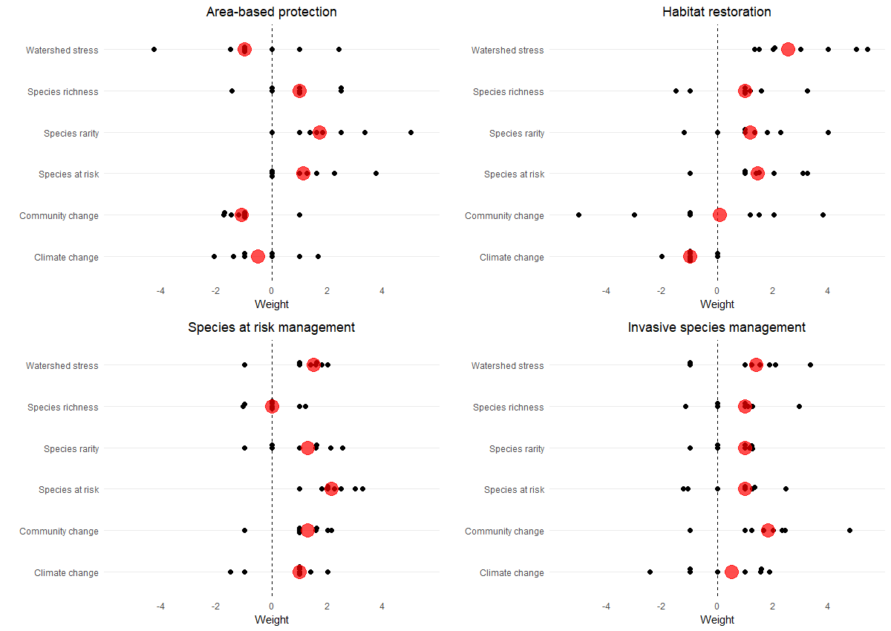

**Figure S1.** Values for weighting each of six watershed indices towards four conservation objectives. Black dots show the suggested weights from each of 8 co-authors for the respective index (y-axis position) and objective (panel). Large red dots indicate the median value across co-authors, which was used for downstream analyses. Positive values (i.e. > 0 ) indicate that watersheds with high values of the index should be selected as priority for the objective, while negative values indicate that watersheds with low values of the index should be selected as priorities.

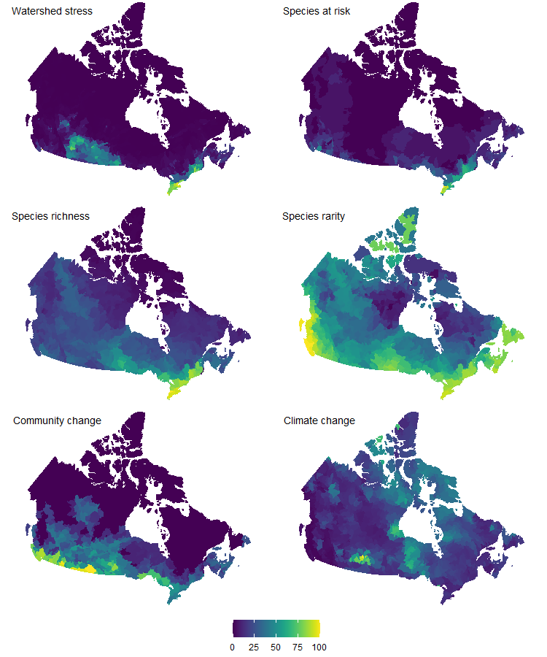

**Figure S2.** Watershed index values for each of 6 indices, normalized on a scale of 1 – 100. Values are plotted for each of 1378 HydroBASIN level 6 watersheds within Canada.

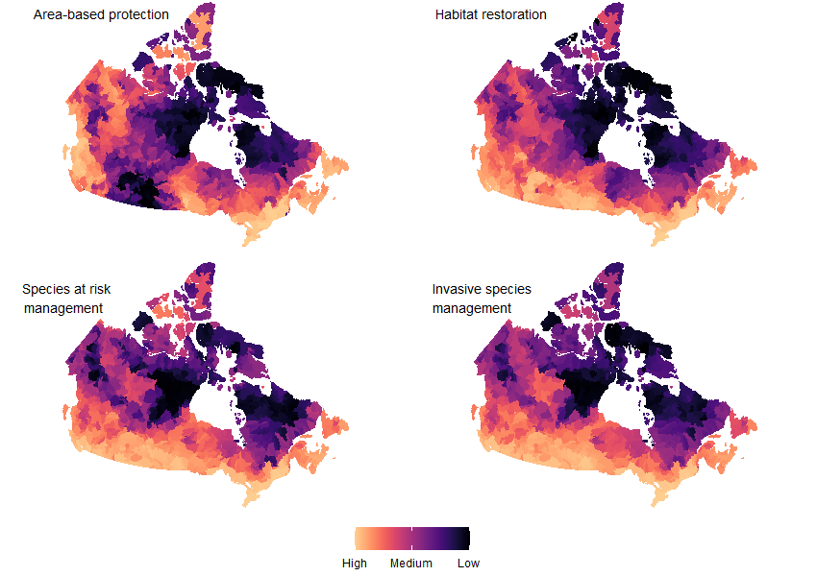**Figure S3.** Priority watersheds for each of 4 conservation objectives based on national rankings of HydroBASIN Level 6 watersheds (n = 1378).