**Lab 3 Report**

Name:朱峻平

Student ID:107598058

Date:2019/4/24

1. **Test Plan**
   1. **Test requirements**

The Lab 3 requires to (1) select 6 methods from 6 classes of the SUT (GeoProject), (2) design Unit test cases by using **basis path and graph coverage** technique for the selected methods, (3) develop test scripts to implement the test cases, (4) execute the test scripts on the selected methods, (5) report the test results, and (6) specify your experiences of designing test cases systematically using the ISP technique.

In particular, based on the statement and branch coverage criteria, the **test requirements** for Lab 3 are to design test cases *with* **basis path and/or graph coverage**for each selected method so that “*each statement and branch of the method will be covered by at least one test case* and *the both minimum* ***statement*** *(node) and* ***branch*** *(edge) coverage are 90%, respectively (greater than Lab 2)*”.

* 1. **Test Strategy**

To satisfy the test requirements listed in Section 1, a proposed strategy is to

1. 選較有變化或程式較複雜的method去畫CFG，以及設計測試盡量達到最大statement coverage以及branch coverage。
2. 從Lab1 和 Lab2中挑選三個method以及再從新的未測 method中挑選三個。
3. statement coverage以及branch coverage達到都90%以上
   1. **Test activities**

To implement the proposed strategy, the following activities are planned to perform.

|  |  |  |  |
| --- | --- | --- | --- |
| **No.** | **Activity Name** | **Plan hours** | **Schedule Date** |
| 1 | Study GeoProject | 3 | 4/22 |
| 2 | Learn **ISP** and JUnit | 2 | 4/22 |
| 3 | Design test cases for the selected methods | 12 | 4/23 |
| 4 | Implement test cases | 5 | 4/24 |
| 5 | Perform tests | 1 | 4/24 |
| *n* | Complete Lab3 report | 3 | 4/24 |

* 1. **Design Approach**

依據CFG去觀察有哪些Branch以及去添加測試案例，設想所以可能狀況去Cover住所有可能的分支，再去Assert期待值以及可能的例外狀況，盡可能提高coverage。

* 1. **Success criteria**

所有測試案例都通過，statement coverage以及branch coverage都要達到90%以上。

1. **Test Design**

To fulfill the test requirements listed in section 1.1, the following methods are selected and corresponding test cases are designed.

|  |  |  |  |  |  |  |
| --- | --- | --- | --- | --- | --- | --- |
| **No.** | **Class** | **Method** | **CFG** | **Basis Path** | **Inputs** | **Expected Outputs** |
| 1 | Base32 | encodeBase32() | 請參考Excel | | T1: {i = 32, lenth=2}  T2={i = -32, lenth=2} | 1. 10  2. -10  2.-101 |
| 2 | Base32 | decodeBase32() | T1: {hash= "-1"}  T2={hash= ""} | 1. -1  2. 0 |
| 3 | GeoHash | adjacentHash() | T1 = { hash="TEST" direction=  Direction.BOTTOM  steps=7}  T2 = { hash="TEST" direction=  Direction.TOP  steps=-7}  T3 = { hash="TEST" direction=  Direction.LEFT  steps=0} | 1.tekw  2.tekw  3.TEST |
| 4 | Base32 | getCharIndex() | T1: {ch= 'b'}  T2={ch= 'a'} | 1.10  2. IllegalArgumentException |
| 5 | Geomem | Find() | T1 = { topLeftLat = 5  topLeftLon=0  bottomRightLat=1  bottomRightLon=5  start=0  finish=5}  (有事先進行add資料)  T2 = { topLeftLat = 5  topLeftLon=0  bottomRightLat=1  bottomRightLon=5  start=0  finish=5}  (沒有事先進行add資料) | 1. New Info<Double,Double>  (1.0,2.0,3.0,4.0,689.0)  2. IllegalArgumentException |
| 6 | GeoHash | fromLongToString() | T1: {hash = 13}  T2={hash = 0}  T3={hash = 2} | 1.00000  2.00000  3.00 |

The details of the design are given below:

[The Excel file of test cases…](https://stv.csie.ntut.edu.tw/107598058/GeoProject/tree/master/LabReport/Lab3)　＜－請點我

1. **Test Implementation**

The design of test cases specified in Section 2 was implemented using JUnit 4. The test scripts of 3 selected test cases are given below. [The rest of the test script implementations can be found in the link (or JUnit files). ＜－請點我](https://stv.csie.ntut.edu.tw/107598058/GeoProject/tree/master/LabReport/Lab3)

|  |  |  |  |
| --- | --- | --- | --- |
| **No.** | **Test method** | **Source test code** | |
| 1 | encodeBase32() |  |
| 2 | decodeBase32() |  |
| 3 | getCharIndex() |  |

1. **Test Results**
   1. **JUnit test result snapshot**

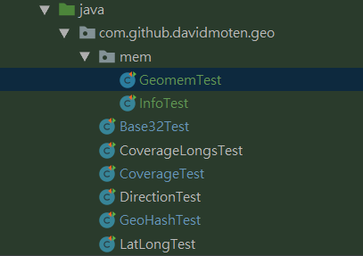

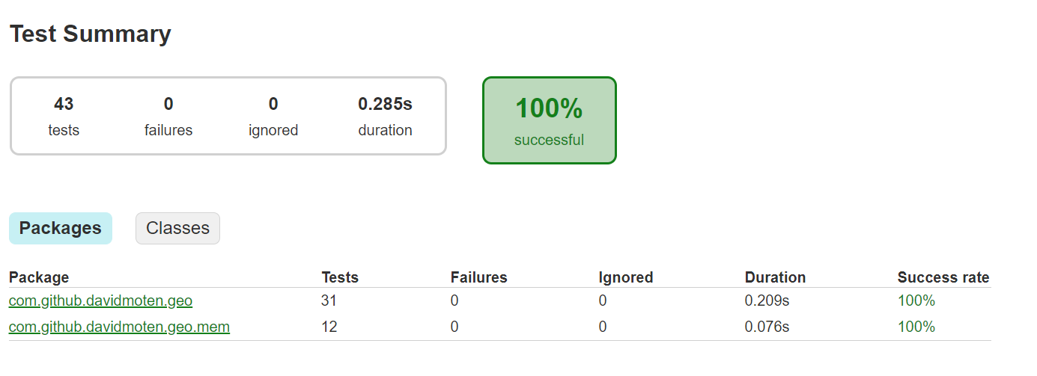

* 1. **Code coverage snapshot**
* Coverage of each selected method

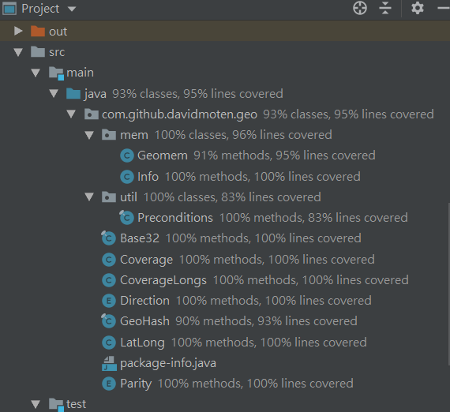

* Total coverage

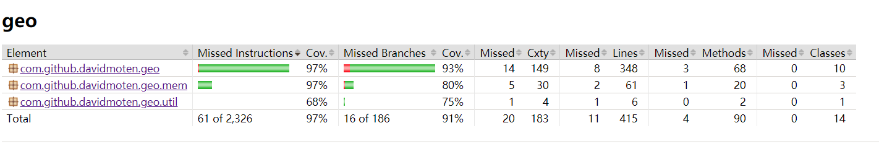

* 1. **CI result snapshot (3 iterations for CI)**
* CI#1

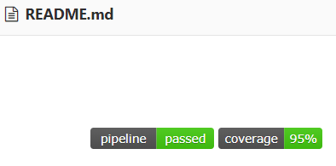

* CI#2



* CI#3



* CI Pipeline

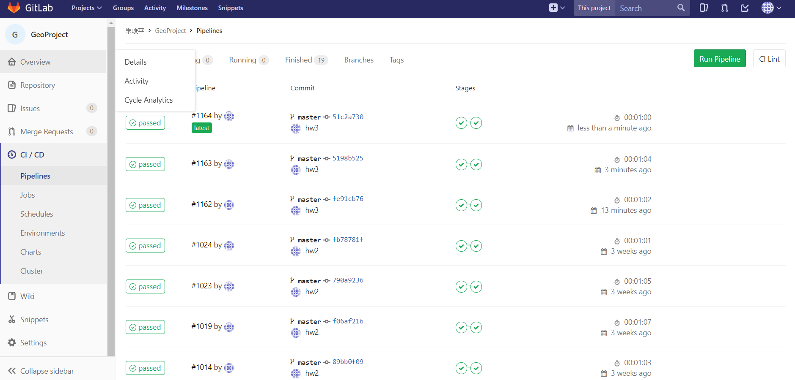

1. **Summary**

已經對GeoProject使用ISP以及CFG方式去進行測試，Statement Coverage達到95%以及Branch Coverage達到91%，經過lab3的練習我更了解如何畫CFG圖以及更有效率的對程式進行測試，已經不是盲測了，也更加了解statemeent coverage 和 Branch Coverage的意義以及對程式開罰人員能帶來的好處，經過這次作業讓我受益良多。