**Lab 1 Report**

Name:朱峻平

Student ID:107598058

Date:2019/3/5

1. **Test Plan**
   1. **Test requirements**

The Lab 1 requires to (1) select 15 methods from 6 classes of the SUT (GeoProject), (2) design Unit test cases based on the experience or intuition for the selected methods, (3) develop test scripts to implement the test cases, (4) execute the test script on the selected methods, and (5) report the test result.

In particular, based on the statement coverage criterion, the **test requirements** for Lab 1 are to design test casesfor each selected method so that “*each statement of the method will be covered by at least one test case* and *the minimum statement coverage is 40%*”.

* 1. **Strategy**

To satisfy the test requirements listed in Section 1, a proposed strategy is to

1. 選擇Public Method來進行測試，參數不限型態。
2. Getter Setter挑幾個重點進行測試不全數進行測試。
3. 學習Junit以及IDE使用
4. 先算出預期值再使用assertEquals與實際值比對。
   1. **Test activities**

To implement the proposed strategy, the following activities are planned to perform.

|  |  |  |  |
| --- | --- | --- | --- |
| **No.** | **Activity Name** | **Plan hours** | **Schedule Date** |
| 1 | Study GeoProject | 3 | 3/3 |
| 2 | Learn JUnit | 3 | 3/4 |
| 3 | Design test cases for the selected methods | 5 | 3/4 |
| 4 | Implement test cases | 3 | 3/4 |
| 5 | Perform test | 1 | 3/4 |
| 6 | Complete Lab1 report | 3 | 3/5 |

* 1. **Success criteria**

**設計的test case 全部通過，總體測試覆蓋率達40%以上。**

1. **Test Design**

|  |  |  |  |  |
| --- | --- | --- | --- | --- |
| **No.** | **Class** | **Method** | **Inputs** | **Expected Outputs** |
| 1 | Base32 | encodeBase32() | Long:75324  Int:4 | String:  “29jw” |
| 2. | Base32 | decodeBase32() | String:1235 | Long:  34917 |
| 3. | Base32 | paLeftWithZerosToLength() | String: “Test1”  Int:9 | String: ”0000Test1” |
| 4 | Base32 | getCharIndex() | Char: ‘2’ | Char: ‘2’ |
| 5 | CoverageLongs | getHashLength() | 無 | Int:5 |
| 6 | CoverageLongs | getHashes() | 無 | Long[]:[5,6,7,8] |
| 7 | Coverage | getHashLength() | 無 | Int:5 |
| 8 | DirectionTest | opposite() | Direction.BOTTOM | Direction.TOP |
| 9 | LatLongTest | add() | Double:8  Double:7 | 無回傳值(void) |
| 10 | GeoHash | adjacentHash() | String:  ” TESTDATA54965959”  Direction: Direction.TOP  Int:1 | String:  “testdata5496595d” |
| 11 | GeoHash | right() | String:  ”TESTDATA54965959” | String:  “testdata5496595c” |
| 12 | GeoHash | left() | String:  ”TESTDATA54965959” | String:  “testdata54965953” |
| 13 | GeoHash | top() | String:  ”TESTDATA54965959” | String:  “testdata5496595d” |
| 14 | GeoHash | bottom() | String:  ”TESTDATA54965959” | String:  “testdata54965958” |
| 15 | GeoHash | encodeHash() | LatLong:temp | String:  “s0uk2w1p45s3” |
| 16 | GeoHash | fromLongToString() | LatLong:temp | String:  “s0uk2w1p45s3” |
| 17 | GeoHash | encodeHashToLong() | double:0  double:1  int:0 | Long:0 |
| 18 | GeoHash | decodeHash() | String:  ”TESTDATA54965959” | New LatLong |
| 19 | GeoHash | hashContains() | String:  ”TESTDATA54965959”  double:1  double:0 | Boolean:false |
| 20 | GeoHash | heightDegrees() | Int: 5 | Int: 0.0439453125 |
| 21 | GeoHash | widthDegrees() | Int: 6 | Int:0.010986328125 |

To fulfill the test requirements listed in section 1.1, the following methods are selected and corresponding test cases are designed.

1. **Test Implementation**

The rest of test script implementation can be found in the [link](https://stv.csie.ntut.edu.tw/107598058/GeoProject).

|  |  |  |
| --- | --- | --- |
| **No.** | **Test method** | **Source code** |
| 1 | encodeBase32() | String encode = Base32.*encodeBase32*(75324, 4); *assertEquals*("29jw", encode); |
| 2 | decodeBase32() | long ans = Base32.*decodeBase32*("1235"); *assertEquals*(34917, ans); |
| 3 | opposite() | *AssertEquals*(Direction.*TOP*,Direction.*BOTTOM*.opposite()); |

1. **Test Results**
   1. **JUnit test result snapshot**

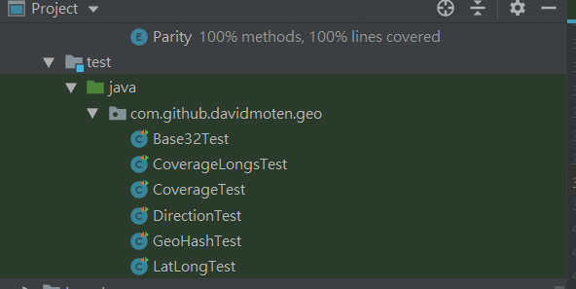

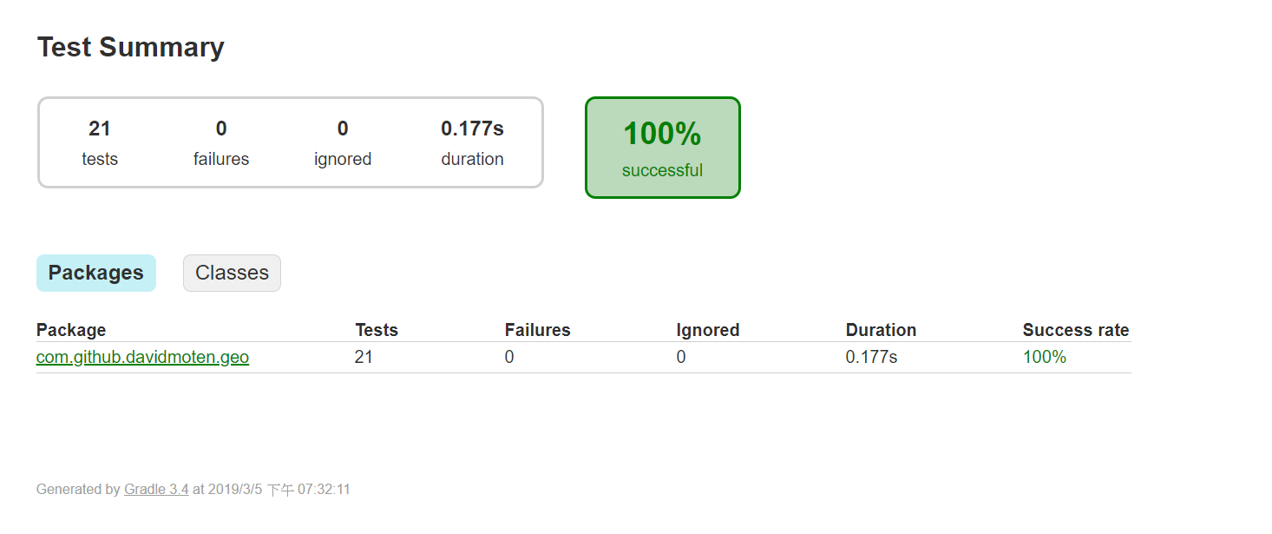

* 1. **Code coverage snapshot**
* Coverage of each selected method

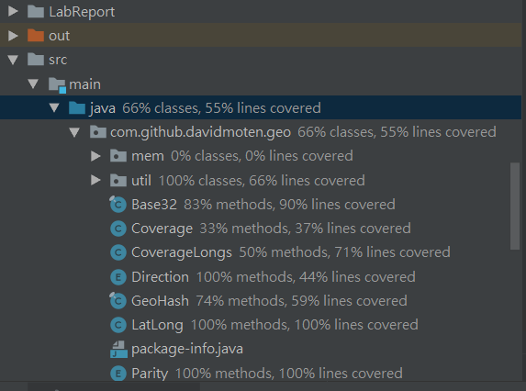

* Total coverage

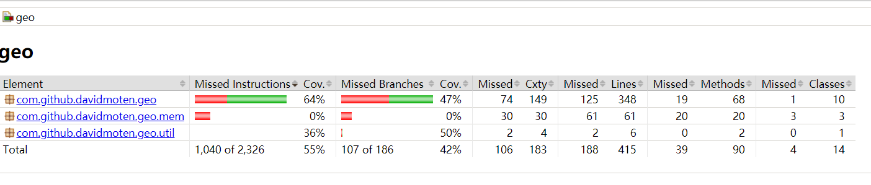

* 1. **CI result snapshot (3 iterations for CI)**
* CI#1

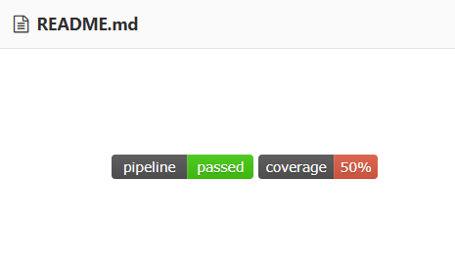

* CI#2

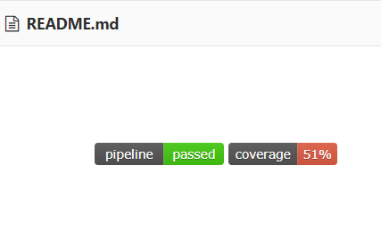

* CI#3

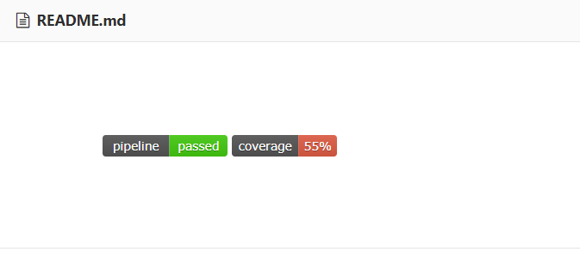

* CI Pipeline

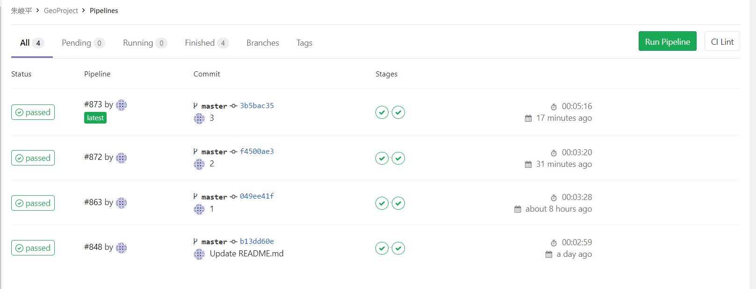

1. **Summary**

在Lab1中我寫了21個test case這次作業我還在習慣JUnit以及新的IDE開發工具，也稍微研究了GeoProject的code，也在一開始測試時制定了簡易的測試策略，所以在撰寫測試上遵循自己的策略，所以沒有遇到太大的問題，最後測試覆蓋率達到55%。