姓名：罗楚晴 | 专业： 物联网工程 | 班级：20181191 | 学号：2018119103
科目：嵌入式系统概论 |  | 实验日期：
实验题目：GPIO输出控制实验-Led闪烁、流水灯
【实验目的】
用按键控制LED灯的亮灭
【实验内容】
1.实验设备
◆ 硬件：小熊派
◆ 软件：win10 系统，STM32CubeMX，Keil 5。
- 实验相关原理图

LED使用的是PC13引脚
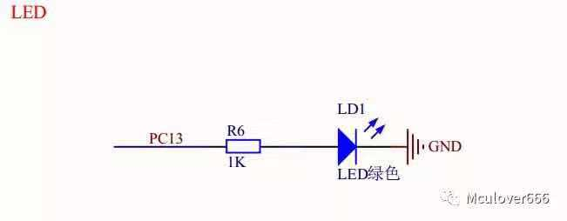

F1按键接的是PB2，F2按键接的是PB3
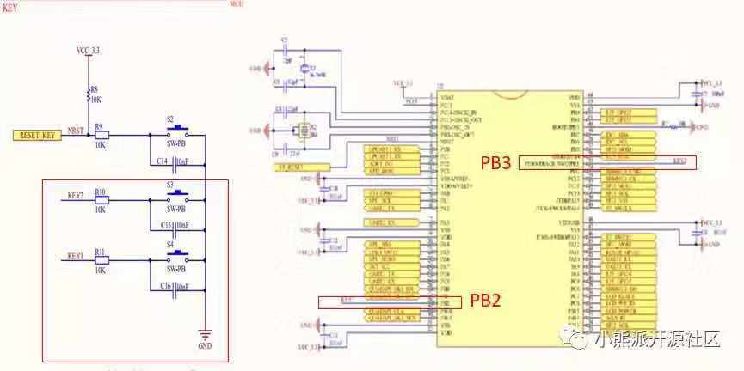
3.实验效果
上电复位时LED处于熄灭状态；
按下KEY1，LED点亮；
按下KEY2，LED熄灭；
【实验结果】
1.构思
步骤1：查看原理图，配置相关的GPIO引脚
步骤2：配置时钟源，使用外部高速时钟（HSE）
步骤3：配置时钟树，配置PLL
步骤4：在main.c中编写代码，当读取到F1按键引脚为低电平时，LED灯引脚输出高电平；当读取到F2按键引脚为低电平时，LED灯引脚输出低电平，所以当按下KEY1，LED点亮，按下KEY2，LED熄灭。

2.实现
/* USER CODE BEGIN Header */
/**
******************************************************************************
* @file : main.c
* @brief : Main program body
******************************************************************************
* @attention
*
* <h2><center>&copy; Copyright (c) 2021 STMicroelectronics.
* All rights reserved.</center></h2>
*
* This software component is licensed by ST under BSD 3-Clause license,
* the "License"; You may not use this file except in compliance with the
* License. You may obtain a copy of the License at:
* opensource.org/licenses/BSD-3-Clause
*
******************************************************************************
*/
/* USER CODE END Header */
/* Includes ------------------------------------------------------------------*/
#include "main.h"
#include "gpio.h"

/* Private includes ----------------------------------------------------------*/
/* USER CODE BEGIN Includes */

/* USER CODE END Includes */

/* Private typedef -----------------------------------------------------------*/
/* USER CODE BEGIN PTD */

/* USER CODE END PTD */

/* Private define ------------------------------------------------------------*/
/* USER CODE BEGIN PD */
/* USER CODE END PD */

/* Private macro -------------------------------------------------------------*/
/* USER CODE BEGIN PM */

/* USER CODE END PM */

/* Private variables ---------------------------------------------------------*/

/* USER CODE BEGIN PV */

/* USER CODE END PV */

/* Private function prototypes -----------------------------------------------*/
void SystemClock_Config(void);
/* USER CODE BEGIN PFP */

/* USER CODE END PFP */

/* Private user code ---------------------------------------------------------*/
/* USER CODE BEGIN 0 */

/* USER CODE END 0 */

/**
* @brief The application entry point.
* @retval int
*/
int main(void)
{
/* USER CODE BEGIN 1 */

/* USER CODE END 1 */

/* MCU Configuration--------------------------------------------------------*/

/* Reset of all peripherals, Initializes the Flash interface and the Systick. */
HAL_Init();

/* USER CODE BEGIN Init */

/* USER CODE END Init */

/* Configure the system clock */
SystemClock_Config();

/* USER CODE BEGIN SysInit */

/* USER CODE END SysInit */

/* Initialize all configured peripherals */
MX_GPIO_Init();
/* USER CODE BEGIN 2 */

/* USER CODE END 2 */

/* Infinite loop */
/* USER CODE BEGIN WHILE */
while (1)
{
/* USER CODE END WHILE */

/* USER CODE BEGIN 3 */
}
/* USER CODE END 3 */
}

/**
* @brief System Clock Configuration
* @retval None
*/
void SystemClock_Config(void)
{
RCC_OscInitTypeDef RCC_OscInitStruct = {0};
RCC_ClkInitTypeDef RCC_ClkInitStruct = {0};

/** Initializes the RCC Oscillators according to the specified parameters
* in the RCC_OscInitTypeDef structure.
*/
RCC_OscInitStruct.OscillatorType = RCC_OSCILLATORTYPE_MSI;
RCC_OscInitStruct.MSIState = RCC_MSI_ON;
RCC_OscInitStruct.MSICalibrationValue = 0;
RCC_OscInitStruct.MSIClockRange = RCC_MSIRANGE_6;
RCC_OscInitStruct.PLL.PLLState = RCC_PLL_ON;
RCC_OscInitStruct.PLL.PLLSource = RCC_PLLSOURCE_MSI;
RCC_OscInitStruct.PLL.PLLM = 1;
RCC_OscInitStruct.PLL.PLLN = 40;
RCC_OscInitStruct.PLL.PLLP = RCC_PLLP_DIV7;
RCC_OscInitStruct.PLL.PLLQ = RCC_PLLQ_DIV2;
RCC_OscInitStruct.PLL.PLLR = RCC_PLLR_DIV2;
if (HAL_RCC_OscConfig(&RCC_OscInitStruct) != HAL_OK)
{
Error_Handler();
}
/** Initializes the CPU, AHB and APB buses clocks
*/
RCC_ClkInitStruct.ClockType = RCC_CLOCKTYPE_HCLK|RCC_CLOCKTYPE_SYSCLK
|RCC_CLOCKTYPE_PCLK1|RCC_CLOCKTYPE_PCLK2;
RCC_ClkInitStruct.SYSCLKSource = RCC_SYSCLKSOURCE_PLLCLK;
RCC_ClkInitStruct.AHBCLKDivider = RCC_SYSCLK_DIV1;
RCC_ClkInitStruct.APB1CLKDivider = RCC_HCLK_DIV1;
RCC_ClkInitStruct.APB2CLKDivider = RCC_HCLK_DIV1;

if (HAL_RCC_ClockConfig(&RCC_ClkInitStruct, FLASH_LATENCY_4) != HAL_OK)
{
Error_Handler();
}
/** Configure the main internal regulator output voltage
*/
if (HAL_PWREx_ControlVoltageScaling(PWR_REGULATOR_VOLTAGE_SCALE1) != HAL_OK)
{
Error_Handler();
}
}

/* USER CODE BEGIN 4 */
void HAL_GPIO_EXTI_Callback(uint16_t GPIO_Pin){
HAL_GPIO_TogglePin(LED_GPIO_Port, LED_Pin);
}
/* USER CODE END 4 */

/**
* @brief This function is executed in case of error occurrence.
* @retval None
*/
void Error_Handler(void)
{
/* USER CODE BEGIN Error_Handler_Debug */
/* User can add his own implementation to report the HAL error return state */
__disable_irq();
while (1)
{
}
/* USER CODE END Error_Handler_Debug */
}

#ifdef USE_FULL_ASSERT
/**
* @brief Reports the name of the source file and the source line number
* where the assert_param error has occurred.
* @param file: pointer to the source file name
* @param line: assert_param error line source number
* @retval None
*/
void assert_failed(uint8_t *file, uint32_t line)
{
/* USER CODE BEGIN 6 */
/* User can add his own implementation to report the file name and line number,
ex: printf("Wrong parameters value: file %s on line %d\r\n", file, line) */
/* USER CODE END 6 */
}
#endif /* USE_FULL_ASSERT */

/************************ (C) COPYRIGHT STMicroelectronics *****END OF FILE****/

3.运行结果
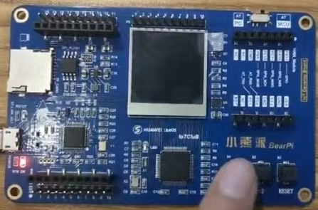

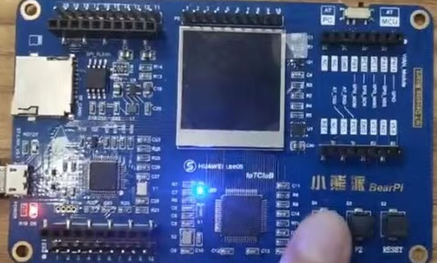

【实验结论】（写结论，心得，和收获）

心得：学会了按键处理LED灯的亮灭。

【教师评语和成绩】

成绩： 指导教师： 日期：

