Image Processing Homework 2
Q56124107 張祝維
Method
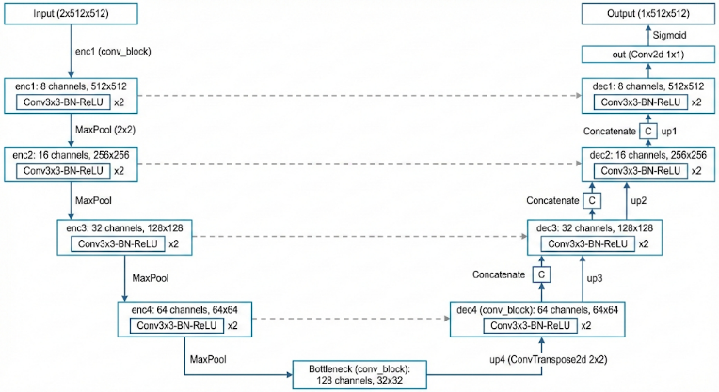
Unet

Data Augmentation:
- shifting & rotating
shifting : 10%
rotation: $±$ 20°
Pre-processing
gaussian filter
kernel size = (5,5)
sigma $≅$ 1.1
Learning Rate Decay
$lr\left(epoch+10\right)=0.7*lr\left(epoch\right)$
$$, starting from lr = 0.005$$
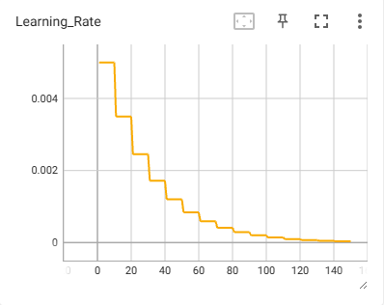

Result
dice score:
 | Dice Score
CT | 0.93
FT | 0.85
MN | 0.81

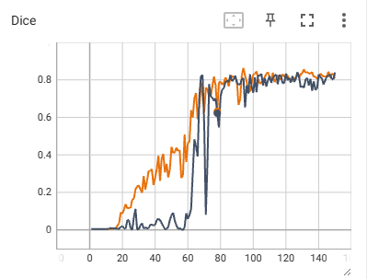
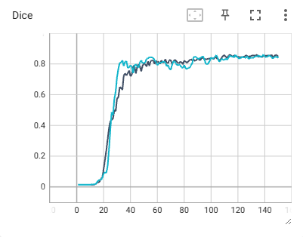
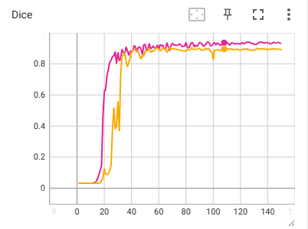





Discussion
- Due to the limited size of the available dataset, data augmentation techniques were employed to prevent overfitting and improve the model's ability to generalize. Specifically, random geometric transformations—including rotation and spatial shifting—were applied during training to artificially increase the diversity of the input samples.
- Preliminary experiments indicated training instability and oscillation in the loss landscape during the final epochs. To address this, learning rate decay was implemented. By progressively reducing the step size of the optimizer, the model was able to converge more smoothly in the later stages of training, resulting in improved stability and precision in the final weights.
- Given the sensitivity of edge detection tasks to high-frequency artifacts, a Gaussian Low-Pass Filter was selectively applied to suppress noise.

However, this smoothing step was excluded for the MN dataset; the intrinsic contours in MN images were already faint, and further blurring would have degraded the structural boundaries essential for accurate segmentation.

- A smaller variant of the U-Net architecture was selected rather than the standard, full-scale implementation. Given the constrained size of the dataset, a standard U-Net with high channel depth would be prone to overfitting, effectively memorizing the training data rather than learning generalizable features. By reducing the number of convolutional filters, the model complexity was aligned with the available data volume to ensure robust generalization.

