**Exercise1:**

package Week6;

import java.util.Random;

import java.util.Scanner;

import java.util.Arrays;

class Method {

public static boolean[] getAbsent(int[][] records){

int studentNumber=records.length;

int labNumber=records[0].length;

boolean[] Absent=new boolean[studentNumber];

for(int i=0;i<studentNumber;i++){

int sum=0;

for(int j=0;j<labNumber;j++){

if(records[i][j]==0){

sum+=1;

}

}

if(sum>=2){

Absent[i]=true;

}

else {

Absent[i]=false;

}

}

return Absent;

}

}

public class Exercise1{

public static void main(String[] args){

Scanner input=new Scanner(System.in);

System.out.printf("Please input the number of students: ");

int studentNumber=input.nextInt();

System.out.printf("Pleas input the number of practises in lab class: ");

int labNumber=input.nextInt();

int[][] records=new int[studentNumber][labNumber];

Random r=new Random();

for(int i=0;i<studentNumber;i++){

for(int j=0;j<labNumber;j++){

records[i][j]=r.nextInt(6);

}

}

for(int i=0;i<studentNumber;i++){

System.out.println("s_"+i+":"+Arrays.toString(records[i]));

}

System.out.print("The absent SID is: ");

boolean absent[]=Method.getAbsent(records);

for(int i=0;i<studentNumber;i++){

if(absent[i]==true){

System.out.print(i );

}

}

}

}

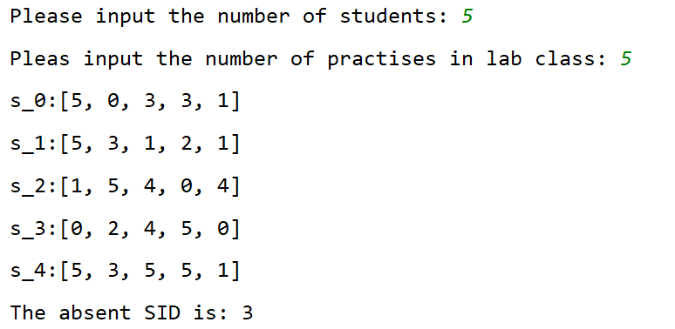

**Exercise2:**

package Week6;

import java.util.Scanner;

public class Exercise2 {

public static void displayElements(double[][] m){

for(int i=0;i<4;i++){

for(int j=0;j<4;j++){

System.out.print(m[i][j]);

}

System.out.println("\n");

}

}

public static double sumColumn(double[][] m,int columnIndex){

double sum=0;

for(int i=0;i<4;i++){

sum+=m[i][columnIndex];

}

return sum;

}

public static double sumMajorDiagonal(double[][] m){

double sum=0;

for(int i=0;i<4;i++){

sum+=m[i][i];

}

return sum;

}

public static void main(String[] args){

System.out.println("Enter a 4-by-4 matrix row by row:");

Scanner input=new Scanner(System.in);

double[][] m=new double[4][4];

for(int i=0;i<4;i++){

for(int j=0;j<4;j++){

m[i][j]=input.nextDouble();

}

}

System.out.println("The input 4-by-4 matrix is:");

for(int i=0;i<4;i++){

for(int j=0;j<4;j++){

System.out.print(m[i][j]+" ");

}

System.out.print("\n");

}

for(int i=0;i<4;i++){

System.out.println("Sum of elements of column"+ i+" is "+sumColumn(m,i));

}

System.out.println("Sum of elements in the major diagonal is "+sumMajorDiagonal(m));

}

}

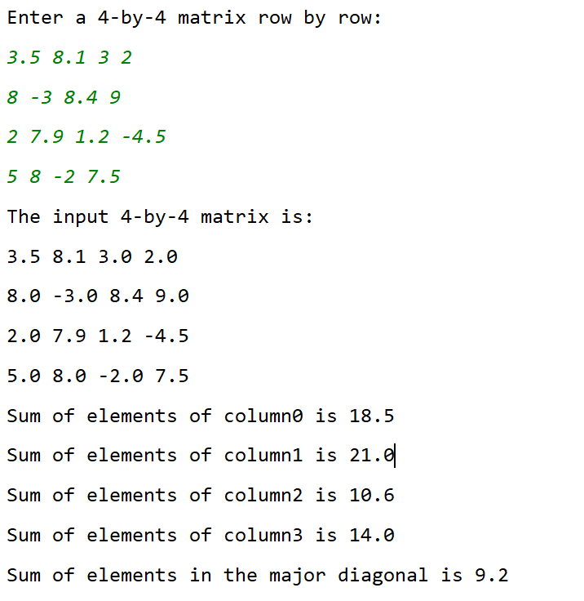

**Exercise3:**

package Week6;

import Week1_2020_02_10.Exercise;

import org.omg.PortableInterceptor.SYSTEM_EXCEPTION;

import sun.applet.Main;

import java.util.Scanner;

public class Exercise3 {

public static boolean isMarkovMatrix(double[][] m){

boolean result=true;

for(int i=0;i<3;i++){

for(int j=0;j<3;j++){

if(m[i][j]<=0){

result=false;

}

}

}

for(int i=0;i<3;i++){

double sum=0;

for(int j=0;j<3;j++){

sum+=m[j][i];

}

if(sum!=1){

result=false;

}

}

return result;

}

public static void main(String[] args){

double[][] m=new double[3][3];

Scanner input=new Scanner(System.in);

System.out.println("Enter a 3-by-3 markov matrix row by row:");

for(int i=0;i<3;i++){

for(int j=0;j<3;j++){

m[i][j]=input.nextDouble();

}

}

if(isMarkovMatrix(m)==true){

System.out.println("It is a Markov Matrix.");

}

else {

System.out.println("It is not a Markov Matrix.");

}

}

}

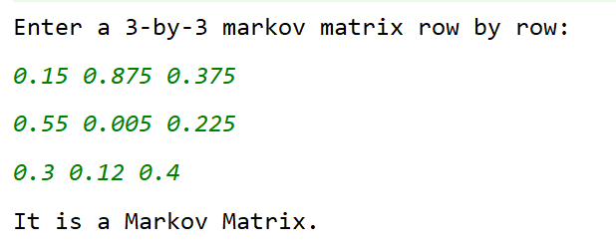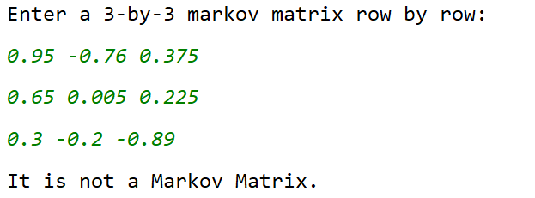

**Exercise4:**

package Week6;

import java.util.Arrays;

import java.util.Scanner;

public class Exercise4 {

public static void main(String[] args){

Scanner input=new Scanner(System.in);

System.out.println("Enter a 3-by-3 matrix row by row:");

double[][] m=new double[3][3];

for(int i=0;i<3;i++){

for(int j=0;j<3;j++){

m[i][j]=input.nextDouble();

}

}

double[][] newM=new double[3][3];

System.arraycopy(m,0,newM,0,3);

for(int i=0;i<3;i++){

Arrays.sort(newM[i]);

}

System.out.println("The row-sorted array is:");

for(int i=0;i<3;i++){

for(double a:newM[i])

System.out.printf("%.2f ",a);

System.out.printf("\n");

}

}

}

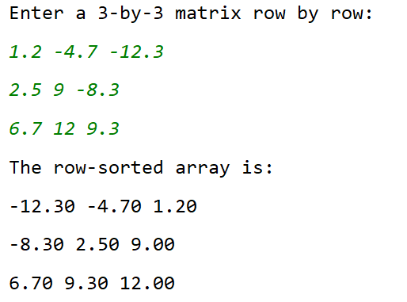

**Exercise5:**

package Week6;

import java.util.Scanner;

import java.util.Arrays;

public class Exercise5 {

public static void main(String[] args){

Scanner input=new Scanner(System.in);

System.out.println("Enter a 3-by-3 matrix row by row:");

double[][] m=new double[3][3];

for(int i=0;i<3;i++){

for(int j=0;j<3;j++){

m[i][j]=input.nextDouble();

}

}

double[][] newM=new double[3][3];

for(int i=0;i<3;i++) {

System.arraycopy(m[i], 0, newM[i], 0, 3);

}

for(int i=0;i<3;i++){

for(int j=0;j<3;j++){

newM[i][j]=m[j][i];

}

}

for(int i=0;i<3;i++){

Arrays.sort(newM[i]);

}

double[][] newNewM=new double[3][3];

for(int i=0;i<3;i++){

for(int j=0;j<3;j++){

newNewM[i][j]=newM[j][i];

}

}

System.out.println("The column-sorted array is:");

for(int i=0;i<3;i++){

for(double a:newNewM[i])

System.out.printf("%.2f ",a);

System.out.print("\n");

}

}

}

