**Exercise1：**

**public class** Exercise1 {  
 **public static int** product(String... numbers){  
 **int**[] argsX=**new int**[numbers.**length**];  
 **for**(**int** i=0;i<numbers.**length**;i++){  
 argsX[i]=Integer.*parseInt*(numbers[i]);  
 }  
 **int** product=1;  
 **for**(**int** a:argsX){  
 product*=a;  
 }  
 **return** product;  
 }  
  
 **public static void** main(String[] args) {  
 System.***out***.print(**"The series of integers are: "**);  
 **for**(**int** i=0;i<args.**length**;i++){  
 **if**(i<args.**length**-2) {  
 System.***out***.print(args[i] + **", "**);  
 }**else** {  
 **if**(i<args.**length**-1){  
 System.***out***.print(args[i]+**" and "**);  
 }**else** {  
 System.***out***.println(args[i]);  
 }  
 }  
 }  
 **for**(**int** i=2;i<args.**length**;i++) {  
 String[] eachArgs=**new** String[i];  
 **for**(**int** j=0;j<i;j++){  
 eachArgs[j]= args[j];  
 }  
 System.***out***.printf(**"The product of first %d integers is %d\n"**, i,*product*(eachArgs));  
 }  
 System.***out***.printf(**"The product of all series integers is %d"**, *product*(args));  
  
 }  
}

**Exercise2：**

**import** java.util.Scanner;  
**import** java.util.Random;  
**import** java.util.Arrays;  
  
**public class** Exercise2 {  
 **public static void** generateArray(**int**[][] records){  
 Random r=**new** Random();  
 **for**(**int** i=0;i<records.**length**;i++){  
 **for**(**int** j=0;j<records[0].**length**;j++){  
 records[i][j]=r.nextInt(10);  
 }  
 }  
 }  
  
 **public static void** printArray(**int**[][] records){  
 **for**(**int** i=0;i<records.**length**;i++){  
 System.***out***.println(**"S_"**+i+**":"**+Arrays.*toString*(records[i]));  
 }  
 }  
  
 **public static void** printAbsentID(**int**[][] records){  
 System.***out***.print(**"The absent SID is: "**);  
 **for**(**int** i=0;i<records.**length**;i++){  
 **int** times=0;  
 **for**(**int** j=0;j<records[0].**length**;j++){  
 **if**(records[i][j]==0){  
 times+=1;  
 }  
 }  
 **if**(times>1){  
 System.***out***.print(i+**" "**);  
 }  
 }  
 System.***out***.print(**"\n"**);  
 }  
  
 **public static void** printPoorLabID(**int**[][] records){  
 **double** totalSum=0;  
 **double**[] averageScore=**new double**[records[0].**length**];  
 System.***out***.println(**"The average score of every lab is: "**);  
 **for**(**int** i=0;i<records[0].**length**;i++){  
 **int** sum=0;  
 **for**(**int** j=0;j<records.**length**;j++){  
 sum+=records[j][i];  
 }  
 averageScore[i]=(**float**)sum/records.**length**;  
 System.***out***.printf(**"%.1f "**,averageScore[i]);  
 totalSum+=averageScore[i];  
 }  
 System.***out***.print(**"\n"**);  
 System.***out***.printf(**"The average score of lab class is: %.1f\n"**,(**float**)totalSum/records[0].**length**);  
 System.***out***.printf(**"The poor performance lab index are: "**);  
 **for**(**int** i=0;i<records[0].**length**;i++){  
 **if**(averageScore[i]<(**float**)totalSum/records[0].**length**){  
 System.***out***.print(i+**" "**);  
 }  
 }  
 }  
  
 **public static void** main(String[] args) {  
 Scanner input=**new** Scanner(System.***in***);  
 System.***out***.print(**"Please input the number of students: "**);  
 **int** sNum=input.nextInt();  
 System.***out***.print(**"Please input the number of practices in the lab class: "**);  
 **int** labNum=input.nextInt();  
 **int**[][] records=**new int**[sNum][labNum];  
 *generateArray*(records);  
 *printArray*(records);  
 *printAbsentID*(records);  
 *printPoorLabID*(records);  
 }  
}

**Exercise3：**

**Step1：**

**import java.util.Random;  
import java.util.Scanner;  
  
public class Exercise3_1 {  
 public static void main(String[] args) {  
 Scanner input=new Scanner(System.in);  
 System.out.println("Please input the numbers of students: ");  
 int stuNum=input.nextInt();  
 System.out.println("Please input the number of practices in lab class: ");  
 int labNum=input.nextInt();  
 int[][] records=new int[stuNum][labNum];  
 Random r=new Random();  
 for(int i=0;i<records.length;i++){  
 for(int j=0;j<records[0].length;j++){  
 records[i][j]=r.nextInt(10);  
 }  
 }  
 for(int i=0;i<records.length;i++){  
 for(int j=0;j<records[0].length;j++) {  
 System.out.print(records[i][j]+" ");  
 }  
 System.out.print("\n");  
 }  
 }  
}**

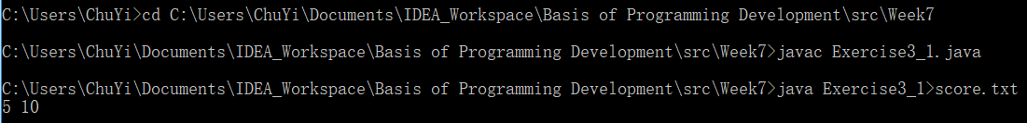

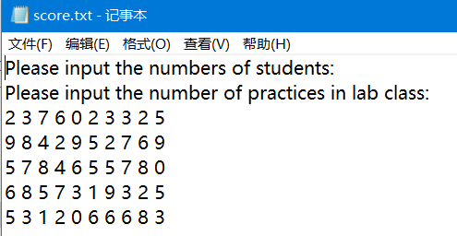

**Step2:**

**import java.util.Scanner;  
  
public class Exercise3_2 {  
 public static void main(String[] args) {  
 Scanner input=new Scanner(System.in);  
 String info1=input.nextLine();  
 String info2=input.nextLine();  
 System.out.println(info1);  
 System.out.println(info2);  
 int[][] records=new int[5][10];  
 for(int i=0;i<5;i++){  
 for(int j=0;j<10;j++){  
 if(input.hasNext()) {  
 records[i][j] = input.nextInt();  
 }  
 }  
 }  
 System.out.print("The absent SID is: ");  
 for(int i=0;i<records.length;i++){  
 int times=0;  
 for(int j=0;j<records[0].length;j++){  
 if(records[i][j]==0){  
 times+=1;  
 }  
 }  
 if(times>1){  
 System.out.print(i+" ");  
 }  
 }  
 System.out.print("\n");  
 double totalSum=0;  
 double[] averageScore=new double[records[0].length];  
 System.out.println("The average score of every lab is: ");  
 for(int i=0;i<records[0].length;i++){  
 int sum=0;  
 for(int j=0;j<records.length;j++){  
 sum+=records[j][i];  
 }  
 averageScore[i]=(float)sum/records.length;  
 System.out.printf("%.1f ",averageScore[i]);  
 totalSum+=averageScore[i];  
 }  
 System.out.print("\n");  
 System.out.printf("The average score of lab class is: %.1f\n",(float)totalSum/records[0].length);  
 System.out.printf("The poor performance lab index are: ");  
 for(int i=0;i<records[0].length;i++){  
 if(averageScore[i]<(float)totalSum/records[0].length){  
 System.out.print(i+" ");  
 }  
 }  
 }  
}**

**Exercise4:**

**import** edu.princeton.cs.algs4.StdDraw;  
**import** java.util.Scanner;  
  
**public class** Exercise4 {  
 **public static void** main(String[] args) {  
 System.***out***.print(**"Please input the n: "**);  
 Scanner input=**new** Scanner(System.***in***);  
 **int** n=input.nextInt();  
 StdDraw.*filledSquare*(0.5,0.5,0.5);  
 StdDraw.*setPenColor*(StdDraw.***BOOK_RED***);  
 **double** r=(**float**)1/n;  
 **for**(**int** i=0;i<n;i++){  
 **for**(**int** j=0;j<n;j++){  
 StdDraw.*filledSquare*((2*j+1)*r+r/2,(2*i+1)*r+r/2,r/2);  
 }  
 }  
 **for**(**int** i=0;i<n;i++){  
 **for**(**int** j=0;j<n;j++){  
 StdDraw.*filledSquare*((2*j)*r+r/2,(2*i)*r+r/2,r/2);  
 }  
 }  
 }  
}

