**Exercise1：**

**import java.util.Scanner;  
  
public class Exercise1 {  
 public static void main(String[] args) {  
 System.out.print("Enter the first city: ");  
 Scanner input=new Scanner(System.in);  
 String[] cities=new String[3];  
 cities[0]=input.nextLine();  
 System.out.print("Enter the second city: ");  
 cities[1]=input.nextLine();  
 System.out.print("Enter the third city: ");  
 cities[2]=input.nextLine();  
 for(int i=0;i<2;i++) {  
 if (cities[i].compareTo(cities[i + 1]) > 0) {  
 String a;  
 a = cities[i];  
 cities[i] = cities[i+1];  
 cities[i+1]=a;  
 }  
 }  
 for(int i=0;i<2;i++){  
 for(int j = 0; j<cities[i].split("").length-1; j++){  
 if(cities[i].split("")[j].compareTo(cities[i+1].split("")[j])<0){  
 String a;  
 a=cities[i];  
 cities[i]=cities[i+1];  
 cities[i+1]=a;  
 }  
 }  
 }  
 System.out.print("The three cities in alphabetical order are ");  
 for(int i=0;i<3;i++){  
 System.out.print(cities[i]+" ");  
 }  
 }  
}**

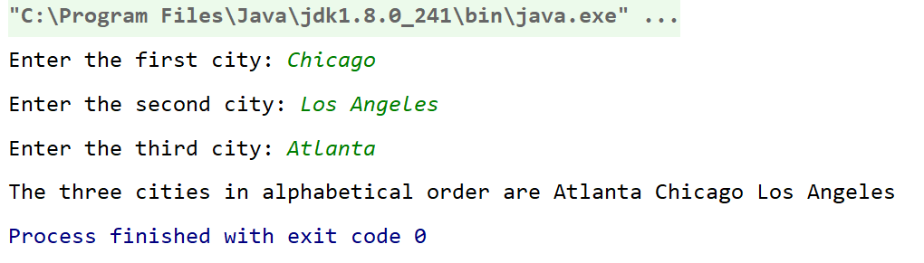

**Exercise2：**

**import java.util.Scanner;  
  
public class Exercise2 {  
 public static void main(String[] args) {  
 System.out.println("Enter a sentence(words separated by blanks):");  
 Scanner input=new Scanner(System.in);  
 String sentence=input.nextLine();  
 String[] wordsEnglish=sentence.split(" ");  
 String[][] wordsLatin=new String[wordsEnglish.length][];  
 for(int i=0;i<wordsEnglish.length;i++){  
 int a=wordsEnglish[i].split("").length;  
 wordsLatin[i]=new String[wordsEnglish[i].length()+1];  
 for(int j=0;j<a-1;j++){  
 wordsLatin[i][j]=wordsEnglish[i].split("")[j+1];  
 wordsLatin[i][a-1]=wordsEnglish[i].split("")[0];  
 wordsLatin[i][a]="ay";  
 }  
 }  
 for(int i=0;i<wordsLatin.length;i++) {  
 for (int j = 0; j < wordsLatin[i].length; j++) {  
 System.out.print(wordsLatin[i][j]);  
 }  
 System.out.print(" ");  
 }  
 }  
}**

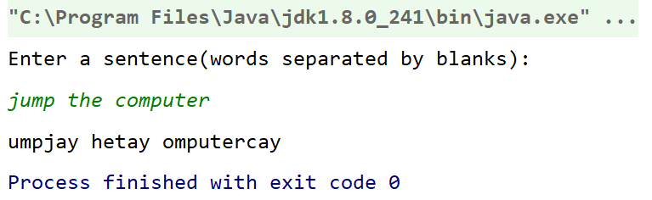

**Exercise3：**

**import edu.princeton.cs.algs4.StdDraw;  
  
public class Exercise3 {  
 public static void main(String[] args) {  
 for(int i=0;i<16;i++){  
 StdDraw.setPenColor(255-(255 / 15 * i),255-(255/15*i),255);  
 for(int j=0;j<16;j++){  
 StdDraw.filledSquare((2.*j+1)/32.,(2.*i+1)/32.,1./32.);  
 }  
 }  
 for(int i=0;i<16;i++){  
 StdDraw.setPenColor((255/15*i),(255/15*i),(255/15*i));  
 for(int j=0;j<16;j++){  
 StdDraw.filledSquare((2.*i+1)/32.,(2.*j+1)/32.,1./64.);  
 }  
 }  
 }  
}**

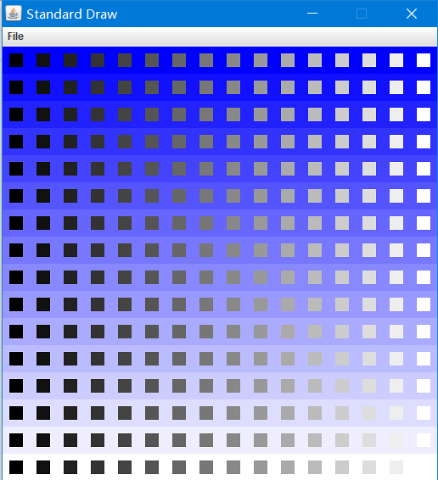

**Exerci4：**

**import edu.princeton.cs.algs4.StdDraw;  
  
public class Exercise4 {  
 public static void main(String[] args) {  
 StdDraw.setScale(-1,1);  
 double x=0;  
 double r=0.1;  
 while(true){  
 StdDraw.clear();  
 StdDraw.setPenColor(StdDraw.YELLOW);  
 StdDraw.filledRectangle(0,0,1,0.5);  
 StdDraw.setPenColor(StdDraw.RED);  
 StdDraw.filledCircle(x-0.9,0.4*Math.sin(10*x),r);  
 StdDraw.setPenColor(StdDraw.GREEN);  
 StdDraw.filledCircle(x-0.9,0.9*Math.cos(10*x+Math.PI/3),r);  
 StdDraw.show();  
 StdDraw.pause(400);  
 x+=0.05;  
 if(x>1.8){  
 x=0;  
 }  
 }  
 }  
}**

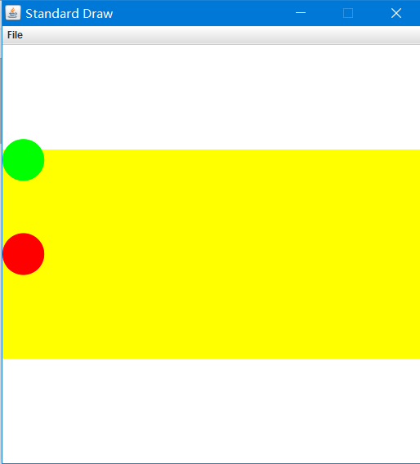

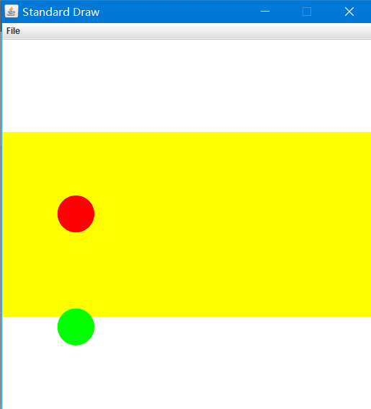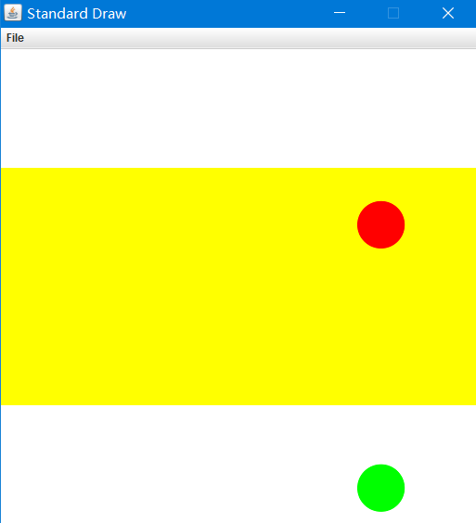

**Exercise5：**

**import edu.princeton.cs.algs4.Picture;  
import java.awt.*;  
import java.util.Random;  
  
public class Exercise5 {  
 public static void main(String[] args) {  
 Picture pic=new Picture(args[0]);  
 int h=pic.height();  
 int w=pic.width();  
 Picture target=new Picture(w,h);  
 for(int col=0;col<w;col++){  
 for(int row=0;row<h;row++){  
 Random r=new Random();  
 int a,b;  
 do {  
 a =col+ r.nextInt(10) - 5;  
 b =row+ r.nextInt(10) - 5;  
 }while(!(a>0&&a<w&&b>0&&b<h));  
 Color finalColor=pic.get(a,b);**  
 **target.set(col,row,finalColor);  
  
 }  
 }  
 target.show();  
 }  
}**



