**Exercise1：**

**Step1：**

**public class Triangle{  
 private int a,b,c;  
 private int perimeter;  
 private double area;  
 private boolean valid;  
  
 public Triangle(){  
 a=3;  
 b=4;  
 c=5;  
 valid=true;  
 }  
  
 public Triangle(int x, int y, int z){  
 a=x;  
 b=y;  
 c=z;  
 };  
  
 public int getA(){  
 return a;  
 };  
 public int getB(){  
 return b;  
 };  
 public int getC(){  
 return c;  
 };  
 public void setA(int x){  
 a=x;  
 };  
 public void setB(int y){  
 b=y;  
 };  
 public void setC(int z){  
 c=z;  
 };  
 public int getPerimeter(){  
 return a+b+c;  
 };  
 public double getArea(){  
 double p=(double)(a+b+c)/2;  
 double a1=(double)a;  
 double b1=(double)b;  
 double c1=(double)c;  
 return Math.sqrt(p*(p-a1)*(p-b1)*(p-c1));  
 };  
 public boolean isValid(){  
 if(a+b>c&&a+c>b&&b+c>a){  
 return true;  
 }else return false;  
 };  
}**

**Step2：**

**import java.util.Scanner;  
  
public class Exercise1 {  
 public static void main(String[] args) {  
 Triangle aTriangle=new Triangle();  
 System.out.println("Create a default Triangle, its edges are: "+aTriangle.getA()+" "+aTriangle.getB()+" "+aTriangle.getC());  
 System.out.println("Its perimeter is: "+aTriangle.getPerimeter()+" and its area is: "+aTriangle.getArea());  
  
 Scanner input=new Scanner(System.in);  
 System.out.println("Create a new Triangle, please input three edges:");  
 int a=input.nextInt();  
 int b=input.nextInt();  
 int c=input.nextInt();  
  
 Triangle newTriangle=new Triangle(a,b,c);  
 if(newTriangle.isValid()){  
 System.out.println("A new Triangle is created, its edges are: "+newTriangle.getA()+" "+newTriangle.getB()+" "+newTriangle.getC());  
 System.out.println("Its perimeter is: "+newTriangle.getPerimeter()+" and its area is: "+newTriangle.getArea());  
 }else System.out.println("The new Triangle is not valid");  
  
 System.out.println("Modify an edge of the new Triangle, please input its value:");  
 int x=input.nextInt();  
 newTriangle.setA(x);  
  
 if(newTriangle.isValid()){  
 System.out.println("A new Triangle is created, its edges are "+newTriangle.getA()+" "+newTriangle.getB()+" "+newTriangle.getC());  
 System.out.println("Its perimeter is: "+newTriangle.getPerimeter()+" and its area is: "+newTriangle.getArea());  
 }else System.out.println("The new Triangle is not valid");  
  
 }  
}**

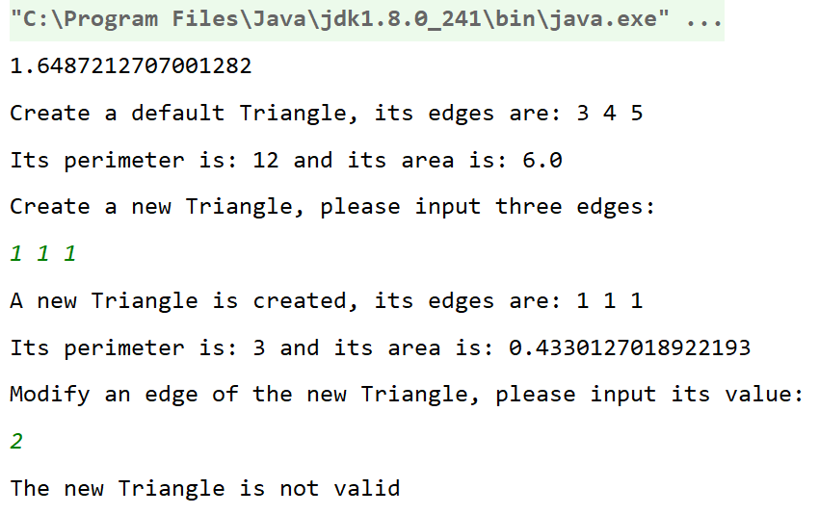

**Exercise2:**

**Step1:**

**import java.util.Random;  
  
public class ClassRoom {  
 private int id;  
 private int seatsNumber;  
 private int[][] arrangement;  
  
 public ClassRoom(){  
 id=201;  
 seatsNumber=45;  
 arrangement=new int[5][7];  
 Random r=new Random();  
 for(int i=0;i<5;i++){  
 for(int j=0;j<7;j++){  
 arrangement[i][j]=r.nextInt(5);  
 }  
 }  
 }  
  
 public ClassRoom(int id,int seatsNumber){  
 this.id=id;  
 this.seatsNumber=seatsNumber;  
 arrangement=new int[5][7];  
 Random r=new Random();  
 for(int i=0;i<5;i++){  
 for(int j=0;j<7;j++){  
 arrangement[i][j]=r.nextInt(5);  
 }  
 }  
 }  
  
 public void printClassRoom(){  
 for(int i=0;i<80;i++){  
 System.out.print("=");  
 }  
 System.out.println();  
 System.out.printf(" Class Room #%d with Seats(%d)",id,seatsNumber);  
 System.out.println();  
 System.out.print(" ");  
 for(int i=0;i<7;i++){  
 System.out.print("Day"+(i+1)+" ");  
 }  
 System.out.println();  
 for(int i=0;i<4;i++){  
 System.out.print((i+1)+"("+(2*i+1)+"_"+(2*i+2)+")"+" ");  
 for(int j=0;j<7;j++){  
 System.out.print(arrangement[i][j]+" ");  
 }  
 System.out.println();  
 }  
 System.out.print("5(9_10) ");  
 for(int j=0;j<7;j++){  
 System.out.print(arrangement[4][j]+" ");  
 }  
 System.out.println();  
 for(int i=0;i<80;i++){  
 System.out.print("=");  
 }  
 System.out.println();  
 }  
  
 public void printValidForExam(int day,int time,int number){  
 if(arrangement[time-1][day-1]==0&&number<=seatsNumber){  
 System.out.printf("Room #%d with seats(%d) on day_%d time_%d is Valid for EXAM",id,seatsNumber,day,time);  
 System.out.println();  
 System.out.println("The number of seats in room is OK");  
 System.out.printf("The room at day_%d time_%d is OK",day,time);  
 }else {  
 System.out.printf("Room #%d with seats(%d) on day_%d time_%d is NOT Valid for EXAM",id,seatsNumber,day,time);  
 System.out.println();  
 if(number<=seatsNumber){  
 System.out.println("The number of seats in room is OK");  
 }else {  
 System.out.println("The number of seats in room is NOT OK");  
 }  
 if(arrangement[time-1][day-1]==0){  
 System.out.printf("The room at day_%d time_%d is OK",day,time);  
 }else {  
 System.out.printf("The room at day_%d time_%d is NOT OK",day,time);  
 }  
 }  
 }  
}**

**Step2:**

**import java.util.Scanner;  
  
public class Exercise2 {  
 public static void main(String[] args) {  
 Scanner input=new Scanner(System.in);  
 System.out.println("There is a classroom");  
 ClassRoom c1=new ClassRoom();  
 c1.printClassRoom();  
 System.out.println("Please input your day, time, nubmer:");  
 System.out.printf("Day(1~7): ");  
 int day=input.nextInt();  
 System.out.printf("Time(1~5): ");  
 int time=input.nextInt();  
 System.out.printf("Number of students: ");  
 int number=input.nextInt();  
 c1.printValidForExam(day,time,number);  
 input.close();  
 }  
}**

