**IM3080 Design and Innovation Project (AY2021/Y3 Semester 1)**

**Individual Report**

Name: Chang Rong Qi, John

Group No: 03

Project Title: Jio

**Contributions to the Project** (1-2 page)

**Leadership**

* Code Lead
* Responsible for Good Quality Code
* Responsible for training team on:
  + Git & GitHub
  + Unity
* By default, the technical slides presenter (haha)
* Collaborated with Leader Boya & Art Lead June to push project forward

**Git**

* Hosted the GitHub Project under the name (Eve-ning)
  + Resolve Git Version Conflicts
  + Oversees Project Git Versioning
    - Responsible for Rollback & Quality Assurance of Code
    - Responsible for Pull Request Merging
  + >354 Git Commits on Project
  + 32 Git Pull Requests on Project
  + >1.5m Line Additions & Deletions
* Taught team how to use Git,
* Simple README.md design

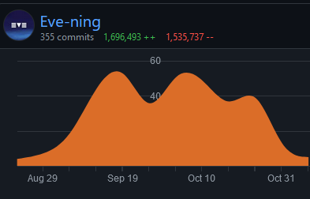 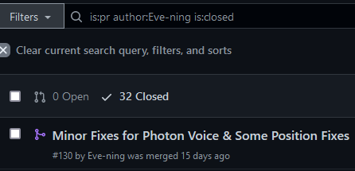

**Unity & C#**

* Responsible for C# code on the project
* Integrated Photon Multiplayer Ecosystem
  + Base Photon
  + Photon Chat
  + Photon Voice
* Collaborated with Joedi for Unity Animation for Sprites & UI
* Collaborated with Jia Le for AWS Cloud Database Integration
* Collaborated with Fu Hao & Jia Le for Tilemap integration
* Collaborated with Design Team (Wei Xuan, June, Wai Seng, Evy, Christy) to integrate wireframes, UI, Sprites into Unity
* Responsible for Cross-Platform integration (Android)

**Major Code Contributions**

* General Code
  + Y-axis Resolution solution for 2D Sprite ordering
  + Enforcing a clean code convention
  + Photon Network Ecosystem coding, mainly integrating Callbacks
  + Implemented Universal Render Pipeline (URP) for dynamic 2D Lighting
  + Ensure that the game works on *MOST ASPECT RATIOS*
* Fishing Expedition Code
  + Server-Client Master-Slave design pattern to runtime synchronize timer reliably.
  + Dynamic Room Creation
  + Reliable Player State synchronization such as
    - Transform
    - Animation Triggers
    - Cat Skin
  + Expedition Prefab-Parent design pattern for consistent Expedition Map implementation.

**Other Contributions**

* Contributed to making the video possible with installation onto Android
* Always-ready backup presenter in case something happens
* Linking up with Code Team on progress with weekly meetings
* Ensuring that the sprites are always correctly rendered

**Reflection on Learning Outcome Attainment**

**Reflect on your experience during your project and the achievements you have relating to at least two of the points below:**

1. Engineering knowledge
2. Problem Analysis
3. Investigation
4. Design/development of Solutions
5. Modern Tool Usage
6. The Engineer and Society
7. Environment and Sustainability
8. Ethics
9. Individual and Team Work
10. Communication
11. Project Management and Finance
12. Lifelong Learning

Point 1: Individual & Team Work

In one of the first meetings, Prof Chua said this project will be a mountainous ascent. Considering that we’re making a game, on-top of a meeting application, it’s an endeavor that calls for high demands between coders and designers to realize this project.

Despite that, I’ve always insisted that “See how, always can one”. Empty gesture such as these may not have given the team much confidence, but I’m determined to piece together the idea.

So here we are, it worked somehow; I wouldn’t say it’s blind luck or sheer overconfidence, but if it works, then don’t touch it.

I’ve always seen people as being talents on their own field. This team really shows.

* Boya is an excellent leader and communicator
* Jia Le is adventurous in coding & design
* June has great design vision
* Fu Hao is a brilliant master of all trades
* Evy, Wei Xuan & Wai Seng make an excellent Sprite Design Team Trio in making most of the sprites possible
* Joedi is a reliable Sprite Animator and lias to the Sprite Design Team
* Christy was a versatile designer for the UI and TileMap

While manning the Git Project, I can see tremendous efforts pushed towards the repository. I’m honored to lead such a great team towards this final project, though it may not be perfect, it was sure a brilliant journey.

I hope my team doesn’t undervalue themselves because of mistakes done in the project. The real value is the perseverance of mind & versatility of tools that only a group of IEM students can achieve.

Point 2: Modern Tool Usage

**C# & Unity**

Have been longing for trying C# (again) for quite a while, also Game Dev!

C# reminds me of a language somewhere between the versatility of Python and the strictness of C++. I do find C# okay, but I do miss writing in languages I’m comfortable with; though a great experience forcing myself to try anyways. (I get to put it on my resume)

Unity wasn’t entirely foreign, but the idea of a multiplayer, voice, chat enabled game made me unsure of myself. Personally, I’ve never tried 90% of what I’ve done in this project, so it was quite a feat.

**Git**

Leading a 10-strong git project is a rare opportunity. It’s an honor, though, a worrying experience to manage a team most of which new to git. Personally, I have used Git for the past >3 years, but hosting a large project like this means I am responsible for

* Rollbacks
* Merge Conflicts
* IT Support
* Pull Requests
* And many more

This pushed me to use new git commands such as cherry-picking, selective rollback, merge upstream, on-fork editing etc. It was honestly a great learning experience, and you don’t get this ever unless you do this project.

**Editor**

Hardcore fan of JetBrains, was meaning to use JetBrains Rider for a long time. Learnt many things who knew was possible.

* Debugging Unity on another editor with breakpoints
* Directly refactoring raw Unity files and hoping it doesn’t break
* Many suggestions in JetBrains Rider led me to learning modern patterns such as
  + Properties
  + LINQ
  + Partials
  + Namespaces
  + Coding Standards

Honestly love JetBrains