# Positive Me First: positive bias toward positive self in cognitive processing

Yi Ding

Department of Psychology, Hubei University, 430062 Wuhan, PR China

Jing Deng

Department of Psychology, Hubei University, 430062 Wuhan, PR China

Chuan-Peng Hu

German Resilience Center, Johannes Gutenberg University Medical Center, 55131 Mainz, Germany;

Neuroimaging Center, Johannes Gutenberg University Medical Center, 55131 Mainz, Germany

**Introduction**

[added later]

**Methods**

**Participants**

The participants were 89 undergraduates and postgraduates from the Hubei University. All participants were students at Hubei University and they had normal vision or corrected vision. All participants read and signed informed consent before the experiment. After the experiment, participants got 20 yuan for compensation.

Table 1. Information of participants for each task

|  |  |  |  |  |  |
| --- | --- | --- | --- | --- | --- |
|  | Self-referential | Self-IAT | Self-associative | Questionnaire | All Task |
| N |  |  |  |  |  |
| Valid N |  |  |  |  |  |
| Female |  |  |  |  |  |
| Age (year) | Mean ± SD |  |  |  |  |

As for the self-referential task, all 89 participants took part in it. The first 30 of them were excluded from data analysis because a major program error [1]. The final results of self-referential memory task include 59 of the participants (43 females, 16 males; age ranging from 18 to 24 years; *M* = 20.47, *SD* = 1.39).

As for the self-referential IAT task, 74 of all participants enrolled in this task. 70 of them completed and the data were valid (56 female, age ranging from 18 to 24 years, *M* = 20.19, *SD* = 1.34).

As for the associative learning task, 68 of all participants attended. using 0.6 as the criterion, 29 participants (23 female, age ranging from 18 to 22 years, *M* = 20.03, *SD* = 1.21) were included in Associative Learning data analyze.

29 participants took part all tasks (23 female, age ranging from 18 to 22 years, *M* = 20.03, *SD* = 1.21).

**Overview**

Our study consists of three behavioural tasks and two sets of questionnaires. If not noted, participants took part in all the tasks described below. The self-referential memory task and one set of questionnaires was finished one day, and the self-referential IAT task and associative learning task at the other day. There were at least 24 hours between the two experimental days. The order of tasks was balanced among participants.

### **Experimental design**

**Self referential recognition task** 2 (domain: morality vs. competence) × 2 (valence: positive vs. negative) × 2 (self-reference: self vs. friend) within-subject design. Moral adjective means words which uses to describe an individual's stable moral qualities, such as nobility, honesty, and so on. Competence means that you can do something well or effectively, such as excellent, powerful and so on.

**IAT Task** 2 (self-relevance: self, non-self) × 2 (domain: morality, competence) × 2 (valence: positive, negative) within-subject design, and the dependent variable was the implicit effect and competence of the moral self. The implicit effect, the mean reaction time of incompatible tasks minus the average reaction time of compatible tasks.

**Associative Learning Task** 2 (self-relevance: self, non-self) × 2 (valence: positive, negative) × 2 (matching: matched, mismatched) within-subject design. Dependent variables: Sensitivity d’ between self-active moral words and self-negative moral words.

### **Stimuli**

**Words preparation**

**Word collection** 32 participants were recruited through internet (14 male, *M* = 23.41, *SD* = 2.64, range from 20 ~ 29). Participants got 5 yuan for compensation. Participants were instructed to recall words based on description. They should write at least 3 Chinese words in 5 (dimension: morality, capability, social competency, physical attractiveness, social economic status) × 2 (valence: positive vs. negative). 2,524 words were collected, 1707 words of them are unique. Additionally, we selected 42 more words from the Chinese personality vocabulary Cui (2005).

**Word rating** 2 undergraduates and 2 master students majored in Chinese were invited to merge the synonyms independently. Based on their classification, one undergraduate research assistant further sort out the vocabulary. Thus, the final vocabulary has ten dimensions (5 domain × 2 valence), and each dimension consist of clusters of synonyms. The materials used in our task is then selected from this final list.

**Final materials**

**Self-referential memory task** We selected 144 words from the above word list, based on two criteria: (a), the frequency of the word is as high as possible; (b) the word didn't repeat in multiple dimensions However, these words are not enough for our recongnition task, therefore, we further selected 42 words from previous personality study (王登峰 & 崔红, 2005). These words were then rated by 32 independent participants on the internet (8 male, age = 21 ± XX, range from 18 ~ 30)[2]. These participants were asked to judge the dimensions (5 dimensions: morality, capability, social competency, physical attractiveness, social economic status) of each word. Based on these ratings, we selected 24 words using the same criteria mentioned above. **168 words were selected**, 8 words will serve as filler words at the beginning and the end of the experiment, 160 words served as the experimental materials, 40 words for each condition (moral positive, moral negative, competence positive, competence negative).

**Self-reference IAT task** The target words for IAT Task came from the study of Huajian Cai (Cai, 2003). The attribute words for IAT Task were obtained the words list we described above. We also choose words based on the above-mentioned criteria 40 adjectives were used in the experiment (moral positive: 10; moral negative: 10; competence positive: 10; competence negative: 10, see appendix).

**Associative learning task** The stimuli for associative learning task is four simple geometric shapes (equilateral triangles, squares, diamonds, and trapezoids, each with a viewing angle of 2.7º × 2.7º). Each shape was paired with different label with different moral meanings. The figure is displayed above the central gaze point (0.8º × 0.8º), and the text appears below (2.6º × 1.6º). The labels are four Chinese words ("good self", "bad self", "good other" and "bad other"). The matching relationship between shapes and labels was balanced among participants. The distance between the gaze point and the center of the figure and text is 2.5º.

**Questinnaires**

**Procedure**

The experiment was finished in two consecutive days. Participants finished the self-referential memory taks at the 1st day, and the self-referential IAT and associative task at the 2nd day, or reverse.

**Recognition Task**

Before the experiment, the participants should write down one of their friend’s name. They knew each other at least 2 years ago and always met him/her in recent 2 years. In the experiment, we use “friend” instead of their real name. And there are 3 phases: learning, distraction and recognition task. Participants were told that the experiment was a rating words task.

In the learning phase, participants were required to rate how suitable the word is to describe themselves or their friend ranging from 1 (not at all) to 5 (very much). Each trial started with the presentation of a central fixation cross for 500 ms. Subsequently, an adjective word and the instruction for rating were presented simultaneously. The rating presented 3000 ms. The next frame showed a blank for 1000 ms.

Then a distraction lasted about 4 minutes. Participants were asked to complete some simple calculation to insure they didn’t repeat the vocabulary in their head.

In the recognition task, participants were randomly presented 168 words that consist of 80 new words and 88 old words which were presented in the learning phrase. Then participants were asked to judge whether the word was learned before. If not, they should press "J" which meant it was a new word, and the trial ended and continue to the next word; if yes, they should press "F" which meant it was an old word. Following the press of “F” button, participants were further asked whether the word was associated with themselves or theirfriend, for the self, they should press “F”, “J” for friend.

../Desktop/5.pdf

Figure 1.1 Experimental flow chart of self-referential memory task

After recognition task, participants need to complete four scales to avoid participants’ influence, including self-esteem (Ji Yifu, 1993; Rosenberg, 1965) moral identity (Aquino & Reed Ii, 2002; ZengKui, 2008), NIP-16 (Ames, 2006; Xiaoyan, 2008), NTBS (Leary, 2013; Shucai, 2008).

**IAT Task**

The IAT Task was performed on the computer through E-prime 2.0.

As shown in Table 2.1, the experimental procedure is divided into seven steps.

(1) Presentation of concept words: Let the participants respond to conceptual words representing self and non-self respectively (e.g., the concept word representing oneself by E, and the non-self by I);

(2) Presenting attribute words: Let participants respond to positive moral vocabulary (e.g., justice) and negative moral vocabulary (e.g., selfishness) (positive vocabulary by E, negative vocabulary by I);

(3) Joint Task 1: Jointly present concept words and attribute words to let participants respond (self-concept words and positive words according to E, non-self word and negative words according to I);

(4) Test the joint task one;

(5) Let participants make opposite judgments on concept words, and exchange the content reflected by the left and right keys (non-self-concept word by E, self-concept word by I);

(6) Joint Task Two: Again presenting conceptual words and attribute words, allowing participants to respond, which is the opposite of the content of a joint task (non-I concept words and positive words by E, self-concept words and negative words by I);

(7) Test joint task two

Table 2.1 Implicit Association Test Experiment Procedure

|  |  |  |  |  |
| --- | --- | --- | --- | --- |
| Step | Traits | Practice/Test | “E” | “I” |
| 1 | 40 | Practice | Self | Non-self |
| 2 | 40 | Practice | Positive word | Negative word |
| 3 | 40 | Practice | Self+Positive word | Non-self+Negative word |
| 4 | 80 | Test | Self+Positive word | Non-self+Negative word |
| 5 | 40 | Practice | Non-self | Self |
| 6 | 40 | Practice | Non-self+Positive word | Self+Negative word |
| 7 | 80 | Test | Non-self+Positive word | Self+Negative word |

**Assoicative learning task**

The associative learning task included two phases: The first phase is the learning phase. Participants need to learn the correspondence between graphics and tags. The four graphics are regular triangles, squares, circles, and diamonds, which correspond to four character tags: good, good, bad, and bad. For example, we may tell a paticipant that "I am a good triangle; a good person is a diamond."

In order to match the concreteness of different people's labels before the beginning of the exercise, participants were informed the meaning of each character's label. For example, "good self" represents the morally noble aspects of oneself, and you can imagine that you have done some morally noble events at the moment. "good other" represents the morally noble side of another person. It can be imagined as a stranger at the moment of a morally noble event; "bad self" represents a morally depraved side, and you can imagine yourself doing something moral; “bad other” represent the morally corrupted side of others, and you can imagine a stranger at the moment of a moral corruption. The meanings of labels were thoroughly explained so that the participant understood them. After that, participants were instructed to learn the association between the shapes and the labels. They were instructed to memorized the association. When they thought they remembered the associations, the practice of matching task began. In general, participants were able to remember the connection between figures and characters within 1 minute.

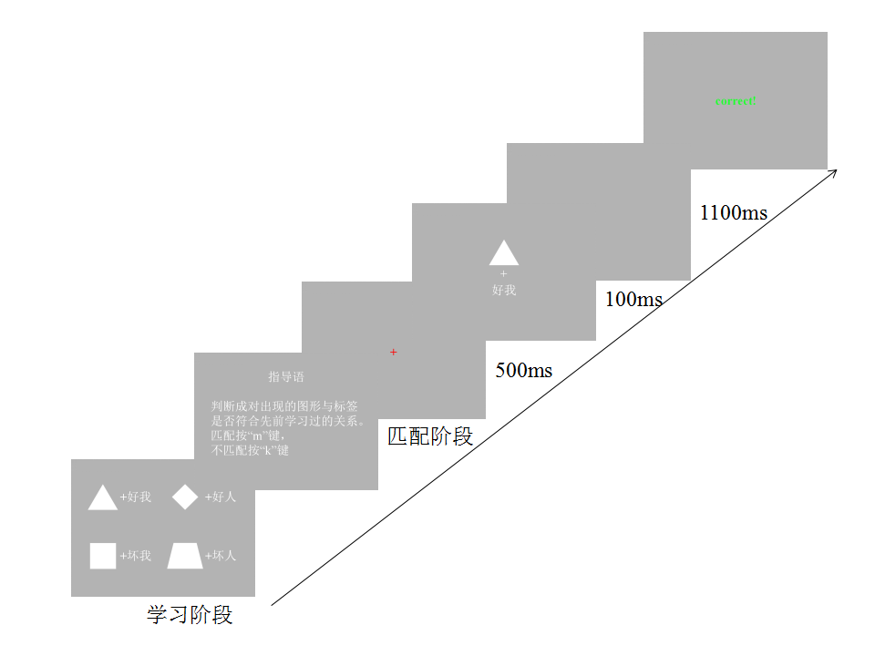

Figure 2 Flow chart of experiment 2

The second phase is the matching phase. Participant need to determine whether the "shape-label" pair is correct (i.e., consistent with the association they learned). In each trial, 500ms of the central fixation was presented at first, and then a pair of "shape-personal" stimuli was presented for 100ms. " shape-label " may conform to the combinations in the guide and may not be compliant. "Graphics - People" is followed by a 1100ms screen. Participant need to press the key in the blank stage. If the match in the instruction is met, press the M key (the other half presses the K key); if not, press the K key (the other half presses the M key). When asked to press the test button, it is fast and accurate (see Figure 2.1). After the test button was pressed, a 500ms feedback screen was provided to encourage participants to learn. The feedback is consistent with the correctness of the response of the test. If no key is detected, the message “too slow” is displayed, allowing the test to speed up the response. After each block is over, the screen will feedback its overall accuracy rate in the entire block.

Before the formal experiment, each participant kept practice unter their overall accuracy rate reached 60%. The formal experiment has a total of 8 blocks, and each block includes 48 trials. Therefore, there are 48 trials for each experimental condition (good me-matching, good me-not matching; good people-matching, good people-not matching; bad me-matching, bad me-not matching; bad people-matching, bad people- Mismatch). Half of the shape-label in the task match previously learned relationships, belong to the matching pair, and half do not match-tag pairs.

**Data Analyzing**

**Self-referential memory task**

The data were analyzed by using repeated measures ANOVAs and put different word lists as covariate. The recognition accuracy, source recognition accuracy, as well as the sensitivity to the target was calculated and then subject to repeated measure ANOVA, with word domain, valence and reference as three within-subject independent variables.

Moreover, we used the multi-process tree model (MPT) (Batchelder & Riefer, 1990) and Treebugs (Heck, Arnold, & Arnold, 2017), a package for R environment (R core team, 2018), to fit the data and further explore the source accuracy and guess for different conditions.

5.pdf

Figure3.1 MPT model, *D*1 = probability of recognizing the word is old in the self-condition, *D*2 = probability of recognizing the word is old in the friend condition, *D*3 = probability of recognizing the word is new, *d*1 = conditional probability of remembering whether the associated word was self, *d*2 = conditional probability of remembering whether the associated word was friend, *a* = probability of guessing that the adjective was associated with self, *b* = probability of guessing that the adjective was associated with friend.

**Self-referential IAT task**

We followed the previous IAT studies to analyze our data [], more specifically, the data analyzing steps are as follows:

(1) Participants with more than 10% less than 300ms were excluded from the number of tasks;

(2) Reject reactions with less than 300ms and greater than 3000ms during reaction;

(3) Replace the wrong reaction in each task with the average reaction time of correct response plus 600ms penalty;

(4) The difference between the average response time of incompatible tasks and compatible tasks is divided by the standard deviation of all responses of the task to obtain the value of d.

**Associative Learning Task**

(1) Select only the data of the test phase, and eliminate reactions less than 200ms during reaction;

(2) Calculate the sensitivity d' value based on the data of matching and mismatch conditions for each condition;

(3) Statistical analysis of response time and d' is performed using variance analysis of repeated measurements.

(4) Repeated measures analysis of variance for response time, with self-relevance and moral valence as two in-subject variables. Subsequently, a separate analysis of the response time under matched and non-matched conditions was performed.

**Cross Task Analysis** In order to further examine the stability of the moral self superiority effect, the implicit self-enhancement effect in the IAT (the d value of the positive moral word minus the d value of the negative moral word) and the moral self-dominance effect in the social associative learning experiment are calculated separately. The d' value is subtracted from the d' value of the good person and a correlation analysis is performed.

**Results**

### **Self-referntial memory task** There were three within-subject variables, 2 (domain: morality vs. competence) × 2 (valence: positive vs. negative) × 2 (reference: self vs. friend). In this experiment, we didn't exclude any data.

Table 1 shows the accuracy of different conditions. The data were analyzed using repeated measures ANOVAs and put different word lists as covariate.

New-Old recognition results

A 2 (domain: morality vs. competence) × 2 (valence: positive vs. negative) × 2 (reference: self vs. friend) RMANOVAs was performed with different word list as covariate. We found a significant main effect of word’s domain, *F*(2, 56) = 18.02, *p* < .001, *η2*= 0.182. The main effect of valence was not significant, *F*(2, 56) = 0.615, *p* = 0.436, *η2*= 0.011; the main effect of self-reference was not significant, *F*(2, 56) = 0.141, *p* = 0.709, *η2*= 0.002; The interaction of word’s domain and word’s valence is significant, *F*(2, 56) = 8.419, *p* = 0.00XXX, *η2*= 0.126. Paired *t*-tests indicated that accuracy differ according to domain for positive words (t(57) = 2.614, p < 0.05 (after Bonferroni adjustment), Cohen’s d = 0.343，95% CI [0.077, 0.607]), but didn’t differ for negative words (t(57) = -1.121, p > 0.05, Cohen’s d = -0.147，95% CI [-0.405, 0.112]). Paired *t*-tests indicated that accuracy differ according to valence for moral words (t(57) = 5.124, p < 0.005 (after Bonferroni adjustment), Cohen’s d = 0.673，95% CI [0.385, 0.956]), but didn’t differ for competent words (t(57) = 0.998, p > 0.05, Cohen’s d = 0.131，95% CI [-0.128, 0.389]). The interaction between domain and reference was not significant, *F*(2, 56) = 1.003, *p* = 0.321, *η2*= 0.017. The interaction between valence and source was significant, *F*(2, 56) = 6.256, *p* < 0.05, *η2*= 0.081. Paired *t*-tests indicated that accuracy didn’t differ according to valence for words related with self (t(57) = 0.916, p > 0.05, but didn’t differ for words related with friend (t(57) = 4.679, p < 0.001, Cohen’s d = 0.614，95% CI [0.331, 0.893]). Paired *t*-tests indicated that accuracy didn’t differ according to word’s source for positive (t(57) = 1.472, p >0.05), but differ for negative words (t(57) = 4.678, p <0.001, Cohen’s d = 0.614，95% CI [0.331, 0.893]). There is no significant three-way interaction.

Table 1.1

Mean accuracy at domain (moral vs. competence), word valence (positive vs. negative) and reference (self vs. friend) (*M* ± *SD*)

|  |  |  |  |  |
| --- | --- | --- | --- | --- |
| Domain | | | | |
| New-old recognition | Positive moral | Negative moral | Positive competence | Negative competence |
| self | 0.597 (0.273) | 0.488(0.244) | 0.493 (0.301) | 0.553 (0.246) |
| friend | 0.529 (0.233) | 0.409(0.210) | 0.505 (0.224) | 0.402 (0.256) |

Table 1.2

*d’* in domain (moral vs. competence), word valence (positive vs. negative) (*M* ± *SD*)

|  |  |  |
| --- | --- | --- |
| Domain  Valence | Moral | Competence |
| Positive | 0.125 (0.390) | 0.080(0.541) |
| Negative | -0.085 (0.597) | -0.025 (0.539) |

Source recognition

Table 2 shows the accuracy of different conditions.

A 2 (domain: morality vs. competence) × 2 (valence: positive vs. negative) × 2 (reference: self vs. friend) RMANOVAs was performed with different word list as covariate. We found a significant main effect of word’s domain, *F*(2, 56) = 23.488, *p* < 0.01, *η2*= 0.214. The effect of valence was not significant, *F*(2, 56) = 0.310, *p* = 0.580, *η2*= 0.005; the effect of reference was not significant, *F*(2, 56) = 3.423, *p* = 0.070, *η2*= 0.055; The interaction of word’s domain and word’s valence is significant, *F*(2, 56) = 10.196, *p* < 0.01, *η2*= 0.150. The interaction between domain and reference was not significant, *F*(2, 56) = 2.572, *p* = 0.114, *η2*= 0.043, the interaction between valence and reference was not significant, *F*(2, 56) = 1.206, *p* = 0.277, *η2*= 0.020, There is no significant three-way interaction, *F*(2, 56) = 0.863, *p* = 0.357, *η2*= 0.014.

And a 2 (domain: morality vs. competence) × 2 (valence: positive vs. negative) simple main effects analyses was performed, which revealed that positive moral words can be remembered better than positive competent words, *F*(2, 57) = 8.591, *p* < 0.01. And negative competent words can be better remembered than negative moral words, *F*(2, 57) = 5.738, *p* < 0.05. Positive moral words can be better remembered than negative moral words, *F*(2, 57) = 29.915, *p* < 0.001.

Table 1.3

Mean accuracy at domain (moral vs. competence), word valence (positive vs. negative) and reference (self vs. friend)

|  |  |  |  |  |
| --- | --- | --- | --- | --- |
| domain | | | | |
| Source recognition | Positive moral | Negative moral | Positive competence | Negative competence |
| Self | 0.366 (0.246) | 0.260 (0.185) | 0.274 (0.240) | 0.362 (0.222) |
| Friend | 0.386 (0.192) | 0.300 (0.187) | 0.345 (0.184) | 0.293 (0.216) |

Questionnaire analysis

We calculated participant’s score in each questionnaire. The results suggested that self-esteem was significantly correlated with New-Old recognition accuracy in negative moral self condition, r = 0.347, p < 0.05, and positive competent self condition, r = 0.333, p < 0.05. NTBS was significantly correlated with positive moral self condition, r = 0.291, p < 0.05, negative moral self condition, r = 0.338, p < 0.05, and negative competent self, r = 0.357, p < 0.05. NIP-16 was significantly correlated with positive competent self condition, r = -0.300, p < 0.05. Moral identity was not significantly correlated with any condition.

Table 1.4

New-Old recognition accuracy correlated with each questionnaire

|  |  |  |  |  |  |  |  |  |  |
| --- | --- | --- | --- | --- | --- | --- | --- | --- | --- |
|  | Positive moral self | | Negative moral self | | Positive competent self | | Negative competent self | |  |
|  | *r* | *p* | *r* | *p* | *r* | *p* | *r* | *p* |
| Self-esteem | 0.109 | 0.460 | 0.347 | 0.016* | 0.333 | 0.021* | 0.205 | 0.162 |
| NTBS | 0.291 | 0.044* | 0.338 | 0.019* | 0.278 | 0.056 | 0.357 | 0.013* |
| NIP-16 | -0.092 | 0.534 | 0.179 | 0.224 | -0.300 | 0.038* | -0.101 | 0.493 |
| Moral identity | -0.068 | 0.645 | 0.092 | 0.533 | 0.010 | 0.949 | 0.071 | 0.633 |

*p < 0.05

**IAT Task** Calculate the average response of compatible tasks (self-words and positive-attribute word combinations, non-self words and negative-property word combinations) and incompatible tasks (self-word and negative-attribute word combinations, non-self words and positive attribute word combinations) in IAT Time and value of implicit effect (difference between the average reaction time of incompatible and compatible tasks) and d value. The results are shown in Table 2.2. It is found that the response time under compatible task conditions is faster than that under incompatible task conditions, and the value of d is larger. A paired-sample t-test was performed again (*t*(69) = 8.331, *p* < 0.001, Cohen's *d* = 0.996, 95% CI [0.706, 1.280]). The results show that between the reaction time of the compatible task and the reaction time of the incompatible task Significant difference.

Table 2.1 Comprehensive and incompatible linking tasks average reaction time and *d* value (n = 70 in ms)

|  |  |  |  |  |
| --- | --- | --- | --- | --- |
|  | Compatible Task | Incompatible Task | Implicit Effect | *d* |
| M | 788.721 | 906.792 | 118.071 | 0.88 |
| SD | 105.387 | 133.977 | 133.920 |  |

The mean and standard deviation of d-values for self-correlation (self, non-self), domain (morality, competence), and valance (positive, negative) were calculated, and the results are shown in Table 2.3.

Table 2.2 Average and standard deviation of d values for different word conditions (N = 70)

|  |  |  |  |  |
| --- | --- | --- | --- | --- |
| Self-correlation | Domain | Valance | M | SD |
| Self | morality | positive | 0.402 | 0.392 |
|  |  | negative | 0.338 | 0.378 |
|  | competence | positive | 0.428 | 0,360 |
|  |  | negative | 0.325 | 0.351 |
| Non-self | morality | positive | 0.318 | 0.356 |
|  |  | negative | 0.253 | 0.377 |
|  | competence | positive | 0.344 | 0.383 |
|  |  | negative | 0.239 | 0.369 |

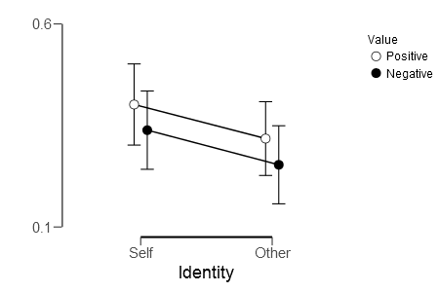

Figure 2.1 The influence of self-correlation in moral vocabulary field and word valence on d value, error line is positive and negative.

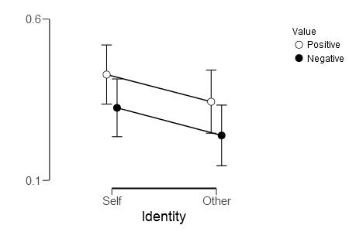

Figure 2.2 Influence of auto-correlation and word valence on the value of d in the vocabulary domain of competence, with a standard error of plus and minus

In order to further examine the influence of self-relevance, domain, and word price on implicit effect, a repeated measurement ANOVAwas performed on the *d* value. The results showed that the main effects of self-reference were significant: *F*(1,69) = 5.543, *p* = 0.021, *η²* = 0.074, 90% CI [0.006, 0.186]. The main effects of domain was not significant, *F*(1,69) = 0.068, *p* = 0.795, *η²* = 0.001, 90% CI [0.000, 0.039]. The main effects of word valence were significant: *F*(1,69) = 8.437, *p* = 0.005, *η²* = 0.109, 90% CI [0.020, 0.229]. There was no significant interaction between self-reference and domains: *F*(1,69) = 0.397, *p* = 0.531, *η²* = 0.006, 90% CI [0.000, 0.067]. The interaction between self- reference and word valence was significant: *F*(1,69) = 7.841, *p* = 0.007, *η²* = 0.102, 90% CI [0.017 0.221]. There was no significant interaction between domain and word potency: *F*(1,69) = 0.713, *p* = 0.401, *η²* = 0.010, 90% CI [0.000, 0.080]. The interaction between the three was not significant: *F*(1,69) = 0.000, *p* = 1.000, *η²* = 0.000, 90% CI [0.000, 0.000].

2 * 2 repeated measures analysis of variance for d in the moral and competence vocabulary domain. Under the lexical conditions, the main effects of self-correlation were significant: *F*(1,69) = 5.525, *p* = 0.022, *η²* = 0.074, 90% CI [0.006, 0.186]. The main effects of valance were not significant: *F*(1,69) = 2.805, p = 0.098, η² = 0.039, 90% CI [0.000, 0.135]. The interaction between self-relevance and word valence was significant: *F*(1,69) = 4.792, *p* = 0.032, *η²* = 0.065, 90% CI [0.003, 0.173].

Analyzing the self and non-self conditions separately, the main effects of word valence under self conditions are not significant: *F*(1,69) = 2.737, *p* = 0.103, *η²* = 0.038, 90% CI [0.000, 0.134]. Paired sample T-test found no significant difference between self and positive moral words and self and negative moral words: *t*(69) = 1.654, *p* = 0.103, Cohen's *d* = 0.198, 95% CI [-0.040, 0.434]. The main effects of word valence under non-self conditions are not significant: *F*(1,69) = 2.874, *p* = 0.095, *η²* = 0.040, 90% CI [0.000, 0.137]. Paired-sample T-test found no significant difference between non-self and positive moral words and non-self and negative moral words: *t*(69) = 1.695, *p* = 0.095, Cohen's *d* = 0.203, 95% CI[-0.035, 0.439]. In addition, the analysis of positive ethical conditions and negative vocabulary conditions found that the main effects of self-correlation under positive vocabulary conditions were significant: *F*(1,69) = 5.444, *p* = 0.023, *η²* = 0.073, 90% CI [0.006, 0.184]. A paired sample T-test found a significant difference between self and positive moral words and non-self and positive moral words: *t*(69) = 2.662, *p* = 0.010, Cohen's *d* = 0.318, 95% CI [0.077, 0.557] . The main effects of self-correlation under negative moral lexical conditions were significant: *F*(1,69) = 5.606, *p* = 0.021, *η²* = 0.075, 90% CI [0.006, 0.187]. A paired sample T-test found a significant difference between the self-negative and negative moral words and the association between non-self and negative moral words: *t*(69) = 2.368, *p* = 0.021, Cohen's *d* = 0.283, 95% CI [0.043, 0.521].

Under the ability vocabulary condition, the main effects of self-correlation were significant: *F*(1,69) = 5.560, *p* = 0.021, *η²* = 0.075, 90% CI [0.006, 0.186]. The main effects of valance were significant: *F*(1,69) = 8.078, *p* = 0.006, *η²* = 0.105, 90% CI [0.018, 0.224]. The interactions between self-relevance and valance were not significant: *F*(1,69) = 3.450, *p* = 0.068, *η²* = 0.048, 90% CI [0.000, 0.148], *ηG²* = 0.0745. By analyzing the self and non-self conditions separately, the main effects of word valence under self conditions are significant: *F*(1,69) = 7.994, *p* = 0.006, *η²* = 0.104, 90% CI [0.018, 0.223]. A paired sample T-test found that there was a significant difference between the association of self and positive ability words and the association of self and negative ability words: *t*(69) = 2.827, *p* = 0.006, Cohen’s *d* = 0.338, 95% CI [0.096, 0.578]. The main effects of word valence under non-self conditions are significant: *F*(1,69) = 8.160, *p* = 0.006, *η²* = 0.106, 90% CI [0.018, 0.225]. Paired-sample T-test found that the associations of non-self with positive ability words and non-self and negative ability words were significantly different: *t*(69) = 2.857, *p* = 0.006, Cohen's *d* = 0.341, 95% CI [0.099, 0.581]. In addition, analyzing the positive and negative ability vocabulary conditions separately, we found that the main effects of self-correlation under the condition of positive ability vocabulary were significant: *F*(1,69) = 5.457, *p* = 0.022, *η²* = 0.073, 90% CI [0.006, 0.184]. Paired-sample T-test found that there was a significant difference between the association of self and active ability words and the association between non-self and positive ability words: *t*(69) = 2.336, *p* = 0.022, Cohen's *d* = 0.279, 95% CI [0.039, 0.517]. The main effects of self-correlation under negative lexical conditions were significant: *F*(1,69) = 5.663, *p* = 0.020, *η²* = 0.076, 90% CI [0.006, 0.188]. A paired sample T-test found significant associations between self-negative and non-negative competence words and associations of non-self and negative ability words: *t*(69) = 2.380, *p* = 0.020, Cohen's *d* = 0.284, 95% CI [0.044, 0.522].

**Associative Learning Task** The mean and standard deviation of the sensitivity *d*’ values for self-correlation (self, non-self) and moral valence (positive, negative) were calculated, and the results are shown in Table 3.1.

Table 3.1 Average and standard deviation of sensitivity *d*’ values for self- and moral-valence conditions (N = 29)

|  |  |  |  |
| --- | --- | --- | --- |
| Self-correlation | Moral valence | M | SD |
| Self | positive | 2.22 | 0.49 |
|  | negative | 1.31 | 0.60 |
| Others | positive | 1.70 | 0.65 |
|  | negative | 1.69 | 0.70 |

To further examine the effect of self-relevance and moral potency on the sensitivity d' value, a 2 * 2 repeated measures analysis of variance was performed on the d' value, and the main effect of self-correlation was found to be insignificant: *F*(1,28) = 0.386, *p* = 0.540, *η²* = 0.014, 90% CI [0.000, 0.144]. The main effects of moral potency are significant: *F*(1,28) = 17.045, *p* < 0.001, *η²* = 0.378, 90% CI [0.141, 0.543]. There is a significant interaction between self-relevance and moral potency. The conditions of the self and others are analyzed separately. Under self-conditions, the main effects of moral valence are significant: *F*(1,28) = 48.747, *p* < 0.001, *η²* = 0.635, 90% CI [0.423, 0.738]. A paired sample T-test found that the sensitivity *d*' value under good conditions was significantly greater than the sensitivity *d'* value under bad conditions: *t*(28) = 6.982, *p* < 0.001, Cohen's *d* = 1.297, 95% CI [0.794, 1.787]. Under other conditions, the main effects of moral valence were not significant: *F*(1,28) = 5.487e-4, *p* = 0.981, *η²* = 0.000, 90% CI [0.000, 0.001]. A paired sample T-test found no significant difference between good and bad: *t*(28) = 0.023, *p* = 0.981, Cohen’s *d* = 0.004, 95% CI [-0.360, 368]. In addition, the sensitivity d' values ​​under self-existence and other conditions under different moral valence levels were also compared. The sensitivity *d*' value under good conditions was found to be significantly greater than the sensitivity d' value under good conditions: *t*(28) = 3.056, *p* = 0.005, Cohen's *d* = 0.567, 95% CI [0.170, 0.956]. The sensitivity *d'* value under bad conditions is significantly greater than the sensitivity d' value under bad conditions: *t*(28) = 2.809, *p* = 0.009, Cohen's *d* = 0.522, 95% CI [0.129, 0.906].

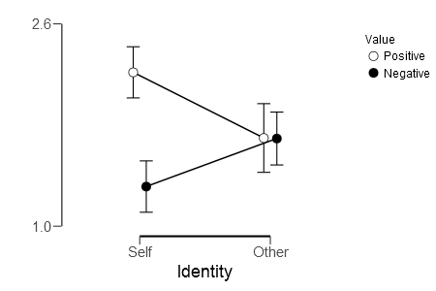

Figure 3.2 Comparison of *d’* mean under self-correlation and ethical valence. Error bars are plus or minus one standard error.

Calculate the average and standard deviation of response time for matching (matching, mismatching), self-correlation (self, others), and moral valence (positive, negative), as detailed in Table 3.2.

Table 3.2 Average and standard deviation at reaction under each condition (N = 29, unit of response is ms)

|  |  |  |  |  |
| --- | --- | --- | --- | --- |
| Matching degree | Self-correlation | Moral valence | M | SD |
| matching | self | positive | 664.909 | 69.852 |
|  |  | negative | 796.672 | 66.338 |
|  | others | positive | 775.351 | 58.773 |
|  |  | negative | 784.424 | 59.752 |
| mismatching | self | positive | 810.064 | 48.431 |
|  |  | negative | 810.618 | 44.034 |
|  | others | positive | 792.297 | 43.047 |
|  |  | negative | 812.304 | 46.545 |

To further examine the influence of each condition on reaction time, a repeated measurement ANOVAwas performed on the response time. The results showed that the main effects of the matching degree were significant: *F*(1,28) = 14.568, *p* <0.001, *η²* = 0.342, 90% CI [ 0.112, 0.514]; The main effects of self-correlation are significant: *F*(1,28) = 20.332, *p* < 0.001, *η²* = 0.421, 90% CI [0.179, 0.577]; the main effect of moral valence is significant: *F*(1, 28) = 85.773, *p* < 0.005, *η²* = 0.754, 90% CI [0.592, 0.823]. The interaction between the degree of match and self-correlation was significant: *F*(1,28) = 24.474, *p* < 0.001, *η²* = 0.466, 90% CI [0.224, 0.612]. The interaction between the degree of match and moral potency was significant: *F*(1,28) = 55.798, *p* < 0.001, *η²* = 0.666, 90% CI [0.465, 0.760]. The interaction between self-relevance and moral potency was significant: *F*(1,28) = 31.556, *p* < 0.001, *η²* = 0.530, 90% CI [0.293, 0.660]. The interactions among the three were significant, *F*(1,28) = 102.733, *p* < 0.001, *η²* = 0.786, 90% CI [0.641, 0.846].

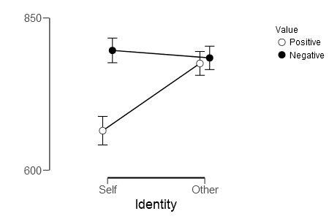

Figure 3.3 Comparison of means of response under self-correlation and moral valence conditions under matching conditions. Error bars are positive and negative. One standard error.

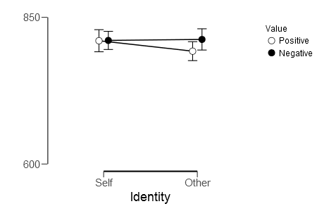

Figure 3.4 Mean comparison of response time under auto-correlation and moral-valence under mismatch conditions, with a standard error of plus and minus

In order to further analyze the relationship between variables, we only consider the matching trials for 2 * 2 repeated measures analysis of variance, and found that the main effects of self-correlation are significant: *F*(1,28) = 29.161, *p* < 0.001, *η²* = 0.510, 90% CI [0.271, 0.645]; main effects of moral valence are significant: *F*(1,28) = 104.245, *p* < 0.001, *η²* = 0.788, 90% CI [0.645, 0.848]; The interactions were significant: *F*(1,28) = 79.179, *p* < 0.001, *η²* = 0.739, 90% CI [0.569, 0.812]. Subsequently, under the conditions of self and others, the main effects of moral valence were significant: *F*(1,28) = 181.880, *p* <0.001, *η²* = 0.867, 90% CI [0.771, 0.904]. The paired sample T-test showed that the good condition was faster than the bad condition: *t*(28) = 13.486, *p* < 0.001, Cohen’s *d* = 2.504, 95% CI [1.752, 3.246]. Under other people's conditions, the main effects of moral valence were not significant: *F*(1,28) = 0.869, *p* = 0.359, *η²* = 0.030, 90% CI [0.000, 0.009]. The paired sample T-test showed that there was no significant difference in response time between good and bad conditions, *t*(28) = 0.932, *p* = 0.359, Cohen’s *d* = 0.173, 95% CI [-0.195, 0.538].

In addition, the analysis of different moral potency conditions were conducted. Under positive moral conditions, the main effects of self-correlation were significant: *F*(1,28) = 65.505, *p* < 0.001, *η²* = 0.701, 90% CI [0.514, 0.785]. The paired-sample T-test showed that the good condition was faster than the good condition: *t*(28) = 8.094, *p* < 0.001, Cohen’s *d* = 1.503, 95% CI [0.962, 2.031]. Under negative ethical conditions, self-correlation was not significant: *F*(1,28) = 2.023, *p* = 0.166, *η²* = 0.067, 90% CI [0.000, 0.009]. The paired sample T-test showed that there was no significant difference in response time between bad and bad conditions: *t*(28) = 1.422, *p* = 0.166, Cohen’s *d* = 0.264, 95% CI [-0.109, 0.632].

Repeated-measures analysis of variance for 2 * 2 unmatched trials found that the main effects of auto-correlation were not significant: *F*(1,28) = 2.537, *p* = 0.122, *η²* = 0.083, 90% CI [0.000, 0.009 The main effects of moral valence are significant: *F*(1,28) = 4.635, *p* = 0.040, *η²* = 0.142, 90% CI [0.004, 0.330]; the interaction between the two is significant: *F*(1,28) = 4.910, *p* = 0.035, *η²* = 0.149, 90% CI [0.006, 0.338]. Subsequently, under the conditions of self and others, the main effects of moral valence were not significant under self-condition: *F*(1,28) = 0.006, *p* = 0.940, *η²* = 0.000, 90% CI [0.000, 0.009]. The paired sample T-test showed that there was no significant difference in the response between the good and bad conditions: *t*(28) = 0.076, *p* = 0.940, Cohen’s *d* = 0.014, 95% CI [-0.350, 0.378]. Under other conditions, the main effects of moral valence were significant: *F*(1,28) = 12.939, *p* = 0.001, *η²* = 0.316, 90% CI [0.092, 0.492]. Paired-sample T-test showed that the response time under good human conditions was significantly faster than that under bad conditions: *t*(28) = 3.597, *p* = 0.001, Cohen’s *d* = 0.668, 95% CI [0.260, 1.067].

In addition, the analysis of different moral potency conditions separately showed that under positive moral conditions, the main effects of self-correlation were significant: *F*(1,28) = 8.118, *p* = 0.008, *η²* = 0.225, 90% CI [0.036, 0.412]. The paired sample T-test showed that the good condition was faster than the response condition of my condition *t*(28) = 2.849, *p* = 0.008, Cohen’s *d* = 0.529, 95% CI [0.136, 0.914]. Under negative ethical conditions, self-correlation was not significant: *F*(1,28) = 0.056, *p* = 0.814, *η²* = 0.002, 90% CI [0.000, 0.074]. The paired-sample T-test showed that there was no significant difference in response time between bad and bad conditions: *t*(28) = 0.237, *p* = 0.814, Cohen’s *d* = 0.044, 95% CI [-0.321, 0.408].

**Cross Task analysis**

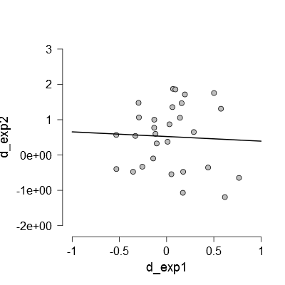

Figure 3.5 Scatter plots of correlation analysis of the effects of moral self-dominance between experiment 1 and experiment 2

**Discussion**

The analysis of the new and old recognition showed that people's memory of moral words was better than competent words. This suggested that people tended to care more about the moral qualities than the competent qualities of people. This may also be related to China's traditional Confucian culture, so that people pay more attention to moral related information.

Compared with friends, there was no significant difference in self-related memory. There was no self-referencing effect. It was inconsistent with previous research results. When analyzing the accuracy of new and old recognition, we found that negative self-related words was better than negative friend-related words. The reason for this result may be that the new and old recognition do not involve judgments on vocabulary sources (self and friends), so whether positive or negative information can be well memorized. Moreover, when analyzed the source recognition, we also found that memory of negative competent words was better than the negative moral words. It might be easier for people to forget negative information in the moral field, or unethical action, when you needed to figure out whether it related to self or friend.

After analyzing the data, we found different word list influenced the result significantly. So we recruited four undergraduates and one graduates rated the words again. They were instructed to rate whether the word was suitable to describe undergraduates and how familiar the word was. But there was no significant different between three word lists.

Experiment 2 shows that only under the self-condition, the respondents will have significant differences between the positive moral information and the negative moral information. Under the condition of others, there was no significant difference in respondents' responses to positive moral information and negative moral information. This result also proves the existence of moral self superiority. Moreover, this effect is not due to the effect of positive valence, but to the self. It also supports the hypothesis that the moral self superiority comes from self-enhancing effect.

Experiment 1 showed that when the self-words were connected with the positive attribute words, non-self words and negative attribute words, the participants responded quickly and the reaction time was short. It shows that the combination method at this time is consistent with the implicit cognition of the test; when the self word is connected with the negative attribute word connection, non-self word and positive attribute word, the response speed of the test is slow and the reaction time is long. The combination pattern was inconsistent with the participant's implicit cognition. In the implicit test, participants were more sensitive to self-words than non-self words, and were more sensitive to positive words than negative words, which could prove the existence of superior self-effects. Among them, participants were more sensitive to positive moral words than negative moral words, but there was no significant difference. participants were sensitive to positive ability words compared to negative ability words, and there were significant differences.

**References**

Ames, D. R., Rose, P., & Anderson, C. P. (2006). The NPI-16 as a short measure of narcissism. *Journal of Research in Personality, 40*, 440-450. doi:10.1016/j.jrp.2005.03.002

Aquino, K., & Reed Ii, A. (2002). The self-importance of moral identity. *Journal of Personality & Social Psychology, 83*(6), 1423.

Batchelder, W. H., & Riefer, D. M. (1990). Multinomial Processing Models of Source Monitoring. *Psychological Review, 97*(4), 548-564. doi:10.1037/0033-295X.97.4.548

Cai, H. (2003). The effect of implicit self-esteem and the relationship of explicit self-esteem and implicit self-esteem. *Acta Psychologica Sinica*.

Cui, D. W. H. (2005). *Interpreting the Chinese personality*: Social Sciences Academic Press(China).

Heck, D. W., Arnold, N. R., & Arnold, D. (2017). TreeBUGS: An R package for hierarchical multinomial-processing-tree modeling. *Behavior Research Methods, in press*, 1-21. doi:10.3758/s13428-017-0869-7

Ji Yifu, Y. X. (1993). The Self-Esteem scale, SES. *Chinese Mental Health Journal*, 251-252.

Leary, M. R., Kelly, K. M., Cottrell, C. A., & Schreindorfer, L. S. (2013). Construct validity of the need to belong scale: Mapping the nomological network. *Journal of Personality Assessment, 95*, 610-624. doi:10.1080/00223891.2013.819511

Rosenberg, M. (1965). Society and the adolescent self-image. *Social Forces, 3*(2), 1780-1790.

Shucai, M. (2008). *The Influence of Adult Attachment and Personality Traits on College Students' Ownership Needs and Interpersonal Orientation under Social Rejection.* Northwest Normal University.

Xiaoyan, W. (2008). *Research on the Influence of College Students' Narcissistic Personality on Self-esteem and Subjective Well-being.* Shanxi Normal University.

ZengKui, W. (2008). *Psychological Development and Construction of Moral Identity.* (Doctor), Nanjing Normal University.

1. The first version of the procedure didn’t include filling words for the first and last word. To avoid the primacy effece and recency effect, we removed the first and last four words, which cause un-balanced trials for each condition.
2. Ratings from 2 participants were removed, because they didn’t pass the attention check items in the questionnaire.