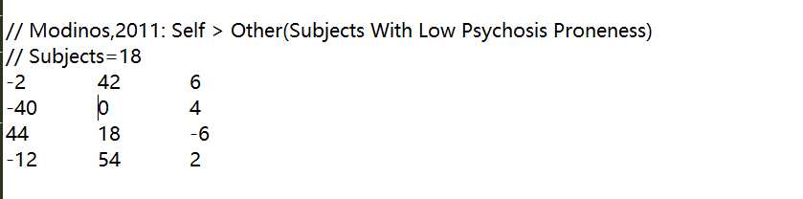

问题1：0 那里错了

问题2：txt标题

问题3：Vander 2008

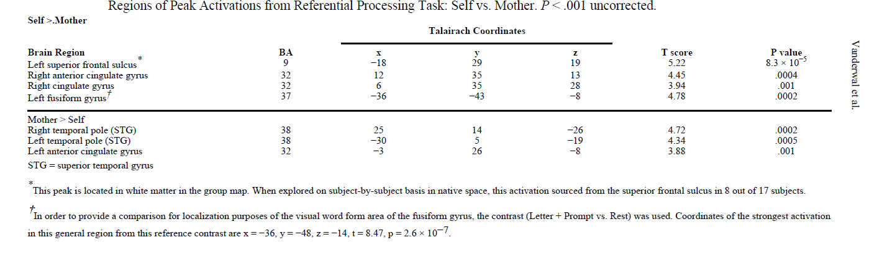

第一行没摘？

Vander 2008

也缺少control；Subjects also performed a social attribution task (SAT) in

which they inferred mental states about interacting geometric shapes. Activations from this visual

theory of mind task were compared with the activations demonstrated during self-referential

processing.

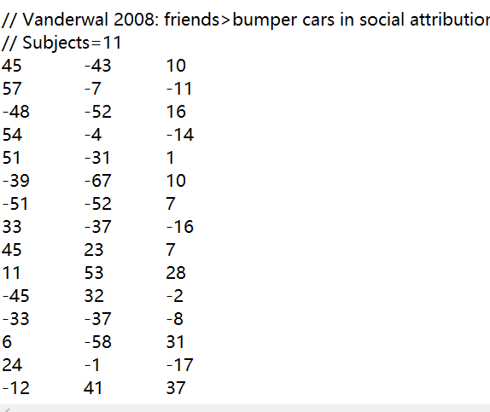

问题4 furichi, 2019里面的0写成了O

问题5 furich, 2019 漏了这一行

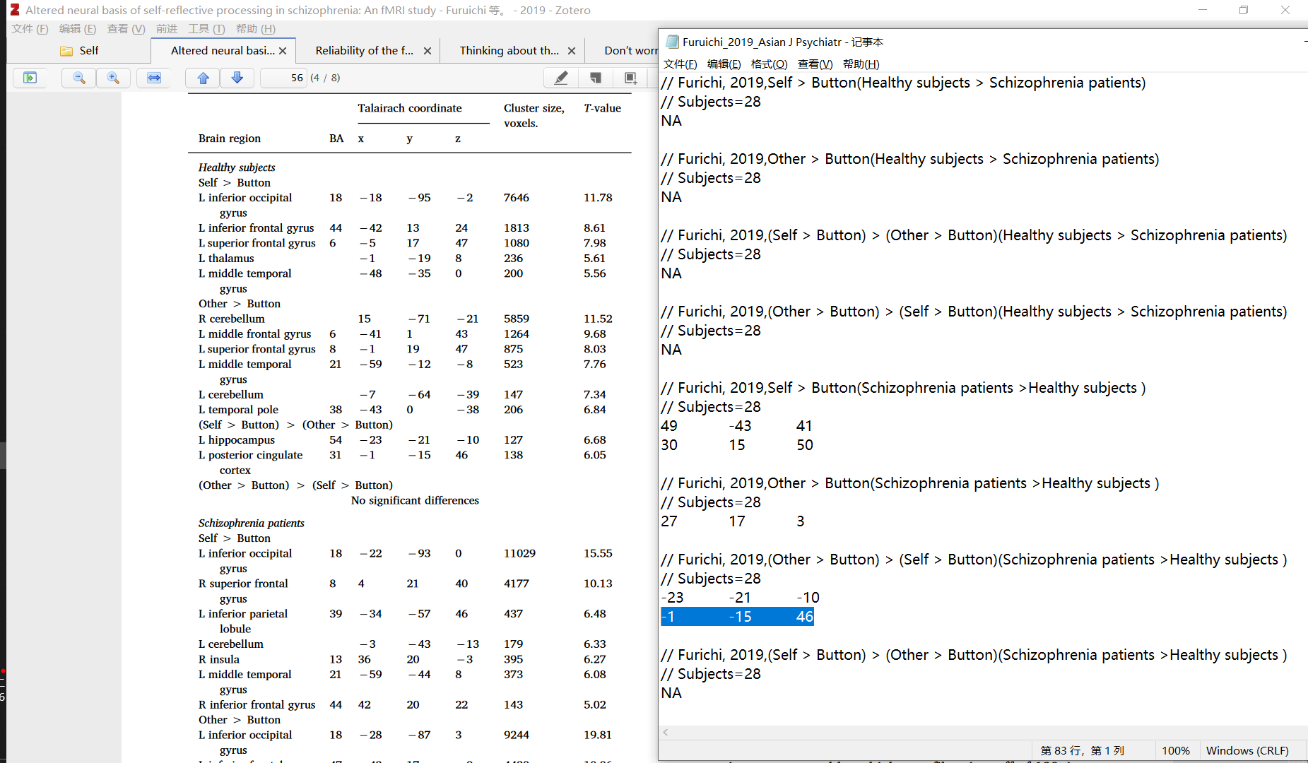

### 0802

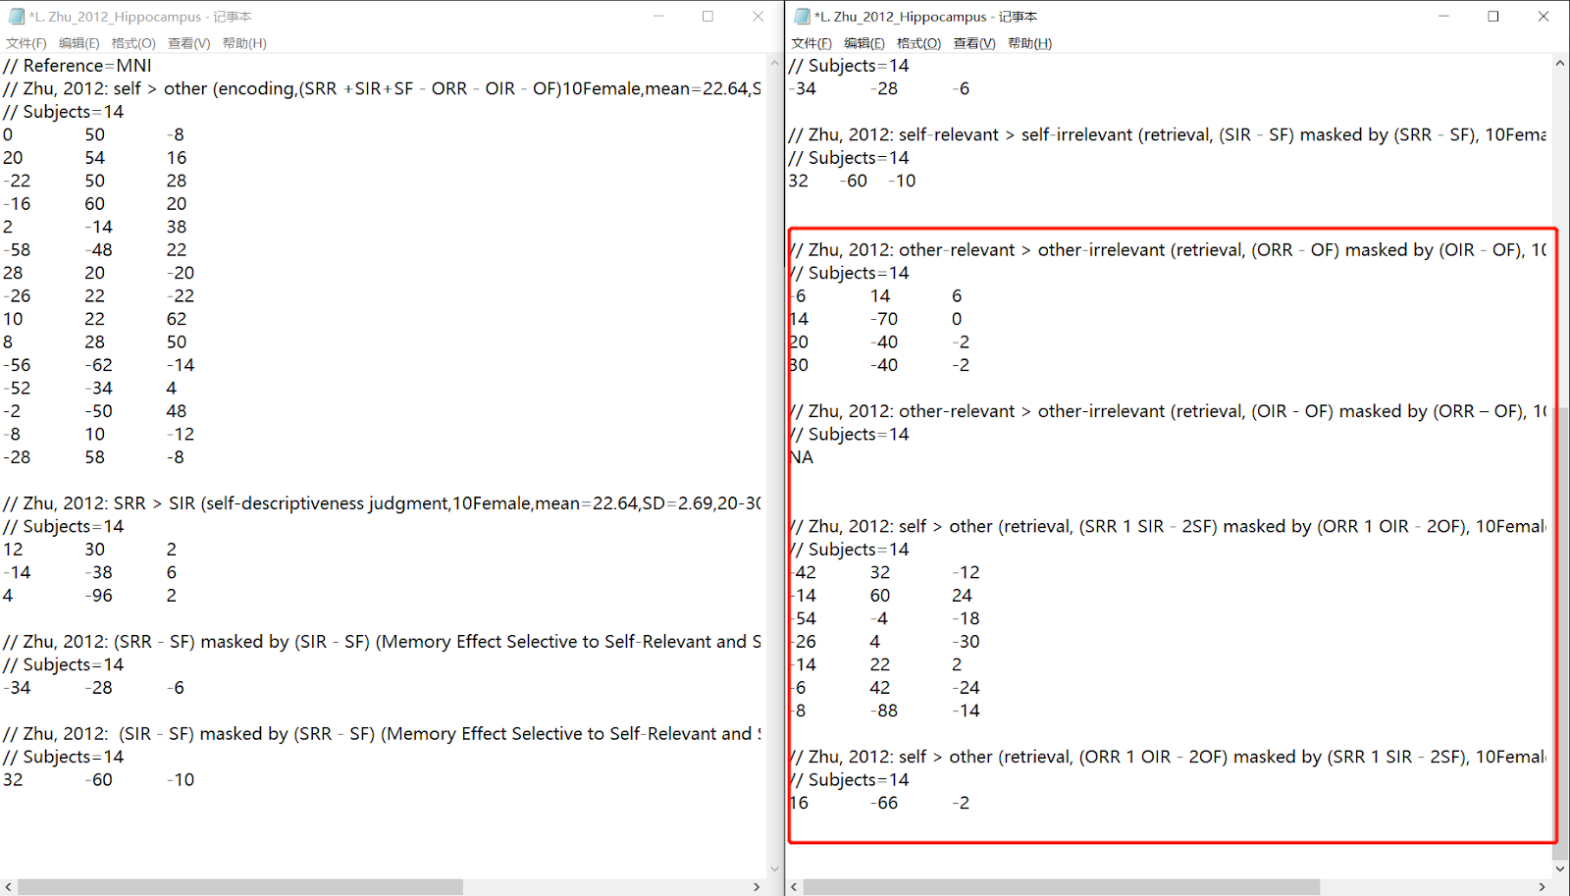

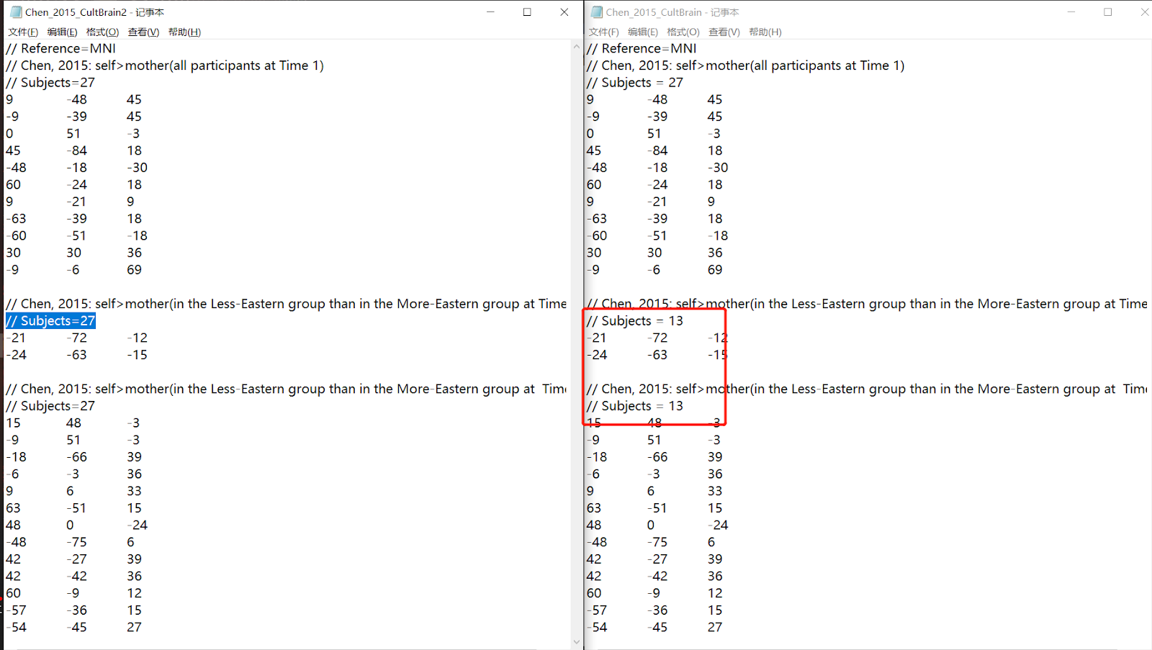

0806

