补充材料和方法

Supplementary methods and results

**1 神经成像元分析方法**

本文采用激活可能性估计法（Activation Likelihood Estimation，ALE）进行神经成像研究的元分析。其基本原理是：以激活峰值为中心，将坐标点还原成3D高斯分布球体。体素越靠近激活峰值点，其激活的可能性越高，反之则越低[1]。正文部分的分析使用Jupyter Notebook作为分析平台，采用Python 3.8.5作为运行环境，安装Nimare工具包[2]（https://nimare.readthedocs.io/）进行基于坐标的元分析，分析过程采取模拟次数为10000次，设置簇水平的阈限为0.001，采用族错误率法（familywise error rate, FWE）[3]进行多重比较校正，P < 0.05为阈值，。补充材料中图5和表1的元分析结果则是采取相同的参数，利用Matlab 2018软件作为运行平台，借助与Eickhoff 合作所得的ALE工具包进行分析。元分析结果的可视化采用BrainNet Viewer[4]，通过SPM Anatomy Toolbox图谱工具包[5]标记显著激活的簇所在的脑区解剖位置，利用脑成像数据处理和分析工具包DPABI 6.1[6]导出具体的激活脑区的医学名称。

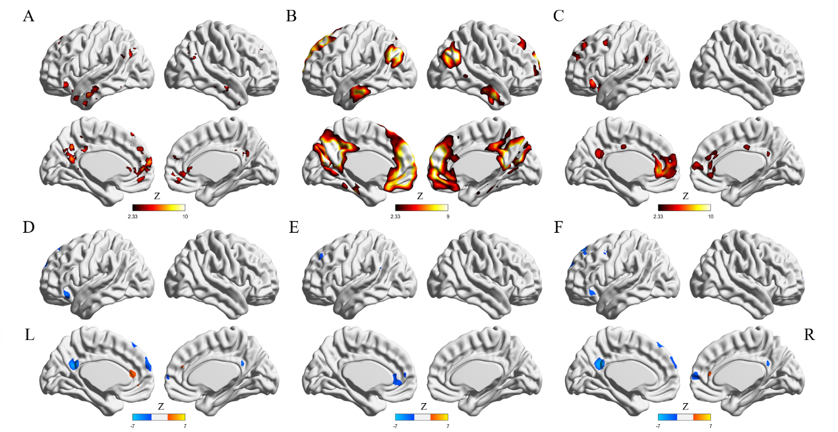

**补充材料 图5 使用Matlab进行分析得到的不同数据库间自我参照的元分析比较图。（A）Neurosynth的元分析结果图；（B）NeuroQuery预测的结果图；（C）本数据库的元分析结果图；（D）自我vs名人与自我vs非人称的元分析结果差异图；（E）自我vs亲密他人与自我vs名人的元分析结果差异图；（F）自我vs亲密他人与自我vs非人称的元分析结果差异图。**

**Supplementary Figure 5 Self-reference meta-analysis comparison between different databases using Matlab.**

**( A ) Neurosynth meta-analysis results ; ( B ) Results of NeuroQuery meta-analysis results ; ( C ) Meta-analysis results for this database ;** **(D) Map of self vs celebrity and self vs impersonal meta-analysis results difference; ( E) Map of self vs celebrity and self vs intimate others meta-analysis results difference; (F ) Map of self vs intimate others and self vs impersonal meta-analysis results difference.**

**补充材料 表格1 元分析的结果**

**Supplementary Table 1 Results of meta-analysis using Matlab.**

| **脑区** | **体积**  **(voxel)** | **Z-值峰值坐标** | | | **解剖位置** |
| --- | --- | --- | --- | --- | --- |
| **x** | **y** | **z** |
| (Self - Close_other) > (Self > non-Person) | | | |  |  |
| 1 | 69 | 6 | 36 | 14 | Cingulate Gyrus, anterior division (R) |
| (Self - non-Person) > (Self - Close_other) | | | |  |  |
| 1 | 467 | 10 | 64 | 10 | Frontal Pole R |
| 2 | 422 | -6 | -52 | 26 | Precentral Gyrus (L) |
| 3 | 329 | -52 | 30 | -6 | Inferior Frontal Gyrus, pars triangularis (L) |
| 4 | 171 | -8 | 38 | 50 | Superior Frontal Gyrus (L) |
| 5 | 128 | -48 | -62 | 20 | Lateral Occipital Cortex, superior division (L) |
| 6 | 114 | -40 | 6 | 46 | Middle Frontal Gyrus (L) |
| (Self - Celebrity) > (Self - non-Person) | | | |  |  |
| 1 | 576 | 0 | 34 | 12 | Cingulum_Ant_L |
| 2 | 109 | -26 | 42 | 36 | Frontal Pole (L) |
| 3 | 77 | -60 | -46 | 16 | Supramarginal Gyrus, posterior division (L) |
| 4 | 29 | -8 | 56 | 6 | Paracingulate Gyrus (L) |
| (Self - non-Person) > (Self - Celebrity) | | | |  |  |
| 1 | 391 | -6 | -52 | 26 | Cingulate Gyrus, posterior division (L) |
| 2 | 376 | -4 | 62 | 26 | Frontal Pole (L) |
| 3 | 324 | -46 | 28 | -14 | Frontal Orbital Cortex (L) |
| 4 | 120 | -4 | 38 | 50 | Superior Frontal Gyrus (L) |
| 5 | 94 | -40 | 6 | 46 | Middle Frontal Gyrus (L) |
| 6 | 66 | -44 | -64 | 26 | Lateral Occipital Cortex, superior division (L) |
| (Self - Close_other) > (Self - Celebrity) | | | |  |  |
| NA | NA | NA | NA | NA | None |
| (Self - Celebrity) > (Self - Close_other) | | | |  |  |
| 1 | 408 | -10 | 36 | 10 | None |
| 2 | 133 | -18 | 40 | 44 | Frontal Pole (L) |
| 3 | 108 | -56 | -52 | 20 | Angular Gyrus (L) |
| 4 | 15 | -26 | 56 | 26 | Frontal Pole (L) |

**参考文献**

[1] Turkeltaub, P. E., Eden, G. F., Jones, K. M., & Zeffiro, T. A. (2002). Meta-analysis of the functional neuroanatomy of single-word reading: Method and validation. NeuroImage,

16(3), 765–780.doi: 10.1006/nimg.2002.1131

[2] Salo, Taylor, Yarkoni, Tal, Nichols, Thomas E., Poline, Jean-Baptiste, Kent, James D., Gorgolewski, Krzysztof J., Glerean, Enrico, Bottenhorn, Katherine L., Bilgel, Murat, Wright, Jessey, Reeders, Puck, Kimbler, Adam, Nielson, Dylan N., Yanes, Julio A., Pérez, Alexandre, Oudyk, Kendra M., Jarecka, Dorota, Enge, Alexander, Peraza, Julio A., … Laird, Angela R. (2022). neurostuff/NiMARE: 0.0.12rc7 (0.0.12rc7). Zenodo. <https://doi.org/10.5281/zenodo.6642243>

[3] Eickhoff, S. B., Bzdok, D., Laird, A. R., Kurth, F., & Fox, P. T. (2012). Activation likelihood estimation meta-analysis revisited. NeuroImage, 59(3), 2349–2361.doi: 10.1016/j. neuroimage.2011.09.017

[4] Xia, M., Wang, J., & He, Y. (2013). BrainNet Viewer: a network visualization tool for human brain connectomics. PloS one, 8(7), e68910. <https://doi.org/10.1371/journal.pone.0068910>

[5] Eickhoff S, Stephan KE, Mohlberg H, Grefkes C, Fink GR, Amunts K, Zilles K: A new SPM toolbox for combining probabilistic cytoarchitectonic maps and functional imaging data. NeuroImage 25(4), 1325-1335, 2005

[6] Yan, C.G., Wang, X.D., Zuo, X.N., Zang, Y.F., 2016. DPABI: Data Processing & Analysis for (Resting-State) Brain Imaging. Neuroinformatics 14, 339-351. doi: 10.1007/s12021-016-9299-4.