

**Sections of a Stage 1 Registered Report**

**Scientific Repo**

Abstract 1

Introduction 2

Methods 3

Ethics information 3

Secondary Data Description 3

Data Collection Procedures 3

Experimental design 4

Measured Variables 4

Stimuli and materials 4

Procedure 5

Pilot data simulated data 5

Analysis Plan 6

Data pre-processing 6

Calculation of indices & quantifying SPE in the SALT 6

Reliability of indices in SALT as individual-level/group-level 7

Split-half reliability of SPE in SALT 8

Data availability 8

Code availability 8

Results 9

Descriptive Statistics 9

ICC(Intraclass correlation coefficient) 9

Split-Half Reliability 10

Discussion 11

Acknowledgements 12

Author contributions 12

Competing interests 12

Figures 12

Figure Legends 12

Supplementary information 13

References 16

**Estimating Reliability of Self-Prioritization Effect as measured by the Self-Associative Learning Task: Evidence from Multiple Dataset**

Zheng Liu 1#, Mengzhen Hu1#, Yuanrui Zheng2, Jie Sui3*, Hu Chuan-Peng 1*

1 School of Psychology, Nanjing Normal University, Nanjing, China

2 School of Education, Kunming City College, Kunming, China

3 School of Psychology, University of Aberdeen, Old Aberdeen, Scotland

# These authors are equally contributed to this study

* Corresponding authors: Hu Chuan-Peng ([hu.chuan-peng@nnu.edu.cn](mailto:hu.chuan-peng@nnu.edu.cn))

# **Abstract**

The self-prioritization effect (SPE) refers to the effect that performance in cognitive tasks is better when stimuli are related to the self than when they are not. The social-associative learning task (SALT) emerged as the mainstream paradigm to study SPE in the last decade for its simplicity and elimination of familiarity effects. As a simple button-pressing task, SALT yields two direct outcomes, reaction time and accuracy. Indirect indices can be derived from reaction times and accuracy, including sensitivity (*d* prime) under signal-detection theory, the efficiency index through a direct division between reaction times and accuracy, and drift rate (*v*) and starting point (*z*) estimated using drift-diffusion models. All these direct and indirect indices can be used to quantify SPE in the literature. However, the reliability of these SPE indices has never been tested. To fill this gap, we will re-analyze existing data from multiple datasets using intraclass correlation coefficient (ICC) and split-half reliability. Our results will provide a benchmark for future studies.

# **Introduction**

The **Self-Prioritization Effect (SPE) refers to the phenomenom that XXX. It** has been established as a robust effect since XXX. In the early days of cognitive psychology, researcher found thatsubjects can recognize their own name from noisy auditory information, even with insufficient cognitive resources, in Craik & Tulving (1975) found that the SPE effect in memorys, i.e., information related to the self is easier to recall, and this effect has been replicated in many other following studies (Conway & Dewhurst, 1995; Craik & Tulving, 1975; Rogers et al., 1977; Symons & Johnson, 1997). Over the following decades, the SPE has also been found when different stimuli was used, such own-face, own voice, own name, and newly owned object (). Also, the effect was found in perceptual task, attentional task, memeory task, and social judgment. advantage in face recognition task (Keenan et al., 2000; Kircher et al., 2000; Turk et al., 2002), attentional task (), Besides that, the SPE has also been observed in sound recognition, with research showing that individuals perceive their own voice as more attractive (Hughes & Harrison, 2013) and respond faster to their own voice compared to others' (Payne et al., 2021).

Although SPE are argued as a self-specific effect, it is difficult to diassociate it from familiarity effect because most studies used stimuli owned by participants and stimuli owned by others as the baseline condition. This issues was addresed by the **Self-Associative Learning Task (SALT)**, in which participants first associate geometrical shapes (e.g., triangle, square, and circle) with labels of persons (e.g., "You," "friend," and "stranger"), and then finish a perceptual matching task in which participants decide if the shape-label pairs presented on the screen match the learned association or not (Sui et al., 2012). Using SALT, researchers found that shapes associated with the self are performed better, with faster response times, better accuracy, and/or higher sensitivity scores as compared to friend and stranger shapes (Schäfer & Frings, 2019; Sel et al., 2019; Sui et al., 2016).

Because of its simplicity and without potential confouding of familiarity, SALT has emerged as the mainstream paradigm in investigating the mechanism underlying SPE. For instance, researchers have explored the importance of personality traits in identity labels (Golubickis et al., 2020), the self-relevant labels that include the past, present, and future self (Golubickis et al., 2017), as well as "good self" and "bad self" labels (Hu et al., 2020), and the group advantage effect of in-group labels (Constable et al., 2019; Constable & Knoblich, 2020; Enock et al., 2018; Enock et al., 2020). Moreover, the SALT paradigm has been applied to various fields, such as neuroscience, physiology, clinical research, cross-cultural research, and child development. In neuroscience and physiology, researchers investigate which brain regions are activated during self-prioritization effect (Feng et al., 2018; Humphreys & Sui, 2015), and gender differences in self-prioritization effect due to oxytocin (Feng et al., 2020). In clinical research, SALT has been used to understand atypical self-processing in populations such as those with autism or depression (Gillespie‐Smith et al., 2018; Nijhof & Bird, 2019; Sui & Humphreys, 2017). Cross-cultural studies have shown that individuals from individualistic cultures demonstrate a stronger self-prioritization effect (Jiang et al., 2019), and that the language of the experimental stimuli can affect the strength of the effect (Ivaz et al., 2016). Finally, SALT has also been applied to child development, with studies examining developmental changes in self-positivity effects (Maire et al., 2020; Zhou et al., 2019).

Despite the popularity of SALT, few attention paid to the exact indices of SPE and their reliability, which need to be examined carefully (Parsons et al., 2019). This issue is especially important because SALT is increasingly used in measuring individual differences in psychiatry (Liu et al., 2022) and social psychology (Enock et al., 2019, sci rep). To fill the gap, we plan to examine the reliability of SPE indicies of SALT by reanalyzing data from multiple sources (see table 1 for the details of data sources).

To have a comprehensive assessment of the SPE indices from SALT, we included six indices of SPE from SALT. All these SPE indices are defined as the difference between self condition and other condition, while using different outcomes of the matching trials of SALT. More specifically, these indices include two direct indices from SALT, reaction times and accuracy, and derived indices such as efficiency (), d prime of SDT, and drift rate and starting point from DDM () and effect size (*d*) between self and other in matching conditions (label and shape matching). Stoeber and Eysenck (2008) introduced efficiency, which is the ratio of average response time to accuracy, and this index was later adopted by Humphreys and Sui (2015) in SALT as one of the indicators of SPE. More recently, Golubickis et al. (2017) introduced the drift rate (v) and starting point (z) of DDM as one of the indexes in SPE.

Given that there are multiple methods for calculating reliability of cognitive tasks, we will calculate the Intraclass Correlation Coefficient (ICC) and Split-Half Reliability for each of the SPE indicies mentioned above.

Our main hypothesis are as follows:

1. The Self-Prioritization Effect (SPE) measured by the experimental indices in the Self-Associative Learning Task (SALT) paradigm is temporally stable
2. Among the multiple indices that measure Self-Prioritization Effect (SPE) in the Self-Associative Learning Task (SALT), there exists a most stable indicator

The results of this study will provide valuable insights into the reliability and consistency of the Self-Associative Learning Task (SALT), which could pave the way for its future use in research, clinical settings, and personal performance monitoring.

# **Methods**

## Ethics information

Our research does not involve any treatment of humans or animals and is a secondary analysis of pre-existing data. As such, informed consent and confidentiality are not relevant. The original study from which the data was collected was approved ethically by the research committee at Tsinghua University.

## Secondary Data Description

To address our research questions, we'll use a pre-existing dataset from a study conducted by Hu Chuan-Peng at Tsinghua University in 2016. The original study aimed to compare the self-prioritization effect (SPE) between sub-clinical depressed and non-depressed participants, but only the non-depressed group was collected due to difficulty in recruiting sub-clinical depressed participants. The dataset contains data from 34 non-depressed and 6 depressed participants, who participated in six testing sessions over a 1-week interval. Each session included a modified SALT task, a set of questionnaires, and another modified SALT task. We plan to **use the results of the neutral condition in the second SALT task from the** **34[1]**  **non-depressed participants with relatively low scores on the depression-related questionnaire.**

## Data Collection Procedures

36 college students from the Tsinghua University community participated in the experiment and received compensation. All participants were right-handed and had normal or corrected-to-normal vision. Unfortunately, data from one participant was excluded due to confusing participant information provided to the experimenter, and data from one male participant was missing due to a programming error. This left a total of 34 valid participants, with 21 females and 13 males, averaging 21 years old (SD = 2.52) in age.

## Experimental design

The origin experiment is a four-factor design, with 2 levels of match vs. non-match, 3 levels of identity (self, friend, stranger), 4 levels of emotion (control, neutral, happy, sad), and 6 repeated sessions. Its purpose is to examine the self-bias effect under different emotions (happy, sad, neutral, control). As our study aims to explore the reliability of Self-Prioritization Effect (SPE) in Self-Associative Learning Task (SALT) and identify the most stable SPE index, we will not consider the variable of emotion in this paper.

## Measured Variables

At each wave, participants' keypress, reaction time, and accuracy in each trial were recorded. The participants also filled out questionnaires that varied from wave to wave and covered topics such as personal wellbeing, physical and mental health, and psychological distance between the self, a friend, and a stranger.

## Stimuli and materials

The experiment was conducted individually in a dimly lit room, using E-Prime 2.0 software on a PC with a 1024 x 768 resolution monitor, refreshing at 100 Hz. Participants recorded their keypresses, reaction time, and accuracy during each trial.

The experiment was split into two phases. The first phase followed the study by (Sui et al., 2012)and involved a learning task where participants paired geometric shapes with labels. The shapes were not shown at this stage. The learning task lasted approximately 60 seconds, and the shape-label associations were balanced across participants. Then, in the matching task, a fixation cross was displayed in the center of the screen for 500 ms, followed by the presentation of a shape-label pairing and the fixation cross for 100 ms. Then, the screen went blank for 1500 ms, or until a response was made. Participants were asked to determine whether the shape matched the label by pressing one of two buttons as quickly and accurately as possible within this timeframe.

The participants took part in a two-phase experiment. In the first phase, they learned four sets of associations between shapes and labels, with one set being a control condition and three others being emotion-based. The control condition involved associating three geometric shapes (circle, horizontal ellipse, and vertical ellipse) with three labels (self, friend, and stranger), while the emotion-based conditions showed facial expressions (happy, sad, and neutral) on the shapes. Before starting the formal trials, each participant went through a training session with 24 practice trials. After the training, each participant completed 6 blocks of 60 trials in the matching task, with 2 match types (match/mismatch) × 3 shape associations, for a total of 60 trials per association. Participants had a short break after each block, lasting up to 60 seconds.

**Figure 1.** In Experiment B, the stimuli and procedure were carried out in Chinese. Participants learned to associate four sets of shapes with labels, including one control condition and three emotion-based conditions. During the learning task, the shape-label matches were evenly distributed among participants, and no feedback was given during the formal trials. The example illustrates the timeline of the experiment.

## Procedure

Participants were given informed consent and took part in 80-minute experiments. They repeated the same experiment five times in the following five weeks. Additionally, the participants also filled out some self-report scales, which are not included in the analysis of experiment reliability, so they will not be discussed further.

## Pilot data simulated data

To avoid any potential biases in hypothesis formation, we didn't conduct any statistical analysis on the primary data during stage 1 registration. Instead, we generated a pilot dataset with the same format as the primary data. We used an open dataset from a previous study examining the self-prioritization effect as a reference to create our pilot data.

We utilized Bootstrap methods, drawing samples from Hu et al. (2020) open dataset (accessible at <https://osf.io/mhdsn/>) with replacement (allowing the same sample to be repeated in the pilot data). The pilot data includes 6 sessions of data from 34 participants, with each participant having 24 practice trials and 360 experimental trials (6 different types of shape-label associations: two matches (matched/mismatched) x three identity associations (self, friend, stranger), 60 trials per association) per session. Figure 1 shows the first 6 rows of the pilot data.

**Figure 2.** The first six rows of the pilot data

We ran the pilot data through our proposed statistical analysis to see whether our proposed analysis is appropriate for the secondary data structure (see analysis plan).

## Analysis Plan

The drift-diffusion model was applied to evaluate the reaction times and accuracy. Our behavioral data analysis will utilize “hausekeep”, an R package to fit the data into the DDM. As a result of this model, we will be able to obtain two indices, the drift rate (*v*) indicating faster evidence accumulation and the starting point (*z*) reflecting a bias in the beginning of information accumulation, which will be included in the analysis (Golubickis et al., 2017; Macrae et al., 2017; Yankouskaya et al., 2020).

In addition to drift rate (*v*) and starting point (*z*), four other indices, namely reaction time, accuracy, D-prime, and efficiency, will be included in our study. The analysis of these six indices will be based on the R Project (R Development Core Team, 2010). We will calculate the SPE for each of these indices and use the "psych" package (William Revelle, 2022) to calculate their Intraclass Correlation Coefficient (ICC) and our own program to calculate their split-half reliability.

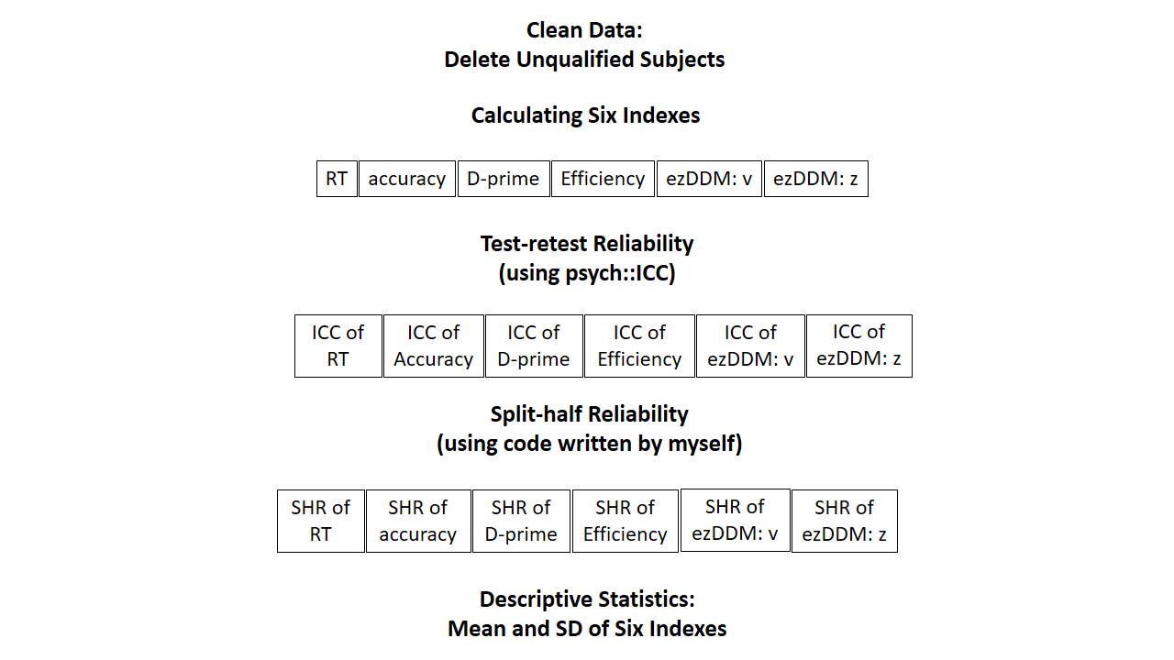

**Figure 3.** Flow Chart

### Data pre-processing

First, we will pre-process the secondary data using the following criteria (we do not pre-process the secondary data at stage 1 registration):

1. Participant exclusion criteria
2. Participant who has the wrong trial numbers because of procedure errors should be excluded from the analysis.
3. Participants with an overall accuracy < 0.5 should be excluded from the analysis.
4. Participants with any of the conditions with zero accuracy should be excluded from the analysis.
5. Behavioural data exclusion criteria
6. Trials with no response or wrong key press should be excluded from the analysis.
7. Trials with responses less than 200 ms or faster than 1500 ms should be excluded from the analysis.
8. The practice trials will be excluded from the formal analysis.
9. The data under conditions other than the “control condition” will not be used in the current study.

### Calculation of indices & quantifying SPE in the SALT

Next, we'll calculate various metrics in the SALT and assess the Self-Prioritization Effect (SPE) at the individual level. We'll use seven common metrics for this purpose. Table 2 outlines how these metrics are calculated, as well as how the SPE is determined from them.

Table 1. Indices in SALT and corresponding calculation of indices and SPE

|  |  |  |  |  |
| --- | --- | --- | --- | --- |
| **Indices ID** | **Indices Calculation** | **SPE Calculation Based on Indices** | | **Source** |
| Mean Reaction times (RT) | $$\frac{\sum{RT} }{n(trials)}$$ | Type 1 calculation | Self-match - other-match | Sui et al. (2012) |
| Type 2 calculation | self-all - other-all | Sui et al. (2012) |
| Accuracy (ACC) | $$\frac{n\left(correct response\right)}{n\left(total respose\right)}$$ | self-match) - other-match | | Sui et al. (2012) |
| d-prime | z-score (ACC (match) - z-score (1 - ACC (non-match)) | self - other | | Sui et al. (2012) |
| Efficiency | $$\frac{mean RT}{ACC}$$ | self-match - other-match | | Humphreys and Sui (2015); Stoeber and Eysenck (2008) |
| Drift rate (v) | DDM：parameters will be identified through model selection | self-match- other-match | | Golubickis et al. (2017) |
| Starting point (z) | self-match - other-match | | Golubickis et al. (2017) |

*Note.* DDM =Drift Diffusion Model.

We'll present the average and standard deviation for each index for each session, along with other important descriptive statistics.

### Reliability of indices in SALT as individual-level/group-level

We'll assess the reliability of the SALT indices using the Intraclass Correlation Coefficient (ICC). ICC is a well-established measure of reliability in test-retest, intra-rater, and inter-rater studies(Fisher, 1992). Compared to Pearson correlation coefficient, ICC considers both the degree of correlation and agreement between multiple measurements, making it a more comprehensive measure of test-retest reliability(Koo & Li, 2016).

Specifically, we will use two-way single-measurement mixed model with absolute agreement between scores of six session (ICC2k) as the reliability measure of group-level SPE across six sessions. For the calculation of ICC2k estimates and their 95% confidence intervals, the formula is:

$$\begin{aligned}\frac{{MS}_{R}-{MS}_{E}}{{MS}_{R}+\left(k-1\right){MS}_{E}++\frac{k}{n}\left({MS}_{C}-{MS}_{E}\right)}\end{aligned}$$

*Note. ${MS}_{R}$* = mean square for rows; ${MS}_{E}$ = mean square for error; ${MS}_{C}$ = mean square for columns; $n$ = number of subjects; $k$ = number of raters/measurements.

We will use a two-way multiple rater’s random effect model with absolute agreement between scores of six sessions (ICC2 ) as the reliability measure of individual-level SPE across six sessions. For the calculation of ICC2 estimates and their 95% confidence intervals, the formula is:

$$\frac{{MS}_{R}-{MS}_{E}}{{MS}_{R}+\frac{{MS}_{C}-{MS}_{E}}{n}}$$

*Note. ${MS}_{R}$* = mean square for rows; ${MS}_{E}$ = mean square for error; ${MS}_{C}$ = mean square for columns; $n$ = number of subjects.

We'll interpret the ICC2 and ICC2k following these guidelines: a value less than 0.6 means poor reliability, a value between 0.6 and 0.8 indicates substantial reliability, and a value greater than 0.8 means excellent reliability (Cicchetti & Sparrow, 1981; Kupper & Hafner, 1989).

### Split-half reliability of SPE in SALT

In psychological research, Cronbach's alpha is often used to determine the reliability of experiments. However, using this method in cognitive experiments can lead to biased results. As a result, more and more studies are using split-half reliability instead of Cronbach's alpha to assess the reliability of cognitive experiments. This is because Cronbach's alpha is calculated based on different experimental conditions, while split-half reliability is calculated based on trial sequences. (Kahveci et al., 2022)

There are four types of split-half reliability: odd-even, front-back, permutation, and Monte Carlo. The odd-even split separates trials into odd and even numbered sequences, while the front-back split separates the first and second halves of trials. The permutation split shuffles the trial order and randomly assigns each half to a group. Monte Carlo split-half is similar to the permutation split-half, repeating the process thousands of times to calculate the average and 95% confidence interval of the split-half reliability. This study will primarily use Monte Carlo split-half to determine the split-half reliability of SALT.

First, the data will be stratified according to Session, Match, and Identity. If not stratified, directly splitting the data in half will result in uneven distribution of trials for each experimental condition in the two halves, thereby overestimating or underestimating the reliability of the split. Therefore, after the data is stratified, we split the data. For example, when using Monte Carlo Split-Half, we randomly split the data into two half. Then we repeat this operation 1000 times. This will result in 1000 pairs of two halves of the data. Next, we use these 1000 pairs of data to calculate 1000 Pearson correlation coefficients, and then obtain the average and 95% confidence interval of the Monte Carlo split reliability. As for first-second split, odd-even split, and permutated split, they are similar to Monte Carlo division, but they only perform one split, so only one split-half reliability is obtained without interval estimate of the split-half reliability.

# **Data availability**

We will adhere to the following open science practices: open materials, open data. We will share the raw data, excluding sensitive participants’ information on acceptance of our Stage 2 manuscript. The simulated data is accessible on the Open Science Framework () and GitHub ().

# **Code availability**

Code used to simulate and analyze the pilot data is made accessible in the same location: Open Science Framework () and GitHub ().

# **Results**

## Descriptive Statistics

As shown in Table 1, we performed descriptive statistics on the six indicators for each Sessions.

Table 3 Descriptive Statistics

|  |  |  |  |  |  |  |
| --- | --- | --- | --- | --- | --- | --- |
|  | Session 1 | Session 2 | Session 3 | Session 4 | Session 5 | Session 6 |
| RT(ms) | 3.96(3.11) | 7.1(31.61) | 3.42(26.81) | -1.67(26.38) | -2.74(21.61) | 4.67(21.78) |
| ACC | 0(.05) | -.01(.06) | -.01(.06) | -.01(.05) | .01(.08) | 0(.06) |
| *d* prime | .02(.33) | -.01(.42) | -.04(.25) | -.04(.38) | .06(.39) | .02(.32) |
| Efficiency | 2.79(58.5) | 18.14(75.16) | 1.19(63.51) | 9.66(62.48) | -7.03(85.87) | 9.46(69.07) |
| *v*(ms) | -57.82(2.65) | -74.95(2.8) | 52.16(2.91) | 37.22(2.55) | -47.73(2.05) | -.19(2.21) |
| *z*(ms) | 1.12(.67) | 3.63(1.13) | -9.98(.89) | -2.96(.88) | 4.59(.77) | -3.7(.73) |

RT reaction time, ACC accuracy, *v* drift rate, *z* starting point

## ICC(Intraclass correlation coefficient)

Intraclass correlation coefficient (ICC) is a measure of the consistency or reliability of measurements made by different raters (observers) or repeated measurements made by the same rater (observer). In essence, it tells us how much of the variation in the data can be attributed to differences between raters or repeated measurements, and how much of it can be attributed to differences within the subjects being measured. In simple terms, it gives an idea of the proportion of total variation in the data that is due to the true differences between subjects, versus due to measurement error or random fluctuations.

The present study aimed to investigate the stability of six indices, including reaction time (RT), accuracy (ACC), *d* prime, Efficiency, drift rate (*v*) and starting point (*z*) in the diffusion decision model (DDM), across six time sessions. We use the Intraclass Correlation Coefficients (ICC) to evaluate how much of the variation in SALT can be attributed to within-subject repeatability over time, and how much can be attributed to between-subject differences. Among them, we are most interested in ICC2 and ICC2k, where ICC2 represents the ratio of between-subject variance to total variance, and ICC2k represents the ratio of within-subject variance to total variance. Therefore, we want ICC2 to be as large as possible and ICC2k to be as small as possible, indicating that the differences in our experimental measures are mainly due to between-subject individual differences, and each subject's performance is relatively stable across the six sessions. As shown in Figure 1, the ICC2 values of the six indices are relatively large and ICC2k values are relatively small, supporting our hypothesis.

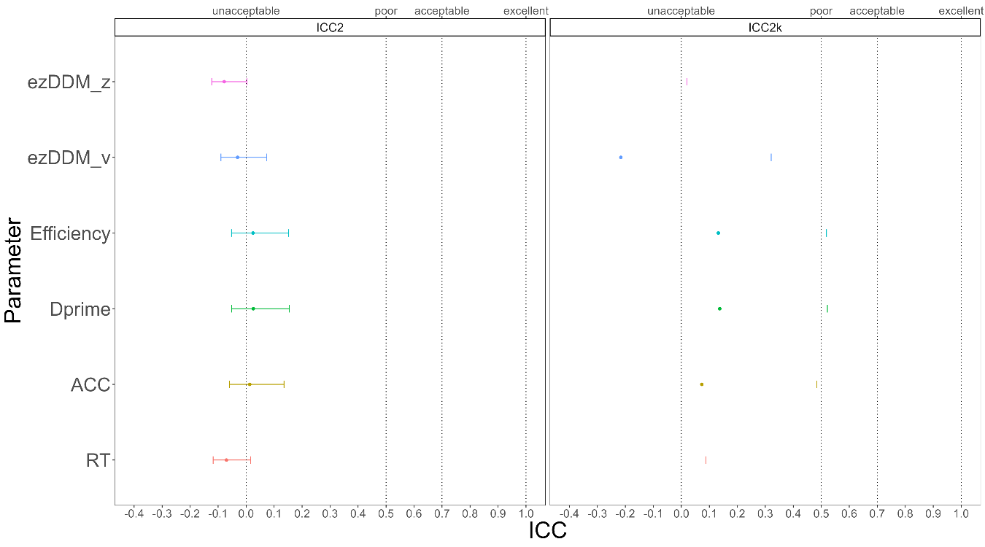

**Figure 4.** ICC2 and ICC2k

## Split-Half Reliability

First, we stratified the data based on three variables: Session, Match, and Identity, and then split the stratified data into two halves using four methods. Next, we calculated the SPE for each of the six indices for each half of the data. Finally, we calculated the split-half reliability for each of the six SPEs. As shown in Figure 2, when using the Monte Carlo split-half, the split-half reliability of the six indices obtained is very high, with the highest value of XXX, which means that it is the most stable of the six SPE indexing calculations for half-confidence. The results from the other three split-half methods were similar to the Monte Carlo method, which will be presented in the supplementary material.

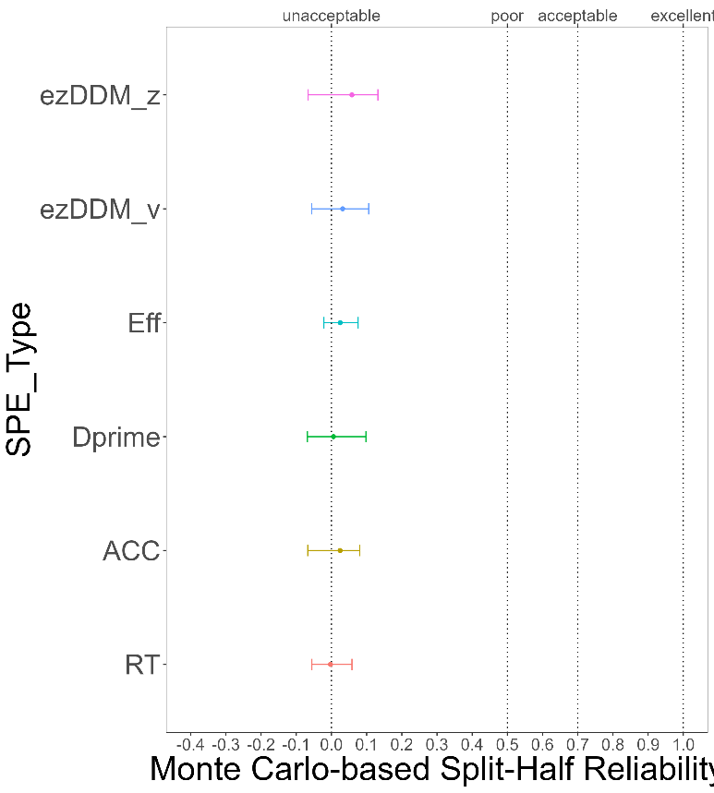

**Figure 5.** Monte Carlo-based Split-Half Reliability

# **Discussion**

Do **not** include a **Discussion** section.

# **Acknowledgements**

The present research is support by xxx.

# **Author contributions**

HCP contributed to the conception and supervision of the study and will provide the methodology expertise. JS contributed to fund raising, HCP contributed to data collection. ZL and ZYR will perform the data pre-processing, analysis and visualize the results. In addition, ZL, JS and HCP will contribute to discussing the results and the drafting of the final manuscript. All authors will critically revise the manuscript.

# **Competing interests**

The authors declare no competing interests.

# **Figures**

You are encouraged to include Figures in the text or at the end of the protocol. Keep in mind that a total of 8 display elements (i.e., combination of Tables and Figures) is permitted in the final, Stage 2, submission. However, to enable typesetting of papers, we advise making the number of display items commensurate with your overall word length (that is, for a shorter paper the number of display items should be lower, for a longer manuscript a higher number may be allowed). Figures/Tables that are not essential should be included in your Supplementary Information file.

# **Figure Legends**

**Figure 1. Guidelines for the preparation of figure captions.** Figure captions should be concise. Begin with a brief title and then describe what is presented in the figure and detail all relevant statistical information. If you show pilot data, list the N of each plot and report full statistics. Aim not to exceed 350 words per legend.

# **Supplementary information**

Please report pilot data in detail here and include any other material that provides background information.

Supplementary Table 1 Design Table

|  |  |  |  |
| --- | --- | --- | --- |
| **Question** | **Hypothesis (if applicable)** | **Analysis Plan** | **Interpretation given to different outcomes** |
| Which indicator (s) is appropriate and consistent to indicate the group-level self-prioritization effect (SPE) in the SALT? | (a) Model-based measurement (*v, z*) and Reaction time-based measurements (Mean Reaction times) are appropriately reliable as group-level SPE indicators in the associative learning task (b) accuracy-based measurements (accuracy, d-prime, efficiency) exhibits different degrees of inconsistency from one time point to another. | We will use two-way single-measurement mixed model with absolute agreement between scores of six session (ICC2k) as reliability measure of group-level SPE across six sessions. | ICC 2k values less than 0.6 are indicative of poor reliability, values between 0.6 and 0.8 indicate substantial reliability, values greater than 0.8 indicate excellent reliability. |
| Which indicator (s) is appropriate and consistent to indicate the individual-level self-prioritization effect (SPE) in the SALT? | (a) Model-based measurement (*v, z*), which may reflect the critical underlying generative process of individuals, are appropriately reliable as individual-level SPE indicators in the associative learning task. (b) RT and accuracy-based measurements (Mean Reaction times, accuracy, d-prime, and efficiency) exhibit different degrees of inconsistency from one time point to another. | We will use a two-way multiple raters’ random effect model with absolute agreement between scores of six sessions (ICC2) as reliability measure of individual-level SPE across six sessions. | ICC 2 values less than 0.6 are indicative of poor reliability, values between 0.6 and 0.8 indicate substantial reliability, values greater than 0.8 indicate excellent reliability. |
| Is there a practice effect across testing sessions? | There is a practice effect on all indices across testing sessions. | The effect of practice will be explored using hierarchical modelling using restricted maximum likelihood estimates with sessions as fixed effects and a random intercept to account for inter-individual differences in baseline performance. Significance will be calculated using Satterthwaite’s method to estimate degrees of freedom and generate *p-*values for mixed models. | *p*<0.05 as evidence for the presence of a practice effect. |

Supplementary Table 2 Split-Half Reliability of Other Split Method

|  |  |  |  |  |  |  |
| --- | --- | --- | --- | --- | --- | --- |
| SPE_type | SH_type | SH_r |  | SPE_type | SH_type | SH_r |
| RT | First-Second | .01 |  | Efficiency | First-Second | .07 |
| RT | Odd-Even | -.05 |  | Efficiency | Odd-Even | -.04 |
| RT | Permuted | .01 |  | Efficiency | Permuted | .05 |
| ACC | First-Second | .02 |  | DDM: v | First-Second | .04 |
| ACC | Odd-Even | -.05 |  | DDM: v | Odd-Even | -.05 |
| ACC | Permuted | .07 |  | DDM: v | Permuted | .10 |
| Dprime | First-Second | .01 |  | DDM: z | First-Second | .07 |
| Dprime | Odd-Even | -.08 |  | DDM: z | Odd-Even | .01 |
| Dprime | Permuted | -.02 |  | DDM: z | Permuted | .13 |

# **References**

Cheng, M., & Tseng, C.-h. (2019). Saliency at first sight: instant identity referential advantage toward a newly met partner. *Cognitive Research: Principles and Implications, 4*(1), 1-18.

Cherry, E.C. (1953). Some experiments on the recognition of speech, with one and with two ears. *The Journal of the acoustical society of America, 25*(5), 975-979. <https://doi.org/10.1121/1.1907229>

Chiarella, S.G., et al. (2020). Mindfulness meditation weakens attachment to self: Evidence from a self vs other binding task. *Mindfulness, 11*, 2411-2422.

Cicchetti, D.V., & Sparrow, S.A. (1981). Developing criteria for establishing interrater reliability of specific items: applications to assessment of adaptive behavior. *Am J Ment Defic, 86*(2), 127-137.

Constable, M.D., et al. (2019). Relevant for us? We-prioritization in cognitive processing. *Journal of Experimental Psychology: Human Perception and Performance, 45*(12). <https://doi.org/10.1037/xhp0000691>

Constable, M.D., & Knoblich, G. (2020). Sticking together? Re-binding previous other-associated stimuli interferes with self-verification but not partner-verification. *Acta psychologica, 210*, 103167. <https://doi.org/10.1016/j.actpsy.2020.103167>

Conway, M.A., & Dewhurst, S.A. (1995). The self and recollective experience. *Applied Cognitive Psychology, 9*(1), 1-19. <https://doi.org/10.1002/acp.2350090102>

Craik, F.I.M., & Tulving, E. (1975). Depth of processing and the retention of words in episodic memory. *Journal of Experimental Psychology: General, 104*(3), 268-294. <https://doi.org/10.1037/0096-3445.104.3.268>

Dalmaso, M., et al. (2019). Self-related shapes can hold the eyes. *Quarterly journal of experimental psychology, 72*(9), 2249-2260.

Desebrock, C., et al. (2018). Self-reference in action: Arm-movement responses are enhanced in perceptual matching. *Acta psychologica, 190*, 258-266.

Enock, F., et al. (2018). Self and team prioritisation effects in perceptual matching: Evidence for a shared representation. *Acta psychologica, 182*, 107-118. <https://doi.org/10.1016/j.actpsy.2017.11.011>

Enock, F.E., et al. (2020). Overlap in processing advantages for minimal ingroups and the self. *Scientific Reports, 10*(1), 18933.

Feng, C., et al. (2018). Neural representations of the multidimensional self in the cortical midline structures. *NeuroImage, 183*, 291-299. <https://doi.org/10.1016/j.neuroimage.2018.08.018>

Feng, C., et al. (2020). Effect of intranasal oxytocin administration on self-other distinction: Modulations by psychological distance and gender. *Psychoneuroendocrinology, 120*, 104804.

Fisher, R.A. (1992). Statistical methods for research workers. *Springer New York*.

Gillespie‐Smith, K., et al. (2018). The I in autism: Severity and social functioning in autism are related to self‐processing. *British journal of developmental psychology, 36*(1), 127-141. <https://doi.org/10.1111/bjdp.12219>

Golubickis, M., et al. (2020). Parts of me: Identity-relevance moderates self-prioritization. *Consciousness and cognition, 77*, 102848. <https://doi.org/10.1016/j.concog.2019.102848>

Golubickis, M., et al. (2017). Self-prioritization and perceptual matching: The effects of temporal construal. *Mem Cognit, 45*(7), 1223-1239. <https://doi.org/10.3758/s13421-017-0722-3>

Hu, C.-P., et al. (2020). Good Me Bad Me: Prioritization of the Good-Self During Perceptual Decision-Making. *Collabra. Psychology, 6*(1), 20. <https://doi.org/10.1525/collabra.301>

Hughes, S.M., & Harrison, M.A. (2013). I like my voice better: Self-enhancement bias in perceptions of voice attractiveness. *Perception, 42*(9), 941-949. <https://doi.org/10.1068/p7526>

Humphreys, G.W., & Sui, J. (2015). The salient self: Social saliency effects based on self-bias. *Journal of cognitive psychology, 27*(2), 129-140. <https://doi.org/10.1080/20445911.2014.996156>

Ivaz, L., et al. (2016). The emotional impact of being myself: Emotions and foreign-language processing. *Journal of Experimental Psychology: Learning, Memory, and Cognition, 42*(3), 489. <https://doi.org/10.1037/xlm0000179>

Jiang, M., et al. (2019). Cultural Orientation of Self-Bias in Perceptual Matching. *Front Psychol, 10*, 1469. <https://doi.org/10.3389/fpsyg.2019.01469>

Kahveci, S., et al. (2022). Reliability of reaction time tasks: how should it be computed? *Preprint*, 1-30. <https://doi.org/10.31234/osf.io/ta59r>

Keenan, J.P., et al. (2000). Self-recognition and the right prefrontal cortex. *Trends in cognitive sciences, 4*(9), 338-344. <https://doi.org/10.1016/S1364-6613> (00)01521-7

Kircher, T.T., et al. (2000). Towards a functional neuroanatomy of self processing: effects of faces and words. *Cognitive Brain Research, 10*(1-2), 133-144. <https://doi.org/10.1016/S0926-6410(00)00036-7>

Koo, T.K., & Li, M.Y. (2016). A Guideline of Selecting and Reporting Intraclass Correlation Coefficients for Reliability Research. *Journal of chiropractic medicine, 15*(2), 155-163. <https://doi.org/10.1016/j.jcm.2016.02.012>

Kupper, L.L., & Hafner, K.b. (1989). On Assessing Interrater Agreement for Multiple Attribute Responses. *Biometrics, 45*(3), 957-967. <https://doi.org/10.2307/2531695>

Liu, Y.S., et al. (2022). Depression screening using a non-verbal self-association task: A machine-learning based pilot study. *Journal of Affective Disorders, 310*, 87-95. <https://doi.org/10.1016/j.jad.2022.04.122>

Macrae, C.N., et al. (2017). Self-Relevance Prioritizes Access to Visual Awareness. *Journal of experimental psychology. Human perception and performance, 43*(3), 438-443. <https://doi.org/10.1037/xhp0000361>

Maire, H., et al. (2020). A Developmental Study of the Self‐Prioritization Effect in Children Between 6 and 10 Years of Age. *Child development, 91*(3), 694-704. <https://doi.org/10.1111/cdev.13352>

Moray, N. (1959). Attention in dichotic listening: Affective cues and the influence of instructions. *Quarterly journal of experimental psychology, 11*(1), 56-60. <https://doi.org/10.1080/17470215908416289>

Nijhof, A.D., & Bird, G. (2019). Self‐processing in individuals with autism spectrum disorder. *Autism research, 12*(11), 1580-1584. <https://doi.org/10.1002/aur.2200>

Parsons, S., et al. (2019). Psychological Science Needs a Standard Practice of Reporting the Reliability of Cognitive-Behavioral Measurements. *Advances in methods and practices in psychological science, 2*(4), 378-395. <https://doi.org/10.1177/2515245919879695>

Payne, B., et al. (2021). Perceptual prioritization of self‐associated voices. *British Journal of Psychology, 112*(3), 585-610. <https://doi.org/10.1111/bjop.12479>

R Development Core Team. (2010). R: A language and enviornment for statistical computing. In R Foundation for Statisticial Computing.

Rogers, T.B., et al. (1977, Sep). Self-reference and the encoding of personal information. *J Pers Soc Psychol, 35*(9), 677-688. <https://doi.org/10.1037//0022-3514.35.9.677>

Schäfer, S., & Frings, C. (2019). Understanding self-prioritisation: the prioritisation of self-relevant stimuli and its relation to the individual self-esteem. *Journal of cognitive psychology, 31*(8), 813-824. <https://doi.org/10.1080/20445911.2019.1686393>

Sel, A., et al. (2019). Self-Association and Attentional Processing Regarding Perceptually Salient Items. *Review of philosophy and psychology, 10*(4), 735-746. <https://doi.org/10.1007/s13164-018-0430-3>

Stoeber, J., & Eysenck, M.W. (2008). Perfectionism and efficiency: Accuracy, response bias, and invested time in proof-reading performance. *Journal of research in personality, 42*(6), 1673-1678. <https://doi.org/10.1016/j.jrp.2008.08.001>

Sui, J., et al. (2012). Perceptual effects of social salience: Evidence from self-prioritization effects on perceptual matching. *Journal of experimental psychology. Human perception and performance, 38*(5), 1105-1117. <https://doi.org/10.1037/a0029792>

Sui, J., & Humphreys, G.W. (2017). The self survives extinction: Self-association biases attention in patients with visual extinction. *Cortex, 95*, 248-256. <https://doi.org/10.1016/j.cortex.2017.08.006>

Sui, J., et al. (2016). Negative mood disrupts self- and reward-biases in perceptual matching. *Q J Exp Psychol, 69*(7), 1438-1448. <https://doi.org/10.1080/17470218.2015.1122069>

Symons, C.S., & Johnson, B.T. (1997, May). The self-reference effect in memory: a meta-analysis. *Psychological Bulletin, 121*(3), 371-394. <https://doi.org/10.1037/0033-2909.121.3.371>

Turk, D.J., et al. (2002). Mike or me? Self-recognition in a split-brain patient. *Nature neuroscience, 5*(9), 841-842. <https://doi.org/10.1038/nn907>

William Revelle. (2022). psych: Procedures for Psychological, Psychometric, and Personality Research. <https://doi.org/CRAN.R-project.org/package=psych>

Yankouskaya, A., et al. (2020). Intertwining personal and reward relevance: evidence from the drift-diffusion model. *Psychol Res, 84*(1), 32-50. <https://doi.org/10.1007/s00426-018-0979-6>

Zhou, A., et al. (2019). Self-referential processing can modulate visual spatial attention deficits in children with dyslexia. *Frontiers in Psychology, 10*, 2270. <https://doi.org/10.3389/fpsyg.2019.02270>

1. Based on the average effect size of group-level SPE reported by Sui et al. (2012), G*Power (f = .40, α = .05, power = 80%) revealed a minimal requirement of 16 participants. Thus, the sample size in the secondary data is sufficient to detect the self-prioritization effect at group-level.