

**Sections of a Stage 1 Registered Report**

**Scientific Repo**

Abstract 1

Introduction 2

Methods 3

Ethics information 3

Secondary Data Description 3

Experimental design 4

Stimuli materials and Procedure 4

Pilot data simulated data 5

Analysis Plan 5

Data pre-processing 6

Calculation of indices & quantifying SPE in the SALT 7

Reliability of indices in SALT as individual-level/group-level 7

Split-half reliability of SPE in SALT 8

Data availability 9

Code availability 9

Results 9

ICC (Intraclass correlation coefficient) 9

SHR (Split-Half Reliability) 10

Discussion 11

Acknowledgements 12

Author contributions 12

Competing interests 12

Figures 12

Figure Legends 12

Supplementary information 13

References 14

**Estimating Reliability of Self-Prioritization Effect as measured by the Self-Associative Learning Task: Evidence from Multiple Dataset**

Zheng Liu 1#, Mengzhen Hu1#, Yuanrui Zheng2, Jie Sui3*, Hu Chuan-Peng 1*

1 School of Psychology, Nanjing Normal University, Nanjing, China

2 School of Education, Kunming City College, Kunming, China

3 School of Psychology, University of Aberdeen, Old Aberdeen, Scotland

# These authors are equally contributed to this study

* Corresponding authors: Hu Chuan-Peng ([hu.chuan-peng@nnu.edu.cn](mailto:hu.chuan-peng@nnu.edu.cn))

# **Abstract**

The self-prioritization effect (SPE) refers to the effect that performance in cognitive tasks is better when stimuli are related to the self than when they are not. The social-associative learning task (SALT) emerged as the mainstream paradigm to study SPE in the last decade for its simplicity and elimination of familiarity effects. As a simple button-pressing task, SALT yields two direct outcomes: reaction time and accuracy. Indirect indices can be derived from reaction times and accuracy, including sensitivity d prime under signal-detection theory, the efficiency index through a direct division between reaction times and accuracy, and drift rate (v) and starting point (z) estimated using drift-diffusion models. All these direct and indirect indices can be used to quantify SPE in the literature. However, the reliability of these SPE indices has never been tested. To fill this gap, we will re-analyze existing data from multiple datasets using intraclass correlation coefficient (ICC) and split-half reliability. Our results will provide a benchmark for future studies.

# **Introduction**

The Self-Prioritization Effect (SPE) refers to the phenomenon where performance in cognitive tasks is better when stimuli are related to the self than when they are not. This effect has been established as a robust finding since the 1950s. During the early days of cognitive psychology, researchers found that subjects could recognize their own name from noisy auditory information even with insufficient cognitive resources, in the dichotic listening tasks (Cherry, 1953; Moray, 1959). Craik and Tulving (1975) discovered the SPE effect in memory, where information related to the self is easier to recall, and this finding has since been replicated in many other studies (Conway & Dewhurst, 1995; Rogers et al., 1977; Symons & Johnson, 1997). Over the following decades, the SPE has also been found when different stimuli was used, such own face (Keenan et al., 2000; Kircher et al., 2000; Turk et al., 2002), own voice (Hughes & Harrison, 2013; Payne et al., 2021), own name(Constable, Rajsic, et al., 2019), and newly owned object (Strachan et al., 2020). Additionally, the effect has been found in perceptual task, attentional task, memory task, and social judgment (Cunningham & Turk, 2017; Desebrock et al., 2018; Sui & Humphreys, 2013).

Although SPE is often argued to be a self-specific effect, it can be challenging to disassociate it from the familiarity effect since most studies use stimuli owned by participants as well as stimuli owned by others as the baseline condition. This issue has been addressed by the Self-Associative Learning Task (SALT). In SALT, participants first associate geometrical shapes (e.g., triangle, square, and circle) with labels of persons (e.g., "You," "friend," and "stranger") and then complete a perceptual matching task in which they decide if the shape-label pairs presented on the screen match the learned association or not (Sui et al., 2012). Using SALT, researchers have found that shapes associated with the self are performed better, with faster response times, better accuracy, and/or higher sensitivity scores as compared to shapes associated with friends and strangers (Schäfer & Frings, 2019; Sel et al., 2019; Sui et al., 2016).

Due to its simplicity and the lack of potential confounds from familiarity, the SALT paradigm has become the mainstream method for investigating the mechanisms underlying the SPE. For instance, researchers have explored the importance of personality traits in identity labels (Golubickis et al., 2020), the self-relevant labels that include the past, present, and future self (Golubickis et al., 2017), as well as "good self" and "bad self" labels (Hu et al., 2020), and the group advantage effect of in-group labels (Constable, Elekes, et al., 2019; Constable & Knoblich, 2020; Enock et al., 2018; Enock et al., 2020). Moreover, the SALT paradigm has been applied to various fields, such as neuroscience, physiology, clinical research, cross-cultural research, and child development. In neuroscience and physiology, researchers investigate which brain regions are activated during self-prioritization effect (Feng et al., 2018; Humphreys & Sui, 2015), and gender differences in self-prioritization effect due to oxytocin (Feng et al., 2020). In clinical research, SALT has been used to understand atypical self-processing in populations such as those with autism or depression (Gillespie‐Smith et al., 2018; Nijhof & Bird, 2019; Sui & Humphreys, 2017). Cross-cultural studies have shown that individuals from individualistic cultures demonstrate a stronger self-prioritization effect (Jiang et al., 2019), and that the language of the experimental stimuli can affect the strength of the effect (Ivaz et al., 2016). Finally, SALT has also been applied to child development, with studies examining developmental changes in self-positivity effects (Maire et al., 2020; Zhou et al., 2019).

Despite the popularity of using SALT, little attention has been paid to the exact indices of SPE and their reliability, which need to be examined carefully (Parsons et al., 2019). This issue is especially important because SALT is increasingly being used to measure individual differences in psychiatry (Liu et al., 2022) , and social psychology (Enock et al., 2018). To address this gap, we plan to examine the reliability of SPE indices in SALT by reanalyzing data from multiple sources (see Table 1 for the details of the data sources).

To comprehensively assess the SPE indices from SALT, we have included six indices of SPE. All of these SPE indices are defined as the difference between self and other, while using different outcomes of the matching trials of SALT. Specifically, these indices include two direct indices based on SALT reaction times and accuracy, as well as derived indices such as efficiency (Humphreys & Sui, 2015; Stoeber & Eysenck, 2008), *d* prime of SDT, and drift rate (*v*) and starting point (*z*) from DDM (Golubickis et al., 2017).

Given that there are multiple methods for calculating reliability of cognitive tasks, we will calculate the Intraclass Correlation Coefficient (ICC) and Split-Half Reliability for each of the SPE indices mentioned above.

Our main hypothesis are as follows:

1. The Self-Prioritization Effect (SPE) measured by the experimental indices in the Self-Associative Learning Task (SALT) paradigm is temporally stable
2. Among the multiple indices that measure Self-Prioritization Effect (SPE) in the Self-Associative Learning Task (SALT), there exists a most stable indicator

The results of this study will provide valuable insights into the reliability and consistency of the Self-Associative Learning Task (SALT), which could pave the way for its future use in research, clinical settings, and personal performance monitoring.

# **Methods**

## Ethics information

Our research involves a secondary analysis of pre-existing data obtained from publicly available datasets from studies that have used SALT in recent years. Therefore, informed consent and confidentiality are not applicable. Our data were obtained from publicly available datasets from studies that have used SALT in recent years.

## Secondary Data Description

We collected over 100 recent literature related to SALT, and selected 11 articles (Bukowski et al., 2021; Cheng & Tseng, 2019; Golubickis & Macrae, 2021; Navon & Makovski, 2021; Orellana-Corrales et al.; Schäfer & Frings, 2019; Schäfer et al., 2019; Schäfer et al., 2021; Schopf, 2020; Svensson et al., 2022; Woźniak et al., 2018) that had publicly available data and did not make significant modifications to the original experimental paradigm.

## Experimental design

The origin experiment is a two-factor design(Sui et al., 2012), with 2 levels of match vs. non-match and 3 levels of identity (self, friend and stranger). As our study aims to explore the reliability of Self-Prioritization Effect (SPE) in Self-Associative Learning Task (SALT) and identify the most stable SPE index.

## Stimuli materials and Procedure

The experiment was conducted individually in a dimly lit room, using E-Prime 2.0 software on a PC with a 1024 x 768 resolution monitor, refreshing at 100 Hz. Participants recorded their keypresses, reaction time, and accuracy during each trial.

The experiment was divided into two phases following the method of Sui et al. (2012). In the first phase (learning phase), participants completed a learning task where they associated three geometric shapes (circle, triangle and square) with three labels (self, friend, and stranger) for approximately 60 seconds. The shape-label associations were balanced across participants. In the second phase (formal experimental phase), participants completed a matching task. Each trial started with a fixation cross displayed in the center of the screen for 500 ms, followed by a shape-label pairing and fixation cross for 100 ms. the screen then went blank for 1500 ms, or until a response was made. Participants were required to judge whether the presented shape and label matched the learned associations from the learning phase and respond as quickly and accurately as possible by pressing one of two buttons within the allotted timeframe.

Prior to the formal experimental phase, participants completed a training session consisting of 24 practice trials. After the training, participants completed six blocks of 60 trials in the matching task, with two match types (match/mismatch) and three shape associations, for a total of 60 trials per association. Short breaks lasting up to 60 seconds were provided after each block.

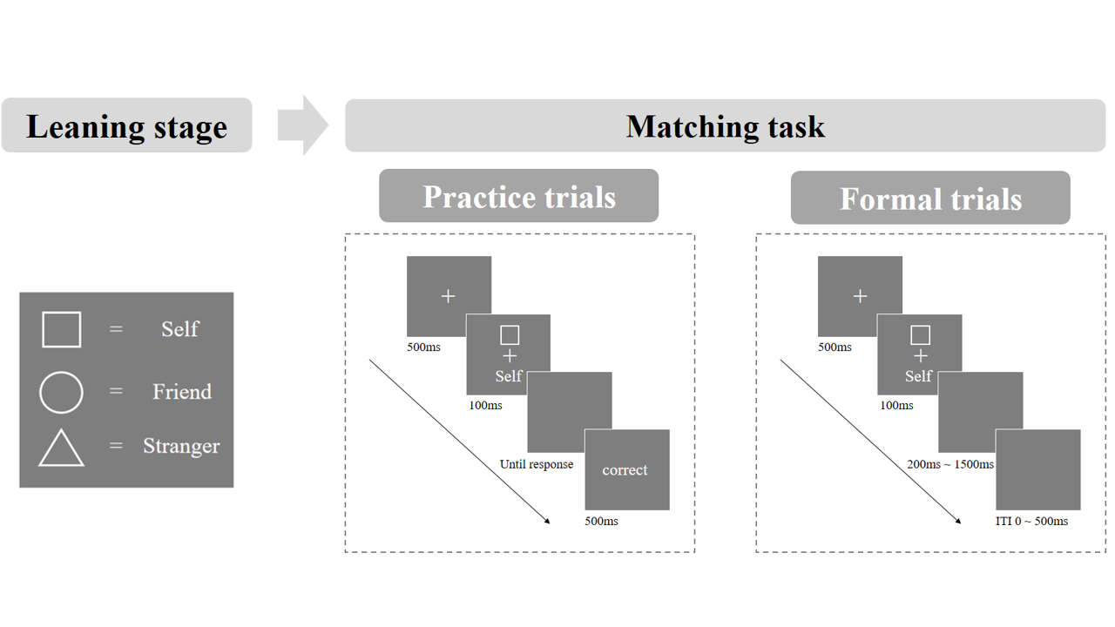

**Figure 1.** Experimental Process of SALT

## Pilot data simulated data

To avoid any potential biases in hypothesis formation, we didn't conduct any statistical analysis on the primary data during stage 1 registration. Instead, we generated a pilot dataset with the same format as the primary data. We used an open dataset from a previous study examining the self-prioritization effect as a reference to create our pilot data.

We utilized Bootstrap methods, drawing samples from Hu et al. (2020) open dataset (accessible at <https://osf.io/mhdsn/>) with replacement (allowing the same sample to be repeated in the pilot data). The pilot data includes 6 sessions of data from 34 participants, with each participant having 24 practice trials and 360 experimental trials (6 different types of shape-label associations: two matches (matched/mismatched) x three identity associations (self, friend, stranger), 60 trials per association) per session. Figure 1 shows the first 6 rows of the pilot data.

**Figure 2.** The first six rows of the pilot data

In the publicly available data from the 11 studies we collected, not all studies had repeated measures like our simulated data. If a publicly available data did not have repeated SALT measurements within a certain time interval, we would not calculate its ICC, but only calculate split-half reliability.

We ran the pilot data through our proposed statistical analysis to see whether our proposed analysis is appropriate for the secondary data structure (see analysis plan).

## Analysis Plan

All analyzes will be performed in R 4.2.2 (R Core Team, 2022).

First, we will clean the 11 publicly available datasets that we collected to obtain data in a form similar to the pilot data mentioned earlier. Then, we will calculate six indices that represent SALT for each dataset, namely reaction time, accuracy, *d* prime, efficiency, drift rate (*v*), and starting point (*z*). Reaction time and accuracy can be obtained directly from the datasets, while D-prime and efficiency will be calculated based on reaction time and accuracy using a simple formula (see Table 1). The calculation of drift rate (*v*) and starting point (*z*) will be based on the drift-diffusion model, with drift rate (*v*) indicating faster evidence accumulation and the starting point (*z*) reflecting a bias in the beginning of information accumulation (Golubickis et al., 2017; Macrae et al., 2017; Yankouskaya et al., 2020). Specifically, we will use the "fit_ezddm" function in the "hausekeep" package in R to obtain these two indices. However, these 11 publicly available datasets do not all adhere strictly to the original experimental design of SALT. For example, some experiments did not use the Friend label or the Stranger label. Therefore, we will make some adjustments when calculating the SPE.

If the data was obtained by conducting multiple SALT experiments at a certain time interval, we will calculate the Intraclass Correlation Coefficient (ICC) for these SPE values to evaluate the test-retest reliability of these six indices. Specifically, we will use the "psych" package to calculate ICC for these indices (William Revelle, 2022). If the SALT experiment was not repeated in a study, we will only calculate the split-half reliability for this dataset. Specifically, we will use four methods for calculating split-half reliability, namely first-second, odd-even, permutation and Monte Carlo split-half. And we will present the results of Monte Carlo split-half in the main text, while the results of other split-half reliability methods will be presented in the supplementary materials. As there is no R package that can directly calculate split-half reliability as we require, we will write our codes for this purpose.

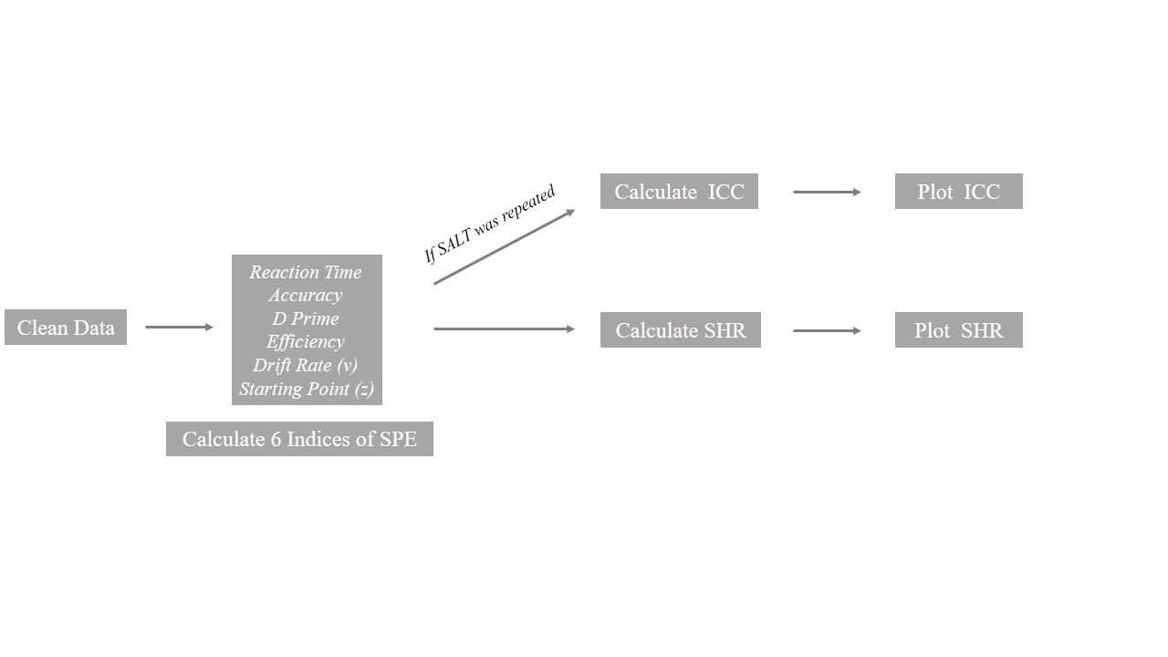

**Figure 3.** Analysis Flow Chart

### Data pre-processing

First, we will pre-process the secondary data using the following criteria (we do not pre-process the secondary data at stage 1 registration):

1. Participant exclusion criteria
2. Participant who has the wrong trial numbers because of procedure errors should be excluded from the analysis.
3. Participants with an overall accuracy < 0.5 should be excluded from the analysis.
4. Participants with any of the conditions with zero accuracy should be excluded from the analysis.
5. Behavioural data exclusion criteria
6. Trials with no response or wrong key press should be excluded from the analysis.
7. Trials with responses less than 200 ms or faster than 1500 ms should be excluded from the analysis.
8. The practice trials will be excluded from the formal analysis.
9. The data under conditions other than the “control condition” will not be used in the current study.
10. Organize data structures
11. Standardize the labels in the variable 'Match' to 'Match' and 'Mismatch’
12. Standardize the labels in the variable 'Identity' to 'Self', ‘Friend’ and 'Stranger’
13. Convert the unit of reaction time from milliseconds to seconds or from seconds to milliseconds, and name them as RT_ms and RT_sec respectively, while keeping both variables.
14. Arrange the variables in the order of Subject, Session (if applicable), Match, Identity, RT_ms, RT_sec, and ACC.
15. TBC(maybe)

### Calculation of indices & quantifying SPE in the SALT

Second, we will calculate six indices based on the cleaned SALT data, which will represent the Self-Prioritization Effect (SPE) in the SALT. Table 2 provides details on the calculation of these metrics and how they contribute to the determination of the SPE.

Table 1. Indices in SALT and corresponding calculation of indices and SPE

|  |  |  |  |  |
| --- | --- | --- | --- | --- |
| **Indices ID** | **Indices Calculation** | **SPE Calculation Based on Indices** | | **Source** |
| Mean  Reaction Times  (RT) | $$\frac{\sum{RT} }{n(trials)}$$ | Type 1 calculation | Self(match) -Other(match) | Sui et al. (2012) |
| Type 2 calculation | Self(all) - Other(all) | Sui et al. (2012) |
| Accuracy (ACC) | $$\frac{n\left(correct response\right)}{n\left(total respose\right)}$$ | Self(match) - Other(match) | | Sui et al. (2012) |
| *D* prime | $${Zscore}_{ACC \left(match\right)}$$ $$-{Zscore}_{1 - ACC (non-match)}$$ | Self - Other | | Sui et al. (2012) |
| Efficiency | $$\frac{mean RT}{ACC}$$ | Self(match) - Other(match) | | Humphreys and Sui (2015); Stoeber and Eysenck (2008) |
| Drift rate  (*v*) | DDM：parameters will be identified through model selection | Self(match) - Other(match) | | Golubickis et al. (2017) |
| Starting Point  (*z*) | Self(match) - Other(match) | | Golubickis et al. (2017) |

*Note.* DDM =Drift Diffusion Model.

We'll present the average and standard deviation for each index for each session, along with other important descriptive statistics.

### Reliability of indices in SALT as individual-level/group-level

We'll assess the reliability of the SALT indices using the Intraclass Correlation Coefficient (ICC). ICC is a well-established measure of reliability in test-retest, intra-rater, and inter-rater studies(Fisher, 1992). Compared to Pearson correlation coefficient, ICC considers both the degree of correlation and agreement between multiple measurements, making it a more comprehensive measure of test-retest reliability(Koo & Li, 2016).

Specifically, we will use two-way single-measurement mixed model with absolute agreement between scores of six session (ICC2k) as the reliability measure of group-level SPE across six sessions. For the calculation of ICC2k estimates and their 95% confidence intervals, the formula is:

$$\begin{aligned}\frac{{MS}_{R}-{MS}_{E}}{{MS}_{R}+\left(k-1\right){MS}_{E}++\frac{k}{n}\left({MS}_{C}-{MS}_{E}\right)}\end{aligned}$$

*Note. ${MS}_{R}$* = mean square for rows; ${MS}_{E}$ = mean square for error; ${MS}_{C}$ = mean square for columns; $n$ = number of subjects; $k$ = number of raters/measurements.

We will use a two-way multiple rater’s random effect model with absolute agreement between scores of six sessions (ICC2 ) as the reliability measure of individual-level SPE across six sessions. For the calculation of ICC2 estimates and their 95% confidence intervals, the formula is:

$$\frac{{MS}_{R}-{MS}_{E}}{{MS}_{R}+\frac{{MS}_{C}-{MS}_{E}}{n}}$$

*Note. ${MS}_{R}$* = mean square for rows; ${MS}_{E}$ = mean square for error; ${MS}_{C}$ = mean square for columns; $n$ = number of subjects.

We'll interpret the ICC2 and ICC2k following these guidelines: a value less than 0.6 means poor reliability, a value between 0.6 and 0.8 indicates substantial reliability, and a value greater than 0.8 means excellent reliability (Cicchetti & Sparrow, 1981; Kupper & Hafner, 1989).

### Split-half reliability of SPE in SALT

In psychological research, Cronbach's alpha is often used to determine the reliability of experiments. However, using this method in cognitive experiments can lead to biased results. As a result, more and more studies are using split-half reliability instead of Cronbach's alpha to assess the reliability of cognitive experiments. This is because Cronbach's alpha is calculated based on different experimental conditions, while split-half reliability is calculated based on trial sequences. (Kahveci et al., 2022)

There are four types of split-half reliability: odd-even, front-back, permutation, and Monte Carlo. The odd-even split separates trials into odd and even numbered sequences, while the front-back split separates the first and second halves of trials. The permutation split shuffles the trial order and randomly assigns each half to a group. Monte Carlo split-half is similar to the permutation split-half, repeating the process thousands of times to calculate the average and 95% confidence interval of the split-half reliability. This study will primarily use Monte Carlo split-half to determine the split-half reliability of SALT.

First, the data will be stratified according to Session (if it has), Match, and Identity. If not stratified, directly splitting the data in half will result in uneven distribution of trials for each experimental condition in the two halves, thereby overestimating or underestimating the reliability of the split. Therefore, after the data is stratified, we split the data. For example, when using Monte Carlo Split-Half, we randomly split the data into two half. Then we repeat this operation 1000 times. This will result in 1000 pairs of two halves of the data. Next, we use these 1000 pairs of data to calculate 1000 Pearson correlation coefficients, and then obtain the average and 95% confidence interval of the Monte Carlo split reliability. As for first-second split, odd-even split, and permutated split, they are similar to Monte Carlo division, but they only perform one split, so only one split-half reliability is obtained without interval estimate of the split-half reliability.

# **Data availability**

We will adhere to the following open science practices: open materials, open data. We will share the raw data, excluding sensitive participants’ information on acceptance of our Stage 2 manuscript. The simulated data is accessible on the Open Science Framework () and GitHub ().

# **Code availability**

Code used to simulate and analyze the pilot data is made accessible in the same location: Open Science Framework () and GitHub ().

# **Results**

## ICC (Intraclass correlation coefficient)

Intraclass correlation coefficient (ICC) is a measure of the consistency or reliability of measurements made by different raters (observers) or repeated measurements made by the same rater (observer). We will calculate ICC only if the study involves repeated measurements of SALT. In essence, it tells us how much of the variation in the data can be attributed to differences between raters or repeated measurements, and how much of it can be attributed to differences within the subjects being measured. In simple terms, it gives an idea of the proportion of total variation in the data that is due to the true differences between subjects, versus due to measurement error or random fluctuations.

The present study aimed to investigate the stability of six indices, including reaction time (RT), accuracy (ACC), *d* prime, Efficiency, drift rate (*v*) and starting point (*z*) in the diffusion decision model (DDM), across six time sessions. We use the Intraclass Correlation Coefficients (ICC) to evaluate how much of the variation in SALT can be attributed to within-subject repeatability over time, and how much can be attributed to between-subject differences. Among them, we are most interested in ICC2 and ICC2k, where ICC2 represents the ratio of between-subject variance to total variance, and ICC2k represents the ratio of within-subject variance to total variance. Therefore, we want ICC2 to be as large as possible and ICC2k to be as small as possible, indicating that the differences in our experimental measures are mainly due to between-subject individual differences, and each subject's performance is relatively stable across the six sessions. As shown in Figure 4, the ICC2 values of the six indices are relatively large and ICC2k values are relatively small, supporting our hypothesis.

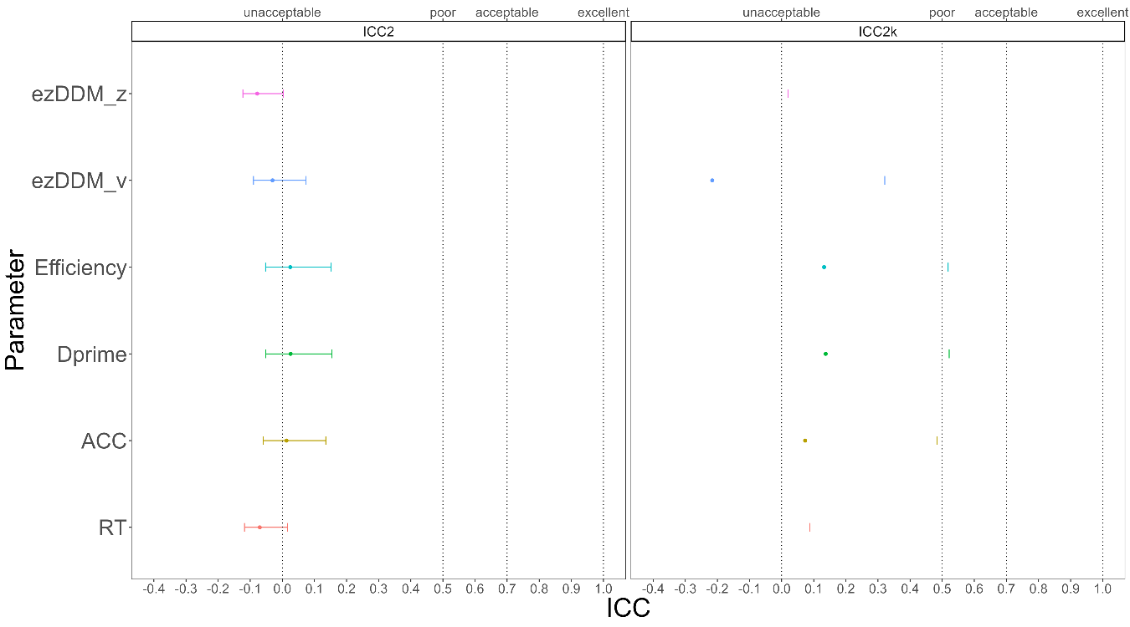

**Figure 4.** ICC2 and ICC2k

## SHR (Split-Half Reliability)

First, we stratified the data based on three variables: Session (if it has), Match, and Identity, and then split the stratified data into two halves using four methods. Next, we calculated the SPE for each of the six indices for each half of the data. Finally, we calculated the split-half reliability for each of the six SPEs. As shown in Figure 5, when using the Monte Carlo split-half, the split-half reliability of the six indices obtained is very high, with the highest value of XXX, which means that it is the most stable of the six SPE indexing calculations for half-confidence. The results from the other three split-half methods were similar to the Monte Carlo method, which will be presented in the supplementary material.

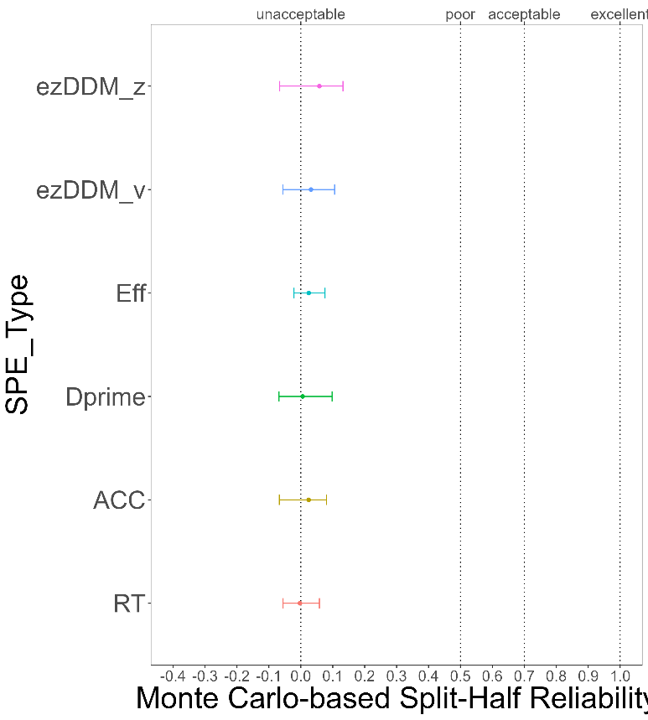

**Figure 5.** Monte Carlo-based Split-Half Reliability

# **Discussion**

Do **not** include a **Discussion** section.

# **Acknowledgements**

The present research is support by xxx.

# **Author contributions**

HCP contributed to the conception and supervision of the study and will provide the methodology expertise. JS contributed to fund raising, HCP contributed to data collection. ZL and ZYR will perform the data pre-processing, analysis and visualize the results. In addition, ZL, JS and HCP will contribute to discussing the results and the drafting of the final manuscript. All authors will critically revise the manuscript.

# **Competing interests**

The authors declare no competing interests.

# **Figures**

You are encouraged to include Figures in the text or at the end of the protocol. Keep in mind that a total of 8 display elements (i.e., combination of Tables and Figures) is permitted in the final, Stage 2, submission. However, to enable typesetting of papers, we advise making the number of display items commensurate with your overall word length (that is, for a shorter paper the number of display items should be lower, for a longer manuscript a higher number may be allowed). Figures/Tables that are not essential should be included in your Supplementary Information file.

# **Figure Legends**

**Figure 1. Guidelines for the preparation of figure captions.** Figure captions should be concise. Begin with a brief title and then describe what is presented in the figure and detail all relevant statistical information. If you show pilot data, list the N of each plot and report full statistics. Aim not to exceed 350 words per legend.

# **Supplementary information**

Please report pilot data in detail here and include any other material that provides background information.

Supplementary Table 1 Split-Half Reliability of Other Split Method

|  |  |  |  |  |  |  |
| --- | --- | --- | --- | --- | --- | --- |
| Indices of SPE | Method of SH | SHR |  | Indices of SPE | Method of SH | SHR |
| RT | First-Second | .01 |  | Efficiency | First-Second | .07 |
| RT | Odd-Even | -.05 |  | Efficiency | Odd-Even | -.04 |
| RT | Permuted | .01 |  | Efficiency | Permuted | .05 |
| ACC | First-Second | .02 |  | DDM: v | First-Second | .04 |
| ACC | Odd-Even | -.05 |  | DDM: v | Odd-Even | -.05 |
| ACC | Permuted | .07 |  | DDM: v | Permuted | .10 |
| Dprime | First-Second | .01 |  | DDM: z | First-Second | .07 |
| Dprime | Odd-Even | -.08 |  | DDM: z | Odd-Even | .01 |
| Dprime | Permuted | -.02 |  | DDM: z | Permuted | .13 |

*Note.* SH = split-half, SHR = split-half reliability, SPE = self-prioritization effect

# **References**

Bukowski, H., et al. (2021). Socio-cognitive training impacts emotional and perceptual self-salience but not self-other distinction. *Acta psychologica, 216*, 103297.

Cheng, M., & Tseng, C.-h. (2019). Saliency at first sight: instant identity referential advantage toward a newly met partner. *Cognitive Research: Principles and Implications, 4*(1), 1-18.

Cherry, E.C. (1953). Some experiments on the recognition of speech, with one and with two ears. *The Journal of the acoustical society of America, 25*(5), 975-979. <https://doi.org/10.1121/1.1907229>

Cicchetti, D.V., & Sparrow, S.A. (1981). Developing criteria for establishing interrater reliability of specific items: applications to assessment of adaptive behavior. *Am J Ment Defic, 86*(2), 127-137.

Constable, M.D., et al. (2019). Relevant for us? We-prioritization in cognitive processing. *Journal of Experimental Psychology: Human Perception and Performance, 45*(12). <https://doi.org/10.1037/xhp0000691>

Constable, M.D., & Knoblich, G. (2020). Sticking together? Re-binding previous other-associated stimuli interferes with self-verification but not partner-verification. *Acta psychologica, 210*, 103167. <https://doi.org/10.1016/j.actpsy.2020.103167>

Constable, M.D., et al. (2019). It is not in the details: Self-related shapes are rapidly classified but their features are not better remembered. *Memory & Cognition, 47*, 1145-1157.

Conway, M.A., & Dewhurst, S.A. (1995). The self and recollective experience. *Applied Cognitive Psychology, 9*(1), 1-19. <https://doi.org/10.1002/acp.2350090102>

Craik, F.I.M., & Tulving, E. (1975). Depth of processing and the retention of words in episodic memory. *Journal of Experimental Psychology: General, 104*(3), 268-294. <https://doi.org/10.1037/0096-3445.104.3.268>

Cunningham, S.J., & Turk, D.J. (2017, Jun). Editorial: A review of self-processing biases in cognition. *Quarterly journal of experimental psychology, 70*(6), 987-995. <https://doi.org/10.1080/17470218.2016.1276609>

Desebrock, C., et al. (2018). Self-reference in action: Arm-movement responses are enhanced in perceptual matching. *Acta psychologica, 190*, 258-266.

Enock, F., et al. (2018). Self and team prioritisation effects in perceptual matching: Evidence for a shared representation. *Acta psychologica, 182*, 107-118. <https://doi.org/10.1016/j.actpsy.2017.11.011>

Enock, F.E., et al. (2020). Overlap in processing advantages for minimal ingroups and the self. *Scientific Reports, 10*(1), 18933.

Feng, C., et al. (2018). Neural representations of the multidimensional self in the cortical midline structures. *NeuroImage, 183*, 291-299. <https://doi.org/10.1016/j.neuroimage.2018.08.018>

Feng, C., et al. (2020). Effect of intranasal oxytocin administration on self-other distinction: Modulations by psychological distance and gender. *Psychoneuroendocrinology, 120*, 104804.

Fisher, R.A. (1992). Statistical methods for research workers. *Springer New York*.

Gillespie‐Smith, K., et al. (2018). The I in autism: Severity and social functioning in autism are related to self‐processing. *British journal of developmental psychology, 36*(1), 127-141. <https://doi.org/10.1111/bjdp.12219>

Golubickis, M., et al. (2020). Parts of me: Identity-relevance moderates self-prioritization. *Consciousness and cognition, 77*, 102848. <https://doi.org/10.1016/j.concog.2019.102848>

Golubickis, M., et al. (2017). Self-prioritization and perceptual matching: The effects of temporal construal. *Mem Cognit, 45*(7), 1223-1239. <https://doi.org/10.3758/s13421-017-0722-3>

Golubickis, M., & Macrae, C.N. (2021). Judging me and you: Task design modulates self-prioritization. *Acta psychologica, 218*, 103350.

Hu, C.-P., et al. (2020). Good Me Bad Me: Prioritization of the Good-Self During Perceptual Decision-Making. *Collabra. Psychology, 6*(1), 20. <https://doi.org/10.1525/collabra.301>

Hughes, S.M., & Harrison, M.A. (2013). I like my voice better: Self-enhancement bias in perceptions of voice attractiveness. *Perception, 42*(9), 941-949. <https://doi.org/10.1068/p7526>

Humphreys, G.W., & Sui, J. (2015). The salient self: Social saliency effects based on self-bias. *Journal of cognitive psychology, 27*(2), 129-140. <https://doi.org/10.1080/20445911.2014.996156>

Ivaz, L., et al. (2016). The emotional impact of being myself: Emotions and foreign-language processing. *Journal of Experimental Psychology: Learning, Memory, and Cognition, 42*(3), 489. <https://doi.org/10.1037/xlm0000179>

Jiang, M., et al. (2019). Cultural Orientation of Self-Bias in Perceptual Matching. *Front Psychol, 10*, 1469. <https://doi.org/10.3389/fpsyg.2019.01469>

Kahveci, S., et al. (2022). Reliability of reaction time tasks: how should it be computed? *Preprint*, 1-30. <https://doi.org/10.31234/osf.io/ta59r>

Keenan, J.P., et al. (2000). Self-recognition and the right prefrontal cortex. *Trends in cognitive sciences, 4*(9), 338-344. <https://doi.org/10.1016/S1364-6613> (00)01521-7

Kircher, T.T., et al. (2000). Towards a functional neuroanatomy of self processing: effects of faces and words. *Cognitive Brain Research, 10*(1-2), 133-144. <https://doi.org/10.1016/S0926-6410(00)00036-7>

Koo, T.K., & Li, M.Y. (2016). A Guideline of Selecting and Reporting Intraclass Correlation Coefficients for Reliability Research. *Journal of chiropractic medicine, 15*(2), 155-163. <https://doi.org/10.1016/j.jcm.2016.02.012>

Kupper, L.L., & Hafner, K.b. (1989). On Assessing Interrater Agreement for Multiple Attribute Responses. *Biometrics, 45*(3), 957-967. <https://doi.org/10.2307/2531695>

Liu, Y.S., et al. (2022). Depression screening using a non-verbal self-association task: A machine-learning based pilot study. *Journal of Affective Disorders, 310*, 87-95. <https://doi.org/10.1016/j.jad.2022.04.122>

Macrae, C.N., et al. (2017). Self-Relevance Prioritizes Access to Visual Awareness. *Journal of experimental psychology. Human perception and performance, 43*(3), 438-443. <https://doi.org/10.1037/xhp0000361>

Maire, H., et al. (2020). A Developmental Study of the Self‐Prioritization Effect in Children Between 6 and 10 Years of Age. *Child development, 91*(3), 694-704. <https://doi.org/10.1111/cdev.13352>

Moray, N. (1959). Attention in dichotic listening: Affective cues and the influence of instructions. *Quarterly journal of experimental psychology, 11*(1), 56-60. <https://doi.org/10.1080/17470215908416289>

Navon, M., & Makovski, T. (2021). Are Self-related Items Unique? the Self-prioritization Effect Revisited.

Nijhof, A.D., & Bird, G. (2019). Self‐processing in individuals with autism spectrum disorder. *Autism research, 12*(11), 1580-1584. <https://doi.org/10.1002/aur.2200>

Orellana-Corrales, G., et al. Does Self-Associating a Geometric Shape Immediately Cause Attentional Prioritization? Comparing Familiar vs. Recently Self-Associated Stimuli in the Dot-Probe Task.

Parsons, S., et al. (2019). Psychological Science Needs a Standard Practice of Reporting the Reliability of Cognitive-Behavioral Measurements. *Advances in methods and practices in psychological science, 2*(4), 378-395. <https://doi.org/10.1177/2515245919879695>

Payne, B., et al. (2021). Perceptual prioritization of self‐associated voices. *British Journal of Psychology, 112*(3), 585-610. <https://doi.org/10.1111/bjop.12479>

R Core Team. (2022). R: A Language and Environment for Statistical Computing. <https://www.R-project.org/>

Rogers, T.B., et al. (1977, Sep). Self-reference and the encoding of personal information. *J Pers Soc Psychol, 35*(9), 677-688. <https://doi.org/10.1037//0022-3514.35.9.677>

Schäfer, S., & Frings, C. (2019). Understanding self-prioritisation: The prioritisation of self-relevant stimuli and its relation to the individual self-esteem. *Journal of cognitive psychology, 31*(8), 813-824.

Schäfer, S., et al. (2019). The natural egocenter: An experimental account of locating the self. *Consciousness and cognition, 74*, 102775.

Schäfer, S., et al. (2021). When self‐prioritization crosses the senses: Crossmodal self‐prioritization demonstrated between vision and touch. *British Journal of Psychology, 112*(3), 573-584.

Schopf, K. (2020). Effects of Affective Valence on the Prioritization of Self-Relevant Stimuli.

Sel, A., et al. (2019). Self-Association and Attentional Processing Regarding Perceptually Salient Items. *Review of philosophy and psychology, 10*(4), 735-746. <https://doi.org/10.1007/s13164-018-0430-3>

Stoeber, J., & Eysenck, M.W. (2008). Perfectionism and efficiency: Accuracy, response bias, and invested time in proof-reading performance. *Journal of research in personality, 42*(6), 1673-1678. <https://doi.org/10.1016/j.jrp.2008.08.001>

Strachan, J.W., et al. (2020). It goes with the territory: Ownership across spatial boundaries. *Journal of Experimental Psychology: Human Perception and Performance, 46*(8), 789.

Sui, J., et al. (2012). Perceptual effects of social salience: Evidence from self-prioritization effects on perceptual matching. *Journal of experimental psychology. Human perception and performance, 38*(5), 1105-1117. <https://doi.org/10.1037/a0029792>

Sui, J., & Humphreys, G.W. (2013, Nov). Self-referential processing is distinct from semantic elaboration: Evidence from long-term memory effects in a patient with amnesia and semantic impairments. *Neuropsychologia, 51*(13), 2663-2673. <https://doi.org/10.1016/j.neuropsychologia.2013.07.025>

Sui, J., & Humphreys, G.W. (2017). The self survives extinction: Self-association biases attention in patients with visual extinction. *Cortex, 95*, 248-256. <https://doi.org/10.1016/j.cortex.2017.08.006>

Sui, J., et al. (2016). Negative mood disrupts self- and reward-biases in perceptual matching. *Q J Exp Psychol, 69*(7), 1438-1448. <https://doi.org/10.1080/17470218.2015.1122069>

Svensson, S.L., et al. (2022). More or less of me and you: self-relevance augments the effects of item probability on stimulus prioritization. *Psychological Research, 86*(4), 1145-1164.

Symons, C.S., & Johnson, B.T. (1997, May). The self-reference effect in memory: a meta-analysis. *Psychological Bulletin, 121*(3), 371-394. <https://doi.org/10.1037/0033-2909.121.3.371>

Turk, D.J., et al. (2002). Mike or me? Self-recognition in a split-brain patient. *Nature neuroscience, 5*(9), 841-842. <https://doi.org/10.1038/nn907>

William Revelle. (2022). psych: Procedures for Psychological, Psychometric, and Personality Research. <https://doi.org/CRAN.R-project.org/package=psych>

Woźniak, M., et al. (2018). Prioritization of arbitrary faces associated to self: An EEG study. *PloS one, 13*(1), e0190679.

Yankouskaya, A., et al. (2020). Intertwining personal and reward relevance: evidence from the drift-diffusion model. *Psychol Res, 84*(1), 32-50. <https://doi.org/10.1007/s00426-018-0979-6>

Zhou, A., et al. (2019). Self-referential processing can modulate visual spatial attention deficits in children with dyslexia. *Frontiers in Psychology, 10*, 2270. <https://doi.org/10.3389/fpsyg.2019.02270>