**Reliability Assessment of Self-Prioritization Effect as Measured by the Perceptual Matching Task**

Zheng Liu1,2#, Mengzhen Hu1#, Yuanrui Zheng1, Jie Sui3, Hu Chuan-Peng 1*

1 School of Psychology, Nanjing Normal University, Nanjing, China

2 School of Humanities and Social Sciences, The Chinese University of Hongkong (Shenzhen), Shenzhen, China

3 School of Psychology, University of Aberdeen, Old Aberdeen, Scotland

# These authors are equally contributed to this study

* Corresponding authors: Hu Chuan-Peng ([hu.chuan-peng@nnu.edu.cn；hcp4715@hotmail.com](mailto:hu.chuan-peng@nnu.edu.cn；hcp4715@hotmail.com))

***Abstract:***

The self-prioritization effect (SPE) refers to the phenomenon where individuals demonstrate faster and more accurate responses to self-relevant stimuli in cognitive tasks. The self-perceptual matching task (SPMT) has emerged as a mainstream paradigm for studying the cognitive mechanisms underlying the SPE. Additionally, the SPE measured by the SPMT has been utilized as an indicator of individual differences in research, including clinical studies. As a simple button-pressing task, SPMT eliminates familiarity effects and yields two outcome variables for quantifying SPE: reaction time (RT) and accuracy (ACC). Existing literature has also reported four additional outcome variables derived from reaction times and accuracy, including sensitivity *d’* under signal-detection theory, the efficiency (*η*), drift rate (*v*) and starting point (*z*) estimated using the drift-diffusion models. Moreover, the calculation of SPE can employ different baseline conditions, including “Close other”, “Stranger”, “Celebrity”, and “Non-person”. However, the reliability of SPE measures computed using different outcome variables under various baseline conditions has not been systematically examined, leaving the stability of using the SPMT for measuring individual differences unknown. To fill the gap, we conducted a pre-registered study wherein we re-analyzed seventeen datasets (N = 833) from nine papers and two projects using split-half reliability and intraclass correlation coefficient (ICC2, ICC2k). The results revealed that the split-half reliabilities, weighted across multiple datasets, of RT (*r* Close = 0.58; *r*Stranger = 0.65) and Efficiency (*r*Close = 0.57; *r*Stranger = 0.64), using close others and strangers as the baseline conditions, are relatively high but still lower than that rule of thumb. The estimated split-half reliability for all other indices is approximately 0.5 or even lower. Similar results were obtained in ICCs, where the ICC2 for individual differences in the reaction time (ICC2 Close = 0.53; ICC2 Stranger = 0.59) and efficiency (ICC2 Close = 0.53; ICC2 Stranger = 0.35) are relatively higher when using close other or stranger as baseline conditions, but still considerably lower than the desired level in psychometrics. For the ICC2k, which measures the stability of SPE on group level, the reaction time measures (ICC2k Close = 0.87; ICC2k Stranger = 0.90) and efficiency measures (ICC2k Close = 0.87; ICC2k Stranger = 0.76) are relatively high when using close other or stranger as baseline conditions, while the remaining ten other ICC2k indices are about 0.5 or even lower. These findings suggest that SPE measures based the reaction time and efficiency are reliable at the group level, while further considerations are needed for measuring individual differences. These results provide insights into the reliability of the SPMT and its future applications.

***Keywords*:** Self-Prioritization Effect (SPE), Self-Perceptual Matching Task (SPMT), Reliability, Multiverse

**1 Introduction**

The Self-Prioritization Effect (SPE) refers to the phenomenon whereby performance in cognitive tasks is better when stimuli are related to the self than when they are not. This effect has been widely documented and confirmed since the 1950s. In the early days of cognitive psychology, researchers found that subjects were able to recognize their own names, even when they were mixed with a noisy auditory background and not the target of the task in dichotic listening tasks (Cherry, 1953; Moray, 1959). SPE was then reported in memory research by Craik and Tulving (1975), who found that participants were able to recall more words when they were related to the self compared to when they were processed at other levels (e.g., semantic). This SPE effect in memory was also replicated by many others (Conway & Dewhurst, 1995; Rogers et al., 1977; Symons & Johnson, 1997). In the following decades, the SPE has also been found to occur with different stimuli, such as own face (Keenan et al., 2000; Kircher et al., 2000; Turk et al., 2002), own voice (Hughes & Harrison, 2013; Payne et al., 2021), own name (Constable, Rajsic, et al., 2019), and newly owned object (Strachan et al., 2020). SPE was also found across a variety of cognitive tasks, such as perceptual task (Cunningham & Turk, 2017; Desebrock et al., 2018), decision-making task (Sui & Humphreys, 2013), attentional task (Shapiro et al., 1997), and ownership task (Cunningham et al., 2008).

Although SPE is often argued to be a self-specific effect, it can be challenging to disassociate it from the familiarity effect since most studies use stimuli owned by participants or by others. Sui et al. (2012) introduced the Self-Perceptual Matching Task (SPMT), a cognitive paradigm designed to investigate the acquisition of social meaning attributed to different geometric shapes. In this task, participants are required to establish associations between specific geometrical shapes (e.g., triangle, square, and circle) and corresponding labels of persons (e.g., "you," "friend," and "stranger"). Subsequently, participants engage in a perceptual matching task, wherein they evaluate whether the shape-label pairs presented on the screen align with the previously learned associations. In this task, Sui et al. (2012) found that shapes associated with the self were responded with faster reaction times, better accuracy and higher sensitivity scores (*d’*), compared to shapes associated with friends and strangers.

The most significant contribution of the SPMT lies in its successful elimination of the familiarity effect by strategically inducing self-relatedness just prior to the commencement of the perceptual matching task. As a result of this innovation, the SPMT has become the mainstream method for investigating the mechanism underlying the SPE. For instance, researchers have explored the importance of personality traits in identity labels (Golubickis et al., 2020), the self-relevant labels that include the past, present, and future self (Golubickis et al., 2017), self-related labels with moral values (Hu et al., 2020), and the group advantage effect of in-group labels (Constable, Elekes, et al., 2019; Constable & Knoblich, 2020; Enock et al., 2018; Enock et al., 2020). Moreover, the SPMT has been applied to various fields. In neuroscience and physiology, researchers investigate which brain regions are activated during the SPE (Feng et al., 2018; Humphreys & Sui, 2015), and gender differences in SPE due to oxytocin (Feng et al., 2020). The SPMT has also been applied to child development, with studies examining developmental changes in SPE (Maire et al., 2020; Zhou et al., 2019). Cross-cultural studies have demonstrated variations in the magnitude of the SPE across different cultural contexts, particularly between individualistic and collectivist cultures (Jiang et al., 2019). Finally, in clinical research, SPMT has also been integrated to understand atypical self-processing in populations such as those with autism or depression (Gillespie‐Smith et al., 2018; Nijhof & Bird, 2019; Sui & Humphreys, 2017).

Evaluating the reliability of a behavioral paradigm is essential for researchers planning to use the paradigm to investigate different research questions, such as individual differences and underlying mechanisms (Green et al., 2016; Hedge et al., 2018; Parsons et al., 2019). While SPMT has gained widespread adoption as a prominent method for investigating the underlying mechanism of SPE, few studies reported of the psychometric properties of the outcomes, leaving the reliability of using the SPMT for measuring individual differences and group level consistency unknown (Zorowitz & Niv, 2023). Furthermore, in tasks as simple as the SPMT, there are multiple approaches to quantify the SPE. The SPMT yields two direct outcome variables for quantifying SPE: mean reaction time (RT) and accuracy (ACC). In addition to these, the existing literature has identified four additional outcome variables derived from RT and ACC. These include efficiency (*η*) (Humphreys & Sui, 2015; Stoeber & Eysenck, 2008), sensitivity score (*d’*) under signal detection theory (Hu et al., 2020; Sui et al., 2012), and drift rate (*v*) and starting point (*z*) estimated using the drift-diffusion models (DDM) (Golubickis et al., 2017). Moreover, the calculation of SPE can employ different baseline conditions, such as “Close other” (Navon & Makovski, 2021; Svensson et al., 2022), “Stranger” (Constable et al., 2021; Orellana-Corrales et al.), “Celebrity” (Qian et al., 2020), and “Non-person” (Schäfer & Frings, 2019). Given the increasing use of SPMT to assess individual differences in fields such as psychiatry (Liu et al., 2022), social psychology (Enock et al., 2018), and cognitive neuroscience (Zhang et al., 2023), it is crucial to ensure a high degree of measurement consistency to accurately assess human perceptual capacities. As a result, two pivotal questions remain unresolved: (1) Can the six outcome variables (RT, ACC, *d’*, *η*, *v*, *z*) reliably measure the SPE under various baseline conditions? Additionally, which of these outcome variables demonstrate the highest level of reliability? (2) Is the SPMT suitable for assessing individual differences and group-level variations in the manifestation of the SPE? Addressing these questions is crucial for establishing the reliability of SPMT measurements, allowing for accurate assessment of the SPE and its implications in various domains.

To address the existing research gap, the present study investigated the reliability of SPE measures computed using different outcome variables under various baseline conditions in the SPMT. This was achieved by re-analyzed 17 independent datasets (N = 833) from 9 papers and 2 unpublished projects that employees SPMT. In order to comprehensively assess the SPE measures derived from SPMT, we examined six outcome variables (RT, ACC, *d’*, *η*, *v*, *z*) under four baseline conditions (“Close other”, “Stranger”, “Celebrity”, and “Non-person”), as mentioned earlier, that is supposed to capture the disparity between self-related and other-related stimuli of the matching trials. Given the methods available for evaluating the reliability of cognitive tasks, we employed both the Split-Half Reliability (*r*) and Intraclass Correlation Coefficient (ICC2 for individual differences and ICC2k for group-level analysis) to determine the reliability of each SPE measures. The findings of our study provide valuable insights into the reliability and consistency of SPMT and its outcome variables, having the potential to facilitate the future utilization of SPMT in research, clinical settings, and personal performance monitoring.

# **2 Methods**

## 2.1 Ethics information

As this study entails a secondary analysis of pre-existing data sourced from publicly available datasets or archived data previously collected by the author's group, informed consent and confidentiality are not applicable.

## 2.2 Experimental Design

We first provided a brief overview of the original experimental design of SPMT, as described in the Experiment 1 by Sui et al. (2012). The original SPMT used a 2 by 3 within-subject design. The first independent variable, labeled “Matching,” consisted of two levels: “Matching” and “Nonmatching,” indicating whether the shape and label were congruent. The second independent variable, labeled “Identity”, comprised three levels: “Self”, “Friend”, and “Stranger”, representing the corresponding identity associated with the shape.

The original SPMT consisted of two stages (see Fig. 1). In the first stage (learning stage), participants completed a learning task in which they associated three geometric shapes (circle, triangle and square) with three labels (self, friend, and stranger) for approximately 60 seconds. The shape-label associations were counter-balanced across participants. In the second phase (formal experimental phase), participants completed a perceptual matching task. Each trial started with a fixation cross displayed in the center of the screen for 500 ms, followed by a shape-label pairing and fixation cross for 100 ms. the screen then went blank for 1500 ms, or until a response was made. Participants were required to judge whether the presented shape and label matched the learned associations from the learning phase and respond as quickly and accurately as possible by pressing one of two buttons within the allotted timeframe. Prior to the formal experimental phase, participants completed a training session consisting of 24 practice trials. After the training, participants completed six blocks of 60 trials in the matching task, with two matching types (matching/nonmatching) and three shape associations, for a total of 60 trials per association. Short breaks lasting up to 60 seconds were provided after each block.

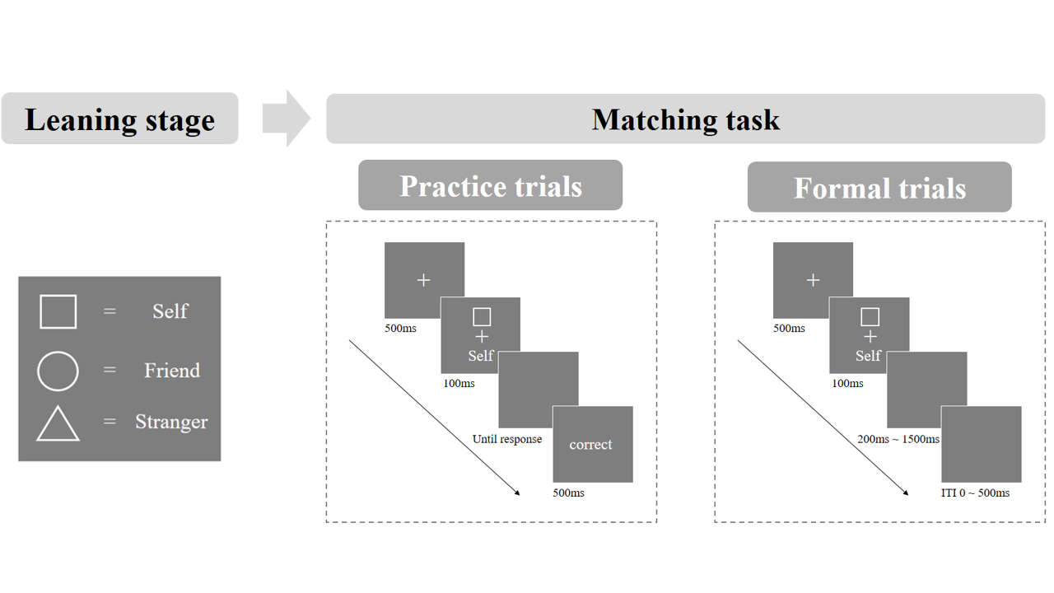

**Fig. 1.** Procedure of the original SPMT in the Experiment 1 (Sui et al., 2012).

## 2.3 Datasets Acquisition

Initially, two datasets that employed the SPMT were available to us: one from an unpublished project conducted in our laboratory (Hu et al., 2023), and the other provided by our collaborators (Liu et al., 2023). Concurrently, we are conducting a meta-analysis on SPE using the SPMT (pre-registration available at <https://osf.io/euqmf>). During this process, we identified an additional thirteen papers with datasets potentially suitable for our present study. The selection of these papers was based on specific criteria:

1. The paper must primarily utilize the SPMT as their method.
2. The experimental design should not incorporate any stimuli that could potentially trigger a familiarity effect (e.g., using self-face, self-name).
3. The trial-level data is either openly available or declared to be obtainable upon request, enabling us to estimate at least one reliability index.

Among the thirteen papers included, seven papers made their trial-level data publicly available (Constable et al., 2021; Constable & Knoblich, 2020; Golubickis & Macrae, 2021; Navon & Makovski, 2021; Qian et al., 2020; Schäfer & Frings, 2019; Svensson et al., 2022). For the remaining six papers, we reached out to the authors and requested access to their trial-level data. Out of those six requests, three papers provided us with trial level data (Kolvoort et al., 2020; Woźniak et al., 2018; Xu et al., 2021). However, in one article, the author did not provide the explanation of the shape and label in the original data (Kolvoort et al., 2020). As a result, we are unable to analyze the raw data in this context. Two papers provided us only with descriptive results (Cheng & Tseng, 2019; Martínez-Pérez et al., 2020), which unfortunately could not be used for calculating reliability. Additionally, one paper referred to data being shared on the Open Science Framework (OSF) platform (<https://osf.io/pcv3u/>) (Bukowski et al., 2021), but we found that the repository was empty, making it ineligible for the current analysis.

In total, our analysis comprised raw data from nine papers and two unpublished projects from our laboratory and collaborators. It is important to highlight that the research culture discourages direct replications (Makel et al., 2012). As a result, all the datasets included in our analysis underwent some degree of modification to the original design (e.g., change shapes, modify sequence) as well as including the incorporation of additional independent variables (refer to Table 1 for specification). For our analysis, we focused exclusively on using data that adhered to the original design of SPMT, without incorporating any stimuli that could potentially trigger a familiarity effect. Additionally, we specifically utilized data from control conditions in the studies, excluding any conditions that involved the presence of other independent variables (e.g., mood changes). In the end, we were able to incorporate 17 independent datasets from the above-mentioned papers and projects. Nonetheless, not all studies incorporated retest sessions. If a publicly available datasets did not include retest session with SPMT, we excluded it from calculating the Intraclass Correlation Coefficient and only considered the split-half reliability. The details of the included studies and conditions in the datasets are described in Table 1.

Table 1. Dataset Information

| Author & Publication Year | Study | Independent Variable | | | | Sample  Size | # of Trials per Condition | Self-Prioritization Effect Indices | | | | | | Reliability | |
| --- | --- | --- | --- | --- | --- | --- | --- | --- | --- | --- | --- | --- | --- | --- | --- |
| IV 1 | IV 2 | IV 3 | IV 4 |  |  | RT | ACC | d | Eff | v | z | ICC | SHR |
| Hu et al. (2023) | 1 | Matching | Identity  Self, Friend, Stranger | Emotion  **Control**, Neutral,  Happy, Sad | Session  **1-6** | 33 | 60 | √ | √ | √ | √ | √ | √ | √ | √ |
| Constable and Knoblich (2020) | 1 | Matching | Identity  Self, Friend, Stranger | Switch Identity  Partner, Stranger | Phase  **1**; 2 | 46 | 20 | √ | √ | √ | √ | √ | √ |  | √ |
| Constable et al. (2021) | 2 | Matching | Identity  Self; Stranger |  |  | 56 | 48 | √ | √ | √ | √ | √ | √ |  | √ |
| Qian et al. (2020) | 2 | Matching | Identity Self; Celebrity | Cue  With, **Without** |  | 25 | 25 | √ | √ | √ | √ | √ | √ |  | √ |
| Schäfer and Frings (2019) | 1 | Matching | Identity Self; Mother; Acquaintance/none |  |  | 32 | 18 | √ | √ | √ | √ | √ | √ |  | √ |
| 3 | Matching | Identity Self; Mother; Acquaintance |  |  | 35 | 24 | √ | √ | √ | √ | √ | √ |  | √ |
| Golubickis and Macrae (2021) | 1 | Matching | Identity  Self, Friend, Stranger | Presentation **Mixed;** Blocked |  | 30 | 30 | √ | √ | √ | √ | √ | √ |  | √ |
| Navon and Makovski (2021) | 1 | Matching | Identity  Self, Friend, Stranger |  |  | 13 | 60 | √ | √ | √ | √ | √ | √ |  | √ |
| 3 | Matching | Identity  Self; Father; Stranger |  |  | 28 | 60 | √ | √ | √ | √ | √ | √ |  | √ |
| 4 | Matching | Identity |  |  | 27 | 60 | √ | √ | √ | √ | √ | √ |  | √ |
| Svensson et al. (2022) | 1 | Matching | Identity Self; Friend |  |  | 20 | 50 | √ | √ | √ | √ | √ | √ |  | √ |
| 2 | Matching | Identity Self; Friend | Frequency  self > friend |  | 24 | 100 | √ | √ | √ | √ | √ | √ |  | √ |
| 3 | Matching | Identity Self; Friend | Frequency  self < friend |  | 25 | 100 | √ | √ | √ | √ | √ | √ |  | √ |
| Xu et al. (2021) | 1 | Matching | Identity  Self, Friend, Stranger | Tasks  Modified; **Unmodified** |  | 105 | 60 | √ | √ | √ | √ | √ | √ |  | √ |
| Woźniak et al. (2018) | 1 | Matching | Identity  Self, Friend, Stranger | Facial Gender  Male; Female |  | 18 | 56 | √ | √ | √ | √ | √ | √ |  | √ |
| 2 | Matching | Identity  Self, Friend, Stranger | Facial Gender  Male; Female |  | 18 | 60 | √ | √ | √ | √ | √ | √ |  | √ |
| Liu et al. (2023) | 1 | Matching | Identity  Self; Stranger |  |  | 298 | 16 | √ | √ | √ | √ | √ | √ |  | √ |

*Note*. Study represents different studies from a single article; IV: independent variable. For IV3 and IV4, we only included the baseline conditions that are similar to the original design in Sui et al. (2012), which were highlighted in **BOLD font**. If other variables that could be counterbalanced are indicated by underscores, we will solely utilize these variables as stratification variables during the split-half process

# **3 Analysis**

Analysis plans for this study were preregistered on OSF (https://osf.io/zv628). The drift rate (*v*) and starting point (*z*) of the drift-diffusion model (DDM) was obtained in R, using the “RWiener” package (Wabersich & Vandekerckhove, 2014). All analyses in this paper were performed using the statistical software R (R Core Team, 2023).

The roadmap of the current study is visually represented in Fig. 2. After collecting the data from each independent study, we performed data cleaning and then calculated the six outcome variables as well as the twenty-four SPE measures computed using different outcome variables and baseline conditions. Finally, we calculated the split-half reliabilities of these SPE measures. If there were test-retest data, we also calculated the test-retest reliability using the intraclass correlation coefficient (ICC2, ICC2k).

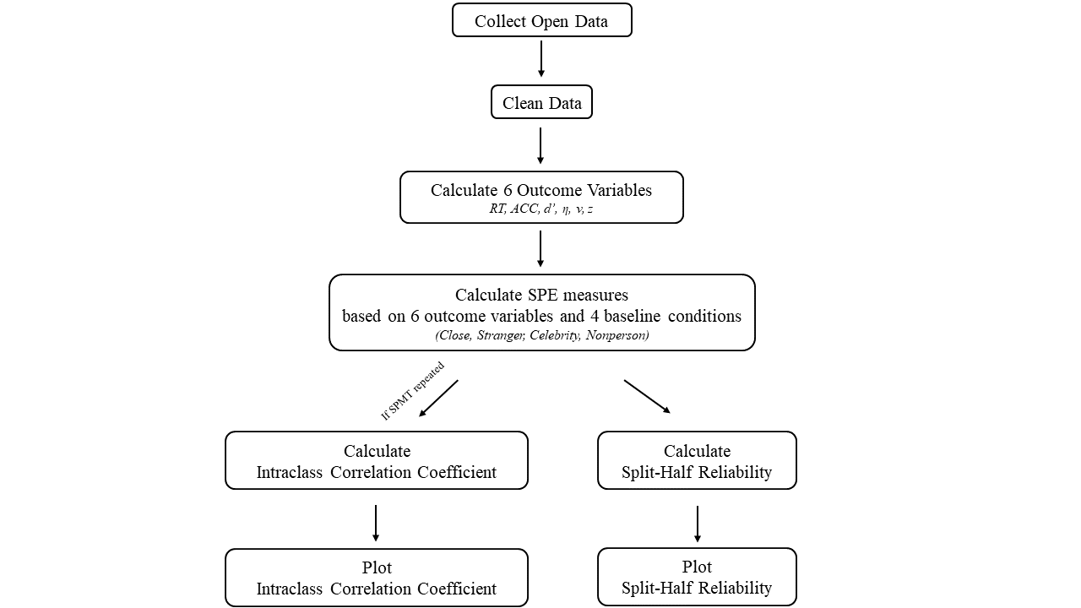

**Fig. 2** Roadmap of the Current Study.

## 3.1 Deviation from Preregistration

We adhere to our pre-registration plan as much as possible, however, there are a few differences between the current report and registration document. First, we used a different algorithm for estimating parameters of the drift-diffusion model. In the registration, we planned to estimate the drift rate (v) and starting point (z) of the drift-diffusion model using the “fit_ezddm” function from the “hausekeep” package (Lin et al., 2020). This function served as a wrapper for the EZ-DDM function (Wagenmakers et al., 2007). However, we found that this algorithm is flawed when estimating parameter *z* during in parameters recovery (details provided in the Supplementary materials). After comparing 5 algorithms, we found that the "RWiener" package (Wabersich & Vandekerckhove, 2014) achieved a favorable balance between accuracy, confidence interval width, and computational efficiency, making it the most suitable choice for our analysis. Nevertheless, for transparency, we have included the results from ezDDM in the supplementary materials (see Supplementary, Fig. 2-4). Second, the writing of the current manuscript was improved based on the preregistration. For example, in our preregistration, we include different baseline conditions when calculating SPE in the method section but did not mention this in our introduction and abstract. In this final report, we improved the writing and adjusted the introduction and abstract accordingly. Third, we did not explicitly state in the preregistration report that we would perform a weighted average of the Monte Carlo split-half reliabilities for all obtained studies. However, considering that the number of trials has a significant impact on reliability (Kucina et al.2023), during the formal analysis, we assigned different weights to each study based on the number of trials and performed a weighted average of the split-half reliabilities. Fourth, based on the data we collected, we also explored the relationship between the number of trials and the Monte Carlo split-half reliability, and found a significant positive correlation (see Supplementary Fig. 4 for our exploratory analysis).

## 3.2 Data Pre-processing

For all the seventeen datasets (see Table 1), we applied the following exclusion criteria for excluding data:

1. Participant exclusion criteria
2. Participants who had wrong trial numbers due to procedure errors is excluded from the analysis,
3. Participants with an overall accuracy < 0.5 is excluded from the analysis,
4. Participants with any of the conditions with zero accuracy is excluded from the analysis.
5. Trial level data exclusion criteria
6. Trials where the keypress occurs outside the two required keys and non-responsive trials are excluded from the analysis,
7. The practice trials are excluded,
8. The data irrelevant to calculating the SPE are excluded.

## 3.3 Calculating the Outcome Variables and SPE Measures

For each study, we calculated six outcome variables for each experimental condition: Mean Reaction Time (RT), Accuracy (ACC), Sensitivity Score (*d′*), Efficiency (*η*), Drift Rate (*v*), and Starting Point (z). Reaction Time and Accuracy are obtained directly from the datasets, while Sensitivity Score and Efficiency are calculated based on Reaction Time and Accuracy. SPE Measures were computed using different outcome variables under four baseline conditions (see Table 2). 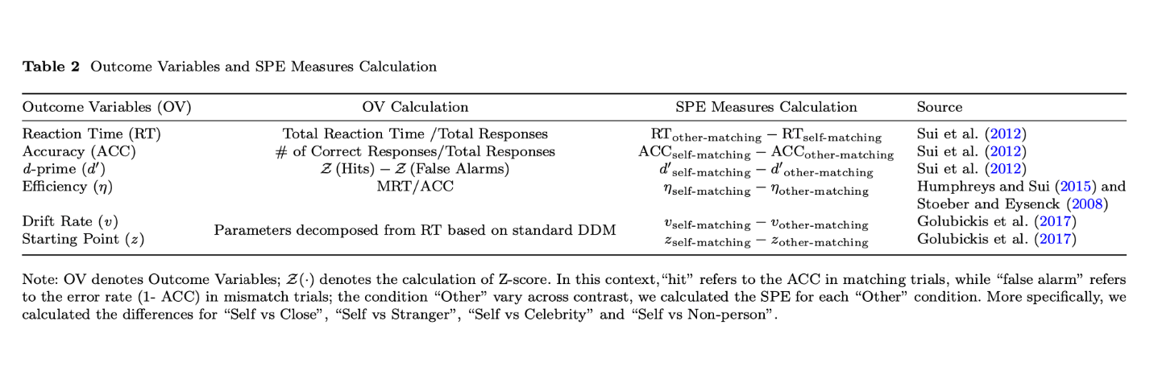

## 3.4 Estimating the Reliability

**Split-half Reliability.** We assessed the split-half reliability by first splitting the trial-level data into two halves and calculating the Pearson correlation coefficients. To ensure methodological rigor, we used four data splitting approaches for splitting the trial-level data: first-second, odd-even, permutated, and Monte Carlo (Kahveci et al., 2022; Pronk et al., 2022). The first-second approach splits trials into the first half and the second half. The odd-even approach splits the trials into sequences based on their odd or even numbers. The permutation approach shuffled the trial order and randomly assigned trials to two halves. The Monte Carlo approach is similar to the permutation approach, but iterates the process multiple times, usually thousands of times, to calculate the average and 95% confidence intervals of the split-half reliability.

In our analyses, we first stratified data by conditions and then employed the above four splitting approaches (Pronk et al., 2022). For example, when using Monte Carlo approach, we randomly split the stratified data into two halves for 5000 times, which resulted in 5000 pairs of two halves of the data. Next, we calculated 5000 Pearson correlation coefficients for these 5000 pairs. After that, we calculated the mean and 95% confidence intervals of the 5000 correlations coefficients. The first-second split, odd-even split, and permutated split are similar to the Monte Carlo approach. However, each of these approaches only results in a single reliability coefficient.

Finally, after computing the split-half reliability coefficients for each dataset, substantial variations were observed across the datasets. To derive a more accurate estimation of the average split-half reliability for each SPE measures, we synthesized these reliability coefficients via a meta-analytical approach. We weighed the reliability coefficients based on the trial numbers of each study because the number of trials significantly influences the reliability of cognitive experiments (Kucina et al.2023) (see also Supplementary Fig. 4 for our exploratory analysis). The weighted-average reliabilities was calculated use the “aggregate.escalc” function in the “metafor” Package (Viechtbauer, 2010). We report the synthesized split-half reliability and its 95% confidence interval in the results.

**Test-Retest Reliability (ICC).** We assessed the test-retest reliability of the six outcome variables for our dataset that involved test-retest sessions by calculating the Intraclass Correlation Coefficient (ICC) using “psych” package (Revelle, 2017). ICC is a well-established measure used in test-retest, intra-rater, and inter-rater studies to assess reliability (Fisher, 1992). Unlike the Pearson correlation coefficient, ICC considers both the correlation and agreement between multiple measurements, making it a more comprehensive measure of test-retest reliability.

Our primary aim is to evaluate the appropriateness of the SPMT in assessing individual differences and group-level variations. To achieve this objective, we focused on using two specific types of Intraclass Correlation Coefficients (ICC) within the ICC family, namely ICC2 and ICC2k. ICC2 focuses on the individual-level reliability of the indices, while ICC2k evaluates the reliability of mean ratings furnished by a group of judges (Koo & Li, 2016). For the calculation of ICC2 estimates, the formula is:A math equations on a white background

where MSBS is the mean square between subjects, MSE is the mean square error, MSBM is the mean square between measurements, k is the number of measurements, n is number of participants. For the calculation of ICC2k estimates, the formula is:



The traditional benchmarks for interpreting ICC values are as follows: ICC less than 0.50 suggests poor reliability; ICC between 0.50 and 0.75 suggests moderate reliability; ICC between 0.75 and 0.9 suggests good reliability; ICC above 0.9 suggests excellent reliability (Cicchetti & Sparrow, 1981; Kupper & Hafner, 1989).

# **4** **Results**

In seventeen independent datasets, 14 of them contain data for the Self vs Close other contrast, 11 of them contain data for Self vs Stranger, 1 of them have the data for Self vs Celebrities, 1 of them has the data for Self vs none condition. We reported the results for all these baseline conditions.

## 4.1 Split-Half Reliability

As described in method part, we applied four different approaches to split the data when calculating split-half reliability, namely the first-second, odd-even, permuted, and Monte Carlo methods. We presented the results from Monte Carlo split-half method in the main text due to its robustness (Pronk et al. (2022). The results of the other three split-half methods can be found in the supplementary materials (see Supplementary Fig. 2), except the odd-even, the other two also have highly similar result pattern with the Monte Carlo methods.

The split-half reliabilities using of Monte-Carlo method for different SPE measures is presented in figure 3. Among the measured outcome variables, the four highest ranking split-half reliabilities are as follows: Reaction Time (RT) with the "Stranger" contrast (*r* = .65, SE = .02, *p* <.001, 95% CI [.60, .70]); Efficiency (*η*) with the "Stranger" contrast (*r* = .64, SE = .03, *p* <.001, 95% CI [.59, .69]); RT with the "Close other" contrast (*r* = .58, SE = .02, *p* <.001, 95% CI [.54, .63]); *η* with the "Self vs Close" contrast (*r* = .57, SE = .02, *p* <.001, 95% CI [.52, . 61]). These SPE measures achieved a split-half reliability around 0.6 or higher, which is considered an acceptable level of reliability.

For the remaining 4 outcome variables, the reliability is around 0.5 or lower, indicating poor test-retest reliability. These include Accuracy (ACC), Sensitivity Score (*d’*), Drift Rate (*v*), and Starting Point (*z*). It is notice that almost all the split-half reliability of *z* using different contrasts are around 0, which suggests a complete lack of reliability.

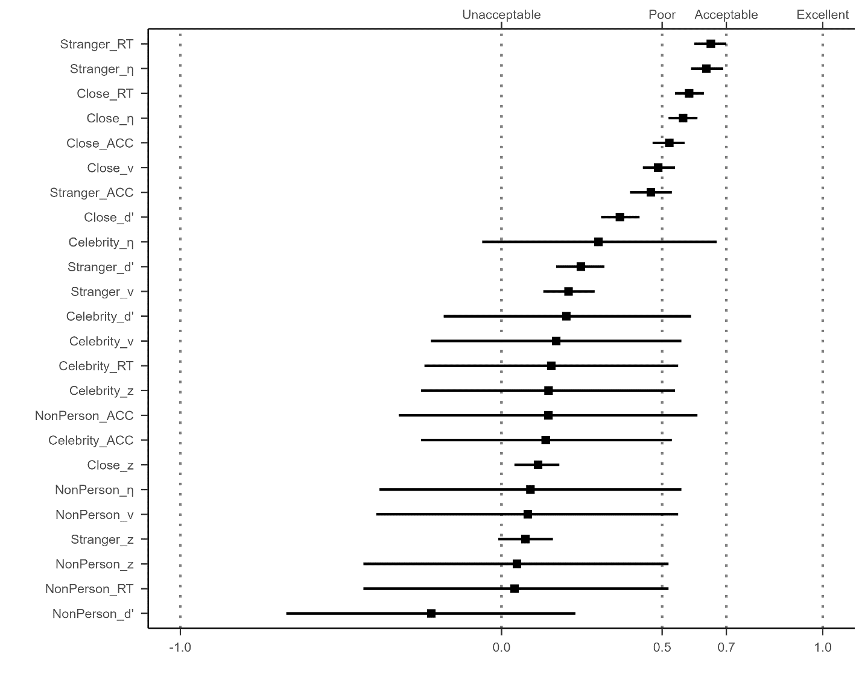

**Fig. 3.** The weighted average of split-half reliabilities (Monte-Carlo) for different SPE measures.

*Note:* The vertical axis represents 24 different SPE measures, combining six outcomes variables (RT, ACC, *d’*, *η*, *v*, *z*) and four baseline conditions (close other, stranger, celebrity, and non-person). The weighted average split-half reliability and 95% confidence intervals are shown by points and lines.

## 4.2 Intraclass correlation coefficient (ICC)

It is important to note that we could only calculate ICC for the study in our labortory (Hu et al., 2023) since all other datasets did not include re-test sessions. For this dataset, we only have 2 contrasts, the “Close other” and “Stranger”. To test the robustness of the results, we also explored one additional datasets that included re-test session but devivated quite strongly from the original SPMT (see Supplementary Fig. 4).

The ICC2, which measure the reliability for individual differences, confirmed the results from split-half reliability: only RT and Efficiency display reliability ranging from poor to acceptable. Specifically, under the "Self vs Close" contrast, the ICC2 for RT is 0.53 (95% CI = [.39, .69]), and for Efficiency, it is 0.52 (95% CI = [.38, .68]). Meanwhile, for the "Self vs Stranger" contrast, the ICC2 for RT is 0.58 (95% CI = [.45, .73]), and for Efficiency, it is 0.35 (95% CI = [.21, .52]). All the other outcome variables exhibit unacceptable to poor ICC2.

However, it is worth noting that the ICC2k values, which measure the reliability of effect on group level, for Reaction Time (RT) and Efficiency demonstrate notably high levels of reliability, while the other outcome variables exhibit unacceptable to poor ICC2k. When considering the "Close" contrast, the ICC2k for RT is 0.87 (95% CI = [.79, .93]), and for Efficiency, it is 0.87 (95% CI = [.78, .93]). Similarly, for the "Stranger" contrast, the ICC2k for RT is 0.90 (95% CI = [.82, .94]), and for Efficiency, it is 0.76 (95% CI = [.61, .87]).

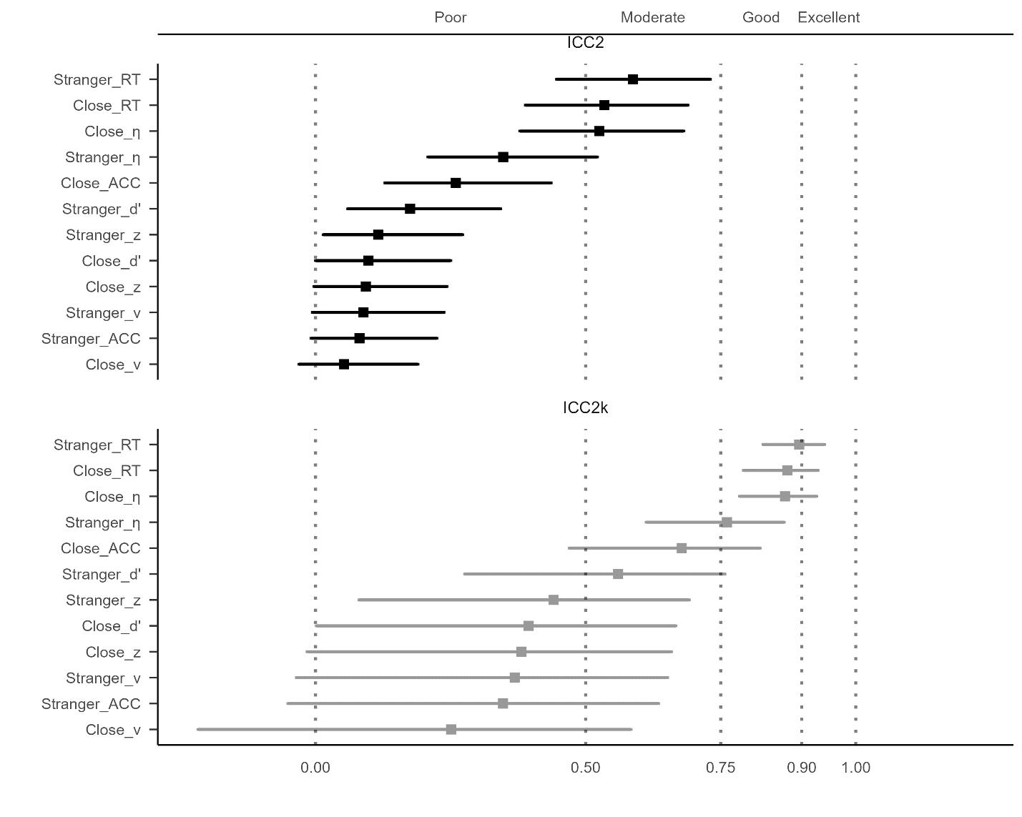

**Fig. 4** Intraclass Correlation Coefficient for SPE Measures. ***NOTE:***The vertical axis represents 12 different SPE measures, combining 6 outcomes variables (RT, ACC, d’, η, v, z) and 2 contrasts (close other, stranger).The upper facet of the figure presents the results for ICC2k, while the lower facet displays the results for ICC. The ICC values and their corresponding 95% confidence intervals are illustrated using points and lines.

# **5 Discussion**

Despite the significance of assessing the reliability of a behavioral paradigm before its implementation, this practice is not yet extensively embraced by researchers (Green et al., 2016; Hedge et al., 2018; Parsons et al., 2019). In this pre-registered study, our objective is to investigate the reliability of the outcome variables related to the SPE measures in the SPMT. To achieve this, we re-analyzed seventeen datasets (N = 833) from nine papers and two unpublished projects, utilizing split-half reliability (*r*) and intraclass correlation coefficient (ICC2, ICC2k). Our findings reveal that the Reaction Time and Efficiency demonstrated better results, with split-half reliability around 0.6 or higher, ICC2 around 0.5 or higher, ICC2k higher than 0.7. All the other outcome variables performed poorly, with weight average split-half reliability lower than 0.5, ICC2 lower than 0.5, ICC2k lower than 0.7. Our analyses suggests that Reaction Time and Efficiency are the most reliable measure of SPE, among all measures available in the SPMT, especially when the SPE is quantified as the difference between self-condition and stranger condition. Moreover, the pattern observed in the ICC values suggests that reaction time and efficiency in the SPMT are better suited for group-level analysis rather than assessing individual-level variation.

Although Reaction Time and Efficiency yielded relatively better results compared to other indices, they still fell short of achieving commonly considered excellent reliability levels (typically a value greater than 0.8 means excellent reliability) (Cicchetti & Sparrow, 1981; Kupper & Hafner, 1989). The low split-half reliability and low ICC2 of SPE suggest that the SPMT, like other traditional cognitive tasks such as Flanker, Simon, or Stroop tasks (Clark et al., 2022; Mollon et al., 2017), may be not suitable for assessing individual-level variation. Several plausible reasons as well as potential solutions can be identified. Firstly, the insufficient number of trials per condition may contribute to the low split-half reliability. As shown in Supplementary Fig. 4, we calculated the correlation coefficient between the trial numbers and the Monte Carlo split-half reliabilities and found a strong positive correlation between trial number and reliability coefficients. A recent study by Kucina et al. (2023) also emphasized the importance of trial numbers for cognitive tasks in determining reliability. The findings revealed that increasing the number of trials and considering greater conflict effects or individual differences can enhance reliability compared to the original paradigm. Specifically, the study identified that satisfactory reliability required 48 or more trials, while achieving a higher level of reliability necessitated 72 trials. Therefore, incorporating a larger number of trials in future implementations of the SPMT paradigm may enhance the split-half reliability by improving measurement consistency.

Secondly, the presence of a practice effect could be another significant factor influencing reliability. If these effects are substantial enough to cause a noticeable change in participants' performance between measurement occasions, it can introduce additional variability in the measurements and lower the ICC2 values (Oswald et al., 2015; Siegelman et al., 2017). This highlights the need for a more nuanced task setting that can consistently capture performance nuances and reveal individual differences more sensitively (Hedge et al., 2018). Recent study on gamification of cognitive tasks have shown that incorporating gamification elements can effectively improve data quality and assessment efficacy (Friehs et al., 2020). Therefore, modifying the SPMT with a more dynamic paradigm, such as incorporating gamification elements, may enhance split-half reliability by improving measurement consistency.

Finally, it is important to acknowledge the potential influence of serial dependence effects on task reliability. As outlined in the methodology and results sections, we evaluated the weighted average split-half reliability of the SPE measures using four distinct data splitting approaches: first-second, odd-even, permutated, and Monte Carlo. Interestingly, the results from the odd-even split-half method differed notably from the other three methods, while the permutated, first-second, and Monte Carlo methods showed similar outcomes (see Supplementary figure 2). This discrepancy in the results may be attributed to the presence of serial dependency within the data. Serial dependence refers to the phenomenon in which the outcome of one trial is influenced by preceding trials, resulting in a systematic relationship between consecutive trials (Pascucci et al., 2023). The odd-even method, being sensitive to temporal dependencies, could have been affected by the inherent sequential nature of the responses in the SPMT. Serial dependence effects have been observed in other cognitive tasks, as documented in recent studies (Braun et al., 2018; Zhang & Alais, 2020). Notably, studies in the field of perceptual decision making have demonstrated strong serial dependence effects in perception, even when the visual stimuli were reliable and varied randomly over time (Fischer & Whitney, 2014; John-Saaltink et al., 2016). In particular, if the split-half design unintentionally separates temporally adjacent trials in the SPMT, the presence of serial dependence may introduce performance differences between the halves, leading to a reduction in the reliability estimate. Thus, to accurately control for the impact of serial dependence in experiments, further research should employ appropriate statistical methods that account for the temporal dependencies between trials. Time series analysis techniques (Huitema, 1986) or modeling approaches that capture the serial correlation (Mei et al., 2023) can be utilized to obtain more accurate results.

Apart from the results of Reaction Time and Efficiency, we were surprised by the low reliability of parameters (*v* and *z*) obtained from the drift diffusion model. In our analysis, we used common and easy-to-use methods to estimate parameter values for each condition of each participant and then calculated the reliability. As for drift rate (*v*), we found that *r*Close = .52, 95% CI [.47, .58] and *r*Stranger = .20, 95% CI [.11, .28]. As for starting point (*z*), we found that *r*Close = .13, 95% CI [.05, .20] and *r*Stranger = .08, 95% CI [-.02, .17]. Several factors may account for these discouraging outcomes. Firstly, it appears that the standard DDM might not adequately capture the underlying cognitive processes in the SPMT. Previous studies often applied the DDM in a somewhat arbitrary manner, without adhering to a comprehensive cognitive modeling workflow, as recommended by Wilson and Collins (2019). As a consequence, the standard DDM exhibited suboptimal performance when applied to task structures similar to the SPMT (Groulx et al., 2020). Consequently, these results raise questions regarding the validity of employing the standard DDM to analyze data from the SPMT. To address this issue, future research should explore hierarchical models (which may require more time for parameter estimation) or develop new variations of the DDM that better capture the latent cognitive processes involved in completing the SPMT. Theoretically, this could enhance the reliability of these parameters. These efforts will contribute to the development of formal models for understanding SPE, leading to more reliable and valid interpretations of cognitive processes in the SPMT and similar paradigms.

It is important to note that ICC values should not be interpreted solely as a measure of the test's overall quality, but rather as an indication of the specific types of questions it can effectively address (Koo & Li, 2016). The results obtained from the intraclass correlation coefficients indicate that the SPMT, particularly the Reaction time and efficiency, is more appropriate for group-level analysis rather than assessing individual-level variation. Specifically, we found that the RT and efficiency measures exhibited excellent test-retest reliability at the group level (ICC2k), regardless of whether the target is, indicating strong group-level consistency over time. On the other hand, the ICC2 values for RT and Efficiency were relatively lower, below 0.7. This discrepancy suggests that these outcome variables are more influenced by variations between participants rather than within participants. The findings also align with the concept of the reliability paradox proposed previously (Hedge et al., 2018; Logie et al., 1996). Behavioral paradigms, including the SPMT, are susceptible to factors such as external conditions and contextual differences, which contribute to greater within-participant variability and lower ICC2 values (Clark et al., 2022; Mollon et al., 2017). However, when averaging performance across different individuals, the task still demonstrates good consistency, leading to higher ICC2k values (Liljequist et al., 2019). In practical terms, our results suggest that the SPMT is better suited for discerning performance differences between individuals or groups rather than capturing consistent performance within the same individuals over time. Therefore, researchers should consider these factors when investigating individual differences using the SPMT.

Our study has several limitations that should be acknowledged. Firstly, although we made efforts to enhance sample diversity by including open data whenever possible, it is important to note that the majority of our samples still consisted of individuals from what is commonly referred to as "WEIRD" populations (Rad et al., 2018; Yue et al., 2023). As a result, our findings may not be fully representative of the broader population, and it is necessary to include a more diverse sample to ensure greater generalizability of the paradigm. Additionally, when assessing the intraclass correlation coefficients (ICCs), only our own dataset had longitudinal data available, which could potentially limit the representativeness of the results. This issue is mitigated by the fact that additional analysis of two datasets that with different design showed similar results as we reported in the main text. Furthermore, the majority of the studies included in our analysis focused on adults from healthy populations. Therefore, further investigation is needed to include more datasets with a more diverse population in order to determine the reliability of the SPMT in different settings. Finally, it is important to clarify the aim of our study, which primarily focused on exploratory purposes and providing information regarding the current state of reliability for the assessed outcome variables. Consequently, future research could concentrate on modifying the paradigm and conducting tests to assess potential improvements (see Zorowitz and Niv (2023)).

In conclusion, this study provides empictal assessment of the reliability of the self-perceptual matching task (SPMT) and highlights important considerations for interpreting its reliabilities. We have demonstrated that the Reaction Time and Efficiency measures exhibit greater reliability compared to other outcome variables in the SPMT. Furthermore, our findings indicate that the SPMT is more suitable for group-level analysis rather than assessing individual-level variation. These findings have important implications for future task design and data collection protocols aimed at improving reliability. Ultimately, our study paves the way for the prospective utilization of these tasks, in various domains including research, clinical applications, and personal performance monitoring. The information obtained from our study also contributes valuable knowledge to the field and sets the stage for further investigations and advancements in utilizing SPMT effectively.

# **Acknowledgements**

The present research is support by.

# **Author contributions**

HCP contributed to the conception and supervision of the study. JS contributed to fund raising, HCP contributed to data collection. ZL, ZYR and HMZ write the simulation code for pre-registration. HMZ collected the datasets and performed the data pre-processing, analysis and visualize the results. In addition, ZL, HMZ and HCP contribute to discussing the results and the drafting of the final manuscript. HCP, JS, ZL and HMZ critically revise the manuscript.

# **Data and Material Availability**

The pre-registration plan is available at <https://osf.io/zv628>. The de-identified raw data from our lab is available at <https://doi.org/10.57760/sciencedb.08117>. The simulated data is accessible on GitHub (<https://github.com/Chuan-Peng-Lab/ReliabilitySPE>).

# **Code Availability**

Code used to simulate and analyze the data is made accessible at <https://github.com/Chuan-Peng-Lab/ReliabilitySPE>.

# **Competing interests**

The authors declare no competing interests.

# **Supplementary Information**

## Parameter Recovery Result for Package Comparison

We chose not to utilize the HDDM package (Wiecki et al., 2013) since the computation process is significantly time-consuming, necessitating high computational resources and leading to prolonged overall analysis time. Instead, we performed a package comparison by generating 100 datasets using the HDDM package in Python, in order to identify the most appropriate package for our analysis. These datasets were specifically configured with parameters *a* = 2, *t* = 0.3, *v* = 1, and *z* = 0.7. Subsequently, we utilized three different DDM packages in R, namely RWiener (Viechtbauer, 2010), hausekeep (Lin, 2019), and FastDMinR (Voss & Voss, 2007), to compute parameter estimates for these generated datasets. The evaluation process involves comparing the computed values obtained from the R packages with the set parameters. If the computed values from the R packages are found to be closer to the set values, it signifies that the respective R package provides more accurate parameter estimation for the drift-diffusion model.

Figure 1 presents the results of the package comparison. The estimated drift rate (*v*) obtained from RWiener is 1.01, with a 95% confidence interval of [.98, 1.03], which closely aligns with our pre-defined values. Similarly, the estimated starting point (*z*) is 0.77, with a 95% confidence interval of [.76, .78], also very close to our pre-defined value. On the contrary, the parameters calculated using other packages either showed high inaccuracies, excessively wide confidence intervals, or required extended computation times. As a result, we have opted to utilize RWiener for our calculations. It strikes a favorable balance between accuracy, confidence interval width, and computational efficiency, making it the most suitable choice for our analysis.

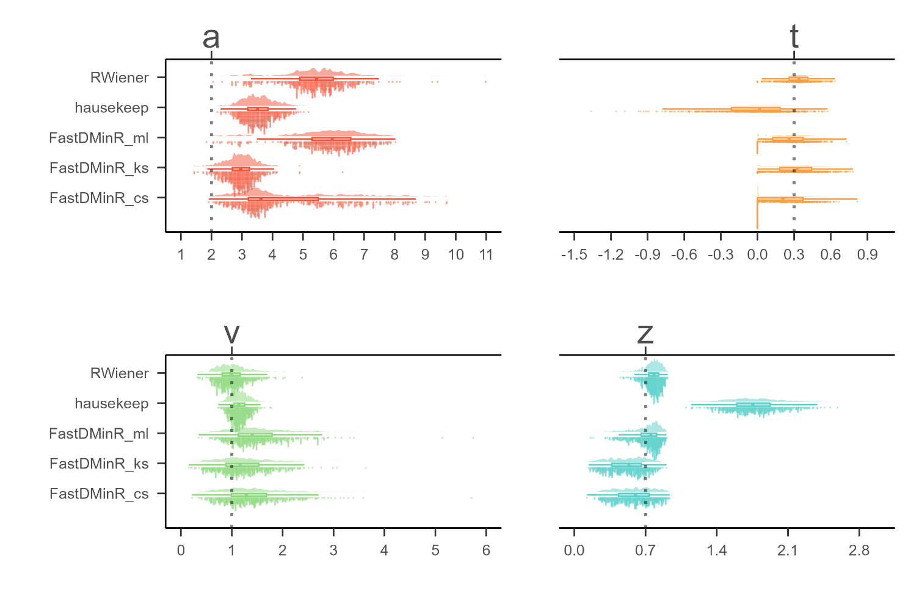

**Supplementary Fig. 1 DDM Packages Comparison.**

*Note:* The parameters of interest in the drift-diffusion model (DDM) are represented as follows: "*a*" denotes the threshold parameter, "*t*" represents the non-decision time, "*v*" indicates the drift rate, and "*z*" corresponds to the starting point. The y-axis of the graph displays the estimation of these DDM parameters using three different R packages: "RWiener," "hausekeep," and "FastDMinR." In total, there are five methods for estimating DDM parameters, with three methods originating from the "FastDMinR" package. On the x-axis, the values of the estimated parameters are plotted. The dashed line on the graph indicates the true value of the parameter being estimated.

* 1. **Split-half Reliabilities Using Four Splitting approaches.**

In this section, we are presenting the split-half reliabilities results for the SPE measures using four split-half methods: Monte Carlo, first-second, odd-even, and permutated. We also include includes the drift rate (*v*) and starting point (*z*) estimated from the "hausekeep" package in the analysis. However, it is important to highlight that the estimation of parameter "*a*" in "hausekeep" significantly deviates from the HDDM approach, primarily because of the assumption that *z* = *a* / 2 (refer to suppl. Fig. 1). As a result, we have chosen not to include the results obtained from this package in the main text. Nevertheless, we present them here for reference and transparency. Please refer to Figure 2(a-d) for the visual representation of the results.

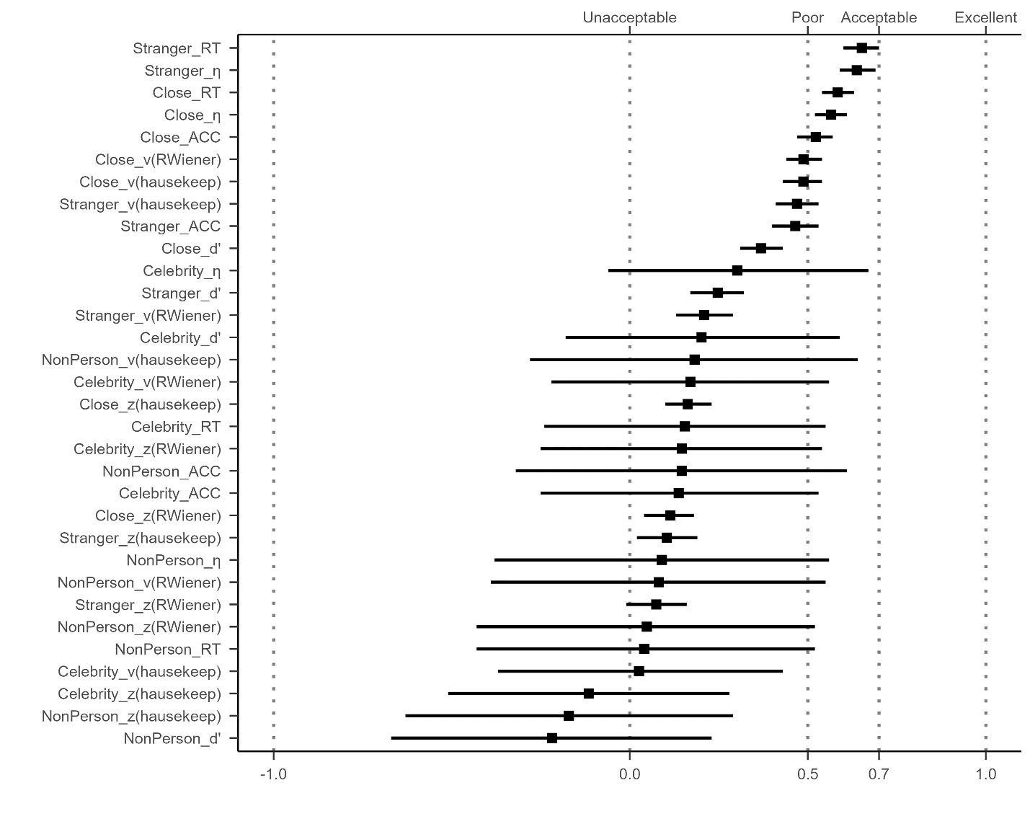

**Supplementary Fig. 2a Results of Split-half Reliabilities using Monte Carlo Split-half Methods.**

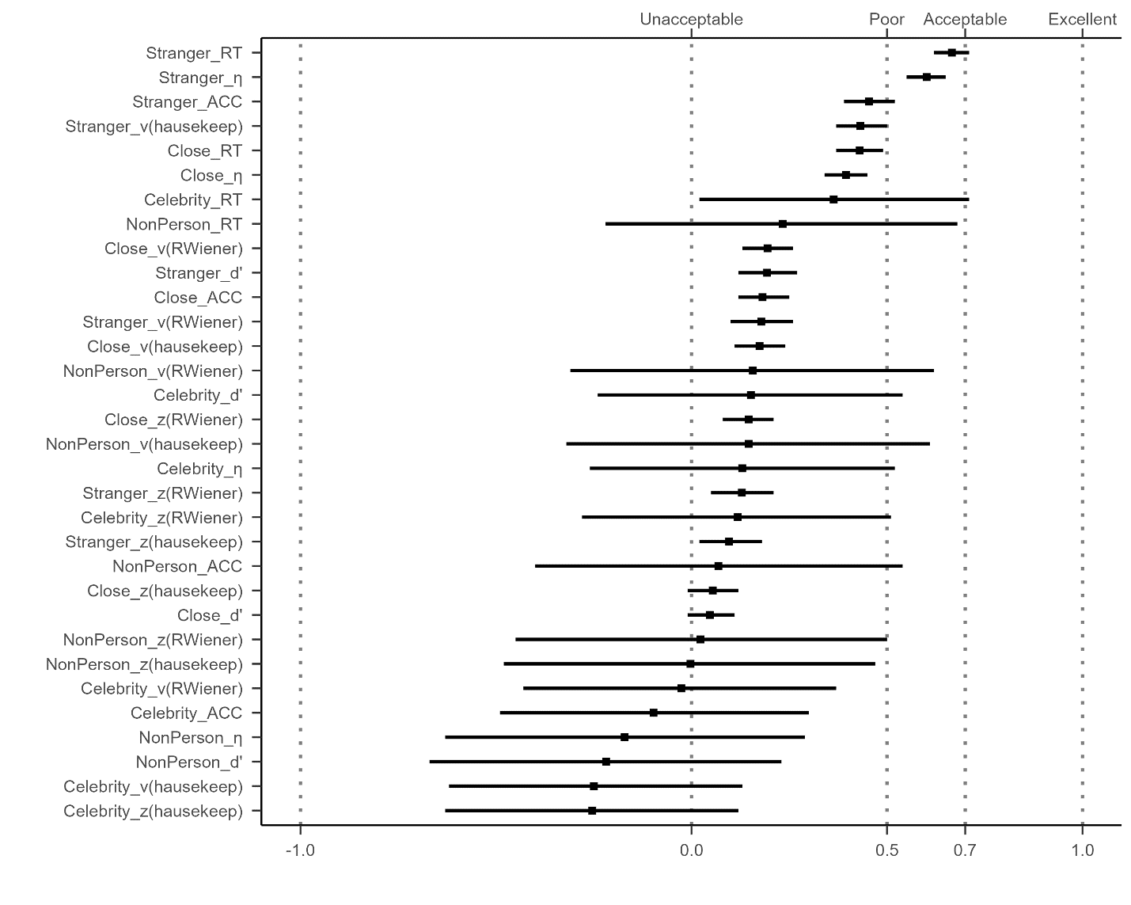

**Supplementary Fig. 2b Results of Split-half Reliabilities using First-Second Split-half Methods.**

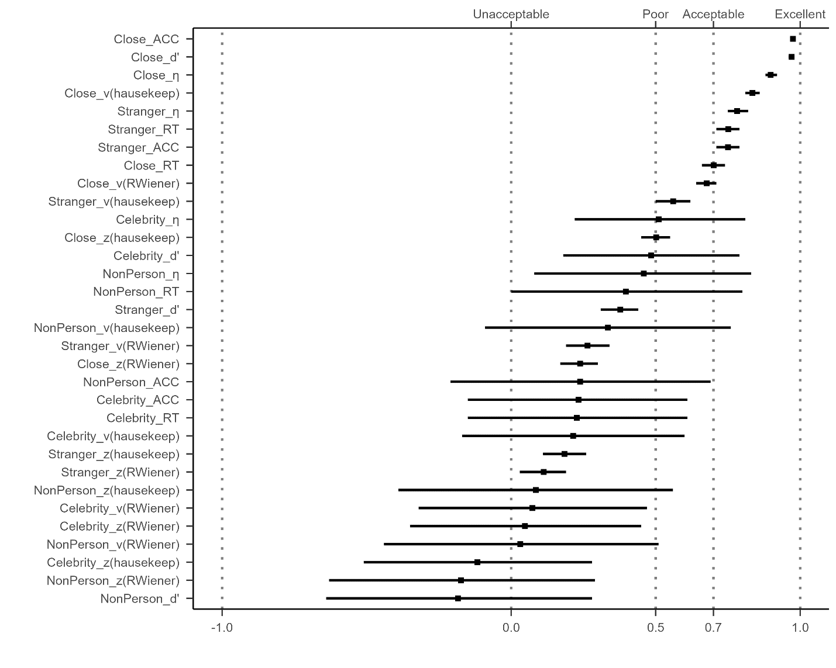

**Supplementary Fig. 2c** **Results of Split-half Reliabilities using Odd-Even Split-half Methods.**

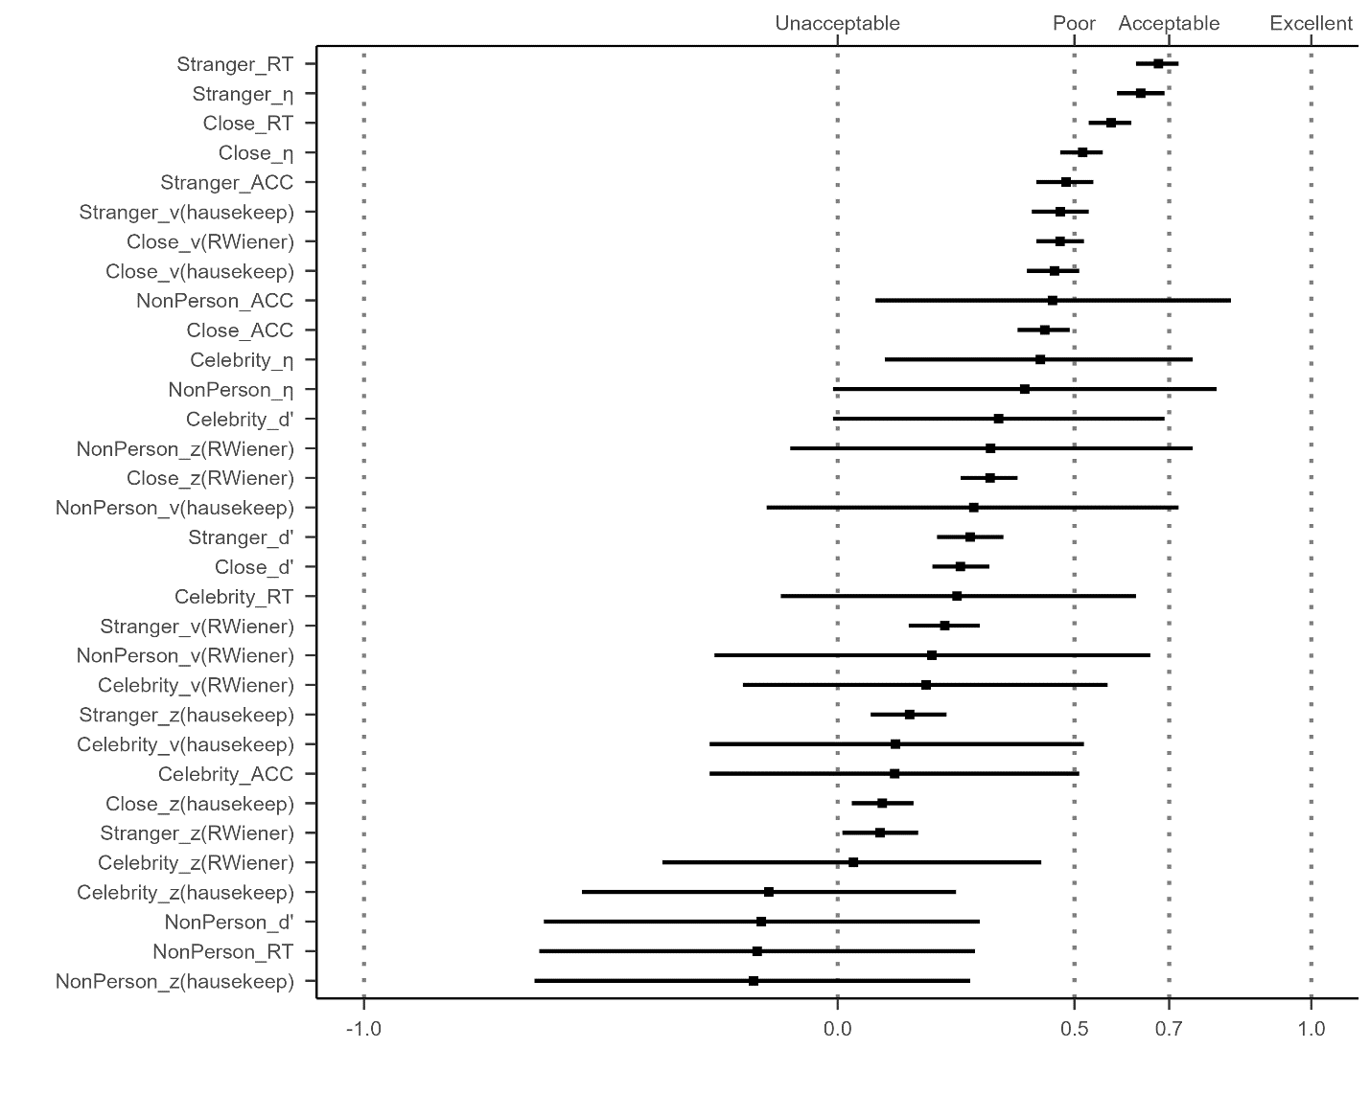

**Supplementary Fig. 2d** **Results of Split-half Reliabilities using Permuted Split-half Methods.**

*Note:* The vertical axis of the graph listed 32 different SPE measures, combining six outcomes variables (RT, ACC, *d’, η, v, z*) and four baseline conditions (close other, stranger, celebrity, and non-person). The *v* and *z* implemented using the "hausekeep" package were also included. The weighted average split-half reliability and 95% confidence intervals are shown by points and lines. The figure is divided into separate facets arranged from left to right, each representing weighted average split-half reliability calculated using three distinct methods: first-second, odd-even, and permuted.

It is evident that the results pattern from the permuted split-half methods and first-second split-half methods closely resemble the Monte Carlo method's outcomes. The top four split-half reliabilities, ranked highest, are as follows: Reaction Time (RT) with the "Stranger" contrast, Efficiency (*η*) with the "Stranger" contrast, RT with the "Close other" contrast, *η* with the "Self vs Close" contrast. However, the results obtained from the odd-even split-half method were notably different from the other three methods. We hypothesize that this discrepancy may be attributed to the presence of serial dependency within the data (see discussion section). Further investigation into the presence and impact of serial dependency in the data would be valuable to better understand the observed variations in the split-half reliabilities among the different methods.

## ICCs for SPE Measures Using Other Dataset

In Figure 3a, we present the results of the Intraclass Correlation Coefficients (ICCs) for the SPE measures, where drift rate (*v*) and starting point (*z*) estimated from the "hausekeep" package were also included. In Figure 3b, we extended our exploration of the ICCs to include the SPE measures from one additional dataset. However, it is important to note that the SPMT used in this dataset deviated quite strongly from the original SPMT paradigm. Due to these significant differences, the ICCs obtained from this dataset may reflect variations introduced by the modified SPMT rather than directly comparable results to the original paradigm.

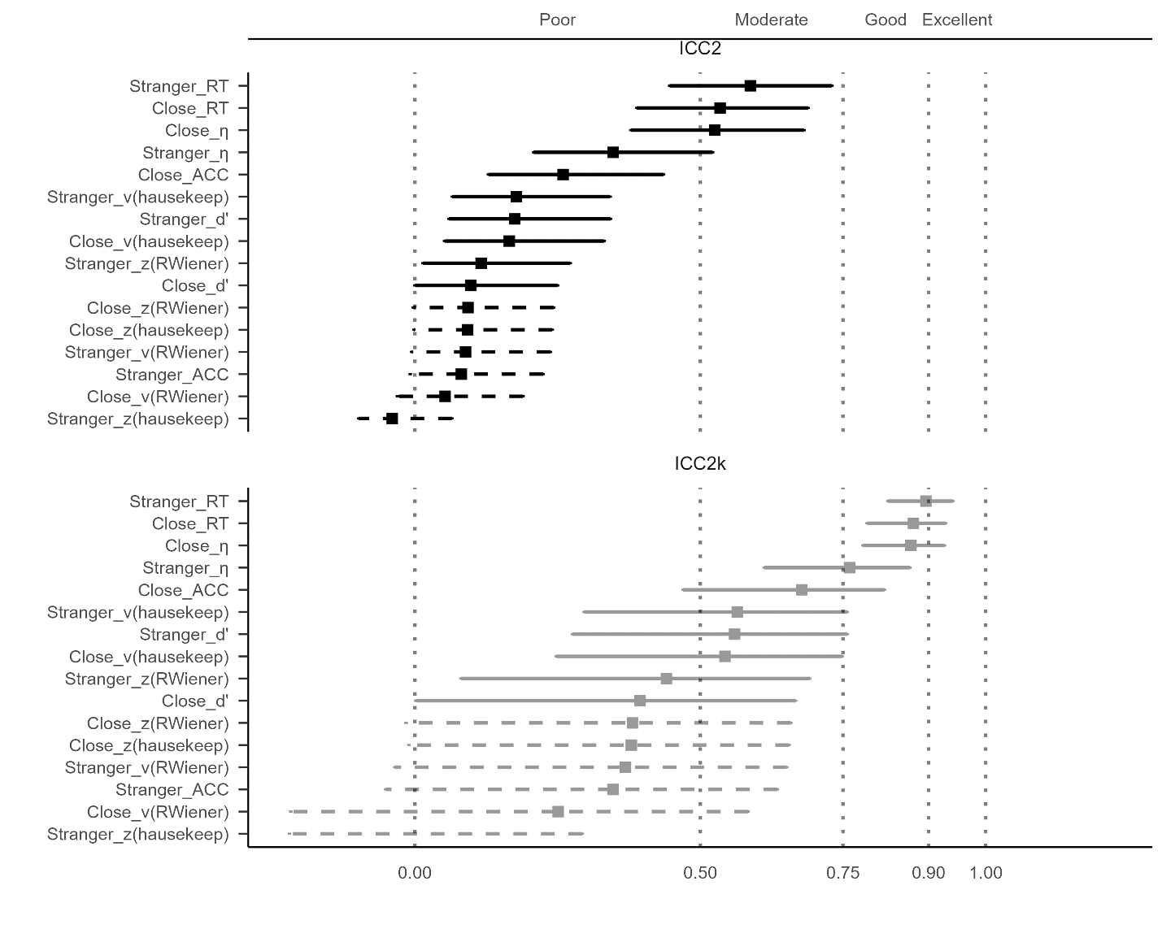

**Supplementary Fig. 3a ICCs for SPE Measures Using Hu et al. (2023).**

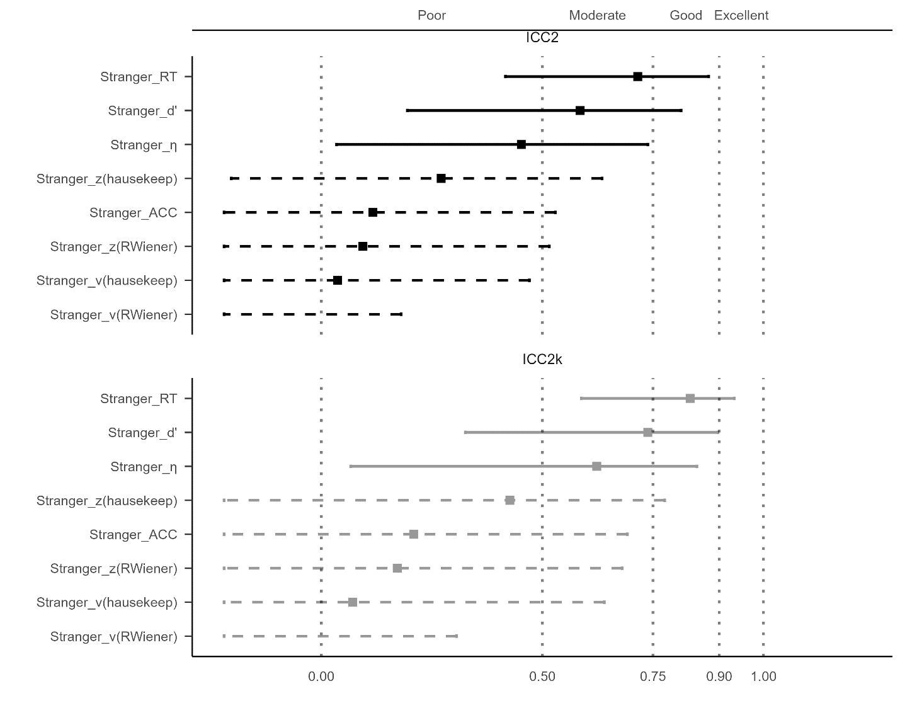

**Supplementary Fig. 3b ICCs for SPE Measures Using an Aditional dataset.**

*Note:*The vertical axis of the graph illustrates eight distinct outcome variables, which includes two additional indices from the DDM, implemented using the "hausekeep" package. The line and dots on the graph represent the value of ICC, along with their corresponding 95% confidence intervals. The dashed line indicates that the confidence interval for that point estimate extends beyond the range of our coordinate axes (0, 1). The upper facet of the figure presents the results for ICC2k, while the lower facet displays the results for ICC.

## Correlation Between Monte Carlo Split-half Reliability and Trial Numbers

In this section, we present the results of the correlation analysis between Monte Carlo split-half reliability and the number of trials (Fig. 4). Notably, we found significant correlations between Monte Carlo split-half reliability and trial numbers for some outcome variables, such as Reaction Time and Efficiency. However, for outcome variables like *d'* and *v*, the correlation with trial numbers was relatively weak.

From the plot, we can observe that the SPMT paradigm requires approximately 80 trials to achieve a Monte Carlo split-half reliability of 0.8 for the SPE measure of RT under the 'Stranger' condition and around 120 trials under the 'Close' condition. Furthermore, achieving a Monte Carlo split-half reliability of 0.8 for the *v* parameter may require more than 120 trials. On the other hand, attaining high Monte Carlo SHR values for the remaining three outcome variables, particularly for the *z* parameter, remains challenging even with 150 or more trials.

It is important to emphasize that here we only conducted a simple regression analysis of trial numbers and Monte Carlo SHR based on the collected datasets. This analysis was not part of the pre-registered plan, and our primary aim was not to provide a well-validated improvement for the SPMT. However, considering the significant correlation between the number of trials and Monte Carlo split-half reliability, our findings suggest that, for the SPMT paradigm, achieving higher reliability for clinical evaluation would necessitate conducting more trials. As a reasonable approach, it might be beneficial to consider having more than at least 80 trials under each experimental condition.

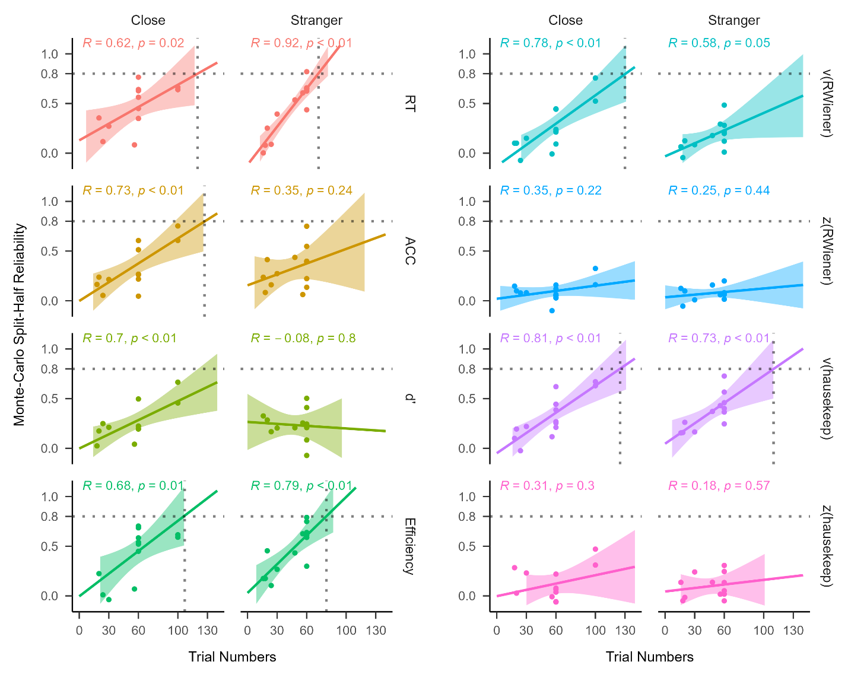

**Supplementary Fig. 4 Regression analysis between Monte Carlo split-half reliability and trial numbers using different SPE measures.**

*Note:* The vertical axis represents Monte-Carlo split-half reliability, and the horizontal axis represents the number of trials. Each facet represents one SPE measures.

# **References**

Braun, A., Urai, A. E., & Donner, T. H. (2018). Adaptive history biases result from confidence-weighted accumulation of past choices. *Journal of Neuroscience, 38*(10), 2418-2429.

Bukowski, H., Todorova, B., Boch, M., Silani, G., & Lamm, C. (2021). Socio-cognitive training impacts emotional and perceptual self-salience but not self-other distinction. *Acta Psychologica, 216*, 103297. <https://doi.org/10.1016/j.actpsy.2021.103297>

Cheng, M., & Tseng, C.-h. (2019). Saliency at first sight: instant identity referential advantage toward a newly met partner. *Cognitive Research: Principles and Implications, 4*(1), 1-18. <https://doi.org/10.1186/s41235-019-0186-z>

Cherry, E. C. (1953). Some experiments on the recognition of speech, with one and with two ears. *The Journal of the acoustical society of America, 25*(5), 975-979. <https://doi.org/10.1121/1.1907229>

Cicchetti, D. V., & Sparrow, S. A. (1981). Developing criteria for establishing interrater reliability of specific items: applications to assessment of adaptive behavior. *Am J Ment Defic, 86*(2), 127-137. <https://psycnet.apa.org/record/1982-00095-001>

Clark, K., Birch-Hurst, K., Pennington, C. R., Petrie, A. C., Lee, J. T., & Hedge, C. (2022). Test-retest reliability for common tasks in vision science. *Journal of Vision, 22*(8), 18-18.

Constable, M. D., Becker, M. L., Oh, Y.-I., & Knoblich, G. (2021). Affective compatibility with the self modulates the self-prioritisation effect. *Cognition and Emotion, 35*(2), 291-304. <https://doi.org/10.1080/02699931.2020.1839383>

Constable, M. D., Elekes, F., Sebanz, N., & Knoblich, G. (2019). Relevant for us? We-prioritization in cognitive processing. *Journal of Experimental Psychology: Human Perception and Performance, 45*(12). <https://doi.org/10.1037/xhp0000691>

Constable, M. D., & Knoblich, G. (2020). Sticking together? Re-binding previous other-associated stimuli interferes with self-verification but not partner-verification. *Acta psychologica, 210*, 103167. <https://doi.org/10.1016/j.actpsy.2020.103167>

Constable, M. D., Rajsic, J., Welsh, T. N., & Pratt, J. (2019). It is not in the details: Self-related shapes are rapidly classified but their features are not better remembered. *Memory & Cognition, 47*, 1145-1157. <https://doi.org/10.3758/s13421-019-00924-6>

Conway, M. A., & Dewhurst, S. A. (1995). The self and recollective experience. *Applied Cognitive Psychology, 9*(1), 1-19. <https://doi.org/10.1002/acp.2350090102>

Craik, F. I. M., & Tulving, E. (1975). Depth of processing and the retention of words in episodic memory. *Journal of Experimental Psychology: General, 104*(3), 268-294. <https://doi.org/10.1037/0096-3445.104.3.268>

Cunningham, S. J., & Turk, D. J. (2017, Jun). Editorial: A review of self-processing biases in cognition. *Quarterly journal of experimental psychology, 70*(6), 987-995. <https://doi.org/10.1080/17470218.2016.1276609>

Cunningham, S. J., Turk, D. J., Macdonald, L. M., & Macrae, C. N. (2008). Yours or mine? Ownership and memory. *Consciousness and cognition, 17*(1), 312-318. <https://doi.org/10.1016/j.concog.2007.04.003>

Desebrock, C., Sui, J., & Spence, C. (2018). Self-reference in action: Arm-movement responses are enhanced in perceptual matching. *Acta Psychologica, 190*, 258-266. <https://doi.org/10.1016/j.actpsy.2018.08.009>

Enock, F., Sui, J., Hewstone, M., & Humphreys, G. W. (2018). Self and team prioritisation effects in perceptual matching: Evidence for a shared representation. *Acta psychologica, 182*, 107-118. <https://doi.org/10.1016/j.actpsy.2017.11.011>

Enock, F. E., Hewstone, M. R., Lockwood, P. L., & Sui, J. (2020). Overlap in processing advantages for minimal ingroups and the self. *Scientific Reports, 10*(1), 18933. <https://doi.org/10.1038/s41598-020-76001-9>

Feng, C., Yan, X., Huang, W., Han, S., & Ma, Y. (2018). Neural representations of the multidimensional self in the cortical midline structures. *NeuroImage, 183*, 291-299. <https://doi.org/10.1016/j.neuroimage.2018.08.018>

Feng, C., Zhou, X., Zhu, X., Zhu, R., Han, S., & Luo, Y.-J. (2020). Effect of intranasal oxytocin administration on self-other distinction: Modulations by psychological distance and gender. *Psychoneuroendocrinology, 120*, 104804. <https://doi.org/10.1016/j.psyneuen.2020.104804>

Fischer, J., & Whitney, D. (2014). Serial dependence in visual perception. *Nature neuroscience, 17*(5), 738-743.

Fisher, R. A. (1992). Statistical methods for research workers. *Springer New York*. <https://doi.org/10.1007/978-1-4612-4380-9_6>

Friehs, M. A., Dechant, M., Vedress, S., Frings, C., & Mandryk, R. L. (2020). Effective gamification of the stop-signal task: two controlled laboratory experiments. *JMIR Serious Games, 8*(3), e17810.

Gillespie‐Smith, K., Ballantyne, C., Branigan, H. P., Turk, D. J., & Cunningham, S. J. (2018). The I in autism: Severity and social functioning in autism are related to self‐processing. *British journal of developmental psychology, 36*(1), 127-141. <https://doi.org/10.1111/bjdp.12219>

Golubickis, M., Falbén, J. K., Ho, N. S., Sui, J., Cunningham, W. A., & Macrae, C. N. (2020). Parts of me: Identity-relevance moderates self-prioritization. *Consciousness and cognition, 77*, 102848. <https://doi.org/10.1016/j.concog.2019.102848>

Golubickis, M., Falben, J. K., Sahraie, A., Visokomogilski, A., Cunningham, W. A., Sui, J., & Macrae, C. N. (2017). Self-prioritization and perceptual matching: The effects of temporal construal. *Mem Cognit, 45*(7), 1223-1239. <https://doi.org/10.3758/s13421-017-0722-3>

Golubickis, M., & Macrae, C. N. (2021). Judging me and you: Task design modulates self-prioritization. *Acta psychologica, 218*, 103350. <https://doi.org/10.1016/j.actpsy.2021.103350>

Green, S. B., Yang, Y., Alt, M., Brinkley, S., Gray, S., Hogan, T., & Cowan, N. (2016). Use of internal consistency coefficients for estimating reliability of experimental task scores. *Psychonomic Bulletin & Review, 23*, 750-763.

Groulx, J. T., Harding, B., & Cousineau, D. (2020). The EZ Diffusion Model: An overview with derivation, software, and an application to the Same-Different task. *The Quantitative Methods for Psychology, 16*(2), 154-174.

Hedge, C., Powell, G., & Sumner, P. (2018). The reliability paradox: Why robust cognitive tasks do not produce reliable individual differences. *Behavior Research Methods, 50*, 1166-1186.

Hu, C.-P., Lan, Y., Macrae, C. N., & Sui, J. (2020). Good Me Bad Me: Prioritization of the Good-Self During Perceptual Decision-Making. *Collabra. Psychology, 6*(1), 20. <https://doi.org/10.1525/collabra.301>

Hu, C.-P., Peng, K., & Sui, J. (2023, 2023-05-06). Data for Training Effect of Self Prioritization[DS/OL]. V1. *Science Data Bank*. <https://doi.org/10.57760/sciencedb.08117>.

Hughes, S. M., & Harrison, M. A. (2013). I like my voice better: Self-enhancement bias in perceptions of voice attractiveness. *Perception, 42*(9), 941-949. <https://doi.org/10.1068/p7526>

Huitema, B. E. (1986). Autocorrelation in behavioral research: Wherefore art thou? In *Research methods in applied behavior analysis: Issues and advances* (pp. 187-208). Springer.

Humphreys, G. W., & Sui, J. (2015). The salient self: Social saliency effects based on self-bias. *Journal of cognitive psychology, 27*(2), 129-140. <https://doi.org/10.1080/20445911.2014.996156>

Jiang, M., Wong, S. K. M., Chung, H. K. S., Sun, Y., Hsiao, J. H., Sui, J., & Humphreys, G. W. (2019). Cultural Orientation of Self-Bias in Perceptual Matching. *Front Psychol, 10*, 1469. <https://doi.org/10.3389/fpsyg.2019.01469>

John-Saaltink, E. S., Kok, P., Lau, H. C., & De Lange, F. P. (2016). Serial dependence in perceptual decisions is reflected in activity patterns in primary visual cortex. *Journal of Neuroscience, 36*(23), 6186-6192.

Kahveci, S., Bathke, A., & Blechert, J. (2022). Reliability of reaction time tasks: how should it be computed? <https://doi.org/10.31234/osf.io/ta59r>

Keenan, J. P., Wheeler, M. A., Gallup, G. G., & Pascual-Leone, A. (2000). Self-recognition and the right prefrontal cortex. *Trends in cognitive sciences, 4*(9), 338-344. <https://doi.org/10.1016/S1364-6613> (00)01521-7

Kircher, T. T., Senior, C., Phillips, M. L., Benson, P. J., Bullmore, E. T., Brammer, M., ..., & David, A. S. (2000). Towards a functional neuroanatomy of self processing: effects of faces and words. *Cognitive Brain Research, 10*(1-2), 133-144. <https://doi.org/10.1016/S0926-6410(00)00036-7>

Kolvoort, I. R., Wainio‐Theberge, S., Wolff, A., & Northoff, G. (2020). Temporal integration as “common currency” of brain and self‐scale‐free activity in resting‐state EEG correlates with temporal delay effects on self‐relatedness. *Human brain mapping, 41*(15), 4355-4374. <https://doi.org/10.1002/hbm.25129>

Koo, T. K., & Li, M. Y. (2016). A Guideline of Selecting and Reporting Intraclass Correlation Coefficients for Reliability Research. *Journal of chiropractic medicine, 15*(2), 155-163. <https://doi.org/10.1016/j.jcm.2016.02.012>

Kucina, T., Wells, L., Lewis, I., de Salas, K., Kohl, A., Palmer, M. A., Sauer, J. D., Matzke, D., Aidman, E., & Heathcote, A. (2023). Calibration of cognitive tests to address the reliability paradox for decision-conflict tasks. *Nature Communications, 14*(1), 2234.

Kupper, L. L., & Hafner, K. b. (1989). On Assessing Interrater Agreement for Multiple Attribute Responses. *Biometrics, 45*(3), 957-967. <https://doi.org/10.2307/2531695>

Liljequist, D., Elfving, B., & Skavberg Roaldsen, K. (2019). Intraclass correlation–A discussion and demonstration of basic features. *PloS one, 14*(7), e0219854.

Lin, H. (2019). How to use hausekeep. <https://doi.org/10.5281/zenodo.2555874>

Lin, H., Saunders, B., Friese, M., Evans, N. J., & Inzlicht, M. (2020). Strong effort manipulations reduce response caution: A preregistered reinvention of the ego-depletion paradigm. *Psychological science, 31*(5), 531-547. <https://doi.org/10.1177/0956797620904990>

Liu, T., Sui, J., & Hildebrandt, A. (2023). To see or not to see: The parallel processing of self-relevance and facial expressions. *Manuscript submitted for publication.* .

Liu, Y. S., Song, Y., Lee, N. A., Bennett, D. M., Button, K. S., Greenshaw, A., Cao, B., & Sui, J. (2022). Depression screening using a non-verbal self-association task: A machine-learning based pilot study. *Journal of Affective Disorders, 310*, 87-95. <https://doi.org/10.1016/j.jad.2022.04.122>

Logie, R. H., Sala, S. D., Laiacona, M., Chalmers, P., & Wynn, V. (1996). Group aggregates and individual reliability: The case of verbal short-term memory. *Memory & Cognition, 24*, 305-321.

Maire, H., Brochard, R., & Zagar, D. (2020). A Developmental Study of the Self‐Prioritization Effect in Children Between 6 and 10 Years of Age. *Child development, 91*(3), 694-704. <https://doi.org/10.1111/cdev.13352>

Makel, M. C., Plucker, J. A., & Hegarty, B. (2012). Replications in psychology research: How often do they really occur? *Perspectives on Psychological Science, 7*(6), 537-542. <https://doi.org/10.1177/1745691612460688>

Martínez-Pérez, V., Campoy, G., Palmero, L. B., & Fuentes, L. J. (2020). Examining the dorsolateral and ventromedial prefrontal cortex involvement in the self-attention network: A randomized, sham-controlled, parallel group, double-blind, and multichannel HD-tDCS study. *Frontiers in Neuroscience, 14*, 683. <https://doi.org/10.3389/fnins.2020.00683>

Mei, N., Rahnev, D., & Soto, D. (2023). Using serial dependence to predict confidence across observers and cognitive domains. *Psychonomic Bulletin & Review*, 1-13.

Mollon, J. D., Bosten, J. M., Peterzell, D. H., & Webster, M. A. (2017). Individual differences in visual science: What can be learned and what is good experimental practice? *Vision research, 141*, 4-15.

Moray, N. (1959). Attention in dichotic listening: Affective cues and the influence of instructions. *Quarterly journal of experimental psychology, 11*(1), 56-60. <https://doi.org/10.1080/17470215908416289>

Navon, M., & Makovski, T. (2021). Are Self-related Items Unique? the Self-prioritization Effect Revisited. <https://doi.org/10.31234/osf.io/9dzm4>

Nijhof, A. D., & Bird, G. (2019). Self‐processing in individuals with autism spectrum disorder. *Autism research, 12*(11), 1580-1584. <https://doi.org/10.1002/aur.2200>

Orellana-Corrales, G., Matschke, C., & Wesslein, A.-K. Does Self-Associating a Geometric Shape Immediately Cause Attentional Prioritization? Comparing Familiar vs. Recently Self-Associated Stimuli in the Dot-Probe Task. <https://doi.org/10.1027/1618-3169/a000502>

Oswald, F. L., McAbee, S. T., Redick, T. S., & Hambrick, D. Z. (2015). The development of a short domain-general measure of working memory capacity. *Behavior Research Methods, 47*, 1343-1355.

Parsons, S., Kruijt, A.-W., & Fox, E. (2019). Psychological science needs a standard practice of reporting the reliability of cognitive-behavioral measurements. *Advances in methods and practices in psychological science, 2*(4), 378-395.

Pascucci, D., Tanrikulu, Ö. D., Ozkirli, A., Houborg, C., Ceylan, G., Zerr, P., Rafiei, M., & Kristjánsson, Á. (2023). Serial dependence in visual perception: A review. *Journal of Vision, 23*(1), 9-9.

Payne, B., Lavan, N., Knight, S., & McGettigan, C. (2021). Perceptual prioritization of self‐associated voices. *British Journal of Psychology, 112*(3), 585-610. <https://doi.org/10.1111/bjop.12479>

Pronk, T., Molenaar, D., Wiers, R. W., & Murre, J. (2022). Methods to split cognitive task data for estimating split-half reliability: A comprehensive review and systematic assessment. *Psychonomic Bulletin & Review, 29*(1), 44-54. <https://doi.org/10.3758/s13423-021-01948-3>

Qian, H., Wang, Z., Li, C., & Gao, X. (2020). Prioritised self-referential processing is modulated by emotional arousal. *Quarterly journal of experimental psychology, 73*(5), 688-697. <https://doi.org/10.1177/1747021819892158>

R Core Team. (2023). R: A Language and Environment for Statistical Computing. <https://www.R-project.org/>

Rad, M. S., Martingano, A. J., & Ginges, J. (2018). Toward a psychology of Homo sapiens: Making psychological science more representative of the human population. *Proceedings of the National Academy of Sciences, 115*(45), 11401-11405.

Revelle, W. R. (2017). psych: Procedures for personality and psychological research. <https://CRAN.R-project.org/package=psych>

Rogers, T. B., Kuiper, N. A., & Kirker, W. S. (1977, Sep). Self-reference and the encoding of personal information. *J Pers Soc Psychol, 35*(9), 677-688. <https://doi.org/10.1037//0022-3514.35.9.677>

Schäfer, S., & Frings, C. (2019). Understanding self-prioritisation: The prioritisation of self-relevant stimuli and its relation to the individual self-esteem. *Journal of cognitive psychology, 31*(8), 813-824. <https://doi.org/10.1080/20445911.2019.1686393>

Shapiro, K. L., Caldwell, J., & Sorensen, R. E. (1997). Personal names and the attentional blink: a visual "cocktail party" effect. *J Exp Psychol Hum Percept Perform, 23*(2), 504-514. <https://doi.org/10.1037//0096-1523.23.2.504>

Siegelman, N., Bogaerts, L., & Frost, R. (2017). Measuring individual differences in statistical learning: Current pitfalls and possible solutions. *Behavior Research Methods, 49*, 418-432.

Stoeber, J., & Eysenck, M. W. (2008). Perfectionism and efficiency: Accuracy, response bias, and invested time in proof-reading performance. *Journal of research in personality, 42*(6), 1673-1678. <https://doi.org/10.1016/j.jrp.2008.08.001>

Strachan, J. W., Constable, M. D., & Knoblich, G. (2020). It goes with the territory: Ownership across spatial boundaries. *Journal of Experimental Psychology: Human Perception and Performance, 46*(8), 789. <https://doi.org/10.1037/xhp0000742>

Sui, J., He, X., & Humphreys, G. W. (2012). Perceptual effects of social salience: Evidence from self-prioritization effects on perceptual matching. *Journal of experimental psychology. Human perception and performance, 38*(5), 1105-1117. <https://doi.org/10.1037/a0029792>

Sui, J., & Humphreys, G. W. (2013, Nov). Self-referential processing is distinct from semantic elaboration: Evidence from long-term memory effects in a patient with amnesia and semantic impairments. *Neuropsychologia, 51*(13), 2663-2673. <https://doi.org/10.1016/j.neuropsychologia.2013.07.025>

Sui, J., & Humphreys, G. W. (2017). The self survives extinction: Self-association biases attention in patients with visual extinction. *Cortex, 95*, 248-256. <https://doi.org/10.1016/j.cortex.2017.08.006>

Svensson, S. L., Golubickis, M., Maclean, H., Falbén, J. K., Persson, L. M., Tsamadi, D., Caughey, S., Sahraie, A., & Macrae, C. N. (2022). More or less of me and you: self-relevance augments the effects of item probability on stimulus prioritization. *Psychological Research, 86*(4), 1145-1164. <https://doi.org/10.1007/s00426-021-01562-x>

Symons, C. S., & Johnson, B. T. (1997, May). The self-reference effect in memory: a meta-analysis. *Psychological Bulletin, 121*(3), 371-394. <https://doi.org/10.1037/0033-2909.121.3.371>

Turk, D. J., Heatherton, T. F., Kelley, W. M., Funnell, M. G., Gazzaniga, M. S., & Macrae, C. N. (2002). Mike or me? Self-recognition in a split-brain patient. *Nature neuroscience, 5*(9), 841-842. <https://doi.org/10.1038/nn907>

Viechtbauer, W. (2010). Conducting meta-analyses in R with the metafor package. *Journal of statistical software, 36*, 1-48.

Voss, A., & Voss, J. (2007). Fast-dm: A free program for efficient diffusion model analysis. *Behavior Research Methods, 39*(4), 767-775.

Wabersich, D., & Vandekerckhove, J. (2014). The RWiener Package: an R Package Providing Distribution Functions for the Wiener Diffusion Model. *R Journal, 6*(1).

Wagenmakers, E.-J., Van Der Maas, H. L., & Grasman, R. P. (2007). An EZ-diffusion model for response time and accuracy. *Psychonomic Bulletin & Review, 14*(1), 3-22. <https://doi.org/10.3758/BF03194023>

Wiecki, T. V., Sofer, I., & Frank, M. J. (2013). HDDM: Hierarchical Bayesian estimation of the Drift-Diffusion Model in Python. *Frontiers in neuroinformatics, 7*, 14. <https://doi.org/10.3389/fninf.2013.00014>

Wilson, R. C., & Collins, A. G. E. (2019, 2019/11/26). Ten simple rules for the computational modeling of behavioral data. *Elife, 8*, e49547. <https://doi.org/10.7554/eLife.49547>

Woźniak, M., Kourtis, D., & Knoblich, G. (2018). Prioritization of arbitrary faces associated to self: An EEG study. *PloS one, 13*(1), e0190679. <https://doi.org/10.1371/journal.pone.0190679>

Xu, Y., Yuan, Y., Xie, X., Tan, H., & Guan, L. (2021). Romantic feedbacks influence self-relevant processing: the moderating effects of sex difference and facial attractiveness. *Current Psychology*, 1-13. <https://doi.org/10.1007/s12144-021-02114-7>

Yue, L., Zuo, X., & Chuan-Peng, H. (2023). The WEIRD problem in a “non- WEIRD” context: A meta-research on the representativeness of human subjects in Chinese psychological research. <https://doi.org/https://doi.org/10.17605/OSF.IO/MTR8D>

Zhang, H., & Alais, D. (2020). Individual difference in serial dependence results from opposite influences of perceptual choices and motor responses. *Journal of Vision, 20*(8), 2-2.

Zhang, Y., Wang, F., & Sui, J. (2023). Decoding individual differences in self-prioritization from the resting-state functional connectome. *NeuroImage*, 120205.

Zhou, A., Duan, B., Wen, M., Wu, W., Li, M., Ma, X., & Tan, Y. (2019). Self-referential processing can modulate visual spatial attention deficits in children with dyslexia. *Frontiers in Psychology, 10*, 2270. <https://doi.org/10.3389/fpsyg.2019.02270>

Zorowitz, S., & Niv, Y. (2023). Improving the reliability of cognitive task measures: A narrative review. *Biological Psychiatry: Cognitive Neuroscience and Neuroimaging*. <https://doi.org/10.1016/j.bpsc.2023.02.004>