**Reliability Assessment of Self-Prioritization Effect as Measured by the Perceptual Matching Task**

Zheng Liu1,2#, Mengzhen Hu1#, Yuanrui Zheng1, Jie Sui3, Hu Chuan-Peng 1*

1 School of Psychology, Nanjing Normal University, Nanjing, China

2 School of Humanities and Social Sciences, The Chinese University of Hongkong (Shenzhen), Shenzhen, China

3 School of Psychology, University of Aberdeen, Old Aberdeen, Scotland

# These authors are equally contributed to this study

* Corresponding authors: Hu Chuan-Peng ([hu.chuan-peng@nnu.edu.cn；hcp4715@hotmail.com](mailto:hu.chuan-peng@nnu.edu.cn；hcp4715@hotmail.com))

***Abstract:***

Recent years have witnessed a growing focus on the reliablity of cognitive tasks, driven in part by the reliability paradox. This paradox stems from the observation that while cognitive tasks yield consistent effects at the group level, they do not exhibit the same reliability when assessing individual differences. In this study, we investigate the reliability of the Self Perceptual Matching Task (SPMT), a widely used tool for investigating the cognitive processes underlying the self-prioritization effect (SPE), a effect that people perform better when stimuli are associated to the self than when they are to others. In a preregistered study, we evaluated both the within- and between-session reliability of 24 SPE measures from seventeen datasets (N = 833), all utilizing the SPMT. We calculated Monte-Carlo based split-half reliability (*r*) and intraclass correlation coefficient (ICC2k) for each SPE measure. Our findings indicate that SPE measures reliant on reaction times (RT) and Efficiency (RT weighted by accuracy) exhibit relatively higher split-half reliability reliability (approximately 0.6), compared to other SPE measures. Evaluating the robustness of the SPE effect at multiple time points, as assessed by ICC2k, RT and Efficiency demonstrated a high level of reliability (close to 0.9). These outcomes uncover the presence of a reliability paradox in the context of SPMT-based SPE assessments. While the reaction time and efficiency-based measures of SPE display substantial robustness at the group level, they manifest lower reliability at the level of the individual. We discussed the implications of the current study for future SPE studies.

***Keywords*:** Self-Prioritization Effect (SPE), Self-Perceptual Matching Task (SPMT), Reliability, Multiverse

**1 Introduction**

The self-prioritization effect (SPE, also known as self-reference effect, SRE) reflects individuals' consistent biased responses towards self-related information in comparison to others-relatedness, spanning a broad range of cognitive tasks. This phenomenon, documented widely since the 1950s (Cherry, 1953), holding a central position within cognitive psychology and underscoring a core facet of human cognition and self-awareness (Sui & Humphreys, 2017). Despite SPE is often argued to be a self-specific effect, it has historically been challenging to disassociate it from the stimulus familiarity effect. This challenge arises from the prevalent use of stimuli either personally owned by participants or by others, as observed in studies involving stimuli like one's own face (Keenan et al., 2000; Kircher et al., 2000; Turk et al., 2002), own voice (Hughes & Harrison, 2013; Payne et al., 2021), own name (Constable, Rajsic, et al., 2019). To overcome such limitation, Sui et al. (2012) introduced the Self-Perceptual Matching Task (SPMT), a cognitive paradigm designed to investigate the acquisition of social meaning attributed to different geometric shapes. In this task, following the pairing of arbitrary geometric shapes with distinct person labels (e.g., circle = you, triangle = best friend, square = stranger), a rapid and significant advantage in processing self-related stimuli over stimuli related to others was consistently observed. This processing advantage of self-relatedness was subsequently replicated by numerous researchers (Constable, Elekes, et al., 2019; Golubickis et al., 2020; Golubickis et al., 2017; Hu et al., 2020), highlighting the robustness of the effect. However, a comprehensive examination of its reliability is still lacking.

## The Different Meanings of Reliability

[Reliability of cognitive tasks are important and of interest]

With an ever-growing emphasis on the precision and replicability of scientific findings (Baker, 2016; Huber et al., 2019; Oberauer & Lewandowsky, 2019), the robustness and consistency of cognitive task outcomes have emerged as critical facets of investigation. The reliability of a cognitive tasks, in this context, refers to its consistency and dependability in producing consistent results within the same session and over time (Parsons et al., 2019; Zorowitz & Niv, 2023). There are a number of ways to operationalize reliability, depending on researcher’s research objective. If the aim is to estimate how well different subsets of a task measure the same construct, testing internal consistency (e.g., split-half reliability) is the most informative. Split-half reliability involves dividing a cognitive task into two equivalent halves and gauging the extent to which participants' performance remains consistent across these sections (Pronk et al., 2022). On the other hand, if the aim is to assess the capacity of a task to measure a temporally stable trait, then test–retest reliability is appropriate. Test-retest reliability refers to the extent to which a measurement or assessment tool produces consistent and stable results over time when administered to the same group of individuals under identical conditions (Kline, 2015). Both internal reliability and test–retest reliability play pivotal roles, not only in shaping the validity of research outcomes but also in laying the foundation for the creation of dependable and efficient cognitive assessments, interventions, and models.

In recent years, concerns have arisen regarding the reliability of numerous cognitive tasks (Hedge, Powell, & Sumner, 2018). A considerable body of research has highlighted the moderate to low level reliability found in the cognitive task measurements (Clark et al., 2022; Enkavi et al., 2019; Green et al., 2016). For instance, Hedge et al. (2018) report a range of test-retest reliabilities pertaining to frequently employed experimental task metrics (such as Stroop and Stop-Signal Task), with a notable prevalence of discrepancies between the reliability as observed at the group level and the reliability relevant to inter-individual variations. This issue has recently garnered attention as the "reliability paradox" (Hedge, Powell, Bompas, et al., 2018; Hedge, Powell, & Sumner, 2018). In a similar vein, Enkavi et al. (2019) discovered low test-retest reliability in behavioral assessments of self-regulation, which prompts inquiries into the suitability of these measures as stable indicators of individual differences over time. In experimental psychology research, the concept of reliability has traditionally revolved around the degree to which a cognitive task can yield a consistent effect at the group level. For example, the "group effect" in the Stop-Signal Task could refer to the proficient at inhibiting responses in the face of changing stop signal delays (Hedge, Powell, & Sumner, 2018). These tasks, characterized by minimal variability between participants, hold particular value for researchers due to their near-universal ability to evoke the targeted effect (e.g., nearly all participants are able to inhibit their responses). However, tasks that generate minimal between-participant variability exhibit limited capacity to discerningly rank individuals based on certain attributes, which conforms to the concept of reliability within the context of individual difference research. In research focused on the individual level, trial-level choices during the task can be used to compute the average task performance. For example, the Stop-Signal Reaction Time (SSRT) acts as a summary score on Stop-Signal Task. It is supposed to index one’s inhibitory control abilities. Some individuals might consistently excel at inhibiting their responses, while others might struggle more. However, notable trends emerge from numerous studies, suggesting the existence of suboptimal stability in these “average task performance”, across diverse experimental paradigms within cognitive neuroscience and experimental psychology (De Schryver et al., 2016; Hedge, Powell, Bompas, et al., 2018; LeBel & Paunonen, 2011). The issue of low reliability at the individual level gains particular prominence within correlational designs, such as those employing structural equation modeling, which rely on natural variability in the measured constructs between different individuals.

## The SPMT in Measuring SPE

[SPMT is an important cognitive task, but its reliability has not been examined.]

The SPMT was developed to mitigate the influence of confounding variables such as familiarity and personal preference on SPE. This task involves two stages (see figure.1). In the instruction stage, participants are required to establish associations between neutral geometrical shapes (e.g., triangle, square, and circle) and corresponding labels of persons (e.g., "you," "friend," and "stranger"). Subsequently, in the matching stage, participants engage in a perceptual matching task, wherein they evaluate whether the shape-label pairs presented on the screen align with the previously learned associations. For a more comprehensive understanding of the methodological details and experimental design of SPMT, please refer to the method section.

**Fig. 1.** Procedure of the original SPMT in the Experiment 1 (Sui et al., 2012).

To date, the SPMT yields various outcome variables for quantifying SPE. These include two direct outcome variables recorded from task: mean reaction time (RT) and accuracy (ACC). Several additional outcome variables derived from RT and ACC were identified in existing literature, including efficiency (*η*) (Humphreys & Sui, 2015; Stoeber & Eysenck, 2008), sensitivity score (*d’*) under signal detection theory (Hu et al., 2020; Sui et al., 2012), and drift rate (*v*) and starting point (*z*) estimated using the drift-diffusion models (DDM) (Golubickis et al., 2017). To calculate the SPE, researchers commonly utilize the subtraction of outcome variables observed under the self-condition from those recorded under various baseline conditions. Indeed, the selection of baseline conditions varies across studies, encompassing “Close other (Friend)” (Navon & Makovski, 2021; Svensson et al., 2022), “Stranger” (Constable et al., 2021; Orellana-Corrales et al.), “Celebrity” (Qian et al., 2020), and “Non-person” (Schäfer & Frings, 2019). In the original experiment, Sui et al. (2012) found that neutral shapes tagged with the self were responded with faster reaction times, better accuracy and higher sensitivity scores (*d’*), compared to the friends and strangers as baselines.

Due to its effective elimination of the familiarity effect, the SPMT has emerged as the predominant approach for exploring the underlying mechanism of SPE (Constable, Elekes, et al., 2019; Golubickis et al., 2020; Golubickis et al., 2017; Hu et al., 2020). Another noteworthy attribute of the SPMT is its adaptability, allowing for straightforward modifications or integration with traditional paradigms. This adaptability facilitates the investigation of the effect of social relevance on cognitive processing (Scheller & Sui, 2022; Sui et al., 2009). The SPMT has also been applied to various fields, addressing inquiries concerning both group-level effects and inter-individual variations. For instance, in cross-cultural studies, researchers have uncovered disparities at the group level in the magnitude of the Self-Prioritization Effect (SPE) across distinct cultural contexts, with a notable emphasis on differences between individualistic and collectivist cultures (Jiang et al., 2019). Furthermore, within the domains of neuroscience and physiology, researchers delve into individual variations in the SPE by employing the SPMT in conjunction with brain imaging techniques (Zhang et al., 2023). Likewise, in clinical investigation, the SPMT has been strategically incorporated to assess deviations in self-processing among specific populations, including individuals affected by autism or depression (Hobbs et al., 2023; Liu et al., 2022).

While the SPE demonstrated through the SPMT showcases strong replicability at group level, there exists a notable gap in the literature regarding its psychometric properties. To begin with, in tasks as simple as the SPMT, there are multiple approaches to quantify the effect, encompassing various outcome variables and baselines. Consequently, researchers often grapple with determining which outcome variable(s) is reliable. Consequently, the reliability of employing the SPMT for gauging individual-level analysis and repeated administration remains unknown. To summaries, two pivotal questions related to SPMT remain unresolved: (1) Among the six outcome variables (RT, ACC, *d’, η, v, z*) under different baseline conditions, which outcome variable(s) is the most reliable in measuring the SPE? (2) Is the SPMT suitable for repeated measurements and assessing individual differences? Addressing these questions is crucial for establishing the reliability of SPMT measurements, allowing for accurate assessment of the SPE and its implications in various domains.

## 1.3 The Present Study

Given the widespread occurrence of the "reliability paradox" in cognitive paradigms, it becomes imperative to establish a strong level of measurement consistency within the SPMT. Such assessments hold significance for researchers intending to use the paradigm to exploring diverse research inquiries, such as individual differences and clinical usage. To address the existing research gap, the present study investigated the reliability of SPE measures computed using different outcome variables under various baseline conditions in the SPMT. This was achieved by re-analyzed 17 independent datasets (N = 805) from 9 papers and 2 unpublished projects that employees SPMT. In order to comprehensively assess the SPE measures derived from SPMT, we examined six outcome variables (RT, ACC, *d’*, *η*, *v*, *z*) under four baseline conditions (“Close other”, “Stranger”, “Celebrity”, and “Non-person”), that is supposed to capture the disparity between self-related and other-related stimuli. Given the methods available for evaluating the reliability of cognitive tasks, we examine the individual level consistency via permutation-based Split-Half Reliability (*r*), and consistency of task performance over time using Intraclass Correlation Coefficient (ICC2k, Two-way random effect model, absolute agreement, multiple measurements). The findings of our study provide valuable insights into the reliability of SPMT and its outcome variables, having the potential to facilitate the future utilization of SPMT in research, clinical settings, and personal performance monitoring.

# **2 Methods**

## 2.1 Ethics information

As this study entails a secondary analysis of pre-existing data sourced from publicly available datasets or archived data previously collected by the author's group, informed consent and confidentiality are not applicable.

## 2.2 Experimental Design

The original SPMT used a 2 by 3 within-subject design. The first independent variable, labeled “Matching,” consisted of two levels: “Matching” and “Nonmatching,” indicating whether the shape and label were congruent. The second independent variable, labeled “Identity”, comprised three levels: “Self”, “Friend”, and “Stranger”, representing the corresponding identity associated with the shape.

Here we provided a detailed overview of the original experimental design of SPMT, as described in the Experiment 1 by Sui et al. (2012). The original SPMT consisted of two stages (refer to Fig. 1). In the first instruction stage (learning stage), participants were instructed to associate three geometric shapes (circle, triangle and square) with three labels (self, friend, and stranger) for approximately 60 seconds. The shape-label associations were counter-balanced across participants. In the second phase (formal experimental phase), participants completed a perceptual matching task. Each trial started with a fixation cross displayed in the center of the screen for 500 ms, followed by a shape-label pairing and fixation cross for 100 ms. the screen then went blank for 1500 ms, or until a response was made. Participants were required to judge whether the presented shape and label matched the learned associations from the learning phase and respond as quickly and accurately as possible by pressing one of two buttons within the allotted timeframe. Prior to the formal experimental phase, participants completed a training session consisting of 24 practice trials. After the training, participants completed six blocks of 60 trials in the matching task, with two matching types (matching/nonmatching) and three shape associations, for a total of 60 trials per association. Short breaks lasting up to 60 seconds were provided after each block.

## 2.3 Datasets Acquisition

Initially, two datasets that employed the SPMT were available to us: one from an unpublished project conducted in our laboratory (Hu et al., 2023), and the other provided by our collaborators (Liu et al., 2023). Concurrently, we are conducting a meta-analysis on SPE using the SPMT (pre-registration available at <https://osf.io/euqmf>). During this process, we identified an additional thirteen papers with datasets potentially suitable for our present study. The selection of these papers was based on specific criteria:

1. The paper must primarily utilize the SPMT as their method.
2. The experimental design should not incorporate any stimuli that could potentially trigger a familiarity effect (e.g., using self-face, self-name).
3. The trial-level data is either openly available or declared to be obtainable upon request, enabling us to estimate at least one reliability index.

Among the thirteen papers included, seven papers made their trial-level data publicly available (Constable et al., 2021; Constable & Knoblich, 2020; Golubickis & Macrae, 2021; Navon & Makovski, 2021; Qian et al., 2020; Schäfer & Frings, 2019; Svensson et al., 2022). For the remaining six papers, we reached out to the authors and requested access to their trial-level data. Out of those six requests, three papers provided us with trial level data (Kolvoort et al., 2020; Woźniak et al., 2018; Xu et al., 2021). However, in one article, the author did not provide the explanation of the shape and label in the original data (Kolvoort et al., 2020). As a result, we are unable to analyze the raw data in this context. Two papers provided us only with descriptive results (Cheng & Tseng, 2019; Martínez-Pérez et al., 2020), which unfortunately could not be used for calculating reliability. Additionally, one paper referred to data being shared on the Open Science Framework (OSF) platform (<https://osf.io/pcv3u/>) (Bukowski et al., 2021), but we found that the repository was empty, making it ineligible for the current analysis.

In total, our analysis comprised raw data from nine papers and two unpublished projects from our laboratory and collaborators. It is important to highlight that the research culture discourages direct replications (Makel et al., 2012). As a result, all the datasets included in our analysis underwent some degree of modification to the original design (e.g., change shapes, modify sequence) as well as including the incorporation of additional independent variables (refer to Table 1 for specification). For our analysis, we focused exclusively on using data that adhered to the original design of SPMT, without incorporating any stimuli that could potentially trigger a familiarity effect. Additionally, we specifically utilized data from control conditions in the studies, excluding any conditions that involved the presence of other independent variables (e.g., mood changes). In the end, we were able to incorporate 17 independent datasets from the above-mentioned papers and projects. Nonetheless, not all studies incorporated retest sessions. If a publicly available datasets did not include retest session with SPMT, we excluded it from calculating the Intraclass Correlation Coefficient and only considered the split-half reliability. The details of the included studies and conditions in the datasets are described in Table 1.

Table 1. Dataset Information

| Author & Publication Year | Study | Independent Variable | | | | Sample  Size | # of Trials per Condition | Self-Prioritization Effect Indices | | | | | | Reliability | |
| --- | --- | --- | --- | --- | --- | --- | --- | --- | --- | --- | --- | --- | --- | --- | --- |
| IV 1 | IV 2 | IV 3 | IV 4 |  |  | RT | ACC | d | Eff | v | z | ICC | SHR |
| Hu et al. (2023) | 1 | Matching | Identity  Self, Friend, Stranger | Emotion  **Control**, Neutral,  Happy, Sad | Session  **1-6** | 33 | 60 | √ | √ | √ | √ | √ | √ | √ | √ |
| Constable and Knoblich (2020) | 1 | Matching | Identity  Self, Friend, Stranger | Switch Identity  Partner, Stranger | Phase  **1**; 2 | 46 | 20 | √ | √ | √ | √ | √ | √ |  | √ |
| Constable et al. (2021) | 2 | Matching | Identity  Self; Stranger |  |  | 56 | 48 | √ | √ | √ | √ | √ | √ |  | √ |
| Qian et al. (2020) | 2 | Matching | Identity Self; Celebrity | Cue  With, **Without** |  | 25 | 25 | √ | √ | √ | √ | √ | √ |  | √ |
| Schäfer and Frings (2019) | 1 | Matching | Identity Self; Mother; Acquaintance/none |  |  | 32 | 18 | √ | √ | √ | √ | √ | √ |  | √ |
| 3 | Matching | Identity Self; Mother; Acquaintance |  |  | 35 | 24 | √ | √ | √ | √ | √ | √ |  | √ |
| Golubickis and Macrae (2021) | 1 | Matching | Identity  Self, Friend, Stranger | Presentation **Mixed;** Blocked |  | 30 | 30 | √ | √ | √ | √ | √ | √ |  | √ |
| Navon and Makovski (2021) | 1 | Matching | Identity  Self, Friend, Stranger |  |  | 13 | 60 | √ | √ | √ | √ | √ | √ |  | √ |
| 3 | Matching | Identity  Self; Father; Stranger |  |  | 28 | 60 | √ | √ | √ | √ | √ | √ |  | √ |
| 4 | Matching | Identity |  |  | 27 | 60 | √ | √ | √ | √ | √ | √ |  | √ |
| Svensson et al. (2022) | 1 | Matching | Identity Self; Friend |  |  | 20 | 50 | √ | √ | √ | √ | √ | √ |  | √ |
| 2 | Matching | Identity Self; Friend | Frequency  self > friend |  | 24 | 100 | √ | √ | √ | √ | √ | √ |  | √ |
| 3 | Matching | Identity Self; Friend | Frequency  self < friend |  | 25 | 100 | √ | √ | √ | √ | √ | √ |  | √ |
| Xu et al. (2021) | 1 | Matching | Identity  Self, Friend, Stranger | Tasks  Modified; **Unmodified** |  | 105 | 60 | √ | √ | √ | √ | √ | √ |  | √ |
| Woźniak et al. (2018) | 1 | Matching | Identity  Self, Friend, Stranger | Facial Gender  Male; Female |  | 18 | 56 | √ | √ | √ | √ | √ | √ |  | √ |
| 2 | Matching | Identity  Self, Friend, Stranger | Facial Gender  Male; Female |  | 18 | 60 | √ | √ | √ | √ | √ | √ |  | √ |
| Liu et al. (2023) | 1 | Matching | Identity  Self; Stranger |  |  | 298 | 16 | √ | √ | √ | √ | √ | √ |  | √ |

*Note*. Study represents different studies from a single article; IV: independent variable. For IV3 and IV4, we only included the baseline conditions that are similar to the original design in Sui et al. (2012), which were highlighted in **BOLD font**. If other variables that could be counterbalanced are indicated by underscores, we will solely utilize these variables as stratification variables during the split-half process

## 2.4 Analysis

Analysis plans for this study were preregistered on OSF (https://osf.io/zv628). The drift rate (*v*) and starting point (*z*) of the drift-diffusion model (DDM) was obtained in R, using the “RWiener” package (Wabersich & Vandekerckhove, 2014). All analyses in this paper were performed using the statistical software R (R Core Team, 2023).

The visual representation of the current study's roadmap can be found in Figure 2 and will be further elucidated in the subsequent sections. After collecting the data from each independent study, we performed data cleaning and then calculated the six outcome variables as well as the twenty-four SPE measures computed using different outcome variables and baseline conditions. Finally, we calculated the split-half reliabilities of these SPE measures. If there were test-retest data, we also calculated the test-retest reliability using the intraclass correlation coefficient (ICC2k, see Estimating the Reliability Section for details).

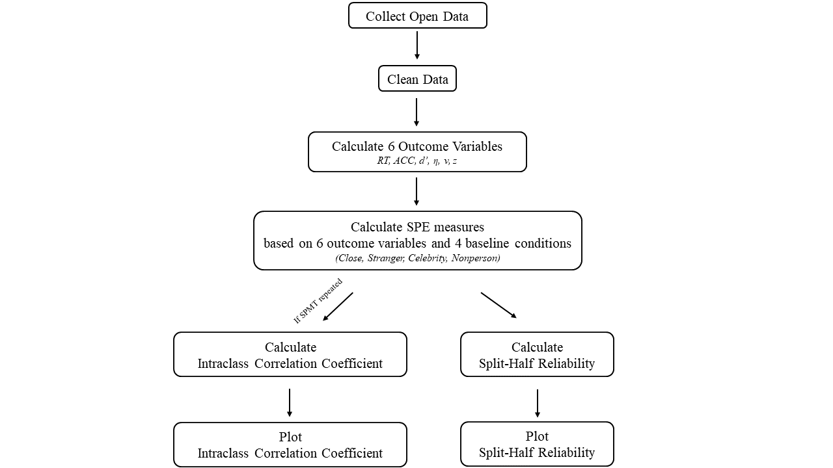

**Fig. 2** Roadmap of the Current Study.

## 2.4.1 Data Pre-processing

For all the seventeen datasets (see Table 1), we applied the following exclusion criteria for excluding data:

1. Participant exclusion criteria
2. Participants who had wrong trial numbers due to procedure errors is excluded from the analysis,
3. participants with an overall accuracy < 0.5 is excluded from the analysis,
4. participants with any of the conditions with zero accuracy is excluded from the analysis.
5. Trial level data exclusion criteria
6. Trials where the keypress occurs outside the two required keys and non-responsive trials are excluded from the analysis,
7. the practice trials are excluded,
8. the data that involved the presence of other independent variables (e.g., emotion).

## 2.4.2 Calculating the Outcome Variables and SPE Measures

For each study, we calculated six outcome variables for each experimental condition: Mean Reaction Time (RT), Accuracy (ACC), Sensitivity Score (*d′*), Efficiency (*η*), Drift Rate (*v*), and Starting Point (z). Reaction Time and Accuracy are obtained directly from the datasets, while Sensitivity Score and Efficiency are calculated based on Reaction Time and Accuracy. SPE Measures were computed using different outcome variables under four baseline conditions (see Table 2).

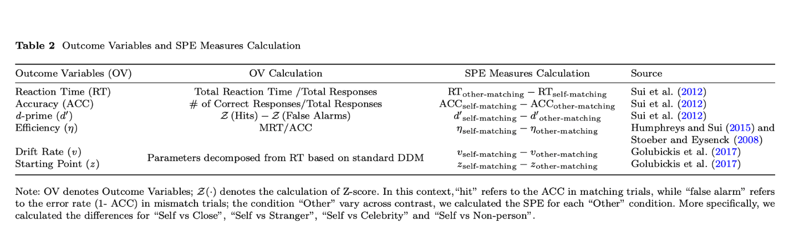

## 2.4.3 Estimating the Reliability

**Split-half Reliability.** We assessed the split-half reliability by first splitting the trial-level data into two halves and calculating the Pearson correlation coefficients. To ensure methodological rigor, we used four data splitting approaches for splitting the trial-level data: first-second, odd-even, permutated, and Monte Carlo (Kahveci et al., 2022; Pronk et al., 2022). The first-second approach splits trials into the first half and the second half. The odd-even approach splits the trials into sequences based on their odd or even numbers. The permutation approach shuffled the trial order and randomly assigned trials to two halves. The Monte Carlo approach is similar to the permutation approach, but iterates the process multiple times, usually thousands of times, to calculate the average and 95% confidence intervals of the split-half reliability.

In our analyses, we first stratified data by conditions and then employed the above four splitting approaches (Pronk et al., 2022). For example, when using Monte Carlo approach, we randomly split the stratified data into two halves for 5000 times, which resulted in 5000 pairs of two halves of the data. Next, we calculated 5000 Pearson correlation coefficients for these 5000 pairs. After that, we calculated the mean and 95% confidence intervals of the 5000 correlations coefficients. The first-second split, odd-even split, and permutated split are similar to the Monte Carlo approach. However, each of these approaches only results in a single reliability coefficient. Finally, after computing the split-half reliability coefficients for each dataset, substantial variations were observed across the datasets. To derive a more accurate estimation of the average split-half reliability for each SPE measures, we synthesized these reliability coefficients via a meta-analytical approach. We weighed the reliability coefficients based on the trial numbers of each study because the number of trials significantly influences the reliability of cognitive experiments (Kucina et al.2023) (see also Supplementary Fig. 4 for our exploratory analysis). The weighted-average reliabilities was calculated use the “aggregate.escalc” function in the “metafor” Package (Viechtbauer, 2010). We report the synthesized split-half reliability and its 95% confidence interval in the results.

Although there is no strict criterion for defining the level of split-half reliability for psychological and educational measures, a widely accepted guideline for split-half reliability coefficient is that a value of 0.70 is “acceptable”, and a value greater than 0.8 means excellent reliability (Cicchetti & Sparrow, 1981; Kupper & Hafner, 1989).

**Test-Retest Reliability (ICC).**  Intraclass Correlation Coefficient (ICC) is a well-established measure used in assessing test-retest reliability (Fisher, 1992). Unlike the Pearson correlation coefficient, which predominantly quantifies the linear relationship between two continuous variables, the ICC extends its prowess to scenarios involving multiple measurements taken on the same subjects, while also considers both the correlation and agreement between multiple measurements, making it a more comprehensive measure of test-retest reliability.

Our primary aim is to evaluate the appropriateness of the SPMT in assessing individual differences and group-level variations. To achieve this objective, we assessed the test-retest reliability of the six outcome variables for our dataset that involved test-retest sessions by calculating ICC using “psych” package (Revelle, 2017).We focused on using one specific type of Intraclass Correlation Coefficients (ICC) within the ICC family, ICC2k (Two-way random effects, absolute agreement, multiple raters). ICC2k evaluates the reliability of mean ratings furnished by a group of judges (Koo & Li, 2016). For the calculation of ICC2k estimates, the formula is:

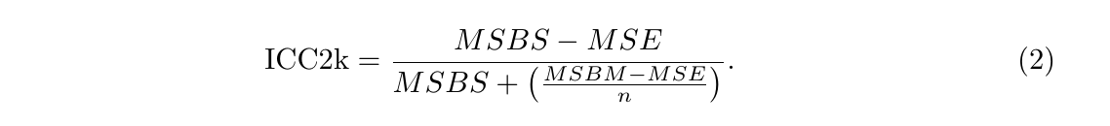

The traditional benchmarks for interpreting ICC values are as follows: ICC less than 0.50 suggests poor reliability; ICC between 0.50 and 0.75 suggests moderate reliability; ICC between 0.75 and 0.9 suggests good reliability; ICC above 0.9 suggests excellent reliability (Cicchetti & Sparrow, 1981; Kupper & Hafner, 1989).

# **3 Deviation from Preregistration**

We adhere to our pre-registration plan as much as possible, however, there are a few differences between the current report and registration document. First, we used a different algorithm for estimating parameters of the drift-diffusion model. In the registration, we planned to estimate the drift rate (*v*) and starting point (*z*) of the drift-diffusion model using the “fit_ezddm” function from the “hausekeep” package (Lin et al., 2020). This function served as a wrapper for the EZ-DDM function (Wagenmakers et al., 2007). However, we found that this algorithm is flawed when estimating parameter z during in parameters recovery (details provided in the Supplementary Materials). After comparing 5 algorithms, we found that the "RWiener" package (Wabersich & Vandekerckhove, 2014) achieved a favorable balance between accuracy, confidence interval width, and computational efficiency, making it the most suitable choice for our analysis. Nevertheless, for transparency, we have included the results from ezDDM in the supplementary materials (see Supplementary, Fig. 2-4). Second, the writing of the current manuscript was improved based on the preregistration. For example, in our preregistration, we include different baseline conditions when calculating SPE in the method section but did not mention this in our introduction and abstract. In this final report, we improved the writing and adjusted the introduction and abstract accordingly. Third, we did not explicitly state in the preregistration report that we would perform a weighted average of the Monte Carlo split-half reliabilities for all obtained studies. However, considering that the number of trials has a significant impact on reliability (Kucina et al.2023), during the formal analysis, we assigned different weights to each study based on the number of trials and performed a weighted average of the split-half reliabilities. Fourth, based on the data we collected, we also explored the relationship between the number of trials and the Monte Carlo split-half reliability, and found a significant positive correlation (see Supplementary Fig. 4 for our exploratory analysis).

# **4** **Results**

In seventeen independent datasets, 14 of them contain data for the Self vs Close other contrast, 11 of them contain data for Self vs Stranger, 1 of them have the data for Self vs Celebrities, 1 of them has the data for Self vs none condition. We reported the results for all these baseline conditions.

## 4.1 Split-Half Reliability

As described in method part, we applied four different approaches to split the data when calculating split-half reliability, namely the first-second, odd-even, permuted, and Monte Carlo methods. We presented the results from Monte Carlo split-half method in the main text due to its robustness (Pronk et al. (2022). The results of the other three split-half methods can be found in the supplementary materials (see Supplementary Fig. 2), except the odd-even, the other two also have highly similar result pattern with the Monte Carlo methods.

The split-half reliabilities using of Monte-Carlo method for different SPE measures is presented in figure 3. Among the measured outcome variables, the four highest ranking split-half reliabilities are as follows: Reaction Time (RT) with the "Stranger" contrast (*r* = .65, SE = .02, *p* <.001, 95% CI [.61, .70]); Efficiency (*η*) with the "Stranger" contrast (*r* = .64, SE = .03, *p* <.001, 95% CI [.59, .69]); RT with the "Close other" contrast (*r* = .58, SE = .02, *p* <.001, 95% CI [.54, .63]); *η* with the "Self vs Close" contrast (*r* = .57, SE = .02, *p* <.001, 95% CI [.52, . 62]). These SPE measures achieved a split-half reliability around 0.6 or higher, which is considered an acceptable level of reliability.

For the remaining 4 outcome variables, the reliability is around 0.5 or lower, indicating poor test-retest reliability. These include Accuracy (ACC), Sensitivity Score (*d’*), Drift Rate (*v*), and Starting Point (*z*). It is notice that almost all the split-half reliability of *z* using different contrasts are around 0, which suggests a complete lack of reliability.

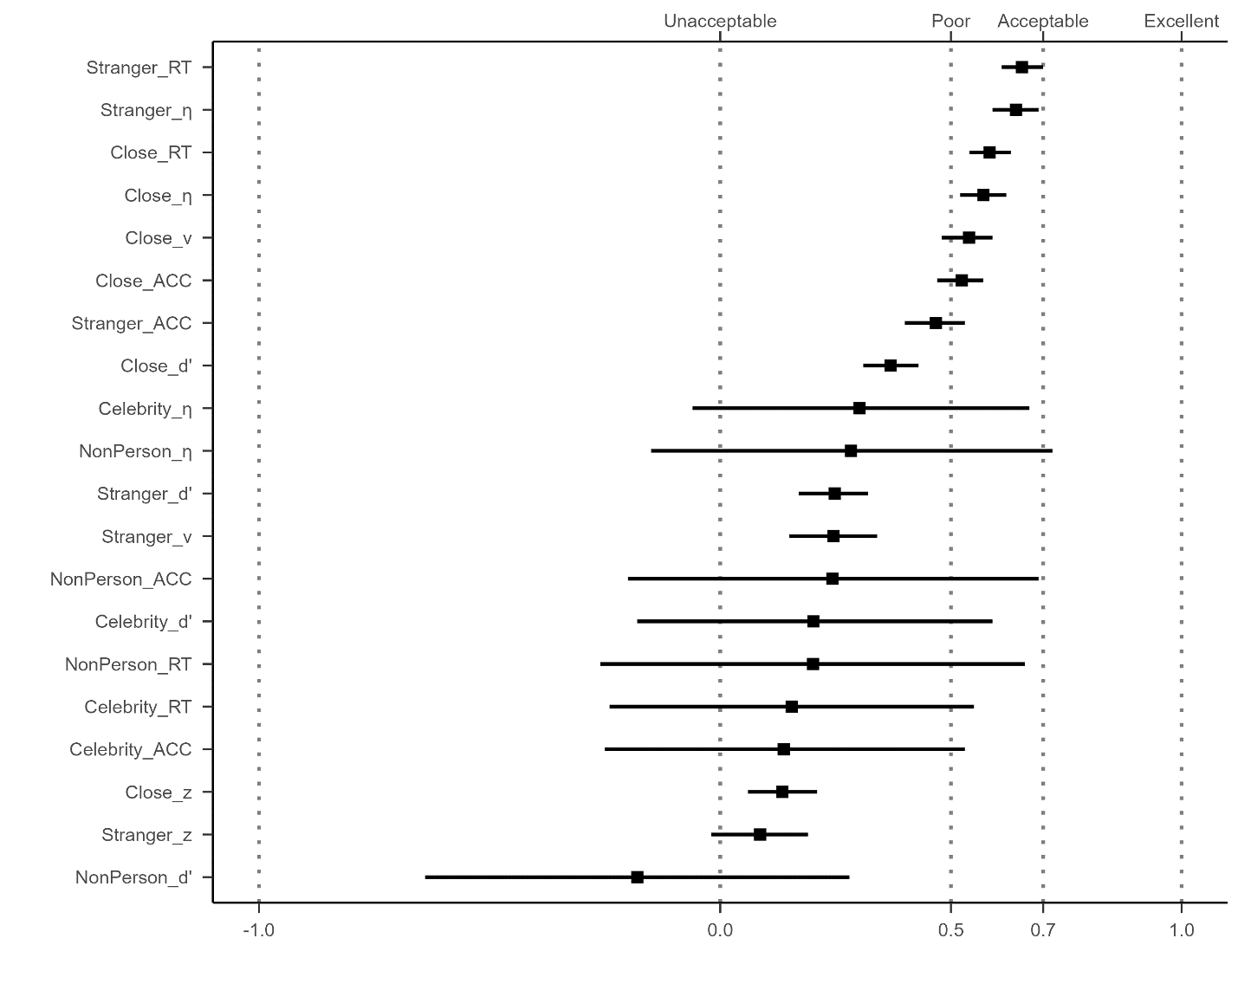

**Fig. 3.** The weighted average of split-half reliabilities (Monte-Carlo) for different SPE measures.

*Note:* The vertical axis represents 24 different SPE measures, combining six outcomes variables (RT, ACC, *d’*, *η*, *v*, *z*) and four baseline conditions (close other, stranger, celebrity, and non-person). The weighted average split-half reliability and 95% confidence intervals are shown by points and lines.

## 4.2 Intraclass correlation coefficient (ICC)

It is important to note that we could only calculate ICC for the study in our labortory (Hu et al., 2023) since all other datasets did not include re-test sessions. For this dataset, we only have 2 contrasts, the “Close other” and “Stranger”. To test the robustness of the results, we also explored one additional datasets that included re-test session but devivated quite strongly from the original SPMT (see Supplementary Fig. 4).

The ICC2, which measure the reliability for individual differences, confirmed the results from split-half reliability: only RT and Efficiency display reliability ranging from poor to acceptable. Specifically, under the "Self vs Close" contrast, the ICC2 for RT is 0.53 (95% CI = [.39, .69]), and for Efficiency, it is 0.52 (95% CI = [.38, .68]). Meanwhile, for the "Self vs Stranger" contrast, the ICC2 for RT is 0.58 (95% CI = [.45, .73]), and for Efficiency, it is 0.35 (95% CI = [.21, .52]). All the other outcome variables exhibit unacceptable to poor ICC2.

However, it is worth noting that the ICC2k values, which measure the reliability of effect on group level, for Reaction Time (RT) and Efficiency demonstrate notably high levels of reliability, while the other outcome variables exhibit unacceptable to poor ICC2k. When considering the "Close" contrast, the ICC2k for RT is 0.87 (95% CI = [.79, .93]), and for Efficiency, it is 0.87 (95% CI = [.78, .93]). Similarly, for the "Stranger" contrast, the ICC2k for RT is 0.90 (95% CI = [.82, .94]), and for Efficiency, it is 0.76 (95% CI = [.61, .87]).

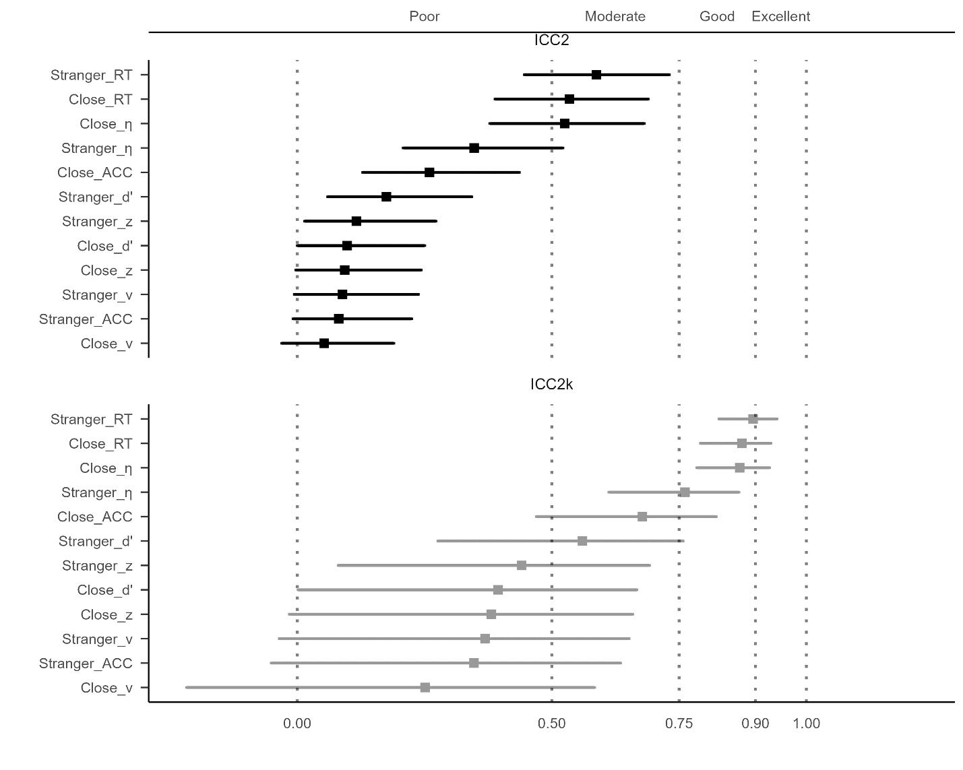

**Fig. 4** Intraclass Correlation Coefficient for SPE Measures. ***NOTE:***The vertical axis represents 12 different SPE measures, combining 6 outcomes variables (RT, ACC, d’, η, v, z) and 2 contrasts (close other, stranger).The upper facet of the figure presents the results for ICC2k, while the lower facet displays the results for ICC. The ICC values and their corresponding 95% confidence intervals are illustrated using points and lines.

# **5 Discussion**

Despite the significance of assessing the reliability of a behavioral paradigm before its implementation, this practice is not yet extensively embraced by researchers (Green et al., 2016; Hedge, Powell, & Sumner, 2018; Parsons et al., 2019). In this pre-registered study, our objective is to investigate the reliability of the outcome variables related to the SPE measures in the SPMT. To achieve this, we re-analyzed seventeen datasets (N = 833) from nine papers and two unpublished projects, utilizing split-half reliability (*r*) and intraclass correlation coefficient (ICC2k). Our analysis reveals that the Reaction Time and Efficiency demonstrated better results, with split-half reliability around acceptable level, ICC2k around moderate to good level. All the other outcome variables performed poorly, with unacceptable to poor level weight average split-half reliability and poor to moderate ICC2k. Therefore, in addressing the first question, our analyses indicate that Reaction Time and Efficiency emerge as the most reliable measure of SPE, among all measures available in the SPMT. When aligned with the outcomes observed from ICC2k, the response to the second question signifies that SPMT is suitable for repeated administration and could consistently capture SPE. Taken result from Split-half reliability and ICC2k, our findings align with previously proposed “reliability paradox” in cognitive tasks. That is, while the SPMT demonstrates robustness at the group level, both with repeated measurement and single administration, its reliability is low at individual level.

For testing the internal consistency of SPMT at individual level, we found that although Reaction Time and Efficiency yielded relatively better results compared to other indices, they still fell short of achieving commonly considered excellent split-half reliability level (Cicchetti & Sparrow, 1981; Kupper & Hafner, 1989). Several plausible reasons as well as potential solutions can be identified. Firstly, the insufficient number of trials per condition may contribute to the low split-half reliability. As shown in Supplementary Fig. 4, we calculated the correlation coefficient between the trial numbers and the Monte Carlo split-half reliabilities and found a strong positive correlation between trial number and reliability coefficients. A recent study by Kucina et al. (2023) also emphasized the importance of trial numbers for cognitive tasks in determining reliability. The findings revealed that increasing the number of trials and considering greater conflict effects or individual differences can enhance reliability compared to the original paradigm. Specifically, the study identified that satisfactory reliability required 72 or more trials, while achieving a higher level of reliability necessitated 100 trials or even more. Therefore, incorporating a larger number of trials in future implementations of the SPMT paradigm may enhance the split-half reliability by improving measurement internal consistency.

Secondly, it is important to acknowledge the potential influence of serial dependence effects on split-half reliability. As outlined in the methodology sections, we used four distinct data splitting approaches: first-second, odd-even, permutated, and Monte Carlo to evaluate the weighted average split-half reliability of the SPE measures. Interestingly, the results from the odd-even split-half method differed notably from the other three methods, while the permutated, first-second, and Monte Carlo methods showed similar outcomes (see Supplementary figure 2). This discrepancy in the results may be attributed to the presence of serial dependency within the data. Serial dependence refers to the phenomenon in which the outcome of one trial is influenced by preceding trials, resulting in a systematic relationship between consecutive trials (Pascucci et al., 2023). The odd-even method, being sensitive to temporal dependencies, could have been affected by the inherent sequential nature of the responses in the SPMT. Serial dependence effects have been observed in other cognitive tasks, as documented in recent studies (Braun et al., 2018; Zhang & Alais, 2020). Notably, studies in the field of perceptual decision making have demonstrated strong serial dependence effects in perception, even when the visual stimuli were reliable and varied randomly over time (Fischer & Whitney, 2014; John-Saaltink et al., 2016). In particular, if the split-half design unintentionally separates temporally adjacent trials in the SPMT, the presence of serial dependence may introduce performance differences between the halves, leading to a reduction in the reliability estimate. Thus, to accurately control for the impact of serial dependence in experiments, further research should employ appropriate statistical methods that account for the temporal dependencies between trials. Time series analysis techniques (Huitema, 1986) or modeling approaches that capture the serial correlation (Mei et al., 2023) can be utilized to obtain more accurate results.

Apart from the results of Reaction Time and Efficiency, the low split-half reliability of parameters (*v* and *z*) obtained from the drift diffusion model was unexpected. In our analysis, we used common and easy-to-use methods to estimate parameter values for each condition of each participant and then calculated the reliability. As for drift rate (*v*), we found that the test-retest reliability was unacceptable to poor level. As for starting point (*z*), we found that the test-retest reliability was poor level. Apart from the results of Reaction Time and Efficiency, the low split-half reliability and test-retest reliability of parameters (Drift rate v and Starting point z) obtained from the drift diffusion model was unexpected. In our analysis, we employed straightforward and user-friendly methods to estimate parameter values for each participant under various conditions, followed by reliability calculations. Several factors may account for these discouraging outcomes. Firstly, it appears that the standard DDM might not adequately capture the underlying cognitive processes in the SPMT. Previous studies often applied the DDM in a somewhat arbitrary manner, without adhering to a comprehensive cognitive modeling workflow, as recommended by Wilson and Collins (2019). As a consequence, the standard DDM exhibited suboptimal performance when applied to task structures similar to the SPMT (Groulx et al., 2020). Consequently, these results raise questions regarding the validity of employing the standard DDM to analyze data from the SPMT. To address this issue, future research should explore hierarchical models (which may require more time for parameter estimation) or develop new variations of the DDM that better capture the latent cognitive processes involved in completing the SPMT. Theoretically, this could enhance the reliability of these parameters. These efforts will contribute to the development of formal models for understanding SPE, leading to more reliable and valid interpretations of cognitive processes in the SPMT and similar paradigms.

For the robustness of the SPE with repeated administration and at group level, we found that the RT and efficiency measures exhibited excellent test-retest reliability (ICC2k), regardless of whether the target is, indicating strong group-level consistency over time. On the other hand, the ICC2k values for other measures were relatively lower, only at a moderate level. It is important to note that ICC values should not be interpreted solely as a measure of the test's overall quality, but rather as an indication of the specific types of questions it can effectively address (Koo & Li, 2016). The results obtained from the intraclass correlation coefficients indicate that the SPMT, particularly the Reaction time and efficiency, is appropriate for repeated administration at group-level analysis. Taken the split-half reliability result together, our findings align with previously proposed “reliability paradox” in cognitive tasks (Hedge, Powell, & Sumner, 2018; Logie et al., 1996). Like other traditional cognitive tasks such as Flanker, Simon, or Stroop tasks (Clark et al., 2022; Mollon et al., 2017), the SPMT is susceptible to factors such as external conditions and contextual differences, which contribute to greater within-participant variability and lower spli-half reliability values (Clark et al., 2022; Mollon et al., 2017). However, when averaging performance across different individuals, the task still demonstrates good consistency, leading to high ICC2k values (Liljequist et al., 2019). In practical terms, our results suggest that the SPMT is better suited for discerning performance differences at group level, rather than capturing consistent performance within the same individuals. Therefore, researchers should consider these factors when investigating individual differences using the SPMT.

We found that the RT and efficiency measures exhibited excellent test-retest reliability (ICC2k). On the other hand, the ICC2 values for these measures were relatively lower, only at a moderate level. This may suggest that, when calculating the test-retest reliability of the SPMT, it should be assumed that the impact of each measurement (6 sessions) on different participants varies. However, our conclusions regarding ICC results stem solely from our own dataset (Hu et al., 2023). Hence, drawing the inference that there is no reliability paradox in SPMT's test-retest reliability is not robust. On the contrary, in terms of split-half reliability, we have observed a significant reliability paradox. Despite the highly significant and stable nature of the self-prioritization effect (SPE) of SPMT, as discovered in our meta-analysis project (pre-registration available at <https://osf.io/euqmf>), the split-half reliability of SPMT is relatively low. Differing from the results of ICC, which are solely based on our own dataset, the results from split-half reliability are drawn from 17 datasets we collected. Consequently, in the overall perspective, we contend that the SPMT also presents a reliability paradox, "Robust experimental effects are not always associated with robust individual difference correlations (Logie et al., 1996)."

It is important to clarify here that the aim of our study, which primarily focused on exploratory purposes and providing information regarding the current state of reliability for the assessed outcome variables. Consequently, future research could concentrate on modifying the paradigm and conducting tests to assess potential improvements (see Zorowitz and Niv (2023)). For example, if researchers want to use SPMT in assessing individual difference, there is a need for a more nuanced task setting that can consistently capture performance nuances and reveal individual differences more sensitively. Recent study on gamification of cognitive tasks have shown that incorporating gamification elements can effectively improve data quality and assessment efficacy (Friehs et al., 2020). Moreover, Despite psychometric shortcomings in assessing individual difference, Enkavi et al. (2019) propose that the results of cognitive tasks' outcome variables can be combined using data-driven methods. These methods aim to derive more consistent latent variables, which could be better suited for trait-like treatment. Hence, introducing modifications to the SPMT by integrating dynamic elements, such as gamification components, or using data-driven approach to undriveable latent variables of SPMT holds the potential to amplify its efficacy in capturing distinctive individual variations. These further explorations will have important implications for future task design and data collection protocols.

## Implications of the current study

Our study yields practical implications for researchers aiming to use SPMT or improve it. First, our analyses indicate that Reaction Time and Efficiency emerge as the most reliable measure of SPE, among all measures available in the SPMT. This is particularly true when quantifying the SPE as the contrast between self and stranger condition. The remaining outcome variables demonstrated low levels of reliability at individual level, and our initial analysis into the factors influencing this individual level reliability deficiency indicates a probable connection to inadequate trial numbers and the emergence of a serial dependence effect. Second, for researchers interested repeated administration of SPE, the Reaction Time and Efficiency metrics in the SPMT prove well-suited to address related inquiries. For researchers who interested in using SPMT as a measure individual difference in SPE, the current version of SPMT demonstrates limitations in capturing trait-like characteristics. Consequently, significant modifications are imperative. Potential modifications could encompass incorporating gamification elements and employing latent variable analysis to refine the SPMT's capacity to elucidate individual variations in SPE.

**Limitations**

Several limitations warrant acknowledgment. Firstly, although we made efforts to enhance sample diversity by including open data whenever possible, it is important to note that the majority of our samples still consisted of individuals from what is commonly referred to as "WEIRD" populations (Rad et al., 2018; Yue et al., 2023). As a result, our findings may not be fully representative of the broader population, and it is necessary to include a more diverse sample to ensure greater generalizability of the paradigm. Additionally, when assessing the intraclass correlation coefficients (ICCs), only our own dataset had longitudinal data available, which could potentially limit the representativeness of the results. This issue is mitigated by the fact that additional analysis of two datasets that with different design showed similar results as we reported in the main text. Furthermore, the majority of the studies included in our analysis focused on adults from healthy populations. Therefore, further investigation is needed to include more datasets with a more diverse population in order to determine the reliability of the SPMT in different settings. Finally, we did not use hierarchical models, which may reveal different results. We are doing so to reveal the reliability of the conventional ways of measuring SPE. Future studies may consider introducing new statistical methods to improve the reliability of SPMT.

# **6 Conclusion**

In conclusion, this study provides empictal assessment of the reliability of the self-perceptual matching task (SPMT) and highlights important considerations for interpreting its reliabilities. We have demonstrated that the Reaction Time and Efficiency measures exhibit greater reliability compared to other outcome variables in the SPMT. Furthermore, our findings indicate that the SPMT is more suitable for group-level analysis rather than assessing individual-level variation. Ultimately, our study paves the way for the prospective utilization of these tasks, in various domains including research, clinical applications, and personal performance monitoring. The information obtained from our study also contributes valuable knowledge to the field and sets the stage for further investigations and advancements in utilizing SPMT effectively.**Acknowledgements.**

The present research is support by.

# **Author contributions**

HCP contributed to the conception and supervision of the study. JS contributed to fund raising, HCP contributed to data collection. ZL, ZYR and HMZ write the simulation code for pre-registration. HMZ collected the datasets and performed the data pre-processing, analysis and visualize the results. In addition, ZL, HMZ and HCP contribute to discussing the results and the drafting of the final manuscript. HCP, JS, ZL and HMZ critically revise the manuscript.

# **Data and Material Availability**

The pre-registration plan is available at <https://osf.io/zv628>. The de-identified raw data from our lab is available at <https://doi.org/10.57760/sciencedb.08117>. The simulated data is accessible on GitHub (<https://github.com/Chuan-Peng-Lab/ReliabilitySPE>).

# **Code Availability**

Code used to simulate and analyze the data is made accessible at <https://github.com/Chuan-Peng-Lab/ReliabilitySPE>.

# **Competing interests**

The authors declare no competing interests.

# **Supplementary Information**

## Parameter Recovery Result for Package Comparison

We chose not to utilize the HDDM package (Wiecki et al., 2013) since the computation process is significantly time-consuming, necessitating high computational resources and leading to prolonged overall analysis time. Instead, we performed a package comparison by generating 100 datasets using the HDDM package in Python, in order to identify the most appropriate package for our analysis. These datasets were specifically configured with parameters *a* = 2, *t* = 0.3, *v* = 1, and *z* = 0.7. Subsequently, we utilized three different DDM packages in R, namely RWiener (Viechtbauer, 2010), hausekeep (Lin, 2019), and FastDMinR (Voss & Voss, 2007), to compute parameter estimates for these generated datasets. The evaluation process involves comparing the computed values obtained from the R packages with the set parameters. If the computed values from the R packages are found to be closer to the set values, it signifies that the respective R package provides more accurate parameter estimation for the drift-diffusion model.

Figure 1 presents the results of the package comparison. The estimated drift rate (*v*) obtained from RWiener is 1.01, with a 95% confidence interval of [.98, 1.03], which closely aligns with our pre-defined values. Similarly, the estimated starting point (*z*) is 0.77, with a 95% confidence interval of [.76, .78], also very close to our pre-defined value. On the contrary, the parameters calculated using other packages either showed high inaccuracies, excessively wide confidence intervals, or required extended computation times. As a result, we have opted to utilize RWiener for our calculations. It strikes a favorable balance between accuracy, confidence interval width, and computational efficiency, making it the most suitable choice for our analysis.

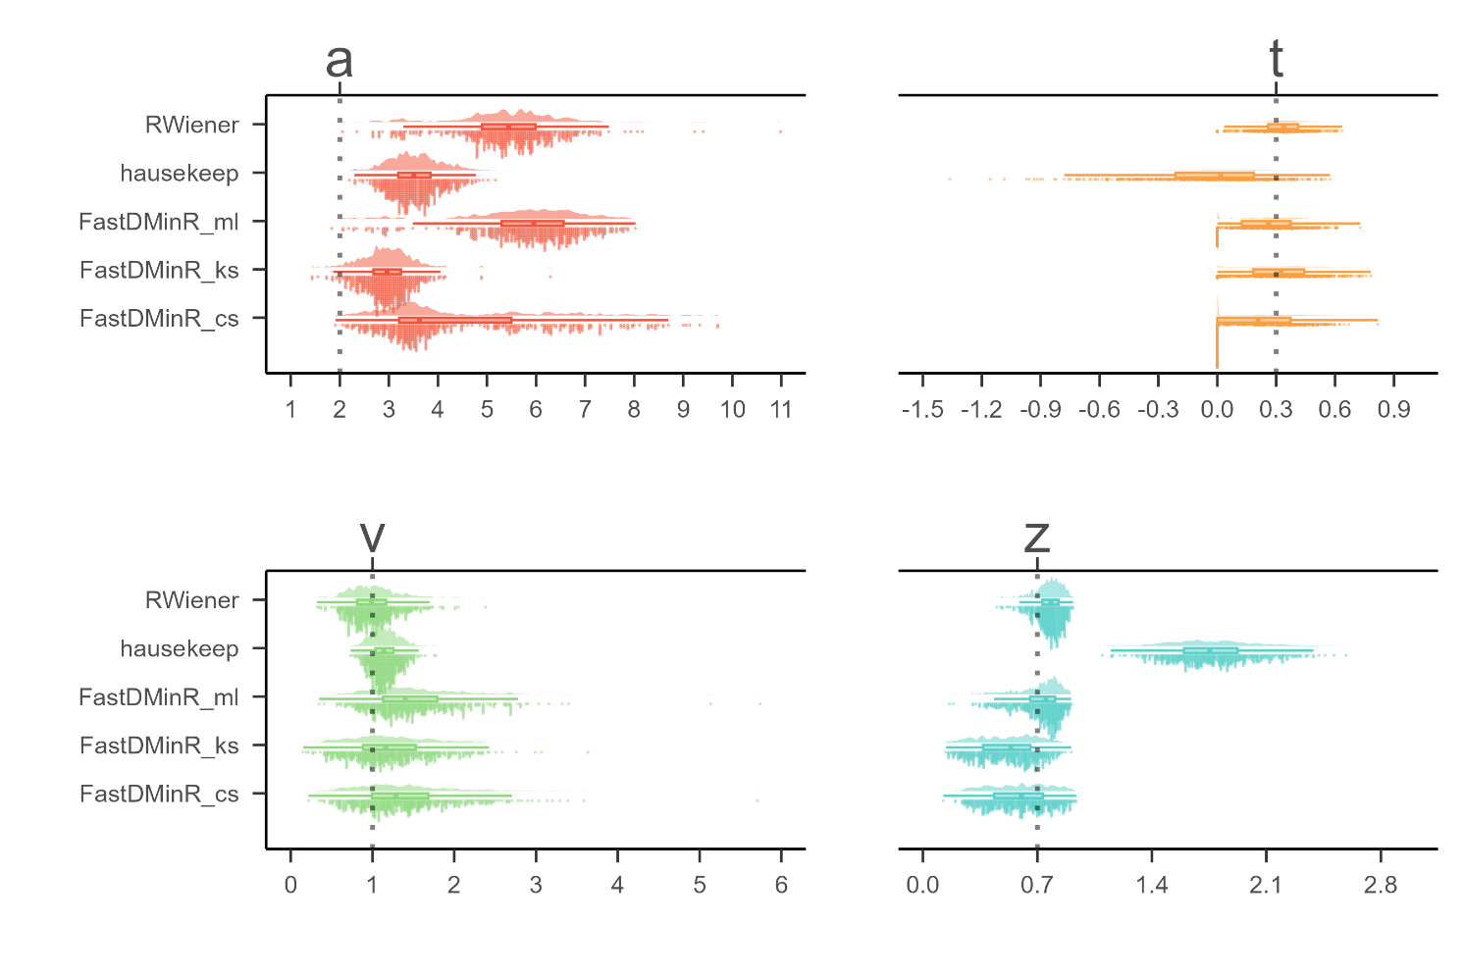

**Supplementary Fig. 1 DDM Packages Comparison.**

*Note:* The parameters of interest in the drift-diffusion model (DDM) are represented as follows: "*a*" denotes the threshold parameter, "*t*" represents the non-decision time, "*v*" indicates the drift rate, and "*z*" corresponds to the starting point. The y-axis of the graph displays the estimation of these DDM parameters using three different R packages: "RWiener," "hausekeep," and "FastDMinR." In total, there are five methods for estimating DDM parameters, with three methods originating from the "FastDMinR" package. On the x-axis, the values of the estimated parameters are plotted. The dashed line on the graph indicates the true value of the parameter being estimated.

* 1. **Split-half Reliabilities Using Four Splitting approaches.**

In this section, we are presenting the split-half reliabilities results for the SPE measures using four split-half methods: Monte Carlo, first-second, odd-even, and permutated. We also include includes the drift rate (*v*) and starting point (*z*) estimated from the "hausekeep" package in the analysis. However, it is important to highlight that the estimation of parameter "*a*" in "hausekeep" significantly deviates from the HDDM approach, primarily because of the assumption that *z* = *a* / 2 (refer to suppl. Fig. 1). As a result, we have chosen not to include the results obtained from this package in the main text. Nevertheless, we present them here for reference and transparency. Please refer to Figure 2(a-d) for the visual representation of the results.

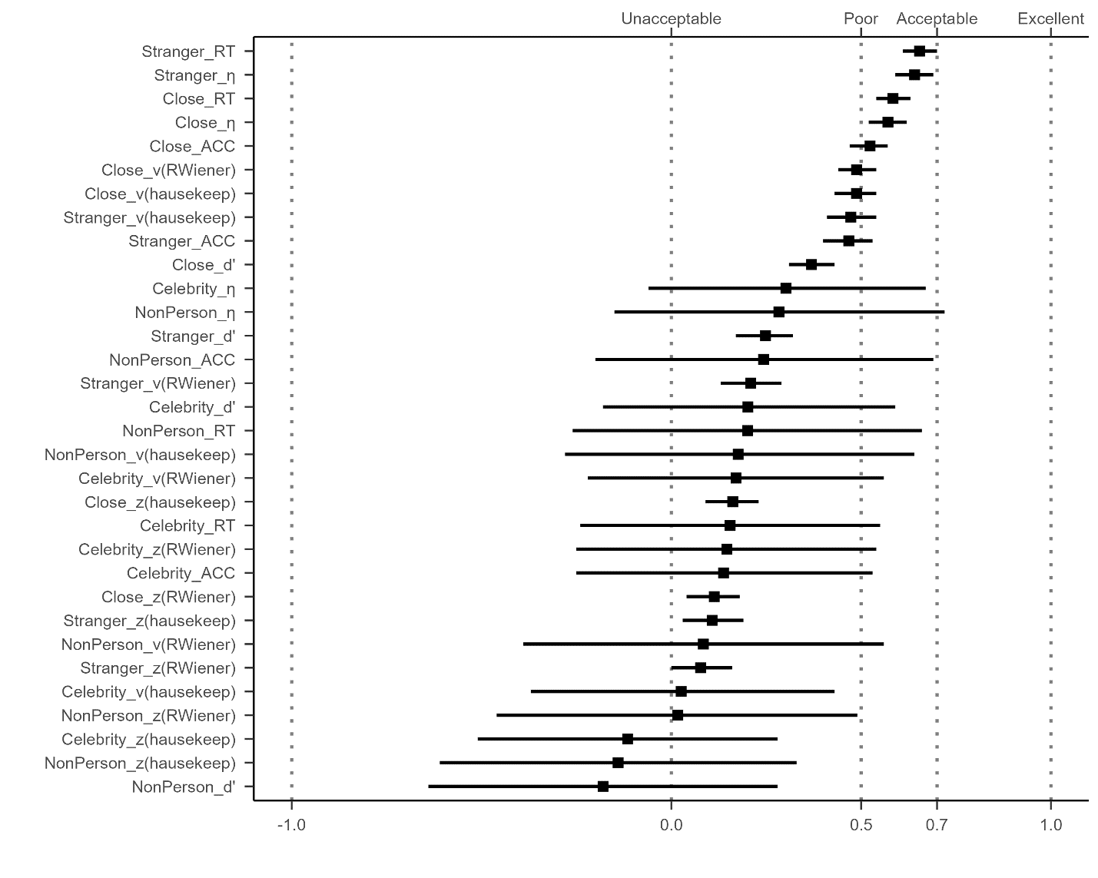

**Supplementary Fig. 2a Results of Split-half Reliabilities using Monte Carlo Split-half Methods.**

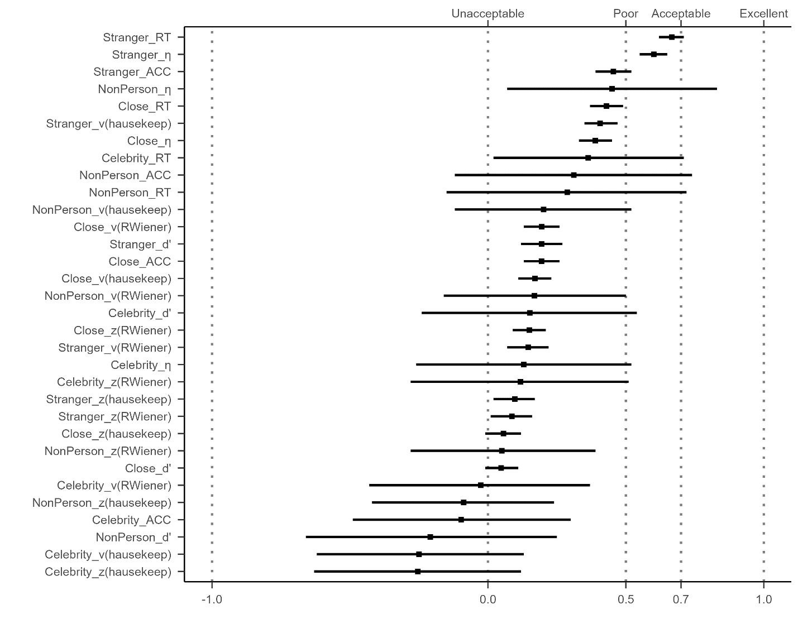

**Supplementary Fig. 2b Results of Split-half Reliabilities using First-Second Split-half Methods.**

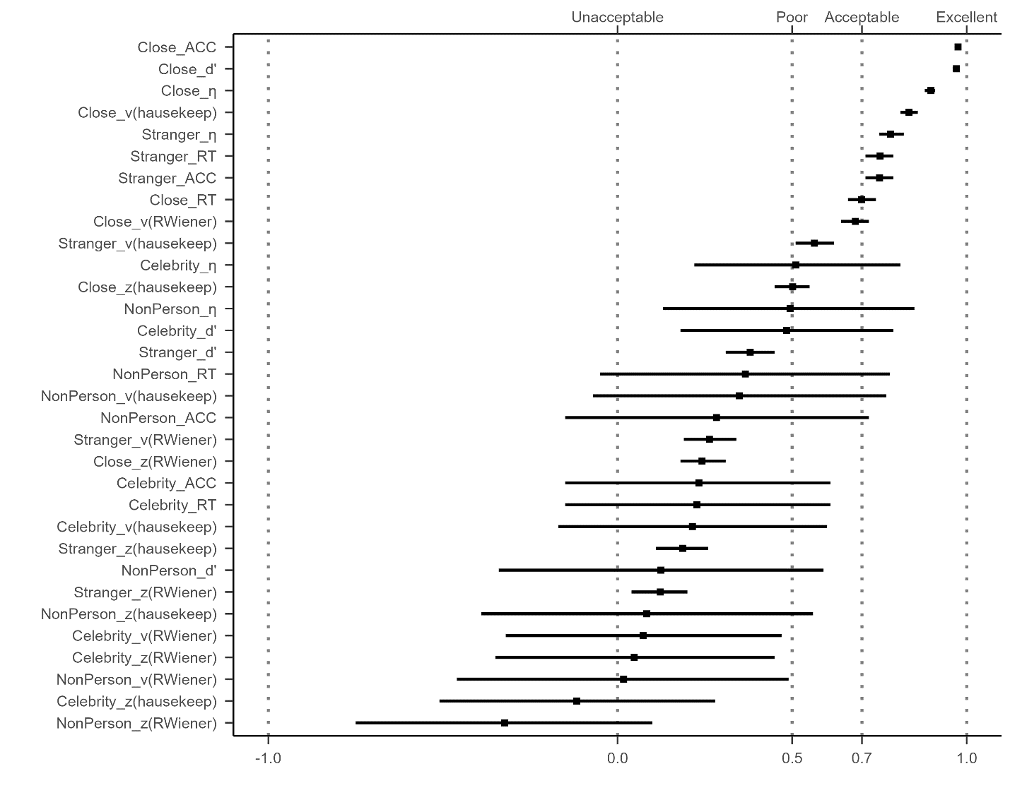

**Supplementary Fig. 2c** **Results of Split-half Reliabilities using Odd-Even Split-half Methods.**

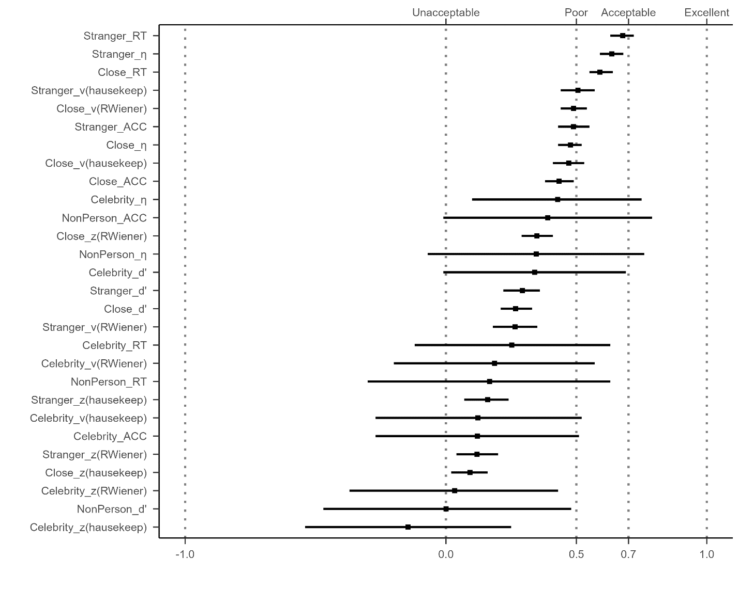

**Supplementary Fig. 2d** **Results of Split-half Reliabilities using Permuted Split-half Methods.**

*Note:* The vertical axis of the graph listed 32 different SPE measures, combining six outcomes variables (RT, ACC, *d’, η, v, z*) and four baseline conditions (close other, stranger, celebrity, and non-person). The *v* and *z* implemented using the "hausekeep" package were also included. The weighted average split-half reliability and 95% confidence intervals are shown by points and lines. The figure is divided into separate facets arranged from left to right, each representing weighted average split-half reliability calculated using three distinct methods: first-second, odd-even, and permuted.

It is evident that the results pattern from the permuted split-half methods and first-second split-half methods closely resemble the Monte Carlo method's outcomes. The top four split-half reliabilities, ranked highest, are as follows: Reaction Time (RT) with the "Stranger" contrast, Efficiency (*η*) with the "Stranger" contrast, RT with the "Close other" contrast, *η* with the "Self vs Close" contrast. However, the results obtained from the odd-even split-half method were notably different from the other three methods. We hypothesize that this discrepancy may be attributed to the presence of serial dependency within the data (see discussion section). Further investigation into the presence and impact of serial dependency in the data would be valuable to better understand the observed variations in the split-half reliabilities among the different methods.

## ICCs for SPE Measures Using Other Dataset

In Figure 3a, we present the results of the Intraclass Correlation Coefficients (ICCs) for the SPE measures, where drift rate (*v*) and starting point (*z*) estimated from the "hausekeep" package were also included. In Figure 3b, we extended our exploration of the ICCs to include the SPE measures from one additional dataset. However, it is important to note that the SPMT used in this dataset deviated quite strongly from the original SPMT paradigm. Due to these significant differences, the ICCs obtained from this dataset may reflect variations introduced by the modified SPMT rather than directly comparable results to the original paradigm.

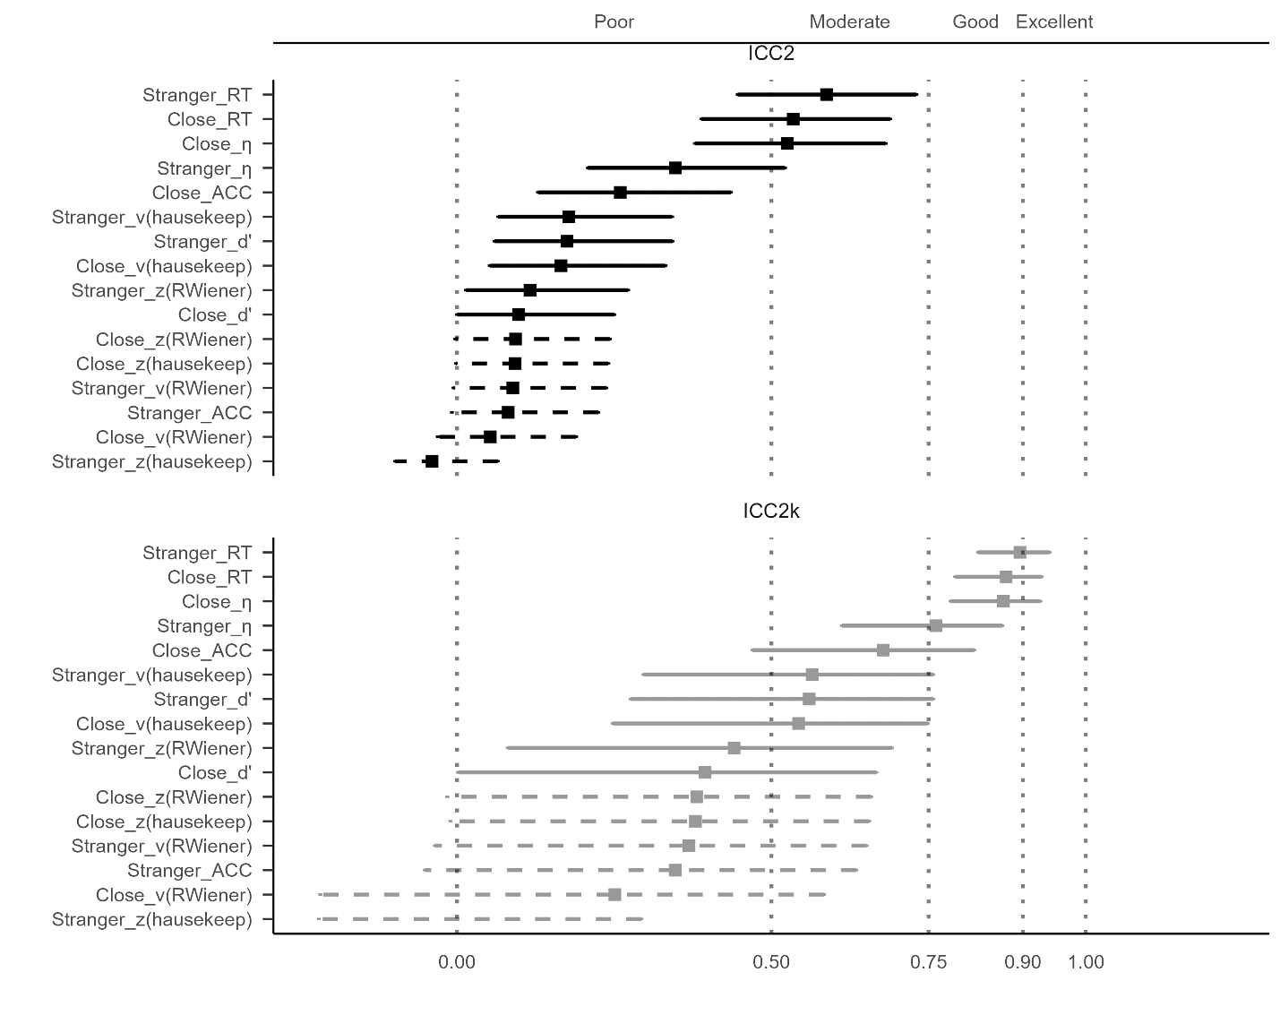

**Supplementary Fig. 3a ICCs for SPE Measures Using Hu et al. (2023).**

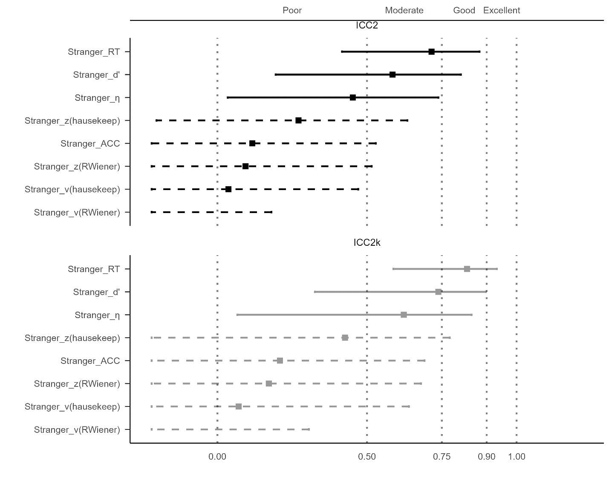

**Supplementary Fig. 3b ICCs for SPE Measures Using an Aditional dataset.**

*Note:*The vertical axis of the graph illustrates eight distinct outcome variables, which includes two additional indices from the DDM, implemented using the "hausekeep" package. The line and dots on the graph represent the value of ICC, along with their corresponding 95% confidence intervals. The dashed line indicates that the confidence interval for that point estimate extends beyond the range of our coordinate axes (0, 1). The upper facet of the figure presents the results for ICC2k, while the lower facet displays the results for ICC.

## Correlation Between Monte Carlo Split-half Reliability and Trial Numbers

In this section, we present the results of the correlation analysis between Monte Carlo split-half reliability and the number of trials (Fig. 4). Notably, we found significant correlations between Monte Carlo split-half reliability and trial numbers for some outcome variables, such as Reaction Time and Efficiency. However, for outcome variables like *d'* and *v*, the correlation with trial numbers was relatively weak.

From the plot, we can observe that the SPMT paradigm requires approximately 80 trials to achieve a Monte Carlo split-half reliability of 0.8 for the SPE measure of RT under the 'Stranger' condition and around 120 trials under the 'Close' condition. Furthermore, achieving a Monte Carlo split-half reliability of 0.8 for the *v* parameter may require more than 120 trials. On the other hand, attaining high Monte Carlo SHR values for the remaining three outcome variables, particularly for the *z* parameter, remains challenging even with 150 or more trials.

It is important to emphasize that here we only conducted a simple regression analysis of trial numbers and Monte Carlo SHR based on the collected datasets. This analysis was not part of the pre-registered plan, and our primary aim was not to provide a well-validated improvement for the SPMT. However, considering the significant correlation between the number of trials and Monte Carlo split-half reliability, our findings suggest that, for the SPMT paradigm, achieving higher reliability for clinical evaluation would necessitate conducting more trials. As a reasonable approach, it might be beneficial to consider having more than at least 80 trials under each experimental condition.

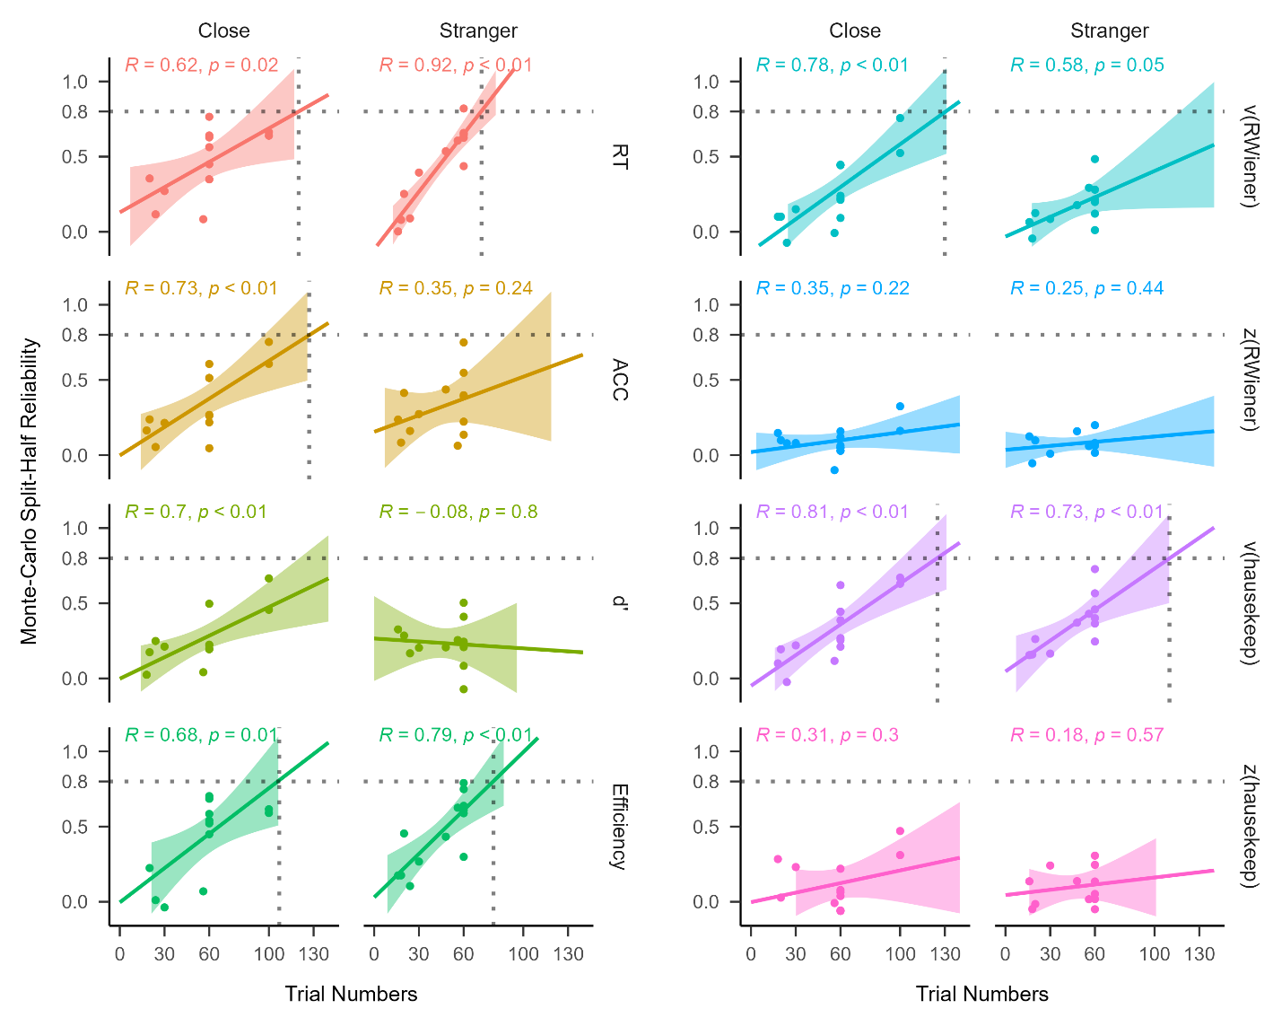

**Supplementary Fig. 4 Regression analysis between Monte Carlo split-half reliability and trial numbers using different SPE measures.**

*Note:* The vertical axis represents Monte-Carlo split-half reliability, and the horizontal axis represents the number of trials. Each facet represents one SPE measures.

# **References**

Baker, M. (2016). 1,500 scientists lift the lid on reproducibility. *Nature, 533*(7604).

Braun, A., Urai, A. E., & Donner, T. H. (2018). Adaptive history biases result from confidence-weighted accumulation of past choices. *Journal of Neuroscience, 38*(10), 2418-2429.

Bukowski, H., Todorova, B., Boch, M., Silani, G., & Lamm, C. (2021). Socio-cognitive training impacts emotional and perceptual self-salience but not self-other distinction. *Acta Psychologica, 216*, 103297. <https://doi.org/10.1016/j.actpsy.2021.103297>

Cheng, M., & Tseng, C.-h. (2019). Saliency at first sight: instant identity referential advantage toward a newly met partner. *Cognitive Research: Principles and Implications, 4*(1), 1-18. <https://doi.org/10.1186/s41235-019-0186-z>

Cherry, E. C. (1953). Some experiments on the recognition of speech, with one and with two ears. *The Journal of the acoustical society of America, 25*(5), 975-979. <https://doi.org/10.1121/1.1907229>

Cicchetti, D. V., & Sparrow, S. A. (1981). Developing criteria for establishing interrater reliability of specific items: applications to assessment of adaptive behavior. *Am J Ment Defic, 86*(2), 127-137. <https://psycnet.apa.org/record/1982-00095-001>

Clark, K., Birch-Hurst, K., Pennington, C. R., Petrie, A. C., Lee, J. T., & Hedge, C. (2022). Test-retest reliability for common tasks in vision science. *Journal of Vision, 22*(8), 18-18.

Constable, M. D., Becker, M. L., Oh, Y.-I., & Knoblich, G. (2021). Affective compatibility with the self modulates the self-prioritisation effect. *Cognition and Emotion, 35*(2), 291-304. <https://doi.org/10.1080/02699931.2020.1839383>

Constable, M. D., Elekes, F., Sebanz, N., & Knoblich, G. (2019). Relevant for us? We-prioritization in cognitive processing. *Journal of Experimental Psychology: Human Perception and Performance, 45*(12). <https://doi.org/10.1037/xhp0000691>

Constable, M. D., & Knoblich, G. (2020). Sticking together? Re-binding previous other-associated stimuli interferes with self-verification but not partner-verification. *Acta psychologica, 210*, 103167. <https://doi.org/10.1016/j.actpsy.2020.103167>

Constable, M. D., Rajsic, J., Welsh, T. N., & Pratt, J. (2019). It is not in the details: Self-related shapes are rapidly classified but their features are not better remembered. *Memory & Cognition, 47*, 1145-1157. <https://doi.org/10.3758/s13421-019-00924-6>

De Schryver, M., Hughes, S., Rosseel, Y., & De Houwer, J. (2016). *Unreliable yet still replicable: A comment on LeBel and Paunonen (2011)* [doi:10.3389/fpsyg.2015.02039]. Frontiers Media S.A.

Enkavi, A. Z., Eisenberg, I. W., Bissett, P. G., Mazza, G. L., MacKinnon, D. P., Marsch, L. A., & Poldrack, R. A. (2019). Large-scale analysis of test–retest reliabilities of self-regulation measures. *Proceedings of the National Academy of Sciences, 116*(12), 5472-5477. <https://doi.org/doi:10.1073/pnas.1818430116>

Fischer, J., & Whitney, D. (2014). Serial dependence in visual perception. *Nature neuroscience, 17*(5), 738-743.

Fisher, R. A. (1992). Statistical methods for research workers. *Springer New York*. <https://doi.org/10.1007/978-1-4612-4380-9_6>

Friehs, M. A., Dechant, M., Vedress, S., Frings, C., & Mandryk, R. L. (2020). Effective gamification of the stop-signal task: two controlled laboratory experiments. *JMIR Serious Games, 8*(3), e17810.

Golubickis, M., Falbén, J. K., Ho, N. S., Sui, J., Cunningham, W. A., & Macrae, C. N. (2020). Parts of me: Identity-relevance moderates self-prioritization. *Consciousness and cognition, 77*, 102848. <https://doi.org/10.1016/j.concog.2019.102848>

Golubickis, M., Falben, J. K., Sahraie, A., Visokomogilski, A., Cunningham, W. A., Sui, J., & Macrae, C. N. (2017). Self-prioritization and perceptual matching: The effects of temporal construal. *Mem Cognit, 45*(7), 1223-1239. <https://doi.org/10.3758/s13421-017-0722-3>

Golubickis, M., & Macrae, C. N. (2021). Judging me and you: Task design modulates self-prioritization. *Acta psychologica, 218*, 103350. <https://doi.org/10.1016/j.actpsy.2021.103350>

Green, S. B., Yang, Y., Alt, M., Brinkley, S., Gray, S., Hogan, T., & Cowan, N. (2016). Use of internal consistency coefficients for estimating reliability of experimental task scores. *Psychonomic Bulletin & Review, 23*, 750-763.

Groulx, J. T., Harding, B., & Cousineau, D. (2020). The EZ Diffusion Model: An overview with derivation, software, and an application to the Same-Different task. *The Quantitative Methods for Psychology, 16*(2), 154-174.

Hedge, C., Powell, G., Bompas, A., Vivian-Griffiths, S., & Sumner, P. (2018). Low and variable correlation between reaction time costs and accuracy costs explained by accumulation models: Meta-analysis and simulations. *Psychological Bulletin, 144*(11), 1200-1227. <https://doi.org/10.1037/bul0000164>

Hedge, C., Powell, G., & Sumner, P. (2018). The reliability paradox: Why robust cognitive tasks do not produce reliable individual differences. *Behavior Research Methods, 50*, 1166-1186.

Hobbs, C., Sui, J., Kessler, D., Munafò, M. R., & Button, K. S. (2023). Self-processing in relation to emotion and reward processing in depression. *Psychological Medicine, 53*(5), 1924-1936. <https://doi.org/10.1017/S0033291721003597>

Hu, C.-P., Lan, Y., Macrae, C. N., & Sui, J. (2020). Good Me Bad Me: Prioritization of the Good-Self During Perceptual Decision-Making. *Collabra. Psychology, 6*(1), 20. <https://doi.org/10.1525/collabra.301>

Hu, C.-P., Peng, K., & Sui, J. (2023, 2023-05-06). Data for Training Effect of Self Prioritization[DS/OL]. V1. *Science Data Bank*. <https://doi.org/10.57760/sciencedb.08117>.

Huber, D. E., Potter, K. W., & Huszar, L. D. (2019). Less “Story” and more “Reliability” in cognitive neuroscience. *Cortex; a journal devoted to the study of the nervous system and behavior, 113*, 347.

Hughes, S. M., & Harrison, M. A. (2013). I like my voice better: Self-enhancement bias in perceptions of voice attractiveness. *Perception, 42*(9), 941-949. <https://doi.org/10.1068/p7526>

Huitema, B. E. (1986). Autocorrelation in behavioral research: Wherefore art thou? In *Research methods in applied behavior analysis: Issues and advances* (pp. 187-208). Springer.

Humphreys, G. W., & Sui, J. (2015). The salient self: Social saliency effects based on self-bias. *Journal of cognitive psychology, 27*(2), 129-140. <https://doi.org/10.1080/20445911.2014.996156>

Jiang, M., Wong, S. K. M., Chung, H. K. S., Sun, Y., Hsiao, J. H., Sui, J., & Humphreys, G. W. (2019). Cultural Orientation of Self-Bias in Perceptual Matching. *Front Psychol, 10*, 1469. <https://doi.org/10.3389/fpsyg.2019.01469>

John-Saaltink, E. S., Kok, P., Lau, H. C., & De Lange, F. P. (2016). Serial dependence in perceptual decisions is reflected in activity patterns in primary visual cortex. *Journal of Neuroscience, 36*(23), 6186-6192.

Kahveci, S., Bathke, A., & Blechert, J. (2022). Reliability of reaction time tasks: how should it be computed? <https://doi.org/10.31234/osf.io/ta59r>

Keenan, J. P., Wheeler, M. A., Gallup, G. G., & Pascual-Leone, A. (2000). Self-recognition and the right prefrontal cortex. *Trends in cognitive sciences, 4*(9), 338-344. <https://doi.org/10.1016/S1364-6613> (00)01521-7

Kircher, T. T., Senior, C., Phillips, M. L., Benson, P. J., Bullmore, E. T., Brammer, M., ..., & David, A. S. (2000). Towards a functional neuroanatomy of self processing: effects of faces and words. *Cognitive Brain Research, 10*(1-2), 133-144. <https://doi.org/10.1016/S0926-6410(00)00036-7>

Kline, P. (2015). *A handbook of test construction (psychology revivals): introduction to psychometric design*. Routledge.

Kolvoort, I. R., Wainio‐Theberge, S., Wolff, A., & Northoff, G. (2020). Temporal integration as “common currency” of brain and self‐scale‐free activity in resting‐state EEG correlates with temporal delay effects on self‐relatedness. *Human brain mapping, 41*(15), 4355-4374. <https://doi.org/10.1002/hbm.25129>

Koo, T. K., & Li, M. Y. (2016). A Guideline of Selecting and Reporting Intraclass Correlation Coefficients for Reliability Research. *Journal of chiropractic medicine, 15*(2), 155-163. <https://doi.org/10.1016/j.jcm.2016.02.012>

Kucina, T., Wells, L., Lewis, I., de Salas, K., Kohl, A., Palmer, M. A., Sauer, J. D., Matzke, D., Aidman, E., & Heathcote, A. (2023). Calibration of cognitive tests to address the reliability paradox for decision-conflict tasks. *Nature Communications, 14*(1), 2234.

Kupper, L. L., & Hafner, K. b. (1989). On Assessing Interrater Agreement for Multiple Attribute Responses. *Biometrics, 45*(3), 957-967. <https://doi.org/10.2307/2531695>

LeBel, E. P., & Paunonen, S. V. (2011). *Sexy but often unreliable: The impact of unreliability on the replicability of experimental findings with implicit measures* [doi:10.1177/0146167211400619]. Sage Publications.

Liljequist, D., Elfving, B., & Skavberg Roaldsen, K. (2019). Intraclass correlation–A discussion and demonstration of basic features. *PloS one, 14*(7), e0219854.

Lin, H. (2019). How to use hausekeep. <https://doi.org/10.5281/zenodo.2555874>

Lin, H., Saunders, B., Friese, M., Evans, N. J., & Inzlicht, M. (2020). Strong effort manipulations reduce response caution: A preregistered reinvention of the ego-depletion paradigm. *Psychological science, 31*(5), 531-547. <https://doi.org/10.1177/0956797620904990>

Liu, T., Sui, J., & Hildebrandt, A. (2023). To see or not to see: The parallel processing of self-relevance and facial expressions. *Manuscript submitted for publication.* .

Liu, Y. S., Song, Y., Lee, N. A., Bennett, D. M., Button, K. S., Greenshaw, A., Cao, B., & Sui, J. (2022). Depression screening using a non-verbal self-association task: A machine-learning based pilot study. *Journal of Affective Disorders, 310*, 87-95. <https://doi.org/10.1016/j.jad.2022.04.122>

Logie, R. H., Sala, S. D., Laiacona, M., Chalmers, P., & Wynn, V. (1996). Group aggregates and individual reliability: The case of verbal short-term memory. *Memory & Cognition, 24*, 305-321.

Makel, M. C., Plucker, J. A., & Hegarty, B. (2012). Replications in psychology research: How often do they really occur? *Perspectives on Psychological Science, 7*(6), 537-542. <https://doi.org/10.1177/1745691612460688>

Martínez-Pérez, V., Campoy, G., Palmero, L. B., & Fuentes, L. J. (2020). Examining the dorsolateral and ventromedial prefrontal cortex involvement in the self-attention network: A randomized, sham-controlled, parallel group, double-blind, and multichannel HD-tDCS study. *Frontiers in Neuroscience, 14*, 683. <https://doi.org/10.3389/fnins.2020.00683>

Mei, N., Rahnev, D., & Soto, D. (2023). Using serial dependence to predict confidence across observers and cognitive domains. *Psychonomic Bulletin & Review*, 1-13.

Mollon, J. D., Bosten, J. M., Peterzell, D. H., & Webster, M. A. (2017). Individual differences in visual science: What can be learned and what is good experimental practice? *Vision research, 141*, 4-15.

Navon, M., & Makovski, T. (2021). Are Self-related Items Unique? the Self-prioritization Effect Revisited. <https://doi.org/10.31234/osf.io/9dzm4>

Oberauer, K., & Lewandowsky, S. (2019). Addressing the theory crisis in psychology. *Psychonomic bulletin & review, 26*, 1596-1618.

Orellana-Corrales, G., Matschke, C., & Wesslein, A.-K. Does Self-Associating a Geometric Shape Immediately Cause Attentional Prioritization? Comparing Familiar vs. Recently Self-Associated Stimuli in the Dot-Probe Task. <https://doi.org/10.1027/1618-3169/a000502>

Parsons, S., Kruijt, A.-W., & Fox, E. (2019). Psychological science needs a standard practice of reporting the reliability of cognitive-behavioral measurements. *Advances in methods and practices in psychological science, 2*(4), 378-395.

Pascucci, D., Tanrikulu, Ö. D., Ozkirli, A., Houborg, C., Ceylan, G., Zerr, P., Rafiei, M., & Kristjánsson, Á. (2023). Serial dependence in visual perception: A review. *Journal of Vision, 23*(1), 9-9.

Payne, B., Lavan, N., Knight, S., & McGettigan, C. (2021). Perceptual prioritization of self‐associated voices. *British Journal of Psychology, 112*(3), 585-610. <https://doi.org/10.1111/bjop.12479>

Pronk, T., Molenaar, D., Wiers, R. W., & Murre, J. (2022). Methods to split cognitive task data for estimating split-half reliability: A comprehensive review and systematic assessment. *Psychonomic Bulletin & Review, 29*(1), 44-54. <https://doi.org/10.3758/s13423-021-01948-3>

Qian, H., Wang, Z., Li, C., & Gao, X. (2020). Prioritised self-referential processing is modulated by emotional arousal. *Quarterly journal of experimental psychology, 73*(5), 688-697. <https://doi.org/10.1177/1747021819892158>

R Core Team. (2023). R: A Language and Environment for Statistical Computing. <https://www.R-project.org/>

Rad, M. S., Martingano, A. J., & Ginges, J. (2018). Toward a psychology of Homo sapiens: Making psychological science more representative of the human population. *Proceedings of the National Academy of Sciences, 115*(45), 11401-11405.

Revelle, W. R. (2017). psych: Procedures for personality and psychological research. <https://CRAN.R-project.org/package=psych>

Schäfer, S., & Frings, C. (2019). Understanding self-prioritisation: The prioritisation of self-relevant stimuli and its relation to the individual self-esteem. *Journal of cognitive psychology, 31*(8), 813-824. <https://doi.org/10.1080/20445911.2019.1686393>

Scheller, M., & Sui, J. (2022). The power of the self: Anchoring information processing across contexts. *Journal of Experimental Psychology: Human Perception and Performance*.

Stoeber, J., & Eysenck, M. W. (2008). Perfectionism and efficiency: Accuracy, response bias, and invested time in proof-reading performance. *Journal of research in personality, 42*(6), 1673-1678. <https://doi.org/10.1016/j.jrp.2008.08.001>

Sui, J., He, X., & Humphreys, G. W. (2012). Perceptual effects of social salience: Evidence from self-prioritization effects on perceptual matching. *Journal of experimental psychology. Human perception and performance, 38*(5), 1105-1117. <https://doi.org/10.1037/a0029792>

Sui, J., Liu, C. H., Wang, L., & Han, S. (2009). Short article: Attentional orientation induced by temporarily established self-referential cues. *Quarterly journal of experimental psychology, 62*(5), 844-849.

Svensson, S. L., Golubickis, M., Maclean, H., Falbén, J. K., Persson, L. M., Tsamadi, D., Caughey, S., Sahraie, A., & Macrae, C. N. (2022). More or less of me and you: self-relevance augments the effects of item probability on stimulus prioritization. *Psychological Research, 86*(4), 1145-1164. <https://doi.org/10.1007/s00426-021-01562-x>

Turk, D. J., Heatherton, T. F., Kelley, W. M., Funnell, M. G., Gazzaniga, M. S., & Macrae, C. N. (2002). Mike or me? Self-recognition in a split-brain patient. *Nature neuroscience, 5*(9), 841-842. <https://doi.org/10.1038/nn907>

Viechtbauer, W. (2010). Conducting meta-analyses in R with the metafor package. *Journal of statistical software, 36*, 1-48.

Voss, A., & Voss, J. (2007). Fast-dm: A free program for efficient diffusion model analysis. *Behavior Research Methods, 39*(4), 767-775.

Wabersich, D., & Vandekerckhove, J. (2014). The RWiener Package: an R Package Providing Distribution Functions for the Wiener Diffusion Model. *R Journal, 6*(1).

Wagenmakers, E.-J., Van Der Maas, H. L., & Grasman, R. P. (2007). An EZ-diffusion model for response time and accuracy. *Psychonomic Bulletin & Review, 14*(1), 3-22. <https://doi.org/10.3758/BF03194023>

Wiecki, T. V., Sofer, I., & Frank, M. J. (2013). HDDM: Hierarchical Bayesian estimation of the Drift-Diffusion Model in Python. *Frontiers in neuroinformatics, 7*, 14. <https://doi.org/10.3389/fninf.2013.00014>

Wilson, R. C., & Collins, A. G. E. (2019, 2019/11/26). Ten simple rules for the computational modeling of behavioral data. *eLife, 8*, e49547. <https://doi.org/10.7554/eLife.49547>

Woźniak, M., Kourtis, D., & Knoblich, G. (2018). Prioritization of arbitrary faces associated to self: An EEG study. *PloS one, 13*(1), e0190679. <https://doi.org/10.1371/journal.pone.0190679>

Xu, Y., Yuan, Y., Xie, X., Tan, H., & Guan, L. (2021). Romantic feedbacks influence self-relevant processing: the moderating effects of sex difference and facial attractiveness. *Current Psychology*, 1-13. <https://doi.org/10.1007/s12144-021-02114-7>

Yue, L., Zuo, X., & Chuan-Peng, H. (2023). The WEIRD problem in a “non- WEIRD” context: A meta-research on the representativeness of human subjects in Chinese psychological research. <https://doi.org/https://doi.org/10.17605/OSF.IO/MTR8D>

Zhang, H., & Alais, D. (2020). Individual difference in serial dependence results from opposite influences of perceptual choices and motor responses. *Journal of Vision, 20*(8), 2-2.

Zhang, Y., Wang, F., & Sui, J. (2023, 2023/08/01/). Decoding individual differences in self-prioritization from the resting-state functional connectome. *NeuroImage, 276*, 120205. <https://doi.org/https://doi.org/10.1016/j.neuroimage.2023.120205>

Zorowitz, S., & Niv, Y. (2023). Improving the reliability of cognitive task measures: A narrative review. *Biological Psychiatry: Cognitive Neuroscience and Neuroimaging*. <https://doi.org/10.1016/j.bpsc.2023.02.004>