The Self-Prioritization Effect Database with Standardized Meta-Data for Experimental Task
Cai Zhenxin¹, Tuo Liu, XXXX, Jie Sui^{x}, Hu Chuan-Peng^{1*}
¹ School of Psychology, Nanjing Normal University, 210024 Nanjing, China
*Email: hcp4715@hotmail.com

Abstract
The self-matching task, also known as self-tagging task, self-assiciative learning task, is widely used to investigate how self-related information is proccessed. In a typical self-matching task, participants first associate social labels (e.g., self, friend, and stranger) with geometric shapes (e.g., circle, triangle, and square) and then finish a matching task where they are asked to decide whether the shape-label pairings match the learned associations. Previous studies using this task have found faster and more accurate responses to self- than other-related pairings, i.e., the self-prioritization effect (SPE). Following the credibility revolution, a substantial number of these studies openly shared their data, created great potential for data re-using. However, there lacks of a standardized framework for sharing trial-level data generated by self-matching task, making it difficult to integrate existing open datasets. To fill the gap, we developed a three-level framework for organizing the metadata and trial-level data. We created machine-readable JSON files to document task implementations, including Physical Environment, Experimental Design, Block Structure, Trial Structure, and Stimulus Properties. We applied this framework to data available from 49 studies (89 experiment-level datasets, 4,875 participants, and over 2.1 million test trials). We demonstrated the value of the standardized open database through three examples: the effect of baseline conditions on SPE magnitude; the variability of SPE under nonmatch conditions; and the relationships between task details (duration of presenting time and number of trials) and SPE magnitude. The three examples show that standardizing meta-data across studies is what makes such aggregated analyses possible: the SPE was reliably positive against every baseline but differed reliably only between the baselines with the largest and the smallest point estimates; the SPE under nonmatching conditions was present but depended on how self-relevance was operationalized; and the magnitude of the SPE was related to stimulus presentation duration but not to the number of trials. Our standardized SPE database provides a valuable resource for the field. Moreover, our standardized framework for self-matching task is also valuable for developing similar databases for other cognitive tasks.
Keywords: Self-matching task, self-prioritization effect, open data, experimental design.

Introduction
The self plays a central role in cognition. Self-relevant information is processed faster and more accurately across perception, attention, and memory domains, which is known as self-prioritization effect (SPE) (Sui et al., 2012; Schäfer, Frings, et al., 2016; Constable et al., 2019). The self-matching task, also known as self-tagging task and self-assiciative learning task, has emerged as an important paradigm for investigating SPE. In a typical self-matching task, participant first associate geometric shapes with self- and non-self-relevant labels (e.g., "I", "Friend", and "Stranger") and then judge a shape-label pair presented on the screen match the learned association or not (Sui et al., 2012). Studies employed this task found better performance for self- than non-self-related stimuli (Liu et al., 2025; Schäfer, Wesslein, et al., 2016; Sui et al., 2012). Importantly, this effect has been observed across diverse cultural contexts (Constable et al., 2019; Grossmann & Jowhari, 2018) and different sensory modality (e.g., Schäfer, Wesslein, et al., 2016). This robust effect suggested a fundamental role of self-relevance in human cognition (Sui & Gu, 2017; Sui & Humphreys, 2015; Sui & Rotshtein, 2019).
In the era of credibility revolution, open data becomes a new norm (Houtkoop et al., 2018; Milham et al., 2018; Munafò et al., 2017). Specialized databases that aggregate data from multiple studies on particular phenomena provide unique opportunities for theory testing and discovery (Haaf et al., 2024; Rodriguez & Williams, 2022). Such resources allow researchers to examine effect sizes across diverse experimental conditions, identify moderating variables, and generate new hypotheses based on patterns that emerge only when data are aggregated across many studies (Cheung & Jak, 2016; Moreau & Gamble, 2022). The Attentional Control Data Collection (ACDC) is a good example, which provides a structured open database for attentional control experiments that has facilitated meta-analyses and methodological advancements (Haaf et al., 2024). Similarly, the Confidence Database aggregates data from hundreds of experiments on confidence judgments and meta-cognitive performance into a unified repository (Rahnev et al., 2020). The Confidence Database enabled researchers to examine individual differences, compare computational models, and investigate theoretical questions that cannot be addressed using isolated datasets (Rahnev, 2025). While many SPE studies made their trial-level data publicly available, no standardized, large-scale dataset exists.
For cognitive paradigms such as the self-matching task, the lack of standardized meta-data and data organization slows down the reuse of open data scattered on the internet. For example, the primary outcome, reaction times, may be named differently across studies, such as RT, Response-Time, or Latency. Similarly, accuracy of each trial may use inconsistent coding schemes, such as 0 vs 1, True vs False, or Correct vs Error. The variable names of critical independent variables, such as the identities used in the self-matching task, may also labelled differently across studies. More importantly, critical methodological information for implementing the task, such as the assignment of shapes to identities, stimulus presentation duration, trial structure, and participant exclusion criteria, is often absent from the raw data files and can only be found by reading the original papers. These issues substantially increase the effort required for reusing open data.
To address these issues, we developed a standardized framework for data organization and documentation, applied this framework to available open data, and formed the SPE database. To capture the methodological details systematically, we decomposed the self-matching task into five components and documented information of each with standardized metadata files. We then collected all available datasets and manually standardized both behavioral variables and methodological descriptors to ensure cross-study comparability. In total, data from 49 studies, comprising 89 experiment-level datasets, were included. The SPE database enables analyses that would be impossible for small sample size studies.
Method

Folder Structure
Following the FAIR principle (Wilkinson et al., 2016), we adopted a three-level folder structure for the database: root folder, study folder, and experiment folder (if there are multiple experiments. Each level is accompanied by standardized metadata encoded in machine-readable JSON files, facilitating both human interpretation and computational accessibility.
The root folder contains information spanning all studies included in the database. The study sub-folder contains information related to a specific study, defined as one or more experiments reported within a single publication, preprint, or thesis. The experiment folders include individual experimental data, typically representing a group of participants completing a specific version of the self-matching task across one or multiple sessions and assessment time points.
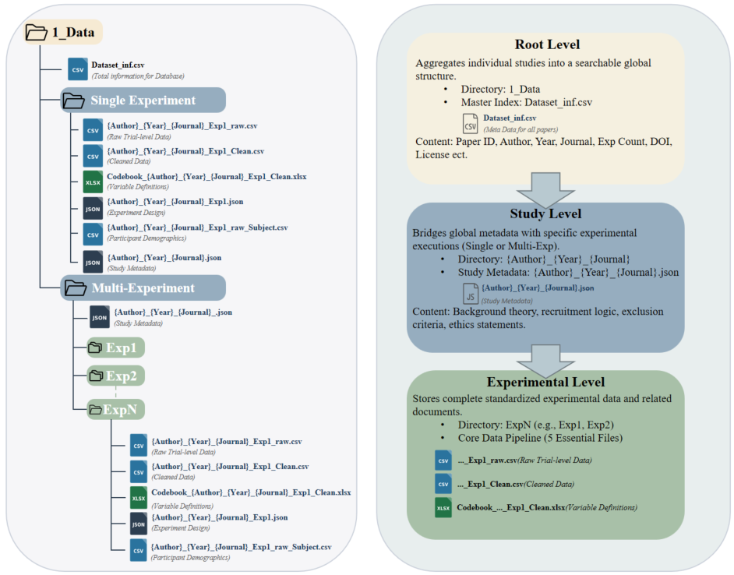
Figure 1. Database folder structure.
The root folder also contains a master metadata file ("Dataset_inf.csv"), which serves as the primary index for the entire database, and study-specific sub-folders (e.g., "Amodeo_2024_CABN"). Each row in this file represents one experiment-by-participant-group unit and is uniquely identified by the combination of the study folder (`Folder_Name`), the experiment identifier (`Exp`), and the participant group (`subj_Group`); the concatenation of these three fields forms the `ID` column, which is the key across the database. Each column of "Dataset_inf.csv" corresponds to a metadata field of the studies, such as authors, publication year, journal name (where applicable), Digital Object Identifiers (DOIs), and sample descriptors. Importantly, the study-specific folder (`Folder_Name`) was included in "Dataset_inf.csv" for clear mapping between studies and their data folders.
The study-specific folder contains a JSON file, e.g., `Amodeo_2024_CABN.json`, and experiment-specific sub-folders. The JSON file contains study-level information such as the theoretical background, a summary of the study, its main conclusion, the publication year and journal (where applicable), the country and city in which the data were collected, and the Digital Object Identifier. The experiment-specific subfolders correspond to the individual experiments reported within the the study. However, if a study contains only a single experiment, the experimental-level data are stored in the study-level folder directly and no experiment-specific subfolder was created.
For those studies reported more than one experiment, each experiment has its own subfolders (e.g., `Exp1`, `Exp2`). Each experimental-level sub-folder include the following files: a CSV file for participants' demographic information (e.g., "Amodeo_2024_CABN_Exp1_subj_info.csv"), a JSON file for the experiment design (e.g., "Amodeo_2024_CABN_Exp1.json"), a CSV file for raw trial-level behavioral data file (e.g., "Amodeo_2024_CABN_Exp1_raw.csv"), a CSV file for the minimally preprocessed dataset (i.e., clean data, e.g., "Amodeo_2024_CABN_Exp1_Clean.csv"), and an xlsx file serves as the codebook for the clean data (e.g., "Codebook_Amodeo_2024_CABN_Exp1_Clean.xlsx"). To facilitate efficient data retrieval and readability, all file names include four pieces of information — last name of the first author, publication year, journal abbreviation, and experiment identifier. Additionally, an optional fifth element specifies the content or function of the file (e.g., "_subj_info" means information related to participants, "_raw" means unprocessed data from original studies, "Codebook_" marks the codebook of the clean data). Together, these rules enhance data interoperability and facilitate large-scale secondary analyses.

Standardization of the task implementation
To further facilitate cross-study integration of datasets, we developed a framework for standardizing the implementation of the self-matching task. This framework dissects the task into five components: Physical Environment, Experimental Design, Block Structure, Trial Structure, and Stimulus Properties (Figure 2). These five components zoom from the enviroment in which the experiment was done to the details of stimuli. Also, these details may also play a role in cognitive proccesses (e.g., Gold & Shadlen, 2007; Ratcliff et al., 2016), and allow nuanced cross-study analyses. We standardized all these five components of each experiment and stored the in the experiment-specific json file (e.g., "Amodeo_2024_CABN_Exp1.json") whenever relevant information is available.
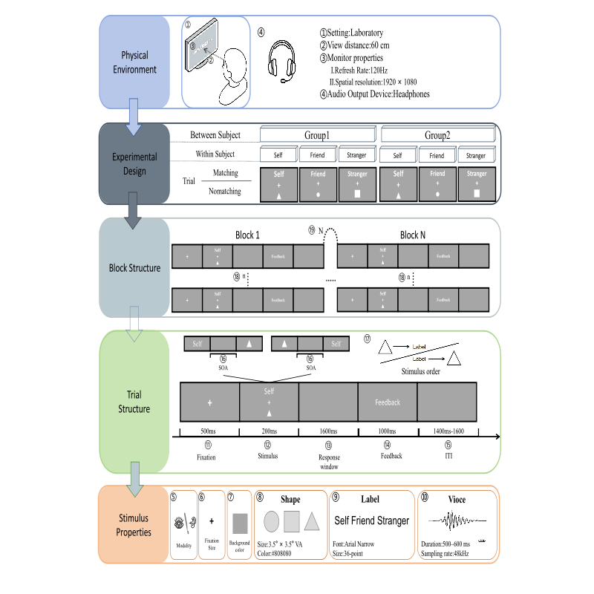
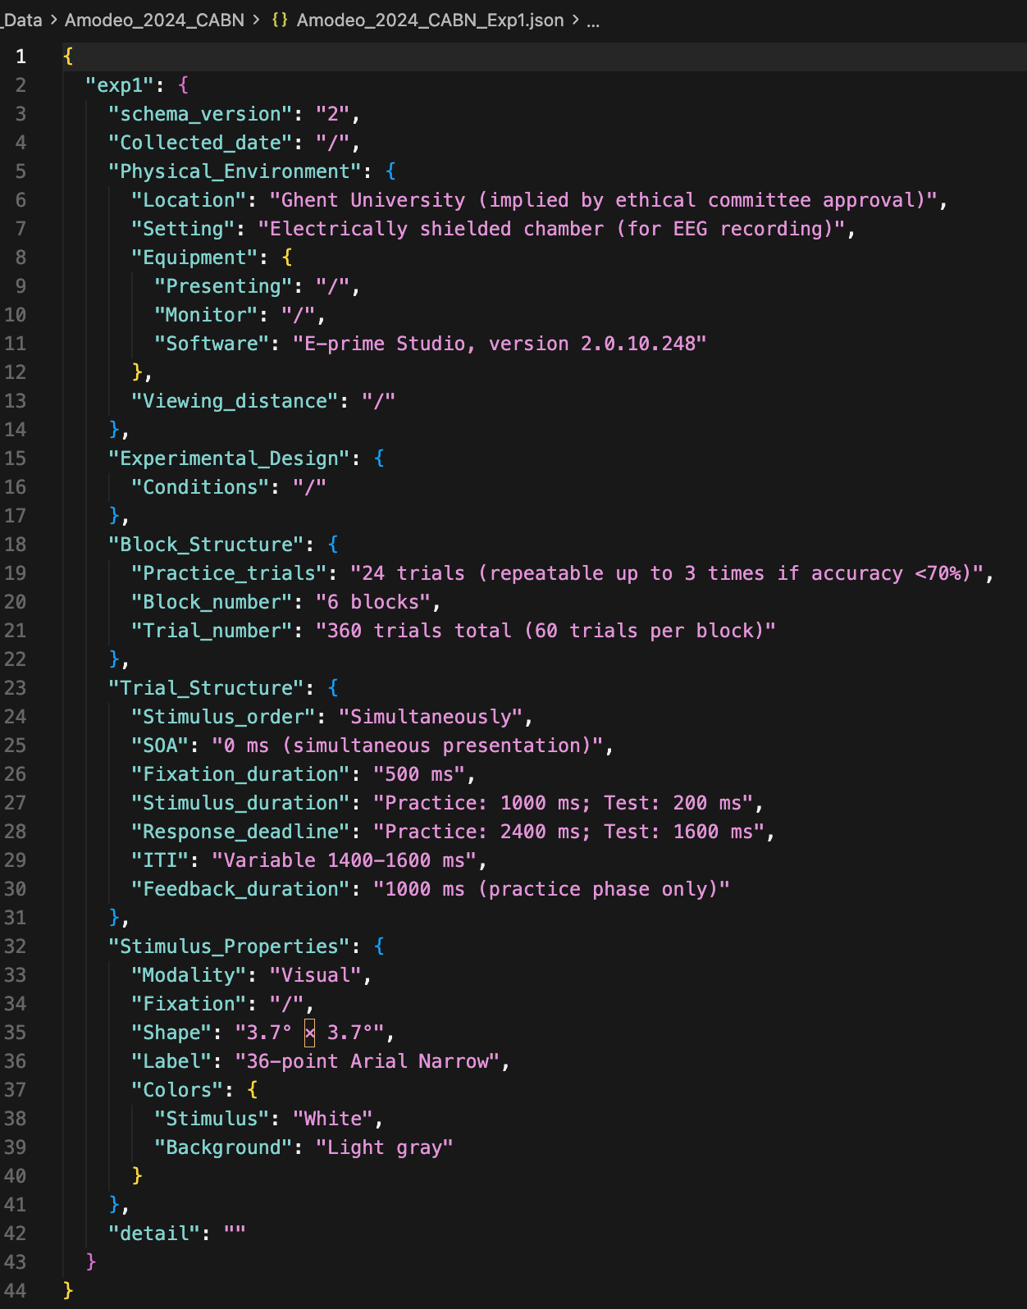
Figure 2. (a) Standardized implementation framework and five-component decomposition of the self-matching task; (b) an example of the experiment-specific json file.
The Physical Environment variables describe the overall environmental conditions under which participants completed the task, including basic settings (e.g., laboratory-based vs. online administration), conditions relevant to multimodal stimulus presentation. For visual stimuli, these encompass viewing distance, monitor refresh rate, display resolution, brightness (Lin et al., 2023). For auditory stimuli, these include hardware specifications (e.g., headphones vs. speakers), sound pressure levels, and ambient noise (Kirk & Cunningham, 2025). These parameters determine how sensory information (e.g., visual or auditory signals) is physically presented to participants and they may modulate the sensory input of information processing (Bridges et al., 2020; Gold & Shadlen, 2007).
The Experimental Design variables define the structure of the study, including both between-subject factors (e.g., cultural group) and within-subject manipulations (e.g., Identity and Matching conditions). What distinguishes this level from the other levels is that design variables specify what is being manipulated and compared for hypothesis testing, rather than how the task is procedurally implemented, although these aspects may overlap. This distinction is consistent with established reporting guidelines that differentiate methodological details from inferential variables (Appelbaum et al., 2018).
The Block Structure describe the block structure of the task, including number of blocks as well and details within a block: trial sequence and composition. Block Structure captures how multiple trials are organized within a block and often may strongly incluence the strategies adopted by participants (Bogacz et al., 2006) or result in serial dependency effect (Cicchini et al., 2024). Usually, trials in self-matching task are pseudo-randomized such that no more than three identical trial types are presented consecutively.
The Trial Structure zoom in each trial and describe how each trial is implemented, including fixation duration, stimulus exposure, stimulus onset asynchrony (SOA), response window, and inter-trial interval (ITI). These parameters govern the temporal dynamics of stimuli presentation and are closely related to cognitive mechanisms such as evidence accumulation and response preparation (Ratcliff et al., 2016).
Finally, the Stimulus Properties describe details of the stimuli, including their modality, their visual/auditory properties, and attributes of labels. The defining boundary of this level is whether a piece of information specifies what information is presented rather than how it is physically delivered, with the latter belong to Trial Structure.

Summary of data included in SPE database
The Self-Matching Database is hosted on the Open Science Framework (OSF) website (XXX) and Science Data Bank (XXX). In the current release (September 2026), the database contains 49 studies, corresponding to 107 experiment-by-participant-group entries (89 experiment-level data files) and aggregating 4,875 participants across 2,131,108 test trials (See Table 1 for details).

Table 1
Overview of Studies Included in the SPE Database
Num | ID | Study | Exp | Country | Language | N (M/F) | Stimulus | Trials | License | Exp_Implement
1 | Amodeo_2024_CABN | L Amodeo et al. (2024) | Exp1 | Belgium | Dutch | 37 | geometric shape | 360 | NA | Lab Experiment
2 | Amodeo_2024_CABN | L Amodeo et al. (2024) | Exp1 | Belgium | Dutch | 30 | geometric shape | 360 | NA | Lab Experiment
3 | Atzeni_2026_PsychRes | Atzeni (2026) | Exp1 | Italy | Italian | 140 | geometric shape | 200 (per session; duplicated/extra runs: 3 T2 + 4 T3 participants) | NA | Online Experiment
4 | Bukowski_2021_ActaPsych | Bukowski et al. (2021) | Exp1 | Austria | German | 19 (0/19) | geometric shape | 360 | NA | Lab Experiment
5 | Bukowski_2021_ActaPsych | Bukowski et al. (2021) | Exp1 | Austria | German | 16 (0/16) | geometric shape | 360 | NA | Lab Experiment
6 | Bukowski_2021_ActaPsych | Bukowski et al. (2021) | Exp1 | Austria | German | 22 (0/22) | geometric shape | 360 | NA | Lab Experiment
7 | Bukowski_2021_ActaPsych | Bukowski et al. (2021) | Exp1 | Austria | German | 21 (0/21) | geometric shape | 360 | NA | Lab Experiment
8 | Bukowski_2021_ActaPsych | Bukowski et al. (2021) | Exp2 | Austria | German | 35 (0/35) | geometric shape | 360 | NA | Lab Experiment
9 | Bukowski_2021_ActaPsych | Bukowski et al. (2021) | Exp2 | Austria | German | 35 (0/35) | geometric shape | 360 | NA | Lab Experiment
10 | Bukowski_2021_ActaPsych | Bukowski et al. (2021) | Exp2 | Austria | German | 33 (0/33) | geometric shape | 360 | NA | Lab Experiment
11 | Constable_2019_JEPHPP | Constable et al. (2019) | Exp1 | Hungary | Hungarian | 28 (12/16) | geometric shape | 288 | No License
12 | Constable_2019_JEPHPP | Constable et al. (2019) | Exp2 | Hungary | Hungarian | 28 (6/22) | geometric shape | 288 | No License
13 | Constable_2019_JEPHPP | Constable et al. (2019) | Exp3 | Hungary | Hungarian | 28 (8/14) | geometric shape | 288 | No License
14 | Constable_2019_JEPHPP | Constable et al. (2019) | Exp4 | Hungary | English | 40 (14/26) | geometric shape | 640 | No License
15 | Constable_2020_ActaPsych | Constable & Knoblich (2020) | Exp1 | Hungary | Hungarian | 48 | geometric shape | 240 | No License | Lab Experiment
16 | Constable_2020_ActaPsych | Constable & Knoblich (2020) | Exp1 | Hungary | Hungarian | 44 | geometric shape | 240 | No License | Lab Experiment
17 | Constable_2021_CogEmo | Constable et al. (2021) | Exp1 | United Kingdom | English | 28 (16/12) | face | 384 | No License | Lab Experiment
18 | Constable_2021_CogEmo | Constable et al. (2021) | Exp1 | United Kingdom | English | 28 (9/19) | face | 384 | No License | Lab Experiment
19 | Constable_2021_CogEmo | Constable et al. (2021) | Exp2 | Hungary | English | 28 (13/15) | grey scale squares | 192 | No License | Lab Experiment
20 | Constable_2021_CogEmo | Constable et al. (2021) | Exp2 | Hungary | English | 28 (15/13) | grey scale squares | 192 | No License | Lab Experiment
21 | Dalmaso_2024_ConsciousCog | Mario Dalmaso et al. (2024) | Exp1 | Japan | Japanese | 40 (19/21) | face | 360 | CC BY 4.0 | Lab Experiment
22 | Dalmaso_2024_ConsciousCog | Mario Dalmaso et al. (2024) | Exp2 | Italy | Italian | 40 (16/24) | face | 360 | CC BY 4.0 | Lab Experiment
23 | Feldborg_2021_IJERPH | M Feldborg et al. (2021) | Exp1 | UK | English | 53 (10/43) | geometric shape and face | 320 | CC BY 4.0 | Online Experiment
24 | Feldborg_2021_IJERPH | M Feldborg et al. (2021) | Exp1 | UK | English | 49 (7/40) | geometric shape and face | 320 | CC BY 4.0 | Online Experiment
25 | Golubickis_2021_ActaPsych | Golubickis & Macrae (2021) | Exp1 | United Kingdom | English | 30 (9/21) | geometric shape | 360 | NA | Online Experiment
26 | Golubickis_2021_ActaPsych | Golubickis & Macrae (2021) | Exp2 | United Kingdom | English | 25 (8/17) | geometric shape | 360 | NA | Online Experiment
27 | Haciahmet_2023_Psychophysiol | Haciahmet et al. (2023) | Exp1 | Germany | German | 40 (8/32) | geometric shape | 240 | CC BY 4.0 | Lab Experiment
28 | Hobbs_2023_PsychMed | Hobbs et al. (2023) | Exp1 | United Kingdom | English | 144 (31/112) | geometric shape and face and currency | 360 | CC BY 4.0 | Lab Experiment
29 | Hu_2020_CollabraPsy | Hu et al. (2020) | Exp1 | China | Chinese | 44 (19/27) | geometric shape | 600 | No License | Lab Experiment
30 | Hu_2023_psyarxiv | Hu et al. (2023) | Exp3a | China | Chinese | 38 (23/15) | geometric shape | 720 | CC-BY-4.0
31 | Hu_2023_psyarxiv | Hu et al. (2023) | Exp3b | China | Chinese | 61 (16/45) | geometric shape | 720 | CC-BY-4.0
32 | Hu_2023_psyarxiv | Hu et al. (2023) | Exp4a | China | Chinese | 32 (17/15) | geometric shape | 360 | CC-BY-4.0
33 | Hu_2023_psyarxiv | Hu et al. (2023) | Exp4a | China | Chinese | 32 (10/22) | geometric shape | 720 | CC-BY-4.0
34 | Hu_2023_psyarxiv | Hu et al. (2023) | Exp6b | China | Chinese | 23 (15/8) | geometric shape | 2700-4320 (S1 1080 + S2 1620 + S3 0-1620 per subject) | CC-BY-4.0
35 | Kirk_2025_BritJPsy | Neil W. Kirk et al. (2025) | Exp1 | United Kingdom | English | 35 (35/0) | voice | 216 | CC BY 4.0 | Online Experiment
36 | Kirk_2025_BritJPsy | Neil W. Kirk et al. (2025) | Exp2 | United Kingdom | English | 90 (90/0) | voice | 216 | CC BY 4.0 | Online Experiment
37 | Kolvoort_2020_HumBrainMap | IR Kolvoort et al. (2020) | Exp1 | Canada | English | 31 (17/14) | geometric shape | 100 | NA | Lab Experiment
38 | Lee_2023_Cognition | Lee et al. (2023) | Exp1 | United Kingdom | English | 47 | geometric shape | 96 | CC BY 4.0 | Online Experiment
39 | Lee_2023_Cognition | Lee et al. (2023) | Exp2 | United Kingdom | English | 51 | geometric shape | 96 | CC BY 4.0 | Online Experiment
40 | Lee_2026_BritJPsy | Lee et al. (2026) | Exp1a | United Kingdom | English | 50 (27/23) | geometric shape | 360 | NA | Online Experiment
41 | Lee_2026_BritJPsy | Lee et al. (2026) | Exp1b | United Kingdom | English | 53 (19/34) | geometric shape | 360 | NA | Online Experiment
42 | Lee_2026_BritJPsy | Lee et al. (2026) | Exp2 | United Kingdom | English | 50 (20/28) | geometric shape | 360 | NA | Online Experiment
43 | Liang_2022_HumBrainMap | Liang et al. (2022) | Exp1 | China | English | 35 (13/22) | geometric shape | 720 | CC BY-NC-ND | Lab Experiment
44 | Liang_2022_HumBrainMap | Liang et al. (2022) | Exp1 | China | English | 38 (22/16) | geometric shape | 720 | CC BY-NC-ND | Lab Experiment
45 | Liang_2022_HumBrainMap | Liang et al. (2022) | Exp1 | China | English | 36 (13/23) | geometric shape | 720 | CC BY-NC-ND | Lab Experiment
46 | Liu_2023_CogRes | Liu et al. (2023) | Exp1 | UK | English | 299 (132/161) | face | 64 | NA | Online Experiment
47 | Martinez-Perez_2024_ConsciousCog | V Martínez-Pérez et al. (2024) | Exp2 | Spain | Spanish | 32 (5/27) | geometric shape | 240 | CC BY 4.0 | Lab Experiment
48 | Mcivor_2021_EJN | L McIvor et al. (2021) | Exp1 | United Kingdom | English | 20 (6/14) | geometric shape and face | 960 | CC BY 4.0 | Lab Experiment
49 | Mcivor_2021_EJN | L McIvor et al. (2021) | Exp1 | United Kingdom | English | 20 (2/18) | geometric shape and face | 960 | CC BY 4.0 | Lab Experiment
50 | Navon_2021_psyarxiv | Navon & Makovski (2021) | Exp1 | Israel | Hebrew | 13 (3/10) | geometric shape | 360 | CC0 1.0 Universal | Lab Experiment
51 | Navon_2021_psyarxiv | Navon & Makovski (2021) | Exp2 | Israel | Hebrew | 27 (9/18) | geometric shape | 360 | CC0 1.0 Universal | Lab Experiment
52 | Navon_2021_psyarxiv | Navon & Makovski (2021) | Exp3 | Israel | Hebrew | 28 (12/15) | geometric shape | 360 | CC0 1.0 Universal | Lab Experiment
53 | Navon_2021_psyarxiv | Navon & Makovski (2021) | Exp4 | Israel | Hebrew | 27 (9/18) | geometric shape | 360 | CC0 1.0 Universal | Lab Experiment
54 | Orellana-Corrales_2020_ExpPsych | G Orellana-Corrales et al. (2020) | Exp1 | Germany | German | 38 (9/29) | geometric shape | 128 | NA | Lab Experiment
55 | Orellana-Corrales_2020_ExpPsych | G Orellana-Corrales et al. (2020) | Exp2 | Germany | German | 32 (2/3) | geometric shape | 128 | NA | Lab Experiment
56 | Orellana-Corrales_2020_ExpPsych | G Orellana-Corrales et al. (2020) | Exp3 | Germany | German | 36 (7/29) | geometric shape | 128 | NA | Lab Experiment
57 | Orellana-Corrales_2021_APP | G Orellana-Corrales et al. (2021) | Exp1 | Germany | German | 34 (9/25) | geometric shape | 128 | No License | Lab Experiment
58 | Orellana-Corrales_2021_APP | G Orellana-Corrales et al. (2021) | Exp2 | Germany | German | 33 (11/23) | letter string | 128 | No License | Lab Experiment
59 | Orellana-Corrales_2023_QJEP | G Orellana-Corrales et al. (2023) | Exp1 | Germany | German | 71 (46/25) | geometric shape | 140 | NA | Online Experiment
60 | Orellana-Corrales_2023_QJEP | G Orellana-Corrales et al. (2023) | Exp1 | Germany | German | 65 (42/23) | geometric shape | 140 | NA | Online Experiment
61 | Pan_2025_unpub | Pan (2025) | Exp1 | China | Chinese | 40 | geometric shape |  | NA
62 | Perrykkad_2022_BMCPsych | Perrykkad et al. (2022) | Exp1 | United States | English | 334 | geometric shape | 360 | CC BY 4.0 | Online Experiment
63 | Qi_2025_SciData | Qi (2025) | Exp1 | China | Chinese | 134 (57/77) | geometric shape | 360 | CC BY 4.0 | Lab Experiment
64 | Qian_2020_QJEP | Qian et al. (2020) | Exp1 | China | Chinese | 24 (9/15) | geometric shape | 576 | No License | Lab Experiment
65 | Qian_2020_QJEP | Qian et al. (2020) | Exp2 | China | Chinese | 25 (7/18) | geometric shape | 200 | No License | Lab Experiment
66 | Schaefer_2019_JCogPsych | Schaefer & Frings (2019) | Exp1 | Germany | German | 32 | geometric shape | 144 | CC-BY-SA 4.0 | Lab Experiment
67 | Schaefer_2019_JCogPsych | Schaefer & Frings (2019) | Exp2 | Germany | German | 36 | geometric shape | 144 | CC-BY-SA 4.0 | Lab Experiment
68 | Schaefer_2019_JCogPsych | Schaefer & Frings (2019) | Exp3 | Germany | German | 35 | geometric shape | 144 | CC-BY-SA 4.0 | Lab Experiment
69 | Smith_2024_Cortex | Smith & Ferguson (2024) | Exp1 | UK | English | 48 (11/5) | face | 360 | CC BY-NC-ND | Lab Experiment
70 | Sui_2014_APP | Sui et al. (2014) | Exp1 | China | Chinese | 24 | geometric shape | 360 | NA | Lab Experiment
71 | Sui_2014_APP | Sui et al. (2014) | Exp2 | China | Chinese | 18 | geometric shape | 360 | NA | Lab Experiment
72 | Sui_2014_APP | Sui et al. (2014) | Exp3 | China | Chinese | 22 | geometric shape | 360 | NA | Lab Experiment
73 | Sui_2014_APP | Sui et al. (2014) | Exp4 | China | Chinese | 20 | geometric shape | 360 | NA | Lab Experiment
74 | Sui_2014_unpub | Sui (2014) | Exp1 | China | Chinese | 24 | geometric shape | 720 | NA
75 | Sui_2015_unpub | Sui (2015) | Exp1 | China | Chinese | 20 | geometric shape | 960 | NA
76 | Sui_2023_ConsciousCog | J Sui et al. (2023) | Exp1 | UK | English | 20 (12/8) | geometric shape | 960 | CC BY-NC-ND | Lab Experiment
77 | Sun_2026_DataExp | Sun et al (2026) | Exp1 | China | Chinese | — | geometric shape |  | No License
78 | Svensson_2022_PsychRes | Svensson et al. (2022) | Exp1 | United Kingdom | English | 20 (6/14) | geometric shape | 200 | NA | Lab Experiment
79 | Svensson_2022_PsychRes | Svensson et al. (2022) | Exp2 | United Kingdom | English | 24 (8/16) | geometric shape | 400 | NA | Lab Experiment
80 | Svensson_2022_PsychRes | Svensson et al. (2022) | Exp3 | United Kingdom | English | 25 (7/18) | geometric shape | 400 | NA | Lab Experiment
81 | Svensson_2023_QJEP | Svensson et al. (2023) | Exp1 | UK | English | 65 (20/45) | geometric shape | 120 | No License | Online Experiment
82 | Vicovaro_2022_JEPHPP | Vicovaro et al. (2022) | Exp1 | Italy | Italian | 30 (14/16) | random dots | 480 | CC BY 4.0 | Mixed (Lab + Online)
83 | Vicovaro_2022_JEPHPP | Vicovaro et al. (2022) | Exp2 | Italy | Italian | 52 (11/36) | random dots | 240 | CC BY 4.0 | Mixed (Lab + Online)
84 | Vicovaro_2022_JEPHPP | Vicovaro et al. (2022) | Exp2 | Italy | Italian | 52 (5/42) | random dots | 240 | CC BY 4.0 | Mixed (Lab + Online)
85 | Vicovaro_2024_PeerJ | Vicovaro et al. (2024) | Exp1 | Italy | English | 64 (26/38) | geometric shape | 240 | NA | Lab Experiment
86 | Vicovaro_2024_PeerJ | Vicovaro et al. (2024) | Exp2 | Italy | English | 64 (16/48) | geometric shape | 240 | NA | Lab Experiment
87 | Wang_2016_JEPHPP | Wang et al. (2016) | Exp1 | China | English | 21 (3/18) | geometric shape | 648 | CC BY 3.0
88 | Wang_2016_JEPHPP | Wang et al. (2016) | Exp2 | China | English | 25 (10/15) | geometric shape | 648 | CC BY 3.0
89 | Wozniak_2018_PLOS | Wozniak et al. (2018) | Exp1 | Hungary | English | 18 (9/9) | face | 672 | CC BY 4.0 | Lab Experiment
90 | Wozniak_2018_PLOS | Wozniak et al. (2018) | Exp2 | Hungary | English | 18 (9/9) | face | 672 | CC BY 4.0 | Lab Experiment
91 | Wozniak_2020_PLOS | Wozniak et al. (2020) | Exp1 | Australia | English | 24 (12/12) | face | 270 | NA | Lab Experiment
92 | Wozniak_2020_PLOS | Wozniak et al. (2020) | Exp2 | Australia | English | 24 (12/12) | face | 270 | NA | Lab Experiment
93 | Wozniak_2020_PLOS | Wozniak et al. (2020) | Exp3 | Australia | English | 24 (12/12) | face | 270 | NA | Lab Experiment
94 | Wozniak_2022_PsychRes | Wozniak et al. (2022) | Exp1 | Hungary | English | 18 (7/11) | geometric shape | 720 | CC BY 4.0 | Lab Experiment
95 | Wozniak_2022_PsychRes | Wozniak et al. (2022) | Exp2 | Hungary | English | 18 (6/12) | geometric shape | 720 | CC BY 4.0 | Lab Experiment
96 | Wozniak_2022_PsychRes | Wozniak et al. (2022) | Exp3 | Hungary | English | 18 (0/18) | geometric shape | 720 | CC BY 4.0 | Lab Experiment
97 | Xu_2022_CurrPsych | Xu et al. (2022) | Exp1 | China | Chinese | 55 (27/28) | geometric shape | 360 | On request | Lab Experiment
98 | Xu_2022_CurrPsych | Xu et al. (2022) | Exp1 | China | Chinese | 50 (24/26) | geometric shape | 360 | On request | Lab Experiment
99 | Zhang_2023_NeuroImage | Yongfa Zhang et al. (2023) | Exp1 | China | Chinese | 346 (172/174) | geometric shape | 96 | CC BY-NC-ND | Lab Experiment
100 | Zhang_2024_PsychJ | Zhang et al. (2024) | Exp1 | China | English | 43 | geometric shape | 216 | NA | Lab Experiment
101 | Zhang_2024_PsychJ | Zhang et al. (2024) | Exp2 | China | English | 36 | geometric shape | 120 | NA | Lab Experiment
102 | Zhang_2026_JNeurosci | Zhang (2026) | Exp1 | China | English | 59 (27/32) | geometric shape | 450 (5 blocks x 90; incomplete blocks in 17 subjects) | NA | Lab Experiment
103 | Zhang_2026_JNeurosci | Zhang (2026) | Exp1 | China | English | 32 (14/18) | geometric shape | 450 (5 blocks x 90; incomplete blocks in 17 subjects) | NA | Lab Experiment
104 | Zhao_2026_PsychonBullRev | Zhao & Wang (2026) | Exp1 | China |  | 45 (12/33) | geometric shape | 360 | NA | Lab Experiment
105 | Zhao_2026_PsychonBullRev | Zhao & Wang (2026) | Exp2 | China |  | 47 (18/29) | geometric shape | 360 | NA | Lab Experiment
106 | Zhao_2026_PsychonBullRev | Zhao & Wang (2026) | Exp3 | China |  | 22 (12/10) | geometric shape | 360 | NA | Lab Experiment
107 | Zhao_2026_PsychonBullRev | Zhao & Wang (2026) | Exp3 | China |  | 22 (13/9) | geometric shape | 360 | NA | Lab Experiment
Note. N = number of participants retained in the minimally preprocessed data of each experiment-by-participant-group entry; Trials = number of test trials per participant as documented in the master index; Exp_Implement = laboratory or online administration as documented in the experiment-level JSON metadata. The diversity of countries, languages, stimulus modalities, and experimental designs ensures that future re-analyses can address a broad range of scientific questions—from the robustness and generalisability of the SPE across cultures and stimulus formats, to the identification of experimental design parameters that moderate the magnitude of the effect.

As we mentioned in the section Folder Structure, data files include both raw trial-level data files shared from each team (e.g., "Amodeo_2024_CABN_Exp1_raw.csv") and minimally preprocessed data files (e.g., "Amodeo_2024_CABN_Exp1_Clean.csv"), both are stored in experiment-specific subfolders (see Section XXX). The corresponding codebook (e.g., "Codebook_Amodeo_2024_CABN_Exp1_Clean.xlsx") describes each column (see Figure 3). Basic information such as participant index (Subject), matching condition (Matching; matching or nonmatching), shape stimulus (Shape), label stimulus (Label), reaction time in milliseconds (RT_ms) and seconds (RT_sec), and response accuracy (ACC) are included in all experiments. The identity columns for both shape and label in data files were standardized into six categories: Self, Close, Acquaintance, Celebrity, Stranger, and NonPerson (Sun et al., 2023). For clarity, we kept the original identity names ("Origin_Identity"), the English-translated identity names ("English_Identity"), and the standardised identity categories ("Standardised_Identity"). The minimally preprocessed data files may also include additional fields that describe the experimental design, such as block number, trial number within block, experimental phase or session, specific stimulus features (e.g., face gender, voice accent, emotional valence), and participant response keys. We expect these minimally preprocessed data files will be valuable for researchers interested in re-using this database.
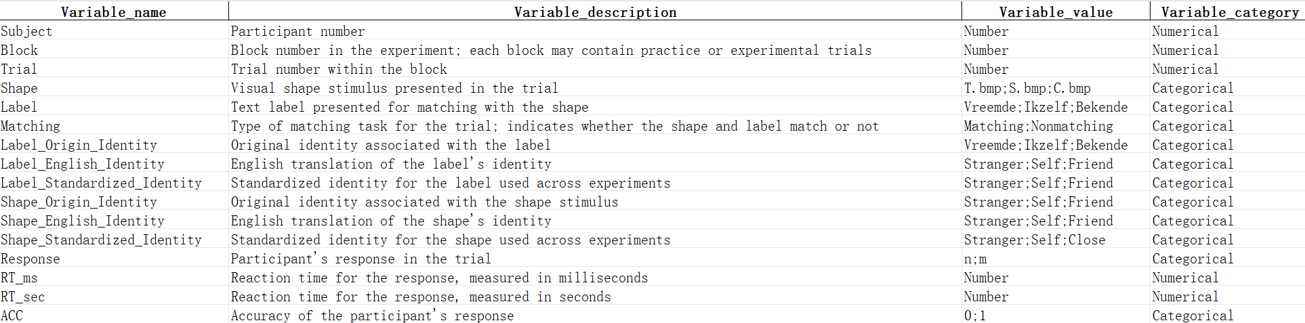
Figure 3. Standardized codebook of the experimental dataset variables.
Example uses of the SPE Database
The Self-Prioritization Database provides a valuable resource for both methodological and theoretical investigations of the self-prioritization effect. For example, the standardized schema allows researcher to develop and test cognitive models of self-prioritization effects; investigate how experimental design parameters shape these effects; clarify the cross-cultural universality and cultural specificity of self-prioritization; and evaluate the robustness and generalizability of findings across laboratory-based and online settings. To demonstrate the unique value of large-scale standardized datasets, we present three examples addressing questions that cannot be adequately examined using data from individual studies alone.
The Magnitude of Self-Prioritization Effect Varies Across Social Distance
The self-prioritization effect (SPE) is typically quantified as the performance difference between self-referential and other-referential conditions. However, different categories of others have been used as baseline conditions when estimating SPE magnitude. Existing studies have yielded inconsistent estimates of the self-prioritization effect (SPE) magnitude. Nevertheless, a systematic examination of how baseline selection affects SPE magnitude remains lacking. Leveraging the large-scale sample size of the SPE database, we compared the effect size of the SPE across five standardized baselines (Sun et al., 2023): Non-person, Stranger, Celebrity, Acquaintance, and Close Other. Standardized effect sizes (Cohen's d) were computed at the participant level by contrasting self-related trials against each baseline condition separately, using a pooled standard deviation. Reaction-time based effect sizes were computed on correct trials with response times above 0 ms and no longer than 10,000 ms; accuracy-based effect sizes were computed on trials with a valid response (0 = error, 1 = correct). Because participant identifiers are unique only within a dataset, participants were nested within datasets (that is, the random effect was defined on the dataset-by-participant key). A linear mixed-effects model without intercept was then fitted to the participant-level Cohen's d values, with this nested participant term as a random intercept and data source as an additional variance component. From this model, 10,000 multivariate normal samples were drawn from the estimated fixed-effects distribution to obtain the posterior-like distributions of each identity's SPE magnitude. For consistency, we use positive Cohen's d for SPE (i.e., faster reaction times or higher accuracy for self relative to other identities).
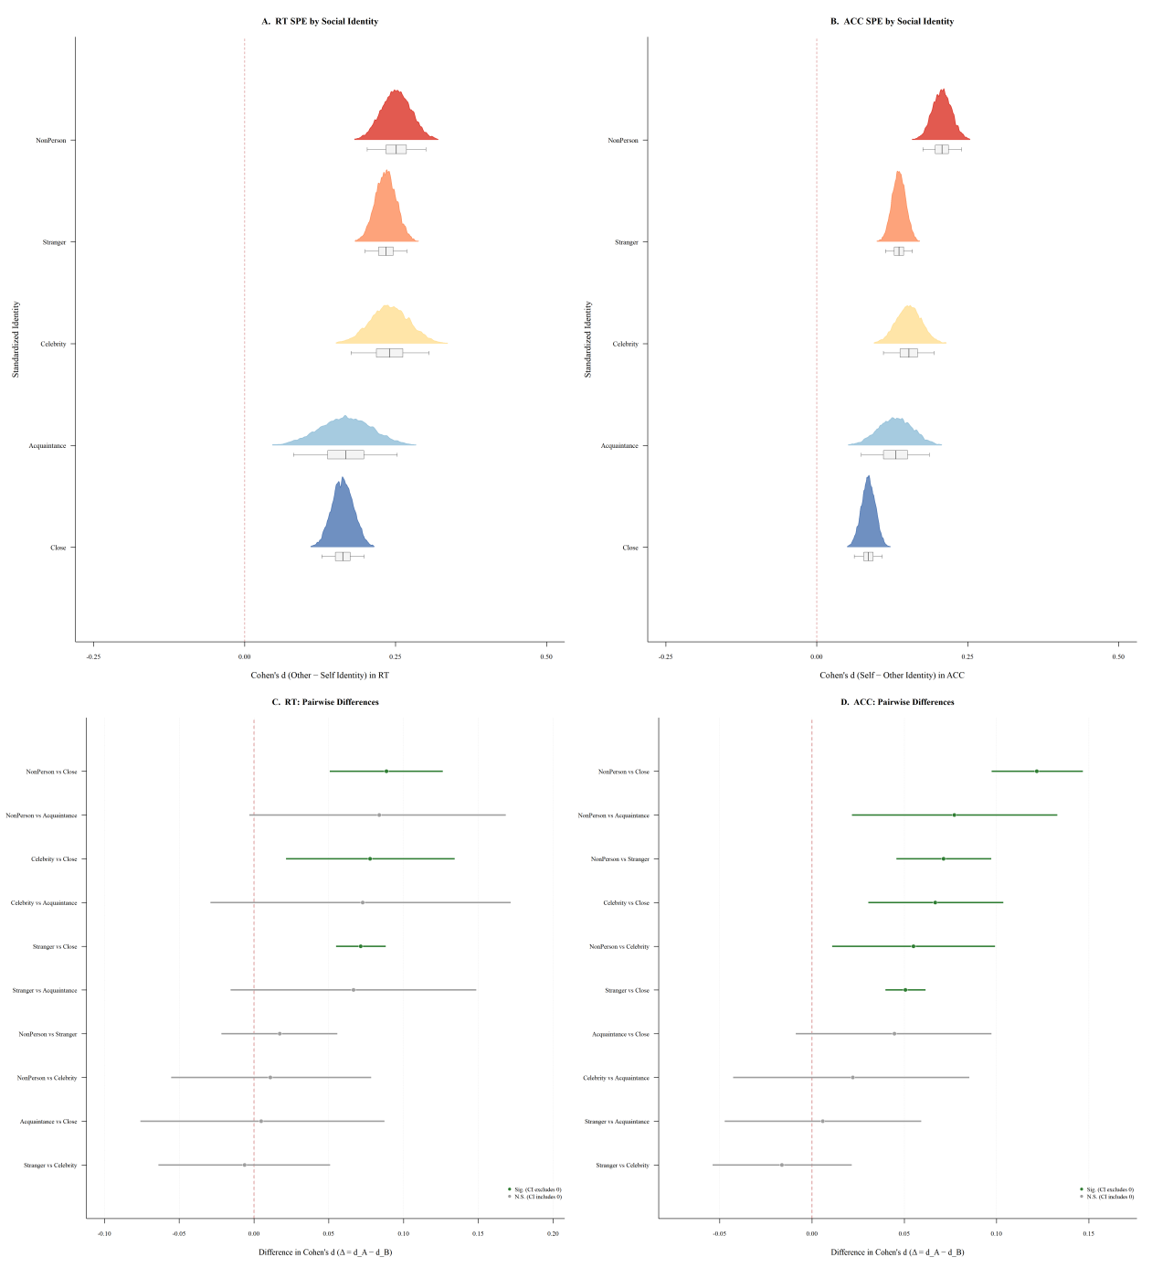
Figure 4. Self-prioritization effects along the social distance continuum and pairwise comparisons across social identities.
For reaction time (RT), the SPE was positive for all five baseline conditions: every bootstrap distribution of the participant-level Cohen's d lay entirely above zero (all 95% confidence intervals excluded zero; see Figure 4A). The magnitude of the SPE, however, differed only between some baselines (see Figure 4). To test whether the magnitude differed statistically between SPEs calculated with different baselines, we computed these effect sizes pairwise (Δ = dA − dB) using the same model-based sampling approach, and inferred a difference when the bootstrap 95% CI excluded zero (see Figure 4C and 4D).
For RT, 3 of the 10 pairwise comparisons were statistically significant, and all three involved Close others as the baseline. The Non-person-based SPE was larger than the Close-other-based SPE (Δ = 0.089, 95% CI [0.051, 0.126], p < .001); the Celebrity-based SPE was larger than the Close-other-based SPE (Δ = 0.078, 95% CI [0.022, 0.134], p = .007); and the Stranger-based SPE was larger than the Close-other-based SPE (Δ = 0.071, 95% CI [0.055, 0.088], p < .001). The remaining seven comparisons were not statistically significant, including all comparisons among Non-person, Stranger, and Celebrity (all |Δ| ≤ 0.018, all ps ≥ .372) and the Acquaintance-versus-Close-other comparison (Δ = 0.005, 95% CI [−0.076, 0.087], p = .910).
Six of the 10 pairwise comparisons reached statistical significance for accuracy (ACC). The Non-person-based SPE was larger than that based on Close others (Δ = 0.122, 95% CI [0.098, 0.146], p < .001), Acquaintances (Δ = 0.077, 95% CI [0.022, 0.133], p = .006), Strangers (Δ = 0.071, 95% CI [0.046, 0.097], p < .001), and Celebrities (Δ = 0.055, 95% CI [0.011, 0.099], p = .014). The Celebrity-based SPE was larger than the Close-other-based SPE (Δ = 0.067, 95% CI [0.031, 0.103], p < .001), and the Stranger-based SPE was larger than the Close-other-based SPE (Δ = 0.051, 95% CI [0.040, 0.061], p < .001). The remaining four comparisons were not significant: Stranger versus Celebrity (Δ = −0.016, 95% CI [−0.054, 0.021], p = .386), Stranger versus Acquaintance (Δ = 0.006, 95% CI [−0.047, 0.059], p = .827), Celebrity versus Acquaintance (Δ = 0.022, 95% CI [−0.042, 0.085], p = .494), and Acquaintance versus Close other (Δ = 0.045, 95% CI [−0.008, 0.097], p = .096).
Taken together, the estimated magnitude of the SPE was reliably positive against every baseline, but the baselines did not order themselves along a clear social-distance gradient. Across both RT and ACC, the only consistent contrast was between the baselines with the largest and the smallest point estimates: the Non-person-based (and, for RT, also the Stranger- and Celebrity-based) SPE exceeded the Close-other-based SPE, whereas the comparisons among Non-person, Stranger, and Celebrity were not reliable in either measure. Two caveats are important. First, the baselines differed markedly in coverage: Non-person and Celebrity were represented by only 8 and 3 datasets respectively, whereas Stranger and Close others were represented by 70 and 50 datasets, so the absence of reliable differences among the more sparsely covered baselines should be interpreted with caution. Second, this pattern qualifies rather than confirms the proposal that the SPE follows a monotonic gradient of closeness to the self (Aron et al., 1992; Markus & Kitayama, 1991).
Presence of Self-Prioritization Effect Under Nonmatching Conditions
Previous studies have reported inconsistent findings regarding the presence of self-prioritization effects (SPEs) under nonmatching conditions. Although several studies have observed reliable nonmatching SPEs (Kirk & Cunningham, 2025), others have failed to detect such effects (Desebrock & Spence, 2021; Golubickis & Macrae, 2021). One potential explanation for these inconsistencies is that nonmatching SPEs are substantially smaller than matching SPEs and therefore require larger samples to be detected reliably. An alternative is that the SPEs under nonmatching conditions were contaminated by the involvement of self-reference in the baseline condition that used for calculating SPE.
Leveraging the large sample size of the current database (89 experiment-level datasets, 1,068,081 nonmatching trials, 4,520 participants), we estimated the SPE using a bootstrap resampling approach (500 iterations per sample size, with replacement) that allows evaluation of effect size stability across increasing sample sizes. Recall that in the self-matching task, each trial presents a shape–label pair. Thus, for matching trials, the shape and label are congruent (e.g., a shape previously associated with "Self" paired with the word "Self"), making the distinction between self-related and other-related trials straightforward. For nonmatching conditions (also referred to as incongruent or mismatching trials), however, the shape and label convey conflicting identity information (e.g., a shape for "Self" paired with the word "Stranger"), creating difficulty in defining what constitutes a "Self" trial. Reaction-time based Cohen's d values were computed on correct trials with response times above 0 ms and no longer than 10,000 ms, accuracy-based Cohen's d values on trials with a valid response (0 = error, 1 = correct), and participants were again identified by the dataset-by-participant key.
To address this ambiguity, we adopted two alternative operationalizations of the self-prioritization effect (SPE) under nonmatching conditions: shape-based SPE or label-based SPE. The shape-based SPE is the difference between trials where the shape is "Self" and the label is non-Self and trials where the shape is non-self condition(s) and the label does not match the shape. The label-based SPE is difference between trials where the label is "Self" and the shape is non-self and trials where the label is non-self condition(s) and the shape does not match the label.
Critically, neither the shape-based nor the label-based operationalization guarantees a clean self versus non-self contrast, because nonmatching trials classified as "non-self" may still contain self-referential information. For example, in an experiment includes only two identities, Self and Stranger, the nonmatching trials are either "Self(shape)-Stranger(label)" or "Stranger(shape)-Self(label)". Under both conditions, part of the information is self-referential, making it impossible to construct a pure contrast between self- versus non-self-referential conditions. A pure self versus non-self contrast becomes feasible only in experiments involving three or more identities. For example, under the shape-based operationalization, self-related trials can be defined as "Self(shape)-Other1(label)/Other2(label)" whereas non-self trials can be defined as "Other1(shape)-Other2(label)". In this case, the comparison trials contain no self-referential information, thereby providing a rigorous estimate of nonmatching SPEs.
To fully exploit the available datasets while preserving interpretability, we implemented both conservative and liberal approach for estimating the SPE for nonmatching trials. The conservative approach only include pure self versus non-self contrasts: only participants from experiments involving at least three distinct identities were eligible for inclusion. At the trial level, additional filtering procedures were applied. For shape-based SPE, nonmatching trials in which the shape corresponded to a non-self identity but the label referred to the Self were excluded. Conversely, for label-based SPE, trials in which the label corresponded to a non-self identity but the shape was associated with the Self were removed. Using these criteria, 38 datasets contributed to the conservative shape-based analysis (1,977 eligible participants) and 27 datasets to the conservative label-based analysis (1,565 eligible participants). The final datasets comprised 371,894 trials for the shape-based SPE and 276,010 trials for the label-based SPE. The liberal approach retained 85 datasets (5,149 participants, 724,323 trials) for the shape-based SPE and 69 datasets (4,487 participants, 628,024 trials) for the label-based SPE.
In contrast, the liberal approach maximized dataset coverage by retaining all eligible experiments and nonmatching trials regardless of the presence of residual self-referential information in the comparison condition. To ensure a fair comparison between shape-based and label-based SPE for nonmatching trials, we aligned sample-size by using the minimum N of the shape- and label-based SPE for the conservative approach (see Table 2 for the bootstrap sample sizes and the results of the two approaches).
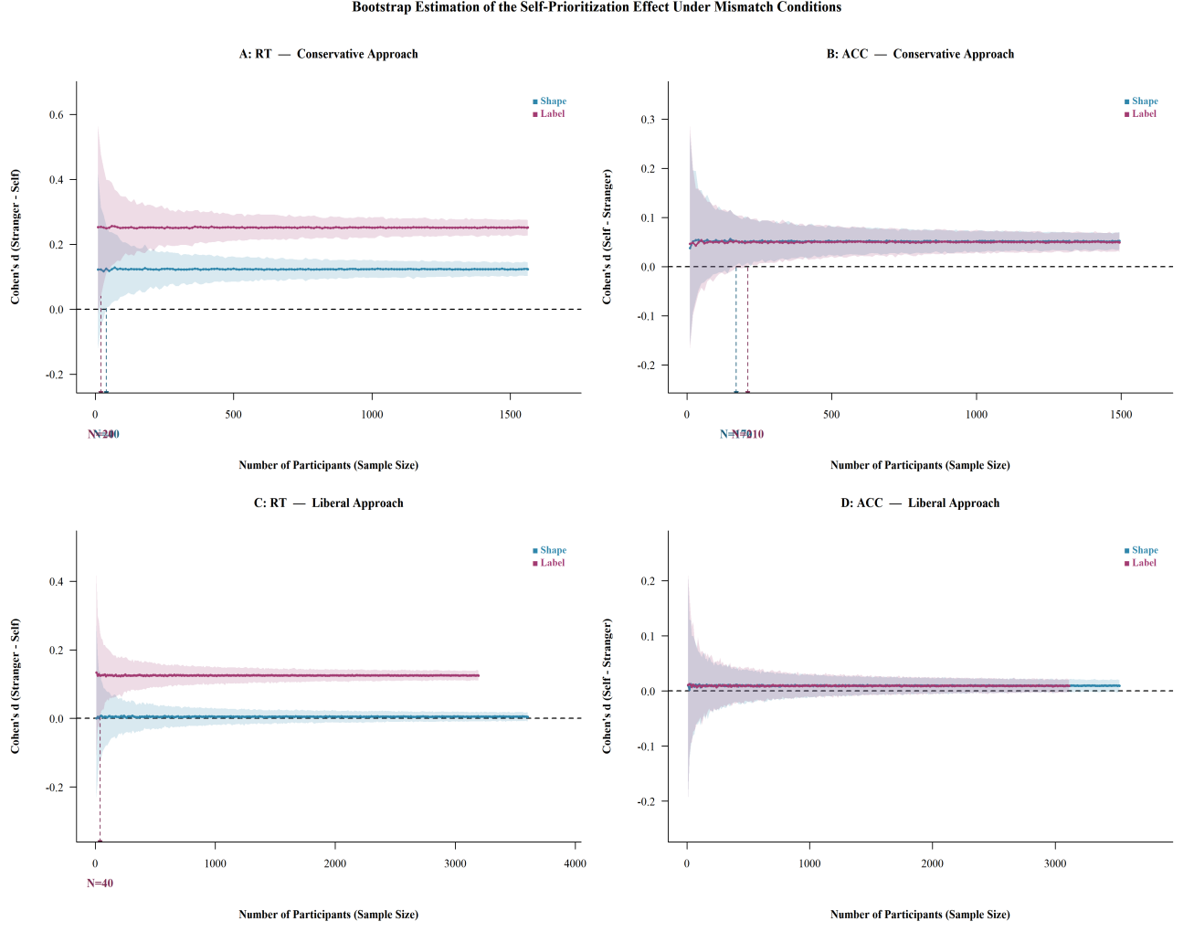
Figure 5. Bootstrap estimation of the self-prioritization effect under nonmatching conditions. A and B, the conservative approach; C and D, the liberal approach.
Table 2
Bootstrap Estimates of the Self-Prioritization Effect Under Nonmatching Conditions
 | Measure | Dimension | N _{Max} | Cohen's d | 95% CI | N _{min}
Liberal Approach | RT | Shape | 3,604 | 0.005 | [−0.008, 0.017] | not reached
Liberal Approach | RT | Label | 3,192 | 0.125 | [0.112, 0.138] | 40
Liberal Approach | ACC | Shape | 3,524 | 0.009 | [−0.002, 0.020] | not reached
Liberal Approach | ACC | Label | 3,114 | 0.009 | [−0.003, 0.021] | not reached
Conservative Approach | RT | Shape | 1,563 | 0.123 | [0.103, 0.144] | 40
Conservative Approach | RT | Label | 1,563 | 0.252 | [0.227, 0.275] | 20
Conservative Approach | ACC | Shape | 1,494 | 0.052 | [0.035, 0.070] | 170
Conservative Approach | ACC | Label | 1,494 | 0.049 | [0.030, 0.069] | 210
Note. For RT, d = (Mean_Stranger − Mean_Self) / Pooled_SD, such that positive values indicate faster responses to self trials (SPE). For ACC, d = (Mean_Self − Mean_Stranger) / Pooled_SD, such that positive values indicate higher accuracy for self trials (SPE). N min is the smallest bootstrap sample size at which the 95% CI no longer includes zero, as marked by vertical dashed lines in Figure 5; "not reached" indicates that the CI included zero across the full range of sample sizes. For the conservative approach, N max is the sample size aligned across the shape-based and label-based analyses.
Using the conservative approach, a robust SPE was observed for both reaction time (RT) and accuracy (ACC). For RT, the label-based operationalization yielded a moderate SPE (d = 0.252, 95% CI [0.227, 0.275], N = 1,563), indicating faster responses for nonmatching trials in which the label corresponded to the Self relative to those in which the label referred to other identities. The corresponding 95% confidence interval first excluded zero at merely N = 20, indicating that the label-based RT SPE can be detected even in relatively small samples (see Figure 5A). The shape-based operationalization also revealed a significant RT SPE, although the effect was substantially smaller (d = 0.123, 95% CI [0.103, 0.144], N = 1,563); in this case the 95% confidence interval first excluded zero at N = 40 (see Figure 5A). For accuracy, both operationalizations produced relatively small but statistically significant effects. The shape-based SPE was estimated at d = 0.052, 95% CI [0.035, 0.070], N = 1,494, with the confidence interval first excluding zero at N = 170 (see Figure 5B). The label-based SPE was comparable, d = 0.049, 95% CI [0.030, 0.069], N = 1,494, with the confidence interval first excluding zero at N = 210 (see Figure 5B). Taken together, a SPE was present for both RT and ACC for nonmatching trials when the conservative approach was used. Descriptively, the label-based SPE was about twice as large as the shape-based SPE for RT (0.252 vs 0.123), whereas the two operationalizations were nearly indistinguishable for ACC (0.049 vs 0.052).
When applying the liberal approach, the label-based SPE was again evident for reaction time (RT), although the effect size was smaller than that observed under the conservative approach, d = 0.125, 95% CI [0.112, 0.138], N = 3,192. The corresponding 95% confidence interval first excluded zero at N = 40 (see Figure 5C), indicating that the label-based RT effect remained detectable with relatively modest sample sizes. In contrast, the shape-based SPE was markedly attenuated under the liberal approach: the point estimate was close to zero (d = 0.005, 95% CI [−0.008, 0.017], N = 3,604) and the confidence interval never excluded zero across the full range of sample sizes (see Figure 5C), suggesting that the effect was too small to be detected reliably in typical experimental samples. For accuracy, neither operationalization was reliable under the liberal approach: shape-based, d = 0.009, 95% CI [−0.002, 0.020], N = 3,524; label-based, d = 0.009, 95% CI [−0.003, 0.021], N = 3,114; neither confidence interval excluded zero at any sample size (see Figure 5D).
Collectively, the presence of a SPE on nonmatching trials depended both on the operationalization of self-relevance and on how strictly the comparison conditions were purified. When only pure self versus non-self contrasts were admitted (conservative approach), the SPE was reliably present for both RT and ACC; when all nonmatching trials were retained (liberal approach), only the label-based RT effect survived. The conservative-liberal discrepancy indicates that part of the apparent nonmatching SPE in the liberal analysis is attributable to residual self-referential information in the comparison trials, exactly as anticipated above. The RT effects were consistently larger than the ACC effects, a pattern that is consistent with previous findings in the SPE literature (Liu et al., 2025). These findings underscores the importance of both adequate statistical power and transparent operational definitions when investigating the SPE under nonmatching conditions.

The Association Between Presenting Duration / Trial Number and magnitude of SPE
The third example illustrates a unique advantage of the current database: the standardized coding of methodological variations in task implementation across studies. Specifically, we examined two implementation parameters that varied across experiments: stimulus presentation duration and trial number. Stimulus duration was chosen because shorter presentation times may create time pressure for participants and alter their processing strategies (Lemaire & Brun, 2016; Ratcliff et al., 2016). Despite its potential theoretical relevance, variation in stimulus duration has received little attention in the SPE literature and is often treated as a minor procedural detail. Trial number was examined because the amount of behavioral data collected from each participant may influence the reliability and stability of SPE estimates, consistent with broader concerns regarding measurement precision in cognitive tasks (Liu et al., 2025). Both implementation parameters were treated as continuous variables. For each analysis, we estimated the association between the implementation parameter and SPE magnitude (Cohen's dz, computed against the Stranger baseline) using bootstrap Spearman correlations with 10,000 resamples. We report the observed Spearman ρ, bootstrap 95% confidence intervals (2.5th–97.5th percentiles), and bootstrap p values (two-tailed; statistical significance assessed at α = .05).
Two datasets were excluded before analysis (Pan_2025_unpub and Wang_2016_JEPHPP), and datasets whose Stranger-based Cohen's dz deviated from the mean by more than three standard deviations were treated as outliers and removed.
The association between stimulus presentation duration and SPE magnitude was negative. Treating duration as a continuous variable (range: 100 – 3,000 ms, n = 54 datasets), bootstrap Spearman correlations revealed a significant negative relationship for both RT (ρ = −.311, bootstrap 95% CI [−.539, −.052], p boot = .018) and ACC (ρ = −.335, bootstrap 95% CI [−.548, −.095], p boot = .010; Figure 6A and 6B). Both bootstrap confidence intervals lay entirely below zero, providing evidence for a reliable negative association between stimulus duration and the magnitude of self-prioritization. Shorter presentation times were associated with larger SPE effect sizes, whereas longer presentation times tended to yield smaller effects.

In contrast, the maximum number of trials in a dataset was not reliably associated with SPE magnitude (Figure 6C and 6D). For reaction time (RT), the bootstrap Spearman correlation was close to zero (ρ = .045, bootstrap 95% CI [−.222, .302], p boot = .748); for accuracy (ACC), the point estimate was numerically positive but the confidence interval again included zero (ρ = .174, bootstrap 95% CI [−.098, .433], p boot = .205). To check whether these associations were driven by a small number of datasets with extreme trial counts, we conducted a sensitivity analysis excluding the three datasets with the largest trial numbers; the picture was unchanged (RT: ρ = .077, p = .560; ACC: ρ = .195, p = .132). The number of trials a dataset contains was therefore not a reliable moderator of the SPE in the present database.
Together, these exploratory findings indicate that the magnitude of the SPE varies with how the task is implemented, but that not every candidate implementation parameter is a reliable moderator. Shorter stimulus presentation durations were associated with larger SPE magnitudes, and this held for both RT and ACC, whereas the maximum number of trials was unrelated to SPE magnitude. These findings should be interpreted with caution. The relationship between SPE magnitude and stimulus presentation duration may not be strictly linear and may depend on important boundary conditions. For example, the SPE may change when the stimulus presentation duration becomes subliminal. Likewise, the absence of a trial-number effect does not exclude non-linear or plateau-like relationships, and the available range of trial numbers is confounded with other study-level design choices. Future studies are needed to experimentally manipulate these implementation parameters to establish their causal contributions to SPE magnitude. Nevertheless, our findings highlight the importance of considering methodological details when studying self-prioritization. More broadly, they demonstrate the value of systematically coding task implementation characteristics in large-scale databases: variables that are often treated as minor procedural details may meaningfully contribute to variability in observed SPE estimates across studies, and standardized metadata are what make such questions answerable at all.
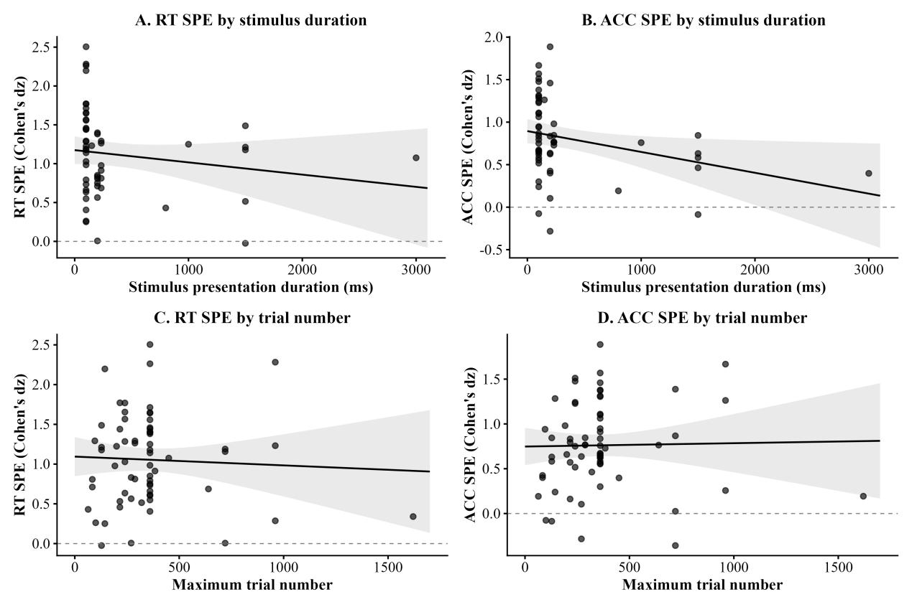
Figure 6. Exploratory moderators of the self-prioritization effect under matching conditions.

Discussion
The present study introduces both standardized data organization framework for self-matching task and the first manually curated, large-scale standardized database for the self-prioritization effect (SPE). Guided by the FAIR principles of data management (Wilkinson et al., 2016), we developed a three-level folder structure consisting of root-, study-, and experiment-level folders, each included standardized, machine-readable JSON metadata files. This folder structure strikes a balance between human interpretability and machine readability, thereby facilitating data sharing, reuse, and large-scale secondary analyses. Moreover, we developed a standardized, five component framework for annotating the metadata of task implementation details of self-matching task, which will facilitate cumulative, reproducible, and data-intensive research on self-prioritization. By applying the folder structure and standardized framework for annotating task details to available data, we curated a large database with unified meta data, which allows researchers to address theoretical and methodological questions that would be difficult or impossible to examine using individual studies alone.
The SPE database provides a valuable resource for understanding of SPE. Through three illustrative examples, we demonstrated how standardized, large-scale datasets can address theoretical and methodological questions that can not be solved by single small sample study. We found that the SPE was reliably positive against every baseline condition but that the baselines did not order themselves along a simple social-distance gradient; that the presence of a SPE under nonmatching conditions depended on how self-relevance was operationalized; and that the magnitude of the SPE was related to stimulus presentation duration but not to the number of trials. Together, these findings examplify the value of such a well-maintained large-scale database for the field.
It worth noting that the SPE database provides the first standardized framework for annotation of data generated from self-matching task. We decomposes the implementation of the self-matching task into five core components: Physical Environment, Experimental Design, Block Structure, Trial Structure, and Stimulus Properties. This decomposition follows explicit operational criteria grounded in classical information-processing theory (Gold & Shadlen, 2007) and formal decision-making models (Ratcliff et al., 2016), thereby providing clear boundaries for assigning variables to each component and avoiding arbitrary categorization. By including comprehensive details in metadata, our database substantially enriches the methodological information available to researchers in ways that are not typically provided in published articles, as demonstrated by our third example.
Importantly, this standardized framework can extend beyond the self-matching task. Many laboratory-based cognitive tasks share similar structural components, our framework can serve as a template for standardizing metadata regarding the implmentation details in other tasks. Reporting these details in machine-readable format will increase the transparency of empirical studies and provide more nuanced data beyond the current best practices recommended by Journal Article Reporting Standards for quantitative research in psychology (Appelbaum et al., 2018). These rich information will be valuable for both peer-review process, post-publication review, and meta-research. The current cognitive tasks may also vulnrable to the jingle-jangle fallacy (e.g., Sun, Wang, Wen, & Chuan-Peng, 2023), reporting these details will help to understand how the details of implmenting task will change the cognitive construct under the investigation.
Limitations of the current database should be acknowledged. First, the curation of SPE database relied heavily on manual extraction, limiting the scalability and efficiency of the standardized framework for task implementation. Future efforts may learn from existing standards such as the Brain Imaging Data Structure (BIDS, Poldrack et al., 2024) or Hierarchical Event Descriptors (HED, Robbins et al., 2022) to improve the level of. Second, the current version of SPE database focuses exclusively on behavioral measures. Future versions should aim to include multimodal datasets, such as EEG (e.g., Sui et al., 2023), fMRI (e.g., Sui et al., 2013), using established standards for neuroimaging data organization. Third, the current SPE database only included data that are permitted by authors or the data license, potentially introducing bias into the database, such as the participants' representativeness (Ghai et al., 2024; Ghai et al., 2025; Liu et al., 2025). We made all code and script of the present database open available to facilitate future larger-scale collaborative projects that will expand the SPE database.
To conclude, we believe the SPE database will serve as a value resource for community-driven initiatives including large-scale collaborative projects and crowdsourced replication efforts. By combining standardized data structures with comprehensive methodological metadata, the database provides an infrastructure capable of supporting coordinated investigations of self-prioritization across diverse experimental settings and populations. More broadly, this work illustrates how standardized, FAIR-compliant databases can transform fragmented collections of open datasets into cumulative scientific resources that accelerate theory development, improve reproducibility, and promote collaborative discovery in cognitive psychology.

Reference
Appelbaum, M., Cooper, H., Kline, R. B., Mayo-Wilson, E., Nezu, A. M., & Rao, S. M. (2018). Journal article reporting standards for quantitative research in psychology: The APA publications and communications board task force report. American Psychologist, 73(1), 3–25. https://doi.org/10.1037/amp0000191
Aron, A., Aron, E. N., & Smollan, D. (1992). Inclusion of Other in the Self Scale and the structure of interpersonal closeness. Journal of Personality and Social Psychology, 63(4), 596–612. https://doi.org/10.1037/0022-3514.63.4.596
Bogacz, R., Brown, E., Moehlis, J., Holmes, P., & Cohen, J. D. (2006). The physics of optimal decision making: A formal analysis of models of performance in two-alternative forced-choice tasks. Psychological Review, 113(4), 700–765. https://doi.org/10.1037/0033-295X.113.4.700
Bridges, D., Pitiot, A., MacAskill, M. R., & Peirce, J. W. (2020). The timing mega-study: Comparing a range of experiment generators, both lab-based and online. PeerJ, 8, e9414. https://doi.org/10.7717/peerj.9414
Cheung, M. W.-L., & Jak, S. (2016). Analyzing big data in psychology: A split/analyze/meta-analyze approach. Frontiers in Psychology, 7, 1–13. https://doi.org/10.3389/fpsyg.2016.00738
Cicchini, G. M., Mikellidou, K., & Burr, D. C. (2024). Serial Dependence in Perception. Annual Review of Psychology, 75(1), 129–154. https://doi.org/10.1146/annurev-psych-021523-104939
Constable, M. D., Rajsic, J., Welsh, T. N., & Pratt, J. (2019). It is not in the details: Self-related shapes are rapidly classified but their features are not better remembered. Memory & Cognition, 47(6), 1145–1157. https://doi.org/10.3758/s13421-019-00924-6
Desebrock, C., & Spence, C. (2021). The Self-Prioritization Effect: Self-referential processing in movement highlights modulation at multiple stages. Attention, Perception, & Psychophysics, 83(6), 2656–2674. https://doi.org/10.3758/s13414-021-02295-0
Ghai, S., Forscher, P. S., & Hu, C.-P. (2024). Big-team science does not guarantee generalizability. Nature Human Behaviour, 8(6), 1053–1056. https://doi.org/10.1038/s41562-024-01902-y
Ghai, S., Thériault, R., Forscher, P., Shoda, Y., Syed, M., Puthillam, A., Peng, H. C., Basnight-Brown, D., Majid, A., Azevedo, F., & Singh, L. (2025). A manifesto for a globally diverse, equitable, and inclusive open science. Communications Psychology, 3(1), 16–24. https://doi.org/10.1038/s44271-024-00179-1
Gold, J. I., & Shadlen, M. N. (2007). The neural basis of decision making. Annual Review of Neuroscience, 30(1), 535–574. https://doi.org/10.1146/annurev.neuro.29.051605.113038
Golubickis, M., & Macrae, C. N. (2021). Judging me and you: Task design modulates self-prioritization. Acta Psychologica, 218, 103350. https://doi.org/10.1016/j.actpsy.2021.103350
Grossmann, I., & Jowhari, N. (2018). Cognition and the self: Attempt of an independent close replication of the effects of self-construal priming on spatial memory recall. Journal of Experimental Social Psychology, 74, 65–73. https://doi.org/10.1016/j.jesp.2017.08.005
Haaf, J. M., Hoffstadt, M., & Lesche, S. (2024). Attentional control data collection: A resource for efficient data reuse. PsyArXiv. https://doi.org/10.31234/osf.io/4evy6
Houtkoop, B. L., Chambers, C., Macleod, M., Bishop, D. V. M., Nichols, T. E., & Wagenmakers, E.-J. (2018). Data sharing in psychology: A survey on barriers and preconditions. Advances in Methods and Practices in Psychological Science, 1(1), 70–85. https://doi.org/10.1177/2515245917751886
Kirk, N. W., & Cunningham, S. J. (2025). Listen to yourself! Prioritization of self-associated and own voice cues. British Journal of Psychology, 116(1), 131–148. https://doi.org/10.1111/bjop.12741
Lemaire, P., & Brun, F. (2016). Effects of problem presentation durations on arithmetic strategies: A study in young and older adults. Journal of Cognitive Psychology, 28(8), 909–922. https://doi.org/10.1080/20445911.2016.1215318
Lin, Z., Ma, Q., Huang, X., Wu, X., & Zhang, Y. (2023). Pervasive failure to report properties of visual stimuli in experimental research in psychology and neuroscience: Two metascientific studies. Psychological Bulletin, 149(7–8), 487–505. https://doi.org/10.1037/bul0000399
Liu, Z., Hu, M., Zheng, Y., Sui, J., & Chuan-Peng, H. (2025). A multiverse assessment of the reliability of the self-matching task as a measurement of the self-prioritization effect. Behavior Research Methods, 57(1), 37–56. https://doi.org/10.3758/s13428-024-02538-6
Markus, H. R., & Kitayama, S. (1991). Culture and the self: Implications for cognition, emotion, and motivation. Psychological Review, 98(2), 224–253. https://doi.org/10.1037/0033-295X.98.2.224
Milham, M. P., Craddock, R. C., Son, J. J., Fleischmann, M., Clucas, J., Xu, H., Koo, B., Krishnakumar, A., Biswal, B. B., Castellanos, F. X., Colcombe, S., Di Martino, A., Zuo, X.-N., & Klein, A. (2018). Assessment of the impact of shared brain imaging data on the scientific literature. Nature Communications, 9(1), 2818. https://doi.org/10.1038/s41467-018-04976-1
Moreau, D., & Gamble, B. (2022). Conducting a meta-analysis in the age of open science: Tools, tips, and practical recommendations. Psychological Methods, 27(3), 426–432. https://doi.org/10.1037/met0000351
Munafò, M. R., Nosek, B. A., Bishop, D. V. M., Button, K. S., Chambers, C. D., Percie Du Sert, N., Simonsohn, U., Wagenmakers, E.-J., Ware, J. J., & Ioannidis, J. P. A. (2017). A manifesto for reproducible science. Nature Human Behaviour, 1(1), 0021. https://doi.org/10.1038/s41562-016-0021
Poldrack, R. A., Markiewicz, C. J., Appelhoff, S., Ashar, Y. K., Auer, T., Baillet, S., Bansal, S., Beltrachini, L., Benar, C. G., Bertazzoli, G., Bhogawar, S., Blair, R. W., Bortoletto, M., Boudreau, M., Brooks, T. L., Calhoun, V. D., Castelli, F. M., Clement, P., Cohen, A. L., … Gorgolewski, K. J. (2024). The past, present, and future of the brain imaging data structure (BIDS). Imaging Neuroscience, 2, 1–19. https://doi.org/10.1162/imag_a_00103
Rahnev, D. (2025). A comprehensive assessment of current methods for measuring metacognition. Nature Communications, 16(1), 701–719. https://doi.org/10.1038/s41467-025-56117-0
Rahnev, D., Desender, K., Lee, A. L. F., Adler, W. T., Aguilar-Lleyda, D., Akdoğan, B., Arbuzova, P., Atlas, L. Y., Balcı, F., Bang, J. W., Bègue, I., Birney, D. P., Brady, T. F., Calder-Travis, J., Chetverikov, A., Clark, T. K., Davranche, K., Denison, R. N., Dildine, T. C., … Zylberberg, A. (2020). The confidence database. Nature Human Behaviour, 4(3), 317–325. https://doi.org/10.1038/s41562-019-0813-1
Ratcliff, R., Smith, P. L., Brown, S. D., & McKoon, G. (2016). Diffusion decision model: Current issues and history. Trends in Cognitive Sciences, 20(4), 260–281. https://doi.org/10.1016/j.tics.2016.01.007
Robbins, K., Truong, D., Jones, A., Callanan, I., & Makeig, S. (2022). Building FAIR Functionality: Annotating Events in Time Series Data Using Hierarchical Event Descriptors (HED). Neuroinformatics, 20(2), 463–481. https://doi.org/10.1007/s12021-021-09537-4
Rodriguez, J. E., & Williams, D. R. (2022). psymetadata: An R package containing open datasets from meta-analyses in psychology. Journal of OPEN Psychology DATA, 10(1), 8–13. https://doi.org/10.5334/jopd.61
Schäfer, S., Frings, C., & Wentura, D. (2016). About the composition of self-relevance: Conjunctions not features are bound to the self. Psychonomic Bulletin & Review, 23(3), 887–892. https://doi.org/10.3758/s13423-015-0953-x
Schäfer, S., Wesslein, A.-K., Spence, C., Wentura, D., & Frings, C. (2016). Self-prioritization in vision, audition, and touch. Experimental Brain Research, 234(8), 2141–2150. https://doi.org/10.1007/s00221-016-4616-6
Sui, J., & Gu, X. (2017). Self as Object: Emerging Trends in Self Research. Trends in Neurosciences, 40(11), 643–653. https://doi.org/10.1016/j.tins.2017.09.002
Sui, J., He, X., Golubickis, M., Svensson, S. L., & Neil Macrae, C. (2023). Electrophysiological correlates of self-prioritization. Consciousness and Cognition, 108, 103475. https://doi.org/10.1016/j.concog.2023.103475
Sui, J., He, X., & Humphreys, G. W. (2012). Perceptual effects of social salience: Evidence from self-prioritization effects on perceptual matching. Journal of Experimental Psychology: Human Perception and Performance, 38(5), 1105–1117. https://doi.org/10.1037/a0029792
Sui, J., & Humphreys, G. W. (2015). The Integrative Self: How Self-Reference Integrates Perception and Memory. Trends in Cognitive Sciences, 19(12), 719–728. https://doi.org/10.1016/j.tics.2015.08.015
Sui, J., & Rotshtein, P. (2019). Self-prioritization and the attentional systems. Current Opinion in Psychology, Attention & Perception, 29, 148–152. https://doi.org/10.1016/j.copsyc.2019.02.010
Sui, J., Rotshtein, P., & Humphreys, G. W. (2013). Coupling social attention to the self forms a network for personal significance. Proceedings of the National Academy of Sciences, 110(19), 7607–7612. https://doi.org/10.1073/pnas.1221862110
Sun, S., Wang, N., Wen, J., & Hu, C.-P. (2023). A dataset of cognitive ontology for neuroimaging studies of self-reference. China Scientific Data, 8(3), 175–189. https://doi.org/10.11922/11-6035.csd.2022.0047.zh
Wilkinson, M. D., Dumontier, M., Aalbersberg, Ij. J., Appleton, G., Axton, M., Baak, A., Blomberg, N., Boiten, J.-W., Da Silva Santos, L. B., Bourne, P. E., Bouwman, J., Brookes, A. J., Clark, T., Crosas, M., Dillo, I., Dumon, O., Edmunds, S., Evelo, C. T., Finkers, R., … Mons, B. (2016). The FAIR guiding principles for scientific data management and stewardship. Scientific Data, 3(1), 160018. https://doi.org/10.1038/sdata.2016.18

