8.14 收了sub01、02，晚上8.30-9.30讨论时，仅发现正确率问题

Sub01、02用的实验程序：任务1为背景方形错误版本、任务2、3缺少注视点，3+8+5

1. 被试反馈

1.1 难

1.2 累

1.3 被试费

1.4 完成任务的策略

1.5 是否有误操作

2. 数据质量检测

2.1 行为质量：正确率的问题

2.1.1 实验一的正确率标准

2.1.2 实验二的正确率标准

2.1.3 实验三的正确率标准

2.2 脑电质量：伍scidata，py，ERP

第一个就是关于做完实验后被试的反馈，第二个是这个实验如何确定被试的正确率

Sub01、02数据情况

**行为数据：**

**脑电数据：**

8.15 上午9.30讨论，发现程序问题（没有注视点以及大小问题原文中变化为5➡10像素点，），此时未确定正确的程序应该怎么修改

Sub03依旧用的同前两个被试的问题版本，3+8+5

条件2的练习阶段，正确率计算，初步定为<2.0s算正确

Sub03数据情况

**行为数据：**

**脑电数据：**

8.16上午9.30讨论，确定正确程序（白色方形大背景应为5像素大小注视点，变化应为5➡10像素点）

Sub04用的修改过后的未穿插版本（全部任务修改大小、增加注视点，任务1修改为5→10像素点的变化），3+8+5，任务1方形maeker有问题

**实验1目前需要修改的地方：**

1、去掉白色背景，用灰色背景

2、增加白色方形注视点（5pixel）

3、白色方形的变化（5-10pixel）,增加注视点增大时刻的marker

4、检查所有程序的视角，计算刺激呈现大小：1）确定一个pixel的大小；2）计算原文中呈现的刺激大小

全部实验任务：

1、生成一个实验条件穿插的版本

**进度安排：**

8.16日：完成对任务1的代码修改并使用新程序收集被试4数据；

8.17日：完成对三个任务的代码修改，收集被试5的数据；

8.18日：生成任务2与3可交替的版本，收集被试6或7的数据；

Sub04数据情况

**行为数据：**

**脑电数据：**

8.16晚上9.30讨论，继续优化程序

**实验程序修改部分：**

1、指导语图片：灰色背景、白色字体

2、练习2的正确率反馈字体大小

3、实验1正方形增大时刻更随机化

4、实验2调整为6个block

5、实验2、3条件穿插版本（伪随机）

6、实验1，增加正方形变大时刻的marker

**需要改进数据预处理的代码和主试手册（摆拍，实验场景）**

8.17上午10.00讨论，汇报了程序修改的情况，遗留任务1，正方形增大时刻marker的问题

**marker问题**，在8.17下午实验前由逸康解决，但此时的解决方法会在增大时刻打两次marker，因为marker持续时间是0.05s，ssec-esec是0.1s，count=0在这个位置会循环两次。Sub05的任务1存在marker问题，程序为8.16晚上讨论后商议修改的版本，3+6+5

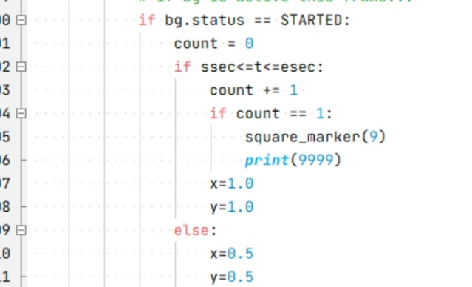

Sub05数据情况

**行为数据：**

**脑电数据：**

8.18未讨论

解决了在增大时刻打两次marker的问题，将count=0的位置提前到block开始循环之前

Sub06使用的穿插版本程序，方形增大时刻marker问题解决，3+6+5

Sub06数据情况

**行为数据：**

**脑电数据：**

8.19晚上8.30讨论

**实验程序修改：**

任务1指导语修改为，注意观察注视点部分，不要提到背景圆环

任务一减少为2个block

实验三可以增加一个反馈，block答案是否正确 （？未改）

疲劳对数据质量的影响

**其他问题：**

**1、三个任务正确率计算问题，特别是任务三，如何保证被试的正确率？**

目前的计算方式：任务1、2为反应在刺激呈现之后1.6s之内

**2、脑电预数据处理标准（除原文提过的标准之外，还需进行其他要求吗？）**

**目前版本：**

**任务1**

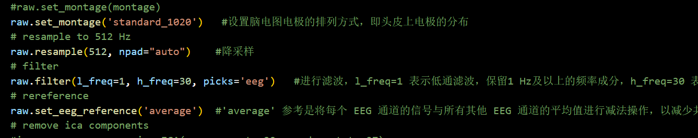

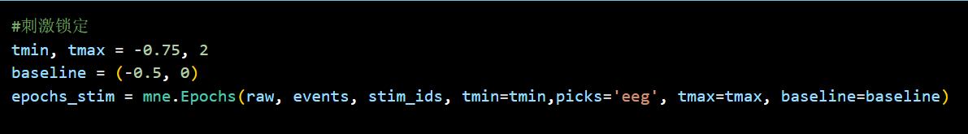

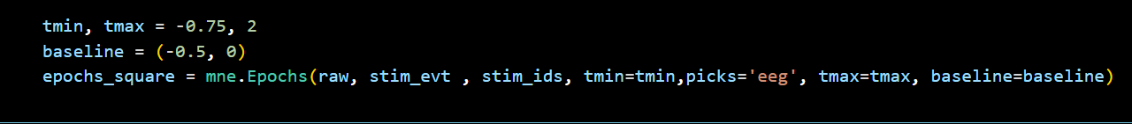

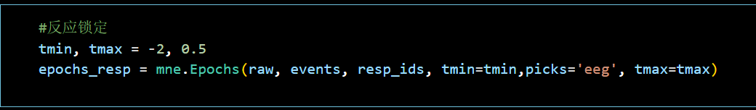

反应选的是每个试次内的第一个反应

**任务2**

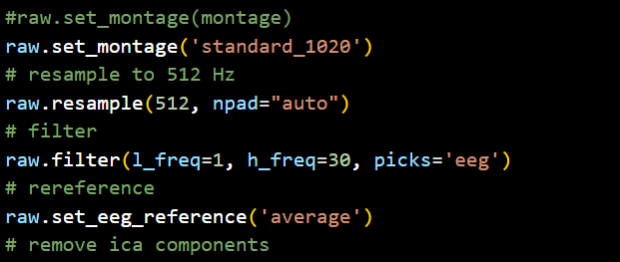

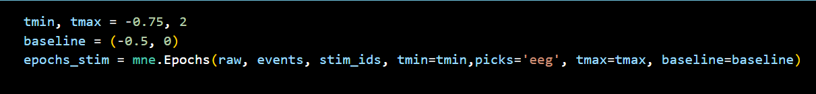

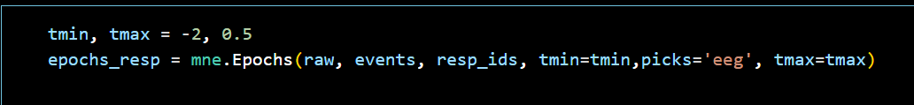

**任务3**

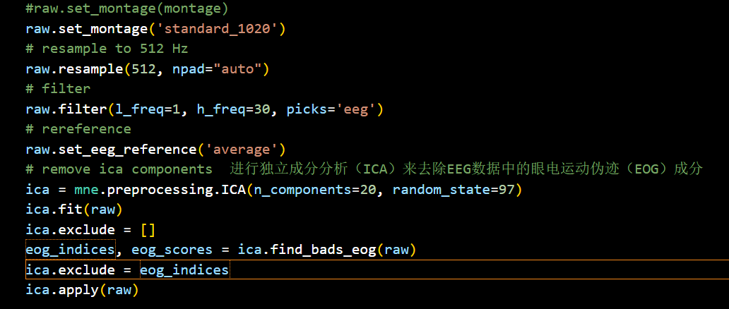

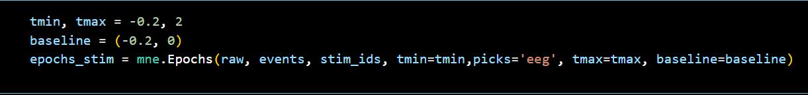

Prior to recording, participants completed a short practice block of eight targets, and rested between blocks thereafter.

**Task version 1: fixed visual contrast decrease and auditory volume decrease.** The first task version was administered to 24 participants, of which five were excluded from analysis because of excessive artifacts (>50% trial loss), leaving a final sample of 19 participants (five females, one left-handed, mean age of 20.4 ± 4). Stimuli were presented on a 51-cm CRT monitor operating an 85-Hz refresh rate

Participants continuously monitored an annular flickering (21.25 Hz) pattern stimulus (inner radius = 1.14°, outer radius = 2.29°) for intermittent targets defined by linear contrast changes from 65 to 35% over 1.6 s. The annular pattern consisted of alternating light and dark radial segments, with two cycles per quadrant. The inter-target interval was randomly 4, 7.2 or 10.4 s. Participants performed eight blocks, each lasting 4 min and containing 25 targets. Participants were instructed to avoid guessing and make a right index finger mouse button press as soon as they were certain that the annulus was fading.

To enable investigation of the domain generality of our decision signals, participants also performed eight 4-min blocks of an auditory analog of the visual task in which they monitored a continuous 500-Hz, 70-dB tone, envelope-modulated at 40 Hz, for targets that were defined by a linear reduction in volume reaching 30% at 1.6 s, matching targets in the visual condition. The sensory modality of the task alternated block by block, and the condition that was performed first was counter-balanced across participants. The visual stimulus was continuously presented in parallel during the auditory detection blocks and vice versa, but the unattended stimulus in each condition was held constant at all times to ensure that it was completely irrelevant to the task at hand.

16blocks, 4-min per block, auditory and visual alternated

视觉(mean detection accuracy, 98% ± 2.8; mean reaction time, 1,310 ms ± 160; mean intra-subject reaction time variability (s.d.), 612 ms ± 65; mean false alarms, 1.1 per block ± 1.3; Fig. 1b)

**Task version 2: visual contrast decreases of variable duration.** To establish the connection between LHB, CPP and target detection accuracy, participants monitored a 20-Hz flickering annulus (as in version 1, except inner radius = 1.14°, outer radius = 3.1°) for targets that were presented at five randomly interleaved levels of difficulty by manipulating the duration of the downward ramp in stimulus contrast. After peaking, contrast linearly increased to reach baseline level at 2.4 s post-onset for all conditions, guarding against the possibility that the return to baseline exogenously cues target appearance. This task was performed by 15 participants, two of which were excluded from analysis because they made insufficient misses (<10) to allow a comparison of hits versus misses at any single target difficulty level. A further two participants were rejected because of insufficient false alarms (<10), leaving a final sample of 11 right-handed participants (three males, mean age = 20.4 ± 4).

Participants performed 12 4-min blocks (25 targets) of the task. The hardest and easiest difficulty levels were presented less often than the intermediate difficulty levels (12.5% versus 25%), as only the latter levels were intended to be divided into hits and misses. Participants were informed that the duration, and therefore the magnitude, of stimulus fading would vary from target to target and instructed to respond as soon as they were sure that the stimulus was fading. Feedback on the percentage detection accuracy for each level of difficulty was provided after every block to promote effort maintenance.

中等难度的实验任务(52.8 ± 18.9%), The false alarm rate (1.86 ± 1.3 per block),

**Task version 3: perturbation of sensory evidence, manipulation of response requirements and task relevance.** A single group of 20 participants performed three separate conditions. Two participants were excluded because of poor counting performance in condition 2 (detection accuracy < 2.5 s.d. below group average) leaving a final sample size of 18 (seven female, two left-handed, mean age = 22.1 ± 4.3).

To establish the sensitivity of the decision signals to perturbations of the sensory evidence, participants completed five 4-min blocks in which they monitored a 20-Hz flickering annulus (as described in task version 2) for contrast decreases and indicated detections with a speeded mouse button press (condition 1). Two different contrast-decrease time courses were randomly interleaved: regular trials that were identical to task version 1 and perturbation trials that contained contrast direction reversals at 400 and 850 ms.

(perturbation, 1,909 ± 148 ms; regular, 1,471 ± 131 ms; P < 0.001), there was no difference in accuracy (perturbation, 94.6%, ± 6.2; regular, 95.7% ± 6.1; false alarms, 0.78 ± 0.78 per block)

To test the extent to which the decision signals were driven by the requirement for an overt motor response, participants performed the same task as described above, but instead of using a button-push response, participants were asked to mentally count the targets and to report the final total at the end of each block (condition 2). We presented 23–27 targets (inclusive, uniform distribution) in each block. mean accuracy, 97 ± 2.7%

To establish the extent to which the CPP was specifically elicited by task relevant sensory information, participants performed two further blocks in which they were presented with the same flickering annulus, but were asked to monitor the central fixation square for transient (100 ms) increases in size from 5 to 10 pixels (condition 3). Participants were asked to indicate these fixation targets with a speeded button press. Gradual decreases in the contrast of the surrounding annulus, identical to those defining the target in conditions 1 and 2, continued to occur, but were rendered irrelevant by the task instructions. Identical inter-trial intervals intermediated between gradual changes. Fixation targets were presented at random times between the offset of an annulus contrast change and 800 ms preceding the following contrast change.

All participants completed the two blocks of condition 3 first to ensure that the contrast decreases would not capture attention. Fixation targets were detected with 100 ± 0% accuracy with an average reaction time of 362 ± 19 ms and 0.06 ± 0.24 false alarms. Thirteen of the participants completed the five blocks of conditions 1 and 2 in sequence, but with the order of conditions counter-balanced across participants. The five remaining participants alternated block by block between conditions 1 and 2. Subanalyses revealed that the results from these five were entirely consistent with those of the other 13 participants.

12blocks, 4-min per block

**Task version 4: visual contrast increases versus decreases.** To test the sensitivity of the CPP to changes in the target feature, we compared two conditions in which a group of seven participants (four male, one left-handed, mean age = 23.3 ± 2.3) alternated block by block between monitoring the flickering annulus for contrast increases (linear rise to 95%) versus decreases (linear drop to 35%, identical to version 1). The starting condition was counter-balanced across participants. Participants completed 3–6 blocks of each condition. On average participants detected 95.6 ± 3.8% of ascending targets with reaction time of 1,314 ± 129 ms and 1.5 ± 1.2 false alarms, and detected 96 ± 5.1% of descending targets with reaction time of 1,348 ± 153 ms, 0.75 ± 0.99 false alarms.

**Task version 5: decreases in auditory frequency versus volume.** To further test the generality of the CPP across target features, we administered an alternate version of the auditory task used in version 1 in which participants monitored a continuous auditory tone for a gradual decrease in frequency from 40 to 30 Hz. A 9-cm diameter circular pattern with linearly increasing contrast from 0 to 100% from center to perimeter was flickered at fixation at 21.25 Hz during auditory performance to allow direct comparison with task version 1, but, again, its contrast was held constant at all times. Visual stimuli were presented on a 51-cm CRT monitor operating a 85-Hz refresh rate. This version was administered to 23 participants, three of which were excluded from the analysis because of excessive artifacts (>50% trial loss), leaving a final sample of 20 participants (seven female, one left-handed, mean age = 21.7 ± 3.2). On average, participants detected 95.9 ± 3.0% of auditory targets with reaction time of 1,215 ± 182 ms and 0.9 ± 0.6 false alarms. In Figure 4, we compare these data for frequency-decrease targets to the data of version 1 (volume decreases) to demonstrate the CPP’s insensitivity to changes in auditory target feature.

8blocks, per 4-min