#### Simple Training Based on simple_train.py

We begin with a simple MLP. The number of units for hidden layer and output layer are 100 and 4.

Here is the graph train/validation loss and training/validation accuracy as we train.

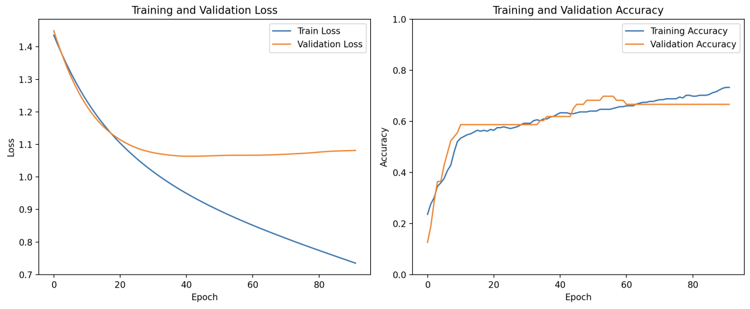

Here is the test set performance

Accuracy: 0.31746031746031744

|  |  |  |  |  |
| --- | --- | --- | --- | --- |
| Class | Precision | Recall | F1 | Support |
| 0 | 0.00 | 0.00 | 0.00 | 5 |
| 1 | 0.21 | 0.17 | 0.19 | 18 |
| 2 | 0.25 | 0.44 | 0.32 | 18 |
| 3 | 0.53 | 0.41 | 0.46 | 22 |
| Accuracy | 0.32 |  |  | 63 |
| Macro Avg | 0.25 | 0.26 | 0.24 | 63 |
| Weighted Avg | 0.32 | 0.32 | 0.31 | 63 |

## Grid Search based on grid_search.py

Here is the result:

|  |  |  |  |
| --- | --- | --- | --- |
|  | hidden_units | learning_rate | test_accuracy |
| 0 | [64] | 0.001 | 0.333333 |
| 1 | [64] | 0.010 | 0.333333 |
| 2 | [64] | 0.100 | 0.365079 |
| 3 | [128] | 0.001 | 0.317460 |
| 4 | [128] | 0.010 | 0.317460 |
| 5 | [128] | 0.100 | 0.365079 |
| 6 | [64, 64] | 0.001 | 0.317460 |
| 7 | [64, 64] | 0.010 | 0.349206 |
| 8 | [64, 64] | 0.100 | 0.349206 |
| 9 | [128, 64] | 0.001 | 0.349206 |
| 10 | [128, 64] | 0.010 | 0.333333 |
| 11 | [128, 64] | 0.100 | 0.317460 |