这是提高前向算法效率的矩阵表达式，公式12

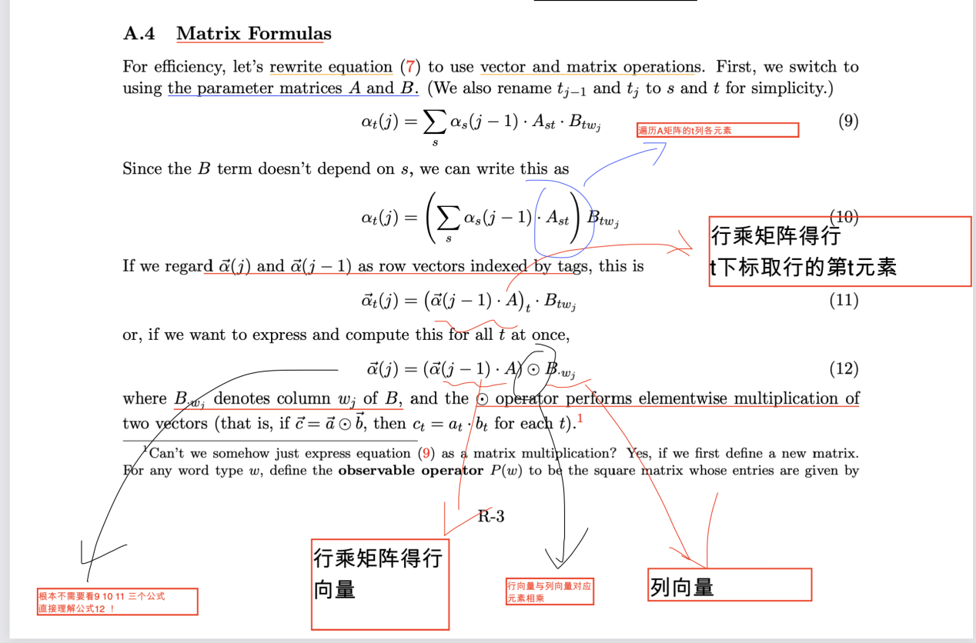

但是这个矩阵表达式并没有处理标签限制tau

partially-tagged restriction

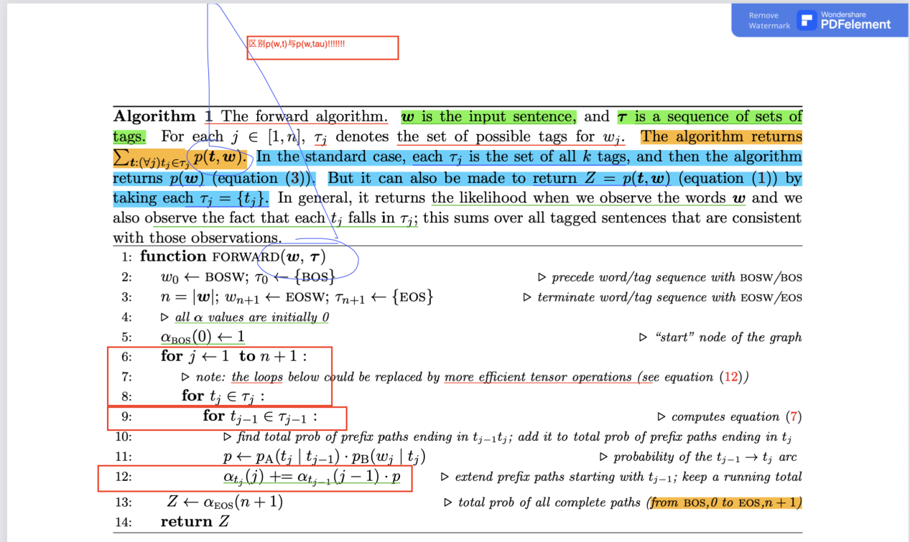

因此我们需要修改公式12

*We utilize A.4 Matrix Formulas and equation 12 to enhance the performance  
Here is equation 12  
a(j) = [a(j-1) @ A ] * B_*wj  
However, to deal with the partially tagged sentence （the tag restriction tau in algorithm 1）,  
we need to make the following changes to equation 12  
Assume that tau(j) is a 0-1 mask vector of length k (where k is the number of tags)  
Then we modify equation 12 into  
a(j) = ( [a(j-1) @ A ] * B_*wj ) * tau(j)*