姓名：黄川欣 | 专业： 物联网工程 | 班级：20181191 | 学号：2018119155
科目：嵌入式系统概论 |  | 实验日期：
实验题目：GPIO输出控制实验-Led闪烁、流水灯
【实验目的】
LED灯的闪烁
【实验内容】
1.实验设备
◆ 硬件：小熊派
◆ 软件：win10 系统，STM32CubeMX，Keil 5。
- 实验相关原理图

LED使用的是PC13引脚
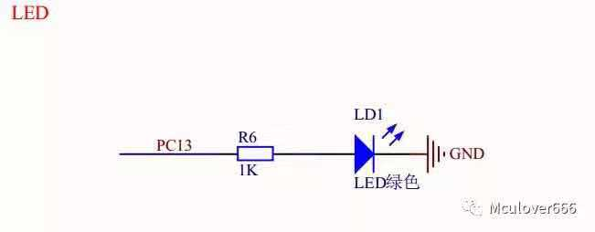

3.实验效果
LED灯以2Hz的频率闪烁
【实验结果】
1.构思
步骤1：查看原理图，配置相关的GPIO引脚
步骤2：配置定时器TIM2，时钟源选择内部时钟
步骤3：配置时钟树，配置PLL
步骤4：编写main函数，编写中断回调函数，启动定时器并使能中断。
2.实现
#include "main.h"
#include "tim.h"
#include "gpio.h"

void SystemClock_Config(void);
/* USER CODE BEGIN PFP */

/* USER CODE END PFP */

/* Private user code ---------------------------------------------------------*/
/* USER CODE BEGIN 0 */

/* USER CODE END 0 */

/**
* @brief The application entry point.
* @retval int
*/
int main(void)
{
/* USER CODE BEGIN 1 */

/* USER CODE END 1 */

/* MCU Configuration--------------------------------------------------------*/

/* Reset of all peripherals, Initializes the Flash interface and the Systick. */
HAL_Init();

/* USER CODE BEGIN Init */

/* USER CODE END Init */

/* Configure the system clock */
SystemClock_Config();

/* USER CODE BEGIN SysInit */

/* USER CODE END SysInit */

/* Initialize all configured peripherals */
MX_GPIO_Init();
MX_TIM2_Init();
/* USER CODE BEGIN 2 */
HAL_TIM_Base_Start_IT(&htim2);
/* USER CODE END 2 */

/* Infinite loop */
/* USER CODE BEGIN WHILE */
while (1)
{
/* USER CODE END WHILE */

/* USER CODE BEGIN 3 */
}
/* USER CODE END 3 */
}

/**
* @brief System Clock Configuration
* @retval None
*/
void SystemClock_Config(void)
{
RCC_OscInitTypeDef RCC_OscInitStruct = {0};
RCC_ClkInitTypeDef RCC_ClkInitStruct = {0};

/** Initializes the RCC Oscillators according to the specified parameters
* in the RCC_OscInitTypeDef structure.
*/
RCC_OscInitStruct.OscillatorType = RCC_OSCILLATORTYPE_HSE;
RCC_OscInitStruct.HSEState = RCC_HSE_ON;
RCC_OscInitStruct.PLL.PLLState = RCC_PLL_ON;
RCC_OscInitStruct.PLL.PLLSource = RCC_PLLSOURCE_HSE;
RCC_OscInitStruct.PLL.PLLM = 1;
RCC_OscInitStruct.PLL.PLLN = 20;
RCC_OscInitStruct.PLL.PLLP = RCC_PLLP_DIV7;
RCC_OscInitStruct.PLL.PLLQ = RCC_PLLQ_DIV2;
RCC_OscInitStruct.PLL.PLLR = RCC_PLLR_DIV2;
if (HAL_RCC_OscConfig(&RCC_OscInitStruct) != HAL_OK)
{
Error_Handler();
}
/** Initializes the CPU, AHB and APB buses clocks
*/
RCC_ClkInitStruct.ClockType = RCC_CLOCKTYPE_HCLK|RCC_CLOCKTYPE_SYSCLK
|RCC_CLOCKTYPE_PCLK1|RCC_CLOCKTYPE_PCLK2;
RCC_ClkInitStruct.SYSCLKSource = RCC_SYSCLKSOURCE_PLLCLK;
RCC_ClkInitStruct.AHBCLKDivider = RCC_SYSCLK_DIV1;
RCC_ClkInitStruct.APB1CLKDivider = RCC_HCLK_DIV1;
RCC_ClkInitStruct.APB2CLKDivider = RCC_HCLK_DIV1;

if (HAL_RCC_ClockConfig(&RCC_ClkInitStruct, FLASH_LATENCY_4) != HAL_OK)
{
Error_Handler();
}
/** Configure the main internal regulator output voltage
*/
if (HAL_PWREx_ControlVoltageScaling(PWR_REGULATOR_VOLTAGE_SCALE1) != HAL_OK)
{
Error_Handler();
}
}

/* USER CODE BEGIN 4 */

/* USER CODE END 4 */

/**
* @brief This function is executed in case of error occurrence.
* @retval None
*/
void Error_Handler(void)
{
/* USER CODE BEGIN Error_Handler_Debug */
/* User can add his own implementation to report the HAL error return state */

/* USER CODE END Error_Handler_Debug */
}

#ifdef USE_FULL_ASSERT
/**
* @brief Reports the name of the source file and the source line number
* where the assert_param error has occurred.
* @param file: pointer to the source file name
* @param line: assert_param error line source number
* @retval None
*/
void assert_failed(uint8_t *file, uint32_t line)
{
/* USER CODE BEGIN 6 */
/* User can add his own implementation to report the file name and line number,
tex: printf("Wrong parameters value: file %s on line %d\r\n", file, line) */
/* USER CODE END 6 */
}
3.运行结果

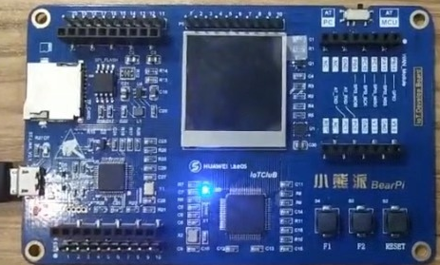

【教师评语和成绩】

成绩： 指导教师： 日期：

