Your name: Yuechuan Li

Monash student ID: 31104908

lab, tutor name: 26_OnCampus Ashwini Narasimhan

URL：[Alcohol Expenditure Visualization (chuandie.github.io)](https://chuandie.github.io/week10Homework/)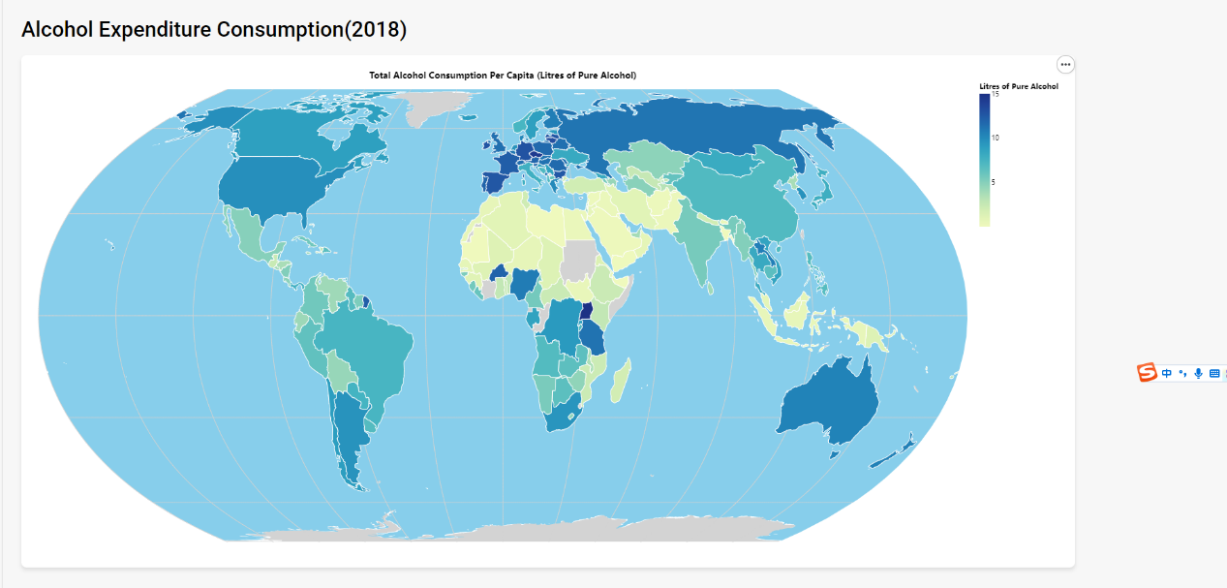

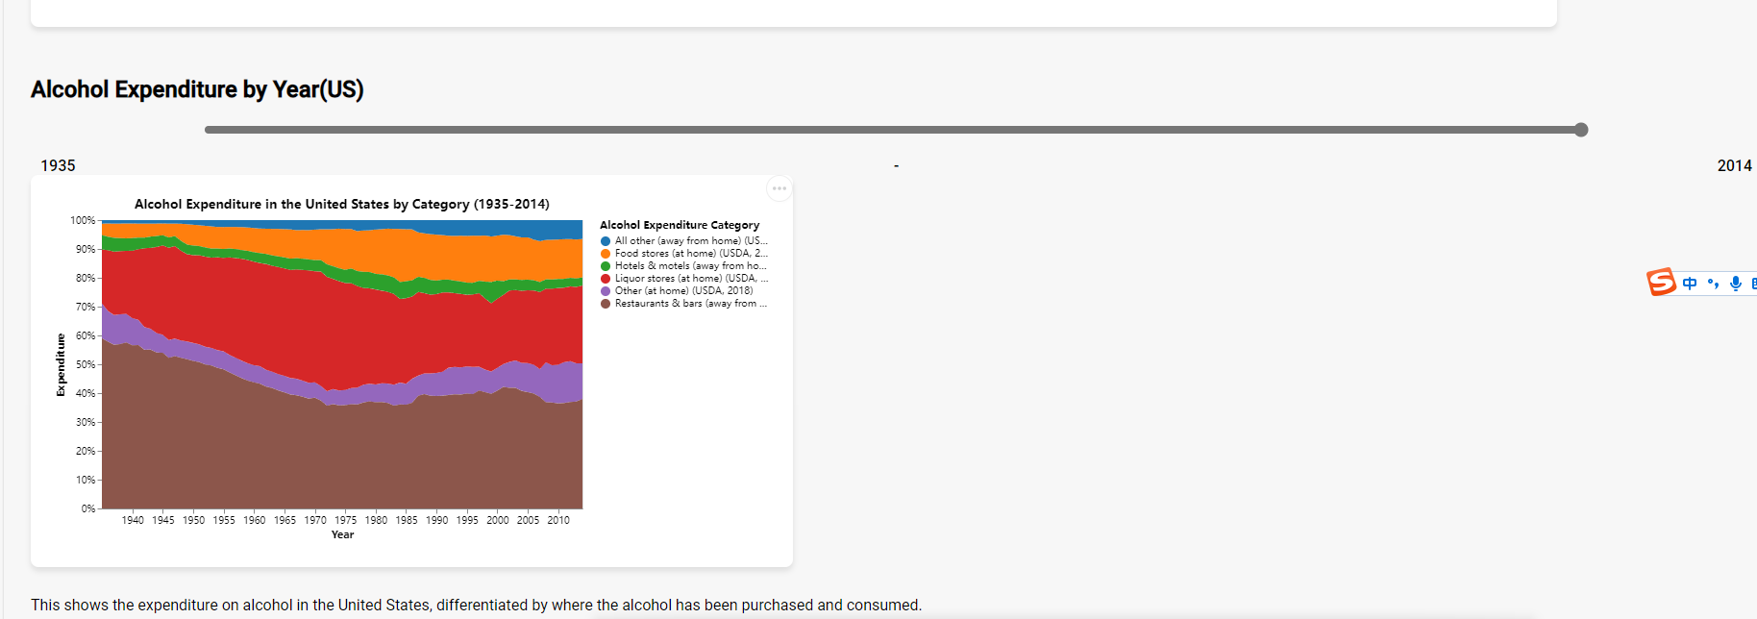

**One short bullet point for each of the following items:**

* **The domain of your Data Visualisation 2**

My visualization topic is "Alcohol". This interface contains two visualizations, one is the per capita alcohol consumption worldwide in 2018, and the other is the location and expenditure of alcohol consumption in the United States from 1935 to 2014. And other potential visualization is some subtopic about alcohol.

* **The visualised dataset (attribute types, source and author, etc.)**

The data for this visualization comes from [Alcohol Consumption - Our World in Data](https://ourworldindata.org/alcohol-consumption#alcohol-consumption-vs-income). These are some public csv files, and their authors are not shown. The data in the second picture comes from the United States Agriculture department.

* **A justification for the type of visualisation idiom used (that is, why are you creating a bubble plot, stacked bar chart, etc.)?**

This map idoms was created to provide a clearer and more intuitive way to display alcohol consumption. In addition, the color also better helps users distinguish the amount of alcohol consumed.Using statistical charts or dot plots can be confusing to users. In contrast, when the user moves the mouse directly to a country, the alcohol consumption in that country for that year is directly displayed. This will make it easier for users to understand. In addition, for the second standard stacked chart, we use the relationship between parts and the whole, which can help us observe trend changes more intuitively through Marks and Glyph.