**Installation Note for GPP_Light**

**1. Configure the MATLAB running environment**

There are two circumstances when you can run this light version of GPCC:

(1) You do have a **MATLAB 2017b** installed on your computer, but a higher or lower MATLAB version is not supported.

(2) Download and install the **MATLAB 2017b runtime (R2017b 9.3)** from the MathWorks official website (<https://www.mathworks.com/products/compiler/matlab-runtime.html>).

(**What is the MATLAB runtime**: *The MATLAB Runtime is a standalone set of shared libraries that enables the execution of compiled MATLAB applications or components on computers that do not have MATLAB installed.)*

**2. GPP_Light package**

(1) Download the GPCC_Light from the author’s GitHub repository.

GPCC_Light repository (https://github.com/Jiechenwhu/GPCC)

(2) GPCC_Light contains 5 files: the icon file (**default_icon.ico**), the executive file (**GPCC_GUI.exe**), the readme text file (**readme.txt**) and the splash figure (**splash.png**) and the installation note (**GPCC_Light_Notes.docx**).

3. Start GPCC

(1) Double click the **GPCC_GUI.exe** to get started.

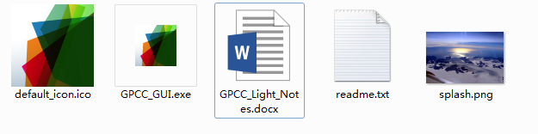

(2) A splash will be shown on your computer when GPCC is started.



(3) Now you will see the interface of GPCC.

