1. Overview
I’m very sorry I don’t have enough time to write a detailed manual of it.
This Matlab GUI software is the improved versions of the semi-automatic TSAnalysis software, retaining the same data format. So before using this automatic version, please first get familiar with the manual and usage of semi-automatic package (including example), then read this manual for the improved functions. And also if there is something you get confused, the manual of semi-automatic package (UserGuide_TSAnalysis.doc) may help you.

2. Data Preparation
Before you start to use this software, all the required data (station list file, instrument response file, waveform data file) have to be prepared.

2.1 Station List file (Necessary)
An example of the stations list file is shown as StationsList.txt. The format of this file is:
StationName_1 Station_NetWork_1 Station_Lat_1 Station_Lon_1
StationName_2 Station_NetWork_2 Station_Lat_2 Station_Lon_2
… …
2.2 Instrument Response file
An example of the station instrument response list file is shown as ./Example_Data/Ex2_Tibet_LHZ_Data/Response /RespFile.txt. All the response files have to be in the same folder as the response list file.
Note:
1. For Love wave using the Transverse component data, the software do not have the function of rotation, so you do not need to remove the instrument response if you have removed the instrument response before rotation.
2. Please guarantee offering the integrated instrument response files with the standard format (http://ds.iris.edu/ds/nodes/dmc/manuals/rdseed/), avoiding the lack of Zeros or Poles.
3. We recommend you remove the instrument response before using TSAnalysis if your data is not generated from the standard rdseed program. (http://ds.iris.edu/ds/nodes/dmc/manuals/rdseed/)

2.3 Waveform data file (Necessary)
An example of the waveform data list file is shown as ./ Example_Data/Ex2_Tibet_LHZ_Data/ /040423_0150_LHZ / 040423_0150File.txt. The format of this file is like:
ISCCD/ISC, 2004/04/23 01:50:30.1400, -9.5471, 122.7329, 88.1, 288, 24, MW, 6.7, MW, 6.6
2004.114.01.52.46.6400.YA.MC24.02.LHZ.M.SAC
2004.114.01.52.48.6400.YA.MC25.02.LHZ.M.SAC

The first line contains information of the source (i.e., event), with the same format as the weed event format. You can obtain this weed format event information from IRIS (http://www.iris.edu/SeismiQuery/events.htm): input search parameters and click the button 'View Results', then on the new webpage click the button 'Weed Event File', then copy and paste the results to an event file, in which each line is the input of our first line in waveform data list file.
All the waveform data files for the same event must be in the same folder as given in the waveform data list file. We usually use LH* component data (1 Hz) for two-station dispersion analysis. If using data with higher sampling frequency (e.g., 20 Hz or higher BH* component data), the code will automatically resample the waveform data to 1 Hz. And the original data sampling frequency must be integer. If you want to the data to be resampled with a different sampling rate, please check the following function in the codes:

function [station, record, ReSampleWave, ampcoef, source]= DataStructTrans(HdrData)
Note:
1. For all the four TSAnalysis modes need the waveform list files in every event data folder.
2. The station and response list files should contain all the same stations. The waveform data file list only contains the waveform data available for the associated event. The number of waveform data files is usually less than the number of stations in the station or response list file due to the malfunction of stations or other problems. The order of the station appearing in the waveform data file list is not required to be same as that in the station or response list file. The code will automatically find the correspondent response file for each waveform data.
3. All the SAC format waveform data file and the response files are generated from the standard rdseed program. (http://ds.iris.edu/ds/nodes/dmc/manuals/rdseed/ or have the standard format (including the names of waveform data and response files) of rdseed program.

2.4 Event list file (necessary for event cycle modes)
An example of the waveform data list file is shown as ./ Example_Data/Ex1_Leighigh_LHT_Data/ Leihigh_LHT_EventList.txt. The format of this file is :
FolderName1
FolderName2
FolderName3

2.5 Reference phase velocity file (necessary for 3 automatic modes)
An example of the reference phase velocity file is shown as ./Necessary/ Rayleigh_phase_v_ref.dat. The format of the file is like:
10.0000 3.0917
12.5000 3.1129
15.0000 3.1372
17.5000 3.1683
20.0000 3.2016
The left column is period, and the right is phase velocity. Then you need to give the range
of perturbation for phase velocity dispersion auto-pick, with default value +/- 0.5 km/s
with respect to the reference values.
You can also give the reference values like this:
10.0000 3.0917 0.4638
12.5000 3.1129 0.4669
15.0000 3.1372 0.4706
17.5000 3.1683 0.4752
The third column gives the perturbation range without using the default value in the box.
Of course, the period range of processing in the "Settings" has to be in within the reference period range given here.

3. Simple Procedure of Two-station Analysis
3.1 TS Setting
3.1.1 Set Wave Type: choose either ‘Rayleigh Wave’ or ‘Love Wave’ in the pop-up menu. If ‘Rayleigh Wave’ is chosen, a group velocity window [2.5 5] km/s is used to extract the Rayleigh wave trains from the entire input waveform for the two-station analysis; if ‘Love Wave’ is chosen, a group velocity window [3 5.5] km/s is used to extract Love wave trains. The two windows are basically suitable for the regional two-station analysis in the period band 15-200 s. If you want to modify this wave window for some particular case, please check the function ProcessIndex = GroupImageArrival (hObject, handles) in the TSAnalysis.m and modify the array GVWinR = [2.5 5] (for Rayleigh waves) or GVWinL = [3 5.5] (for Love waves) to your desired value, e.g., GVWinR = [2.0 5.5]. If you choose ‘Rayleigh Wave’, the input waveform data should be the vertical component. For ‘Love Wave’, we use the transverse component data, which is transformed from S-N and E-W component data.
3.1.2 Set Period Range for the two-station analysis: you need to input the start period (T Start ) Ts, the end period (T End ) Te, and the period interval (Delta T) dT in the edit boxes. The unit for the inputs is sec. For example, if Ts = 20 s, Te = 100 s and dt = 1 s, you are expecting to obtain the phase velocity dispersion curve from 20 s to 100 s with 1 s interval.
3.1.3 Set weather choose to remove instrument responses or not. If you choose to remove response, click Remove Resp button, then Click Resp File List button, input the station instrument response list file RestFile.txt.
3.1.4. Set the two maximal deviation angles alfa and beta (deg) for two-station paths as shown in Figure 13. The default values for alfa and beta are 3º and 5º. User may take the default values or define their own values for the selection of two-station paths.
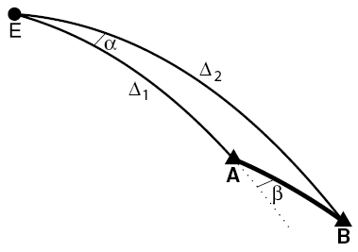

Figure 1. Illustration of two deviation angles α and β defined in the TS method: α is the azimuthal difference of the earthquake (E) to the two stations (A and B, with A nearest to the earthquake); β is the azimuthal difference between the earthquake (E) to the station A and the station A to the station B. The solid lines are all great-circle paths and the dashed line is the extended great-circle path from E to A. Δ₁ is the great-circle distance between E and A and Δ₂ is the great-circle distance between E and B (from Yao et al., 2006, GJI).

3.1.5 Click Station File button, input stations list file StationsList.txt . Then in the Fig 1 box you will see the stations location (black triangles) on a background topography map (the topography data is stored in topomap.mat). Green shows low elevation while brown shows high elevation.
3.1.6 Set the folder containing all the output dispersion data: click the Disper Output Folder button, select the folder which will store all the obtained dispersion data in the two-station analysis. You can choose the ./OutPut or any other folder.

3.2 Filter Design
3.2.1. In the 1.Filter Domain, choose one of the alternatives in the pop-up menu Period (T) to define the domain (either in Period or Frequency) of the band width for the band-pass filter. For two-station analysis, we suggest to choose the Period domain. The difference of choosing filter domain will be discussed in the following ‘3. Make Filter’ part.
4.2.2. In the 2. Window, choose the band-pass filter window type (either Kaiser or Gaussian window) in the pop-up menu Kaiser. For two-station analysis, I suggest to choose Kaiser window.
3.2.3 Click Make Filter button, you need to enter the passing band width ΔT (or Δf) for the band-pass filter. Therefore, the passing band for the band-pass filter is [T –ΔT/2, T +ΔT/2] (or [f –Δf/2, f +Δf/2]). Then, You need to either input the beta value for the Kaiser window if you choose Kaiser Window in 3.2.2. , or the alfa value for the Gaussian window if you choose Gaussian Window in 3.2.2.. You may refer to the Matlab Help for the detail of ‘kaiser’ or ‘gaussian’ window. For two-station analysis, I suggest to use Period domain in 3.2.1. and Kaiser window in 3.2.2.. From my experience, when Kaiser beta = 5 – 10, the effect of band-pass filtering seems quite good.
3.2.4 If you want to see the band-pass filter examples to test the parameters, Click Dome button, and a ‘Data Sampling Frequency’ input dialog box is created. You need to input the test waveform data sampling frequency, which is typically 1Hz or lower, in the edit line and then click ’OK’ button. Then a ‘Set Filter Parameter’ input dialog, you need to enter the test central period T if you choose Period domain or enter the test central frequency f if you choose Frequency domain in 3.2.2. Then the example of band-pass filter is shown as Figure 2

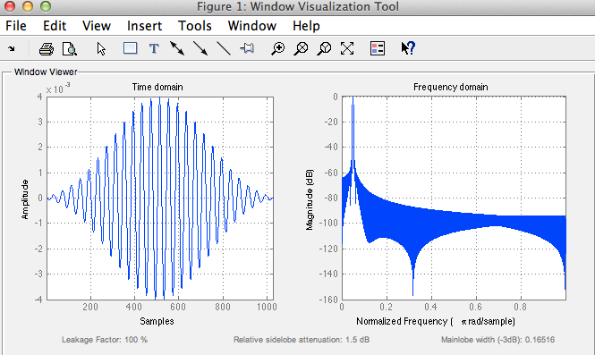
Figure 2. Example of created band-pass filter in both time domain and frequency domain

Note:
What you have set in 3.2.1-3.23 will be used in the later two-station analysis. So please make sufficient tests before you start the data processing.

3.3 TSAnalysis Mode
Automatic TSAnalysis affords four kinds of process mode to choose, and for different modes it will need different input files and reference file or not.
Set TSAnalysis Mode: choose one mode from ‘Semi-automatic Mode’, ‘Automatic Mode’, ‘Visible Mode’ and ‘Silent Mode’ in the pop-up menu.

For processing single event, the two modes below can only process one event once, and the both modes need a waveform list file which is loaded by clicking the Waveform List File bottom. For the specific format of the waveform list file, please read the 2.3 section.
Semi-automatic Mode: This mode is same of semi-automatic TSAnalysis, picking the dispersion curve manually.
Automatic Mode: This mode can pick the dispersion curve automatically with the necessary reference dispersion curve.

For processing multi-events, the both automatic modes below can process multi-events circularly, with or without the processing and result figures. For the two cycle modes, they both need an event list file, which is loaded by clicking the Event List File bottom. The format of the event list file is explained in 2.4 section.
Visible Mode: This mode can pick the dispersion curve automatically with the necessary reference dispersion curve, and the processing and result figures are visible.
Silent Mode: This mode can pick the dispersion curve automatically with the necessary reference dispersion curve, and the processing and result figures are invisible for saving time.
Note:
1. For the three automatic mode, the reference setting is necessary to supply a reference phase velocity dispersion curve, and a good reference phase velocity dispersion curve is very important for the good results. Click Ref C Disper button, input the reference dispersion file. The format of the file is explained in 2.5 section.

3.4 Processing Control
Start Processing: Click this button if you want to start processing.
Pause: Click this button if you want to pause.
Go on: If you want to go on the processing after clicking Pause button, click this button.
Exit: Click this button, then exit the processing.
Note:
1. Ensure that you have set all the settings before click Start Processing button.
2. The detailed procedure for the two-station analysis is explained in the manual of semi-automatic package.

Some Important Notes:
1. Name and format of dispersion file: The name of the saved dispersion file is like ‘C040423_0150KMI-MC05.dat’, in which ‘C’ means phase velocity, ‘040423_0150’ is the source time with the format ‘YYMMDD_HHMM’, ‘KMI-MC05’ is the two-station pair name with the format ‘StaName1-StaName2’, and ‘.dat’ is the file extension. Here ‘StaName1’ and ‘StaName2’ are in alphabetical order by the name. The format of the dispersion file is:

Station_Lon1 Station_Lat1
Station_Lon2 Station_Lat2
Period_1 Phase_Velocity_1
Period_2 Phase_Velocity_2
…… ……
The unit for period is second and the unit for phase velocity is km/s.

2. How to choose the right dispersion curve: Please see the manual of semi-automatic package (UserGuide_TSAnalysis.doc).

3. Half-wavelength Criterion: As stated in Yao et al., (2006, GJI), I use a half-wavelength criterion to save the dispersion data. The half-wavelength criterion is that we require the surface wave propagation distance between two stations (Δ₂ –Δ₁) has to be at least half of the wavelength (λ= c(T ) T). Therefore, the shorter the interstation distance is, the shorter the period is at which we can obtain the dispersion data. Actually in the band-pass filtering of the two-station waveforms, the longest period for the band-pass filtering is set to be the minimum between 2*(Δ₂ –Δ₁)/2.5, in order to reduce the computational time for shorter two-station paths.

4. About legend of result dispersion curve: The green dots stand for the dispersion curve picked up automatically, the cyan dots will plot on the green dots which in the range of reference dispersion curve with smaller radius, at last the red dots will stand for the final reserved dispersion points which fit with the half-wavelength criterion. The examples are shown as Figure 3. and Figure 4.

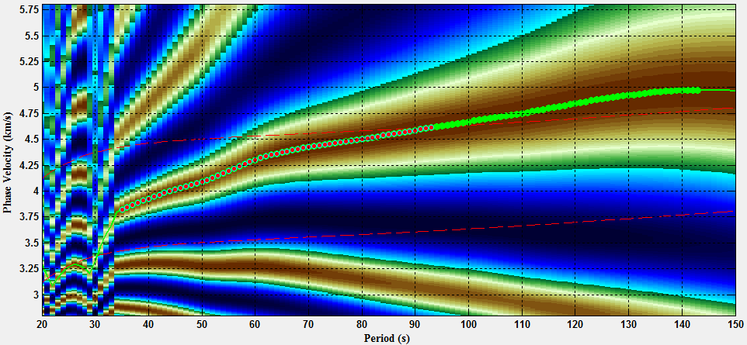
Figure 3. Dispersion data points
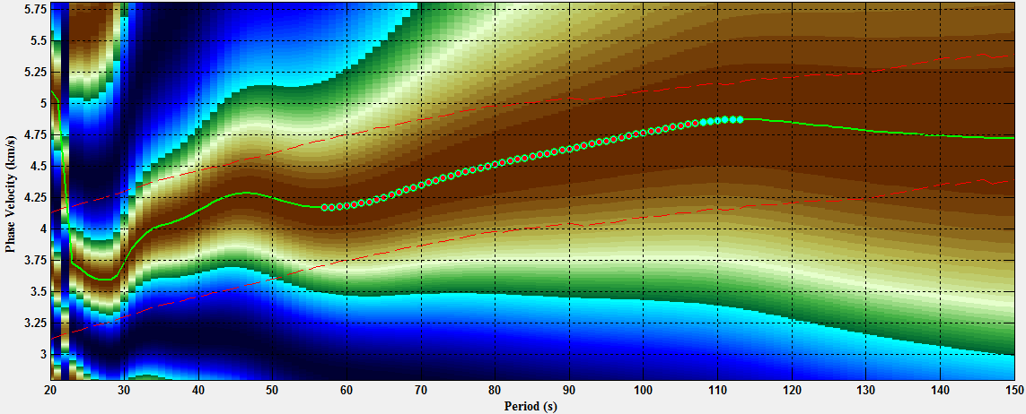
Figure 4. Dispersion data points

