A User’s Guide

To

Semi-automatic Surface Waves Two-station Dispersion Analysis Software

Version 1.2

Huajian Yao
huajianyao@gmail.com

Dec 31, 2012

1. Overview

This Matlab GUI software is designed for the semi-automatic two-station phase velocity dispersion analysis of surface waves. The current settings of this software can only be used for earthquake-based surface wave dispersion analysis in regional or global surface wave studies, not for the exploration scale studies. With this software, users can greatly enhance the efficiency of inter-station phase velocity dispersion measurements. This software was written with Matlab 7.0.1. It can run on Matlab platform with the same or higher version. So far, I have successfully run this software on Linux, Windows, and Mac system. For Mac or linux, there may be some displaying problem of figures, but will not generally affect the use of this codes. The Minimum screen resolution requirement for this software is 1024 x 768. All the test figures in the following chapters are based on the results on Windows system

The scheme for two-station dispersion analysis is based on moving window procedure and image analysis technique, as described in the following three papers:
1. Yao H., van der Hilst R.D., and de Hoop, M.V..Surface-wave array tomography in SE Tibet from ambient seismic noise and two-station analysis : I - Phase velocity maps. 2006, Geophysical Journal International, Vol. 166, 732-744, doi: 10.1111/j.1365-246X.2006.03028.x.(PDF)
2. Yao H. , Xu G., Zhu L.,and Xiao X., Mantle structure from inter-station Rayleigh wave dispersion and its tectonic implication in Western China and neighboring regions. Physics of the Earth and Planetary Interiors , 2005, Vol 148, 39–54. (PDF)
3. Yao H. , Xu G., and Xiao X., A Quick Tracing Method Based on Image Analysis Technique for the Determination of Interstation Phase Velocities Dispersion Curve of Surface Wave, Seismological and Geomagnetic Observation and Research , 2004, No.1, 1-8 (in chinese)
I will briefly describe the procedure in the following chapters. For reference, I suggest to use paper 1.

2. Software Interface

In the Matlab Command Window, inputting TSAnalysis , you will start to run this software. There are following functional groups on the software interface (Figure 1):
- Processing Message: display messages during the data processing; users need to follow some messages to continue the data processing.
- Fig. 1 Box: display the map of stations location and effective inter-station ray paths during the processing. The effective inter-station ray path is the two-station path on which we obtain the dispersion data successfully.
- Fig. 2 Box: display waveforms of two stations and the final phase velocity - period (c-T) image. Users need to left click on this c-T image to choose the right dispersion curve from the prior information and their own experience.
- Data File Input: input station list file (button 1. station file), instrument response list file (button 2. Response File, and waveform list file (button 3.Waveform File).
- Filter Design: set band-pass filter parameter and make band-pass filter.
- TS Settings: set parameters for two-station analysis.
- Processing: data processing block: start and stop the data processing.
- Src & Sta Message Box: display information of the source and stations, including longitude (Lon), latitude (Lat), station name (Name), source-station great circle distance in km (Dist), source→ station azimuth (Azim).

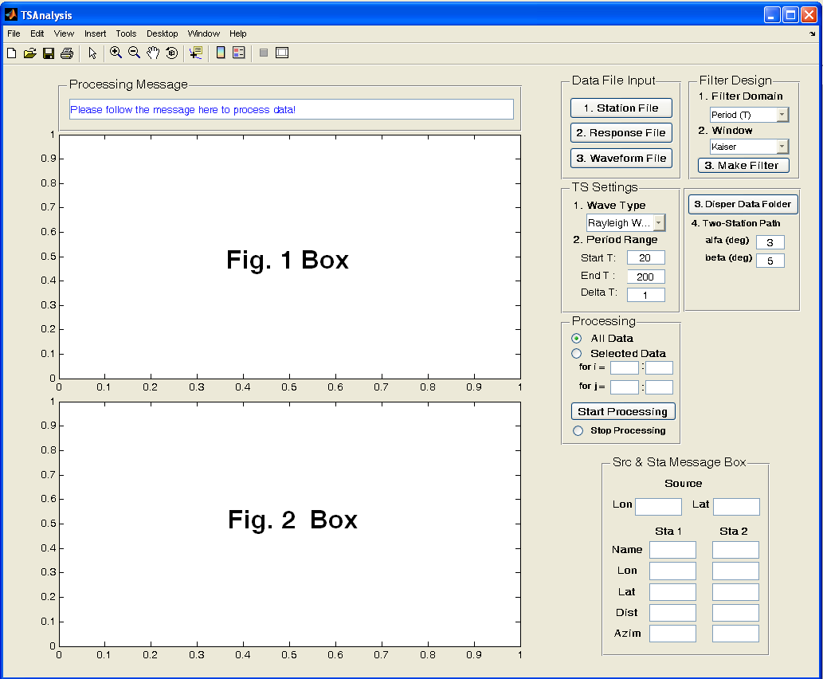

Figure 1. Two-station analysis software Interface

3. Data Preparation

Before you start to use this software, all the required data (station list file, instrument response file, waveform data file) have to be prepared. An example of the stations list file is shown as StationsList.txt. The format of this file is:
StationName_1 Station_NetWork_1 Station_Lat_1 Station_Lon_1
StationName_2 Station_NetWork_2 Station_Lat_2 Station_Lon_2
… …

An example of the station instrument response list file is shown as ./ Response/RespFile.txt. All the response files have to be in the same folder as the response list file.

An example of the waveform data list file is shown as ./ SAC_ASC_Data/040423_0150/ 040423_0150File.txt. The format of this file is like:
ISCCD/ISC, 2004/04/23 01:50:30.1400, -9.5471, 122.7329, 88.1, 288, 24, MW, 6.7, MW, 6.6
2004.114.01.33.54.8859.IC.KMI.00.LHZ.Q.SAC_ASC
2004.114.01.43.58.6400.YA.MC08.02.LHZ.R.SAC_ASC
… …
The first line contains information of the source (i.e., event), with the same format as the weed event format. You can obtain this weed format event information from IRIS (http://www.iris.edu/SeismiQuery/events.htm): input search parameters and click the button 'View Results', then on the new webpage click the button 'Weed Event File', then copy and paste the results to an event file, in which each line is the input of our first line in waveform data list file.
All the waveform data files for the same event must be in the same folder as given in the waveform data list file. We usually use LH* component data (1 Hz) for two-station dispersion analysis. If using data with higher sampling frequency (e.g., 20 Hz or higher BH* component data), the code will automatically resample the waveform data to 1 Hz. And the original data sampling frequency must be integer. If you want to the data to be resampled with a different sampling rate, please check the following function in the codes:

%function Rd_Sac_ASC : read SAC_ASC format seimic data
function [station, record, ReSampleWave, ampcoef, source] = Rd_Sac_ASC(seisfile)

For data format with SAC, please check the folder ./SAC_Data/040423_0150_BHZ/ for 40 Hz sampling rate and ./SAC_Data/040423_0150_LHZ/ for 1 Hz sampling rate.

The station and response list files should contain all the same stations. The waveform data file list only contains the waveform data available for the associated event. The number of waveform data files is usually less than the number of stations in the station or response list file due to the malfunction of stations or other problems. The order of the station appearing in the waveform data file list is not required to be same as that in the station or response list file. The code will automatically find the correspondent response file for each waveform data. All the SAC_ASC format waveform data file and the response files are generated from the standard rdseed program. (http://www.iris.edu/manuals/rdseed.htm).

4. Procedure of Two-station Analysis

4.1 Data File Input
4.1.1. Click 1. Station File button, input stations list file StationsList.txt (Figure 2). Then in the Fig 1 box you will see the stations location (black triangles) on a background topography map (the topography data is stored in topomap.mat). Green shows low elevation while brown shows high elevation.
4.1.2. Click 2. Response File button, input the station instrument response list file RespFile.txt in the folder ./ Response/ (Figure 3).
4.1.3. Click 3. Waveform File button, input the waveform data list file, e.g., as shown in Figure 4. The data list file is in the folder ./ SAC_ASC_Data/040423_0150/. You will notice that the color of some (or all) station signs will become red (Figure 5). Those ‘red’ stations have waveform data while the ‘black’ stations do not have data for that particular event.
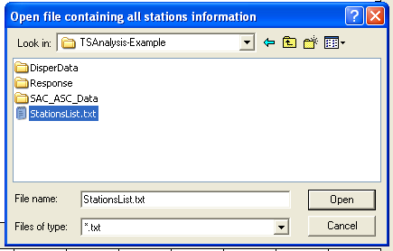
Figure 2. Open Stations List File

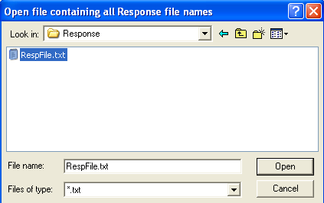
Figure 3. Open the station instrument response list file

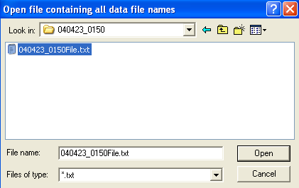
Figure 4. Open the waveform data list file

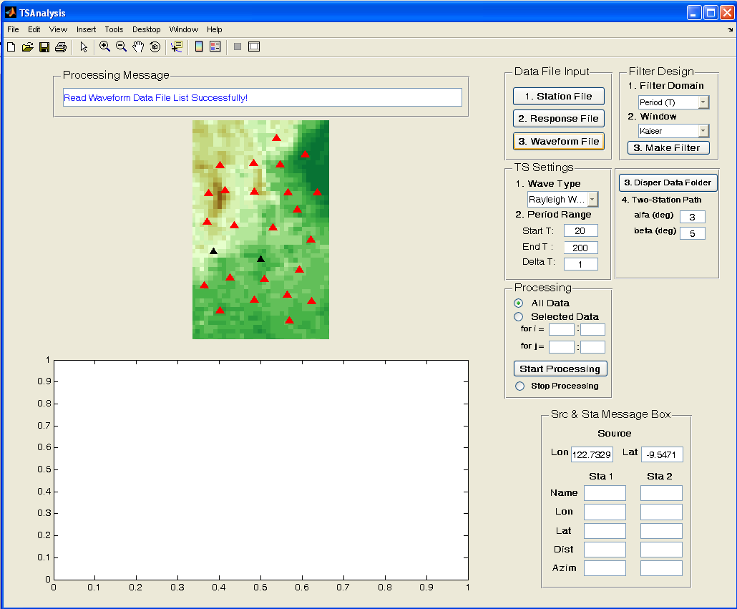
Figure 5. All Stations Location (both the red and black triangles) in the Fig.1 Box. The stations shown as red triangles have waveform data for the current event, while the black ones do not have data.

4.2 Filter Design
4.2.1. In the 1.Filter Domain, choose one of the alternatives in the pop-up menu Period (T) to define the domain (either in Period or Frequency) of the band width for the band-pass filter. For two-station analysis, we suggest to choose the Period domain. The difference of choosing filter domain will be discussed in the following ‘3. Make Filter’ part.
4.2.2. In the 2. Window, choose the band-pass filter window type (either Kaiser or Gaussian window) in the pop-up menu Kaiser . For two-station analysis, I suggest to choose Kaiser window.
4.2.3. Click 3. Make Filter button and a ‘Data Sampling Frequency’ input dialog box is created, shown as Figure 6. You need to input the waveform data sampling frequency, which is typically 1 Hz or lower, in the edit line and then click ‘OK’ button. (Note that in section 3. Data Preparation, if the sampling frequency is higher than 1 Hz, the code will automatically resample it to 1 Hz.)
Then a ‘Set Filter Parameter’ input dialog box is created, shown as Figure 7 if you choose Period domain in 4.2.1, or Figure 8 if you choose Frequency domain in 4.2.1. In Figure 7 (or 8) input dialog, you need to enter the test central period T (or frequency f) and passing band width ΔT (or Δf) for the band-pass filter. Therefore, the passing band for the band-pass filter is [T –ΔT/2, T +ΔT/2] (or [f –Δf/2, f +Δf/2]).
After you’ve already set the Filter Parameter dialog, an input dialog for filter window parameter (Figure 9 or 10) is created. You need to either input the beta value for the Kaiser window (Figure 9) if you choose Kaiser Window in 4.2.2. , or the alfa value for the Gaussian window (Figure 10) if you choose Gaussian Window in 4.2.2.. You may refer to the Matlab Help for the detail of ‘kaiser’ or ‘gaussian’ window. For two-station analysis, I suggest to use Period domain in 4.2.1. and Kaiser window in 4.2.2.. From my experience, when Kaiser beta = 5 – 10, the effect of band-pass filtering seems quite good. The example of band-pass filter is shown as Figure 11 when I choose Figure 7 and Figure 9 as input.
What you have set in this block except the test central period T (or central frequency f) will be used in the later two-station analysis. So please make sufficient tests before you start the data processing.

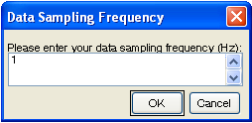
Figure 6. Data Sampling Frequency input dialog

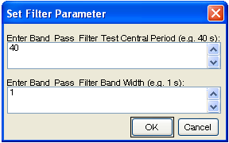
Figure 7. Set Filter Parameter for period domain filtering

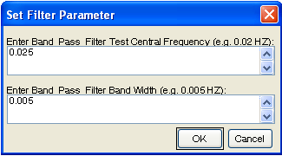
Figure 8. Set Filter Parameter for frequency domain filtering

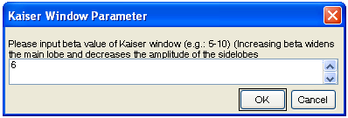
Figure 9. Set beta value for Kaiser window

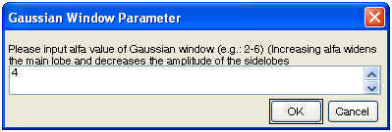
Figure 10. Set alfa value for Gaussian window

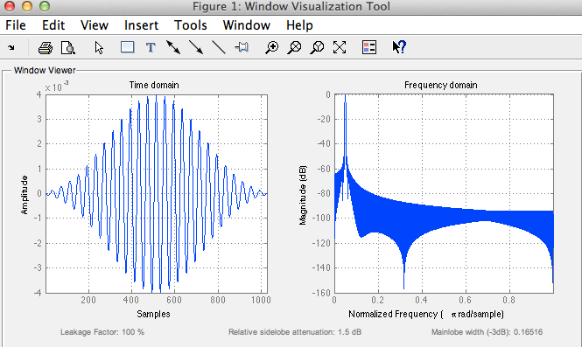
Figure 11. Example of created band-pass filter in both time domain and frequency domain

4.3 TS Settings
4.3.1. Set Wave Type: choose either ‘Rayleigh Wave’ or ‘Love Wave’ in the pop-up menu. If ‘Rayleigh Wave’ is chosen, a group velocity window [2.5 5] km/s is used to extract the Rayleigh wave trains from the entire input waveform for the two-station analysis; if ‘Love Wave’ is chosen, a group velocity window [3 5.5] km/s is used to extract Love wave trains. The two windows are basically suitable for the regional two-station analysis in the period band 15-200 s. If you want to modify this wave window for some particular case, please check the function ProcessIndex = GroupImageArrival (hObject, handles) in the TSAnalysis.m and modify the array GVWinR = [2.5 5] (for Rayleigh waves) or GVWinL = [3 5.5] (for Love waves) to your desired value, e.g., GVWinR = [2.0 5.5]. If you choose ‘Rayleigh Wave’, the input waveform data should be the vertical component. For ‘Love Wave’, we use the transverse component data, which is transformed from S-N and E-W component data.
4.3.2. Set Period Range for the two-station analysis: you need to input the start period (Start T) Ts, the end period (End T) Te, and the period interval (Delta T) dT in the edit boxes. The unit for the inputs is sec. For example, if Ts = 20 s, Te = 100 s and dt = 1 s, you are expecting to obtain the phase velocity dispersion curve from 20 s to 100 s with 1 s interval.
4.3.3. Set the folder containing all the dispersion data: click the 3. Disper Data Folder button, select the folder which will store all the obtained dispersion data in the two-station analysis, as shown in Figure 12. You can choose the ./DisperData or any other folder.

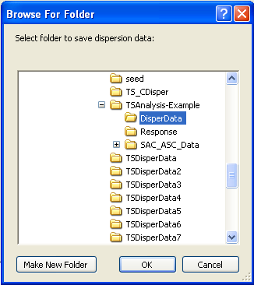
Figure 12. Browse for folder to save dispersion data file

4.3.4. Set the two maximal deviation angles alfa and beta (deg) for two-station paths as shown in Figure 13. The default values for alfa and beta are 3º and 5º. User may take the default values or define their own values for the selection of two-station paths.
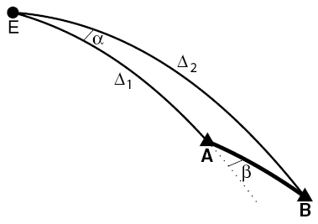

Figure 13. Illustration of two deviation angles α and β defined in the TS method: α is the azimuthal difference of the earthquake (E) to the two stations (A and B, with A nearest to the earthquake); β is the azimuthal difference between the earthquake (E) to the station A and the station A to the station B. The solid lines are all great-circle paths and the dashed line is the extended great-circle path from E to A. Δ₁ is the great-circle distance between E and A and Δ₂ is the great-circle distance between E and B (from Yao et al., 2006, GJI).

4.4 Processing
There are two modes for the two-station data processing: O All Data mode and O Selected Data mode. The default is all data mode, in which the processing will start from the first station (e.g., KMI in Figure 14) to the last station (MC12 in Figure 14) in the data list file. If you choose the selected data mode, you have to specify the ‘for loop’ (Matlab Scripts) as shown in Figure 15.

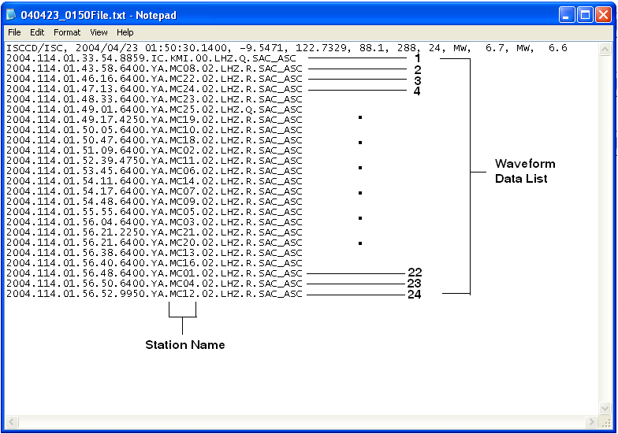
Figure 14. Waveform Data File list

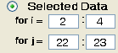
Figure 15. Example of inputs for the selected data mode in the two-station analysis

The detailed procedure for the two-station analysis is shown as following:

Here, i and j are the indexes for the stations shown in the waveform data file list (Figure 14). StartIndex1 = 1, EndIndex1 = N-1, StartIndex2 = 2, and EndIndex2 = N, for the all data mode, in which N is the total number of stations in the waveform data list file. For the selected data mode, StartIndex1, EndIndex1, StartIndex2 and EndIndex2 take value from the edit box in Figure 15.

for i = StartIndex1:EndIndex1
for j = StartIndex2:EndIndex2
Read i_th and j_th waveform data file names in the waveform data file list (Figure 14)
if ( Station (i) & Station(j) satisfy the two-station criterion )
(alfa ≤ 3º , beta ≤ 5º, epicenter distance > 1000 km)
Read waveform data for Station(i) & Station(j) and remove the mean
Remove instrument response for the waveform data
if ( the waveform data is enough long for both stations (at least containing
surface wave trains in the group velocity window set in 4.3.1)
1.Extract wave trains in the group velocity window for both stations. The extracted waveforms for both stations are shown in Fig.2 Box, e.g. Figure 16
2.Band-pass filter the extracted waveforms in the periods Ts : dt : Te and get the surface wave group travel time at each period, corresponding to the point of the maximal amplitude on the wave envelope of the band-pass filtered waveform. A group travel time image will be plotted, e.g., as shown in Figure 17. This figure will be closed automatically after 0.5 sec. The group travel time image is a very important index to check the quality of the waveform data. The waveform data without much contamination usually has a clear and continuous group travel time curve (e.g., the broad red band in Figure 17).
3.Moving-window process: window the extracted waveform with a 4*T seconds boxcar window centered at the group travel time for each period T and a Gaussian taper besides the boxcar window in order to eliminate the contamination of other phases or noises, then band-pass filter the windowed waveform again. A new group travel time image will be plotted, e.g., as shown in Figure 18, which will be much cleaner than Figure 17.
4.Cross-correlate the windowed and band-passed waveforms for two stations at each period. The cross-correlation wave train (shift time v.s. correlation amplitude) will be interpolated to a phase_velocity-amplitude wave train using c = (Δ₂ –Δ₁)/t, where c is the phase velocity, t is the shift time, (Δ₂ –Δ₁) is the propagation distance. Then we construct the phase velocity – period (c-T) image in Fig. 2 Box (Figure 19) by combining all the phase_velocity-amplitude wave trains at all periods. For the detail of this image transformation, please check the listed references in 1. Overview.
5.Pick and save the dispersion data: you can choose to pick or do not pick the dispersion curve, shown as the question dialog in Figure 19. If you choose ‘Yes’, you need to left or right click at the brown area (high correlation value) with typical phase velocity dispersion characteristics on the Fig. 2 Box to select the right dispersion curve! You can pick multiple points to better constrain the position of the dispersion curve, with left click to start and right click to finish. If you only want pick one point, you can simply make a right click. After you make a successful click ( + shown on the Fig. 2 Box in Figure 20), a dispersion curve (the black line in Figure 20) will be automatically traced. Each point on this curve corresponds to the local maximum of the cross-correlation of the band-pass filtered waveforms at each period. On Figure 20, you also need to input the start and end period (shown as the input dialog on Figure 20) of the dispersion data you want to save, because sometimes the dispersion curve is only good (or reliable) in certain period bands, e.g., only in 35-100 s, but not good (not continuous, noisy) in 20-35 s and 100-120 s. After you successfully input the start and end periods, you can press the ‘OK’ button to continue and Figure 21 will appear to you, on which the red ‘+’ points are the dispersion data points ready to be saved. You will also see a question dialog on Figure 21 which asks you whether you want to revise the dispersion curve or not. If you press the ‘Yes’ button, it will goes back to Figure 19 for your re-pick the dispersion curve. If you press the ‘No’ button, the red ‘+’ dispersion points will be saved automatically in the file. After the dispersion file is saved, the correspondent two-station ray path is plotted in red color on Fig.1 Box and the associated two stations are plotted in green. (After the next dispersion curve for another two-station pair is ready to be saved, the previous ray path in red will be re-plotted in blue and the color of previous two stations will become red again. Only the current processing two-station ray path is in red and the associated two stations are in green, as shown in Figure 22.)
end (if)
end (if)
end (for)
end (for)

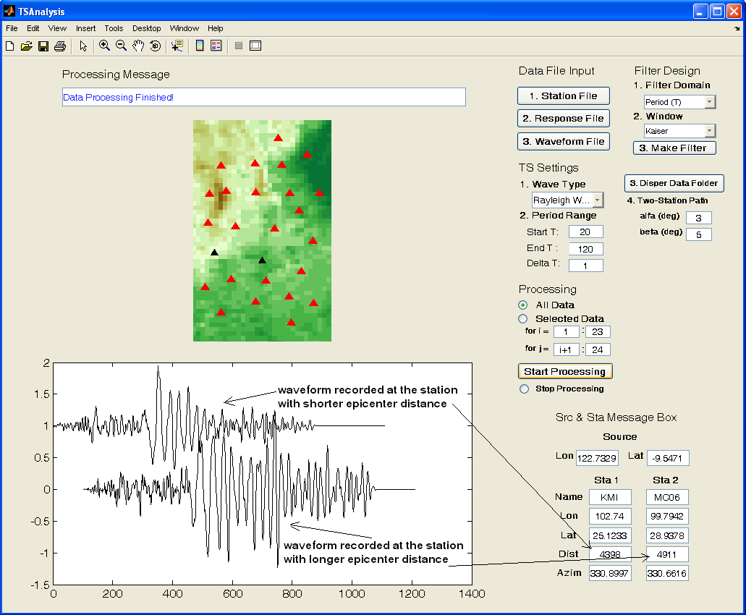
Figure 16. The extracted waveforms in the surface wave window recorded at both stations for cross-correlation analysis

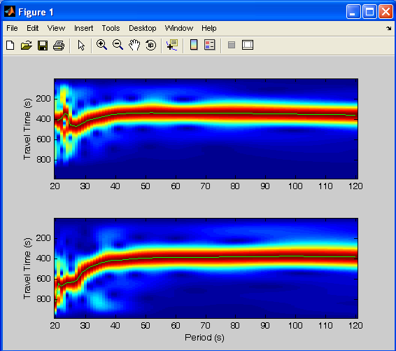
Figure 17. Group travel time image of the extracted waveforms for two stations shown in Figure 16. Red shows high amplitude of the normalized wave envelope at each period, while blue shows low amplitude. The group travel time curve is shown as the green line in each plot.

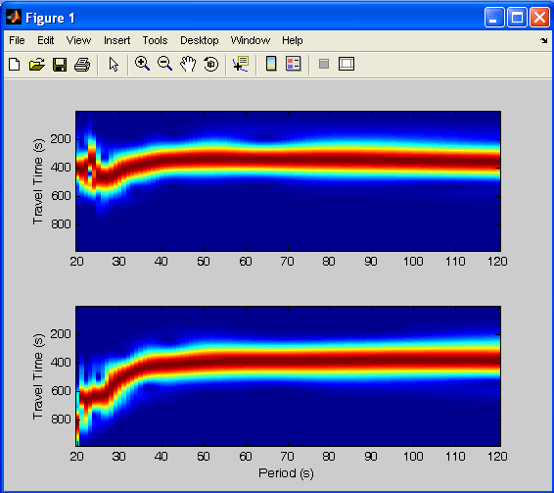
Figure 18. Group travel time image after applying moving-window process, which mainly contains the desired surface wave part and (successfully) removes other phases and noise signal shown in Figure 17.

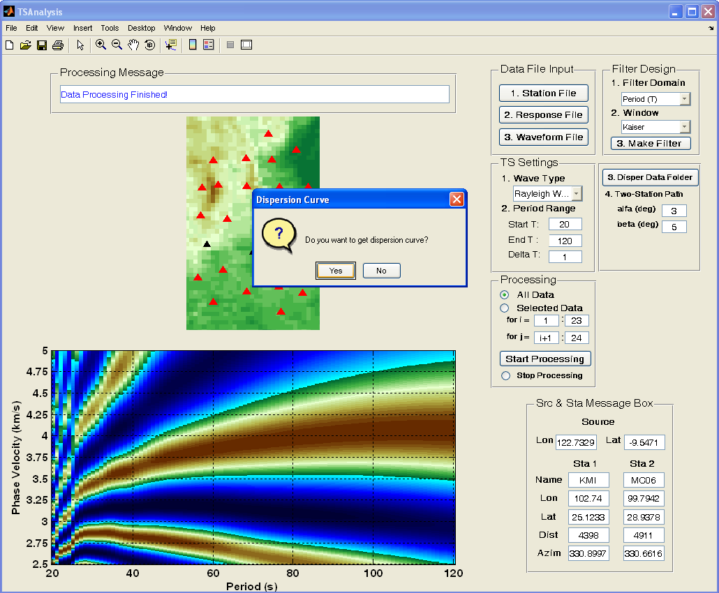
Figure 19. The constructed phase velocity – period (c-T) image in Fig. 2 Box. Brown shows high correlation value and blue shows low correlation value.

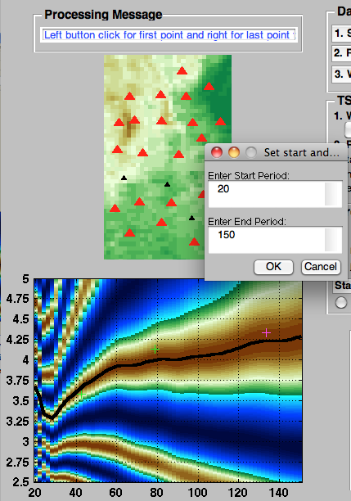

Figure 20. Dispersion curve picking: the green and magenta + shows the positions where you click on the c-T image. You can pick multiple points to better constrain the position of the dispersion curve, with left click to start and right click to finish. If you only want pick one point, you can simply make a right click. the black line is the dispersion curve automatically traced from the crosses. On this figure, you also need to input the start and end period of the dispersion data to be saved, as shown in the input dialog.

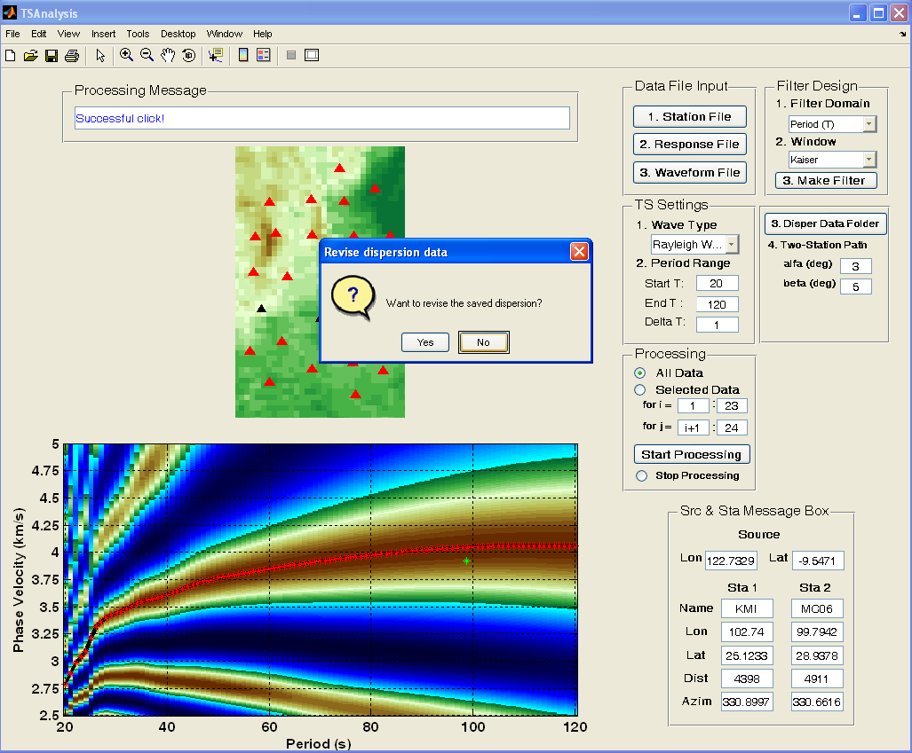
Figure 21. Dispersion data points (red +) ready to be saved in the data file.

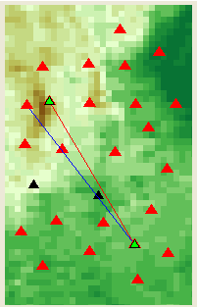
Figure 22. Two-station ray path distribution: the blue ray path is for the two-station path which has already been processed, while the current processing two-station ray path is in red and the associated two stations are in green.

Some Important Notes:

1. Name and format of dispersion file: The name of the saved dispersion file is like ‘C040423_0150KMI-MC05.dat’, in which ‘C’ means phase velocity, ‘040423_0150’ is the source time with the format ‘YYMMDD_HHMM’, ‘KMI-MC05’ is the two-station pair name with the format ‘StaName1-StaName2’, and ‘.dat’ is the file extension. Here ‘StaName1’ and ‘StaName2’ are in alphabetical order by the name. The format of the dispersion file is:

Station_Lon1 Station_Lat1
Station_Lon2 Station_Lat2
Period_1 Phase_Velocity_1
Period_2 Phase_Velocity_2
…… ……
The unit for period is second and the unit for phase velocity is km/s.

2. How to choose the right dispersion curve: We basically know the phase velocity dispersion curve for global 1-D model, e.g., ak135, or for regional structure from your prior information (Figure 23). So it is not very hard for us to determine which branch of the high correlation area (e.g., in Figure 20) is the most possible dispersion curve. We usually determine this from the longer periods, at which the peak correlation point for each branch is quite far away from each other and the 2π phase ambiguity can be relatively easily resolved. This is not always true if longer period surface waves are contaminated by unknown noise or surface waves from other events. In this case, it is extremely dangerous for the dispersion pick. Since longer periods Rayleigh wave phase velocities are generally sensitive to shear velocities in a broad depth range (around λ/3 depth range) in the upper mantle (Figure 24), and also because upper mantle is generally more homogeneous than the crust, you will expect a smoother dispersion curve at longer periods (e.g., > 80 s). And in most cases, phase velocity increases as period increases, especially for intermediate and longer periods (e.g., > 40 s). Therefore, then you see phase velocities decreases at longer periods, you should be very careful about the reliability of the results and need to check whether the recorded surface waves are contaminated by other phases. In very short period bands (< 25 s), the phase velocity is mainly sensitive to the (very) heterogeneous crustal structure and the scattering may be very strong, which may probably give you complicated dispersion curves. We can refer to Figure 17 about the quality of the group travel time image and determine whether or not we should pick the dispersion curve. If group travel time image seems noisy and the group travel time (red area) jumps a lot, you should be very careful about the picking of the dispersion curve. Sometimes, in certain period band the dispersion curve seems quite good, but in other period bands, especially at shorter (e.g., < 30 s) and longer (e.g., > 150 s) periods, sometimes it seems noisy or weird. Then in this case you can only choose to save the dispersion data in one reliable period band. Users may try another data set in ./SAC_ASC_Data/040630_2337/ to see how weird the dispersion curves are. It is very likely the surface wave data is contaminated by other phases in some period bands. I give several examples in Figure 25, from which users may get some idea about how the real data is like. The right pick of the dispersion curve is based on the prior information and your data processing experience. This code only provides you a good tool to analyze it. Therefore, please be careful if you are new to the surface wave analysis.

3. Half-wavelength Criterion : As stated in Yao et al., (2006, GJI), I use a half-wavelength criterion to save the dispersion data. The half-wavelength criterion is that we require the surface wave propagation distance between two stations (Δ₂ –Δ₁) has to be at least half of the wavelength (λ= c(T ) T). Therefore, the shorter the interstation distance is, the shorter the period is at which we can obtain the dispersion data. Actually in the band-pass filtering of the two-station waveforms, the longest period for the band-pass filtering is set to be the minimum between 2*(Δ₂ –Δ₁)/2.5 and the end period as inputted in Figure 20, in order to reduce the computational time for shorter two-station paths.

4. Stop the data processing: Below the Start Processing button, there is a O Stop Processing radio button, where you can click to stop the data processing when some unexpected error happens. If you want restart the processing, you can just press the Start Processing button.

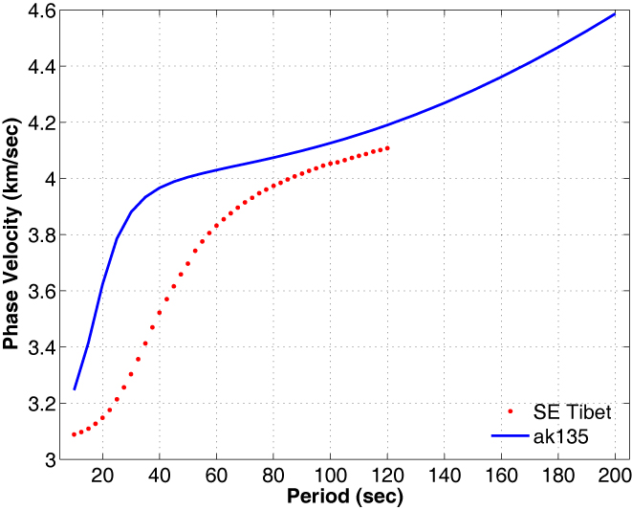
Figure 23. Example of dispersion curves for the global model ak135 (blue line) and for the southeastern Tibet (red dots, measured from two-station analysis and ambient noise analysis)

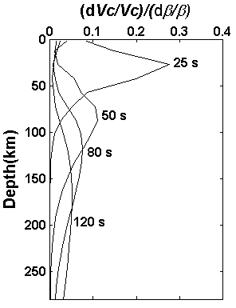
Figure 24. Depth sensitivity kernel to shear velocity (β) for Rayleigh wave phase velocities (Vc) at different periods

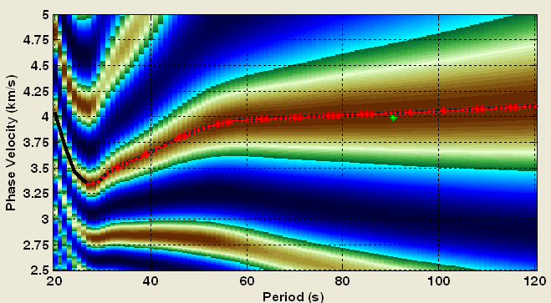
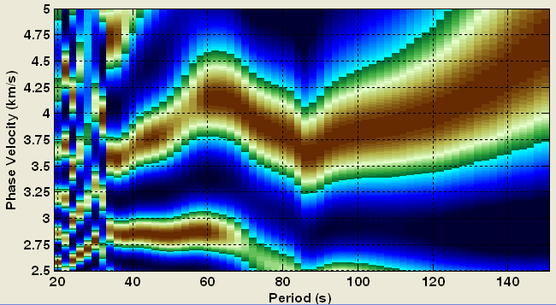
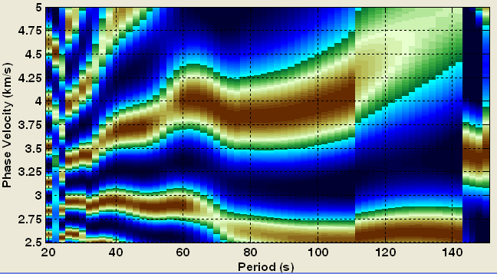
Figure 25. Some phase velocity – period (c-T) images: the phase velocity measurements for the first one seems quite good in the period band 28-120 s (shown as red +), while at shorter period bands (< 28 s) it seems not reliable; the second and third ones seem very suspicious.

5. Displaying problems
For linux or mac system, you may see the following interface (Fig. 26) when you run the codes,
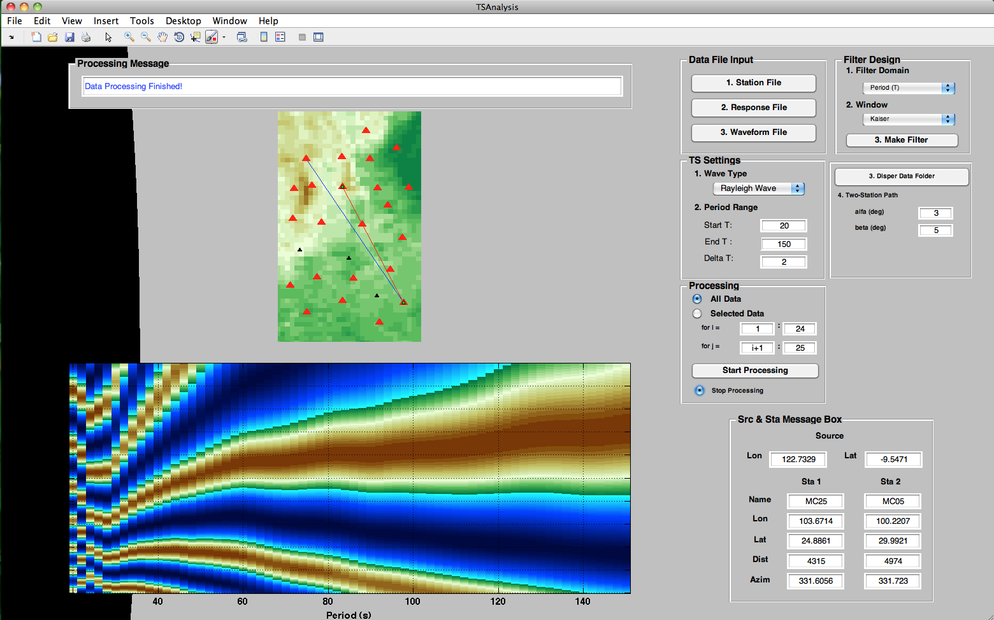
Fig. 26. Displaying problem
but you can resize the interfac like this to avoid this annoying issue. I haven’t figured out why it happens.
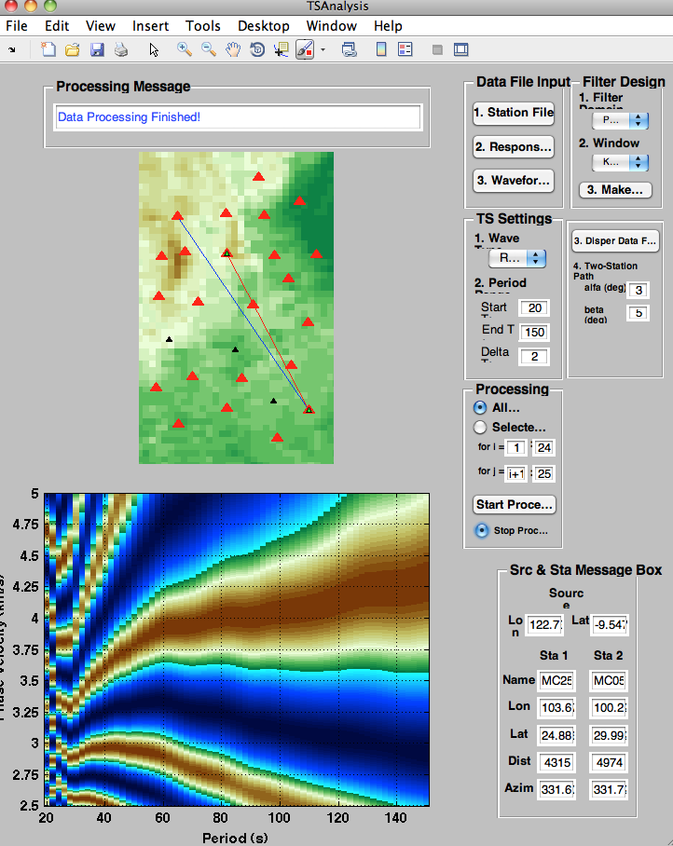

6. User’s Feedback

If you have any questions or problems when using this software, please feel free to let me know. I will appreciate if you can find out some bugs in the codes, or provide innovated ideas to modify the codes, or find some errors in this User’s Guide. I hope this software can be a great help for you research. For the updating of this software, please contact me via email (huajianyao@gmail.com).

