**NENS 230: Analysis Techniques for Neuroscience using MATLAB**Fall 2011

**Assignment Four:** Plotting Spike Rasters and Peristimulus Time Histogram

**DUE DATE:** 7pm, Tuesday, October 25th

**Please submit this assignment to** [**nens230@gmail.com**](mailto:nens230@gmail.com)**, with the subject line “hw4”. A detailed assignment description is below, but in short, you will submit everything in your Assignment4 directory. Specifically we are looking for your *MakeReachingFigure.m, drawPSTH.m*, *drawRasters.m*, and *addShadedEpoch.m* functions as well as a figure for channel 16 of the data in .fig format. You should send these files in a single (zipped) folder attached to your email called hw4_SUID where SUID is your SuNET ID (e.g. sstavisk).**

In this assignment you will draw upon what you’ve learned about creating and manipulating graphics objects to build a complex multi-pane figure piece by piece. You will be provided with neural data consisting of spike times recorded from a macaque performing arm reaches to targets. You will make a function that lets you clearly visualize the neural data from any electrode. This function will create a figure consisting of subplots for each experimental condition (reach direction) which show the spike times during each trial in the form of spike rasters and also the across-trial average firing rate for each time bin in the form of a peristimulus time histogram. To make the figure more informative, you will add useful lines, epoch of interest shading, and a text annotation.

The goal of this assignment is to practice creating and manipulating graphics objects to instantiate a specific type of data visualization.

***Brief neuroscience background***

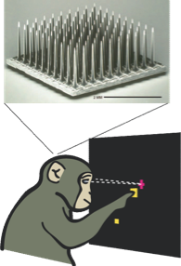

**Figure 1: Cartoon of the experimental setup. A macaque makes reaches from a central hold target to one of eight radial targets while spiking activity is recorded from a 96-channel array implanted in M1 cortex.   
(from Afshar et al, 2011, *submitted)***

In order to test hypotheses about how populations of neurons represent and manipulate information in order to perform a task, systems neuroscientists will record the firing activity of one or more neurons while an animal is performing a task. In the subfield of motor control, experimenters often will use a multichannel array to simultaneously record from many cortical neurons (typically in layers 2 to 4) while a non-human primate performs a motor task such as making precise reaches from one location in space to another. Many neurons in the primary motor cortex (M1) will exhibit marked changes in firing rate during a reaching trial, and the degree of modulation will depend on parameters of the arm movement, such as its direction or speed.

In this exercise, you will be provided data recorded from a macaque that has made repeated reaches from a central start point to one of eight radially located targets. In this data, the monkey made twelve reaches in each of the 8 directions. You are provided the spike times (at 1ms resolution, with t=0 being the start of the trial) for each trial on by each of the 96 electrodes of an array located in M1 region of the cortex. In these trials the target appears 50ms after trial onset. The trial ends after the money’s finger reaches the target and stays there for 500ms. Thus, a typical trial will be 800-1200ms long, during which time each electrode may record anywhere between zero and ~100 spikes.

At the level of analysis of these experiments, we generally treat action potentials as discrete events (fully characterized by their time of occurance) and do not care about the voltage trace or spike waveform. Therefore a common way of displaying the data for a given neuron is with a **spike raster plot** in which time (relative to trial start) is on the horizontal axis, and the times of spikes are denoted with tick marks. Each trial is displayed on a single row, and different experimental conditions are typically plotted in different subplots. Raster plots present all of the neural data in a compact form.

Furthermore, many motor neuroscientists believe that the activity on a single trial of a neuron is a noisy estimate of an underlying firing rate which is a more accurate readout of what information processing the neuron is doing. Therefore, **peristimulus time histograms** (PSTHs) bin the spikes recorded in a given time bin across all trials of a certain condition to provide a trial-averaged estimate of the hypothetical time-varying underlying firing rate. PSTHs can display either the absolute number of spikes in the bin (averaged across trials), or be normalized by the bin time to provide an estimate of the firing rate in hertz; in this assignment, you will do the latter.

*Note to the curious:* You may be wondering why each electrode records from exactly one neuron. In truth, we are using a very crude form of spike detection consisting of thresholding crossings without waveform sorting. Thus, many of these “crossing events” may come from different neurons. Remarkably, some groups have found that decoding reach kinematics from this noisy neural activity turns out to be more accurate than decoding well-sorted single-neuron activity.

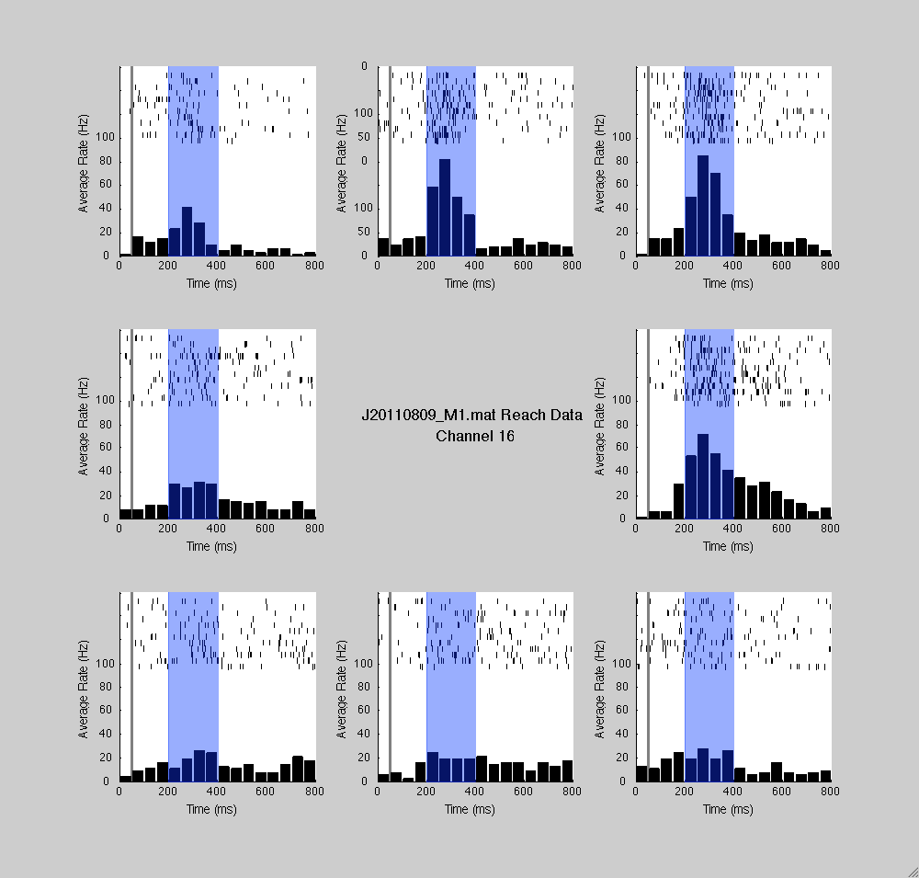

Figure 2: Example of the type of figure your program will generate. Each subplot shows the spiking activity recorded on electrode 16 of the multielectrode array from twelve trials as well as average firing rate in successive 50ms bins. This neuron shows increased firing during rightward reaches.

***Detailed Instructions***

Copy the Assignment 4 directory to your MATLAB directory. It contains the data you will need as well as incomplete functions to help you make the desired figure.

You are trying to write a function MakeReachingFigure(filename,chan)which will load the neural data in file specified by <filename> and will generate a comprehensive figure showing the data from electode <chan>.

You will see an example figure; use this as your guide for what your code should produce. Basically, you want it such that when you call  
figh = MakeReachingFigure( 'J20110809_M1.mat', 16 )  
a figure similar to the one provided is generated.

You want to organize your figure such that each subplot shows the data from the trials in which the subject reached in the corresponding direction (e.g. top-right subplot shows the data for the up-right “NE” trials). Each subplot should consist of a single axis. This axis will contain spike rasters from each trial (ordered with the first trial on top) above a PSTH showing the firing rate as calculated from 50ms bins. You should display data only from the first 800ms of each trial.

To make these plots more readable, you will also add a vertical gray line to mark the target onset time (t=50ms). Furthermore, since the bulk of the arm movement happens between t=200 and t=400ms, you will shade this epoch of interest in blue.

Finally, you will annotate the figure by putting text in the central subplot that specifies the filename of the data and the channel whose data is being plotted.

You will find that a lot less code is already provided compared to previous assignments (but there are still many comments to guide you). In some ways this makes the assignment harder, but on the other hand you don't have to worry as much about following the instructors’ logic. A good approach to doing this assignment is to step through the code using the debugging tools we've shown you, and then work on it by adding line after line to get each piece of the program working. Remember that at the end of the day you just need to make the figure; if you want to go with a different organization that is fine. As long as the code you submit makes the figure, your assignment is complete.

You will notice that the provided (incomplete) **MakeReachingFigure.m** function calls several other functions:  
**drawRasters.m** (draws spike rasters in the specified subplot; it is incomplete).

**drawPSHT.m** (adds a PSTH to the specified subplot; it is incomplete).

**addShadedEpoch.m** (shades an epoch of the specified subplot; no partial code for this function is provided, you will need to make this from scratch).

You are also provided a function **binSpikeTimes.m,** which does bins the spikes for you. This function works as is and you do not need to modify it.

When your program is complete, it’s very easy to call it for other channels besides channel 16 and immediately see the data for these channels. You’re encouraged to poke around and look at some of the other channels; 3, 47, 83, and 95 are also well-tuned and interesting to look at.

The figure below may be useful to understand the organization of the reachingData structure’s .spikeTimes field:

