**How are JavaScript and ECMA Script related?**

ECMA Script are like rules and guideline while Javascript is a scripting language used for web development.

**What is the role of break and continue statements?**

Break statement is used to come out of the current loop while the continue statement continues the current loop with a new recurrence.

**What is the difference between .call() and .apply()?**

The function .call() and .apply() are very similar in their usage except a little difference. .call() is used when the number of the function's arguments are known to the programmer, as they have to be mentioned as arguments in the call statement. On the other hand, .apply() is used when the number is not known. The function .apply() expects the argument to be an array.

The basic difference between .call() and .apply() is in the way arguments are passed to the function.

**Describe the properties of an anonymous function in JavaScript?**

A function that is declared without any named identifier is known as an anonymous function. In general, an anonymous function is inaccessible after its declaration.

**Explain the for-in loop?**

The for-in loop is used to loop through the properties of an object.

**What is break and continue statements?**

Break statement exits from the current loop.

Continue statement continues with next statement of the loop.

**What are callbacks?**

A callback is a function that will be executed after another function gets executed.  
  
they can be used as an argument of another function, can be returned by another function and can be used as a property of an object.  
  
**Functions that are used as an argument to another function are called callback functions.**

**What is recursion in a programming language?**

Recursion is a technique to iterate over an operation by having a function call itself repeatedly until it arrives at a result.

**What is the use of a constructor function in javascript?**

Constructor functions are used to create objects in javascript.  
  
When do we use constructor functions?  
  
If we want to create multiple objects having similar properties and methods, constructor functions are used.

Constructor functions allow us to group similar objects.

**What are arrow functions?**

Arrow functions were introduced in the ES6 version of javascript.  
  
They provide us with a new and shorter syntax for declaring functions.  
  
Arrow functions can only be used as a function expression.

Arrow functions are declared without the function keyword. If there is only one returning expression then we don’t need to use the return keyword as well in an arrow function as shown in the example above. Also, for functions having just one line of code, curly braces { } can be omitted.

If the function takes in only one argument, then the parenthesis () around the parameter can be omitted

The biggest difference between the traditional function expression and the arrow function, is the handling of the **this**keyword.  
By general definition, the **this**keyword always refers to the object that is calling the function.  
In the arrow functions, there is no binding of the **this**keyword.  
  
The **this**keyword inside an arrow function, does not refer to the object calling it. It rather inherits its value from the parent scope.

### What is the use of promises in javascript?

**Promises are used to handle asynchronous operations in javascript like server requests**  
  
Before promises, callbacks were used to handle asynchronous operations. But due to limited functionality of callback, using multiple callbacks to handle asynchronous code can lead to unmanageable code.  
  
Promise object has four states -

* Pending - Initial state of promise. This state represents that the promise has neither been fulfilled nor been rejected, it is in the pending state.
* Fulfilled - This state represents that the promise has been fulfilled, meaning the async operation is completed.
* Rejected - This state represents that the promise has been rejected for some reason, meaning the async operation has failed.
* Settled - This state represents that the promise has been either rejected or fulfilled.

A promise is created using the **Promise**constructor which takes in a callback function with two parameters, **resolve**and **reject**respectively.

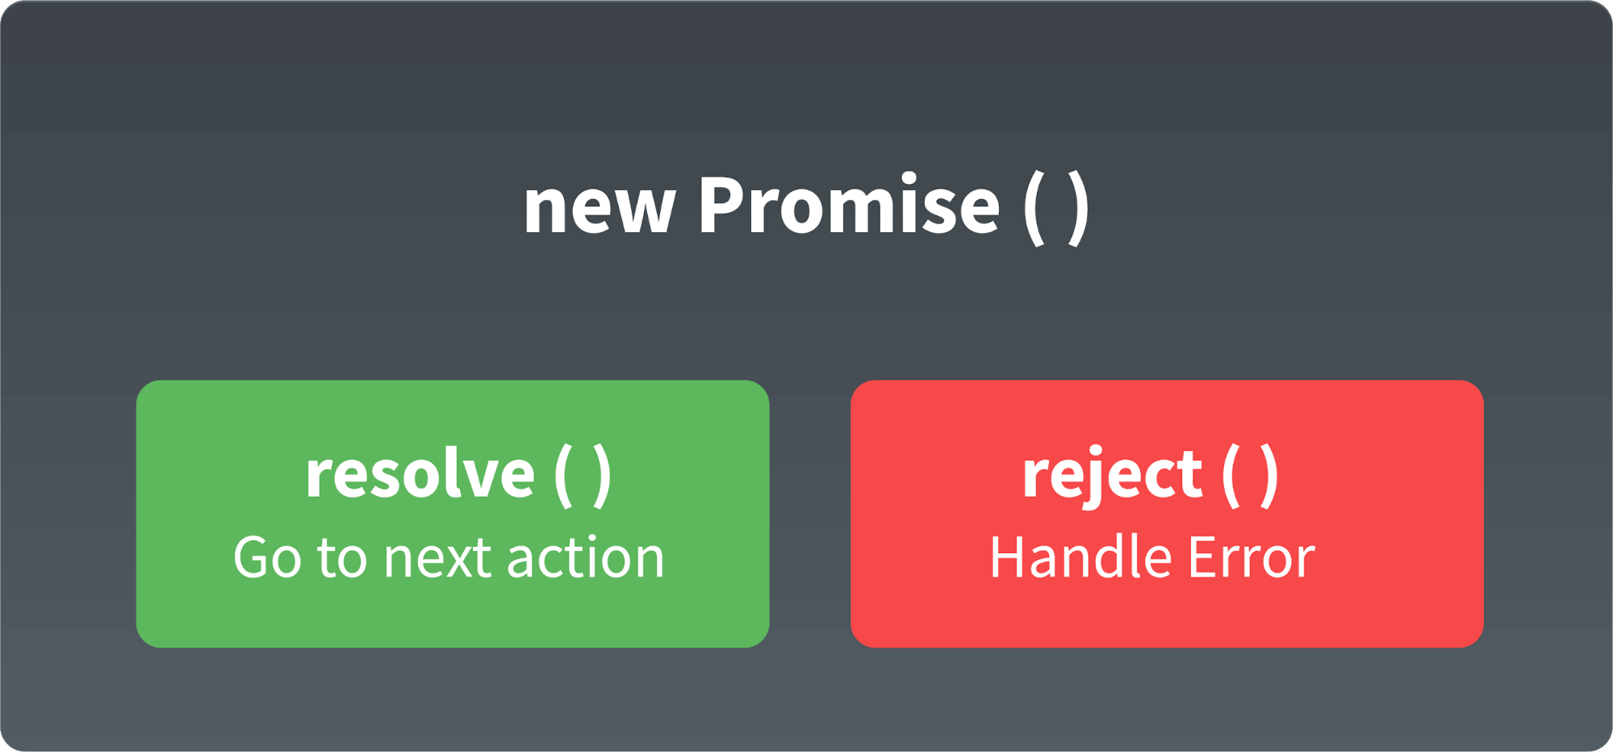

**resolve**is a function that will be called, when the async operation has been successfully completed.  
  
**reject**is a function that will be called, when the async operation fails or if some error occurs.  
  
We can consume any promise by attaching then() and catch() methods to the consumer.

**then()**method is used to access the result when the promise is fulfilled.  
  
**catch()**method is used to access the result/error when the promise is rejected.

### What are classes in javascript?

Introduced in the ES6 version, classes are nothing but syntactic sugars for constructor functions.  
  
They provide a new way of declaring constructor functions in javascript.

* Unlike functions, classes are not hoisted. A class cannot be used before it is declared.
* A class can inherit properties and methods from other classes by using the extend keyword.
* All the syntaxes inside the class must follow the strict mode(‘use strict’) of javascript. Error will be thrown if the strict mode rules are not followed

### What is Object Destructuring?

Object destructuring is a new way to extract elements from an object or an array.

### ****What are the data types supported by JavaScript?****

* Undefined
* Null
* Boolean
* String
* Symbol
* Number
* Object

### ****What is the purpose of ‘This’ operator in JavaScript?****

The JavaScript **this** keyword refers to the object it belongs to. This has different values depending on where it is used. In a method, this refers to the owner object and in a function, this refers to the global object.

### ****What is the difference between Local storage & Session storage?****

**Local Storage** – The data is not sent back to the server for every HTTP request (HTML, images, JavaScript, CSS, etc) – reducing the amount of traffic between client and server. It will stay until it is manually cleared through settings or program.

**Session Storage** – It is similar to local storage; the only difference is while data stored in local storage has no expiration time, data stored in session storage gets cleared when the page session ends. Session Storage will leave when the browser is closed.

**Session Storage:**

It stores data of current session only. It means that the data stored in session storage clear automatically when the browser is closed.

**Local Storage:**

Local storage is another type of HTML5 Web Storage. In local storage, data is not deleted automatically when the current browser window is closed.

### ****What is the purpose of using alternative texts in images?****

The required alt attribute specifies an alternate text for an image, if the image cannot be displayed.

The alt attribute provides alternative information for an image if a user for some reason cannot view it (because of slow connection, an error in the src attribute, or if the user uses a screen reader).

The purpose of using alternative texts is to define what the image is about. During an image mapping, it can be confusing and difficult to understand what hotspots correspond to a particular link. These alternative texts come in action here and put a description at each link which makes it easy for users to understand the hotspot links easily.

Атрибут alt устанавливает альтернативный текст для изображений. Такой текст позволяет получить текстовую информацию о рисунке при отключенной в браузере загрузке изображений. Поскольку загрузка изображений происходит после получения браузером информации о нем, то замещающий рисунок текст появляется раньше. А уже по мере загрузки текст будет сменяться изображением.

The alt attribute sets the alternate text for the images. This text allows you to get textual information about the image when the image download is disabled in the browser. Because images are loaded after the browser receives information about them, the replacement text appears earlier. And already in process of loading the text will be replaced by the image.

**16) Does a hyperlink apply to text only?**

No, hyperlinks can be used in the text as well as images. That means you can convert an image into a link that will allow users to link to another page when clicked. Surround the image within the <a href=” “>…</a> tag combinations.