

**SE – OVERVIEW OF THE IT INDUSTRY**

**ASSIGNMENT – 1**



**SUBMITTED BY:**

MADHURI MISKIN

**SUBMITTED TO:**

CHINMAYEE MAM

**FULL STACK DEVELOMENT | TOPS TECHNOLOGIES**

**Software Engineering Assignment**

**MODULE: 1 (SDLC)**

1. **What is software? What is software engineering?**

* **Software:**
* Software means a set of code/programs (sequence of instructions) that allows the users to perform a well-defined function or some specified task.
* In another words we can say that software commands the computer that what to do. For example like MS-Word, MS-Excel, PowerPoint, etc.
* Different high-level languages are used to build application software.
* **Software Engineering:**
* Software Engineering means to develop software with designing principle of Engineering,
* Software Engineering is working for the process of designing, developing, testing, and maintaining software.
* Software engineering applies a disciplined and organized approach to software development with the stated goal of improving quality, time and budget

1. **Explain types of software**

a) System software

b) Application software

c) Driver software

d) Middleware

1. **System Software:**

* System software which is provided by System.
* In simple terms, you can say that the system acts as a middle man that checks and facilitates the operations flowing between the user and the computer hardware.
* System software is also known as "low-level software" because the end-users do not operate them. e.g notepad, clock , etc.

1. **Application Software:**

* Software developed or provided by developers. e.g whats app, instagram, facebook, M.s excel.
* Application software which we have to purchase it for our computer and after that you can use that application.
* Some of the well-known examples of application software are Microsoft Word, Excel and search engines like Opera and Google Chrome.

1. **Driver software:**

* Driver software is same as system software,
* Device should connected to a computer needs at least one device driver to function.
* Some common examples of such device drivers that connect hardware devices
* (Printers, sound cards, network cards, hard disks, floppy disk, keyboard, mouse, etc.) To a system.

1. **Middleware:**

* Middleware is software that bridges gaps between other applications, tools, and databases in order to provide unified services to users.
* Data management, application services, messaging are all commonly handled by middleware.

1. **What is SDLC??? Explain each phase of SDL.**

* SDLC means Software Development Life Cycle.
* The software development lifecycle (SDLC) is the cost-effective and time-efficient to development/build high-quality software.
* A step by step approach to develop a software with high quality, at lowest cost with shortest possible time.

**Time line + Budget + Quality = SDLC**

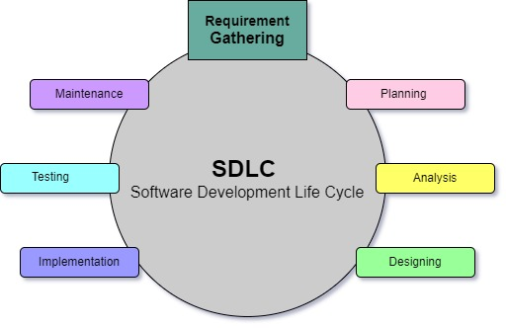

**SDLC describe as below,**

1. Planning / Requirement Gathering (What)
2. Analysis (How)
3. Designing (DFD, E-R Diagram, Use case , Flow chart)
4. Implementation/ Coding/ Building (hardware & software requirement)
5. Testing (QA)
6. Maintenance

🡪**Planning / Requirement Gathering (What):**

* The planning includes tasks like cost-benefit analysis, scheduling, estimation, and allocation.
* The development team collects requirements on behalf of customera from several stakeholders, internal and external experts, and managers to create a software requirement specification document.

🡪**Analysis:**

* The team analysis estimates costs, creates a schedule, and has a detailed plan to achieve their goals.
* The document sets expectations and defines common goals that aid in project planning.

🡪 **Designing:**

* In the design phase, software engineers analyze requirements and identify the best solutions to create the software.

🡪 **Implementation/ Coding/ Building (hardware & software requirement):**

* In the Analysis phase, the development team codes the product.
* They analyze the requirements to identify smaller coding task to achieve the final result.

**🡪 Testing (QA):**

* Quality analysis includes testing the software for errors and checking if it meets customer requirements.
* Because many teams immediately test the code they write, the testing phase often runs parallel to the development phase.

🡪 **Maintenance:**

* In the maintenance phase, the team fixes bugs, resolves customer issues, and manages software changes.
* In addition, the team monitors overall system performance, security, and user experience to identify new ways to improve the existing software.

1. **What is DFD? Create a DFD diagram on Flipkart.**

* A data flow diagram (DFD) is a graphical representation of data flow through a system. DFD diagram creat to understand how data is processed, stored, and communicated within a system. It’s also called a bubble chart.
* Also known as DFD, Data flow diagrams are used to graphically represent the flow of data in a business information system.
* Data flow diagrams can be show as logical and physical.
* The logical data flow diagram describes flow of data through a system to perform functionality of a business and
* The physical data flow diagram describes the implementation of the logical data flow.

🡪 **DFD Diagram for Flipkart.**

**Level – 0 DFD Diagram for Flipkart**

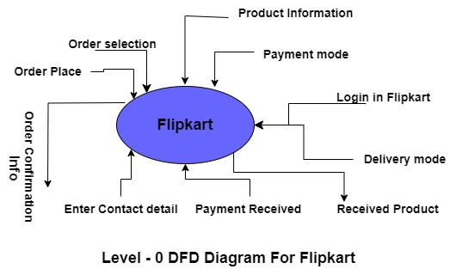

**Level – 1 DFD Diagram for Flipkart**

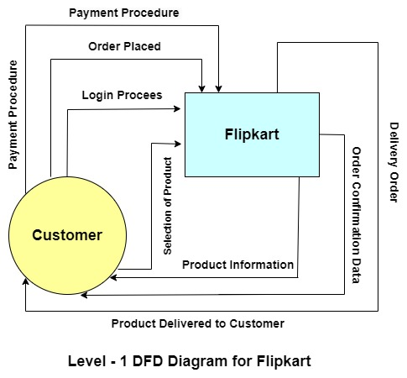

**Level – 2 DFD Diagram for Flipkart**

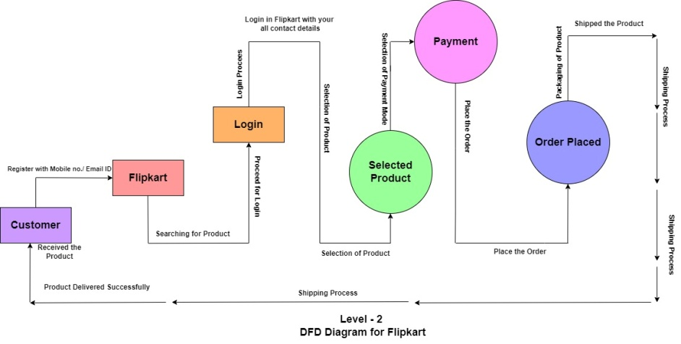

1. **What is Flow chart? Create a flowchart to make addition of two numbers.**

* Flowchart diagram represents a workflow or process. It describes a process with a fixed sequence of steps and Work flow step-by-step in an understandable way.
* It also defines a number of procedures, including administrative, service, and project planning procedures as well as manufacturing processes.
* E.g. Different steps, decision points, and courses through a process are displayed using flowcharts, which are visual representations of processes and systems.
* A well-made flowchart should be simple to understand and show the stages in a logical order.

**A Flowchart for two numbers**

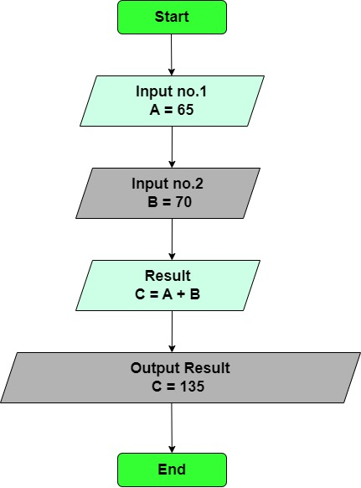

1. **What is Use case Diagram? Create a use-case on bill payment on Paytm.**

* Use case is uses for Specify the context of a system, Capture the requirements of a system and Developed by analysts together with domain experts.
* A use-case diagram can help provide a higher-level view of the system. In a Use Case Diagram, relationships play a crucial role in depicting the interactions between actors and use cases.

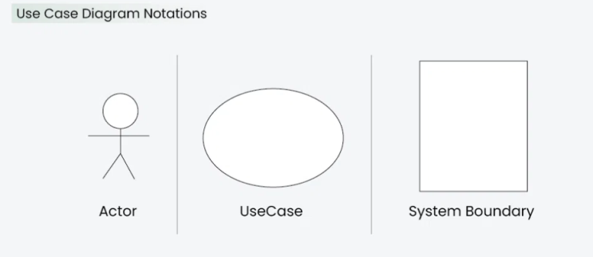

* **Actors:**
* Actors are external entities that interact with the system. These can include users, other systems, or hardware devices.
* Proper identification and understanding of actors are crucial for accurately modelling system behaviour.
* **Use Cases:**
* Use cases are like scenes in the play. They represent specific things your system can do. In the online shopping system,
* Examples of use cases could be “Place Order,” “Track Delivery,” or “Update Product Information”.
* **System Boundary:**
* The system boundary is a visual representation of the scope or limits of the system you are modelling.
* The system boundary is typically represented by a rectangular box that surrounds all the use cases of the system.
* There are two boundary as below,
* Scope Definition: Indicating which components are internal to the system and which are external actors or entities interacting with the system.
* Focus on Relevance: The diagram can focus on illustrating the essential functionalities provided by the system without unnecessary details about external entities.

