

BUSINESS VALUATION
«entity»
As of «valuation_date»

«date_of_issuance»

«engaging_party»
«title»
«company»
«city»

Description of Engagement
This valuation has been performed according to the Professional Standards of the National Association of Certified Valuators and Analysts (NACVA). According to the professional standards of the NACVA and the nature of the engagement, the valuation will determine the “fair market value” of the subject business as of «valuation_date». The purpose of this report is «purpose». Any other use of this report is not authorized, and it should be noted that the information contained in this report may not be appropriate for other uses.

Conclusion of Value
The estimate of value that results from this valuation report is expressed as a Summary Conclusion of Value. Based on the analysis described in this valuation report, the value of «entity» is «reconciled_value» as of the valuation date. This value is believed to best reflect the intended purpose for this valuation, the business, and the marketplace. The transaction has been presented as «Transaction_Type_Language»
As of the valuation date, the value consists of «assets_» in tangible operating assets and «goodwill» in intangible assets. This is not intended to propose purchase price allocation and the asset value may not represent collateral value.
This conclusion is subject to Limiting Conditions presented in Section 1.8.


Will Katz, MBA, CVA
Blue Owl Valuation, LLC
Lawrence, Kansas

Table of Contents
I. Description of Assignment 6
1.1 Subject of the Valuation Engagement 6
1.2 Summary Description of the Subject 6
1.3 Purpose and Use of Valuation Report 7
1.4 Standard of Value 8
1.5 Date of Valuation 8
1.6 Ownership and Control 9
1.7 Scope of the Engagement 9
1.8 Limiting Conditions 10
II. Survey of the Subject Company 11
2.1 Description of the Company 11
2.2 Management 11
2.3 Form of Organization 11
2.4 Restrictions on the Sale of Subject Interest 12
2.5 Prior Ownership Transactions 12
2.6 Subsidiaries and Affiliates 12
2.7 Location 12
III. Economic Conditions 13
3.1 Overview of the National Economy 13
3.2 Overview of the State/Local Economy 16
3.3 Overview of the Industry 17
3.4 Implications for the Company 19
IV. Financial Performance of the Company 20
4.1 Financial Statements 20
4.2 Financial Statement Analysis Overview 20
4.3 Historical Income Statement (and Common Size) 21
4.4 Income Statement Observations 23
4.5 Historical Balance Sheet (and Common Size) 24
4.6 Balance Sheet Observations 26
4.7 Select Ratio Analysis 26
V. Adjustments to Financial Statements--Normalization 27
5.1 Balance Sheet Normalization 27
5.2 Normalized Balance Sheet 28
5.3 Income Statement 29
VI. Valuation of the Subject—Asset Method 31
6.1 Rejected Methods 31
6.2 Adjusted Net Assets Method 32
6.3 Notes on Adjustments 32
6.4 Asset Method Valuation 32
VII. Valuation of the Subject—Income Method 33
7.1 Capitalization of Earnings Method 33
7.2 Calculation of the Benefit Stream 33
7.3 Weighted Calculation 34
7.4 Calculation of the Capitalization Rate 34
7.5 Weighted Average Cost of Capital 37
7.6 Capitalization of Earnings Valuation 37
VIII. Valuation of the Subject—Market Method 38
8.1 Dividend Paying Capacity Method 38
8.2 Completed Transaction Method 39
8.3 Market Method Using DealStats 39
8.4 Market Method Using BizComps 42
8.5 Market Method Indicated Value 42
IX. Valuation Adjustments 43
9.1 Adjustment for Control 43
9.2 Adjustment for Marketability 44
9.3 Restricted Stock Studies 44
9.4 Quantifying the Adjustment for Marketability 45
X. Reconciliation of Values 47
XI. Conclusion of Value 48

Description of Assignment

Subject of the Valuation Engagement
Blue Owl Valuation has been engaged by «engaging_party» of «company» to perform a valuation analysis for «entity» of «entity_city» (hereinafter may be referred to as “«abbreviation»”). This valuation has been performed according to the Professional Standards of the National Association of Certified Valuators and Analysts (NACVA). This report is intended to provide the users sufficient information to understand the data, reasoning, and analyses underlying the conclusion of value.

The purpose for this report is «purpose». According to the professional standards of the NACVA and the nature of the engagement, the valuation will determine the “fair market value” of the business as of «valuation_date». Any other use of this report is not authorized and it should be noted that the information contained in this report may not be appropriate for other uses.

Summary Description of the Subject
«abbreviation» «comp_description»
«abbreviation» appears to operate in NAICS code «NAICS». According to IBISWorld reporting, “«NAICS_Desc»”

Purpose and Use of Valuation Report
The purpose of this valuation report is to provide an opinion of the fair market value of «abbreviation». This value shall be in accordance with IRS Revenue Ruling 59-60. The purpose for the report is «purpose».

«Transaction_Language» «abbreviation». The transaction in question is «Transaction_Type_Language»
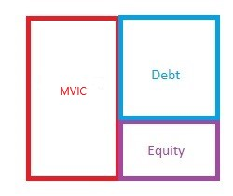

Due to the nature of the report and the expressed purpose for this valuation, analyst may make use of forward-looking statements. Historical financial statements may be limited in their ability to forecast the future of «abbreviation». According to the National Association of Certified Valuators and Analysts training materials, it is important to understand the purpose for a valuation report in order to apply the correct methodology and use of data:
“The purpose for the valuation may suggest whether or not it is appropriate to use historical vs. projected economic income. Historical economic income is generally used to estimate future benefits for tax, buy-sell, and divorce valuations because the historical data is based on fact and hence considered more reliable. Projected economic income, however, is used for both tax or non-tax valuations including litigation matters, ESOPs and transactional valuations because the projected income may be more representative of the expected future results.”

Standard of Value
According to U.S. Treasury regulations and IRS Revenue Ruling 59-60, Fair Market Value is defined as:
"The price at which such property would change hands between a willing buyer and a willing seller, neither being under any compulsion to buy or to sell, and both having reasonable knowledge of relevant facts."
To appreciate this standard of value, it is important to understand that “fair market value” as defined for this report includes the following assumptions:
- The hypothetical buyer and seller are both willing and interested in this transaction and are able to enter this transaction (implying that the buyer has sufficient funds).
- The hypothetical buyer is a prudent, rational buyer, but is not motivated by strategic or synergistic influences. In other words, the buyer is a “financial” buyer and not a “strategic” buyer.
- The business will continue as a going concern and not be liquidated unless the collection of individual assets is more valuable put to separate uses.
- The hypothetical sale will be for cash.
- The buyer and the seller are prudent, rational agents with reasonable knowledge of the relevant facts and under no compulsion to enter the transaction.
- The hypothetical buyer and hypothetical seller know the market for relevant property and also know the industry and other economic conditions and their effect on the subject property.
It is worth noting that, even when the transaction occurs between known parties, the fair market value standard requires us to determine a fair market value as though the company were being sold to an independent third party.

Date of Valuation
As previously mentioned, the date of the valuation for the purposes of this report is «valuation_date». The date of issuance of this report is «date_of_issuance».

Ownership and Control
As of the valuation date, «abbreviation» is owned by «owner».

Scope of the Engagement
This Summary Conclusion of Value and the accompanying report have been completed in accordance with the Professional Standards of The National Association of Certified Valuators and Analysts Professional Standards. The preparation and analysis have been performed by Blue Owl Valuation.
Blue Owl Valuation has no present or prospective financial interest in «abbreviation». There are no issues that would prevent an unbiased review of the subject. Compensation is in no way dependent on opinions, analyses, or conclusions from this report, nor any uses of the report.
The specifics of this valuation analysis were based on a variety of information. These sources of information include (but are not limited to):
- Discussions and information exchange between Blue Owl Valuation and «engaging_party» on several occasions between «engaging_party_date» and the date of this report. These discussions involved the procurement of financial records, as well as other pertinent information about the subject business.
- Financial statements for «abbreviation» with a period of review from «period_of_review_beg» through «valuation_date».
- Various sources of economic and industry data, cited in report.

We have relied on the accuracy of the supplied financial statements and external sources. We have undertaken no independent investigation to assure the accuracy of other data or expert opinions used in the preparation of this report. We have taken the information above to be true and correct to the best of his knowledge and belief.

Blue Owl Valuation has reviewed and analyzed both internal and external factors in order to arrive at a conclusion of value. The internal factors include the company’s financial position and results of operations. External factors include the status of the industry and the position of the company relative to the industry, as well as the economic environment in which the company operates.

Limiting Conditions
The business valuation process contains, by nature, certain assumptions and limiting conditions. Many of these assumptions and conditions may have a significant impact on the valuation conclusion.
- Valuation of closely-held businesses requires specific assessments, judgments, and assumptions, and as a result, reasonable and educated people can differ in their analyses and conclusions. We are not guarantors of value. We have, however, used sound and commonly accepted methods and procedures in the preparation and delivery of this report.
- This valuation is not intended to be a legal opinion or a tax opinion. The purpose of this document is specific to the engagement, as noted in Section 1.3. We assume no responsibility for legal or tax matters relative to its findings.
- The company’s compliance with applicable federal, state, and local laws and regulations is assumed in the reliance on management’s representation. The valuation report should not be relied upon to disclose errors, irregularities, or illegal acts.
- Public information as well as industry and statistical information have been obtained from sources we believe to be reliable. However, we have performed no investigative procedures of our own to corroborate that information.
- The conclusion of value presented assumes that the current level of management expertise and effectiveness would be maintained and that the character and integrity of the enterprise would not be significantly changed.
- We are under no obligation to update this report or the conclusion of value based on information that becomes available after the date of this report.
- To the best of our knowledge, neither «abbreviation» nor any subsidiaries have any other current pending legal action or legal liability. Blue Owl Valuation has not independently investigated the presence of any potential future liability related to any legal or environmental issues. We take no such liabilities into account in this report. In addition, we have not accounted for any potential future impact on the business due to changes in regulations or legislation pertaining to the business.
- The valuation reflects conditions as of the valuation date. There may be impact to the subject business not reflected in the financials as of that date. The analyst considers any additional impact subsequent to the valuation date to be a subsequent event.

Survey of the Subject Company

Description of the Company
«entity» «comp_description»
«abbreviation» appears to operate in NAICS code «NAICS». According to IBISWorld reporting, “«NAICS_Desc»”
Analyst notes the tax return information for the subject business shows NAICS code 45991. This code is for Pet and Pet Supplies Retailers. The judgment of the analyst is that the 44424 code is a better representation of the subject business. Analyst notes that industry taxonomy is often imprecise. Any material impact to value in this case is likely to be minimal.
The analyst has neither identified nor quantified any risks for seasonality, cyclicality, or supply chain that fall outside of the parameters for standard industry risks, as quantified in Section VII.

Management
As of the valuation date, «abbreviation» is owned and managed by «owner». Non-owner management oversees daily operations.

Form of Organization
«entity» is registered as a «org_entity» in the State of «org_state». The registration date was «org_date». The current status as of the report date is «org_status». The «org_name_of_file» is «org_file_number».

Restrictions on the Sale of Subject Interest

There are no known restrictions on the sale of subject interest.

Prior Ownership Transactions

There do not appear to be any prior ownership transactions relevant to the current valuation.

Subsidiaries and Affiliates

No relevant subsidiaries and/or affiliates are known to the analyst.

Location
«abbreviation» is located in the «metro» Metropolitan Statistical Area.

Economic Conditions
In order to develop some reasonable expectations about the future of any business, it is important to understand the overall conditions in which the business is operating. IRS Revenue Ruling 59-60 requires that an analyst consider “the economic outlook in general and the outlook of the specific industry in particular”.

Overview of the National Economy
Gross Domestic Product:
- Broad quantitative measure of US economic activity. Percent change from prior year.
- Reading—5.37% Q3 2025
- Previous—4.59% Q2 2025
- Previous—4.65% Q1 2025
- Previous—4.93% Q4 2024

FOMC GDP Projections:
- Central tendency reading, midpoint
- Projection—1.70% for 2025
- Projection—2.30% for 2026
- Projection—2.10% for 2027
- Projection—1.95% for 2028

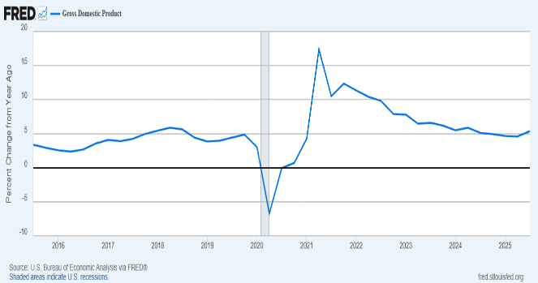

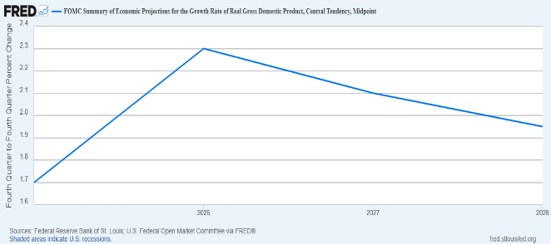

Unemployment Rate:
- Measures percentage of workers who are not employed
- Reading—4.5% in December 2025
- Previous—4.4% in November 2025
- Previous—4.4% in September 2025
- Previous—4.3% in August 2025

Industrial Production: Manufacturing:
- Measures industrial production in the US. Readings over 100 indicate expansion
- Reading—98.17 in December 2025
- Previous—97.62 in November 2025
- Previous—98.19 in October 2025
- Previous—98.03 in September 2025

Personal Consumption Expenditures:
- Measures personal income and consumption in US
- Reading—5.39% in November 2025
- Previous—5.23% in October 2025
- Previous—5.61% in September 2025

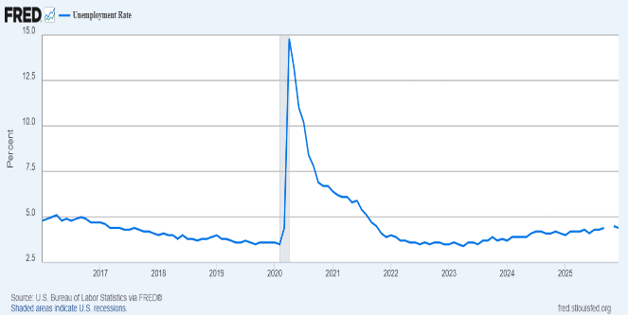

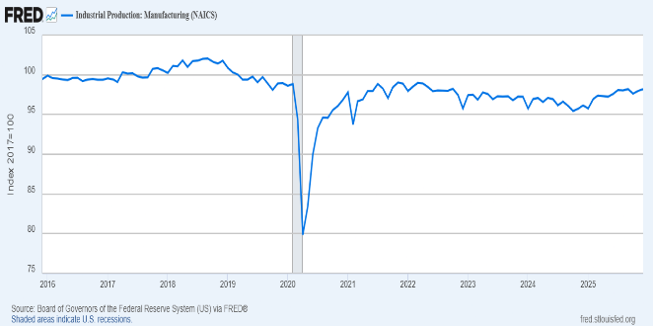

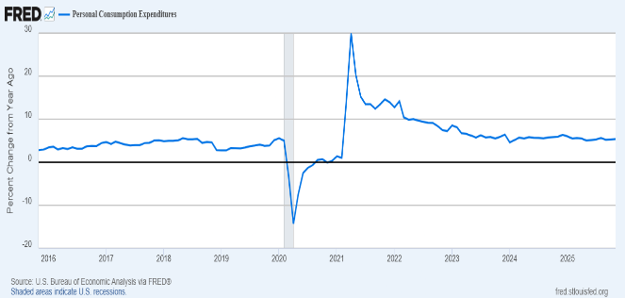

Consumer Sentiment (University of Michigan):
- Measure of consumer sentiment with 1966 = 100
- Reading—52.9 in December 2025
- Previous—51.0 in November 2025
- Previous—53.6 in October 2025
- Previous—55.1 in September 2025

Total Retail Trade:
- Percent change from one year ago
- Reading—2.97% in November 2025
- Previous—3.03% in October 2025
- Previous—3.88% in September 2025

Construction Spending:
- Percent change from one year ago
- Reading—negative 0.99% in October 2025
- Previous—negative 1.53% in September 2025
- Previous—negative 1.27% in August 2025

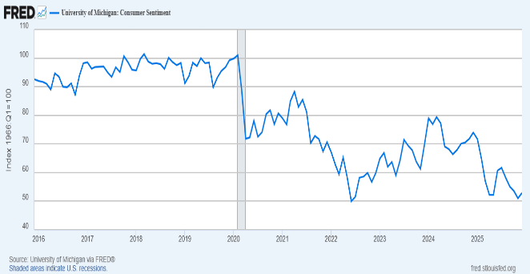

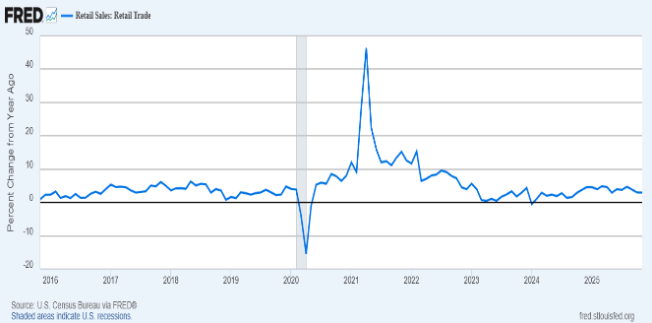

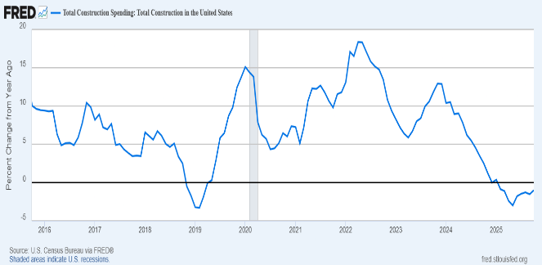

Overview of the State/Local Economy

Market Indicator | Metric for Kansas City MSA | Sourcing
Population | 1,754,000 | Macrotrends (2025)
Growth | 0.86% | Macrotrends (2025-2026)
Age | 38.6 | Census Reporter (2024)
Households | 914,522 | Census Reporter (2024)
Income | $83,785 | Census Reporter (2024)
Unemployment | 3.50% | BLS (Dec 2025)
Home Value | $314,300 | Census Reporter (2024)
Businesses | 55,241 | Census Bureau SUSB (2022)
Observation 1 | The Kansas City MSA median home value of $314,300 is 32% below the 2026 national median.
Observation 2 | Regional median household income of $83,785 is 17.0% higher than the Missouri state median of $71,589.
Observation 3 | The annual population growth rate increased from 0.81% in 2024 to an estimated 0.86% for the 2025-2026 period.

Overview of the Industry
«abbreviation» appears to operate in NAICS code «NAICS».
According to IBISWorld reporting, “«NAICS_Desc»”
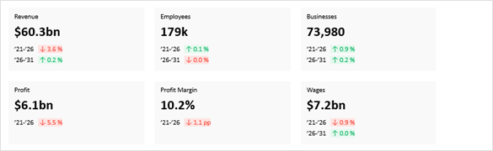

Performance
- Interest rate fluctuations significantly impact engineering services revenue volatility. High rates and inflation have depressed demand, but with anticipated rate cuts, construction activity and industry revenue are expected to recover.
- Technological integration is making engineering services more efficient and profitable. By adopting tools like BIM, 3D printing and cloud technology, engineering service providers can reduce costs, enhance collaboration and streamline project timelines.
- Sustainability has become a critical differentiator for engineering firms. By adopting eco-friendly practices and using sustainable materials, companies can meet regulatory demands and cater to a customer base increasingly focused on environmental impact.
External Environment
- State and local government investments boost engineering service demand. When these investments rise, they lead to new construction projects, creating opportunities for engineers to engage in diverse and lucrative work.
- Occupational health and safety regulations are crucial for workplace protection. They ensure employee safety by covering essentials like personal protective equipment and hazardous materials management, and non-compliance can lead to serious legal repercussions.
- The value of private nonresidential and utilities construction is a major driver of the demand for engineering services. Growth in these sectors indicates strong investment trends, leading to increased demand for engineers for project development and safety assurance.

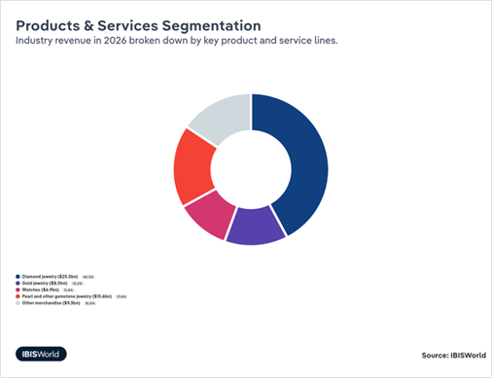
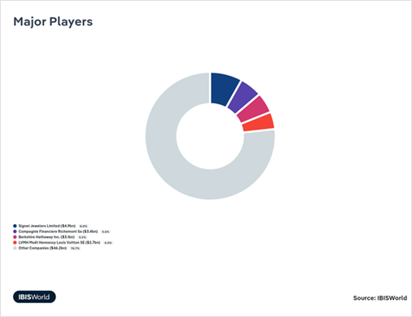

3.4 Implications for the Company
The economy appears to be in a time of some uncertainty. GDP growth rates are forecast at variable rates over the next several years. The industry, after growing 0.5% per year over the last five years, is expected to grow over the next five years (IBISWorld projects 1.6%). Demographic trends (population, personal income) appear to be stable. Analyst is inclined to support a growth rate in line with GDP and industry growth moving forward.

Financial Performance of the Company

Financial Statements
Financial statements were acquired for «abbreviation» from «engaging_party». As mentioned, the analyst did not make any investigation to verify the accuracy of the reporting or engage in any specific determination of the accounting policies and procedures utilized by «abbreviation».

Financial Statement Analysis Overview
The purpose of financial statement analysis is to understand the historical events of a business, analyze potential strengths and weaknesses, and to help us gather information that will help understand the likely trajectory of future trends.
Common size analysis can frequently be helpful in this endeavor. By expressing income statement items as a percentage of revenues and balance sheet items as a percentage of assets, we are better able to compare the subject business to industry peers and examine trends in the operation. In this case, using ProfitCents by SageWorks data, we compared the financials to benchmarks for the relevant NAICS code.

Historical Income Statement (and Common Size)
 | 2022 | 2023 | 2024 | 2025 | 2/16/2026-ttm
Income Statement Data
Sales (Income) | 0.00 | 0.00 | 4694354.00 | 5053612.00 | 6205128.00
Cost of Sales (COGS) | 0.00 | 0.00 | 2773845.00 | 2726991.00 | 3436268.00
Gross Profit | 0.00 | 0.00 | 1920509.00 | 2326621.00 | 2768860.00
Depreciation | 0.00 | 0.00 | 224.00 | 224.00 | 0.00
Amortization | 0.00 | 0.00 | 0.00 | 0.00 | 0.00
Depreciation and Amortization | 0.00 | 0.00 | 224.00 | 224.00 | 0.00
Officer compensation | 0.00 | 0.00 | 175484.00 | 422500.00 | 535712.00
Salaries and wages | 0.00 | 0.00 | 555925.00 | 568821.00 | 710915.00
Rents | 0.00 | 0.00 | 126309.00 | 162739.00 | 177063.00
Taxes and licenses | 0.00 | 0.00 | 64734.00 | 73741.00 | 80926.00
Advertising | 0.00 | 0.00 | 237854.00 | 197906.00 | 158726.00
Consulting | 0.00 | 0.00 | 0.00 | 80849.00 | 52093.00
Credit and collection | 0.00 | 0.00 | 133550.00 | 82291.00 | 74118.00
Auto expense | 0.00 | 0.00 | 1512.00 | 21118.00 | 1946.00
Overhead or S,G,&A Expense | 0.00 | 0.00 | 1295368.00 | 1609965.00 | 1791499.00
Other Operating Income | 0.00 | 0.00 | 0.00 | 0.00 | 0.00
Other Operating Expenses | 0.00 | 0.00 | 295067.00 | 277756.00 | 387528.00
Operating Profit | 0.00 | 0.00 | 329850.00 | 438676.00 | 589833.00
Interest Expense | 0.00 | 0.00 | 5668.00 | 567.00 | 57.00
Other Income | 0.00 | 0.00 | 634.00 | 0.00 | 0.00
Other Expenses | 0.00 | 0.00 | 0.00 | 0.00 | 0.00
Net Profit Before Taxes | 0.00 | 0.00 | 324816.00 | 438109.00 | 589776.00
Adjusted Owner's Compensation | 0.00 | 0.00 | 0.00 | 0.00 | 0.00
Adjusted Net Profit before Taxes | 0.00 | 0.00 | 324816.00 | 438109.00 | 589776.00
Taxes Paid | 0.00 | 0.00 | 0.00 | 0.00 | 0.00
Extraordinary Gain | 0.00 | 0.00 | 0.00 | 0.00 | 188204.00
Extraordinary Loss | 0.00 | 0.00 | 0.00 | 0.00 | 0.00
Net Income | 0.00 | 0.00 | 324816.00 | 438109.00 | 777980.00

 | 2022 | 2023 | 2024 | 2025 | 2/16/2026-ttm | Industry
Income Statement Data
Sales (Income) | #DIV/0! | #DIV/0! | 100% | 100% | 100% | 100%
Cost of Sales (COGS) | #DIV/0! | #DIV/0! | 59% | 54% | 55% | 53%
Gross Profit | #DIV/0! | #DIV/0! | 41% | 46% | 45% | 47%
Depreciation | #DIV/0! | #DIV/0! | 0% | 0% | 0% | 0%
Amortization | #DIV/0! | #DIV/0! | 0% | 0% | 0% | 0%
Depreciation and Amortization | #DIV/0! | #DIV/0! | 0% | 0% | 0% | 0%
Officer compensation | #DIV/0! | #DIV/0! | 4% | 8% | 9%
Salaries and wages | #DIV/0! | #DIV/0! | 12% | 11% | 11% | 10%
Rents | #DIV/0! | #DIV/0! | 3% | 3% | 3%
Taxes and licenses | #DIV/0! | #DIV/0! | 1% | 1% | 1% | 3%
Advertising | #DIV/0! | #DIV/0! | 5% | 4% | 3%
Consulting | #DIV/0! | #DIV/0! | 0% | 2% | 1% | 3%
Credit and collection | #DIV/0! | #DIV/0! | 3% | 2% | 1%
Auto expense | #DIV/0! | #DIV/0! | 0% | 0% | 0%
Overhead or S,G,&A Expense | #DIV/0! | #DIV/0! | 28% | 32% | 29% | 35%
Other Operating Income | #DIV/0! | #DIV/0! | 0% | 0% | 0%
Other Operating Expenses | #DIV/0! | #DIV/0! | 6% | 5% | 6% | 2%
Operating Profit | #DIV/0! | #DIV/0! | 7% | 9% | 10% | 9%
Interest Expense | #DIV/0! | #DIV/0! | 0% | 0% | 0% | 0%
Other Income | #DIV/0! | #DIV/0! | 0% | 0% | 0%
Other Expenses | #DIV/0! | #DIV/0! | 0% | 0% | 0%
Net Profit Before Taxes | #DIV/0! | #DIV/0! | 7% | 9% | 10% | 10%
Adjusted Owner's Compensation | #DIV/0! | #DIV/0! | 0% | 0% | 0%
Adjusted Net Profit before Taxes | #DIV/0! | #DIV/0! | 7% | 9% | 10%
Taxes Paid | #DIV/0! | #DIV/0! | 0% | 0% | 0%
Extraordinary Gain | #DIV/0! | #DIV/0! | 0% | 0% | 3%
Extraordinary Loss | #DIV/0! | #DIV/0! | 0% | 0% | 0%
Net Income | #DIV/0! | #DIV/0! | 7% | 9% | 13% | 10%

Income Statement Observations
Some observations and analysis regarding select income statement items:

- «IS_Annualized»
- «IS_Rev»
- «IS_COGS»
- «IS_GA_Wages»
- «IS_COGS__GA_Wages»
  - «IS_COGS__GA_Y4»
  - «IS_COGS__GA_Y3»
  - «IS_COGS__GA_Y2»
  - «IS_COGS__GA_Y1»
  - «IS_COGS__GA_CY»
- «IS_Rent_Expenses»
- «IS_Other_Overhead»
- «IS_Net_IncomeEBITDA»
  - «IS_NIEBITDA_Y4»
  - «IS_NIEBITDA_Y3»
  - «IS_NIEBITDA_Y2»
  - «IS_NIEBITDA_Y1»
  - «IS_NIEBITDA_CY»
- «IS_Earnings_Generation»

Historical Balance Sheet (and Common Size)

 | 2022 | 2023 | 2024 | 2025 | 2/16/2026
Balance Sheet Data
Cash (Bank Funds) | 0.00 | 0.00 | 255905.00 | 51300.00 | 197977.00
Accounts Receivable | 0.00 | 0.00 | 0.00 | 0.00 | 0.00
Inventory | 0.00 | 0.00 | 2736248.00 | 1762092.00 | 1657708.00
Other Current Assets | 0.00 | 0.00 | 0.00 | 0.00 | -85987.00
Total Current Assets | 0.00 | 0.00 | 2992153.00 | 1813392.00 | 1769698.00
Gross Fixed Assets | 0.00 | 0.00 | 269822.00 | 269822.00 | 282958.00
Accumulated Depreciation | 0.00 | 0.00 | 268366.00 | 268590.00 | 250105.00
Net Fixed Assets | 0.00 | 0.00 | 1456.00 | 1232.00 | 32853.00
Gross Intangible Assets | 0.00 | 0.00 | 0.00 | 0.00 | 0.00
Accumulated Amortization | 0.00 | 0.00 | 0.00 | 0.00 | 0.00
Net Intangible Assets | 0.00 | 0.00 | 0.00 | 0.00 | 0.00
Other Assets | 0.00 | 0.00 | 0.00 | 0.00 | 0.00
Total Assets | 0.00 | 0.00 | 2993609.00 | 1814624.00 | 1802551.00
Accounts Payable | 0.00 | 0.00 | 128330.00 | 134077.00 | 76519.00
Short Term Debt | 0.00 | 0.00 | 0.00 | 0.00 | 1579.00
Notes Payable/ Current portion of Long Term Debt | 0.00 | 0.00 | 0.00 | 0.00 | 0.00
Other Current Liabilities | 0.00 | 0.00 | 463400.00 | 172743.00 | -4822.00
Total Current Liabilities | 0.00 | 0.00 | 591730.00 | 306820.00 | 73276.00
Notes minus short-term | 0.00 | 0.00 | 288346.00 | 0.00 | 0.00
subordinated | 0.00 | 0.00 | 0.00 | 0.00 | 0.00
Other Long Term Liabilities | 0.00 | 0.00 | 0.00 | 0.00 | 0.00
Long Term Liabilities | 0.00 | 0.00 | 288346.00 | 0.00 | 0.00
Total Liabilities | 0.00 | 0.00 | 880076.00 | 306820.00 | 73276.00
Preferred Stock | 0.00 | 0.00 | 0.00 | 0.00 | 0.00
Common Stock | 0.00 | 0.00 | 0.00 | 0.00 | 0.00
Additional Paid-in Capital | 0.00 | 0.00 | 0.00 | 0.00 | 0.00
Other Stock/ Equity | 0.00 | 0.00 | 0.00 | 0.00 | 0.00
unclassified equity | 0.00 | 0.00 | 2113533.00 | 1507804.00 | 1729275.00
Total Equity | 0.00 | 0.00 | 2113533.00 | 1507804.00 | 1729275.00
Total Liabilities + Equity | 0.00 | 0.00 | 2993609.00 | 1814624.00 | 1802551.00

 | 2022 | 2023 | 2024 | 2025 | 2/16/2026 | Industry
Balance Sheet Data
Cash (Bank Funds) | #DIV/0! | #DIV/0! | 9% | 3% | 11% | 15%
Accounts Receivable | #DIV/0! | #DIV/0! | 0% | 0% | 0% | 0%
Inventory | #DIV/0! | #DIV/0! | 91% | 97% | 92% | 76%
Other Current Assets | #DIV/0! | #DIV/0! | 0% | 0% | -5%
Total Current Assets | #DIV/0! | #DIV/0! | 100% | 100% | 98% | 89%
Gross Fixed Assets | #DIV/0! | #DIV/0! | 9% | 15% | 16% | 30%
Accumulated Depreciation | #DIV/0! | #DIV/0! | 9% | 15% | 14% | 24%
Net Fixed Assets | #DIV/0! | #DIV/0! | 0% | 0% | 2% | 6%
Gross Intangible Assets | #DIV/0! | #DIV/0! | 0% | 0% | 0% | 0%
Accumulated Amortization | #DIV/0! | #DIV/0! | 0% | 0% | 0% | 0%
Net Intangible Assets | #DIV/0! | #DIV/0! | 0% | 0% | 0% | 0%
Other Assets | #DIV/0! | #DIV/0! | 0% | 0% | 0%
Total Assets | #DIV/0! | #DIV/0! | 100% | 100% | 100% | 100%
Accounts Payable | #DIV/0! | #DIV/0! | 4% | 7% | 4% | 16%
Short Term Debt | #DIV/0! | #DIV/0! | 0% | 0% | 0% | 1%
Notes Payable/ Current portion of Long Term Debt | #DIV/0! | #DIV/0! | 0% | 0% | 0% | 0%
Other Current Liabilities | #DIV/0! | #DIV/0! | 15% | 10% | 0% | 17%
Total Current Liabilities | #DIV/0! | #DIV/0! | 20% | 17% | 4% | 50%
Notes minus short-term | #DIV/0! | #DIV/0! | 10% | 0% | 0%
subordinated | #DIV/0! | #DIV/0! | 0% | 0% | 0%
Other Long Term Liabilities | #DIV/0! | #DIV/0! | 0% | 0% | 0%
Long Term Liabilities | #DIV/0! | #DIV/0! | 10% | 0% | 0% | 9%
Total Liabilities | #DIV/0! | #DIV/0! | 29% | 17% | 4% | 59%
Preferred Stock | #DIV/0! | #DIV/0! | 0% | 0% | 0%
Common Stock | #DIV/0! | #DIV/0! | 0% | 0% | 0%
Additional Paid-in Capital | #DIV/0! | #DIV/0! | 0% | 0% | 0%
Other Stock/ Equity | #DIV/0! | #DIV/0! | 0% | 0% | 0%
unclassified equity | #DIV/0! | #DIV/0! | 71% | 83% | 96% | 40%
Total Equity | #DIV/0! | #DIV/0! | 71% | 83% | 96% | 40%
Total Liabilities + Equity | #DIV/0! | #DIV/0! | 100% | 100% | 100% | 99%

Balance Sheet Observations
Some observations and analysis regarding select balance sheet items:
- No balance sheet information was available for 10/31/2024. Analyst imputed the 10/24/2024 balance sheet data to the 10/31/2024 date. Given the purpose and use for the report, the judgment of the analyst is that this does not preclude a conclusion of value.
- Cash: «BS_Cash»
- Accounts Receivable: «BS_Receivables»
- Inventory: «BS_Inventory»
- Total Current Assets: «BS_Current_Assets»
- Fixed Assets: «BS_Fixed_Assets»
- Total Current Liabilities: «BS_Current_Liabilities»
- Long-Term Liabilities: «BS_Longterm_Liabilities»
- Total Liabilities: «BS_Total_Liabilities»
- Total Equity: «BS_Total_Equity»

Select Ratio Analysis
- Current ratio: «Current_Ratio»
- Quick ratio: «Quick_Ratio»
- Return on Equity: «Return_on_Equity»
- Return on Assets: «Return_on_Assets»

Adjustments to Financial Statements--Normalization
In order to make the best use of valuation methods, it is not uncommon to make normalizing adjustments to the financial statements. These adjustments should give us a more economically realistic view of the subject business. In the case of the subject business, we will have some normalizing adjustments to make on both the balance sheet and the income statement. These adjustments will allow us to value the business properly in future sections.

Balance Sheet Normalization
The following normalizing adjustments were considered and/or made to the «valuation_date» balance sheet.
- Cash: «cash_adjust»
- Accounts receivable: «Acct_rec_note»
- Inventory: «invent_note»
- Other current assets: «other_curr_note»
- Fixed Assets: «net_dep_note»
- Other Assets: «other_note»
- Intangible assets: «intang_note»
- Accounts payable: «account_pay_note»
- Short-term debt: «short_term_note»
- Current portion long-term debt: «curr_port_ltd_note»
- Other current liabilities: «other_curr_liab_note»
- Long-term liabilities: «longterm_liab_note»
- No normalizing adjustments were necessary. All assets and liabilities are expected to transfer to new ownership.
Analyst notes that this normalization is not an attempt to view the business post-transfer, but rather this is an attempt to view, as of the valuation date, the value of the assets that will transfer.
«BS_Normalization_Summary»

Normalized Balance Sheet
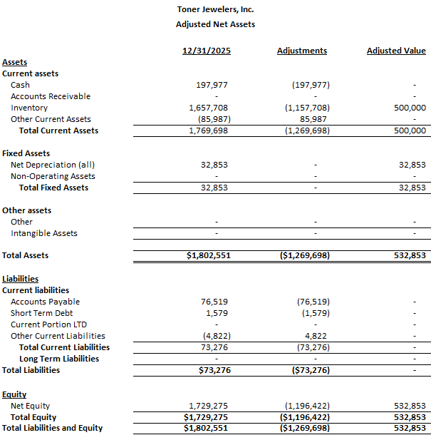

Income Statement
In order to assist with straight-line best-fit calculation of the value line for «abbreviation», the following statement has been prepared. This will be used to calculate the benefit stream in the valuation analysis, which is pre-tax cash flows to total invested capital.
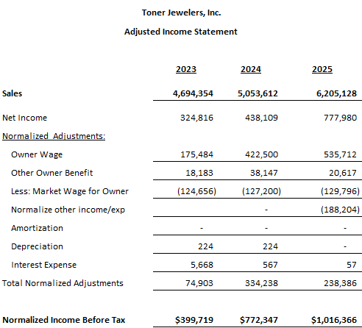

Notes on adjustments:
- Compensation adjustment. The goal with this adjustment would be to correct for market value for a financial buyer.
  - Frequently, business owners will take profits in the form of added payroll benefits. For example, if the market value of a construction manager is $90,000, the owner of a construction business may pay him/herself $150,000. In that case, we would add the $60,000 back into cash flows.
  - If the owner paid him/herself $60,000, we would subtract $30,000 to reflect the fact that a financial buyer would likely be forced to replace that owner at a market rate of salary, which would cost $30,000 more and reduce cash flows by that amount.
  - Owner Wage: Added back to cash flows for the period of review.
  - Other benefits: Imputed employer-side payroll tax at 9.5% of wages.
  - Less Market Wage: Analyst consulted Bureau of Labor Statistics data for the Kansas City Metropolitan Statistical Area. The most relevant job code was deemed to be 41-1011 First-Line Supervisors of Retail Sales Workers with a median wage of $51,800As per BLS reporting, benefits were imputed at 22%. The total of $56,721 was removed from cash flows for the most recent period, with prior periods reduced by 2% per period.

- Rent. Added back a rent charge that was not paid to a third-party entity, but rather this was a bookkeeping offset for an owned, non-operating asset of real estate.
- Less market rate rent. Normalized by imputing a market rate rent charge for what the business would pay if the non-operating asset of real estate were not owned.
- Amortization. Added back to cash flows as a non-cash expense. None noted in 2019 and note noted in the annualized period.
- Depreciation. Added back to cash flows as a non-cash expense. None noted in the annualized period.
- Interest. Adjusted interest expense as a component of the composition of capitalization.

Valuation of the Subject—Asset Method
This section represents the best efforts to value «abbreviation» using asset-based methods. The analyst has used his best professional reasoning, judgment, and experience to apply standard and accepted methods of valuation. The intent of this report is to provide facts and analyses to support the conclusions herein.

Rejected Methods
- Liquidation Value Method: Liquidation Value represents the value of the assets of the business, as though the business were no longer a going concern. We rejected this method because it does not seem to represent the value of «abbreviation» as of the valuation date. Assets being liquidated are subject to unusual price pressures that are not appropriate under the current consideration of value. This also does not take into account management’s ability to generate cash flows with the assets.

- Book Value Method: This method is based on GAAP value of assets. GAAP rules do not allow for adjustments to be made to reflect market changes. One clear example of the limitations of Book Value would be when an operational asset, say, a truck, is fully depreciated. Imagine that the depreciation period is 5 years. After 5 years, the asset has absolutely no value on the books according to GAAP. However, there is a very real possibility that 1) the asset continues to provide value for the company, and/or 2) the asset would have some resale value. In the case of «abbreviation», we do have management-provided information about the market value of certain assets, so it stands to reason that we would use more accurate market values instead of somewhat arbitrary, GAAP-based book values.

Adjusted Net Assets Method
The Adjusted Net Assets method is based on the difference between the fair market value of the assets of the business and the liabilities of the business. Generally speaking, this method is best used for holding companies or companies that are not generating consistent profits. If the value of the future benefit stream resulting from the operation of the business is higher than the fair market value of the assets, a reasonable agent would continue to operate the business. If the value of the assets at fair market value is greater than the future benefit stream, a reasonable agent would likely sell the assets at market value.

Of the asset-based methods, the Adjusted Net Assets Method seems to be the most grounded in facts that we can observe and reasonable conclusions to be drawn from those facts. It should also be noted that the Adjusted Net Assets Method could realistically set a “floor value” for a subject company. If other valuation methods yield greater value resulting from operations, we will take that into account in the Conclusion of Value.

Notes on Adjustments
- Refer to sections 5.1 and 5.2 for specifics on adjustments.
- Book value has been used for fixed assets.
- Analyst notes that this is not necessarily the same as a collateral value.
- Adjusted net assets on the balance sheet come to «asset_method_value».

Asset Method Valuation
The indicated value for «abbreviation» based on adjusted net assets as of the valuation date is «asset_method_value». This is a controlling, marketable value.

Valuation of the Subject—Income Method
This section represents the best efforts of the analyst to value «abbreviation» using income-based methods. Revenue Ruling 59-60 states that an income method should be used when the earning capacity of the subject company is a factor for consideration.

Capitalization of Earnings Method
The Capitalization of Earnings Method is one of the most frequently used income-based methods of valuation. Using this method, there is no need to distinguish between tangible assets and intangible assets of the business. Basically, the business is valued by the future benefit stream, in this case cash flows to invested capital, divided by an appropriate capitalization rate.

In the judgment of the analyst, this benefit stream and capitalization rate offers a reasonable conclusion of value. The cash flows to invested capital benefit stream can be reasonably derived from recast and adjusted data. The appropriate capitalization rate can be reasonably derived from reliable and known information, as well, in this case through the Build-Up Method and calculating the cost of capital.

Calculation of the Benefit Stream
The benefit stream to be used in this analysis is net cash flows to invested capital, as calculated in section 5.3 after applying the appropriate adjustments.

Weighted Calculation
Weighting the historical normalized income can be a difficult proposition. The analyst must use a certain amount of judgment and discretion. One could arguably weight all years, or one could choose to give weight to only one year, if one could make the claim that this year would represent the best expression of likely value. In this case, the analyst chose to weight each of the periods equally.
As for capital expenditure, analyst set this to «capex». Typically, depreciation and capital expenditure would even out over time. Capital expenditure should be similar to the arithmetic average of depreciation over the period of review. In this case, the arithmetic average was «avg_deprec». In the judgment of the analyst, the subject business is likely to be «ahead_behind» the capital expenditure curve based on the depreciation and the net fixed assets compared to industry benchmarks.
In the best judgment of the analyst, a working capital adjustment of «work_cap» was required. A new owner will have to bring working capital to the business. This figure represents approximate debt service on a credit line for sufficient working capital as of the transfer date.
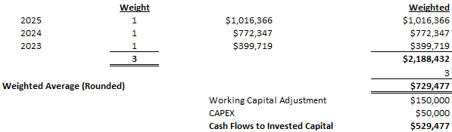

Calculation of the Capitalization Rate
The capitalization rate is the denominator used to convert the benefit stream into a calculated value. The expected rate of return for any potential purchaser or investor is based on the perceived risk of the investment and the rates of return and risk on alternative investments. This expected rate of return is expressed by calculating the capitalization rate plus the growth rate for the business. Inherent in the fair market standard of value is that the rate must be appropriate for both the willing, hypothetical buyer and the willing hypothetical seller without compulsion and with appropriate and relevant knowledge.

In order to calculate rates of return in the known marketplace for the sake of risk/return comparison, there are a number of elements to consider. Kroll Cost of Capital (formerly Duff and Phelps) data is frequently used in determining rates of return and risk premiums. Their data goes back to 1926 and their formula is widely respected as a standard in the valuation industry. In order to apply the Kroll data, we will use the following:

- Risk-free rate of return: This would be the rate of return an investor could expect without taking on market risk. The consensus among financial analysts is that the 20-year US Treasury yield to maturity is the best measurement of a risk free rate. This is a smoothed rate (as recommended by Kroll), not a spot rate.
- Expected equity risk premium: This is the return required by investors for taking the risk of owning securities. This is calculated by Kroll using arithmetic returns of the S&P 500 over the return from the 20-year US Treasury bond for the same period.
- Industry risk premium: Per Kroll data for appropriate SIC/GICS code.
- Size premium: This represents the additional risk involved with owning securities in smaller companies as compared to larger companies. Smaller companies tend to outperform larger ones over time, however there are risks involved such as limited access to capital, limited product/service offerings, limited geographic exposure, limited management depth, and more.
- Specific Company Risk: Specific company risk relates to other factors specific to the subject company. No empirical data or evidence exists to measure these specific elements of risk. Rather, it is incumbent on the valuation analyst to identify these elements of risk and also to determine their magnitude relative to the rate of return. Some elements include:
  - Diversification and size
  - Financial risk—leverage/liquidity
  - Operating history and earnings volatility
  - Other risk factors
- Long-term sustainable growth: It is incumbent on the valuation analyst to take into account overall economic conditions, industry conditions, and specific company conditions in order to select an appropriate long-term sustainable growth rate. We looked at IBISWorld reporting as well as company history.

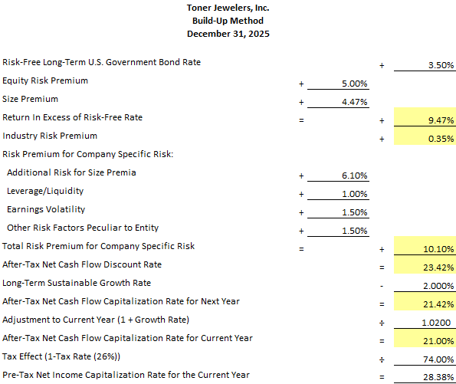

Size premium: This is from the 10th decile of the smallest size range on available date
Industry risk premium: Duff and Phelps data for SIC code
Additional risk for size premia: Subject business is still significantly smaller than smallest decile; this adjustment takes the subject from decile 10b to decile 10z
Leverage/liquidity: Subject business has reasonably low liquidity risk based on balance sheet
Earnings volatility: Based on analyst judgment, low risk
Other risk factors: Analyst judgment based on market, competition, transition risk
Long term sustainable growth: Analyst judgment, based on IBISWorld reporting and other factors. Figure should approximate GDP growth plus population growth over long term, with a nod to factors specific to industry.

Weighted Average Cost of Capital
For a capital structure made up entirely of equity, we have determined that the required rate of return for a hypothetical buyer would be «cap_rate». However, the capital structure for the enterprise consists of both equity and debt. The required rate of return is not the same as the equity capitalization rate, because the debt will be paid at a much lower rate. In order to figure out the required return on equity, we need to use a weighted average cost of capital.
Analyst examined the benchmark capital structure for the calculation using ProfitCents by Sageworks (see work papers). Industry benchmarks indicate «Bench_Equity» equity and «Bench_Debt» debt. The subject business has a capital structure of «Company_Equity» equity and «Company_Debt» debt. Analyst chose to use an “ideal” capital structure approach, «Ideal_Rate_Lang»

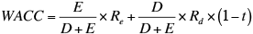
- Cost of equity: «cap_rate»
- Equity: «WACC_Equity_»
- Cost of debt: «WACC_Cost_of_Debt»
- Debt: «WACC_Debt_»
- Tax rate: «WACC_Tax_Rate»
- WACC: «WACC»

Capitalization of Earnings Valuation
The indicated value based on the Capitalization of Earnings Method is as follows:
- Benefit stream pre-tax: «benefit_stream»
- Divided by capitalization rate: «cap_rate» (weighted «WACC»)
- Indicated value: «income_value»
This is the indicated value for a control, marketable position. «MVIC_Verbiage»

Valuation of the Subject—Market Method
The idea behind the market approach is that the value of a business can be determined by referencing transactions of comparable companies when those transaction values are known. Sometimes the guideline companies are publicly traded. Sometimes they are not publicly traded, but the terms of the transaction have been disclosed.
The market method can be advantageous when valuing a business. The method uses actual data from completed transactions. This data can be obtained and verified in a variety of ways. Since the data is based on actual transactions, it reduces the number of estimates and assumptions that the valuation analyst must make. The data is the data. There is no need for forecasting cash flows, estimating growth rates, or making assumptions about relative risk.
There are also some downsides. One does not always know everything about the verified transactions. We don’t necessarily know what standard of value was being used. Comparisons aren’t always perfect because we don’t know everything about the operations of the businesses in the database and how that compares with the subject business. Sometimes, it’s not easy to find relevant comparable data.
However, the simplicity of application of the market method is elegant. The valuation process requires:
- Searching for comparable businesses/transactions
- Identifying the appropriate parameter(s) for comparison
- Appropriately quantifying those parameters
- Simple mathematics to apply appropriate parameter(s) to the subject business

Dividend Paying Capacity Method
This method of valuation is based on the future estimated dividends to be paid. These dividends are then capitalized with a five-year weighted average of dividend yields of five comparable companies. For estate and gift tax purposes, IRS Ruling 59-60 requires consideration of this method. It was decided that this method was not applicable because of the lack of comparisons available in publicly traded markets and the difference in economic scale.

Completed Transaction Method
The Completed Transaction Method provides a value for a business based on prices paid for comparable companies in the same industry as the subject business. There are several sources of transaction data for private company transactions. The search for appropriate transaction data led us to the following databases in search of appropriate transactions.

Market Method Using DealStats
The DealStats database contains information on approximately 57,000 transactions. Median revenues of the companies in the database are around $900,000. DealStats contains 81 data points on each completed transaction, including income statement and balance sheet information. Information comes from equity transactions and asset transactions. The calculated result is MVIC, or Market Value of Invested Capital. This represents the selling price of both debt and equity, which would be a total purchase price in an asset sale.

Analyst made an objective pass of the database looking for transactions by parent industry code with revenues between «rev_beg» and «rev_end» and a transaction date in the «DS_years» years prior to the valuation date. There were «DS_trans» comparable sales located.

Analyst has considered four parameters, MVIC/Net Sales, MVIC/Gross Profit, MVIC/EBITDA, and MVIC/SDE.

Statistic | Count | Range | 10th Percentile | 25th Percentile | Median | 75th Percentile | 90th Percentile | H Mean | WH Mean | Mean | Coefficient of Variation
Sale Date | 18 | 07/15/2002 — 06/30/2025
MVIC/Net Sales | 18 | 0.08x — 2.50x | 0.14x | 0.30x | 0.43x | 0.70x | 1.79x | 0.31x | 0.85x | 0.68x | 0.98
MVIC/Gross Profit | 18 | 0.12x — 4.37x | 0.25x | 0.59x | 0.94x | 1.36x | 2.30x | 0.53x | 1.52x | 1.20x | 0.86
MVIC/EBIT | 14 | 0.9x — 137.9x | 1.2x | 2.2x | 4.0x | 6.5x | 8.4x | 2.7x | 5.0x | 13.6x | 2.5
MVIC/EBITDA | 12 | 0.9x — 119.9x | 1.9x | 2.9x | 4.6x | 6.3x | 8.3x | 3.2x | 4.9x | 13.9x | 2.3
MVIC/SDE | 14 | 0.9x — 21.3x | 1.0x | 1.5x | 2.2x | 3.9x | 5.7x | 2.0x | 3.6x | 3.9x | 1.3
MVIC/BVIC | 4 | 1.1x — 15.7x | 1.2x | 1.3x | 2.6x | 6.7x | 12.1x | 2.0x | 4.5x | 5.5x | 1.1
MVIC Price | 18 | $100,000 — $15,750,000 | $147,000 | $201,250 | $520,000 | $2,237,500 | $5,900,000 |  |  | $2,344,182
Net Sales | 18 | $579,402 — $9,672,786 | $618,464 | $841,269 | $1,204,860 | $3,980,914 | $7,913,249 |  |  | $2,769,550
Gross Profit | 18 | $282,000 — $6,793,608 | $324,569 | $395,986 | $824,446 | $2,333,018 | $3,422,942 |  |  | $1,537,590
EBIT | 17 | ($1,298,706) — $1,001,634 | ($219,128) | $70,793 | $125,733 | $337,548 | $792,085 |  |  | $152,354
EBITDA | 13 | ($304,666) — $1,001,634 | $17,996 | $124,510 | $149,114 | $464,440 | $924,531 |  |  | $318,297
Seller's Discretionary Earnings (SDE) | 14 | $21,869 — $1,317,746 | $110,447 | $131,656 | $202,237 | $559,042 | $1,070,536 |  |  | $405,274
Owner's Compensation | 10 | $0 — $200,781 | $0 | $24,414 | $80,003 | $97,250 | $198,198 |  |  | $80,937
Book Value Invested Capital | 6 | ($2,045,259) — $770,747 | ($1,876,721) | ($1,249,893) | $221,557 | $319,062 | $545,059 |  |  | ($370,035)
Gross Profit Margin | 18 | 28.3% — 100.0% | 34.8% | 41.2% | 54.8% | 79.5% | 89.7% |  |  | 59.1%
SDE Margin | 14 | 2.3% — 41.2% | 9.3% | 13.9% | 17.9% | 27.9% | 32.2% |  |  | 20.1%
EBITDA Margin | 13 | (4.0%) — 34.6% | 2.2% | 9.6% | 10.9% | 25.4% | 32.7% |  |  | 16.0%

The following table represents the analyst’s approach to market method using DealStats. See work papers for transaction details:

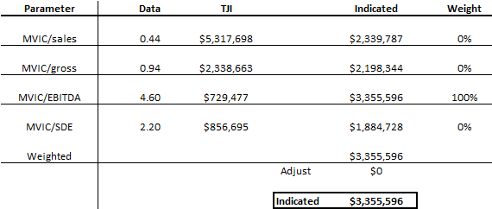

- Each parameter was calculated using the same weighting used in Section VII.
- In the judgment of the analyst, the top-of-the-income-statement parameters of MVIC/Sales and MVIC/Gross do not account for management decision-making, earnings, or management efficiency. These parameters were not weighted.
- Based on size and management structure, the judgment of the analyst is that the MVIC/EBITDA parameter was a more logical parameter than the MVIC/SDE parameter. The MVIC/EBITDA parameter was weighted at 100%.
- DealStats values are given as inclusive of fixed assets, so no adjustment was made.
- Analyst interpolated between the median and the 75th percentile for each parameter based on the performance of the subject business compared to benchmarks.
- The number of transactions in the database does meet minimum threshold for statistical significance (n=20).

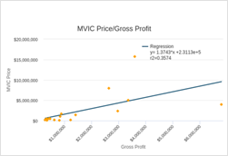
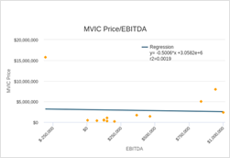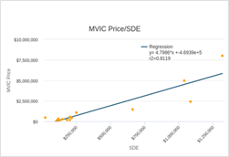

Market Method Indicated Value
Based on the analysis above using DealStats, the market method indicated value is «market_value». This is a controlling, marketable value. «MVIC_Verbiage»

Valuation Adjustments
As stated in Section 1.4, Section 25.2512-1 of the U.S. Treasury regulations and IRS Revenue Ruling 59-60, defines Fair Market Value as:
"The price at which such property would change hands between a willing buyer and a willing seller, neither being under any compulsion to buy or to sell, and both having reasonable knowledge of relevant facts."
Court decisions have consistently stated that in addition to being willing, the hypothetical buyer and seller must also be able to buy and/or sell the valued interest in the business.
In order to properly value a business, it is important to identify and consider the fundamental ownership interest characteristics that apply to the interest being valued. These two characteristics, control and marketability, are characteristics of the ownership interest being values that require a more in-depth analysis to determine their impact on the conclusion of value for that ownership interest

Adjustment for Control
For most businesses, it is more valuable to hold a controlling interest in the business than it is to have a non-controlling value. Controlling owners have several advantages over non-controlling positions:
- Ability to set company policy regarding business operations
- Ability to acquire and/or dispose of company assets
- Ability to hire/fire management
- Ability to determine compensation and benefits
- Ability to manage cash, including payment and/or non-payment of dividends
- Ability to establish or revise buy/sell agreements
- Ability to reorganize significant elements of the business, including acquisitions, public offerings, liquidations, and more
Again, controlling owners can make significant decisions that affect the receipt of the calculated benefit stream for all owners. There is also a fairly wide range of potential points of control to be evaluated, for example, voting rights, placement on the board of directors, concentration of ownership, contractual restrictions, and more.
In this situation, we are charged with determining the value of a controlling ownership interest. Therefore, no discount for lack of control is appropriate for this valuation.

Adjustment for Marketability
The ability to convert an investment into cash is an ownership characteristic of significant value. To be sure, an investment that cannot be converted to cash quickly and with minimal expense carries much more risk than an easily converted investment. As such, all else being equal, an investment in a small, privately held business that is difficult to convert would be less valuable than the same investment in a more liquid vehicle.
In Valuing a Business, Fourth Edition, Dr. Shannon Pratt identifies the following risks related to marketability:
- Uncertain time horizon to complete the offering or sale
- Cost to prepare and execute the offering or sale
- Risk as to eventual sales price
- Non-cash and deferred transaction proceeds
- Inability to borrow against the estimated value of the stock
Clearly, marketability concerns would apply to the subject interest of this valuation.
As with the adjustment for control, the adjustment for marketability can be difficult to quantify. There are two sources of empirical data that were considered for the purposes of this valuation.

Restricted Stock Studies
Frequently, shares of stock with a recent IPO are restricted from trading freely for a period of time. There are some other situations where shares of stock have trade restrictions, as well. Often, these shares can be sold in private transactions, which are reported to the Securities and Exchange Commission. Restricted stock studies simply quantify the difference in share price between restricted shares and un-restricted shares of the same stock. The theory is that the difference should help us quantify the difference in value between a security with a ready market and one without.
There have been a wide variety of restricted stock studies. From the book, Business Valuations: Fundamentals, Techniques, and Theory published by the National Association of Certified Valuators and Analysts, we have a summary of many such studies:

Study | # of Trans. | Median | Mean | Low | High
SEC Inst. Investors | 398 | 24% | 26% | -15% | 80%
Gelman | 89 | 33% | 33% | <15% | >40%
Moroney | 146 | 34% | 35% | -30% | 90%
Mather | 34 | 33% | 35% | 3% | 76%
Trout | 60 | n/a | 34% | n/a | n/a
Willamette | 33 | 31% | n/a | n/a | n/a
Stryker/Pittock | 28 | 45% | n/a | 7% | 91%
Silber | 69 | n/a | 34% | -13% | 84%
Hall & Polacek | 100+ | n/a | 23% | n/a | n/a
Johnson | 72 | n/a | 20% | -10% | 60%
CFIA 1 | 23 | 14% | 21% | 0.8% | 68%
CFIA 2 | 15 | 9% | 13% | 0% | 30%
Mgmt Planning 1 | 53 | 25% | 27% | 3% | 58%
Mgmt Planning 2 | 27 | 9% | 12% | n/a | n/a
FMV Opinions | 243 | 20% | 22% | n/a | n/a
Average |  | 25% | 26%
The average discount for lack of marketability in the observed restricted stock studies is 25%.

Quantifying the Adjustment for Marketability
In recent years, several court cases, including Estate of Mandlebaum and Okerlund vs The United States, courts have ruled in favor of significantly lower-than-historical discounts for marketability. There is a clear trend downward in DLOM. This trend is also evident in the most recent IRS publications and IRS job aids for valuators considering appropriate DLOM.
Many of the recent court cases revolve around valuations that are not done for acquisitions, but rather for disputed divorce cases, shareholder dissent, estate and gift taxes, and other transactions that are markedly different from a buyer and a seller agreeing to a price point. One could construct a reasonable argument, possibly, that there could be a much lower DLOM for any case of a business with a willing buyer.
The IRS job aid referenced above also indicates that it is generally agreed that a controlling interest will have a lower DLOM than a non-controlling interest. This is found in Estate of Andrews v. Comm, Estate of Simpson v. Comm, and Gray v. Comm. In this case, we are valuing a controlling interest. The job aid also points out that lack of marketability can frequently be intertwined with lack of liquidity. For a small, privately-held business, it is not appropriate to mix the two.
In the view of the analyst, however, some of the bulleted points in section 10.2 are applicable even in an acquisition case with a ready buyer—notably the time horizon and the price risk that lasts until closing.
The following table represents a heuristic approach as outlined by Gerald Barney in the May/June 2015 issue of The Value Examiner.

DLOM factors | «abbreviation»
 |  | Beginning Discount: | 26.0%
Factor | Impact On DLOM
Controlling interest | Reduction | Controlling interest being valued | -3% | 3%
Time horizon | No impact | Not relevant | 0% | 3%
Cost to prepare | Reduction | Lower than public offering | -3% | 3%
Transaction costs | Reduction | Lower than public offering | -3% | 3%
Key execs insured | Reduction | Likely and likely a requirement in future | -3% | 3%
Put agreement to sell | No impact | Not relevant | 0% | 3%
Intangible assets large part of total | Increase | Yes | 3% | 3%
Restriction on transfer | No impact | None known | -3% | 3%
Shares can be collateral | Reduction | Some collateral value | -2% | 2%
Cost to monitor investment | Reduction | Low cost | -2% | 2%
 |  |  | 10.0%

Given the Okerlund and Mandelbaum decisions, given the data points found throughout all cited studies, and given the specifics of this case, it is our judgment to use a 10% discount for lack of marketability of the entity. This best recognizes some of the transactional costs and risks associated with a potential transaction, as well as the current trends. It also recognizes the significantly different situation between a controlling interest as compared to the minority interest discounts referenced in the restricted stock studies.

Reconciliation of Values
Three different valuation methods have been presented in this study. This purpose of this section is to select the level of confidence and weight to apply to each method.
Adjusted Net Assets: Treating any business as a collection of assets does not take into account the ability of management to make efficient use of these assets to generate profitable returns. This method is often used to value holding companies. For an operational business, the main point of this method is typically to establish a floor value. This method was not used at all in the reconciliation of values.
Capitalization of Earnings: This method takes into account the historical earnings of the business and considers the financial return generated as well as the expected return rate of similar investments. This method produces a result that is in keeping with IRS Revenue Ruling 59-60. This is a linear approach based on historical results. This method was given a weight of 100% in the reconciliation of values.
Completed Transaction Method: Market-based methods are often useful in the determination of value for closely-held businesses. In this case, the data set from DealStats displayed a reasonable coefficient of variation and the number of transactions was sufficient for statistical significance. The difference between the market method value and the income method value was very low, at «Market_Difference». The best judgment of the analyst was to use the more specific income method and to treat this method as a confirmation of value. This method was not used at all in the reconciliation of values.

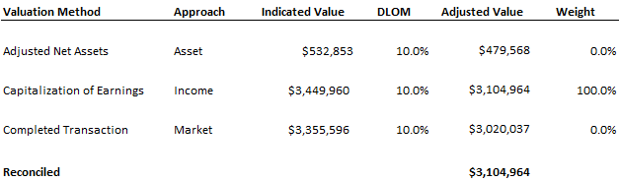

Conclusion of Value
This valuation has been performed according to the Professional Standards of the National Association of Certified Valuators and Analysts (NACVA). According to the professional standards of the NACVA and the nature of the engagement, the valuation will determine the “fair market value” of the subject business as of «valuation_date». The purpose for this report is «purpose». Any other use of this report is not authorized and it should be noted that the information contained in this report may not be appropriate for other uses.
Based on the analysis described in this valuation report, the value of «entity» is «reconciled_value» as of the valuation date. This value is believed to best reflect the intended purpose for this valuation, the business, and the marketplace. The transaction has been presented as «Transaction_Type_Language»
As of the valuation date, the value consists of «assets_» in tangible operating assets and «goodwill» in intangible assets. This is not intended to propose purchase price allocation and the asset value may not represent collateral value.

BIBLIOGRAPHY AND RESOURCES
IRS Revenue Ruling 59-60: available many places including here
US Census Bureau, American Community Survey
Revenue Ruling 68-609, July 1968, available many places including here http://users.wfu.edu/palmitar/Law&Valuation/chapter%205/Documents/RevRul68-609.html
Ibbotson Associates 2015 Yearbook Valuation Edition
DealStats available at www.bvmarketdata.com
Mergerstat Review 2003 via NACVA textbook Business Valuation, Fundamentals, Techniques, and Theory p. 7-13

The Mergerstat Industry Analysis 2005 pp.72-73
Business Valuation Discounts and Premiums, (Second Edition) Dr. Shannon Pratt (Wiley, 2009)
Valuing a Business, Sixth Edition, Dr. Shannon Pratt (ASA 2022)
Jeffrey Okerlund, et al. v. United States; No. 99-133T; No. 99-134T (14 Feb 2003).
Bernard Mandelbaum, et al. v. Commissioner, T.C. Memo 1995-255
- Population/Age: data.census.gov/table?q=DP05&g=310XX00US48620
- Income: data.census.gov/table?q=S1901&g=310XX00US48620
- PCPI/GDP: apps.bea.gov/itable/
- Housing: fred.stlouisfed.org/series/NEWLISCOU48620
- Labor: bls.gov/eag/eag.ks_wichita_msa.htm

IBISWorld Industry Report for «NAICS», «NAICS_date»
Available online: http://edu.nacva.com/preread/2012BVTC/2012v1_FTT_Chapter_Four.pdf (page 6)
IRS Revenue Ruling 59-60; 1959-1
«org_foot»
US. Bureau of Economic Analysis, Gross Domestic Product [GDP], retrieved from FRED, Federal Reserve Bank of St. Louis https://research.stlouisfed.org/fred2/series/GDP.
Federal Reserve Bank of St. Louis and US. Federal Open Market Committee, FOMC Summary of Economic Projections for the Growth Rate of Real Gross Domestic Product, Central Tendency, Midpoint [GDPC1CTM], retrieved from FRED, Federal Reserve Bank of St. Louis https://research.stlouisfed.org/fred2/series/GDPC1CTM
US. Bureau of Labor Statistics, Civilian Unemployment Rate [UNRATE], retrieved from FRED, Federal Reserve Bank of St. Louis https://research.stlouisfed.org/fred2/series/UNRATE
Board of Governors of the Federal Reserve System (US), Industrial Production: Manufacturing (NAICS) [IPMAN], retrieved from FRED, Federal Reserve Bank of St. Louis; https://fred.stlouisfed.org/series/IPMAN
US. Bureau of Economic Analysis, Personal Consumption Expenditures [PCE], retrieved from FRED, Federal Reserve Bank of St. Louis https://research.stlouisfed.org/fred2/series/PCE.
University of Michigan, University of Michigan: Consumer Sentiment© [UMCSENT], retrieved from FRED, Federal Reserve Bank of St. Louis; https://fred.stlouisfed.org/series/UMCSENT
Total Retail Trade in United States [MRTSSM44000USS], retrieved from FRED, Federal Reserve Bank of St. Louis; https://fred.stlouisfed.org/series/MRTSSM44000USS
US. Bureau of the Census, Total Construction Spending [TTLCONS], retrieved from FRED, Federal Reserve Bank of St. Louis; https://fred.stlouisfed.org/series/TTLCONS
https://www.bls.gov/oes/current/oes_28140.htm
https://www.bls.gov/news.release/pdf/ecec.pdf
https://costofcapital.kroll.com/
Valuing a Business, Fourth Edition, Dr. Shannon Pratt p.444
NACVA textbook Business Valuation, Fundamentals, Techniques, and Theory p. 7-28
The Market Approach to Valuing a Business, Shannon Pratt, 2005, John Wiley and Sons
http://www.irs.gov/pub/irs-utl/dlom.pdf
The Value Examiner May/June 2015 p.18

