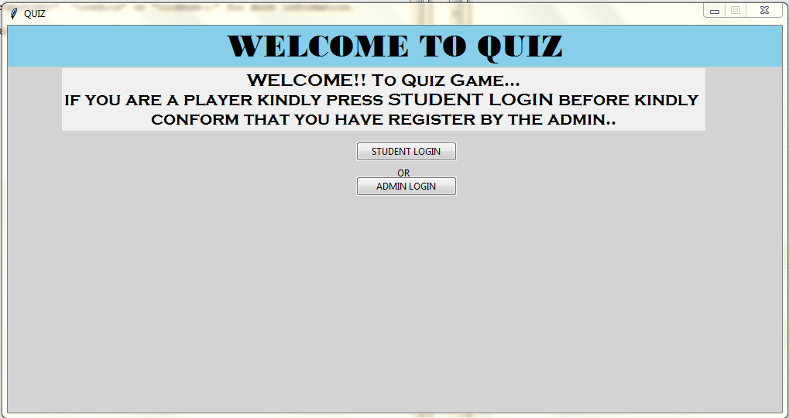

1.FIRST PAGE

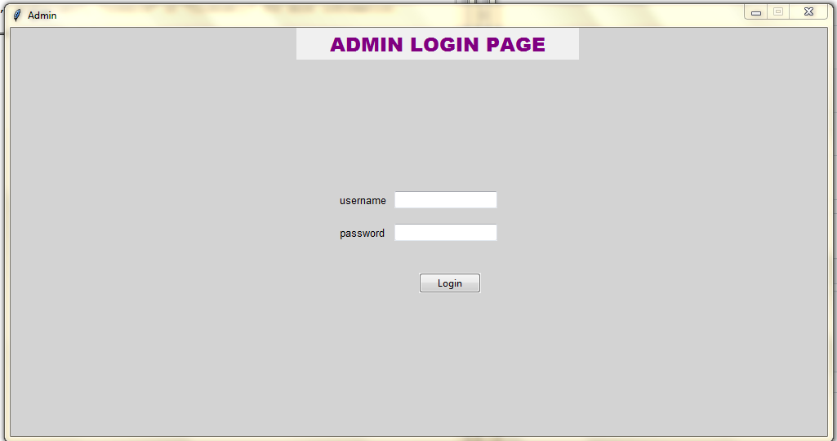

2.ADMIN LOGIN PAGE

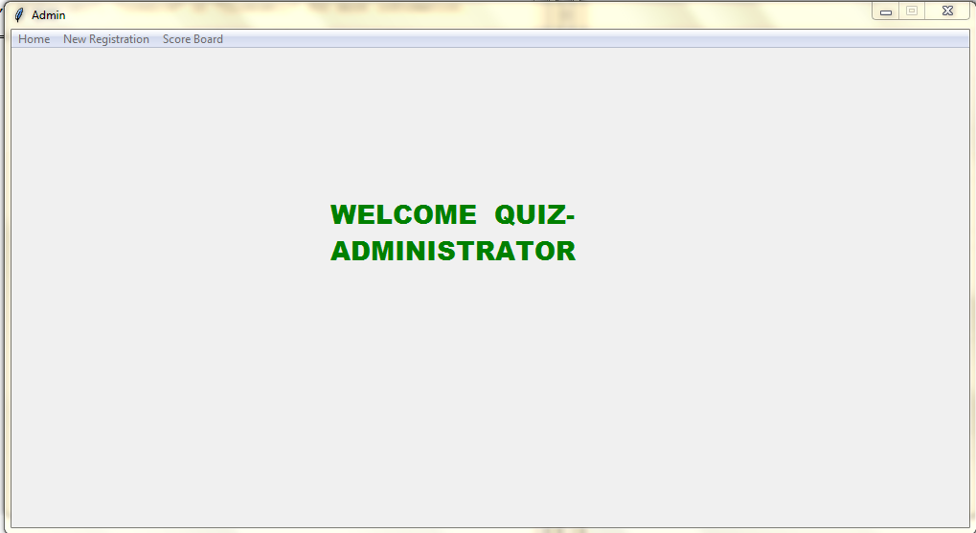

3.ADMIN HOME PAGE

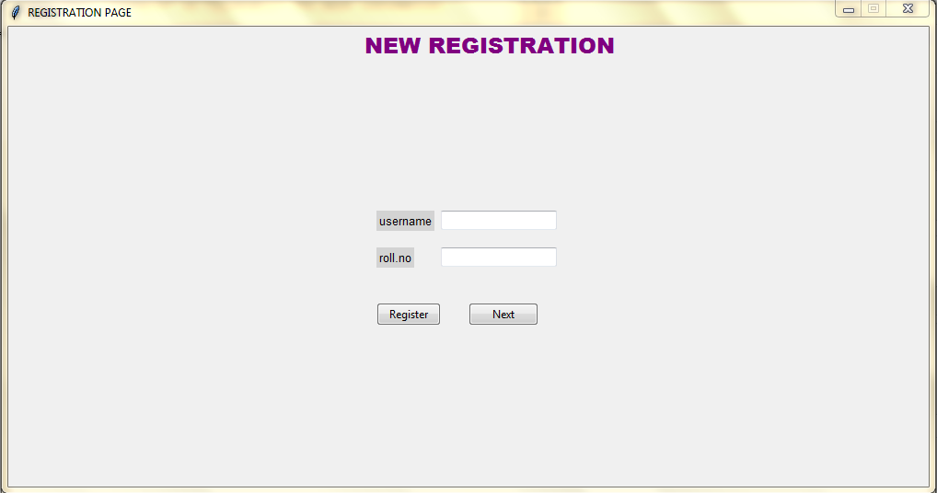

4.NEW REGISTRATION PAGE

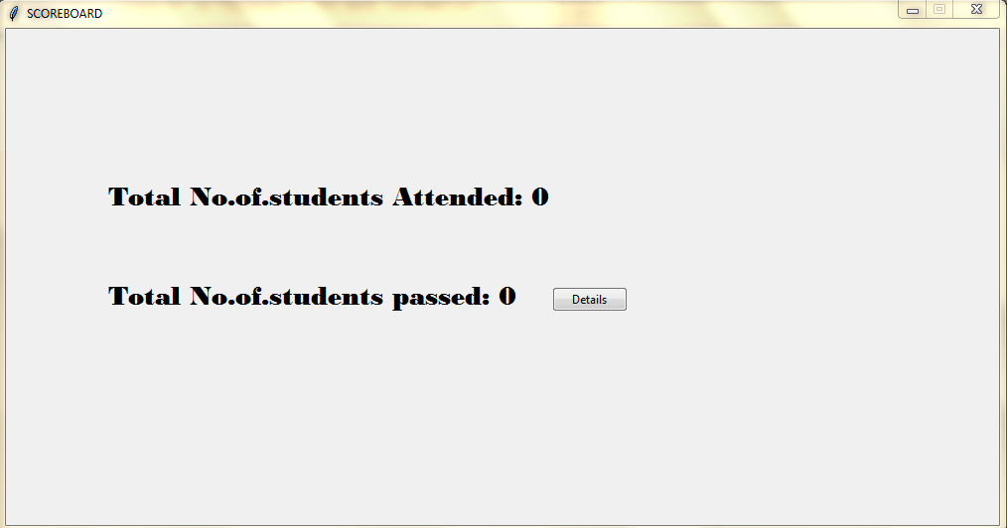

5.SCORE BOARD

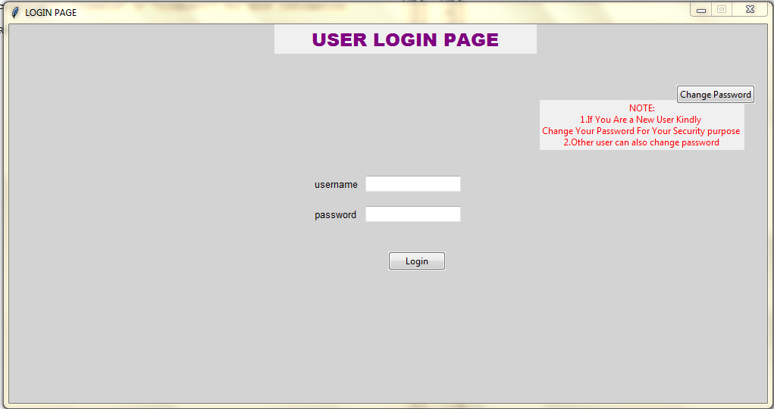

6.USER LOGIN PAGE

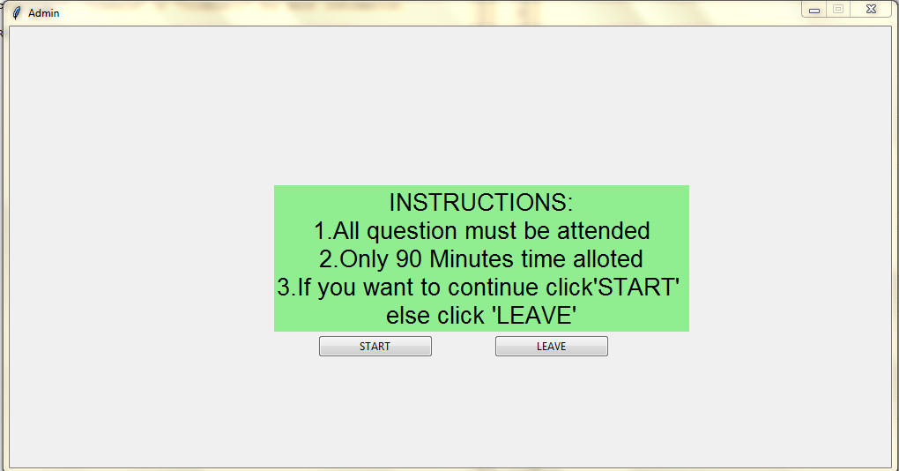

7.INSTRUCTION PAGE FOR THE STUDENTS

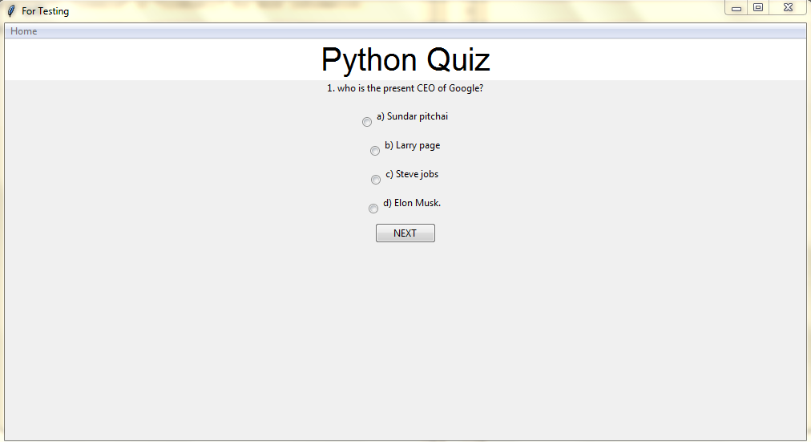

8.QUESTIONS