# Mines, Minerals, and Minecraft

## Class Repository

* Class files will be saved online in a special repository that you can access from home.
* It uses a service called Github
* URL: https://github.com/ChuckBell/Mines-Minerals-and-Minecraft

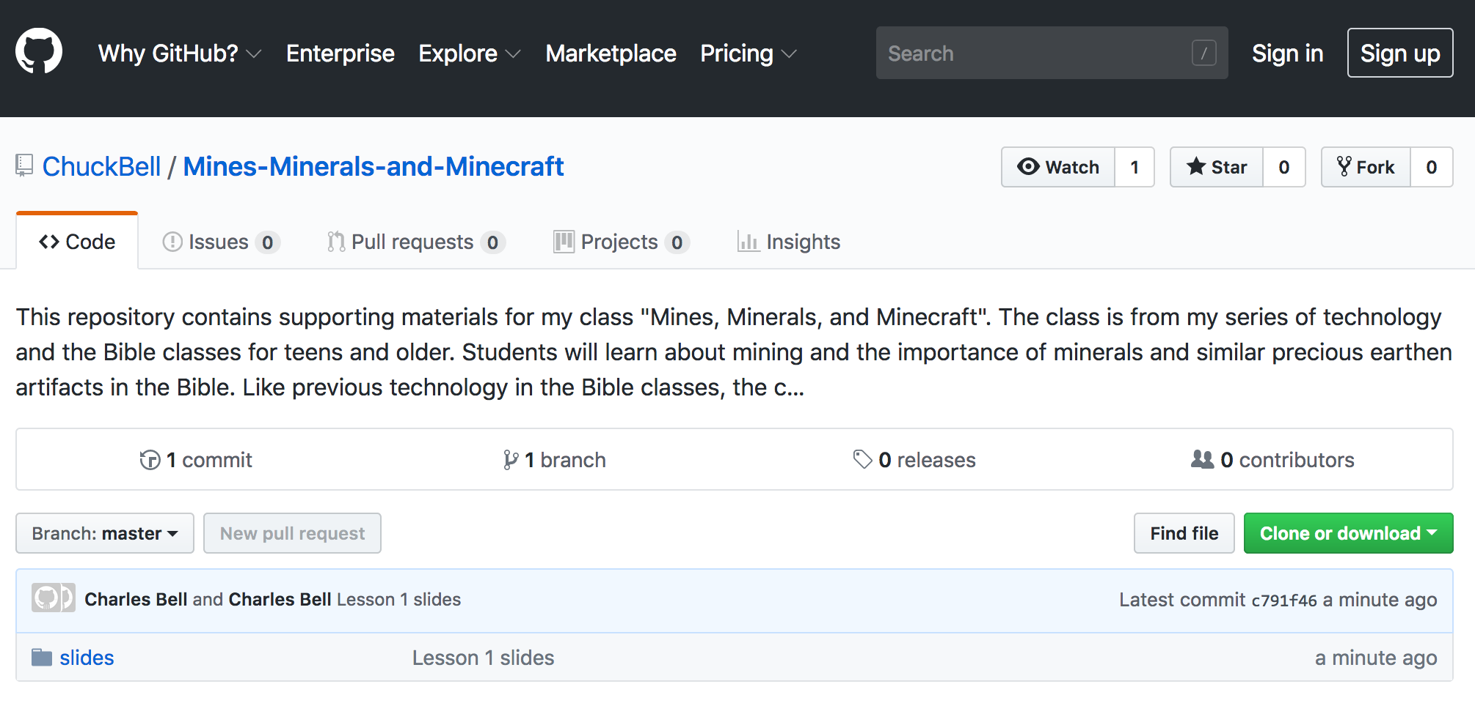

## Example (commands in bold)

MacBook-Pro:~ cbell$ **cd Documents/**

MacBook-Pro:Documents cbell$ **mkdir class**

MacBook-Pro:Documents cbell$ **cd class**

MacBook-Pro:class cbell$ **git clone https://github.com/ChuckBell/Mines-Minerals-and-Minecraft.git**

Cloning into 'Mines-Minerals-and-Minecraft'...

remote: Counting objects: 17, done.

remote: Compressing objects: 100% (14/14), done.

remote: Total 17 (delta 3), reused 7 (delta 1), pack-reused 0

Unpacking objects: 100% (17/17), done.

MacBook-Pro:class cbell$ cd Mines-Minerals-and-Minecraft/

MacBook-Pro:Mines-Minerals-and-Minecraft cbell$