- Accrued season: When a player spends six or more regular-season games on a club's active/inactive list, injured reserve list, or "physically unable to perform" list.
- Agent: A person who represents players during contract negotiations. Many agents are attorneys; some are friends and relatives of the players they represent. Agents are banned from most college campuses.
- First-year player: A player who spent the preceding season on an NFL practice squad, was injured and never played before, or played in another league — the CFL or Arena — and isn't considered a rookie by professional standards.
- Franchise player: A team can designate only one of its players as a franchise player. This player must be paid a minimum of the average of the top five salaries at his position or 120 percent of his previous salary, whichever is greater. If the player declines this salary increase and wants even more money, the club can designate him as a non-exclusive rights player, and the player can negotiate with other teams for a better contract. However, his team can match the new club's offer or receive two first-round draft choices as compensation.
- Injured reserve: A special category in which a team can place an injured player who is deemed a physical risk. Usually, these players require surgeries for their injuries. This player cannot return to the active roster (and play again) during that season.
- Practice squad: Each team can place five players on this squad, and they are eligible only to practice. These players are paid $4,350 a week and are free agents. Teams routinely sign players from other teams' practice squads in order to complete their 45-man active rosters when they lose players due to injury or release them due to poor performance.
- Pro-Bowler: A player who is selected by a vote of the fans, players, and coaching staffs to represent his conference in an all-star game that takes place the week after the Super Bowl. Any player chosen to play in the Pro Bowl is considered among the league's elite. The Pro Bowl is held in Hawaii.
- Restricted free agent: A player who has completed three accrued seasons and now has an expired contract. Under the terms of the collective bargaining agreement, the club basically controls what he will be paid. Most teams attempt to sign this player to a long-term contract if he's deemed a valuable starter, thus preventing him from being an unrestricted free agent in his fourth season.
- Roster reduction: Each team is allowed to open training camp with 80 players on its roster. By mid-August, teams have to cut down to 60 players. The next week, each club must cut seven more players, leaving their roster at 53. The weekend before the start of the regular season, teams must announce their active rosters of 45 players. They are allowed to retain eight inactive players.
- Rookie: A player who's on an NFL roster for the first time. A player who has played in another league, such as the CFL or Arena League, is still considered a rookie by the NFL.
- Trading period: Generally it begins in mid-February and ends on the Tuesday following the sixth regular-season game, which is usually in early October.
- Transition player: This player's club must pay him the average of the prior season's top ten salaries of players at the same position or 120 percent of the player's previous year's salary, whichever is greater. A transition player can seek a contract from another team, but his current team has seven days to match the offer and thus retain his services. A team can have no more than two transition players in the same season, as long as it doesn't also have a designated franchise player.
- Unrestricted free agent: A player who has completed four or more accrued seasons and now has an expired contract. Such a player is free to negotiate and sign a new contract with any team.
- Veteran: A player who has played at least one season in the NFL.
- Waiver system: The procedure by which a player's contract or NFL rights are made available by his current team to other teams in the league. During the procedure, the 31 other teams either file a claim to obtain the player or waive the opportunity to do so, thus the term waiver. The claiming period is typically ten days during the off-season, but from early July through December, it lasts only 24 hours. If a player is claimed by two or more teams in this period, priority is based on the inverse won-lost standing of the teams. The team with the worst record has priority. If no team selects the player, he's free to sign with any team, including his previous employer. If no one signs him, he is unemployed — technically fired from the NFL.

Instead of simply calling every carry a run, the football powers that be have invented a few running back terms that you should remember. These are the basic styles of rushing plays, and they're used in all levels of football:
- Blast or dive: Every team has the blast or dive run in its playbook; it's the simplest of carries. Usually led by a blocking fullback, the running back takes a quick handoff from the quarterback and hits a hole between an offensive guard and a tackle. On some teams, this run ends up between a guard and the center.
The offense calls this run when it needs a yard or two for a first down. The runner lowers his head and hopes to move the pile before the middle linebacker tackles him.
- Counter: A misdirection run by design. The quarterback fakes a lateral toss to one back who's heading right, running parallel to the line of scrimmage. He's the decoy. The quarterback then turns and hands off to the remaining runner in the backfield, generally a fullback, who runs toward the middle of the line, hoping to find an opening between either guard and the center.
- Draw: A disguised run, which means that it initially looks like a pass play. The offensive linemen draw back like they're going to pass-protect for the quarterback. The quarterback then drops back and, instead of setting up to pass, turns and hands the ball to the runner. After the runner receives the ball, he wants to reach his maximum speed quickly to take advantage of the anticipated huge holes at the line of scrimmage.
The goal of every draw play is for the defensive linemen to come charging at the quarterback (QB), only to be pushed aside by the offensive linemen at the last second. To fool the defense with this run, a team must have an above-average passing game. (See Figure 1.)
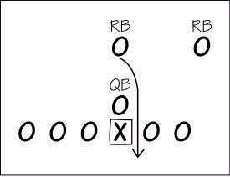
Figure 1: In the draw play, the QB drops back to pass and then hands off to the running back (RB), who's pretending to pass-block.
- Off-tackle: The oldest run around, a by-product of the old single wing offense of 90 years ago. It's a strong-side run, meaning that the halfback (HB) heads toward the end of the line where the tight end — the extra blocker — lines up. The runner wants to take advantage of the hole supplied by the tackle, tight end, and his running mate, the fullback (FB).
He can take the ball either around the tight end (as shown in Figure 2) or outside the tackle. He hopes that the fullback will block the outside linebacker.
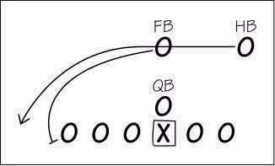
Figure 2: In the off-tackle run, the FB leads the HB around the right side. The FB clears a path for the HB by blocking either the outside linebacker or the defensive end on that side.
- Pitch: This run is usually from a two-back formation. The quarterback takes the snap and fakes a handoff to the first back (HB), who's heading directly toward the line of scrimmage; then he tosses (pitches) the ball laterally to the other runner (FB), who has begun to move to the outside.
The runner can either take the pitch outside or cut back toward the inside. Pitch plays can be designed to go in either direction. (See Figure 3.)
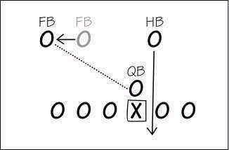
Figure 3: In the pitch run, the QB fakes a handoff to the HB and then tosses the ball to the FB.
- Reverse: For this play, the halfback receives the handoff from the quarterback and then runs laterally behind the line of scrimmage. (The play can be designed for the back to run in either direction.) The ball carrier meets up with a wide receiver (WR) or flanker running toward him and then hands the ball to that receiver or flanker.
The offensive line blocks as if the ball were intended for the halfback so that the defensive players follow him. After the receiver comes in motion and has the ball, he runs in the opposite direction, or against the flow of his own blockers. This play really works if the receiver is a fast and tricky runner. It helps if the interior defensive players and linebacker fall for the halfback's initial fake.
Also, the weak-side defender, the last line of defense, must leave his position and chase the halfback. Otherwise, this weak-side defender is in perfect position to tackle the receiver. (See Figure 4.)
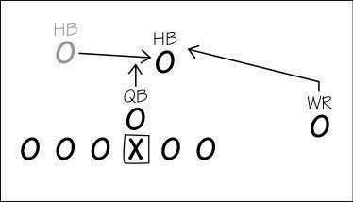
Figure 4: For a reverse, the QB hands off to the HB running to his left. The WR then takes a handoff from the HB and runs the other way.
- Slant: This run is exactly like it sounds. Instead of running straight toward the line of scrimmage, the runner (HB) slants his angle outside after he receives the ball. A slant is used to take advantage of defenses that overpursue, allowing offensive linemen to be more effective by pushing the defenders to one side. (See Figure 5.)
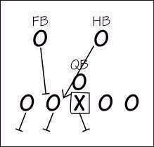
Figure 5: In the slant play, the HB takes a handoff and slants his run to the right side after aligning on the left side.
- Sweep: This run is pretty common in every team's playbook. It begins with two or more offensive linemen leaving their stances and running toward the outside of the line of scrimmage. The ball carrier (HB) takes a handoff from the quarterback and runs parallel to the line of scrimmage, waiting for his blockers to lead the way around the end. The run is designed to attack the defensive end, outside linebacker, and cornerback on a specific side.
Most right-handed teams (that is, teams that have a right-handed quarterback) run the sweep toward the left defensive end. The sweep can begin with the other back faking receipt of a handoff and running in the opposite direction of where the sweep run is headed. Many teams simply have the other back, a fullback, help lead the blocking for the ball carrier. (See Figure 6.)
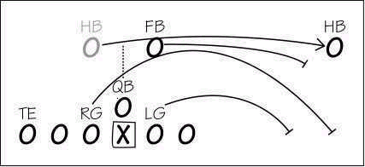
Figure 6: For a sweep play, the HB receives a handoff from the QB and follows the two pulling guards (RG and LG) and FB around the weak-side end.
- Trap: Teams don't use this run very often because it requires quick and agile offensive linemen, and most teams use big blockers these days. The trap is a sucker run that, like the draw, is intended to take advantage of the defensive players' willingness to attack the offense. The trap works well against an aggressive defensive line and linebackers.
On the trap, a guard vacates his normal area, allowing the defensive player to cross the line of scrimmage and have a clear lane into the backfield. The guard from the opposite side then moves across the line and blocks the defender. (This action by the guard is called pulling, hence the term pulling guard.) The trap play has to be well timed, and after the ball carrier receives the ball, he must quickly dart through the hole behind the trap block. (See Figure 7.)
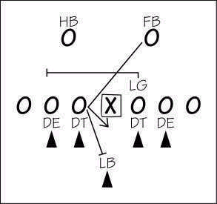
Figure 7: As the FB takes a handoff for the trap play, the LG pulls to his right. The center blocks the defensive tackle who is left unblocked.
- Veer: College teams run this play more often than pro teams do because it generally requires a quarterback who is quick-footed and an excellent ball-handler — a quarterback who can run if he has to. The veer is a quick-hitting run in which the ball can be handed to either running back, whose routes are determined by the slant or charge of the defensive linemen.
The term veer comes from the back veering away from the defense. In Figure 8, the quarterback hands off to the halfback, who veers to the right behind his blockers.
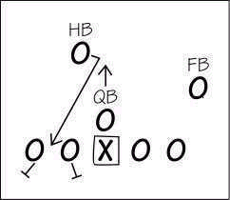
Figure 8: The QB hands off to the HB, who veers to the right between the guard and tackle.

Today's defensive linemen are bigger, and maybe faster, than those who played 20 years ago. Of course, they've had to keep pace with their main opposition, the offensive linemen. Two decades ago, you could count the number of 300-pound offensive linemen on one hand. Now, you need more than two hands to count a single team's 300-pounders!
Defensive linemen have to battle these huge offensive linemen. Then they have to deal with running backs and quarterbacks, whose main function in life is to make the defensive line look silly. Few linemen can run and move, stop and go, like former Detroit Lions running back Barry Sanders and current Green Bay Packers quarterback Brett Favre, two of the best offensive players in NFL history and also superb all-around athletes.
Linemen, who generally weigh 100 pounds more than Sanders, have a difficult time catching and tackling him. The few who can are the great linemen. However, many linemen have the ability to put themselves in position to stop a great offensive player. The key is: Can they make the tackle?
For the defense to do its job effectively, the linemen and linebackers (the players who back up the defensive linemen) must work together. This collaboration is called scheming — devising plans and strategies to unmask and foil the offense and its plays. To succeed as a group, a defensive team needs linemen who are selfless, men who are willing to go into the trenches and play the run while taking on two offensive linemen.
These players must do so without worrying about not getting enough pass-rushes and sack opportunities.

Types of defensive linemen
The term defensive lineman doesn't refer to a specific position, as you might think. A player who plays any of the following positions is considered a defensive lineman:
- Nose tackle: The defensive lineman who lines up directly across from the center, "nose to nose." Like in baseball, you build the strength of your team up the middle, and without a good nose tackle, your defense can't function.
This player needs to be prepared for a long day because his job is all grunt work, with little or no chance of making sacks or tackles for minus yardage.
- Defensive tackles: The two players who line up inside the defensive ends (see the following bullet) and usually over (football lingo for "across from" or "opposite") the offensive guards.
- Defensive ends: The two defensive linemen who line up over the offensive tackles or on those players' outside shoulders. The ends are responsible for chasing the quarterback out of the pocket and trying to sack him.
These players are usually smaller than nose tackles and defensive tackles in weight (that is, if you consider 290 pounds small), and they're generally the fastest of the defensive linemen.

Standout linemen traits
Great defensive linemen, like future Hall of Famers Bruce Smith and Reggie White, are very rare players. Their combination of size, speed, strength, and durability is not found in many players. A good defensive lineman has the majority of these qualities:
- Size: A defensive lineman needs to be big. Most offensive linemen are over 300 pounds (at least at the pro level), while most NFL running backs weigh over 200 pounds.
- Durability: Defensive linemen must be able to withstand the punishment of being hit or blocked on every play. Because they play 16 or more games a season, with an average of 70 plays per game, defensive linemen are hit or blocked at least 1,120 times a season.
- Quickness: Speed is relative, but quickness is vital. A lineman's first two steps after the ball is snapped should be like those of a sprinter breaking from the starting blocks. Quickness enables a defensive lineman to react and get in the proper position before being blocked.
Think of this visually as "quickness in a phone booth." A defensive lineman may not be fast over 40 yards, but in that phone booth (5 yards in any direction), he's a cat!
- Arm and hand strength: Linemen win most of their battles when they ward off and shed blockers. Brute strength helps, but the true skill comes from a player's hands and arms. Keeping separation between yourself and those big offensive linemen is the key not only to survival but also to success.
You have to use your hands and arms to maintain separation, which cuts down on neck injuries and enables you to throw an offensive lineman out of your way to make a tackle.
- Vision: Defensive linemen need to be able to see above and around the offensive linemen. They also need to use their heads as tools to ward off offensive linemen attempting to block them. A defensive lineman initially uses his head to absorb the impact and stop the momentum of his opponent. Then, using his hands, he forces separation.
But before the ball is snapped and before impact, the opponent's backfield formation usually tells him what direction the upcoming play is going in. Anticipating the direction of the play may lessen the impact that his head takes after the ball is snapped.
- Instincts: Defensive linemen need to know the situation, down, and distance to a first down or a score. And they must be able to read and know the stances of all the offensive linemen they may be playing against. For example, if an offensive lineman is leaning forward in his stance, the play is probably going to be a run. The offensive lineman's weight is forward so that he can quickly shove his weight advantage into his opponent and clear the way for the ball carrier.
If the offensive lineman is leaning backward in his stance (weight on his heels, buttocks lower to the ground, head up a bit more), the play is usually going to be a pass, or the O lineman may be preparing to pull (run to either side rather than straight forward).
In an effort to move those big bodies where they need to go a little more quickly, offensive linemen "cheat" in their stances more than any position in all of football. By doing so, they telegraph their intentions. Defensive linemen must assess these signs prior to the snap in order to give themselves an edge.

