**Problem Statement:**  
Is there a difference in public attitude toward the two major business subsidiaries of Unitedhealth Group; Optum and United Healthcare (UHC)? Both businesses are traded under the NYSE ticker ‘UNH’. Details of the public opinion of these two businesses could help identify drivers of fluctuations in the UNH stock price, areas of further research to support strategic initiatives in public relations.

**Results:**

Tweets about Optum and United Healthcare carry neither the same attitude nor polarity. The differences between both the mean subjectivities and mean polarities were found to be statistically significant. Though both Optum and UHC tweets are generally neutral in polarity and not heavily subjective, Optum and UHC tweets are not equal in sentiment.

As shown in Figure 1, both Optum and UHC tweets were neutral in polarity relative to the grading scale. The difference, while small, was enough to state that they are not equal. Similar results are shown in Figure 2 for the subjectivity of tweets. The differences could be an indication that different public relations strategies are required for the two businesses. More broadly stated, the public has a different opinion of Optum than UHC.

**Analysis & Procedure:**

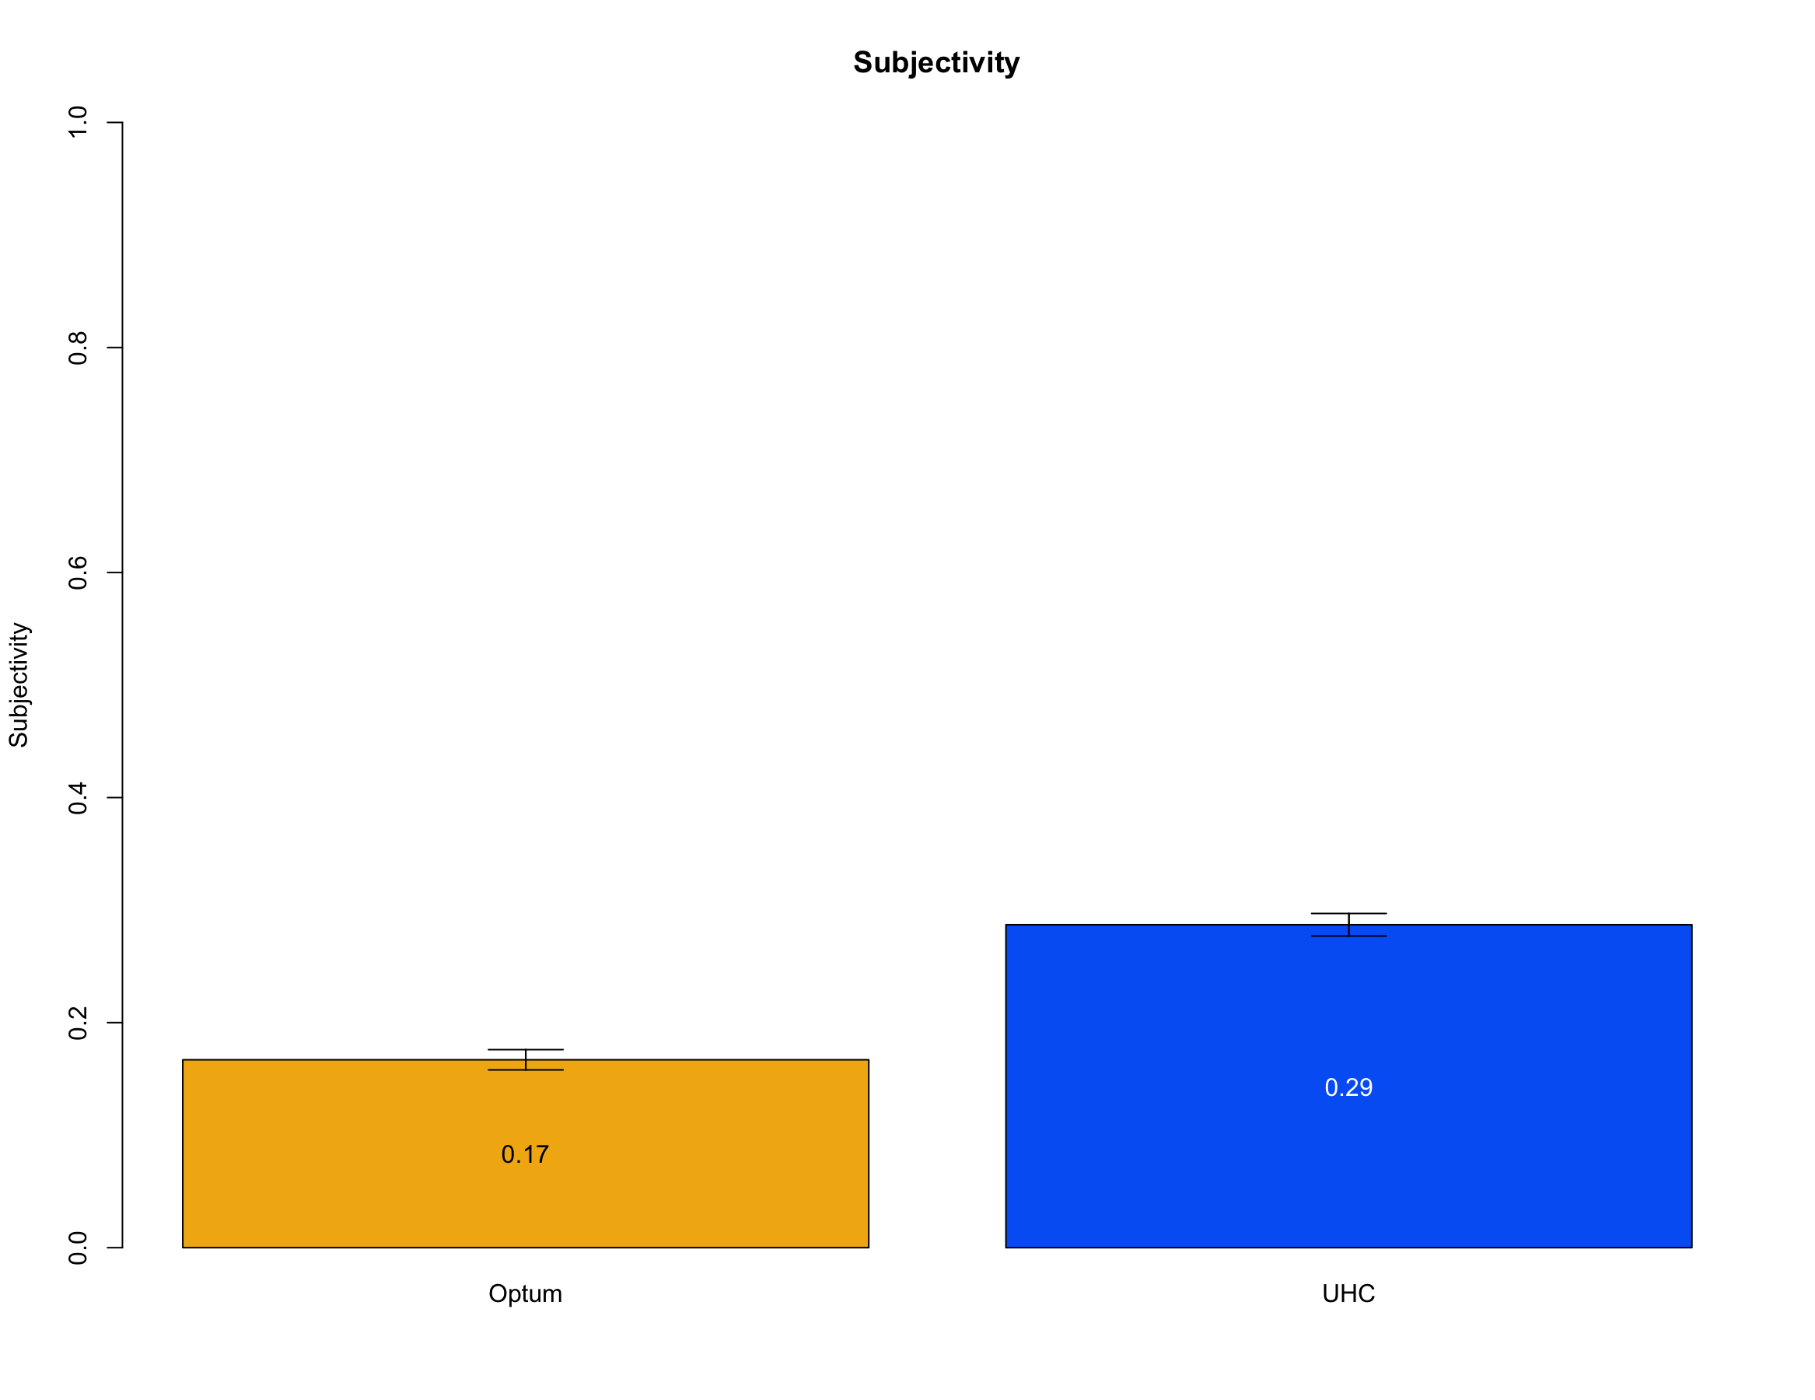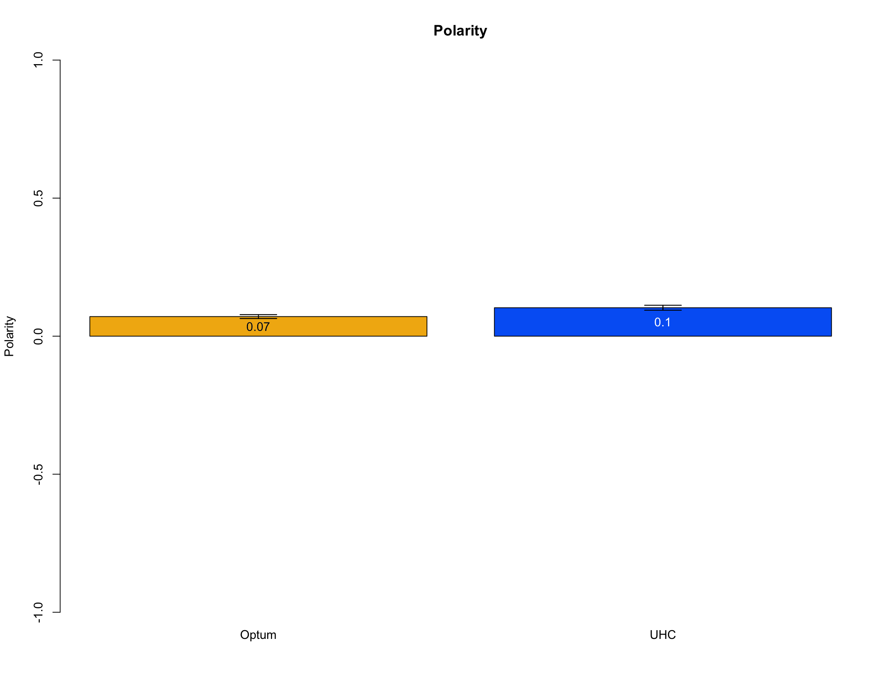

Figure 2: The subjectivity scale runs from 0 to 1. UHC tweet subjectivity were statistically different than Optum.

Figure 1: Optum and UHC tweets were not equal in polarity, but were relatively neutral on the -1 to +1 scale.

1515 and 2000 tweets were collected for Optum and UHC, respectively, via Twitter’s REST API via the *Tweepy* Python package. Tweets were searched using the keywords #optum, @optum, optum, and #uhc for Optum and UHC, respectively. All tweets were collected on December 3rd, 2017. Duplicate tweets from the same user were removed in addition to basic text cleaning procedures such as removing punctuation and special characters. This process resulted in a sample of 942 tweets to analyze for each group.

The *TextBlob* Python package was used to determine the polarity and subjectivity of the sample of tweets via a procedure called *sentiment analysis*. Polarity is the measure of the emotional positivity or negativity of the tweet with a range of values -1 to +1. Subjectivity quantifies the degree to which the tweet relates to the user’s personal feelings or beliefs and has a range of 0 to 1, with 1 being most subjective.

The mean polarity and mean subjectivity of the tweets for Optum and UHC were compared using a two-sample, two-sided, t-test. This test was used to evaluate the null hypothesis that mean polarity and mean subjectivity are equal between Optum and UHC. In this study, Optum’s polarity and subjectivity scores were different than UHC’s polarity and subjectivity score. The density distribution of the polarity and subjectivity scores for Optum and UHC are provided in Appendix A.

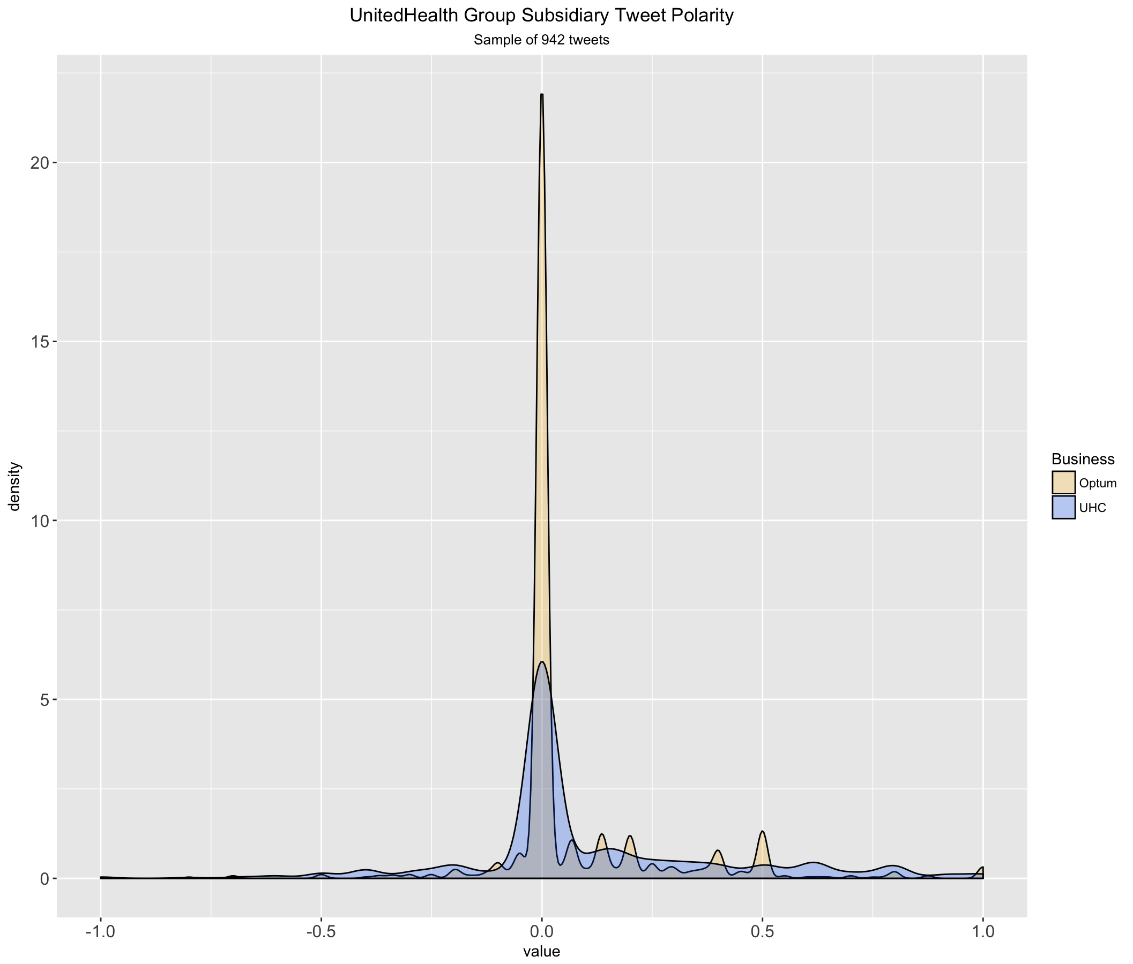

Figure A2: UHC tweets had a wide distribution of polarity, while Optum tweets tended to be more neutral.

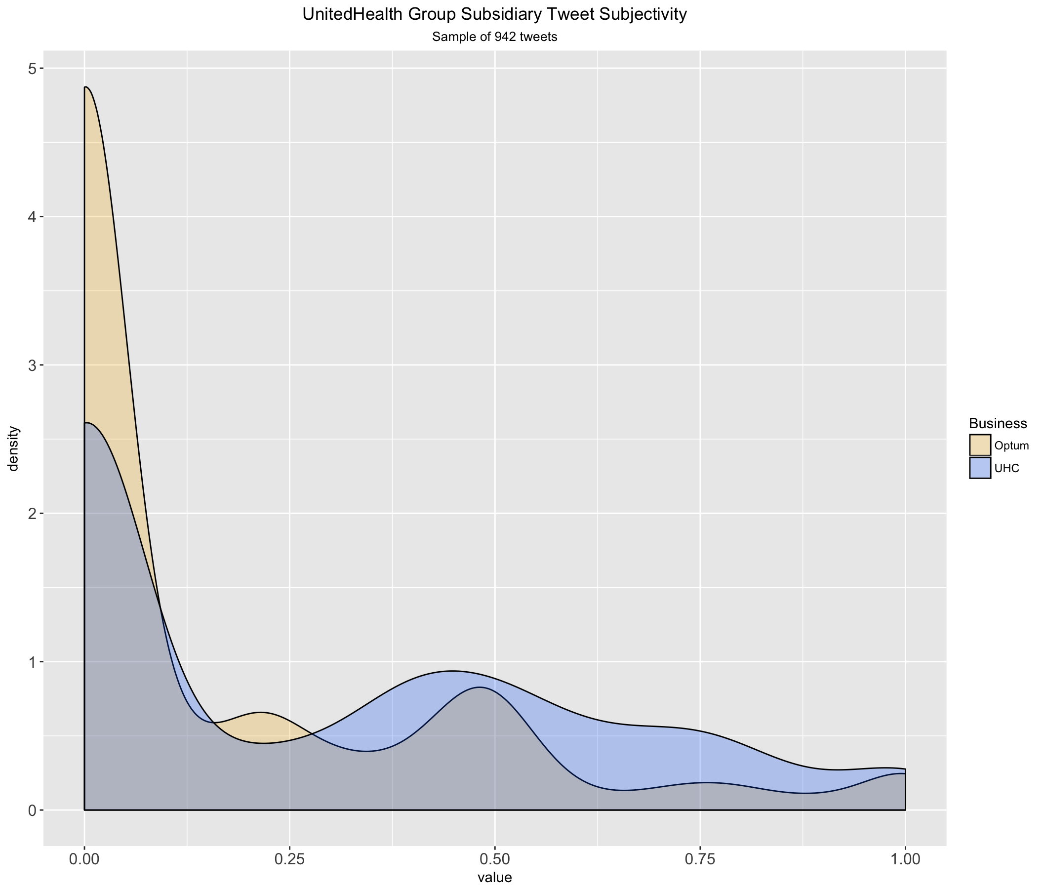

Figure A1: While most Optum and UHC tweets tend to have subjectivity scores near zero, UHC’s mean subjectivity was higher was than Optum.