**My Top 5 Favorite Features of Windows 10**

**5. Windowed Store Applications**

Windows Store Applications now open in a window; Just as a classic desktop application would. Finally, apps don’t consume your entire workspace in full screen (which is especially obnoxious on larger monitors). In Windows 8, if you wanted to run a Windows Store app such as Netflix or even the default PDF reader, it would be full screen or the sorry excuse for partial width known as Snap View, which worked great on tablets, but not so great on desktops. Thanks to this simple change, I’ve found myself using Store apps much more regularly in Windows 10.

**4. Integrated Driver Updates**

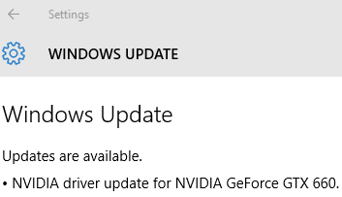

Windows Update seems to automatically find, download, and install non-Microsoft drivers now. At first, I was surprised to see that device driver updates were showing up in Windows Update, but it seems like the logical next step. Windows knows what hardware your computer has, thus, it makes sense that it should be able to find the drivers rather than requiring you to find your driver out in the wild. Now, with Windows 10, Windows Update does the work for you, which is a great step in the right direction. In the future, we’ll probably look back at the process of visiting each Vendor’s site trying to find drivers and laugh at how ridiculous it was.

**3. Classic Desktop Apps in the Windows App Store**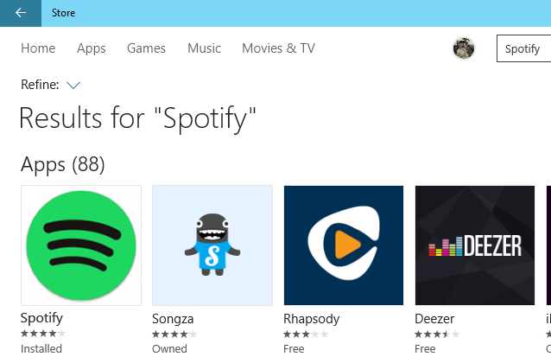(Picture for illustrative purposes only. Spotify is not currently available in the Windows App Store)

Project Centennial is a bridge from Microsoft which allows developers to package and publish their classic Windows apps (such as Photoshop, Spotify, or pretty much any other app you use on a regular basis) to the Windows Store. This makes it much simpler and more secure to find and use classic Windows apps rather than traversing the minefield known as the internet. This bridge also allows developers to add some Universal Windows Platform (UWP) capabilities and APIs to their apps as well (such as Notifications, access to their Microsoft Account, the Action Center, etc.). Project Centennial will be made available for public testing some time in 2016.

**2. Photos App in File Explorer**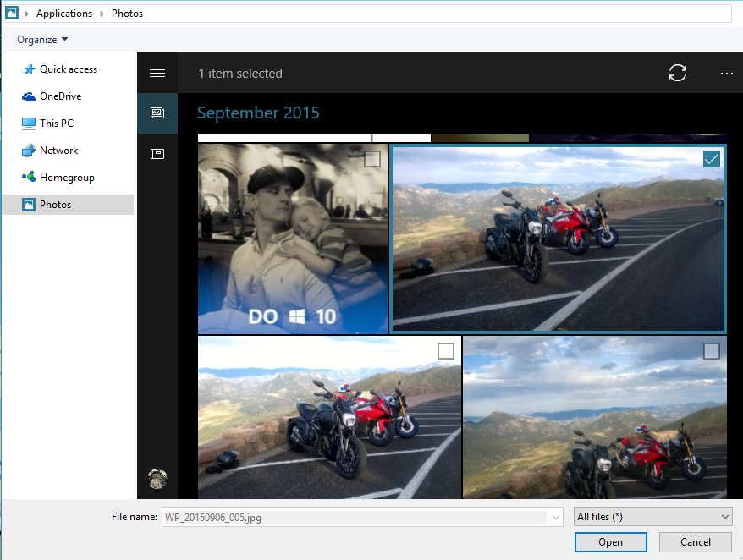

The UWP Photos app aggregates all of your photos from your computer and OneDrive. If you have the OneDrive app configured on your phone, all of your pictures should automatically be stored on OneDrive. The photos app is quite handy when you need to find a photo and having the UWP Photos app directly integrated into File Explorer when you browse for a picture on say Facebook or Instagram, makes it all the better.

**1. Quick Access**  
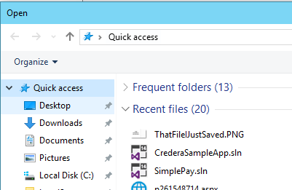

Quick Access shows all of your recent files and folders in one place. Do you remember the pain of navigating through the file explorer to find that file you JUST saved? Cue Quick Access. This is by far one of the most welcome additions to Windows 10 (aside from the obvious: the Start Menu). Now, when you need to upload a file to a website or just find that file again, it shows up in the Quick Access menu immediately after you save it.