**Step 1: Install the log4net NuGet Package**

1. Open the **Package Manager Console** in Visual Studio.
2. Run the following command: *dotnet add package log4net*

**OR**

* Install the nugget package using the nugget package manager.

**Step 2: Add a log4net Configuration File:**

1. Add a new file named log4net.config to the root of your API project.
2. Configure it to log to a text file:

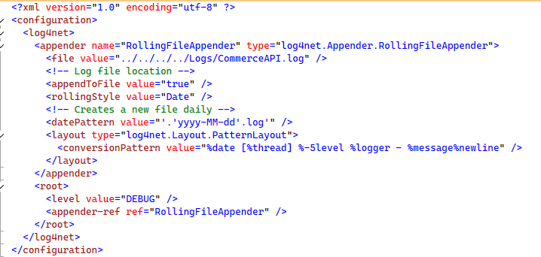

**Step 3: Configure log4net in Startup.cs**

1. Open your Startup.cs file.
2. Add the following log4net setup in the Startup constructor or ConfigureServices method: 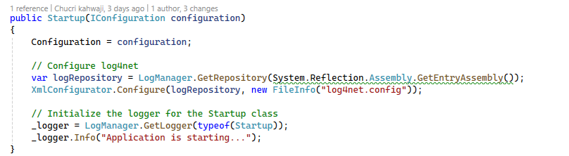

**Step 4: Use log4net in Your Application**

Now you can use **log4net** throughout your application. Here's an example for logging in a controller:

