The system shall allow users to create custom categories.
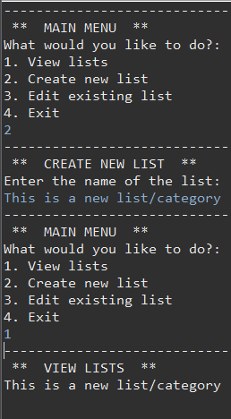
The system shall allow users to add items to designated categories of each to-do list.
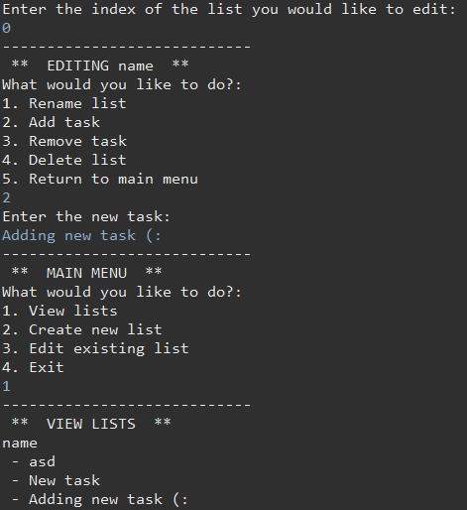

The system shall allow users to delete created lists.
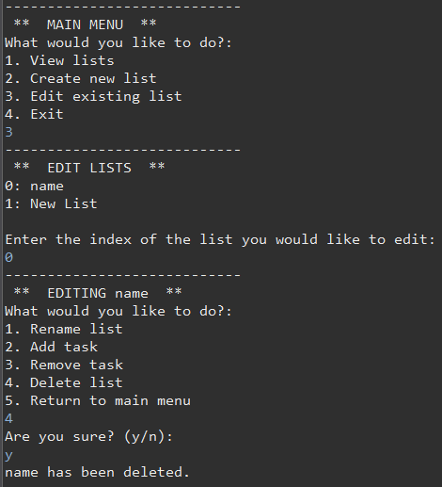
The system shall allow users to rename created lists.
