Anthony Galczak – CS591 HW3

**Leaky Integrate & Fire Model with Spike-Rate Adaptation and Single Synapse**

First, I used the default parameters for the model and plotted without and with SRA.

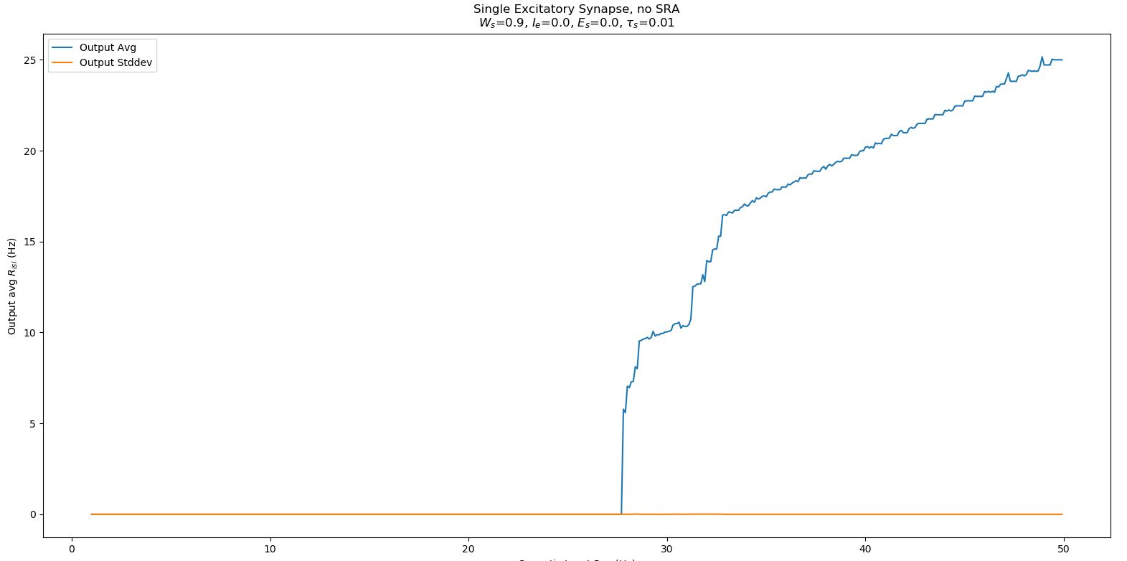

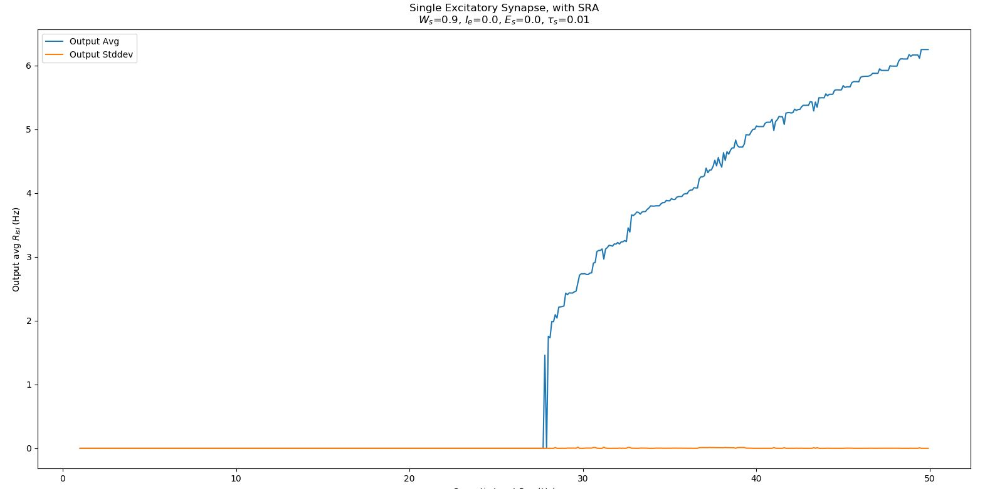

I toyed around with increasing Ws, but I noticed mostly that this caused the neuron to fire sooner. I will now post my results from adding a standard current of 1e-09 and what that did to the plots.

To be expected the firing rate on the non-SRA plot skyrocketed. This makes intuitive sense as we are introducing an artificial current to the neuron in addition to the synaptic input.

