Anthony Galczak

CS591 HW5

“Winner Takes All”

This is the standard plot from the prompt.

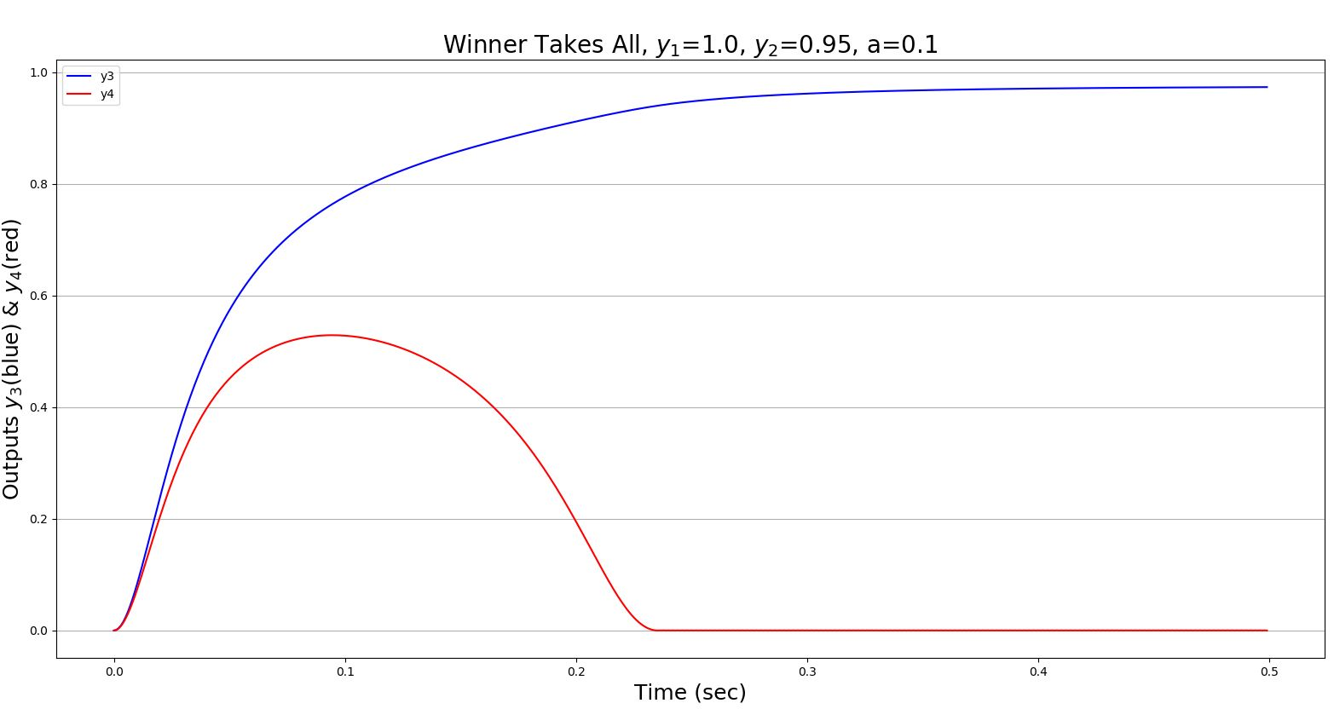

This plot shows what happens when we scale up the **a** parameter. Notice that it takes much longer for y3 to win. If you look closely, it never actually goes all the way to 1. Likely, it will reach it with more time.

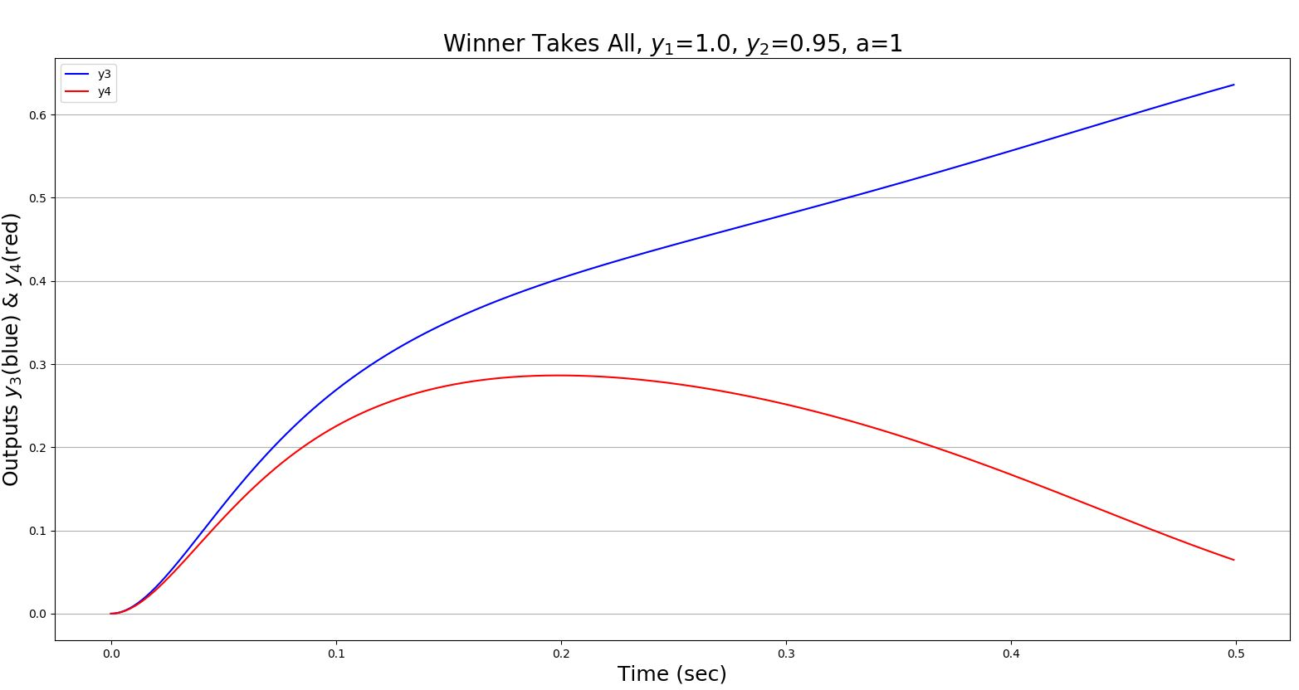

This plot keeps **a** the same, but scales the weight from y4 to y3 from -1.5 to 1. This makes it so that when y4 fires it doesn’t inhibit y3, but excites it. Thus, we can see that y4 reaches its’ maximum faster and y3’s hump doesn’t go as high. Basically, y3 is winning faster because it isn’t being inhibited by y4.

