1. Below we have the graph of both the “LHS” (maxnorm(Xtilde)/maxnorm(Xexact)) and the “RHS” (condition number * machine epsilon). We are considering the rule of thumb to be the RHS which we can see graphed in the color yellow.

By visual inspection, it looks like the rule of thumb is a pretty good estimate of the error. It seems to be consistently about 1 order of magnitude above the true error, but it scales very similarly to the true error. Since the rule of thumb seems to be consistently 1 order of magnitude higher than the LHS; we could add linear scaling to make it significantly more accurate as well.

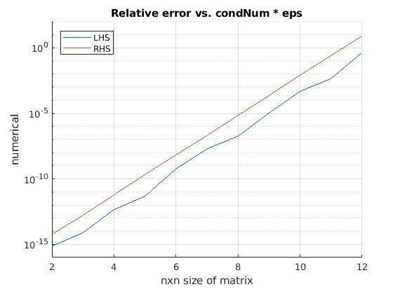

MATLAB code

lhsrhsMatrix = 3*12;

deltasMatrix = 2*12;

format long

**for** i = 2:12

% Generate hilbert matrix given A.

A = hilb(i);

% Solve for x_num and x_tilde

x = ones(i,1);

b = A*x;

x_num = A\b;

x_tilde = x_num - x;

% Left hand side (max-norm(x_tilde)/max-norm(x))

LHS = norm(x_tilde,inf) / norm(x,inf);

% Right hand side (condition number * machine epsilon)

RHS = cond(A,inf) * eps;

% Maximum norm of error (Note: This is the same as LHS)

deltaN = norm(x - x_num, inf);

% Populating the rows of our matrices

lhsrhsMatrix(i,1) = i;

lhsrhsMatrix(i,2) = LHS;

lhsrhsMatrix(i,3) = RHS;

deltasMatrix(i,1) = i;

deltasMatrix(i,2) = deltaN;

**end**

% Setting up for plotting

LHScolumn = lhsrhsMatrix(:,2);

RHScolumn = lhsrhsMatrix(:,3);

deltascolumn = deltasMatrix(:,2);

% Displaying numerical values for left hand and right hand sides.

disp(LHScolumn(2:**end**));

disp(RHScolumn(2:**end**));

disp(deltascolumn(2:**end**));

% Setting titles

title('Relative error vs. condNum * eps');

xlabel('nxn size of matrix');

ylabel('numerical');

% Plotting the elements we want to see

hold on

plot1 = plot(LHScolumn);

plot2 = plot(RHScolumn);

plotLabel1 = "LHS";

plotLabel2 = "RHS";

legend([plot1,plot2], [plotLabel1, plotLabel2]);

grid on

% Setting x-axis and y-axis limits and setting y-axis to log scale.

xlim([2 12]);

ylim([1e-16 1e+2]);

set(gca, 'YScale', 'log');