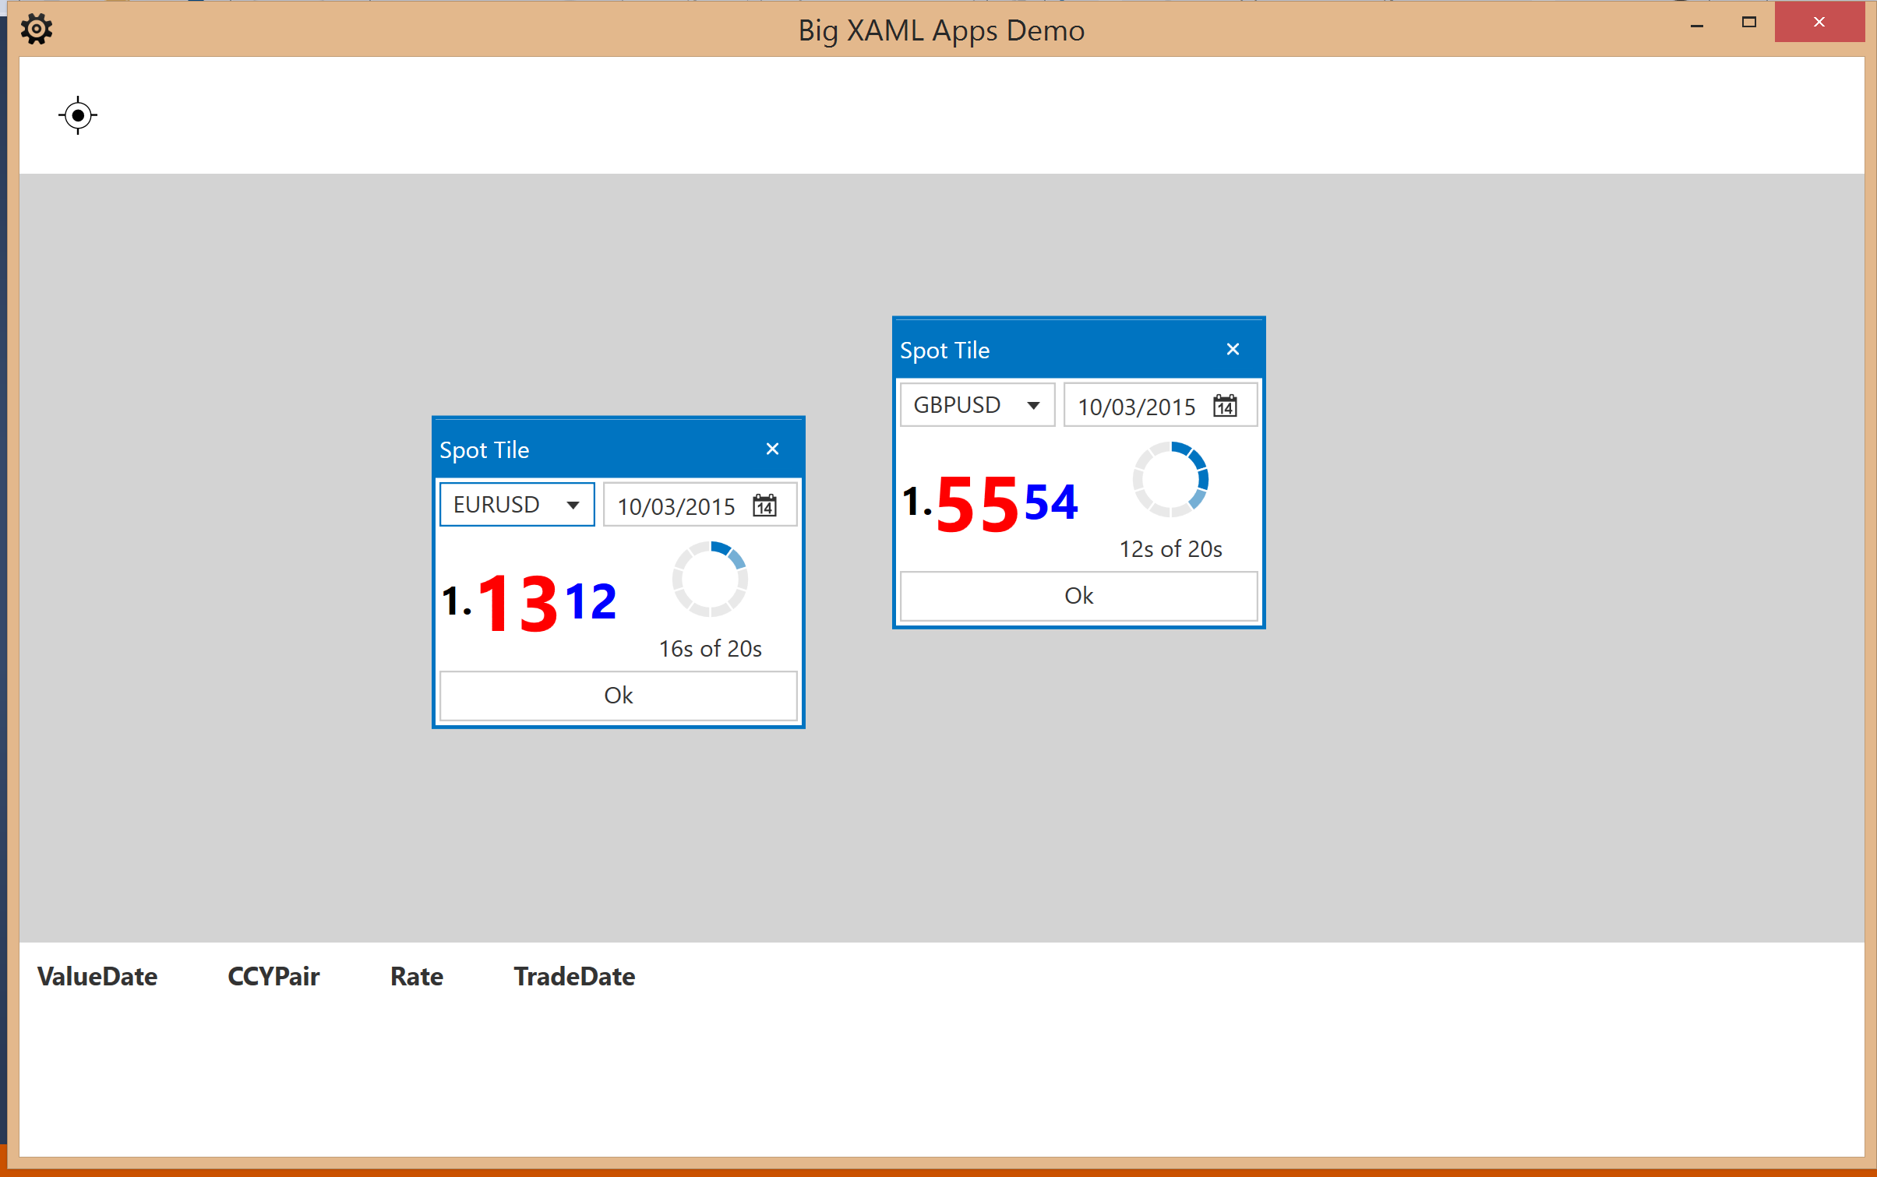

Uses child IOC container

Uses child IOC container

Shell uses main IOC container

1. Request VM to show
2. Close button tell VM to remove, and also Disposes of VM (which also Disposes of child IOC container and any scoped singletons in child container)

**X**

**Some**

**Code**

**The View (DataTemplate for VM)**

**Show ViewModel**

**IOC**

**Resolve**

1. Time passes by
2. Show VM via DataTemplate
3. Resolve VM from child IOC container
4. Resolve VM Behaviours from child IOC container
5. Add child IOC container to VM as IDisposable
6. Create child IOC container for VM navigation request

**IOC**

**Wire up**