Jia Ming Ma and Jiande Li

December 11, 2019

CSC 30400 – Theoretical Computer Science

**Turing Machine:**

**Test Cases:**

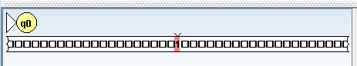

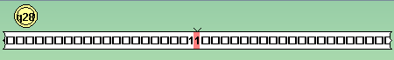

With input = 0, we get the answer 1, which is correct.

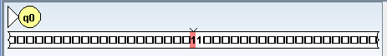

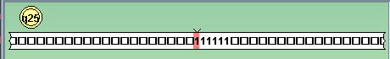

With input = 1, we get six 1s, which means that is equal to 5. $1^{2}+3\left(1\right)+1$ is equal to 5.

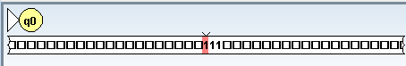

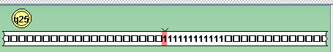

With input = 2, we get twelve 1s, which means that is equal to 11. $2^{2}+3\left(2\right)+1$ is equal to 11.

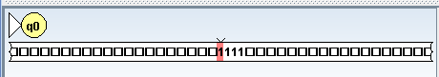

https://i.gyazo.com/aa974711c99e6be2f00152bb12214a06.png

With input = 3, we get the output of twenty 1s, which is equal to 19. $3^{2}+3\left(3\right)+1$ is indeed equal to 19.

https://i.gyazo.com/b167190b7b5fca1f1a797af51e6ec018.png

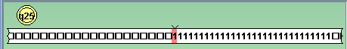

With input = 4, we get the output of thirty 1s, which is equal to 29. $4^{2}+4\left(3\right)+1$ is indeed equal to 29.

Which means all our test cases thus far are correct.

**Time Complexity Analysis:**

[Time to go thought all “1”] + [Time to go to next step] + [Time to confirm n is equal to] + [Time to go to next step] + [Time to calculate n2] + [Time to go to next step] + [Time to calculate 3n] + [Time to +1] + [Finish]

$$n+8n+4+n\left(4+6n+3\right)+4n+5$$

$=n+8n+4+4n+6n^{2}+3+4n+5$

$=6n^{2}+13n+12$

Time m(n) = $6n^{2}+13n+12$ = $O(n^{2})$

**Space Complexity:**

The space complexity should be $n^{2}+3n+1$ and plus 1 to determine to finish, we do this by counting the number of total slots that we used on the tape.

Space m(n) = $n^{2}+3n+2$ = $O(n^{2})$

**Finite Automata $aa{\left(a+b\right)}^{*}bb$**

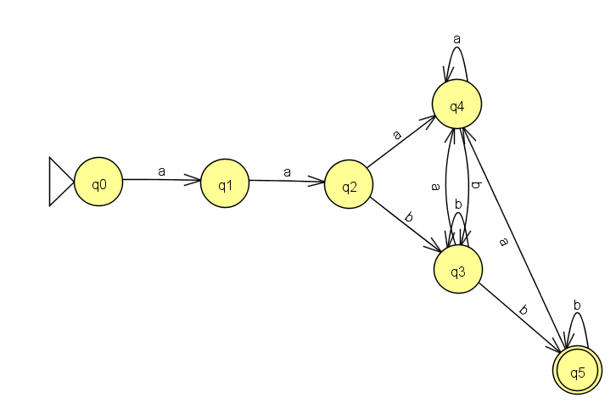

**Test Cases:**

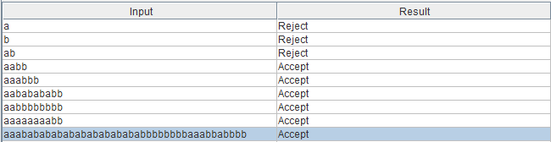

As you can see in the test cases, a, b, and ab fail because they fail to satisfy the language. However, the rest of the inputs such as aabb, aaabbb, aababababb etc. all satisfy our language, and therefore are accepted.

**Time Complexity Analysis:**

The time complexity of this program n because we are reading the input linearly from beginning to the end, therefore, no matter what we will go through n states and read through n input characters. Time complexity is **O(n).**

**Space Complexity:**

The space complexity is n where n is the length of the input, we don’t change the input in anyway but are just going through it. Therefore, space complexity is **O(n)**.