**Question 1. Resolution to FOPL**

*All CCNY Students are intelligent*

*All Intelligent students work hard*

*Either Joe or Carol goes to CCNY*

*Carol is not a CCNY student*

This implies that all City College Students work hard and because Carol is not a CCNY student, Joe is a CCNY student. Since it is implied that all City College students are intelligent, then that means joe is intelligent and because he is intelligent, it is implied that he also works hard.

**Question 2. Semantic Network**

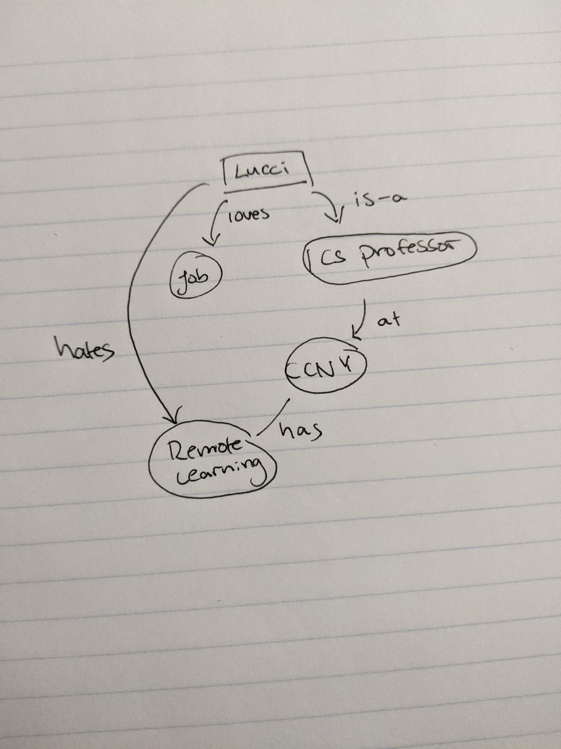

**Question 3. Target Achievement**

The Target achievement in AI is the same target achievement for the past century and that is automation. To simulate the human life form enough to do the tasks that humans can do, thus requiring less work to be done and in theory, live a more comfortable life as a result. Isn’t AI at its core just automation? To perform given a goal, a task and doing it efficiently or according to what the user desires it to. Take a chess bot for example, you can change the difficulty if you want to test your own limit and that’s the purpose of it. It’s not always desired to go against another human, a bot will suffice. Also because of the race for automation, we see a lot of complaints about people losing their jobs as they have complained during the industrial revolution, everything is just repeating. So, in the last 20 years, the only goal in the minds of people were automation, to automate life and human interactions.

**Question 4. Genetic Algorithm**

I will have N concurrent iterations of a solution and pick out the best solution from the group which is my fitness function. Then continue until a solution is found. The gist of it is that I will have the function perform iteratively following the best previous paths until the solution is reached.

The fitness function will decide based on a fitness score where points will be added to the fitness value if the diagonal to the point is clear. Traverse through the highest score first for all possible solutions then if no solution, backtrack.

The general outline of the algorithm will go as followed

1. N number of people/bots will run the function at the same time then calculate the fitness score
2. Whichever has a good fitness score that is also valid will proceed
3. If no good fitness score, go back to a parent node
4. Repeats steps a-c until a solution is come upon

**Question 5. Ant Colony Optimization**

Like the Algorithm is described, there will be random traversal of the graph until the destination is reached in which there will be certain points that will be marked as you traverse. Any other paths that happen to traverse through those markers will know that they are traversing in the correct path and will continue until they find the destination, then again leave markers for future searches such that there will be enough markers to know. For example, we get a worker who reaches a destination, go back to the starting point leaving markers. The next worker who shows up at destination will then also go back and leave more markers (no duplicate markers) such that if will repeat until a path of markers from start to finish is created.

**Question 6. Perceptron Learning**

Epoch 1

|  |  |  |  |  |  |  |  |  |  |  |  |
| --- | --- | --- | --- | --- | --- | --- | --- | --- | --- | --- | --- |
| X1 | X2 | X3 | W1 | W2 | W3 | X.W | y | t | △w1 | △w2 | △w3 |
| 0 | 0 | -1 | 0.1 | 0.4 | 0.3 | -0.3 | 0 | 0 | 0 | 0 | 0 |
| 0 | 1 | -1 | 0.1 | 0.4 | 0.3 | 0.1 | 1 | 0 | 0 | 0 | -1 |
| 1 | 0 | -1 | 0.1 | -0.1 | 0.8 | -0.7 | 0 | 1 | 0 | -1 | -1 |
| 1 | 1 | -1 | 0.6 | -0.1 | 0.3 | 0.3 | 1 | 1 | -1 | 0 | -1 |

Epoch 2

|  |  |  |  |  |  |  |  |  |  |  |  |
| --- | --- | --- | --- | --- | --- | --- | --- | --- | --- | --- | --- |
| X1 | X2 | X3 | W1 | W2 | W3 | X.W | y | t | △w1 | △w2 | △w3 |
| 0 | 0 | -1 | 0.6 | -0.1 | 0.3 | -0.3 | 0 | 0 | 0 | 0 | 0 |
| 0 | 1 | -1 | 0.6 | -0.1 | 0.3 | -0.4 | 0 | 0 | 0 | 0 | 0 |
| 1 | 0 | -1 | 0.6 | -0.1 | 0.3 | 0.3 | 1 | 1 | 0 | 0 | 0 |
| 1 | 1 | -1 | 0.6 | -0.1 | 0.3 | 0.2 | 1 | 1 | 0 | 0 | 0 |

As we can see that in Epoch 2, the changes in △w1 - △w3 is all 0, W3 stays constant for all iterations which shows that the final weights are

W1 = 0.6

W2 = -0.1

W3 = 0.3

The formula I used to calculate all of the elements in the table is

W’ = wi + (Learning Rate * (t-y) * xi)

**Question 7. BPN**

a.

Input:

1. Persons name + Address
2. Risk level
   1. Low-risk = 0
   2. High-risk = 1
   3. Higher risk means higher chance of rejecting insurance, lower risk means higher chance of acceptance

We have 2 inputs as stated above with the hidden layer being the evaluation of the risk level of the person and the output layer being the decision made being yes accept or no don’t accept

2-1-1 Initial architecture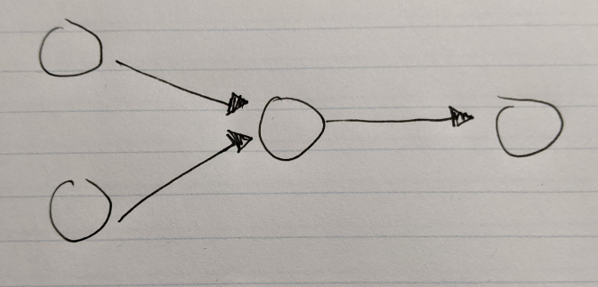

b.

There will be training from the general population as the more we use it the more it will get trained. Furthermore, what will be provided for training is previous data before the system was created. This data is also address, name and risk levels and how we humans evaluated them, then go based on this information.

c.

Money based ethical issues; we are judging people in an unbiased environment, but the reality is that not everyone could afford to pay for their medical expenses, so insurance is extremely necessary. Let’s say a person who has high risk and has low income gets their insurance rejected. This person will pretty much be in the gutter and legal issues can come from mistakes that can happen in the algorithm, what happens if we charge someone an obscene amount on accident? Legal actions will be taken

d.

As stated above, there will be an intake of data from the past which it will train off of at the start and when the error at evaluation is low enough, it will proceed to work with actual people and continue training and using data. The point of stopping will be reached when a certain level of error is reached such that it is low enough to be disregarded. How low? Well maybe something like 0.000000001 margin error

e.

The advantages would be that it is very simple to work with, easy to evaluate. You get some data, and you throw it into the algorithm, and it decides on how to evaluate it then after evaluation, it will put that information into good use for the future to lower margin errors for mistakes.

Disadvantage - Dependent on the input data, as it will dictate how the BPN will act so that would be its major disadvantage. It is also something that takes a very long time to train and is sensitive to training data that it might receive, say an unusual input was given, it might mess up the system. Furthermore, we have to consider the bias as there is none. It is not trained to deal with bias.

**Question 8. Ethics**

1. A Huge ethical issue in AI recently is Elon Musk’s self-driving cars and how it evaluates danger. Would it prioritize the driver, or would it prioritize a group of people and there is no real way to avoid this? Either party suffers and the question is how should it prioritize? People often say that there should be no self-driving module to avoid such situations but even then, if an actual person were to make these choices, it would be just as difficult.

Another issue that is hot at the moment is how AI would become too advanced thus overtaking the human race and making us their slaves or something. People are fearful of the fact that the humans will be wiped out and only automatons will be left in the world.

1. My view on the self-driving car is that it should be limited to things like bus driving or train operating because the problem of blame stems too far out if a self-driving car were to make the ethical choice. It would go from the drivers blame to the cars blame, to the manufacturers blame to the developers blame. Its too vast, so just have people not have access to such technology to keep things simple. As for AI overtaking the human race, I could care less. My view on this is that it would not matter to me whether they overtake us because humans are weak and fickle and have too many desires and internal fights with others. If the robot overlords don’t overtake us, we’ll probably wipe ourselves out instead.