Student : Chue Zhang

EMPLID : 23398187

1. Suppose we have **n = 0**, this would mean that you would give you

$$f\left(n\right)<f\left(n+1\right) \\ f\left(0\right)<f\left(1\right)$$

Upon analysis, what can be understood is that for any **n** in the set of natural numbers **N,** f(n) will always be smaller than f(n +1). This means that if we plug any number **n** into the function f(n), the resulting f(n+1) will be larger so if we plug in INFINITY, we’d get f(INF + 1) as the larger function. Since the set of numbers **N** is uncountable, then we can safely say that there are an uncountable number of monatomic increasing functions because they have a 1-1 correspondence.

1. (a*b*)c*

In this expression, we have a b and c such that a comes before b and b before. With the * symbol, this allows the expression to deal with cases where there are no a b or c’s.

1. S 🡪 XY|Ɛ

X 🡪 aXb| Ɛ

Y 🡪 bYa | Ɛ

Since there are two “a” strings with different lengths we needed to have a case for both aXb and bYa. Where X will handle the amount of a’s on the left first then work on the amount of a’s on the right. With this method, we don’t even need to look at b because the # of a’s on the left side + # of a’s on the right side = # of b’s.

1. a.

|  |  |  |
| --- | --- | --- |
|  | a | b |
| Q0 | Q1 | Q0 |
| Q1 | Q1 | Q2 |
| Q2 | Q0 | Q1 |

b. **BAAB, ABAAAB** are accepted by M

**BABA** ends at q0, **ABAB** also ends at q0

c. (b*a+ b (b a* b)*)(a b*a+ b (b a* b)*)*

For this regular expression, I made it so that it could loop as many b’s first, then at least one a, then one b to finish. Then I added an entire loop where there is an “a” after the “b” at q2 which transitions state over from q2 to q0. Then just keep running the same loop as before.

1. f1 = (X v ~Y),

f2 = (~X v Z),

f3 = (Y v ~Z),

f4 = (~X v ~Z),

f5 = (Y v Z)

|  |  |  |  |  |  |  |  |  |
| --- | --- | --- | --- | --- | --- | --- | --- | --- |
| x | y | z | f1 | f2 | f3 | f4 | f5 | together |
| 0 | 0 | 0 | 1 | 1 | 1 | 1 | 0 | 0 |
| 0 | 0 | 1 | 1 | 1 | 0 | 1 | 0 | 0 |
| 0 | 1 | 0 | 0 | 1 | 1 | 1 | 0 | 0 |
| 0 | 1 | 1 | 0 | 1 | 1 | 1 | 1 | 0 |
| 1 | 0 | 0 | 1 | 0 | 1 | 1 | 1 | 0 |
| 1 | 0 | 1 | 1 | 1 | 0 | 1 | 1 | 0 |
| 1 | 1 | 0 | 1 | 0 | 1 | 0 | 1 | 0 |
| 1 | 1 | 1 | 1 | 1 | 1 | 0 | 1 | 0 |

Outcome for the all combinations for this formula results in 0 which means that this is not satisfiable no matter what.

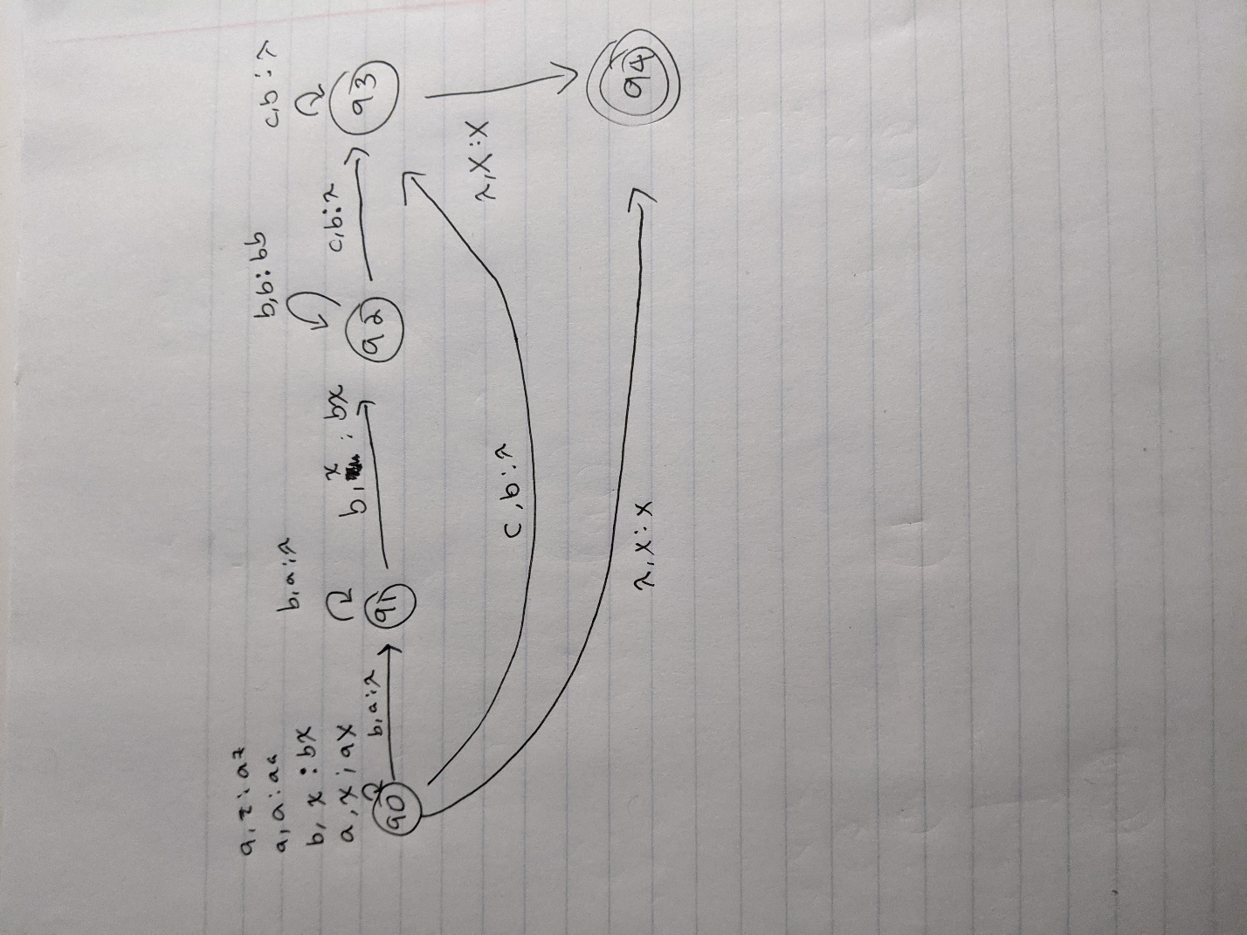

In this PDA, I am trying to imitate question 3 but its slightly different in the sense that instead of aXb, bXa, it is aXb, bXc. But the logic is still the same.

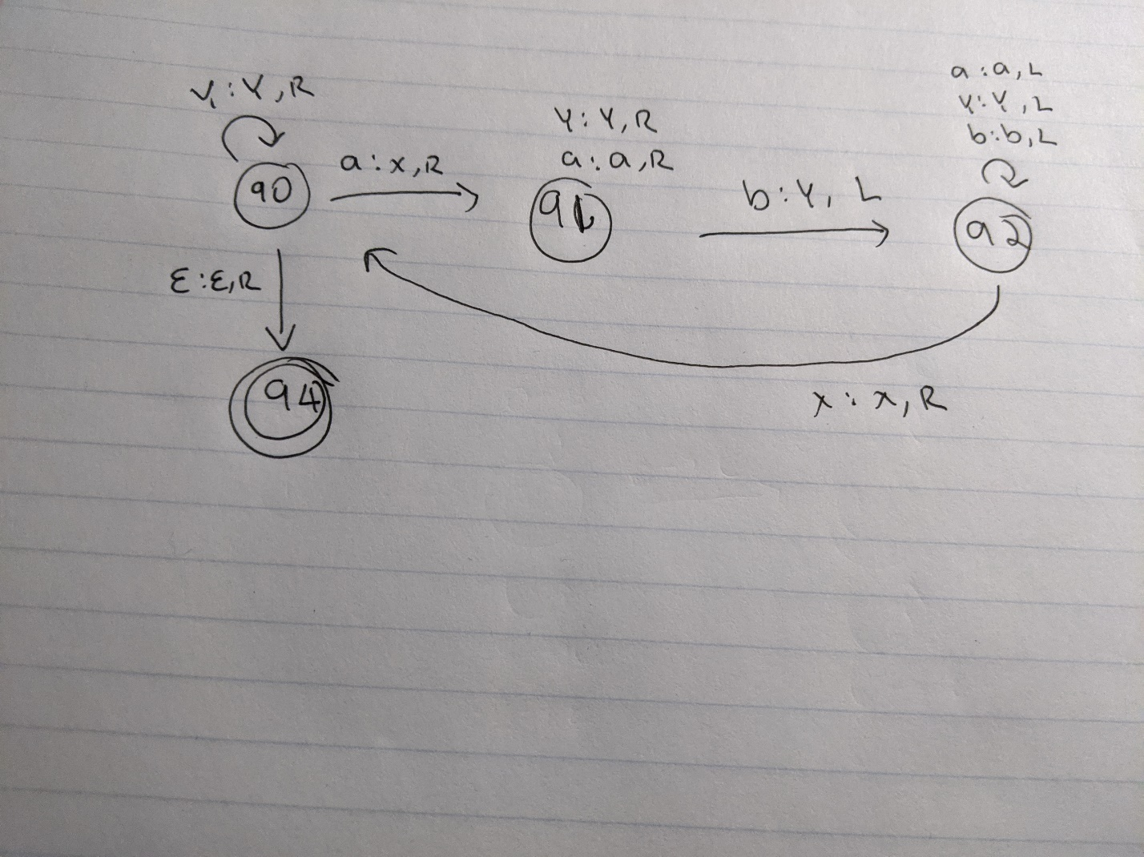

1. P = is the set of all decision problems that can be solved in polynomial time. It is deterministic

2 x 2 = 4

NP = is the set of all decision problems that answers with yes ( can return in polynomial time if help is given)

That is your dog?

NP-complete = set of all decision problems that have no efficient algorithm for a solution

Traveling salesman problem

CO-NP = is the set of all decision problems that answers with no

That is not your dog?